
BA(HONS) LEADERSHIP AND MANAGEMENT SKILLS FOR THE WORKPLACE
LEADING AND IMPLENTING CHANGE
BMSW6103
DR DENNIS PEPPLE AND NADEEM MIRZA
A CHANGE MANAGEMENT PLAN FOR MERCEDES BENZ
20/11/2024

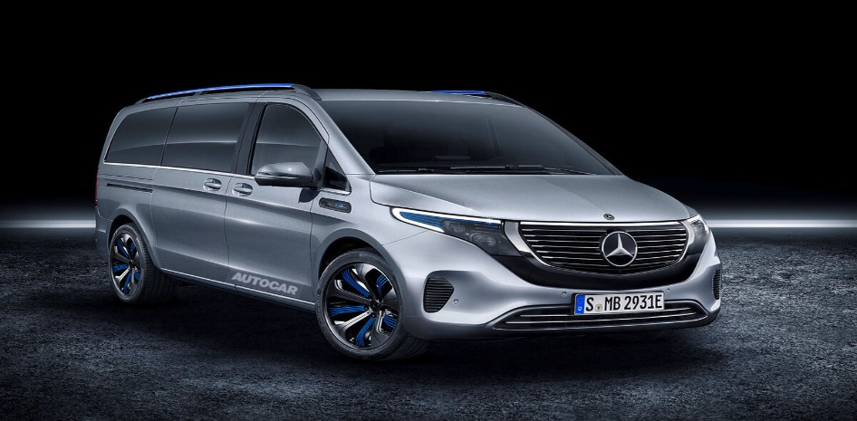
CONTENTS
PAGE 1 TITLE PAGE
PAGE 2 CONTENTS
PAGE 3.BRIEF REVIEW OF MERCEDES BENZ
PAGE 4.MY ANALYSIS OF THE RECENT HISTORY OF MERCEDES BENZ
PAGE 5/67.IMPACT OF EXTERNAL ENVOIRENMENTS ON MERCEDES BENZ
PAGE 7/8.EVALUATION OF THE IMPACT OF ORGANISATIONAL CULTURE ON CHANGE MANAGEMENT AT MERCEDES BENZ
PAGE 9 CONCLUSION AND ACADEMIC REFERENCES

A BRIEF REVIEW OF THE CURRENT STATE OF MERCEDES-BENZ
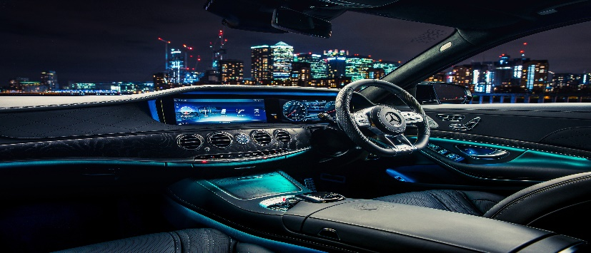

As I’m writing this report, Mercedes-Benz continues to be a massive player in the luxury and sport vehicle market, known for its unwavering commitment to innovation, quality, and performance. The brand has been very actively transitioning towards electric mobility to keep up with modern demands and legal requirements with a huge investment in electric vehicles (EV) development under its EQ sub-brand as well the luxury multi seater vehicles and their formula 1 team. This range also includes the introduction of models like the EQS and EQE, which showcase advanced technology and sustainability.
In addition to electrification, Mercedes-Benz is focusing on enhancing its digital offerings, integrating advanced driver-assistance systems, and improving connectivity features across its vehicle lineup. The company is also addressing supply chain challenges and semiconductor shortages that have affected the automotive industry.
- Drive strategic and data-driven change in business.
Overall, Mercedes-Benz is positioned to maintain its reputation for luxury and performance while adapting to the evolving automotive landscape, emphasizing sustainability and technological advancement.
Mercedes-Benz, a prominent luxury automobile manufacturer, has undergone significant transformations in recent years, influenced by various external factors, including digital disruption and economic uncertainty.

My Analysis of the Recent History of Mercedes-Benz
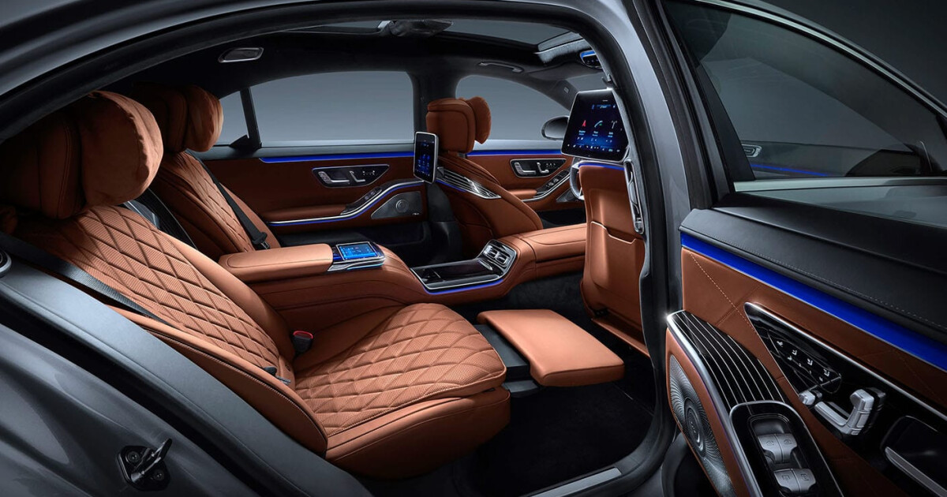
1. Electrification and Sustainability: In response to growing environmental concerns and regulatory pressures, Mercedes-Benz has accelerated its shift towards electric vehicles (EVs). The launch of the EQ brand in 2016 marked a pivotal moment, with the company committing to a comprehensive electrification strategy. By 2022, Mercedes-Benz announced plans to become a fully electric brand by 2030, contingent on market conditions.

2)’’Change can only succeed if people buy into it’’

2. Technological Advancements: The integration of advanced technologies, such as autonomous driving features and connectivity, has been a focal point for Mercedes-Benz. The introduction of the MBUX (Mercedes-Benz User Experience) infotainment system exemplifies the brand's commitment to enhancing user experience through digital innovation.

3. Global Supply Chain Challenges: The COVID-19 pandemic and subsequent geopolitical tensions have disrupted global supply chains, affecting production and delivery timelines. Mercedes-Benz, like many automakers, faced challenges in sourcing components, particularly semiconductors, which are critical for modern vehicles.

4. Market Positioning: Despite these challenges, Mercedes-Benz has maintained a strong market presence, focusing on luxury and performance. The brand has continued to invest in high-performance models and innovative designs, appealing to a discerning customer base.
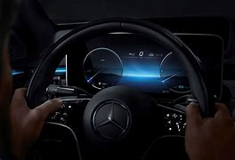
Impact of External Environments on Mercedes Benz

1. Digital Disruption: The automotive industry is experiencing a significant digital transformation, with increasing competition from tech companies and new entrants in the EV market. Mercedes-Benz has responded by investing in software development and partnerships with technology firms to enhance its digital capabilities. This includes advancements in over-the-air updates and in-car services, which are becoming essential for modern consumers.
2. Economic Uncertainty: Ongoing economic challenges, including inflation and fluctuating consumer demand, have impacted luxury goods sales. Mercedes-Benz has had to navigate these uncertainties by adjusting production levels and focusing on cost management. The brand adapts to changing market conditions easily and this has been crucial in keeping its business edge.
3. Regulatory Changes: Stricter emissions regulations in various markets have compelled Mercedes-Benz to innovate rapidly. The company has invested heavily in research and development to meet these standards while also appealing to environmentally conscious consumers.
4. Consumer Preferences: There has been a noticeable shift in consumer preferences towards sustainability and technology. Mercedes-Benz has responded by expanding its EV lineup and enhancing the technological features of its vehicles, ensuring alignment with market trends.
In summary to the 4 impacts of external environment on Mercedes-Benz, the company has navigated a very layered landscape directed by digital disruption and economic uncertainty. The business has been very proactive in its approach to electrification, technological innovation, and adaptability to market changes has positioned it to stay a leader in the luxury vehicle sector. As the car industry greatly continues to evolve, Mercedes-Benz's long-standing commitment to brand sustainability and digital transformation these will all be crucial in shaping its own future path to staying relevant to new generations of buyers.

Change management structures allow us to have a multi angle viewpoint to transitioning single entities, large teams, and massive organizations from their current state to how we want it to be in the future. Many models have been developed to take organizations through the process of change. Below I will evaluate several well-known change management models and try to relate them to strategic changes at Mercedes-Benz, including how these changes are managed and the leadership styles used by the business.
1. Kotter’s 8-Step Change Model
the Kotter model uses a formal approach for bringing about change, increasing urgency, putting together a coalition, creating a vision, and making new approaches in the culture.
Application of the model at Mercedes-Benz:
In recent years, Mercedes-Benz has undergone significant strategic changes, particularly in its shift towards electric vehicles (EVs) and digital transformation. The urgency for change was driven by market demands and regulatory pressures for sustainability.
Leadership Style: Transformational leadership was evident as leaders inspired and motivated employees to embrace the vision of becoming a leader in the EV market. The emphasis on collaboration and communication aligns with Kotter’s model, particularly in forming coalitions and communicating the vision.
2. ADKAR Model
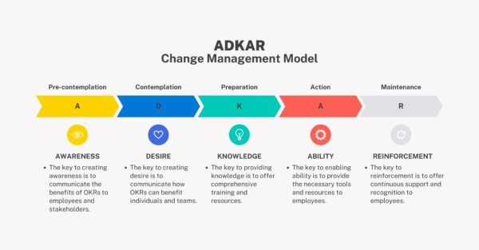
This model focus’s on change and consists of 5 elements: Awareness, Desire, Knowledge, Ability, and Reinforcement.
Application of the model at Mercedes-Benz:
As the company moved to electric mobility, it was important to ensure that employees were made aware of the changes and desired to take part in the transformation. Training programs were implemented to give greater knowledge and ability regarding new technologies used in the business transformation
Leadership Style: ‘’A do as I do ‘’leadership style was utilized, encouraging employee involvement in the change process. This approach helped in addressing concerns and fostering a culture of support and reinforcement.
3. Lewin’s Change Management Model
This model is made up of three stages: Unfreeze, Change, and Refreeze. The emphasis being on the need to prepare for the changes, putting it in place, and to solidify the newly made state.
Application of the model at Mercedes-Benz: The unfreezing stage involved recognizing the need for change in response to competitive pressures and environmental concerns. The change phase included the rollout of new EV models and production processes. Finally, the refreezing stage involved integrating these changes into the company culture.
Leadership Style: A directive leadership style was initially necessary to guide the organization through the unfreezing phase, ensuring that all employees understood the necessity of the changes. As the process progressed, a more supportive style emerged to help employees adapt to new practices.
4. McKinsey 7-S Framework
This framework focuses on 7 interdependent stages: Strategy, Structure, Systems, Shared Values, Skills, Style, and Staff.
Application of this model at Mercedes-Benz:
The strategic shift towards electrification required alignment across all seven elements. For instance, the strategy was redefined to prioritize sustainability, while the structure was adjusted to support new product lines.
Leadership Style: A strategic leadership style was employed to ensure that all elements were aligned with the new vision. Leaders worked to foster shared values around innovation and sustainability, which were critical for successful implementation.
Issues Related to Strategic Change at Mercedes-Benz
1. Cultural Resistance: staff would resist changes due to not knowing about plans or liking existing working practices. Addressing issues through effective communication and involvement is crucial.
2. Skill Gaps: Transitioning to electric vehicles requires upgrading skills alongside knowledge. Mercedes-Benz had to reinvest in training with development to bridge these gaps.
3. Market Competition: The luxury car industry is super-fast moving, especially in the EV sector. Mercedes-Benz needed to ensure that its strategic changes were not only innovative but also timely to maintain market relevance.
4. Regulatory Compliance: As regulations around emissions and sustainability tighten, Mercedes-Benz had to ensure that its strategic changes aligned with legal requirements.
Conclusion into the effect of models on change management
Mercedes-Benz's strategic changes, particularly in the context of electrification and digital transformation, illustrate the application of various change management models. The leadership styles employed ranged from transformational to participative and strategic, reflecting the need for adaptability in managing change. By addressing cultural resistance, skill gaps, market competition, and regulatory compliance, Mercedes-Benz can navigate its transformation effectively and position itself as a leader in the evolving automotive landscape.
Evaluation of the impact of organisational culture on the change management programme at Mercedes Benz and development of a suitable change management plan (proposed change, financial plan, communication plan, evaluation plan),
Organisational culture has a massive role in the success of change management plans at Mercedes-Benz. The company's culture, which emphasizes innovation, quality, and a commitment to excellence, can either facilitate or hinder change efforts.
1. Support for Innovation: Mercedes-Benz has a culture that values innovation and technological advancement. This can positively impact change management by fostering an environment where employees are more open to new ideas and processes.
2. Resistance to Change: Conversely, a strong adherence to traditional practices and a hierarchical structure may lead to resistance among employees, particularly if they perceive changes as threats to their roles or the company's legacy.
3. Employee Engagement: A culture that prioritizes employee engagement and collaboration can enhance the effectiveness of change management by ensuring that employees feel valued and involved in the process.
4. Leadership Influence: The leadership style at Mercedes-Benz, which often emphasizes top-down decision-making, can impact how changes are perceived and implemented. Leaders must embody the change they wish to see to encourage buy-in from employees.

Proposed Change Management Plan for Mercedes-Benz
3)“Companies carry responsibility,” Mercedes CEO
1. Proposed Change
Implementation of Electric Vehicle (EV) Production: As part of the global shift towards sustainability, Mercedes-Benz aims to transition a significant portion of its production to electric vehicles over the next five years.
2. Financial Plan
- Budget Allocation: Allocate a budget of €1 billion for the transition, covering research and development, production line modifications, and employee training.
- Cost-Benefit Analysis: Conduct a thorough analysis to project long-term savings from reduced emissions and increased market share in the EV sector.
- Funding Sources: Explore partnerships with technology firms and government grants aimed at promoting sustainable practices.
3. Communication Plan
- Stakeholder Engagement: Identify key stakeholders (employees, suppliers, customers) and develop tailored communication strategies for each group.
- Regular Updates: Implement a schedule for regular updates through newsletters, town hall meetings, and digital platforms to keep all stakeholders informed about progress and changes.
- Feedback Mechanism: Establish channels for employees to give feedback and express issues arising regarding the transition, ensuring their voices are heard and considered.
4. Evaluation Plan
- Performance Metrics: Defining KPIs to see the success of the change initiatives, things like production efficiency, employee satisfaction, and market share in the EV segment.
- Regular Reviews: having quarterly meetings to assess progress measured by the KPIs and all necessary adjustments to the plan.
- Employee Surveys: Conduct bi-annual employee surveys to gauge sentiment towards the changes and identify areas for improvement.

Conclusion
4)Mercedes-Benz is the most valuable luxury car brand in the world
The successful implementation of a change management program at Mercedes-Benz hinges on understanding and leveraging its organisational culture. By focusing on innovation, engaging employees, and maintaining clear communication, the company can navigate the transition to electric vehicle production effectively. The proposed change management plan outlines a structured approach to ensure that the transition is financially viable, well-communicated, and continuously evaluated for success.
Academic References
1)https://management-consulting.mercedes-benz.com/
2) https://www.mercedes-benz-consulting.de/en/expertise/capabilities/change-management/
3) https://www.forbes.com/sites/karlmoore/2021/02/10/leading-a-tradition-rich-company-evolve-your-strategy-while-staying-true-to-your-roots/
4) https://www.prnewswire.com/news-releases/new-mercedes-benz-strategy-announced---targeting-structurally-higher-profitability-301146429.html

