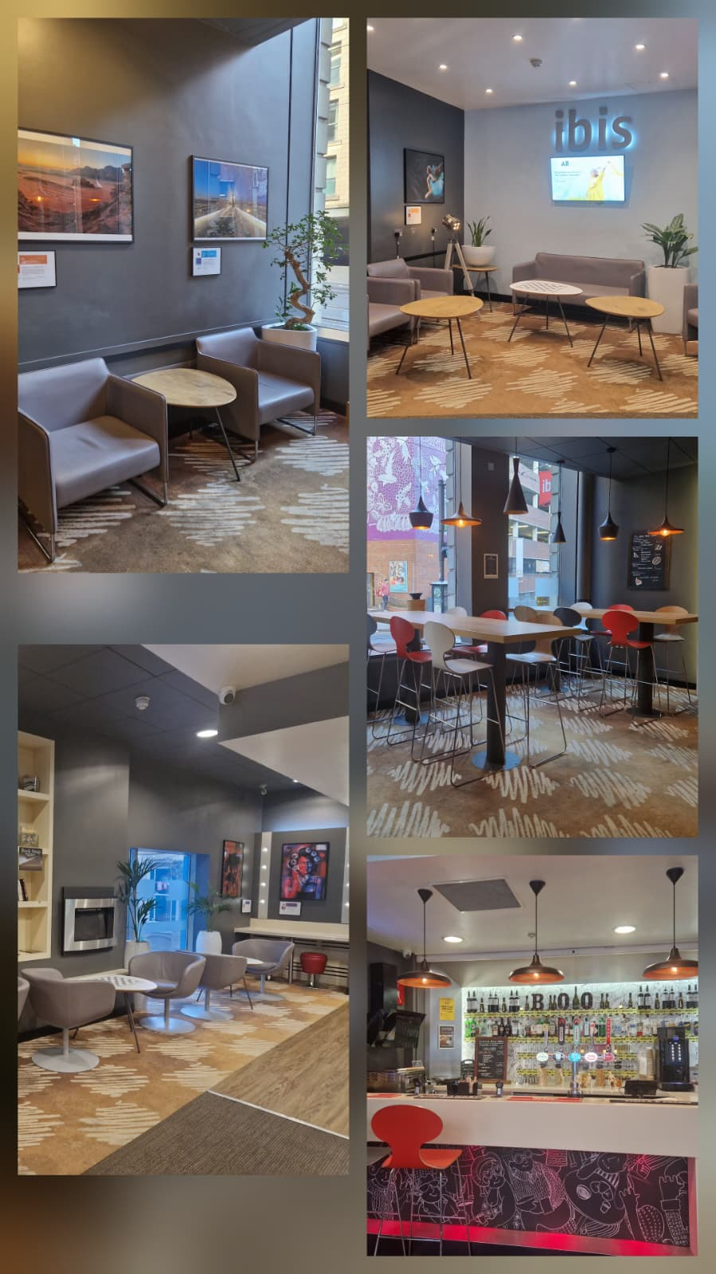  REFLECTIVE LEARNING LOG | Module title: Managing Guest Service Operations Module code: BMIH6003.  Lecturer name: Jessica Newport  Student name: Anamaria Alma Vida  Student ID: 2244885  Placement Hotel: Ibis Nottingham Centre

I acknowledge the use of Copilot (https://copilot.microsoft.com/) on 26th of September to create a draft of my reflective journal using the prompt:
- Can you please help me create a draft of a reflective journal to focus on my student placement in a hotel?
I acknowledge the use of Grammarly (https://www.grammarly.com/) on 14th of November to check my work using the prompt:
- Please check the following text for readability, grammar, and syntax.
I confirm that I have not presented any AI generated text as my own work. I confirm I have copies of my drafts, notes, and other resources I used before, and after the use of AI tools which I may be asked to provide in evidence.

Introduction
During my ten-week placement at Ibis Nottingham Centre, I was assigned to the Front Office, a department that directly represents the brand’s first impression and operational efficiency. Although the Front Office is not one of the departments listed in the assignment brief, I chose to focus on it because my placement did not provide direct experience in other listed departments such as housekeeping or maintenance. Discussing the Front Office allows me to demonstrate my understanding of guest service operations, teamwork, and organisational culture while linking theory to practice.
The Front Office in this property functions uniquely: it is positioned directly behind the bar, with no designated reception desk. This layout, while efficient for staffing and multitasking, slightly compromises the visibility of the reception function. Guests are sometimes uncertain about where to check in, although the setup improves efficiency by eliminating unnecessary staff movement.
The department operates across three shifts—early, late, and night—each handling distinct responsibilities. The early shift manages check-outs, emails, and paperwork for the next shift; the late shift focuses on check-ins, upselling services, and assisting guests; the night shift finalises accounts and restocks the bar. Each shift is staffed by a single employee, requiring autonomy and excellent communication across transitions.
This reflection explores culture, teamwork, and motivation within this Front Office environment, linking practical experiences to theories from the Personnel Resourcing and Development module. I will justify the theoretical frameworks used and connect them to real-life examples, demonstrating my understanding of how culture and motivation influence guest service operations.

Main Body – Department Reflection
1. Understanding Culture and Teamwork in the Front Office
Organisational culture shapes how employees interpret their roles and deliver service. According to Wood (2013), culture provides a shared identity, guiding decision-making even in decentralised operations. At Ibis Nottingham, the Front Office culture emphasised independence, accountability, and mutual respect. Because each shift was run by a single staff member, teamwork relied heavily on structured communication rather than physical collaboration.
I learned the essential routines from Arash Haidiri, who exemplified patience, precision, and hospitality. His approach reflected Walker’s (2021) assertion that culture is transmitted through social learning—new employees absorb expectations from experienced colleagues. This is important because it demonstrates how informal mentoring can sustain service quality and operational consistency even in small, autonomous teams.
Communication between shifts occurred through structured handovers and informal WhatsApp groups. This allowed staff to share updates, guest requests, and urgent notices efficiently. However, Rutherford and O’Fallon (2007) note that informal systems, while flexible, can lack consistency and accountability. I experienced this first-hand when notes from the previous shift were incomplete, leading to minor duplication of tasks. This example shows how theory about communication systems directly relates to operational challenges.
2. Linking Theory to Organisational Practice
The Personnel Resourcing and Development module emphasises that organisational culture and employee motivation are mutually reinforcing. Felce (2019) argues that environments promoting respect, feedback, and recognition increase engagement, particularly in small teams where each contribution is highly visible.
At Ibis Nottingham, autonomy-built responsibility and self-confidence but limited formal motivation. Praise or acknowledgment depended largely on informal feedback from senior staff. I noticed that motivation often came from professional pride rather than structured recognition. This aligns with Johnston, Clark, and Shulver (2012), who emphasise that sustainable service quality relies not only on procedural efficiency but also on emotional engagement.
For example, during a particularly busy late shift, I observed that my colleague’s initiative-taking communication in the WhatsApp group helped manage guest expectations efficiently. Linking this to theory, Wood (2013) highlights that communication alone does not create culture; shared values and recognition consolidate it. This demonstrates that theory is essential to understanding why even efficient systems require attention to human factors to sustain performance.
3. The Reception-Behind-the-Bar Layout: Cultural and Operational Implications
The physical layout of the reception influences guest perception and employee workflow. While this design centralises guest interaction and beverage service, it blurs the distinction between reception and bar areas. On my first day, I instinctively asked where the reception was, illustrating common guest confusion.
From an operational perspective, the layout improves efficiency by allowing one employee to manage multiple functions. As Vallen and Vallen (2014) explain, multifunctional service areas are increasingly common in economy hotels where flexibility enhances profitability. Personally, I felt challenged at first by managing guest check-ins while simultaneously monitoring the bar area, but over time I adapted and developed multitasking skills, showing how theory about operational flexibility translates into practical learning.
4. Reflection on Learning and Professional Development
I recognised that teamwork does not always mean working side by side; it can mean working sequentially with shared responsibility. The consistent use of handovers and online communication tools maintained operational continuity, reflecting Walker’s (2021) concept of “virtual teamwork.”
Learning from Arash taught me that professionalism relies as much on consistency and attitude as on technical skill. This illustrates the modelling concept from Personnel Resourcing and Development: employees learn culture through behaviour, not instruction.
I also realised that recognition plays a critical role in sustaining morale. Even with effective communication and autonomy, lack of visible appreciation can lead to routine fatigue. Hagg (2013) highlights that structured recognition supports retention and engagement, particularly in placements and early-career roles. For example, when I received informal praise for managing a busy check-in smoothly, it motivated me to maintain ambitious standards and engage proactively with guests.
5. Improvement Plan – Recognition System (Three Steps)
To enhance motivation, cohesion, and performance within the Front Office, I propose the following recognition-focused plan:
a) Peer-to-Peer Acknowledgement
Introduce a weekly “Thank You” message via the WhatsApp group. Each staff member nominates another colleague for helpful acts or positive guest feedback.
b) Managerial Recognition Board
Create a noticeboard displaying guest compliments and positive online reviews mentioning staff names. Public recognition reinforces positive behaviour and links performance with appreciation.
c) Quarterly “Front Office Star” Award
A small reward (certificate or voucher) presented quarterly by management, based on peer nominations and guest feedback. This formal recognition supports engagement and aligns with brand values.
These steps formalise appreciation within an already communicative culture, strengthening morale and operational consistency without significant cost or complexity.

Conclusion
My placement at Ibis Nottingham Centre demonstrated that effective teamwork could exist without constant physical collaboration when supported by communication, trust, and shared responsibility. Although the Front Office is not a listed department in the assignment brief, discussing it allowed me to demonstrate understanding of guest service operations, teamwork, and culture in a real-world setting.
The experience highlighted that recognition is the missing element in an otherwise efficient structure. Even with effective communication and autonomy, consistent acknowledgment of staff efforts would strengthen engagement, align behaviour with organisational values, and enhance the guest experience.
Linking theory from the Personnel Resourcing and Development module with workplace practice reinforced my understanding of how culture and motivation intertwine. The proposed recognition plan offers a practical solution that supports employee wellbeing and operational consistency. I have learned that culture evolves through daily actions and that small, meaningful recognition practices can sustain excellence in hospitality environments where independence and teamwork coexist.

Reference List
Felce, A. (2019) ‘Managing the quality of higher education in apprenticeships’, Higher Education, Skills, and Work-based Learning, 9(2), pp.141–148.
Hagg, E. (2013) Internship Guide: Work Placements Step by Step. 5th edn. The Hague: Eleven International Publishing.
Johnston, R., Clark, G. and Shulver, M. (2012) Service Operations Management. London: Pearson.
Rutherford, D.G. and O’Fallon, M.J. (2007) Hotel Management and Operations. 4th edn. Hoboken, N.J.: John Wiley.
Vallen, G.K. and Vallen, J.J. (2014) Check-In Check-Out: Managing Hotel Operations. 9th edn. Harlow: Pearson Education Limited.
Walker, J.R. (2021) Introduction to Hospitality. 8th edn. Harlow: Pearson Education Limited.
Wood, R.C. (2013) Key Concepts in Hospitality Management. London: SAGE Publications Ltd.

