Name:_____________Matthew Hope____________________

Student Number: ______2509337__________________
__________________________________________________________

WORKSHEET 3 – TESTING (Lap Times)

- Original code:
[Copy and paste your original code from Moodle into this box. Do not change it.]

print("Welcome to the Racing Stats program:")

print()
print("Please enter the latest lap times...(in seconds)")

laps = []

for i in range(5):
while True:
try:
lap = float(input("Lap " + str(i + 1) + ": "))

if lap > 0:
laps.append(lap)
break
else:
print("Please enter a positive number.")

except:
print("Invalid input. Please enter a number.")

print()

while True:
try:
target = float(input("What are your target lap times? "))

if target > 0:
break
else:
print("Please enter a positive number.")

except:
print("Invalid input. Please enter a number.")

print()
print("Your statistics...")
print()

# total
total = sum(laps)
print("1. Overall time for 5 laps was:", total, "seconds")
print()

average = total / 5
print("2. Average lap time was:", round(average, 2), "seconds")
print()

fastest = min(laps)
fastest_lap = laps.index(fastest) + 1
print("3. The fastest lap was lap", fastest_lap, "in", fastest, "seconds")
print()

slowest = max(laps)
slowest_lap = laps.index(slowest) + 1
print("4. The slowest lap was lap", slowest_lap, "in", slowest, "seconds")
print()

count = 0
for lap in laps:
if lap <= target:
count += 1

print("5.", count, "of your laps were better than or equal to your target")
print()

print("Lap 1 was", laps[0])

for i in range(1, 5):
if laps[i] < laps[i - 1]:
print("Lap", i + 1, "was", laps[i], "which was faster than the previous lap")
else:
print("Lap", i + 1, "was", laps[i], "which was slower than the previous lap")

- Code Testing
For each test below, run your code and show the results of the scenarios below. Present a screenshot of what happened when the programme ran. Did the programme behave correctly, or did it do something unexpected, and if so, why?

- Test a lap time for your programme:
- 42 seconds
- 2 seconds
- -4 seconds
- 53444 seconds
- Test the target lap time – show that the values entered are reasonable

- Using the same five lap times as the sample output ie

Lap 1: 42.3
Lap 2: 42.1
Lap 3: 44
Lap 4: 44
Lap 5: 39.4

Examine each statistic (1-6) and comment on whether the correct answer(s) are displayed or not. (If any statistics were incomplete after Phase 1 (code completed in class) simply write “Unfinished”)

- Test two further sets of lap times of your own choice.

Template for tests:
Test:

Screenshot(s) of output:
A)
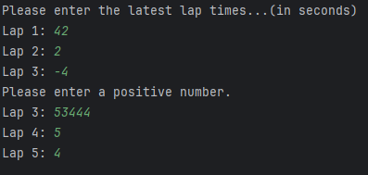

Test completed for question A. Validation recognised that -4 would be incorrect and the code has prompted the user to enter a positive number.

B)
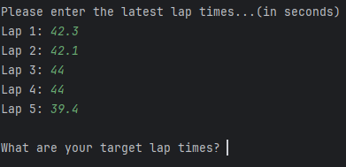

Testing completed for question B. All working.

C)

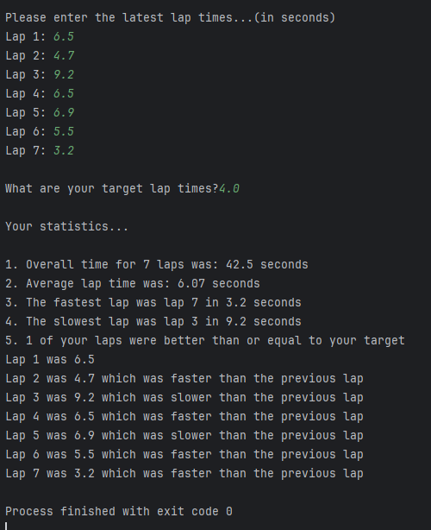

2 further lap times have been added and tested. All run correctly.

- Code ran efficiently with no errors, all validation entered prompts the user to enter different information if entered incorrectly. Numerous variables have been used and are also working correctly.

Result: Did the programme behave as expected ie syntactically and logically correct?
YES/NO (delete as appropriate)
If YES, comment on what happened.
If NO, what went wrong and why? Suggest how things could be improved

(Copy and paste box above for each of the rest of the tests)
- Consider the results of the above tests and revisit your original code in order to address any tests that failed and/or improve code efficiency.

(Note: you may not be able to solve all of the problems that were encountered, but solve as many as you can.)

Paste your full revised code here :

[Copy and paste your full revised code here – note, do not use a screenshot]

Test 1 ran efficiently.

Final code checked and tested:

print("Welcome to the Racing Stats program:")

print()

laps = []

print("Please enter the latest lap times...(in seconds)")

# input 7 laps
for i in range(7):
lap = float(input("Lap " + str(i + 1) + ": "))
laps.append(lap)

print()

target = float(input("What are your target lap times?"))

print()
print("Your statistics...")
print()

total = sum(laps)
print("1. Overall time for 7 laps was:", total, "seconds")

average = total / 7
print("2. Average lap time was:", round(average, 2), "seconds")

fastest = min(laps)
fastest_lap = laps.index(fastest) + 1
print("3. The fastest lap was lap", fastest_lap, "in", fastest, "seconds")

slowest = max(laps)
slowest_lap = laps.index(slowest) + 1
print("4. The slowest lap was lap", slowest_lap, "in", slowest, "seconds")

count = 0
for lap in laps:
if lap <= target:
count += 1

print("5.", count, "of your laps were better than or equal to your target")

print("Lap 1 was", laps[0])

for i in range(1, 7):
if laps[i] < laps[i - 1]:
print("Lap", i + 1, "was", laps[i], "which was faster than the previous lap")
else:
print("Lap", i + 1, "was", laps[i], "which was slower than the previous lap")

