
(BMSW5106_LON)
Knoledge and Information management SKILLS FOR THE WORKPLACE
Ivanovitch Bumba Girao Paiva (1916038)
Zainab Atta

Executive Summary

The purpose of this assignment is to be able to know how knowledge management is important to companies and organization, which role knowledge management plays inside the business, in this report it will be possible to recognize the key aspects and the importance of it. Amazon will be the company that is going to be analysed as an example and discussion comparing and associating their practice with models and theories about Knowledge management, is an academic report structured with introduction where can be founded the background of the organisation and which models and theories will be discussed in the report, evaluation of theories and models about Amazon how they apply and how is beneficial to them, and in this discussion will be associated with the pandemic how did they survive, improved and changed, which struggle they faced between that time and how was possible to apply KM in that situation. Each heading and subheading will guide and make aware what the discussion is about and will be finishing with a conclusion where the final findings will be summarize and personal opinions will be shared based in the discussion.
Some recommendation will be given at the end based in how Amazon could improve their service and strategy in how they apply knowledge management efficiency in the daily bases.

Table of Contents
Executive Summary 1
Introduction 3
Knowledge and information management 5
The importance of Knowledge Management in any Organization 7
The Importance of Knowledge Management in Amazon 8
Evaluation of Knowledge and Information Management Models/theories 9
Knowledge Management Techniques used by Amazon 10
Conclusion and Recommendation 12
References 13

Introduction

The purpose of this report is to discuss about the academic knowledge management models, methods and theories, how we can apply and process to different companies in this report we will use Amazon as the company.
Amazon is an American multinational company founded on 5 of July in 1994 by Jeff Bezos in Washington in his house garage, it all started as online bookstore, in the first two months the company sold the books around 50 states and 45 countries putting the sales up USD 20.000 per/week, seeing the progress Jeff Bezos had the idea to expand by selling more products as electronics, software, video game, and many other goods turning amazon the most valuable brand in the world and the biggest online retailer doing in 2020, USD 386.064 millions in revenue, USD 21331 millions of net income and employing 1.298.000 employees (Hall, 2020).
I will examined amazon, talking how and which principles, models and theories they used thru the coronavirus pandemic, I will explain how they deal with the situation using academic knowledge management how they are applying the tacit and explicit knowledge using the Kujiro Nanoka and Hirotaka Takeuchi knowledge theories, how they apply knowledge using the DIKW model, how they use the data warehouse and the data marts the knowledge cycle and the information lifecycle, the entity relationship diagrams.
The expectation of this report is to introduce Amazon as the organization that I will be talking about, introduce the Knowledge theories that I will mention, and explain my understanding about knowledge management how it works and how it can be applied demonstrating and relating to the organisation that I will be talking about it discussing the challenges though the covid-19 pandemic analysing the system implemented by Amazon and talking about the input and output processing as a system and be able to look at companies in a big picture knowing all the management cycle and understand the theories and decisions making, being able to apply all the theories in a real situation, identify awareness, procedures, active knowledge management, communication and change of management and be able to see knowledge as assets.
I will use DIKW model that means data, information, knowledge, and wisdom this model will help me to describe amazon in different process like what type of decision, how they transform the data to information how relevant is the communication in the business, how important is to know the difference between the knowledge how they process the information and take the decisions, I will write about this model and applying to evaluate amazon.
My expectation for this report is to simplify all the process of the knowledge management to be able to apply in the daily basis in what is requires for, also helping me identify what type of decision I can make in different situations I want to take the most outcome from this report because will bring to me another vision of knowledge and how important and useful it is and be able to use the wisdom as asset to improve my career.

Knowledge and information management

Amazon Background

Amazon is the second name that the founder Jeff Bezos came up to, the first idea was “Cadabra” but soon as they realise that people could easily misheard with “Cadaver” his lawyer did not approved, perhaps he came with Amazon and November 1 of 1994 he registered the domain, it all started when Jeff Bezos proposed a list of 20 commodities that we could sell via internet and his boss and he refused, from that one Jeff Bezos had the idea to start by his own. (Capitalism.com, 2020)
From the list that he proposed he chose selling books because he believed that the demand of books was high and expensive by that time he was using the explicit knowledge to help him understanding how to transfer the knowledge via products and services, also the accesses was limited so in July 1995 amazon started the first online bookstore, from his garage in Seattle in one month in sales he done it US 20.000 per week, in five months amazon was selling in every state in America plus 45 countries employing 250 employees at the end of the year. (Capitalism.com, 2020)
Because of the high demand Jeff Bezos needed additional capital to meet the satisfaction in 1997 Bezos decided to put Amazon IPO in share at US 18.00 that means that if you invested at that time and price, it would be worth now US 12 million, Amazon was able raised a fund of US 54 million taking the place of the biggest online book retailer of that time (Chaffey, 2020). In 1998 he realised that Amazon could sell anything taking the idea to expanding and selling more products starting to sell computers, games, music, software toys, pets, accessories and clothes but the ambitions did not stop there after consuming the whole food market you can even order groceries online he was transformed all data those to information to help him to take structure decisions. (Capitalism.com, 2020)
The winning idea that Jeff Bezos had did not stop there he wanted to invest more in computer software to run business operation, they managed to create “AWS” to help other singulars and companies to run their business that happen in 2006 when Amazon enter in web services “AWS”. Amazon become the biggest business in the world buying corporations and creating they own products “Alexa and Kindle tablet” they also streaming on televisions Amazon studios that was a big strategy to have more attention and engage the world in 2008 amazon in revenue was reported at US 232,887 million considering to be a massive success investing in all sectors in the company to make efficient. (Webster, 2019)

Amazon Mission and Vision
As a company Amazon had a clear ambition to be the first choice in the world and the world most centric company and be obsessive with costumers need, this ambition we still can identify because the numbers are growing costumers are worldwide numbers of sellers, content creator, developers and enterprises all of them have a different need but they always work to meet those needs to make everything accessible, great and more cost- effective. (Chaffey, 2020)
Jeff Bezos calls the true customers obsession because there are many ways to center a business either you be focus on the competition or focus on the quality of the product, or in the technology or in the business model but from his point of view obsessive costumer focus is by far the most important. (Chaffey, 2020)

Amazon Marketing Strategy
The vision of their marketing strategy is to be focus on the customer experience, giving low prices and a wide selection of products, they also keep the value of communication on the site the way they display the products the easy access in what the costumer is looking for and the customer service that is 24 hours and online ready to help for any quires. (Chaffey, 2020)
Amazon define success as customer loyalty and to achieve that they been focus in making every payment secure and easy, providing easy functionality, fast fulfilment and fast costumer service, free shipping to make the costumer buy more, the availability of products in the inventory and the notification of the delivery dates and updates, the translation of diverse languages all this made them win in 2004 the excellent American customer satisfaction. (Chaffey, 2020)
Amazon Strategy During the Covid-19

During the pandemic of covid-19, one of the worst global crisis, Amazon team knew it that they needed to act fast finding the best strategy to keep selling and work hard for the customer satisfaction one of the most important strategy was “Fishing where the fish are” realising that all the customer were stuck at home and it would be a high demand of online orders causing delays on the shipment and stock, Amazon decided to employ more people in their warehouses and invest more on the marketing strategy boosting amazon ads to bring all customer attention providing an excellent customer service, monthly revenue from advertising was between £15 to £20 Thousand within in the third month of lockdown it raised up to £97 Thousand. (Crawford, 2020)

The importance of Knowledge Management in any Organization

Knowledge Management is a resource or process that allow us to collect, convert and share experience, facts, context and knowledge of employees within organization (Kai Mertins, 2003) or the process of build a structure that can help organization to retain and share the experience between the employee to achieve the organization efficiently. (Kazuo Ichijo, 2007)
Knowledge Management is very important for any organization and can be applied in different ways, in a company is difficult to keep employees forever and sometimes with the most experience decide to leave and that for a company is a reason to lose a lot of things such as profit, customers and sometimes prestige, because not all employees have the same level of experience and just hiring is not a good solution, that’s why knowledge management is important because it helps us to identify the expertise in the organization and help them share the knowledge and experience, KM is the way to make sure that all employees have access to learn with the expertise in the organization in a smarter way to learn and be informed to benefit the company. (Valamis, 2019)
Some of the main reasons that companies apply the knowledge management:
- The need to make the team share their experience and knowledge.
- To avoid that key employees, get the retirement or end the contract without share the experience.
- To help in the recruitment using the wisdom though the Knowledge management to assist in the training of new employees. (Valamis, 2019)

These reasons are very important to Amazon to keep their high standards and providing quality service and to maintain the good practice a live in the company. All companies apply that to a big benefit because makes the workplace efficient, the ability to make a decision is better and fast, increase the performance and makes the company more organise, helps the new employees getting a better training. Knowledge management is viewed as a way for the company achieve the goals such as the customer satisfaction, innovation. (Kai Mertins, 2003)
Knowledge management is changing today’s environment is very important that owners and managers understand and implement all tools for success employing knowledge management in their organization, because knowledge in the future can became absolute that’s why knowledge is a continues creation it never stops to change.(Kazuo Ichijo, 2007)

The Importance of Knowledge Management in Amazon

Amazon realised that to be the biggest e-commerce in the world needed to be able to share the knowledge and experience, though the employees they viewed knowledge as assets that could drive the company to success, and structure knowledge as a tacit and explicit they realised that codify the knowledge would be easier to share internally and externally. Amazon creates a structure knowledge that can be shared more faster via internet than though the expertise with other people that helped the company investing in the knowledge map.(MacMillan, 2015)
Implementing knowledge Management to amazon it helped the company improving in the customer service and the efficiency in the workplace making the company more organise in problem context, cognitive factors, and social context the structure and unstructured decisions that helped the company been in the correct path taking advantages on the competitors realising the level of diffusion that allow they to know how distribute the knowledge though the employees because is really difficult to collect all tacit experience and put into a computer system that make them only focusing on the knowledge asset that are important for the success of the company. (MacMillan, 2015)
For Jeff Bezos customer satisfaction is a primordial priority by understanding the importance of transform knowledge to goods and service made him able to value the knowledge as asset retaining and sharing with the employees depending on the cognition and awareness and personal memory to help them perform in a high level and keeping this standard in the company.(Wai, 2014)
knowledge management principles they were able to value the costumers in diverse ways helping the company achieve the objectives the decision and the problem solving stated to be more quicker improving organization agility, the innovation increased a lot such as the growth and development of the employee and communication between the expertise and costumer gain much quality even the business practicing begin to be more accurate. (Rosenberg, 2014)

Evaluation of Knowledge and Information Management Models/theories

When we talk about knowledge and information management models and theories, we need to be aware about the existence of many models and theories about KM, Kujiro Nanoka and Hirotaka Takeuchi they contribute extensively for the tacit and explicit knowledge therefore they introduced SECI model in 1996 that became the inspiration for the knowledge creation and transfer theory they came with the idea that there is four ways that knowledge can be combined and converted showing how we can share and create knowledge in the organization.(Tools, 2012)
Amazon uses socialization as a guidance for improve their services and communication between them using tacit to tacit knowledge sharing factors such perceptions beliefs and values though employees and high management and that helps them be aware with the new deals and unexpected situations. Talking about the externalization that is tacit to explicit knowledge Amazon use their powerful technology to be able to collect and easily save as formal perceptions to help improving the feature of their website transfer the knowledge making easy to buy their products and expand the quality though their products and service, this combination allows companies sharing and codifying tacit knowledge though documents making easy to share information, that was very crucial in the covid-19 pandemic because they needed to communicate often with employees and costumers all the time. (Tools, 2012)
The combination of explicit to explicit is the easiest way to transfer the knowledge internally for the organization sharing tangible value information though KT process the knowledge giver and knowledge receiver they need to have the same interesse so they can have a formal communication.
Internalization that is a combination of tacit and explicit knowledge is the combination that the most companies use included Amazon they apply in the way to put the team thinking trying to find connections between ideas with the aim to reach the same conclusion making it more perceptive and easier to share, the ideas is formal and systematic supported by learning by doing or leading by example. (Hall, 2020)
The embedded knowledge in Amazon is a combination of formally and informally, formally because the management can have an initiative to create routines that will be beneficial to the company and informally because the organization applies another knowledge as well.
DIKW model is an analytical model process that helps companies transform data to wisdom is very necessary because it helps understand insights and transform to knowledge and knowledge to wisdom, this process follows the pyramid structure where it starts with data at the bottom and wisdom at the top is a hierarchical model that helps Amazon processing the data that they collect to get the knowledge of it to help taking structured decision. (Chaffey, 2020)
Amazon uses information system to have competitive advantage because the company have a vast customer base, investing in the efficiency of collect and store customer personal information is a big influence to the business this process to analyse through data acquisition to have details and description information improve the business to be ahead from the challenges of competitors, this system implementation is to help Amazon taking decision and the costumers to have exactly what they look for. Amazon web platform allow costumers create profiles and store they transaction information that is an important component to business system information (Kai Mertins, 2003)

Knowledge Management Techniques used by Amazon

Amazon is the biggest e-commerce in the world and knowledge management made a big contribution to that, using tacit and explicit knowledge, Amazon long of this years is coming with more and more techniques one of them delivery to the consumer where the consumer can see the products online and make a purchase via credit card transition and being able to receive the order by his preference, analysing the customer knowledge management Amazon felt the necessity to create a strategy to be able to deliver more faster creating warehouse all over the world offering their own service to track all orders that the costumer purchase, tacit knowledge is used to improve relationships between individuals is very crucial to e-business using explicit and tacit knowledge in Amazons web technologies to create interfaces that meet the customers’ needs to retain personal private information making easy to know each customers products interesse for the company send suggestion related to their interesse making easy to sell, once you sign up to Amazon website the company keeps your information and cookies to keep tracking preferences so this process is from tacit knowledge to explicit knowledge. (Capitalism.com, 2020)
Post read reviews is another technique that amazon created for costumers express their own opinion about the products rating stars 1-5 to make the communication tacit to explicit where opinions are shared and recommend to other costumers that is how they apply the knowledge, this socialization is tacit to tacit knowledge helping the personal interaction between the company and costumers, the 24 hours costumer service is a great technique to satisfying their customers in any time and language, Amazon have their website in all idiom to make easy the access and the interaction between the company and costumer the externalization that is tacit knowledge to explicit and a big investment from Amazon is AWS that is a cloudy service platform that allows costumers store they database and other functionality that help business grow and this software allows the company running web application, secure the files on the cloud, manage the database and server to store information send bulk emails to the costumers.(Ydav, 2018)
The knowledge management principles in Amazon helped this company to achieve the goal to be the most successful e-commerce in the world, even with that they determinate that the key was to give the user and costumers the ability to find and buy what they want and when they want easy and fast, but it was not enough that’s when they decided to apply knowledge management practices to give to the costumer what they deserve.(Rosenberg, 2014)
Amazon wanted that all the business should be done in the same portal that they call one shop one shop the aim was to make all costumers familiarize with one interface so in that way they don’t need to figure it out where to go if they needed diverse items, another technique was to display all products information in the same way and same order to make it easy for the employees and customers to don’t spend to many times trying to interpret contents. (Rosenberg, 2014)
Amazon is a big company therefore standard operating procedure will increase significantly this routine brings culture in the company and knowledge management helps sharing the experiences in the way that the knowledge does not stuck in someone’s head makes the knowledge available to everyone execute, and this process in Amazon is executed in multiple forms of knowledge tacit to tacit, tacit to explicit and explicit to tacit the results depend on how they apply this procedure. (Rosenberg, 2014)

The main outcomes that Amazon is getting from this procedure is:

- The quality on hiring and recruitment process it gives to Amazon a clear instruction on everyone about their responsibilities sharing the tangible value information analysing the cognitive factors.
- Costumers’ usage routine, putting expertise to explain each of the products how to use after buying booking appointments with costumers and have periodic calls to make them understand the usage and all feedback using as a knowledge acquisition.
- Prevent process failures
- Reducing error and corrective actions
- Making process scalable
- Improving communications (Rosenberg, 2014)

Amazon can still improve on their online stream applicative “Amazon Prime” fixing the price for rent movies and series, and the most important the subscription price, they can look as well the possibility to separate the services on their platform because it brings some confusion to some costumers, home delivery the fact that you cannot choose the days that you want to your product be delivered is an opportunity for the company to invest to improve and be ahead form the competitors.
Improving the artificial intelligence products like Alexa allowing to connect in many other devices would be very important, leaving no space for the competitions (Siri) to be number one choice in the market investing in the fixtures and software. Amazon is selling groceries, software and much more but if they could invest in healthcare would be a market changer starting with pharmacy services and distribute to medical services like hospitals and privet clinics. Expansion is a big improvement been able to have warehouses all over the world Amazon will improve a lot their services and making their products accessible everywhere would bring more customers and employees. (Ydav, 2018)

Conclusion and Recommendation

This report is all about the importance of knowledge management in the organization in this case Amazon understand the importance of all process of knowledge management that companies need to develop their internal practicing such as communication, decision making and problem solving. The discussion starts with the background of the organization where is explained summarised how Amazon started, and how they become the biggest e-commerce in the world after that will be explained which method and theories of knowledge management will be used to evaluate Amazon internally to find out which theories Amazon uses based in Kujiro Nanoka and Hirotaka Takeuchi model of theories. Based in this model Amazon will be evaluated finding the benefits that came since they implemented those theories and methods personal opinions will be shared in the way to make contributions and recommendations. Discussion about the potential knowledge and challenge that amazon face identifying situations that the company uses the KM and trying to compare with real situations.
Amazon is the biggest e-commerce in the world and been able to learn about the company background history the process that they took the transformation and effort made me inspired, all our dreams can be afforded, and Knowledge management is very important and crucial when we take as asset give us space to transform and to educate an organization.

My framework recommendation that Amazon can use is the continuous improvement especially with people, business and technology the improvement Knowledge management (IKM) is to transform the good to great trying to find every time how things can be great with the mentality that “ is never enough” and introducing this framework to a company will help all employees become great, sharing this mindset innovation will increase creativity will come from everybody this framework can be implemented on 30TH of April 2021 giving the manager the opportunity to see the vision of IKM and the implementation strategy the connection and how they need to approach in order to make more efficient.

IKM implementation strategy Map:
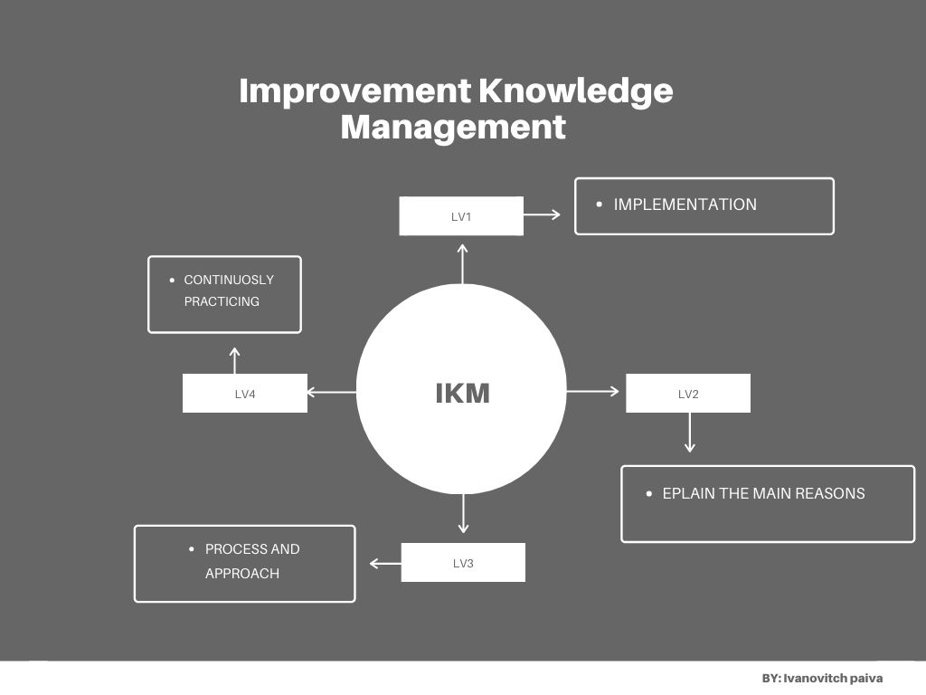

References

Bibliography
Capitalism.com, 2020. History of Amazon. [Online]
Available at: https://www.capitalism.com/history-of-amazon/
[Accessed 11 April 2021].
Chaffey, D., 2020. Smart Insights. [Online]
Available at: https://www.smartinsights.com/digital-marketing-strategy/amazon-case-study/
[Accessed 13 April 2021].
Crawford, M., 2020. Adido. [Online]
Available at: https://www.adido-digital.co.uk/blog/amazon-marketing-strategy-during-covid-19-what-should-my-ecommerce-business-do/
[Accessed 14 April 2021].
Hall, M., 2020. Amazon.com. [Online]
Available at: https://www.britannica.com/topic/Amazoncom
[Accessed 23 March 2021].
Kai Mertins, P. H. J. V., 2003. Knowledge Management. 2nd Edition ed. Berlin: Springer - Verlag.
Kazuo Ichijo, I. N., 2007. Knowledge Creation Management. 1st Edition ed. New York: Oxford University Press.
MacMillan, I., 2015. World Economic Forum. [Online]
Available at: https://www.weforum.org/agenda/2015/04/do-you-understand-your-companys-knowledge-assets/
[Accessed 14 April 2021].
Rosenberg, M., 2014. Learning Solutions. [Online]
Available at: https://learningsolutionsmag.com/articles/1480/the-knowledge-management-genius-of-amazoncom
[Accessed 20 April 2021].
Tools, K. M., 2012. The SECI Model and Knowledge Conversion. [Online]
Available at: https://www.knowledge-management-tools.net/knowledge-conversion.php
[Accessed 14 April 2021].
Valamis, 2019. Knowledge Managment. [Online]
Available at: https://www.valamis.com/hub/knowledge-management#importance-of-knowledge-management
[Accessed 13 April 2021].
Wai, W. M., 2014. Semantic Scholar. [Online]
Available at: https://www.semanticscholar.org/paper/Development-of-Knowledge-Assets-Valuation-Model-Wai-Ramasamy/d099af0ea97801594189e911b077357808854d5b#paper-header
[Accessed 14 April 2021].
Webster, S., 2019. LABS. [Online]
Available at: https://labsnews.com/en/articles/business/how-amazon-grew-from-a-small-virtual-bookseller-to-an-international-giant/
[Accessed 11 April 2021].
Ydav, K., 2018. Noteworth. [Online]
Available at: https://blog.usejournal.com/what-is-aws-and-what-can-you-do-with-it-395b585b03c
[Accessed 18 April 2021].

