Yaqoob Talukdaar

Student : 2126722
Module Title: Managing Hotel Administration
Module code: BMIH6004
Tutor: Kathryn Roberts
Word Count: 1200

I confirm that I have not used any AI tools in the research and creation of this assignment. I confirm that I have not presented any AI generated materials as my own work. I confirm I have copies of my drafts, notes, and other resources I used, which I may be asked to provide in evidence.

Contents
Introduction 2
Section 1: Role Reflection 3
Section 2: Discussion of Key Hotel Administration Issues 6
Section 3: Future Trends in Hotel Administration 7
Conclusion 7
Reference 8

Introduction
The following reflective learning log is focused on the Human Resources Management (HRM) department of Delta Hotels by Marriott Birmingham. This is a highly reputed 4-star hotel located at the city centre and well known for its modern service and business-friendly facilities (Marriott, 2025).
HRM department is one of the crucial components of its operational success as it directly handles recruitment, staff development, employee relations, and performance management. During my placement I was fortunate enough to observe its roles very closely which help me to understand its strategic and operational functions in a practical and high-pressure hotel environment.
The learning objectives included:
- To understand recruitment and onboarding in hotel industry.
- To obtain practical experience regarding HR information systems and software for employee management and training
- To improve business communication and interpersonal skills in the context of practical and high-pressure hotel environment
In this reflective log using the Gibbs’ Reflective Cycle I have reflected on my role and experiences in regard to HRM activities at the aforementioned hotel critically analysing pertinent HR functions and trends in hotel HR practices.

Section 1: Role Reflection
The following reflection section utilised the Reflective Cycle proposed by Gibbs (1988) which is comprised of six phases: description, feelings, evaluation, analysis, conclusion, and action plan.
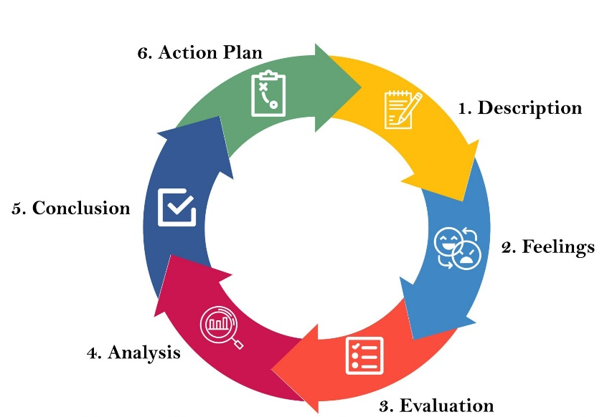
Sundgren et al. (2021)
Description
During the time of my placement at the Human Resources Management (HRM) department of Delta Hotels by Marriott Birmingham, I worked as a HR Assistant Intern and my responsibilities included helping in the recruitment process, employee records maintenance using HR information systems, supporting training coordination, and helping to ensure efficient communication between staff and management. The department was led by a HR Manager, who demonstrated a strong transformational leadership style encouraging team collaboration and continuous improvement.
According to Greimel et al. (2023) in this type of leadership style leaders try to inspire and motivate the employees to attain a shared vision emphasising on strong sense of purpose, belongingness and teamwork to reach their full potential at individual levels.
The following are two most notable duties I performed at HR department during my placement:
- During my placement, I used Oracle PeopleSoft to update employee records like attendance and leave, ensuring data accuracy and compliance.
- I helped coordinate staff training using Cornerstone OnDemand LMS to schedule sessions, track progress, and generate reports, improving training efficiency.
Feelings
Understanding that HR operations are vital to general hotel performance, I first felt both thrilled and nervous about working in a fast-paced hotel atmosphere. As I got into, I felt more confident about managing administrative duties and interacting with staff members at several levels.
Evaluation
One positive feature of my placement was the chance I had to work directly with the HR software system, which greatly enhanced my technical aptitude. I also noted how well departmental leadership and communication boosted operational effectiveness. Managing time during busy recruiting times was one of my difficulties; occasionally this resulted in stress and pressure which is common as mentioned by Bardi (2010).
Analysis
The supervisory role performed by HR department plays a key role in developing operational efficiency, through strong leadership and clear communication (Costa, Oliveira and Oliveira, 2021). The transformational leadership style following by the HR manager helped to create a positive work environment that encouraged team collaboration. In my experience, it also helped to streamline recruitment and training process as the employee were highly motivated to maintain positive communication, highly efficient service delivery and prioritising the integrity of strong team performance over individual performance (Sarwar, Ishaq and Franzoni, 2024).
From purely technical perspective, software like the Oracle PeopleSoft and Cornerstone OnDemand LMS helped to accurately maintain and manage employee records maintain and ensure the effectiveness of training programs. These tools show how modern HR practices are empowered by technology (Islam et al., 2022).
About my personal strengths, I showed great adaptability and attention to detail, which enabled me to precisely handle employee data and seamlessly organize training sessions. My interactions with personnel at varying levels also helped me to hone my report writing ability.
I also noticed flaws primarily in time management and stress handling under intense recruiting pressure. These difficulties occasionally interfered with my ability to staying calm under pressure.
Conclusion
My placement in human resources operations at Delta Hotels by Marriott Birmingham confirmed the need of leadership and communication in improving departmental efficiency and gave insightful practical experience. Although I effectively gained technical knowledge using HR software, I saw areas for improvement—especially in time and stress management during high-pressure and stressful times.
Action Plan
Considering the strengths and weaknesses revealed through my experience I plan to perform the following to improve my knowledge, skills and abilities:
- Enrol in a project management course to improve my time management and organizational skills.
- Pursue certification in HR software tools like Oracle PeopleSoft to deepen my technical expertise.
- Attend workshops focused on communication and stress management to better handle high-pressure situations in a dynamic workplace.

Section 2: Discussion of Key Hotel Administration Issues
During my placement at the HRM department of Delta Hotels by Marriott Birmingham I observed some issues in regard to limited follow-up in employee training. Even though the hotel uses Cornerstone OnDemand LMS for onboarding and compliance training, new recruited stuff did not receive enough supervision or feedback after finishing initial modules which led to inefficient knowledge application and job performance on the floor (Pinnington et al., 2022).
I could relate this problem with the previous lessons I received in my earlier level 4 and 5 modules regarding Personnel Resourcing and Development that highlighted the significance of ongoing training and Continuous Professional Development (CPD) (Harunavamwe and Mnqayi, 2021).
According to Taylor and Woodhams, (2022) without reinforcement or feedbacks, training cannot bring meaningful changes to employee attitude or performance. I got to experience that first hand as I saw many of the new staff confused about their roles and asking HR members about operational procedures, which should have been covered by the initial onboarding and followed up through reinforcements (Kalgi, Kale and Punde, 2022).
Moreover, one-time training is insufficient given changing guest expectations and higher service levels. Briffa, (2022) argues that in order to acquire both technical and soft skills, hospitality workers must receive constant training. Even though the hotel has employed sophisticated software system, there is a lack of human touch.
The hotel could set up organized feedback points and designate departmental "training buddies" to handle this. These minor adjustments would improve knowledge retention, boost confidence, and enhance service quality, hence aligning practical HR delivery with theory-driven best practices (Webster, 2023).

Section 3: Future Trends in Hotel Administration
The inclusion of artificial intelligence (AI) in administrative operations including recruiting, scheduling, and performance monitoring is one developing trend influencing hotel HRM. Digital tools like Oracle PeopleSoft and Cornerstone OnDemand can aid in simplifying data management and training procedure. Future systems, however, might use AI for recruitment, forecast employee turnover, or provide more personalised training (Mer, 2023).
Technological developments are also improving the automation of basic human resources activities, therefore allowing human resources departments to focus more on strategic roles (Giousmpasoglou and Marinakou, 2024). This is in line with existing body of research, which emphasise how AI improves decision-making and lowers administrative burden (Kichuk, Hui and Kourtidis, 2024).
These developments will require HR employees to become more flexible and emotionally intelligent with certain technological expertise (Casado, 2012). My placement experience shows a rising need—particularly in service-driven sectors like hospitality—to balance human empathy with digital efficiency.

Conclusion
My placement at Delta Hotels HRM confirmed leadership and communication are essential for efficiency. I gained strong technical skills but saw weaknesses in time and stress management. Continuous learning and balanced human-tech skills will be vital for future HR success in hospitality.

Reference
Bardi, J.A., (2011). Hotel Front Office Management.
Briffa, M.R., (2022). Continuing Professional Development in the Tourism and Hospitality Industry among Women in Malta: Opportunities, Motivations, Expectations, and COVID-19 Pandemic. The Online Open Access Repository of the Institute of Tourism Studies (Malta).
Casado, M.A., (2011). Housekeeping management. John Wiley & Sons.
Costa, N., Oliveira, C.M. and Oliveira, I., (2021). The role and relevance of human resource management and its practices in the portuguese hotel industry. Tourism and hospitality management, 27(2), pp.407-427.
Gibbs, G., (1988). Learning by doing: A guide to teaching and learning methods. Further Education Unit.
Giousmpasoglou, C. and Marinakou, E., (2024). Human resources management in hotels. In The contemporary hotel industry: A people management perspective (pp. 129-158). Cham: Springer International Publishing.
Greimel, N.S., Kanbach, D.K. and Chelaru, M., (2023). Virtual teams and transformational leadership: An integrative literature review and avenues for further research. Journal of Innovation & Knowledge, 8(2), p.100351.
Harunavamwe, M. and Mnqayi, R.B., (2021). Exploring the Effect of Continuous Professional Development (CPD) Programs on Employee Performance at Company A in Empangeni, KwaZulu-Natal. Expert Journal of Business and Management, 9(1).
Islam, M.A., Hack‐Polay, D., Haque, A., Rahman, M. and Hossain, M.S., (2022). Moderating role of psychological empowerment on the relationship between green HRM practices and millennial employee retention in the hotel industry of Bangladesh. Business Strategy & Development, 5(1), pp.17-29.
Kalgi, D., Kale, A. and Punde, P., (2022). A Study on the Significance of Training and Development in the Hospitality and Tourism Industry in India. Current and Futuristic Trends.
Kichuk, A., Hui, T. and Kourtidis, M., (2024). Talent management strategies and practices in the age of digital transformation: Building bridges to successful hospitality organisations in the UK, Greece, and Hong Kong. International Marketing Journal of Culture and Tourism, (6), pp.28-47.
Marriott.com. (2025). Available at: https://www.marriott.com/en-us/hotels/bhxde-delta-hotels-birmingham/overview/ [Accessed 30 May 2025].
Mer, A., (2023). Artificial intelligence in human resource management: Recent trends and research agenda. Digital transformation, strategic resilience, cyber security and risk management, pp.31-56.
Pinnington, A., Aldabbas, H., Mirshahi, F. and Pirie, T., (2022). Organisational development programmes and employees’ career development: the moderating role of gender. Journal of workplace learning, 34(5), pp.466-496.
Sarwar, H., Ishaq, M.I. and Franzoni, S., (2024). Influence of HRM on CSR and performance of upscale hotels in developed and developing countries. Environment, Development and Sustainability, 26(1), pp.335-357.
Sundgren, M.K., Millear, P.M., Dawber, C. and Medoro, L., (2021). Reflective practice groups and nurse professional quality of life. TheAustralian Journal of Advanced Nursing, 38(4), pp.49-67.
Taylor, S. and Woodhams, C., (2022). Studying human resource management: a guide to the study, context and practice of HR. Kogan Page Publishers.
Webster, A., (2023). Continuing professional development and the standards of practice.

