Jess Eardley (2217994)

Lab Report 2
Rate of Reaction Experiment

Table of Contents
Aim of the experiment 3
Variables 3
Theory 4
Applied theory in OME 4
Data and Observations 5
Formulas and Calculations 8
Results and Discussions 9
Conclusion 9
References 10
Appendices 11
Appendix 1- Procedure, Chemicals and Equipment. 11

Table of Figures

Figure 1 A graph plotting Log 1/t against Log [H₂O₂] to determine the reaction order, m, using results from Table 1. 5
Figure 2 A graph plotting Log 1/t against Log [I-] to determine the reaction order, n, using results from Table 2. 6

Table of Tables

Table 1 Data from Trials 1.1 to 1.4 investigating the order of reaction in [H2O2]. 5
Table 2 Data from Trials 2.1 to 2.4 investigating the order of reaction in [I-]. 6
Table 3 using the data from the experiment to calculate the rate constant, k. 7

Aim of the experiment

The aim of the experiment was to determine the rate law for the formation of iodine in the reaction between hydrogen peroxide (H₂O₂) and iodide ions (I-) in aqueous solution, using ascorbic acid (Vitamin C) as a reducing agent and starch as an indicator.

Hypothesis

When the concentration of H₂O₂ is increased, the time it takes for the solution to turn blue will decrease. The rate of the decrease will be dependent on the rate order of the reactants. The rate order will be obtained using the gradient of the line when the Log(1/t) is plotted against Log [Reactant]₀.

Variables

Control variables- Part 1- Volumes and concentration of:

- KI
- Ascorbic acid
- Starch indicator
- Distilled water

Control variables- Part 2- Volumes and concentration of:

- H₂O₂ solution
- Ascorbic acid
- Starch indicator
- Distilled water

- Independent variable: Concentration of reactants, Part 1: H₂O₂ and Part 2: I- ions.
- Dependant variable: Rate of reaction for H₂O₂ and I- ions, time (s) of solution to turn blue.

See Appendix 1, for the procedure and chemicals of this experiment.

Theory

The overall chemical reactions in this experiment [1]:
- H₂O₂ + 2I⁻ + 2H⁺ → I₂ + 2H₂O
- C₆H₈O₆ + I₂ → C₆H₆O₆ + 2I⁻ + 2H⁺, Vitamin C reduces iodine back to iodide.
The general rate law for the reaction:
Rate = k[H₂O₂]^{m}[I⁻]^{n} [2]
The rate depends on each reactants concentration. The rate law for the reaction between hydrogen peroxide and iodide ions in an aqueous solution can be deduced by varying one reactant concentration at a time and comparing the reciprocal of the times [1].
The starch indicator remains clear with the aid of the ascorbic acid, vitamin C. Once the ascorbic acid is used up and no longer able to reduce iodine to iodide, the iodine accumulates and reacts with the starch indicator to form a blue coloured solution [1].
The time (t measured in seconds) until this colour appears reflects the rate of iodine formation.
This means the average rate of the reaction is inversely proportional to the measured clock time: Rate ∝ 1/t. [2] [1]
See Appendix 1, for the procedure of this experiment.

Applied theory in OME

In OME Safety, it is important to understand reaction kinetics to mitigate risks associated with uncontrolled reactions. Understanding reaction rates is essential in the storage, manufacture and handling [3] of energetics and energetic articles, as it governs the speed and intensity of energy release. The knowledge of reaction kinetics and rate laws, enables the predictions and modelling of energetic material behaviour under various environmental stresses, such as temperature cycling (that can lead to unplanned explosions, degradation, and reduced shelf life) to design process’s to analyse and monitor the storage conditions of energetic articles [3] [4].

Data and Observations

Once solution B containing, 0.9 M H₂O₂, was added to the conical flask containing solution A, the time the solution took to turn and stay dark blue was recorded and added to Table 1.
In Table 1, the time taken for the formation of iodine, I₂, indicated by the solution turning blue (starch indicator reacting with the iodine present in the solution). The time taken for the product, Iodide to be made, decreased as the concentration of the reactant, [H₂O₂], increased.
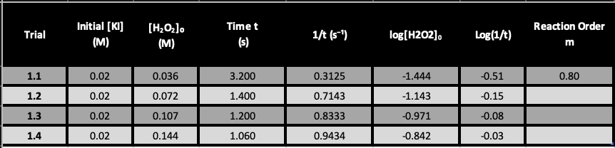
Table 1 Data from Trials 1.1 to 1.4 investigating the order of reaction in [H2O2].
Figure 1 was created using Log(1/t) against Log[H₂O₂]₀ from Table 1. The gradient gives the reaction order, m, of [H₂O₂]. The reaction order of [H₂O₂] is 0.8, therefore, [H₂O₂]^{0.8}.
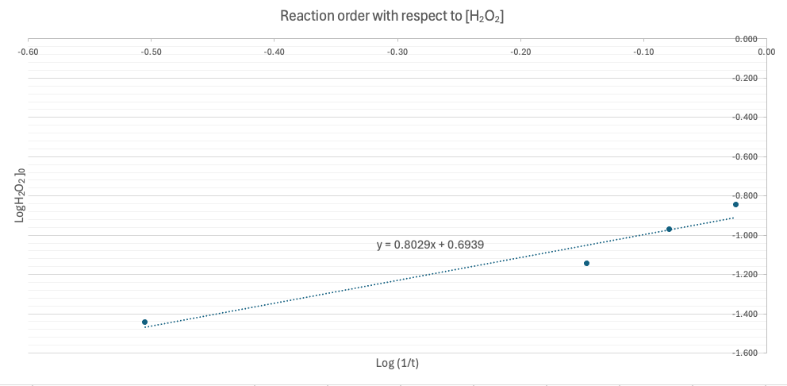
Figure 1 A graph plotting Log 1/t against Log [H₂O₂] to determine the reaction order, m, using results from Table 1.

Table 2 shows the results from varying the concentration of the initial reactant, by increasing the volume of a 0.2 M KI solution in part 2 of the experiment, Trials 2.1 to 2.4. This part of the experiment was conducted to investigate the order of reaction of [I-] , using the speed as t (seconds) in which iodine was formed.
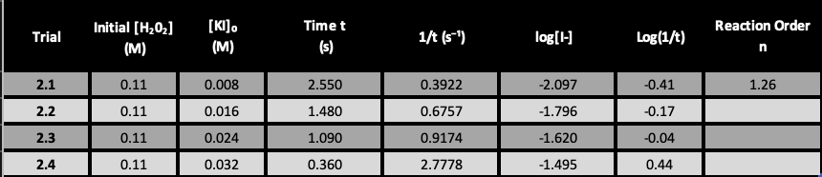
Table 2 Data from Trials 2.1 to 2.4 investigating the order of reaction in [I-].

Graph 2 shows the results from Table 2. The line equation the gradient is reaction order, n, which equals 1.26, therefore, [I-]^{1.26}.

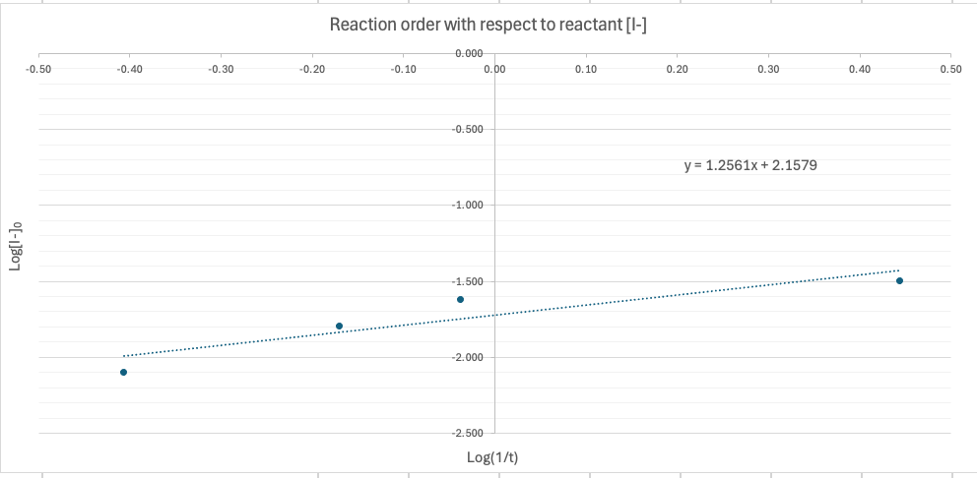
Figure 2 A graph plotting Log 1/t against Log [I-] to determine the reaction order, n, using results from Table 2.

Table 3 shows the rate calculations uses values taken from Tables 1 & 2, and Figures 1 & 2. Table 3 displays the rate constant, k, calculated for each trial. An average value of k is taken across all trials. The average rate constant for the reaction is k = 813.00 2 dp.
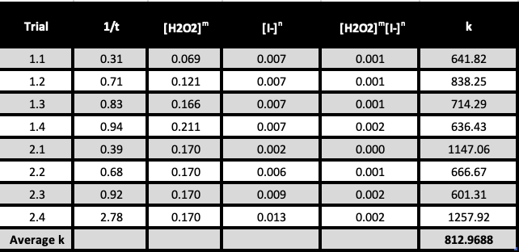
Table 3 using the data from the experiment to calculate the rate constant, k.

Formulas and Calculations

$$C_{1}V_{1}=C_{2}V_{2} CITATION Lib4 \backslash l 2057 [5]$$
$${Trial 1.1: C}_{2}={\left[Reactant\right]}_{0}(M)=\frac{Vol of solute×Conc of solute}{Total vol of solution}=\frac{1ml×0.9M}{25.13ml}=0.0358 M$$

$$Molarity \left(M\right)=\frac{n}{V} CITATION Lib4 \backslash l 2057 [5]$$

$$log (1/t) = log k' + n log [Reactant]0$$

$$k = \frac{1/t}{m[H_{2}O_{2}]n[I-]}$$

$$Value of k for Trial 1.1=\frac{0.31}{0.069^{0.8}{×0.007}^{1.26}}=641.8$$

Using the value of k, m and n the rate of the reaction can be calculated using the rate equation [2].

$$Rate=k{\left[A\right]}^{m}+ {[B]}^{n}$$
$$Rate = k{[H_{2}O_{2}]}^{0.8}{[I-]}^{1.26}= 103.4$$

The unit of k is calculated using the overall reaction order for a reaction is the sum of all the order of the reaction [2].
$$m+n= 1.26+0.8=2.06$$

2nd order overall reaction, where the unit of k= mol⁻¹ dm³ s⁻¹ [2].
$$K = 813 {mol}^{-1} {dm}^{3}{ s}^{-1}$$

Results and Discussions

The observations proved the hypothesis of the experiment. The rate of the reaction increased with the increase of the concentrations of both reactants. This rate order for reactance averaged a first order.
The primary source of experimental error was human error. There could have been a lag of up to a second in the reaction time when stopping the stopwatch with the sudden colour change, clear to blue. This affects the measured time and therefore the calculated rate of reaction.

Conclusion

The hypothesis was supported by the results and observations in the experiment. The rate of the reactions was calculated using all the results from the experiment. This could have been improved by first finding any outliers in the collected data and removing them for a truer average when calculating k.
The were a few sources of error but he main source, measuring the time of the reaction was observed to be the primary source. This error could be removed in future experiments with the use of a colorimeter and programable timer. This will deduce the point of the colour change and remove the human factor of stopping the stopwatch.

References
[1] | LibreTexts, “1.18: Kinetics of Hydrogen Peroxide Decomposition,” LibreTexts, [Online]. Available: https://chem.libretexts.org/Courses/Howard_University/Howard%3A_Physical_Chemistry_Laboratory/01%3A_New_Page/1.18%3A_Kinetics_of_Hydrogen_Peroxide_Decomposition.
[2] | LibreTexts, “12.4: Rate Laws,” LibreTexts, [Online]. Available: https://chem.libretexts.org/Bookshelves/General_Chemistry/Chemistry_1e_(OpenSTAX)/12%3A_Kinetics/12.04%3A_Rate_Laws#:~:text=in%20which%20%5BA%5D%2C%20%5B,with%20temperature%20and%20surface%20area..
[3] | JSP, “JSP 482 Chapter 17: Explosives Facilities – Safety Precautions,” 2013. [Online]. Available: https://assets.publishing.service.gov.uk/media/5a7b63e440f0b64646935d71/C17_Edt4_FINAL.pdf.
[4] | The suitablity of things, “Real-world examples of reaction rates in industrial processes,” [Online]. Available: https://www.solubilityofthings.com/real-world-examples-reaction-rates-industrial-processes.
[5] | LibreTexts, “8.4: Concentration of solutions,” [Online]. Available: https://chem.libretexts.org/Courses/Rio_Hondo/Chemistry_110%3A_An_Introduction_to_General_Organic_and_Biological_Chemistry_(Garg)/08%3A_Solutions/8.04%3A_Concentration_of_solutions.

Appendices

Appendix 1- Procedure, Chemicals and Equipment.



