

Albert Sefa, 2112523.

Module Title: Professional Career Development

Module number: BMSW4005_BIRM

Lecturer: Farah Islam

Reflective Portfolio.

Table of Contents
INTRODUCTION 2
KNOW YOURSELF 2
Johari Window 4
SWOT ANALYSIS 6
STATE/IDENTIFY THE CAREER OPTIONS AVAILABLE. 7
RESEARCH OPTIONS 7
EMERGING TRENDS 8
SETTING GOALS AND OBJECTIVES 8
UK EMPLOYMENT LAW AND CAREER DEVELOPMENT 9
LEARNING THEORIES 10
SELF-AWARENESS METHODS 11
MOCK INTERVIEW AND OPEN BOOK EXPERIENCE. 11
CONCLUSION 11
REFERENCES 12

INTRODUCTION
My experience with this module has been challenging and fascinating over this term. Especially in the discussions of the materials presented by the lecturer. In this report, I evaluate strategies I have learned during this term with the aim of exploring employment opportunities based on my career path. As a result of this term, I have learned how important it is to develop oneself and be aware of one's surroundings. My chosen career path is software engineering. In order to better understand my strengths, weaknesses, and areas for improvement, I conducted a SWOT analysis. My career path was mapped out using it as a tool to assess myself. The Johari window and personality test are other theories that I was introduced to. This term I have learned many new skills and improved on skills I already possessed.

KNOW YOURSELF
I will explore and identify my personality type using a website called 16 Personalities before discussing my career choice. The test analyses personal traits by putting them on a scale from 0 to 100, based on a list of five different traits in this order: mind, energy, nature, tactics, and identity. Each trait represents a different side of the scope (Zeman, 2022)

MIND | ENERGY | NATURE | TACTICS | IDENTITY
Introverted | Observant | Thinking | Judging | Assertive
Extroverted | Intuitive | Feeling | Prospecting | Turbulent

This test was an activity given by the lecturer on week 2 during this term. After completing the 16 Personalities test, Architect was my personality type. Results indicate that I have a strong sense of independence, and I don't mind acting alone, especially when waiting for others to catch up with me. Despite this, some of the strengths of my personality type include being rational, informed, independent, determined, curious, and original.

- Rational: According to my personality type, Architects are known for their mental power. They use rational thinking to solve problems, which means they come up with innovative solutions to even the most challenging problems

- Informed: Research and analysis are very important to Architects, and their conclusions are based on evidence. It is never a problem for them to challenge their ideas in the face of disagreements.

- Independent: Architects strive to do things their way, regardless of arbitrary rules or conventions that may hinder their success.

- Determined: There is no such thing as failure for this type of personality. It is the ambition and goal-oriented nature of architects that make them successful.

- Curious: It is always welcome by architects to receive new ideas, and they are generally happy to reassess their opinions when they are proven wrong with facts.

- Original: People around an architect are often forced to consider new ways of thinking by their rebellious personality types

Being an Architect also comes with its own weaknesses, such as being arrogant, dismissive of emotions, overly critical, combative and socially clueless.

- Arrogant: Self-confidence is a characteristic of Architects. Often, they have a very one-sided view, and it is difficult to have a civil and constructive conversation with them.

- Dismissive of Emotions: Due to their rational mindset, this personality type can sometimes be perceived as insensitive. Facts are more important to them than feelings

- Overly Critical: Architects take their feelings and thoughts seriously, especially when it comes to self-control. If the people around them fail to match their level of restraint, they can be scathingly critical.

- Combative: Sometimes these personality types can become involved in unnecessary arguments over rules and regulations because they dislike the following anything without understanding why.

- Socially Clueless: Rationality is very important for Architects. As a result, they may feel isolated or disconnected from other people because of their frustrations in their social lives.

Johari Window

In addition to being a powerful tool for self-awareness, the Johari Window can also be used to improve personal relationships, interpersonal relations, team relations, communications, group dynamics, and relationships between groups. (Self Awareness, 2013). It was a tool created by Joseph Luft and Harry Ingham in 1955.

The Johari Window consists of four panes; open area, blind spot, hidden area, and unknown area.

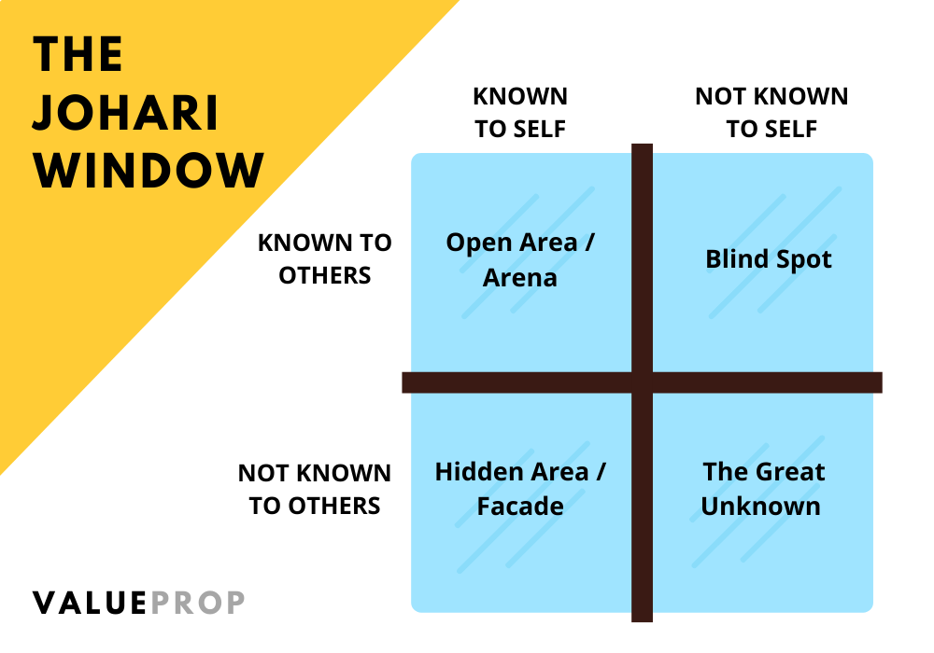
(Valueprop, 2021)

- Open area: In this area, you fill in attributes about a person. In addition to being recognized by the individual, these attributes are also recognized by others. This area should be developed through disclosure and feedback.

- Blind spot: A person may be unaware of some of these characteristics or qualities in this area. Because of this, they may find that other people interpret them differently than they expected. In order to minimise blind spots, self-awareness and understanding are essential.

- Hidden area: The person is the only one who knows their personal characteristics in this area. It is possible, however, to shrink this area with disclosure. There may be times when a person does not wish to reveal bits and pieces of information about themselves that are sensitive.

- Unknown area: In this area, the individual and their peers are unaware of certain characteristics. The purpose of this section is to help a person improve themselves by discovering skills, hidden qualities, and abilities they did not know they had (Hampson, 2021).

During week 2 of this term, my lecturer gave me an activity to complete at home, which was to ask my family and friends to complete a Johari Window for me. Below you can find the results.

OPEN AREA | BLIND SPOT
- Calm  - Logical  - Adaptable  - Friendly  - Sporty  - Confident  - Relaxed  - Helpful | - Knowledgeable  - Kind  - Wise  - Self-assertive  - Organized
HIDDEN AREA | UNKOWN AREA
- Self-conscious  - Sensible  - Realist  - Introverted | - Brave  - Shy  - extroverted

Judging from the results, this activity really helped me to know things that I never knew about myself. The more open I am, the less I have blind spots and hidden areas. Through conversations with others and pushing myself beyond my comfort zone, I will be able to shirk the unknown area.

SWOT ANALYSIS

I selected the skills that I believe need the most improvement and the ones that need more work for my SWOT analysis.

- Strengths: Communication skills, group working skills, and good writing skills

- Weaknesses: Procrastination

- Opportunities: Improve my time management skills, leadership skills in group projects

- Threats: Unnecessary distractions

My SWOT analysis indicates that I should work on preventing procrastination. To accomplish this, I will improve my time management skills and prioritize tasks according to their importance. It is also important that I remain focused and disciplined at all times in order to avoid unnecessary distractions.

STATE/IDENTIFY THE CAREER OPTIONS AVAILABLE.
Considering my personality/self-awareness, I possess a strong creative drive and an innate ability to recognize connections where others cannot. My ideal career is one that ignites my curiosity and leverages my intellect, so I can expand my prowess and take on meaningful challenges.

The career options that I want to explore are Software engineer, Software developer and Cybersecurity analyst. The career option I am most interested in exploring more is Software engineering. In software engineering, user requirements are analysed and then developed, designed, and tested to meet the needs of the user (Martin, 2022).

Despite not having any experience in this field, I plan on getting a degree in Software engineering and taking some online courses to improve my skills. With the rise of competitors in the software industry, new ideas and software are constantly being created each year in this field. Home study and personal research will help me succeed in this industry.

RESEARCH OPTIONS
To gain some experience while studying Software engineering, Indeed will be a great place to search for Software engineering jobs or any IT jobs. As soon as I graduate, I plan to start my career by creating a LinkedIn account to showcase my expertise. A platform like LinkedIn is used by employers when they're looking for prospective employees. I can also expand my network through it.

For me to be successful on LinkedIn, I will need to have detailed information about myself, my previous employment history, qualifications, and any skills that would make me attractive to prospective employers. Moreover, I will network as much as possible in order to enhance my chances of landing my dream job.

EMERGING TRENDS
According to Peter Diamandis, technology will reshape the health and materials sciences, energy, transportation, and a wide range of other industries and domains over the next decade. (McKinsey Digital, 2022). In the tech industry, there will be many innovations and breakthroughs, for example, datafication, which aims to transform most aspects of a business into quantifiable data that can be tracked, monitored and analysed (Techslang, 2019).

Technology will play a more and more significant role in almost every job by 2030. Companies will seek to incorporate digital platforms as a core part of their innovation processes (UKCES, 2014). Due to safety guidelines, many office workers were not able to return to work during COVID19. Because of that online workspaces have become increasingly popular. With the growth of digitalisation, companies that design collaborative tools will upgrade their services. (Kilinga, 2022)

To take advantage of these opportunities, I will learn as much as possible, and get as many qualifications and accreditations as possible. A bachelor's degree and a master's degree in software engineering will give me a wide range of tech career options.

SETTING GOALS AND OBJECTIVES
Organizing myself really helped me for this term, especially when setting SMART GOALS. SMART GOALS are defined as specific, measurable, attainable, relevant, and time-bound. The setting of goals was very important to my self-development because it provided me with a long-term vision and motivation in the short term. Setting clear, measurable goals helped me organize my time and resources so that I could maximize my efforts, measure my success and feel satisfied with my accomplishments. As I updated my to-do list on a daily basis and reviewed my plans periodically, I remained on course.

- Specific: In order to reach your goals, you should make sure that they are very specific and achievable.

- Measurable: When you measure your goals, you know when you've reached your goal or when you're close to achieving it.

- Attainable: Ideally, your goals should be attainable, something you can achieve and grasp.

- Relevant: When setting goals, it is important to make them realistic and attainable so that you can put them in place.

- Time-bound: You should have a starting point and an endpoint for goal setting in order to be able to evaluate what you have accomplished (Shelley, 2021)

UK EMPLOYMENT LAW AND CAREER DEVELOPMENT
The employment law regulates the relationship between employers and employees. Hence, if a business has more than one employee, there is a good chance that employment law will be used by the business. Protecting workers' rights, preventing discrimination, and promoting a safe working environment are the main objectives of employment law. (Dugger, 2021).

I have gained a deeper understanding of the recruitment process, employment contracts, and employee rights in the UK through learning about employment law. A lot of things came to my attention, such as whistleblowing, which means an employee who discloses information regarding alleged wrongdoings at their employer is not to be unfairly terminated.

As a result of this term, I've learned that career development is crucial if I hope to achieve maximum success and happiness at work. The development of my career will be helped by setting goals and developing plans to achieve them. It is likely that between the second and third year of my Software Engineering course, I will be able to spend a year working in the industry. As a result, I will be able to apply what I have learned in my course and gain valuable networking experience.

LEARNING THEORIES
As far as I understand, students learn differently based on their learning styles. Learning styles refer to the manner in which an individual absorbs, processes, comprehends, and retains information. Kolb’s learning styles are one of the best-known and widely used learning style theories. His view of learning is based on a four-stage cycle. As a starting point, observations are based on immediate and concrete experience. In the next step, the individual reflects on these observations and begins to construct a general theory about what it might mean (Cherry, 2020).

- The Converger: Practical application of ideas is one of the strengths of people with this learning style. Usually, they do best when there is only one best solution or answer to a problem.

- The Diverger: The learning style of this type focuses on seeing the "big picture" and organizing small chunks of information into meaningful conversations. In addition to being emotional and creative, they enjoy brainstorming for new ideas.

- The Assimilator: Work that involves planning and research appeal to people with this learning style. Abstract ideas tend to interest them more than people do.

- The Accommodator: The learning style of this group is characterized by the enjoyment of experiments and the ability to implement real-world plans. The ability to change their plans spontaneously in response to new information is one of their greatest strengths.

As part of week two, I took a quiz to determine my strongest learning style, and after completing the quiz, I determined that I was a Converger. Understanding my learning style helped me maximize my learning potential as well as expand my current learning methods and strategies.

SELF-AWARENESS METHODS
To progress in our personal development journey, self-awareness is a vital skill to cultivate. By monitoring our thoughts and feelings as signals, self-awareness helps us monitor our inner and outer worlds (Miller, 2020).
I was able to self-evaluate myself more effectively in the professional world by understanding my personality type, Johari window, strengths, and weaknesses.

MOCK INTERVIEW AND OPEN BOOK EXPERIENCE.
My lecturer gave me an open book assessment in week four of this term. I had to choose two scenarios and then express my feelings about them by using my knowledge and resources relating to the problem at hand, in the open-book assessment. I found the open book assessment to be a great way to test my knowledge of direct discrimination and victimization.

During this term, the lecturer gave me the task to find a job vacancy that I would like to apply for and then creating a CV and a cover letter that will be well suited for that job vacancy. In week 7 I had my mock interview with my lecturer. Since it had been a while since I had a proper job interview, I was nervous at first. When I finished the mock interview, I got feedback on how I did and what I needed to improve on. In addition to improving my communication skills, this mock interview gave me the opportunity to familiarize myself with the interview process by practising answering common interview questions confidently.

CONCLUSION
My overall impression is that this term has been an excellent learning experience for me when it comes to self-awareness and how to improve it using tools like 16 personalities, Johari window, and SWOT analysis. With these self-awareness tools, I was able to identify the right career path for me, and by setting SMART goals, I will be able to organize my time and resources so that I can maximize my efforts in future endeavours. There is still much I would like to learn as a student and as a professional, and I continue to strive toward improving my skills.

REFERENCES
Zeman, J. (2022). 16 Personalities. Available at: https://developerexperience.io/practices/16personalities (Accessed: 24 July 2022).

16 Personalities. (2022). Architect Personality. Available at: https://www.16personalities.com/intj-careers (Accessed: 24 July 2022).

Self Awareness. (2013). Understanding the Johari Window Model. Available at: https://www.selfawareness.org.uk/news/understanding-the-johari-window-model (Accessed: 25 July 2022).

Valueprop. (2021). The Johari Window: Uncovering the Blinds Spots in your Business. Available at: https://www.valueprop.com/blog/the-johari-window-uncovering-the-blind-spots-in-business (Accessed: 28 July 2022).

Hampson, S. (2013). The Johari window Model: How to improve communication and productivity at work. Available at: https://www.tsw.co.uk/blog/leadership-and-management/the-johari-window/ (Accessed:30 July 2022).

Martin, M. (2022). How to become a software Engineer/Developer: #10 Steps. Available at: https://www.guru99.com/become-a-software-engineer.html (Accessed:30 July 2022).

McKinsey Digital. (2020). The top trends in tech. Available at: https://www.mckinsey.com/business-functions/mckinsey-digital/our-insights/the-top-trends-in-tech (Accessed: 31 July 2022).

Techslang. (2019). What is datafication? Available at: https://www.techslang.com/definition/what-is-datafication/ (Accessed: 31 July 2022).

UKCES. (2014). The future of work: Jobs and skills in 2030. Available at https://assets.publishing.service.gov.uk/government/uploads/system/uploads/attachment_data/file/303334/er84-the-future-of-work-evidence-report.pdf (Accessed: 31 July 2022).

Kilinga, P. (2022) Top 10 essential technology trends you must follow in 2022. Available at: https://www.itproportal.com/features/top-10-essential-technology-trends-you-must-follow-in-2022/ (Accessed: 1 August 2022).

Shelly, R. (2021). Why SMART Goals are Important to Your Long-term Success. Available at: https://www.smamarketing.net/blog/why-smart-goals-are-important (Accessed: 2 August 2022).

Dugger, A. (2021). What is Employment Law? – An introduction to Employment law. Available at https://study.com/academy/lesson/what-is-employment-law-an-introduction-to-employment-law.html (Accessed: 3 August 2022).

Cherry, K. (2020). Kolb’s Theory of Learning Styles. Available at https://www.verywellmind.com/kolbs-learning-styles-2795155 (Accessed: 4 August 2022).

Miller, K. (2020). Building Self-Awareness: 15 Activities and tools for Meaningful Change. Available at: https://positivepsychology.com/building-self-awareness-activities/ (Accessed: 5 August 2022).

