By: Rohid Hussain Ph.D. (Business Consultant)
05/04/19
TOY STORE
To: Michelle Sullivan: Swansea

Executive Summary
This report will aim to investigate the current team structure of a rapidly growing toy store and will advise on effective communication methods and teamwork theories that will aid this toy shop to move forward. Several textbooks, journals and websites were consulted, and a conclusion drawn for a recommended action plan.

Contents Page
Content Page No.
1.0 - Terms of Reference 1
2.0 – Procedure 1
3.0 – Findings 2-5
4.0 – Conclusion 5
5.0 – Recommendations 6
6.0 – Appendices 7-12
7.0 – Acknowledgments 13
8.0 – References 14
9.0 – Bibliography 15

1.0 Terms of Reference
This is a report requested by toy store owner Michelle Sullivan located in Swansea from myself Rohid Hussain as a business consultant. The current team’s structure will be evaluated followed by advice on effective communication and certain applications of team work theories that will help this rapidly growing business to thrive, this report will be submitted on 05/04/19.

2.0 Procedure
Journals, websites and textbooks were consulted to help prepare this report.

3.0 Introduction
Toy store owner Michelle Sullivan can benefit her rapidly growing store by applying effective communication models to the workplace, which will prevent communication from breaking down and applying team work theories such as Tuckman & Belbin which will help facilitate more formal team structures with effective methods of communications as new staff are taken on the workforce. Benna (2015) emphasises that success of businesses depends on how effective communication is, effective communication in businesses start from the top hierarchy and works its way down through all employees. There are three levels of top leadership communication which are self-communication, one-to-one and group communication.

Effective Communication
The toy store can accommodate rapid expansion with effective ‘employee communication and consultation’. Employees perform at their best when they thoroughly understand their roles and when they have freedom to express any issues. Coleman (2017) observed that the best places to work are those environments where staff do not feel restricted, rather that they can express themselves to flourish. ACAS (2019) claim good employee communication and consultation is vital to management process and when dealing with changes that occur in the workplace especially in ad hoc management structures. This will result in higher organisational performance, there will be less time communicating on a project with less misunderstanding. It will improve the employees input to the organisation by guiding them with accurate information along with feedback on performances. The employee’s commitment and motivation level can be enhanced if they know the organisation’s mission and know exactly how they can make an impact. This will also improve management performance, allowing employees the freedom to express any issues which will make employees feel valued and it will help managers produce the right decision that fits best for the organisation which promotes ‘Positive Discretionary Behaviour’ amongst employees, they will go the extra mile for the organisation (ACAS 2019).
Poor communication results in employees feeling disengaged with their employers. Managers who do not engage with employees accordingly in terms of communicating accurate information and not allowing employees to express themselves results in low productivity and them desiring to leave the organisation (Hunter 2016 & Filev 2017).
The importance of two-way communication cannot be overstated. It is vital for employee consultation to be effective for the expansion of the toy store and to have more formal team structures ensuring the business operates smoothly through many methods of communication. Verbal communication is crucial, for example staff members would be working together on a project for the toy store such as a target to sell a certain number of toys, communicating through open meetings would have a positive impact on all staff working various shifts. All members can form together and voice any issues openly, this is one of the best approaches to communicate effectively. Managers using one on one
communication would benefit any disciplinary meeting and appraisals, experts confirm one on one helps people understand better along with strong non-verbal communication such as eye contact and paralinguistic communication like the tone of the voice. Communicating through emails would help staff communicate non verbally for example, the managers would email staff about their pay slips and any notices of change in policies. Managers should use presentations to effectively communicate with staff on training methods and the future goals of the toy store (Trends, Team and Belonwu, 2019 & Maund, Schriek and Tinkler 2017).
The store manager can use communication methods when interacting with staff, different teams, customers, staff consultation making sure staff know when they are working such as using a rota displaying shift times. There are multiple models that illustrate effective cycles of communication such as The Communication Cycle (Appendices A) The Shannon & Weaver Cycle (Appendices B), Schramms (Appendices C) and Berlos Communication Cycle (Appendices D) all these models are beneficial to the store managers.

Tuckman’s Teamwork Model
The toy store can benefit by implementing the Tuckman’s team development model (Appendices F: Tuckman’s Diagram) which is a theory created by a psychology professor called Bruce Tuckman who claims that building teams are necessary for an effective organisation environment. He identified four key stages of team development that all teams must go through which includes an unproductive period before becoming a full operating unit. He states that unless issues and feelings have been addressed it is unlikely that the team will advance to the final stage, which is the stage where the team is operating at the highest level. What the team does, how the team works together to achieve the objective, feelings of how the team members relate to each other and the impact of leadership available to them. This will ultimately determine how well the team performs so it is important that all current shifts in the toy store always has a manager supervising which will prevent communication breakdown. It is crucial for the leader to have the necessary skills to facilitate group and team development to maximize full potential and establish strong personal vision while balancing tasks. Micromanaging and focusing on certain groups at the expense of other for example, if the manager focuses all their time on the new staff taken on the workforce this can have a negative effect such as low productivity and bad cohesion with other members of staff (Kumar, Deshmukh and Adhish 2014 & Watson et al. 2014).
The first stage of the model is called ‘FORMING’ this is the stage of group formation where members begin to engage with each other by exchanging personal information. The new staff members who are hired due to expansion would be anxious and uncertain as they are unsure of their purpose, they would seek guidance from a leader in this process. It is important at this stage for a leader to impose authority to gain control.
The second stage is called ‘STORMING’ which would include conflict, members will challenge management, there is likely to be division amongst members of the current group of staff who may not have gelled with the new group of staff. The manager must know how to divert the conflict towards a constructive purpose such as setting targets for the team to achieve for the toy store. The conflict can also occur when a staff member is off sick and when staff turn up late to their shifts, this will increase workload for existing staff members which will cause stress it is important that the manager supports them to cope with increased workload. Furthermore, making sure everyone turns up at the right time along with having fixed breaks; according to a study in 2011 from the University of Illinois at Urbana-Champaign, this will minimize the likelihood of mistakes helping them remain alert and productive. Campbell (2016) states that conflict is a regular part of everyday workplace, it creates innovative solution that establishes strong networking amongst staff members (Zolton and Vancea 2016 & Haughton 2017).
The third stage is called ‘NORMING’ this is where storming conflict has ended. The new staff members develop individuality, they know their roles well at this point. The new staff would have gelled with current staff, this is an essential stage for the whole toy store staff to perform cohesively.
The last stage is called ‘PERFORMING’ this is where the group function at an optimal level. They address any barriers on achieving tasks and work together for the common goal. They are producing excellent results such as hitting positive targets for the toy store, It is vital at this stage for the leader to provide constructive feedback and maintain high trust amongst staff members (Zolton and Vancea 2016 & Haughton 2017). Trust is crucial in the organisation without it the Tuckman’s model will be inefficient. When there is low trust there are consequences such as taxes in interaction, communications, strategies, weak decisions are made, and the speed is inefficient which ultimately brings cost up for organisations. With high trust, organisations can multiply their performance, interaction, communication and make better decision at a faster pace (Covey 2019).

Belbin Team Roles
Belbin (2010) suggests that by introducing Belbin team roles into the toy store, team members can identify roles that play to their strengths and identify how to manage weaknesses. This will ensure that all staff operate as a team at an advanced level to accomplish complex tasks such as increased workload and high company target due to the expansion, there will be an increased demand from customers. Belbin team roles can be defined as a tendency to behave, contribute and interrelate in a way. The current team of the toy store includes staff of varying ages and experience, Belbin team roles can provide knowledge of specific mix of members which will help staff identify their role accurately. This will help managers develop staff, resolve conflicts and produce high performance. There are nine key roles which are:
- Implementer
- Resource Investigator
- Plant
- Monitor
- Shaper
- Coordinator
- Complete Finisher
- Team worker
- Specialist
(Appendices F: Belbin Team Role Diagram)
According to Belbin (2019) Belbin ‘s team roles is integral to effective management at all levels, it will provide useful human angle insights to key behavioural strengths and weaknesses along with preferences of staff is key for top level management. This will equip any current and new managers that may be recruited due to shortage of management staff during nights shifts and any new staff such as sales assistant, the manager can help them maximise their potential.

4.0 Conclusion
Based on the findings of this report it concludes that Michelle Sullivan’s toy store can ensure effective teamwork and communication in the store by implementing the Tuckman and Belbin’s team work theories. Success in all business depend on how effective communication is, which starts from the leader down to the employee. Leaders who practise good employee communication consultation, result in staff members expressing themselves freely to flourish which produces high organisational performances. Effective communication needs at least one sender and one receiver of the message which takes place verbally, and non-verbally both are equally important when a message needs to be transmitted and received. Managers who use communication models in various methods can ensure high leadership communication. It is imperative for managers to guide staff members during times of confusion and unproductivity, undivided attention is required from an authoritative leader to manage stages of team development in order to produce high results for the organisation and to avoid any communication breakdowns. Team members who can identify their strengths and weaknesses along with unique internal character insights and use them as a unit can ensure advanced team work to maximize organisational performances and conflict management. There will be effective communication due to fully understanding each other from the leadership down to the employees.

5.0 Recommendations
I would highly recommend that there is a manager on duty who works in all shifts especially on night shift to supervise the staff, this will prevent any issues from occurring that may impact the toy store negatively. I would recommend all staff including managers to undergo a Belbin self-assessment test which will determine their strengths and weakness accurately, this will result in more productivity for the toy store. The managers can use this assessment to gain authentic leadership and different angle insights on staff which will help them adapt their leadership in the expanded workplace environment (Belbin 2019). I would recommend that all managers undergo training with ACAS which will provide valuable training such as absent management, managers will have insights on root causes of absences this will reduce absence and encourage attendance culture. There is also conflict management training which will help managers effectively handle employee during the storming phases, they will be able to diffuse any tension with top level negotiation skills (ACAS 2019).

Action Plan
Toy Store: Swansea 2019
Purpose: Create formal team structures and effective communication.

ACTION | RESPONSIBLE | DATE | COST
Set up training for all staff to undergo Belbin self-perception test | Michelle Sullivan | April 2019 | £42 inc VAT per staff
Set up ACAS ‘Conflict Management’ and ‘Absent Management’ training courses for management staff | Michelle Sullivan | April 2019 | £150 inc VAT per manager staff

6.0 Appendices
A) The Communication Cycle:
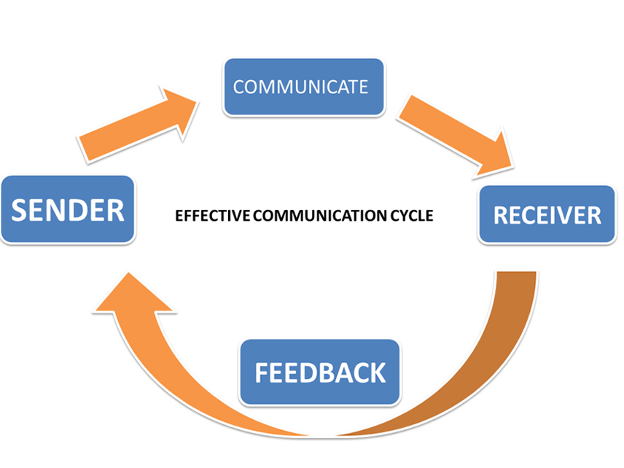
The manager would use this cycle to encode a message through the means of face to face and verbal communication such as one to one with staff, non-verbal communication would also take place such as body language and paralinguistic communication. This includes varieties of other mediums such as emailing and written communication which is needed for staff reports.

B) Shannon and Weaver:
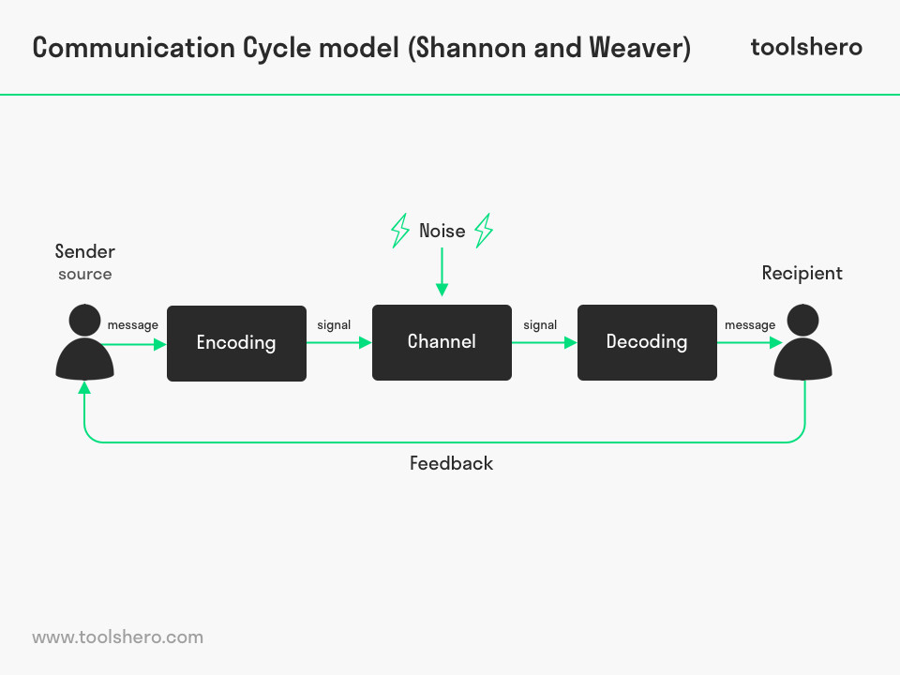

Communication has been met when a message has been sent and received. Noise can interfere with the message such as environmental which can have an impact on the understanding of the message. This cycle could take place when there are group meeting and people talking in the background.

C) Schramms:
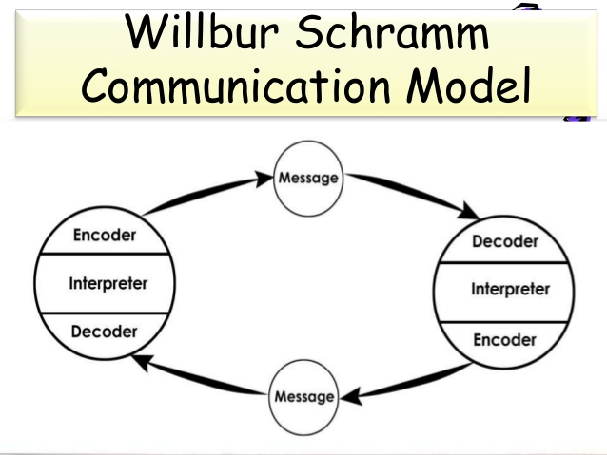
This is a two-way communication process; this communication relies on the sender and receiver sending messages back and forth. The sender will send a message and then become the receiver this would be used when staff are interacting with customers.

D) Berlo:
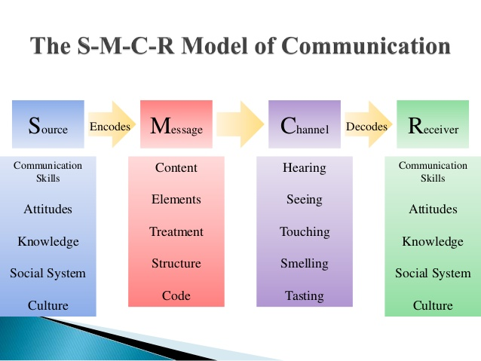
The Berlo Communication is one way it includes verbal and non-verbal with emotional aspects of the messages. Source is the sender who transfers the message to the receiver and there is no feedback or barriers to communication and no noise from this model. It requires people to have the same level of communication, this communication would take place during formal management presentations.

E) Tuckman Group and Team Development:
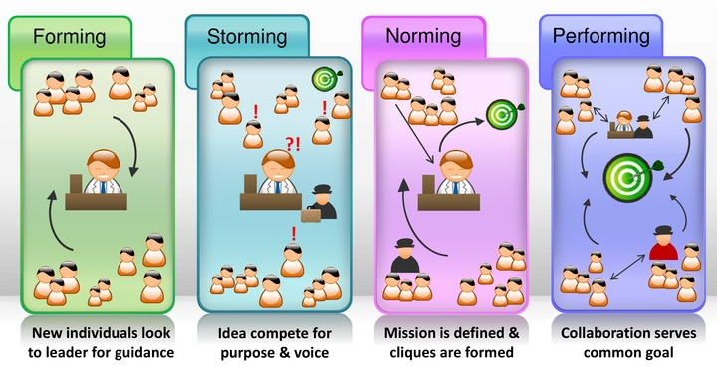

E) Belbin Team Roles:
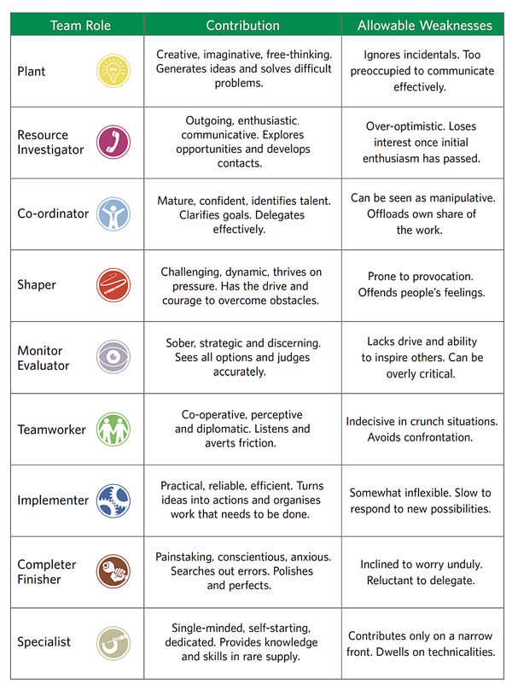

7.0 Acknowledgements
I would like to express my appreciation to all those who provided me the possibility to complete this report, Miss Sabrina whose contribution in stimulating suggestions and encouragement.

8.0 Reference List
- Acas.org.uk. (2019). Employee communications and consultation | Advisory booklet | Acas. [online] Available at: http://www.acas.org.uk/index.aspx?articleid=663 [Accessed 30 Mar. 2019].
- Benna, S. (2015). 7 communication skills all successful leaders have mastered. [online] World Economic Forum. Available at: https://www.weforum.org/agenda/2015/07/7-communication-skills-all-successful-leaders-have-mastered/ [Accessed 30 Mar. 2019].
- Belbin, M.R. (2010) Team Roles at Work. Second Edition. London: Routhledge.
- Belbin.com. (2019). Why Use Belbin?. [online] Available at: https://www.belbin.com/about/why-use-belbin/ [Accessed 2 Apr. 2019].
- Campbell, S. (2016). The 10 Benefits of Conflict. [online] Entrepreneur. Available at: https://www.entrepreneur.com/article/279778 [Accessed 3 Apr. 2019].
- Coleman, A. (2017). Teamwork, social events and company culture are vital to happiness at work. [online] the Guardian. Available at: https://www.theguardian.com/careers/2017/feb/10/teamwork-social-events-and-company-culture-are-vital-to-happiness-at-work [Accessed 30 Mar. 2019].
- Covey, S. (2019). How the Best Leaders Build Trust by Stephen M. R. Covey @ LeadershipNow. [online] Leadershipnow.com. Available at: https://www.leadershipnow.com/CoveyOnTrust.html [Accessed 1 Apr. 2019].
- Cramman, H. (2018). Tried and tested: this company built an app for employee communication. [online] Managers.org.uk. Available at: https://www.managers.org.uk/insights/news/2018/january/tried-and-tested-this-company-built-an-app-for-employee-communication [Accessed 30 Mar. 2019].
- Filev, A. (2017). Three ways to prevent communication breakdown in teams - Personnel Today. [online] Personnel Today. Available at: https://www.personneltoday.com/hr/three-ways-prevent-communication-breakdown-teams/ [Accessed 30 Mar. 2019].
- Haughton, J. (2017). 5 Ways to Achieve Top Results From Your Short-staffed Team. [online] Managers.org.uk. Available at: https://www.managers.org.uk/insights/news/2017/february/5-ways-to-achieve-top-results-from-your-short-staffed-team?sc_trk=follow%20hit,%7B86CB756B-AB02-44E6-995A-305C69252B29%7D,Teamwork [Accessed 30 Mar. 2019].
- Hunter, D. (2016). Poor communication is the biggest reason for wanting to leave a job. [online] Fresh Business Thinking. Available at: https://www.freshbusinessthinking.com/poor-communication-is-the-biggest-reason-for-wanting-to-leave-a-job/ [Accessed 30 Mar. 2019].
- Kumar, S., Deshmukh, V. and Adhish, V. (2014). Building and leading teams.
- Maund, A. & Schriek, M. & Tinkler, K.P. (2017) Certificate in Higher Education: Skills for the Workplace Student Yearbook. London: Sage.
- Trends, S., Team, 2. and Belonwu, V. (2018). 20 Ways to Communicate Effectively With Your Team - Small Business Trends. [online] Small Business Trends. Available at: https://smallbiztrends.com/2013/11/20-ways-to-communicate-effectively-in-the-workplace.html [Accessed 1 Apr. 2019].
- Watson, Gillian & Reissner, Stephanie. (2014) Developing skills for business leadership. Chartered Institute of Personnel and Development.
- Zolton, R. & Vancea, R. (2016) Work Group Development models – The Evolution From Simple Group To Effective Team. 5(1), pp. 241-246.

9.0 Bibliography
- Alvesson, M. and Willmott, H. (2012). Making sense of management. 2nd ed. London: SAGE Publications Ltd.
- Al-Fedaghi, S. (2012). A Conceptual Foundation for the Shannon-Weaver Model of Communication. [pdf] Kuwait University: Computer Engineering Department. Available at: https://www.researchgate.net/publication/272964534_A_Conceptual_Foundation_for_the_Shannon-Weaver_Model_of_Communication [Accessed 30 Mar. 2019].
- Bailey, M. (2015). What the England rugby side can teach you about teamwork. [online] Telegraph.co.uk. Available at: https://www.telegraph.co.uk/men/the-filter/11872429/What-the-England-rugby-side-can-teach-you-about-teamwork.html [Accessed 30 Mar. 2019].
- Brandon, N. (2016). The Effect of Face-to-Face versus ComputerMediated Communication on Interpersonal Outcomes in Getting-Acquainted Situations. University of Arkansas, Fayetteville.
- Cripps, B. (2017) Psychometric Testing: Critical Perspectives. Chichester: Wiley-Blackwell.
- Egolf, B.D. Ph.D & Chester, L.S. Ph.D. (2013) Forming Storming Norming Performing: Successful Communication in Groups and Teams. United States: Writer Club Press. Third Edition.
- Haines, N. (2018). Can you lead successfully with kindness?. [online] Hrmagazine.co.uk. Available at: http://www.hrmagazine.co.uk/article-details/can-you-lead-successfully-with-kindness/452286/?utm_content=Can%20you%20lead%20successfully%20with%20kindness%3F&utm_campaign=HR14Aug18&utm_source=HR%20Magazine&utm_medium=adestra_email&utm_term=http%3A%2F%2Fwww.hrmagazine.co.uk%2Farticle-details%2Fcan-you-lead-successfully-with-kindness%2F%24AMF_FIELD_mab_userid%24%2F [Accessed 30 Mar. 2019].
- Morgan, P. (2017) The Business Student’s Guide To Study And Employability. London: Sage.
- Wietrak, E. (2018). Effective team communication? Focus on quality! • ScienceForWork. [online] ScienceForWork. Available at: https://scienceforwork.com/blog/team-communication/?utm_source=mc&utm_medium=email&utm_content=Issue_78.6/22/2018.559980.https%3A%2F%2Fscienceforwork.com%2Fblog%2Fteam-communication%2F&utm_campaign=&utm_term=1150904 [Accessed 30 Mar. 2019].

