3/23/2026
University of Wales Trinity Saint David
London campus
Module Name: Learning In the Digital Era
Module Code: ACCA 4025

Student Name: Biniam Aregawi Abraha
Student ID: 2532266
Group: 1

Lecturer’s Name: Koushik Modak

E-Portfolio Link: https://2532266.wixsite.com/my-site-1

LDE Assignment 1
E-Portfolio

Table of Contents
Introduction 2
Main Body 2
Task 1: Essential Academic and Employment Skills for the future career Path 2
Task 1 (a): Report on Essential Academic and Employment Skills 2
Task 1 (b): Evaluation of Task 1 (a) based on Similarity report 2
Task 2: Collaborative Mind Map and Individual Poster 2
Mind Map (Collaborative) 2
Poster (Individual) 2
Task 3: Virtual Collaboration and RefWorks 2
Report on Virtual Collaboration 2
Step-by-step process of using RefWorks with visuals 2
Task 4: E-Portfolio Creation and Evaluation 2
Task 4 (a): E-Portfolio Creation 2
Task 4 (b): Illustrative Review of E-Portfolio tool Selection 2
Conclusion 2
References 2
Task 1 References: 2
Task 3 References: 2

Introduction

Main Body

Task 1: Essential Academic and Employment Skills for the Future Career Path

Task 1 (a): Report on Essential Academic and Employment Skills
Essential academic and employment skills are crucial to achieving success, especially in today’s rapidly changing world, whether as a student or a professional. I am referring to skills such as communication, critical thinking, time management, and teamwork.
When people are nervous about talking to others, it can affect how they're seen at work. They might be thought of as not working hard enough, not likely to succeed, and they might not be happy with their job. On the other hand, people who are comfortable communicating tend to do better. As one expert, Yusuf, Florence Adeoti, pointed out, being a good thinker means you can ask important questions, gather useful information, think about big ideas, and share your thoughts clearly with others. Managing your time is also really important. It takes effort to do it well, but it's worth it because it helps you achieve your goals. The goal of managing your time isn't just to spend more time on things, but to get things done more efficiently. For example, if you have a project to finish, good time management can help you complete it on time and do a good job. There's a big difference between working in a group and working as a team. When people work in a group, they often do their own parts of the project separately. But when people work as a team, they work together, sharing ideas and helping each other out. This can make a big difference in how well the project turns out. Teamwork is all about collaboration and cooperation, and it can lead to better results and a more positive experience for everyone involved. In fact, being able to work well with others is a key part of being successful in many areas of life. When you can communicate effectively, manage your time well, and work collaboratively with others, you're more likely to achieve your goals and be happy with your work. So, it's worth putting in the effort to develop these skills and become a more effective team player. By doing so, you can improve your relationships with your colleagues, increase your productivity, and contribute to the success of your organization. And, as you become more confident and skilled in your work, you'll be more likely to take on new challenges and pursue new opportunities, which can lead to even greater success and fulfillment in the long run.
The picture below shows the important skills we talked about in this article. Keep reading to learn about the things you can do to really succeed, not just get by, while you're in university.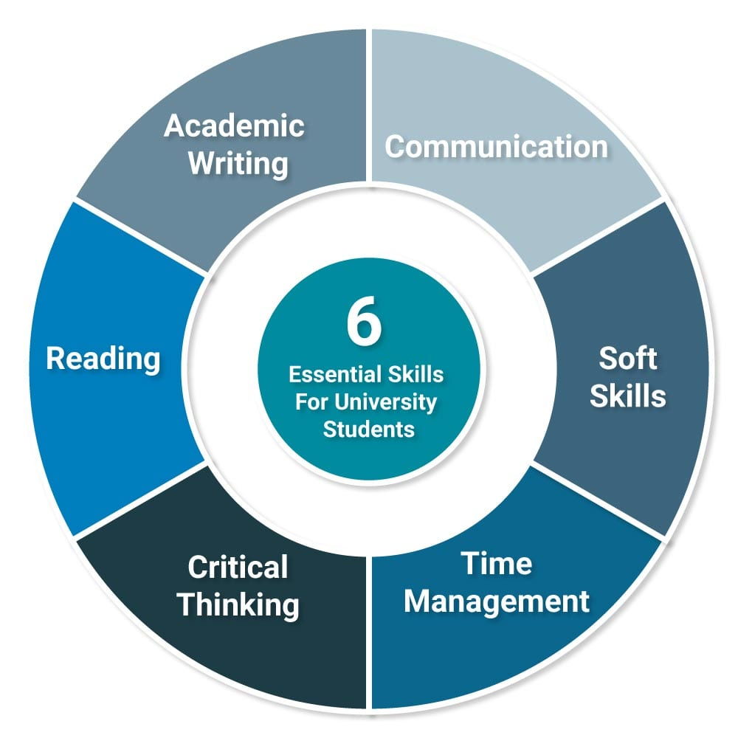
Figure 1: Essential Skills for Academic and Employment Career [5]
To succeed in my chosen career in computing, I need to develop a set of key skills. Being able to communicate effectively is crucial, as it will allow me to work well with my colleagues and clients. At the same time, critical thinking is essential, because it will enable me to solve problems in a clever and efficient way, and to come up with new and innovative ideas. Managing my time properly is also vital, as it will ensure that I can meet deadlines and get a lot done. Additionally, being a good team player is important, because many projects in computing involve working with people from different backgrounds and disciplines. Furthermore, having a good understanding of technology and being able to use digital tools with confidence will help me to stay ahead of the curve in a field that is constantly changing. By mastering these skills, I will be able to perform my job effectively, but also to adapt to new situations, come up with new ideas, and thrive in my career. This will not only benefit me, but also my employer and clients, as I will be able to make a positive contribution to the team and deliver high-quality results. Overall, developing these skills is essential for anyone who wants to succeed in the computing industry, and I am committed to putting in the time and effort required to become a skilled and accomplished professional.

Task 1 (b): Evaluation of Task 1 (a) based on Similarity report
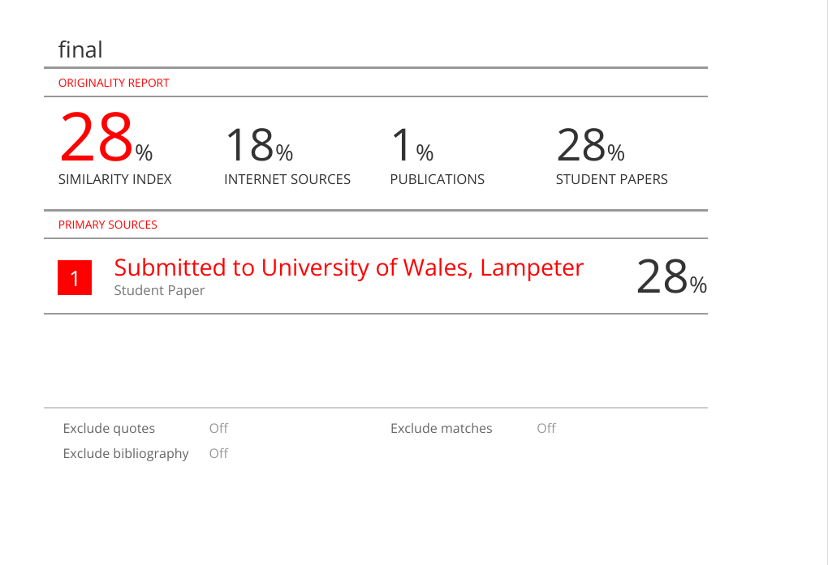

The Turnitin report gives you an idea of how similar your work is to other sources out there, but it's not just about the percentage score. You see, some similarities are okay and don't count as plagiarism, like when you use standard keywords or academic templates that everyone uses. Even reference lists can make your work look similar to others, but that's not a problem. The real issue is when big chunks of your text are basically copied from somewhere else, just reworded or translated badly. To make your report look better, you need to take some of those sentences and rewrite them in your own words. Also, make sure you're citing your sources correctly and don't overdo it with the direct quotes. If the similarities are just because of references or standard phrases, your work is probably fine.

I'd give the Turnitin similarity report a solid 8 out of 10. It does a great job of breaking down the meaning and identifying acceptable sources of similarity, like keywords, templates, and references. Plus, it offers some really useful tips on how to improve the text. I like that it's concise and doesn't just copy and paste generic responses. The report is also well-organized and follows the guidelines, which makes it easy to understand and work with. Overall, it's a pretty helpful tool for making sure your writing is original and effective.

Task 2: Collaborative Mind Map and Individual Poster

Mind Map (Collaborative)
The link is here
https://www.mindmeister.com/app/map/3952566501

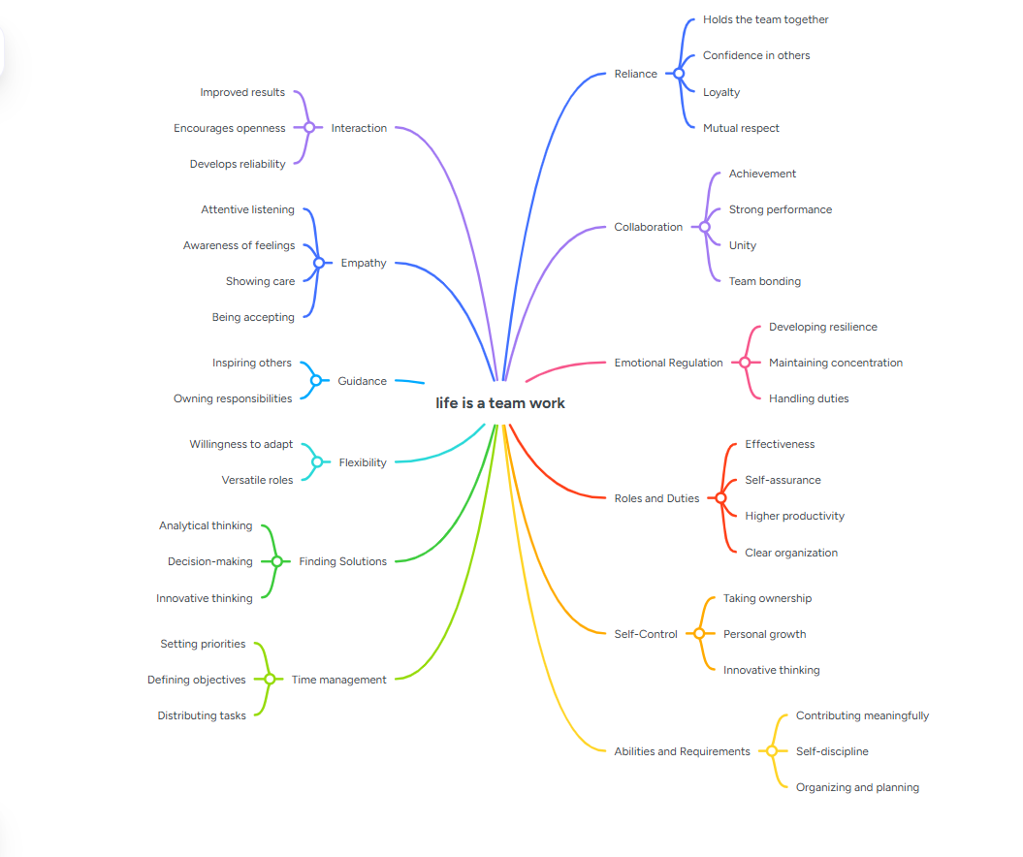

Poster (Individual)
https://www.canva.com/design/DAG2_rBdPYo/f6_rfMRunxkwjdOhIqHUFQ/edit?utm_content=DAG2_rBdPYo&utm_campaign=designshare&utm_medium=link2&utm_source=s
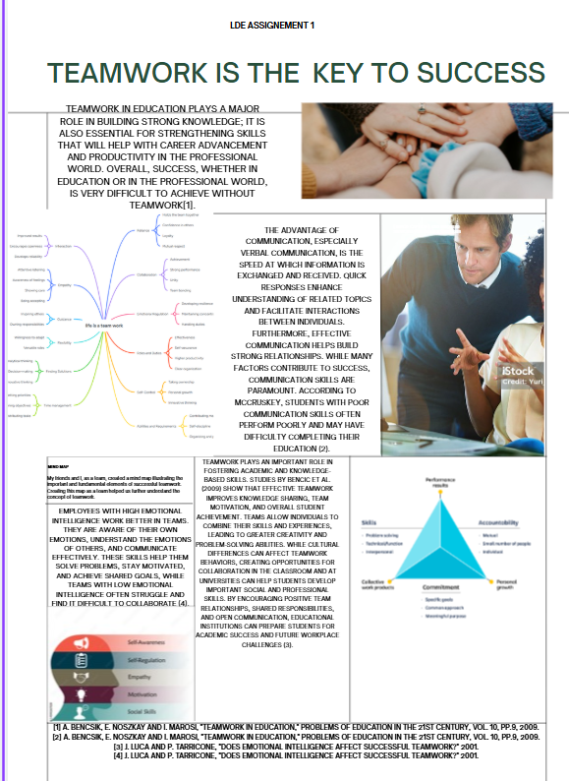

Task 3: Virtual Collaboration and RefWorks

Report on Virtual Collaboration
Forming Team

Being able to work well with others is a really important skill to have in any job. Employers want people who can talk to each other, share ideas, and help their team get things done. How well a team does depends on how good each person is at their job, but also on how well they can work together and help each other out. These days, teams are often virtual, meaning people work together online from different places. This means you need to be good at using digital tools, staying organized, and managing your time well. It's a new way of working, and it needs new skills. For example, you need to be able to communicate clearly and quickly with your team, even if you're not in the same room. You also need to be able to use technology to share ideas and work on projects together. And, you need to be able to stay focused and motivated, even when you're working alone. By developing these skills, you can be a valuable member of a team and help your organization succeed. Additionally, working effectively in a team can help you learn from others, get feedback on your ideas, and build strong relationships with your colleagues. It's an important part of being successful in your career, and it's something that you can develop with practice and experience.

When a team first comes together, it's like the starting point of a journey. This is called the formation phase, and it's where everyone meets for the first time, trying to figure out what the team is all about and what they want to achieve. It's natural for people to feel a bit nervous and unsure of themselves, since they're still getting to know each other and learning how to work together. But as they start talking and sharing their ideas, something cool happens - they start to connect and trust each other. Communication is key here, because when team members can express themselves and really listen to each other, it helps build a strong foundation for the team. As they work together, they'll start to feel more comfortable and confident, and that's when the real magic happens.

Building a team in a virtual setting can be a unique challenge. Since people are interacting with each other through screens, it's not the same as meeting in person. However, tools like Microsoft Teams and Zoom can really help get things started and bring everyone together. But it's still up to the team leaders to make sure everyone is on the same page and participating. To do this, they need to set clear goals, define each person's role, and figure out how they'll share information with each other. These are crucial steps in getting the team off the ground. By doing so, team leaders can create a sense of unity and cooperation, even in a virtual environment. This way, everyone knows what's expected of them and can work together seamlessly, despite the physical distance between them.

Building a strong team is all about laying the groundwork for people to work together effectively. When everyone starts out with respect for each other, is open with one another, and shares a common goal, they can take their teamwork to the next level by trusting each other. A team that really works is one that knows where it's going, values collaboration, and is ready to tackle problems as a unit. This kind of team is able to achieve great things because its members are able to rely on each other and work together seamlessly. By working together and supporting one another, team members can build a strong foundation for success and make progress towards their shared goals. Step-by-step process of using RefWorks with visuals
References
[1] G. Stavrou, P. Adamidis, J. Papathanasiou, and K. Tarabanis,
"Team Formation: A Systematic Literature Review," International Journal of Business Science and Applied Management, vol. 18, no. 2, pp. 17–34, 2023.
[2] J. Y. Chen and C. Y. Lin,
"A team formation model based on knowledge and collaboration," Expert Systems with Applications, vol. 36, no. 5, pp. 9121–9134, 2009.
[3] M. Liu et al.,
"Team formation and team impact: The balance between team freshness and repeat collaboration," Information Processing & Management, 2022.
[4] J. Lykourentzou et al.,
"Crowdsourcing team formation with worker-centered modeling," ACM Transactions on Social Computing, 2022.

Log in to your RefWorks account, go to My Folder, and click on Add New.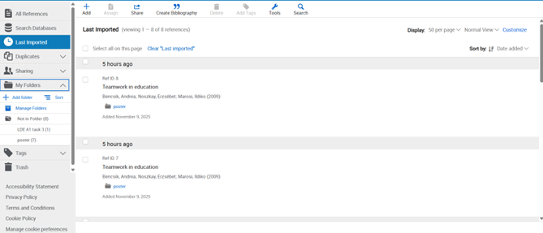
Pressing Add New

Give your reference folder a name.

Once you enter the name, click Save.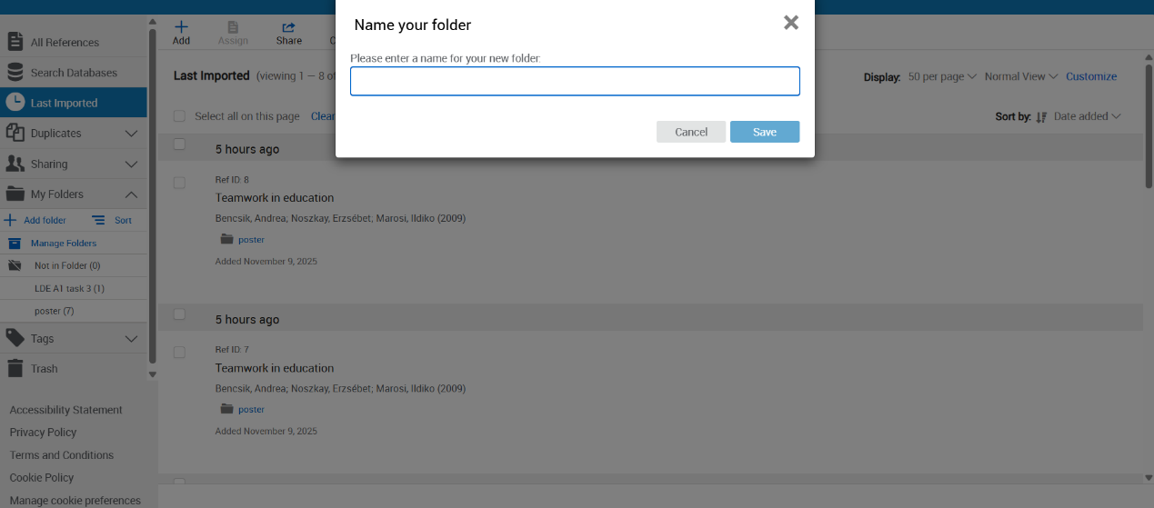
Press save

Now we have a Folder in the Refwork, we can upload the reference in it, so how to upload the reference ,first when we choose the right reference, we press the Cite
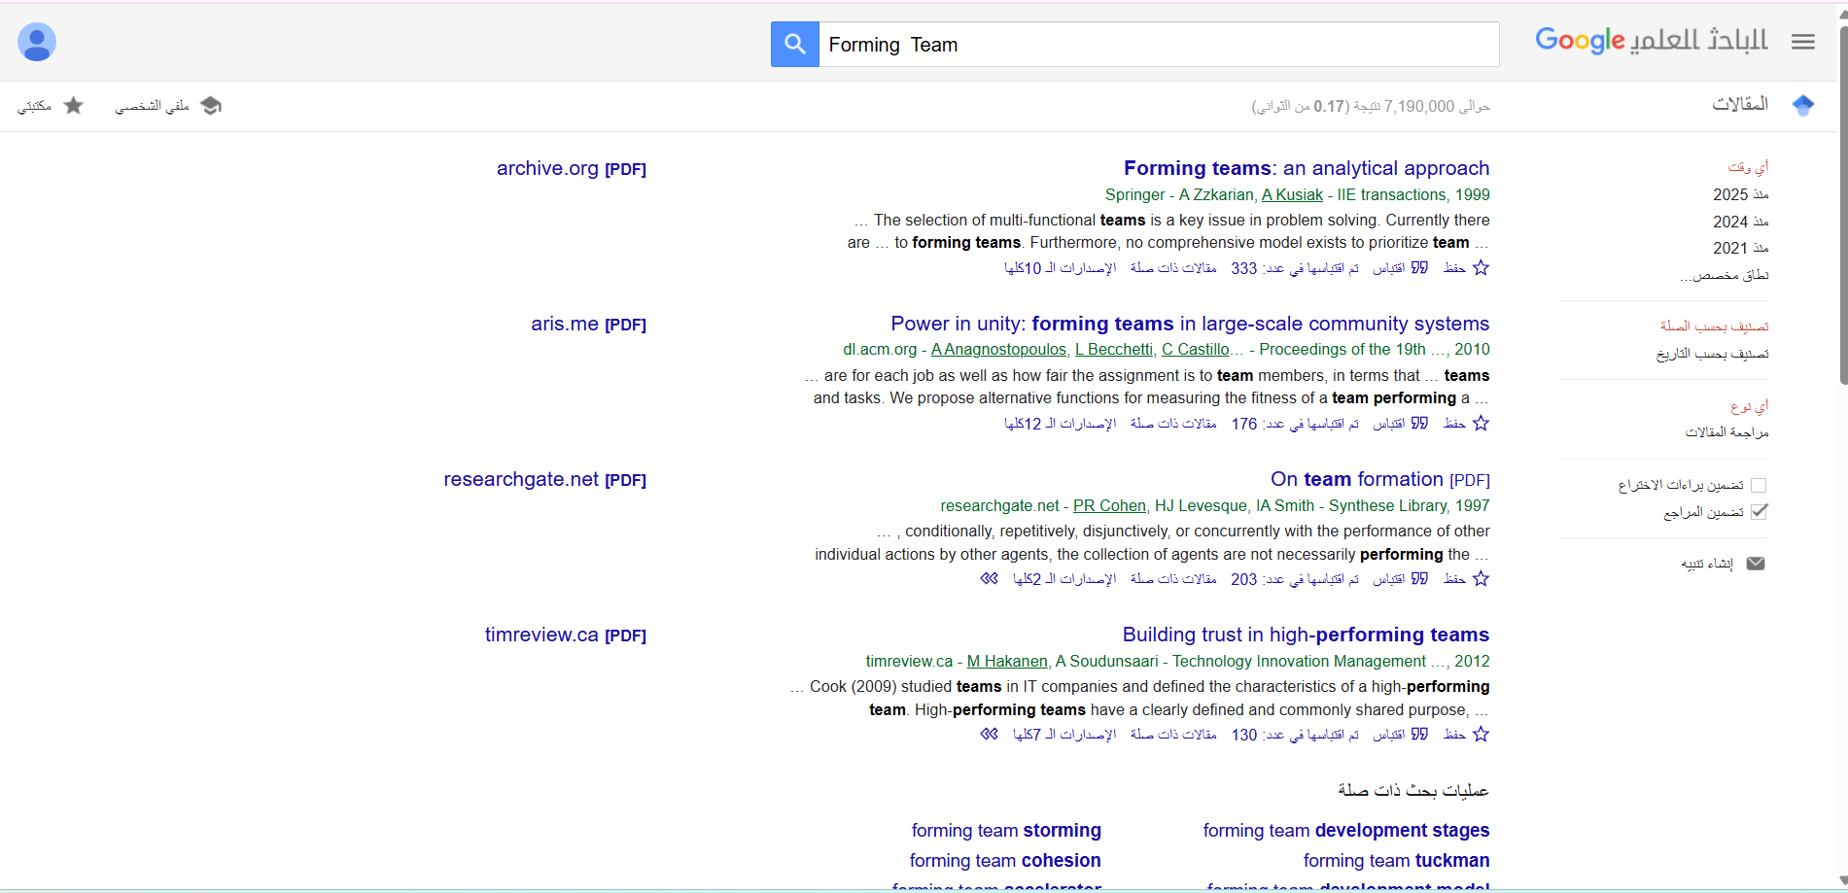
Press Cite

Then, click on RefWorks.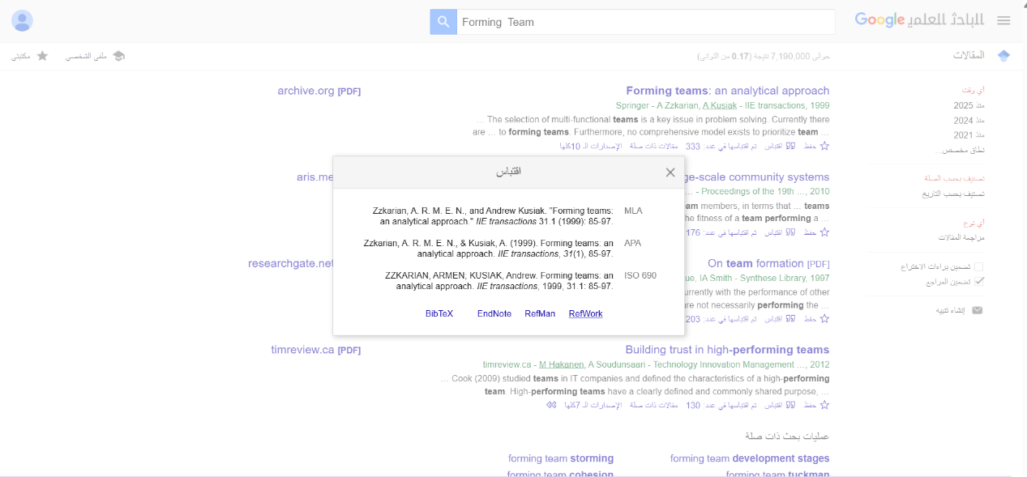
Here

After that, choose the folder you recently created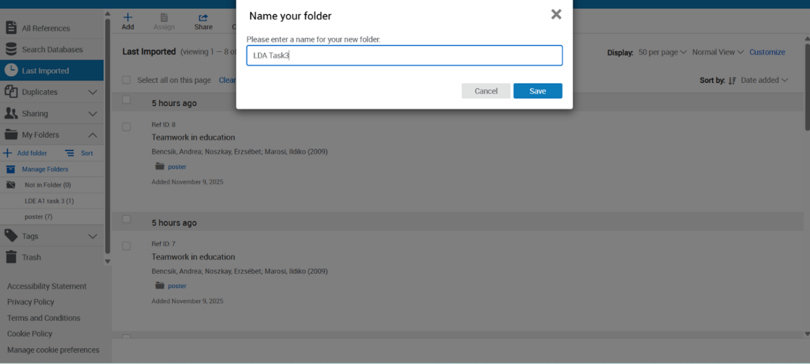
From here

And selected from the folders

As you can see, the import process is complete.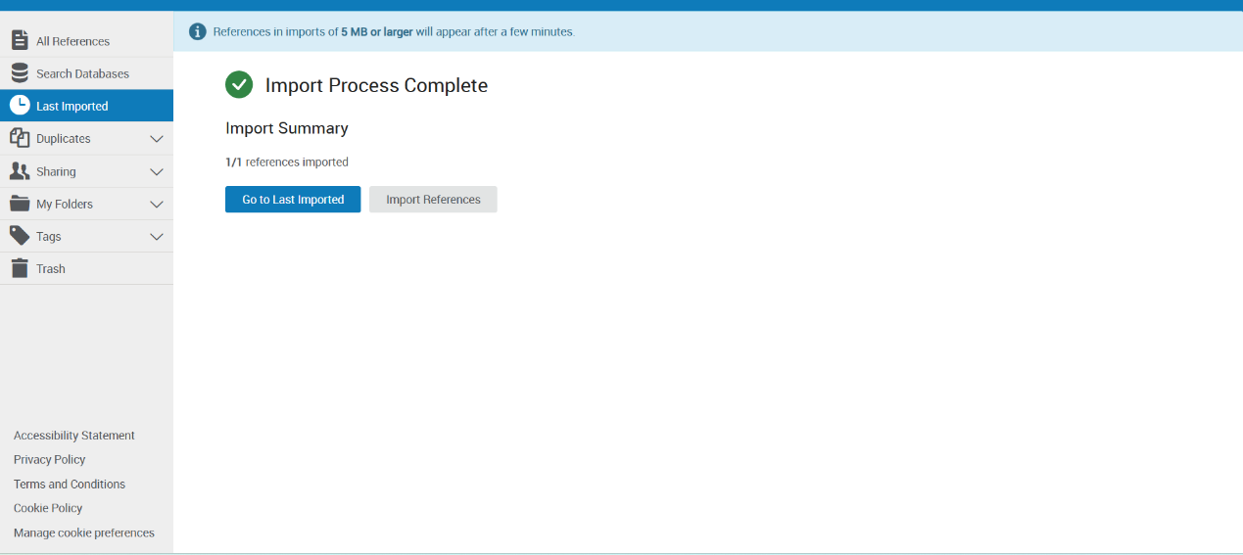

If we check our folder, we will see that one reference has been uploaded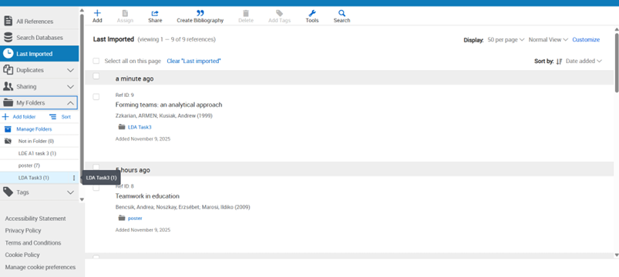
One reference uploaded

We can view it.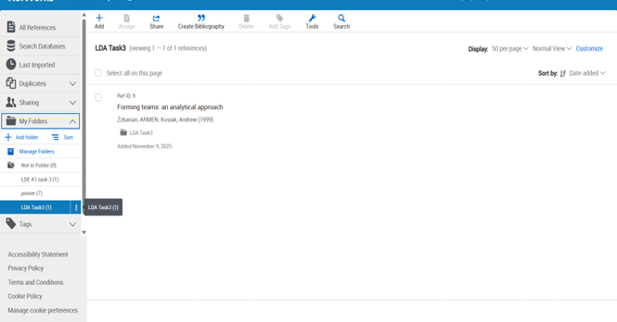

Now we will open Microsoft Word to begin Task 3.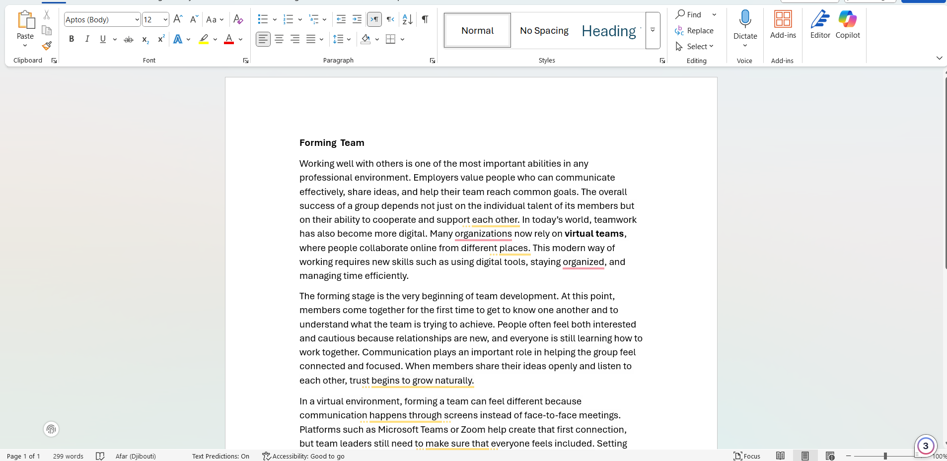

After the report appears on the toolbar, click Add In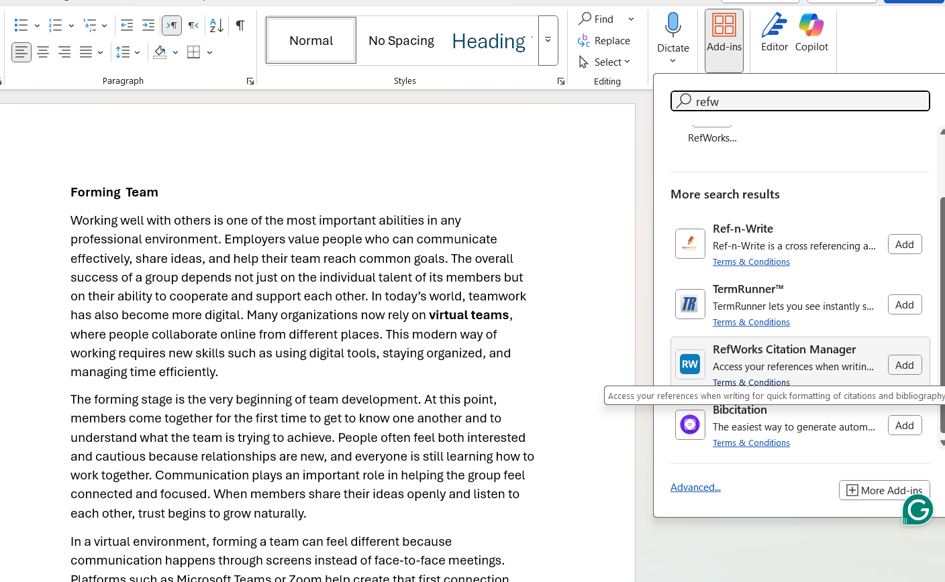
Add in
Then select RefWorks Citation Manager, and the window below will appear.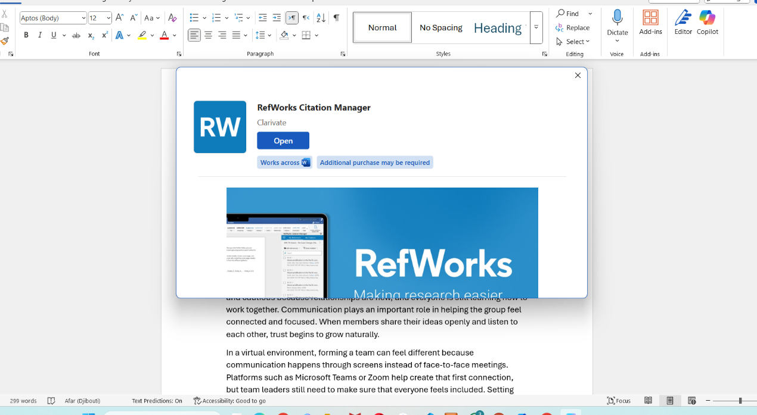

Click on Open

The RefWorks Citation Manager will appear on the right side of Microsoft Word.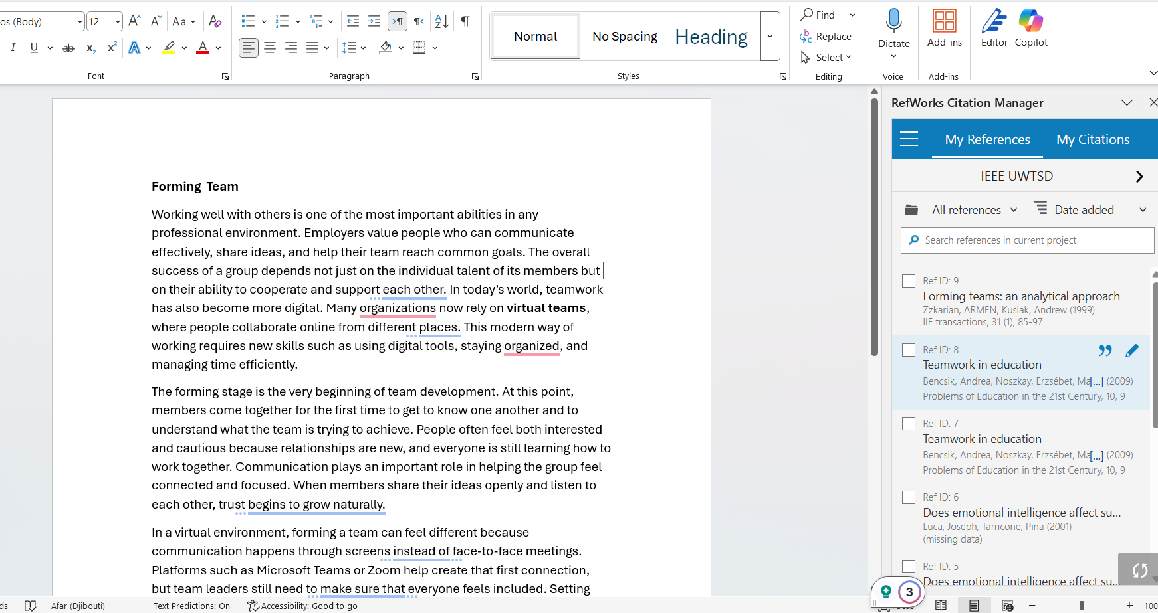
After that, we can select our reference folder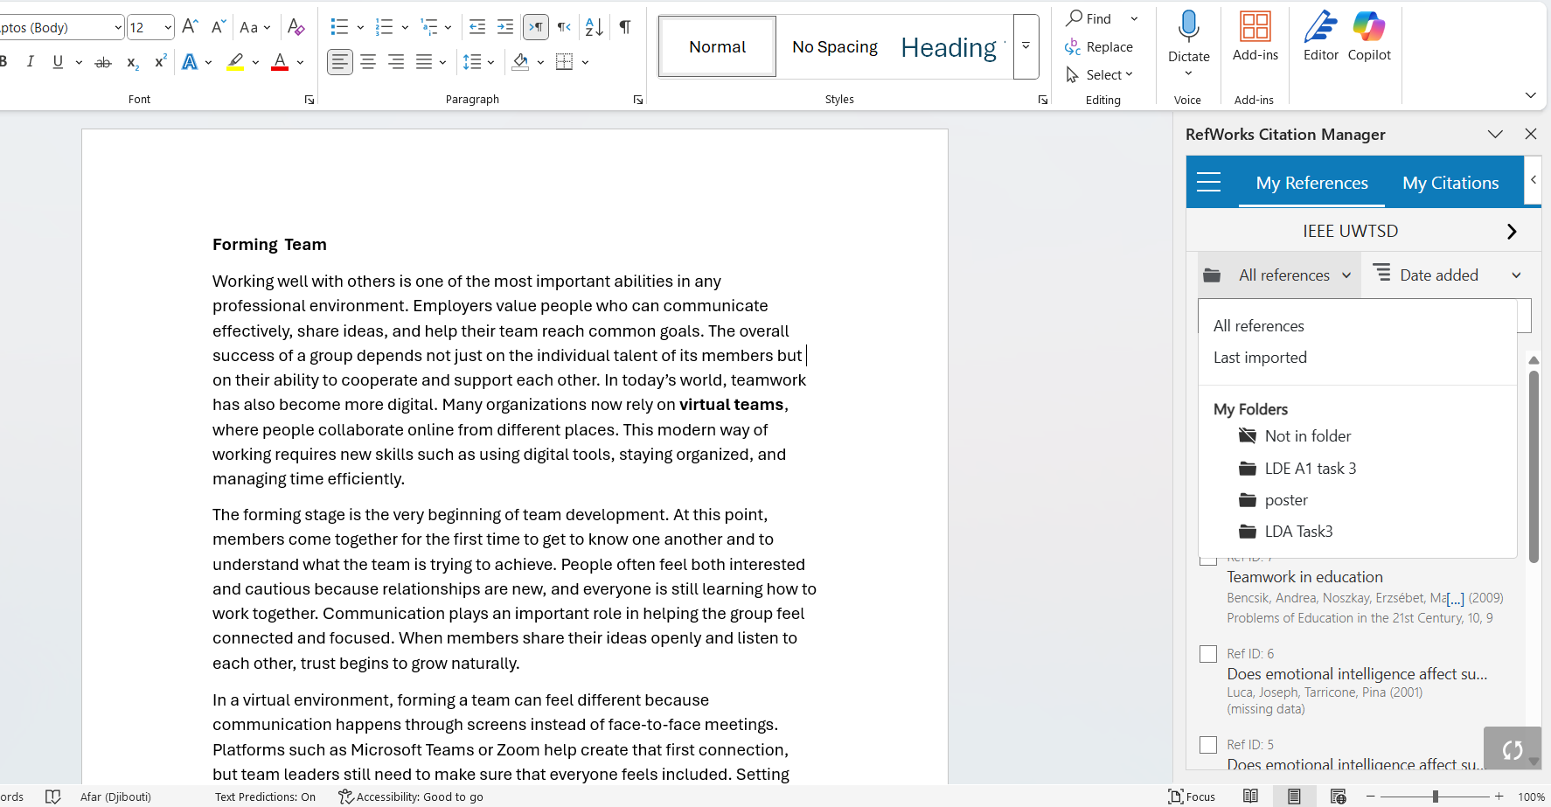
The reference folder

To create a citation in IEEE style, after selecting our reference folder, we must ensure the indicator is in the correct position.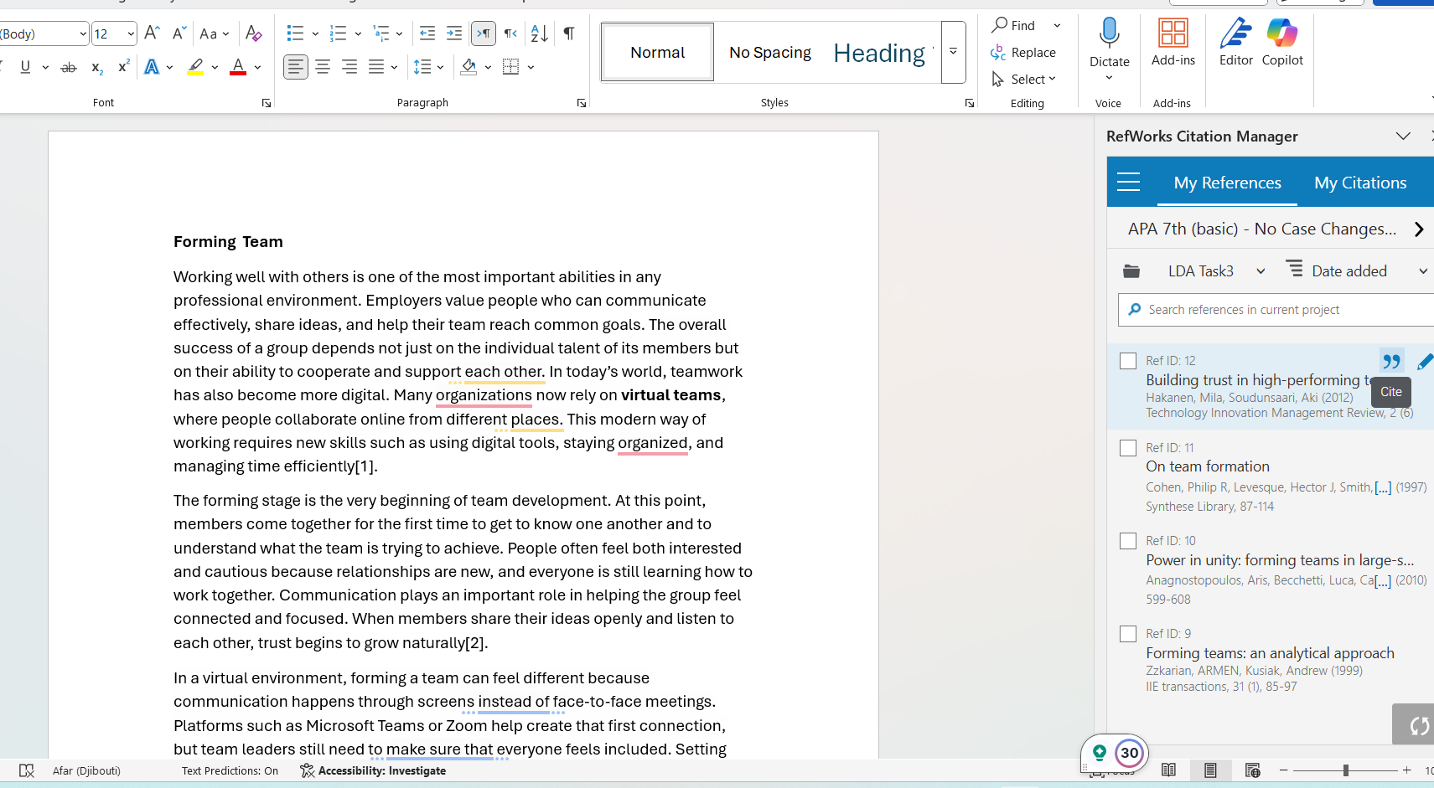
IEEE citation

Finally, to create the bibliography, we should click Create Bibliography.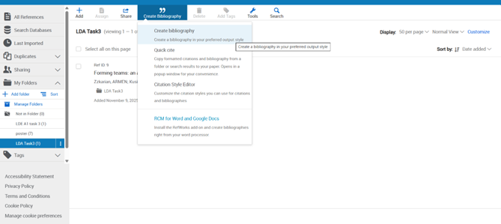

The window below will appear.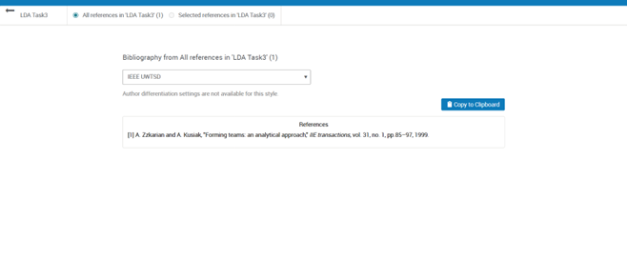

Copy the Bibliography
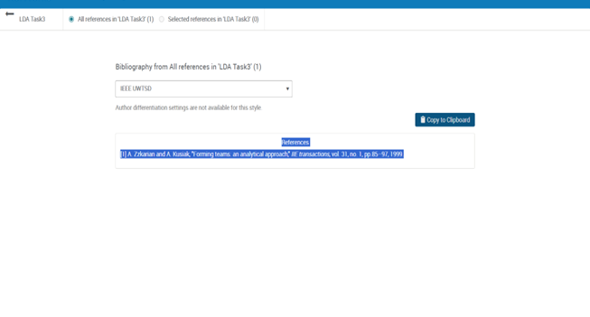

The content has been pasted here.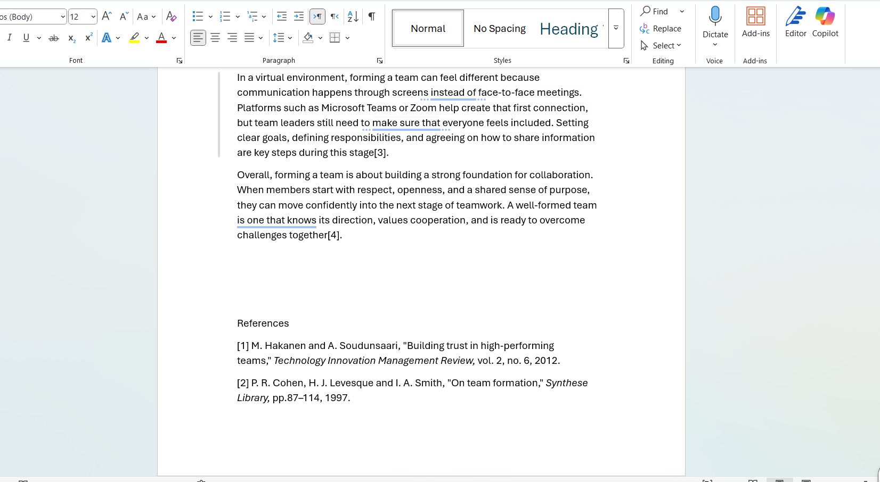

[1] M. Hakanen and A. Soudunsaari, “Building trust in high-performing teams,” Technology Innovation Management Review, vol. 2, no. 6, 2012.
[2] P. R. Cohen, H. J. Levesque, and I. A. Smith, “On team formation,” Synthese Library, pp. 87–114, 1997.
[3] A. Anagnostopoulos et al., “Power in unity: Forming teams in large-scale community systems,” in Proc. 19th ACM Int. Conf. Information and Knowledge Management, 2010.
[4] A. Zzkarian and A. Kusiak, “Forming teams: An analytical approach,” IIE Transactions, vol. 31, no. 1, pp. 85–97, 1999.

Task 4: E-Portfolio Creation and Evaluation

Task 4 (a): E-Portfolio Creation
https://2532266.wixsite.com/my-site-1
First, make an account on wix.com
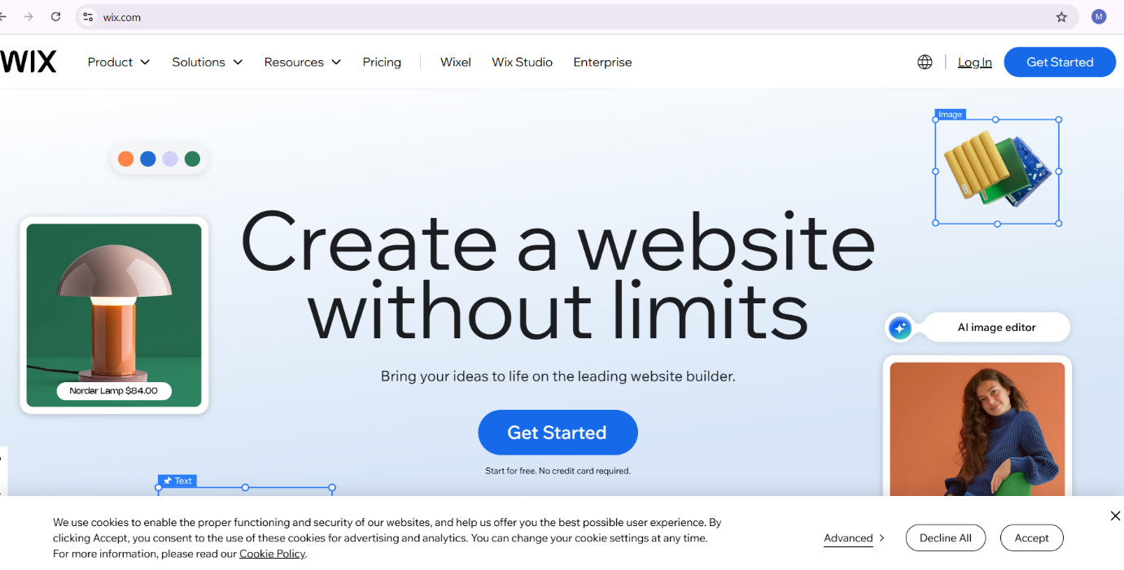

By pressing Get Started, this will be displayed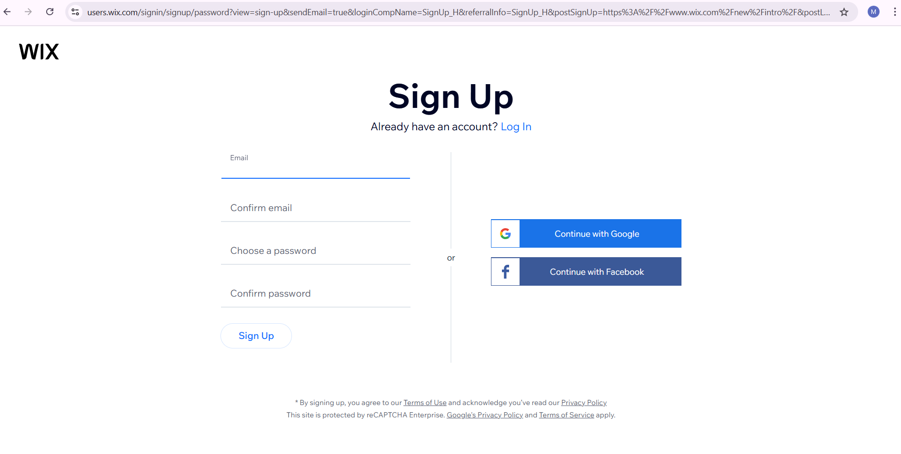
I am accessing the system with a university account.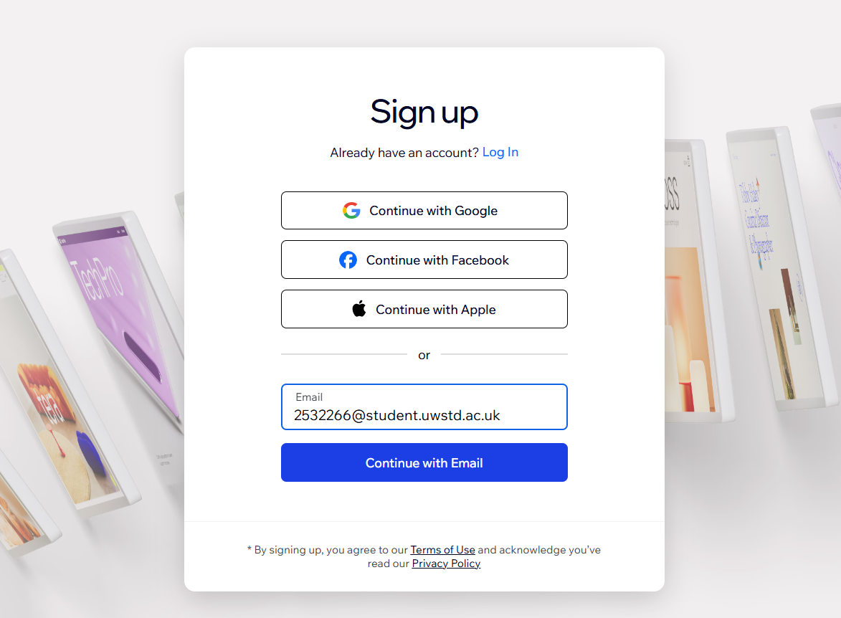
Proceed by entering your email and password.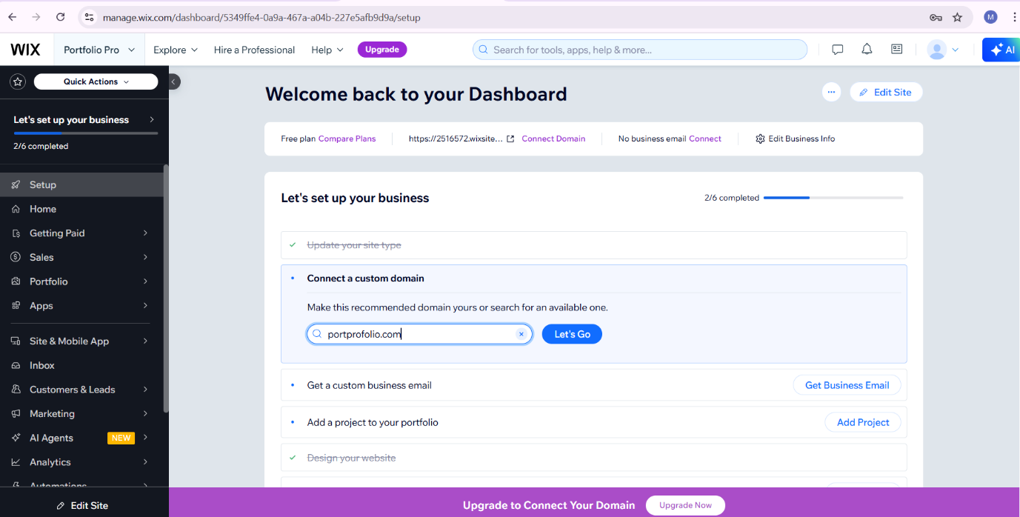
This is my account dashboard.

This is the cover I designed.

Open the menu, choose Manage Menu, and rename the page.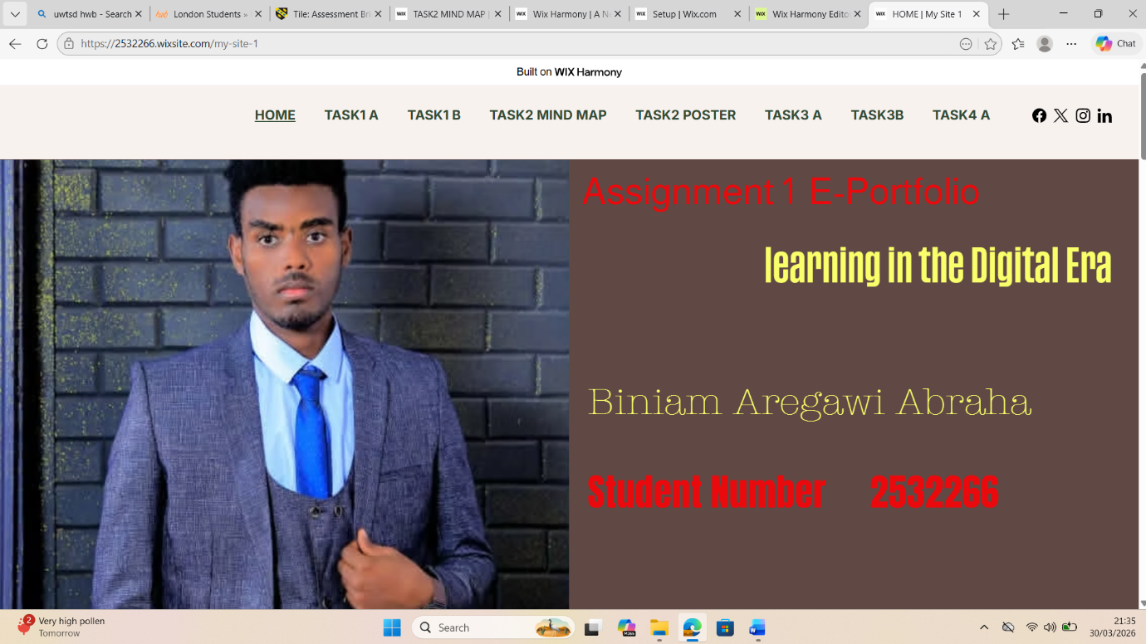
In this step, I renamed the items as Task 1A, Task 1B, Task 2 Mind Map, Task 2 Poster, Task 3A, and Task 3B, and then started transferring them into my E-Portfolio as shown below.

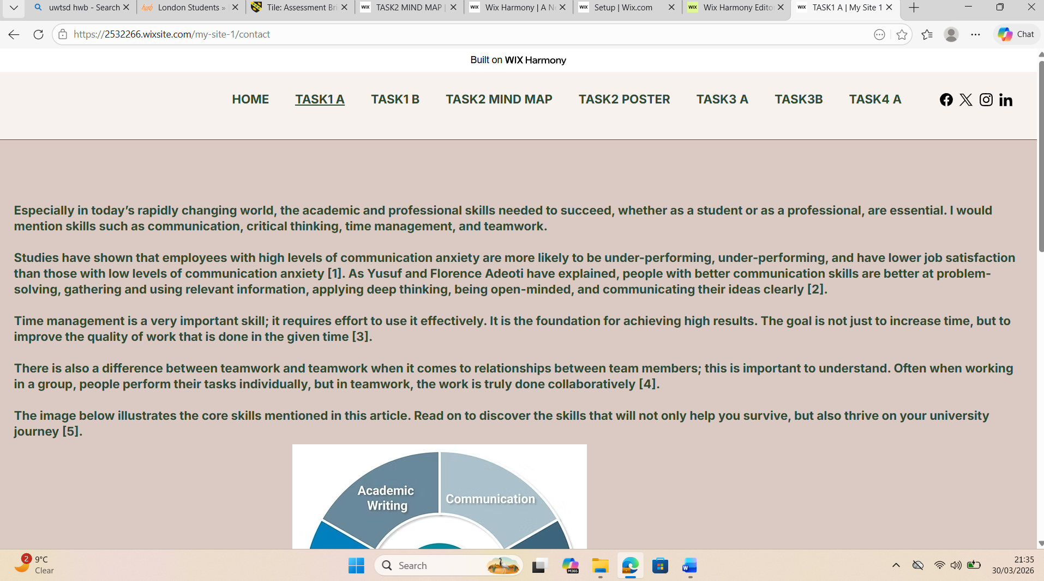
and aftrer that I started to move my tasks into my E-Portfolio as the following
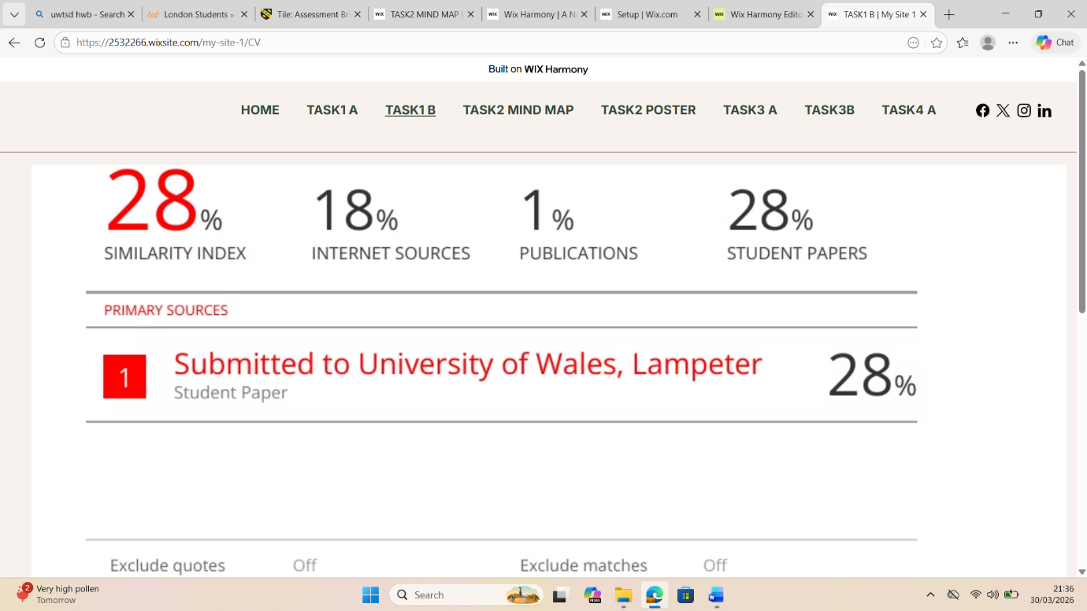

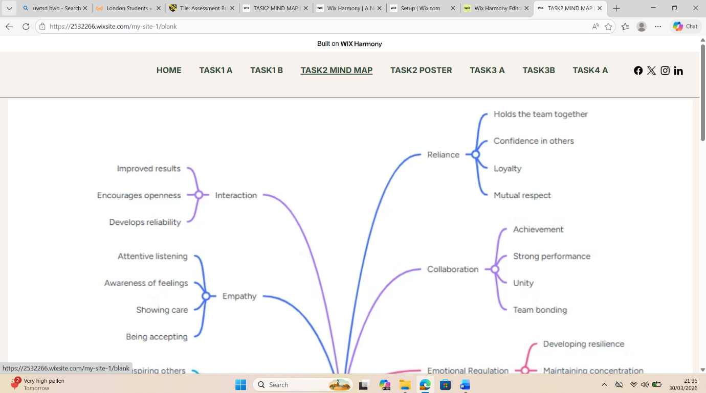

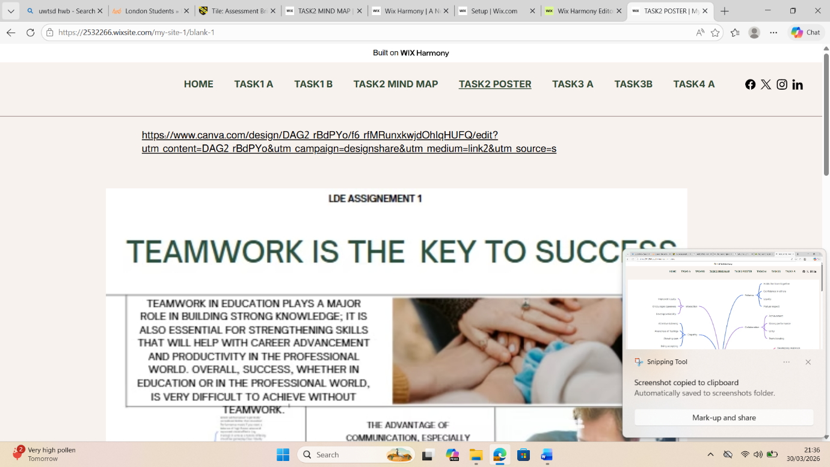

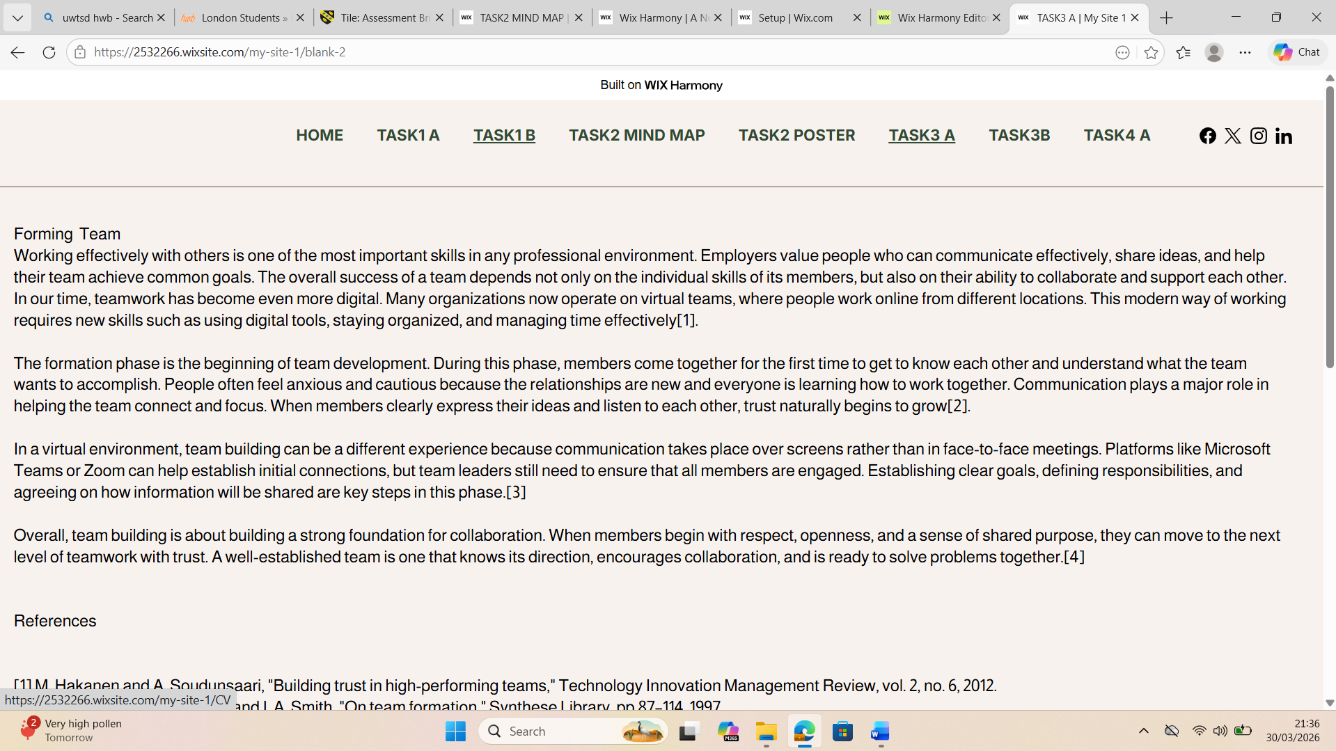

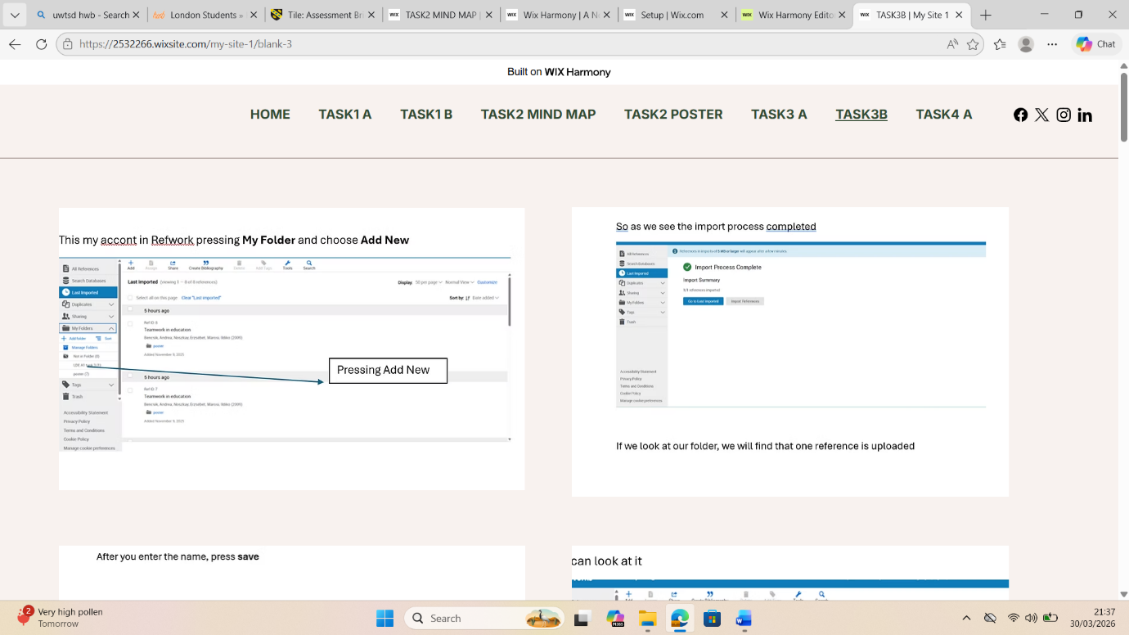

Task 4 (b): Illustrative Review of E-Portfolio tool Selection

I picked Wix to create my online portfolio because it's really easy to use and has a lot of flexible design options. The drag-and-drop editor made it simple to arrange my pages and organize my content - it was a smooth process from start to finish. I could upload images, add links, and include different types of media, which helped me showcase my work in a clear and attractive way. Plus, Wix lets me create a public link that I can easily share with others, so my teacher can access my portfolio without any hassle. This was a big plus for me, as I wanted to make sure my teacher could see my work without running into any technical problems. Overall, Wix made it easy for me to build a portfolio that I'm proud of, and I'm happy with how it turned out.

Conclusion

I was able to develop some really valuable skills by completing this task. For one, I learned how to create a professional online portfolio using Wix, which helped me get better at organizing my work and presenting it in a clear and concise way. I also got to work on a lot of different tasks, which really helped me improve my communication and teamwork skills. Plus, I got more comfortable with managing my time and using digital tools. Overall, this experience has been really helpful in preparing me for my future studies and career. I feel more confident now in my ability to work independently and use digital tools in both academic and professional settings References

Task 1 References:

[1] | [1] E. Dias-Oliveira, R. Pasion, R. Vieira da Cunha, and S. L. Coelho, “The development of critical thinking, teamwork, and communication skills in a business school – A project-based learning approach,” Thinking Skills and Creativity, 2024.
[2] | [2] J. McKay, “Student perceptions of collaborative group work and its impact on teamwork and communication skills,” Studies in Higher Education, 2024.
[3] | [3] J. Navío-Marco, “Teamwork skills development in hybrid and online universities,” Education and Information Technologies, 2025.
[4] | [4] G. L. Geissler, “Improving students’ critical thinking, creativity, and communication skills,” Education Resources Information Center (ERIC), 2012.
[5] | [5] M. S. Nyamayedenga, “Fostering critical thinking skills: The case for academic communication skills learning at Women’s University in Africa,” Journal of Research Innovation and Implications in Education, vol. 6, no. 4, pp. 174–181, 2022.

Task 3 References:

