Student name : Dumitru Ciprian Iancu
ID Student: 2133738

Table of Contents

Introduction 2
Title of the Project 2
Aims and Objectives 2
Questions 2
Secondary Research- Literature Review 3
The Concept of Virtual Learning Environments (VLE) 3
Impact of Virtual Learning Environment on the learning experience of students 3
The Virtual Learning Environment of Moodle 4
Research Methodology 5
Philosophy 5
Approach 5
Data Sources 5
Data Collection 5
Data Analysis 5
Ethical Considerations 5
Primary Research- Survey Questionnaire 6
Results 6
Findings 12
Conclusion and Recommendations 13
Reflection 14
References 15
Appendix 16

Introduction
Virtual learning environments are e-learning platforms that assist students in the process of learning. There are several virtual learning environments developed for assisting students in their learning process and to enhance their academic experience (Hamid et al., 2018). Different institutes use different virtual learning environment platforms for this purpose. Model is a popular VLE that is used by several universities and educational institutes in the UK and other parts of the globe. This research project will study the impact of Moodle on the learning experience of the students currently studying at the University of Wales Trinity St David London campus.

Title of the Project
The Impact of Virtual Learning Environments (VLEs)- Moodle on the learning experience of student at the University of Wales Trinity Saint David London Campus.

Aims and Objectives
To understand the concept of Virtual Learning Environments or VLEs.
To assess the impact of Virtual Learning Environments on the learning experience of students.
To understand the importance of Moodle, one of the Virtual Learning Environments.

Questions
What are Virtual Learning Environments or VLEs?
How do Virtual Learning Environments on the learning experience of students?
What is the importance of Virtual Learning Environments?

Secondary Research- Literature Review

The Concept of Virtual Learning Environments (VLE)
According to Daheriya (2021), Virtual Learning Environments or VLEs are a set of tools designed for enhancing the teaching and learning process to improve the learning experience of students by the inclusion of computers and the Internet in the process of learning. these are cloud based digital solutions and thus can be accessed from anywhere through the Internet. VLEs contain information regarding the various modules taught in a college or institute in the form of PDF course materials, videos, audio files, slideshows and presentations and other forms of data (Hamid et al., 2018). It also contains lesson plans, progress reports, student assessments and curriculum statements. VLEs is provide different communication, collaboration, and administrative tools beneficial for both the administration of the institute as well as the learners.
The study by Davies (2020) states that Virtual Learning Environments are designed extend the experiences in education without replicating them. Students are granted access numerous resources and ways of interaction that enhance the quality of the learning process which physical classrooms and the traditional learning processes lack. Advancement in the digital technology has created opportunities to digitize the learning process even before the pandemic (Torres Martin et al., 2021). Many tutors and educators depend on these virtual learning environments to enhance the quality of the teaching process.

Impact of Virtual Learning Environment on the learning experience of students
Flavin and Bhandari (2021) state that Virtual Learning Environments were developed what is the transformation of students from passive learners to active learners. VLEs help students to engage in active learning and thus helps in promoting the critical thinking skills that help them develop in the academic and professional context. This is the result of VLEs assisting in the transfer of knowledge acquired in the classrooms to a practical setting (Davies, 2020).
VLEs combine informational resources related to course in one place. They are affordable and require only Internet access for students to engage in active learning. It helps in making the revision process easy for students during examinations. According to Torres Martin et al. (2021), They also increase inclusivity, providing students with a comfortable learning process that is less stressful, and increases their productivity. Some VLEs also help in connecting students with their peers from all over the globe, expanding the worldview and providing them with useful insights into various concepts through a different standpoint. The use of wheelies improving the technical skills of students (Munas and Arun, 2020). One of the biggest advantages of VLEs is that students can get immediate feedbacks on their tasks.

The Virtual Learning Environment of Moodle
According to Gamage et al. (2022), Moodle is a VLE software that provides an e-learning platform for students. It was developed by Martin Dougiamas and has been a leading VLE platform since its inception. It helps students in easing the online education process and accomplishment of course work and assignments. MOODLE is an abbreviation for Modular Object-Oriented Dynamic Learning Environment. It has over 14 million users engaged in e-learning through approximately 1.4 million degrees and courses (Ximenes, 2020). Moodle provides numerous features for students like blogs, knowledge database, and glossaries along with chat options, student assessment and student support.
Students rely on the e-learning platform for preparing for tests and completion of assignments. Students can submit their assignments through the portal. Also, the platform provides immediate feedback on the tasks submitted by the students and also student module assessments (Grossi et al., 2018). educators also rely on the platform for engaging with the students and assisting them in their learning experience. Educators can also access student information and their module progress for identifying the learning needs of the students for developing relevant teaching structure (Abdula et al., 2022).

Research Methodology

Philosophy
Research philosophies refer to the play nature and source of data and the process of its development for obtaining the results of the research process (Gale, 2018). Include three functions- demystifying and understanding the data collected and the facilitation of appropriate research methods. The research philosophy used in this research project is interpretivism.

Approach
Research approaches are the methods of collecting data and its analysis for the identification and assessment of patterns in the data (Jaradat, 2018). It helps in the formulisation of conclusions from the data findings. The deductive approach of research is used in this research project. It will help in the identification of the various factors contributing to the impact of VLEs on the learning process of students.

Data Sources
Two data sources are used in this research project- primary and secondary. The primary source of data used in the project is a survey questionnaire undertaken by several classmates of the author. The secondary sources of data used are research journals, papers, and other online data sources like Google Scholar (Gale, 2018).

Data Collection
The primary data was collected through a survey questionnaire created using google forms. The data collected through the Google forms was represented in the form of pie chart. The secondary data collected was represented in the form of literature review and discussed the important aspects of the project derived from its objectives.

Data Analysis
The data collected through primary sources using google forms was studied and analysed through segregation, compartmentalization, and graphical representation in the form of a pie chart. The secondary data was structured by dividing it into three sections, addressing the questions of the project. The findings were discussed by comparing the results of the primary and secondary data.

Ethical Considerations
Verbal permission was obtained from all the participants of the survey for abiding to the principles of ethical considerations. Also, anonymity was assured to the participants. This will ensure the authenticity and reliability of the data (Jaradat, 2018).

Primary Research- Survey Questionnaire
A survey questionnaire was prepared for understanding and analyzing the impact of Virtual Learning Environments (VLEs)- Moodle on the learning experience of student at the University of Wales Trinity Saint David London Campus.

Results
- How often do you refer to MOODLE for study material?
Everyday | 5
Once in a week | 2
Not often | 3
Total Responses | 10

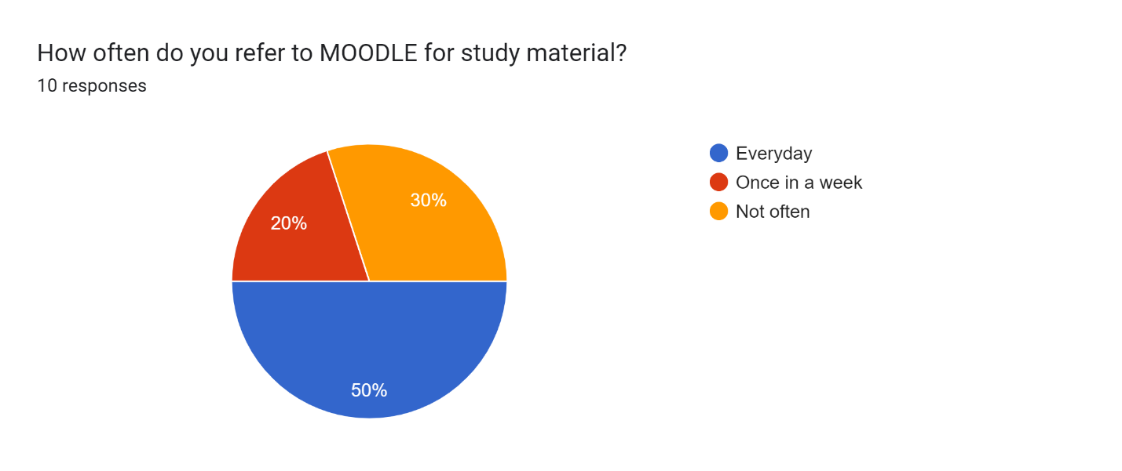

- Do you find the resources available on MOODLE reliable?
Yes | 6
No | 3
Sometimes | 1
Total Responses | 10

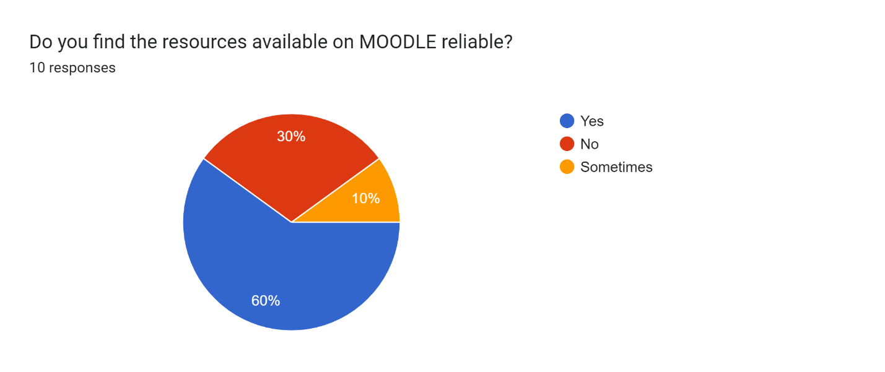

- Has MOODLE helped you in improving your grades?
Yes | 4
No | 5
Don’t know | 1
Total Responses | 10

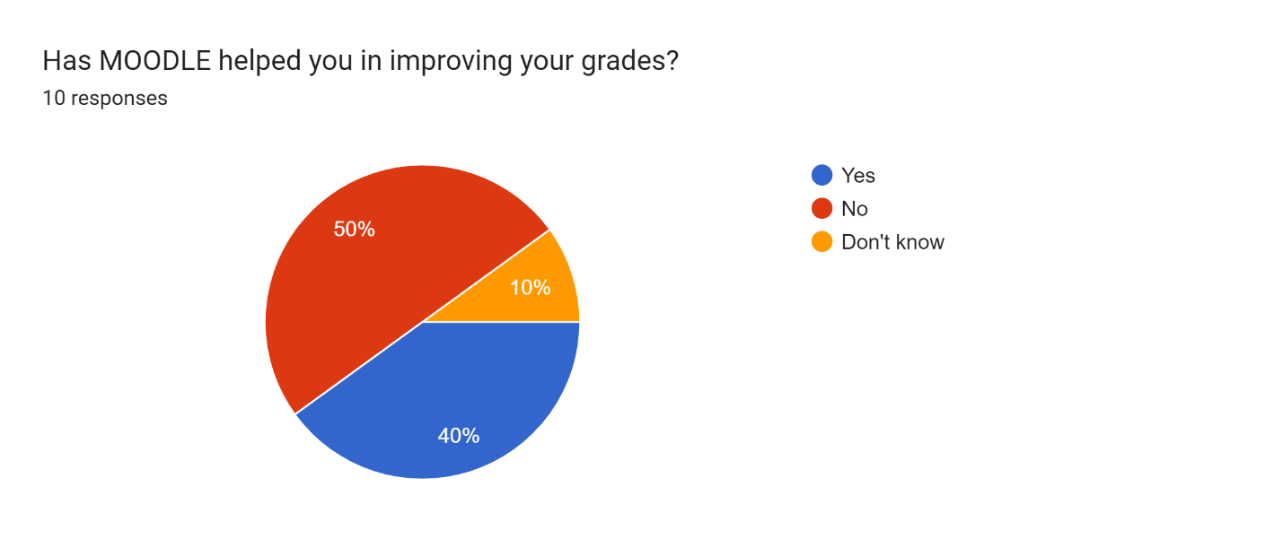

- Has MOODLE contributed to the accomplishment of your academic goals?
- Yes
- No
Yes | 7
No | 3
Total Responses | 10

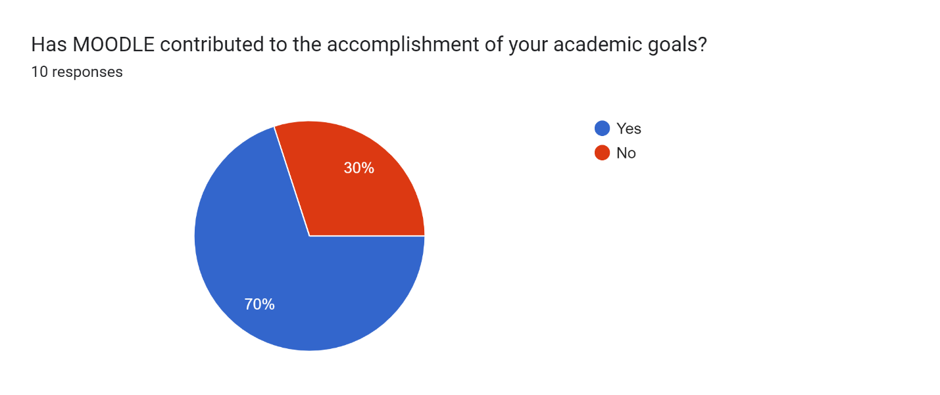

- Would you recommend MOODLE to your fellow classmates or peers?
- No
- Yes
- Maybe
No | 3
Yes | 6
Maybe | 1
Total Responses | 10

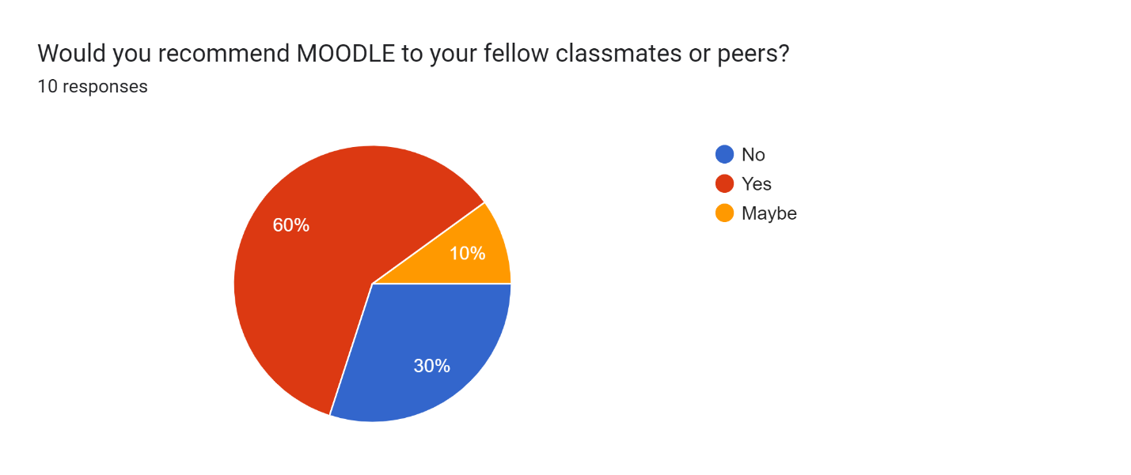

- How would you rate your experience with MOODLE on a scale of 1 to 5?
1 (poor) | 1
2 | 1
3 (moderate) | -
4 | 5
5 (excellent) | 3
Total Responses | 10

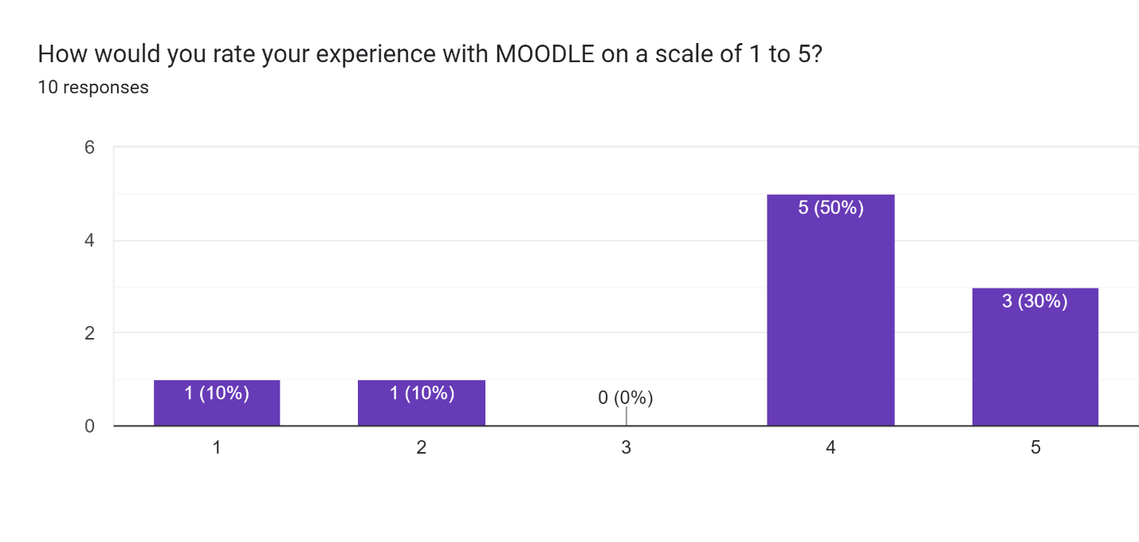

Findings
- Based on the results of the questionnaire, 50% of the students use Moodle every day, while 20% use it once a week. 30% students do not use Moodle as often as the others.
- 60% of the students find Moodle resources reliable in their learning process while 30% do not rely on Moodle. 10% students are of the opinion that Moodle resources are reliable only sometimes.
- 40% students believe that Moodle has helped them in improving their grades while 50% students are against that belief. 10% students are not aware of the impact of Moodle on their grades.
- 70% students believe that Moodle has contributed to the accomplishment of their academic goals while 30% students are against this belief.
- 60% of students say that they recommend Moodle to others while 30% say that they would not. 10% of students are not sure whether they will recommend Moodle to other or not.
- 80% of the students rate their experience with Moodle between good to experience while 20% of the students rate it as poor to not bad.

Conclusion and Recommendations
Based on the findings of the survey, it can be said that most students rely on Moodle for easing their learning process. Also, many students have made considerable progress or believe that they had done so through the use of Moodle. Many students access Moodle on a regular basis to refer to the academic resources available on the platform. These students believe that Moodle has helped them improve their grades and accomplish their academic goals. Many students also recommend Moodle to their classmates and peers. However, it was also observed that some of the students do not either access Moodle or are not aware of the benefits of using Moodle. Also, a few students do not believe that Moodle is an efficient tool in their academic progress.
It is recommended that educators should inform students on the importance of using Moodle. Also, students should be made aware of the many tools and resources available on Moodle. Students should be given assignment tasks that require them to access Moodle on a regular basis, helping them acquire the habit of using the e-learning portal for their academic growth and development. Educators and institutions should formulate policies and frameworks that positively influence the growth of students by increasing their use of the platform and boosting the positive outcomes of their assignment tasks. The grades of these students can also be improved through the promotion of the use of Moodle.

Reflection
The Gibbs reflective cycle can be implemented to reflect on the research project. The research project can be studied and assessed for understanding the proficiency of the author and the strengths and weaknesses of the project. The structure of the project provided insights into the importance of classification of data for facilitating its analysis. The collection of the primary and secondary data was a relatively easy process due to the of availability of data in ample quantity.
Various factors were involved in the completion of this research project. All these factors were interrelated and the outcome of the project was positive through the identification and assessment of these factors. Understanding these factors provided guidelines for conducting the processes in research methodology.
The process of collection of the primary data provided significant insights into the inclination of participants in providing relevant information to help in the completion of the project. However, it was also observed that more research needs to be conducted regarding this topic. This will help and reducing the occurrence of negative findings in the research results. Also, further study needs to be conducted to design efficient policies and models of learning that can help in increasing the utilization of virtual learning environments in future educational context.

References
Abdula, A.I., Baluta, H.A., Kozachenko, N.P., Kassim, D.A. and Zhuravlev, F.M. (2022). The Use of Moodle in the Teaching of Philosophy and Distance Learning. AET 2020, p.616.
Daheriya, M.G.M.A. (2021). A VIRTUAL LEARNING ENVIRONMENT (VLE): PLATFORM FOR LEARNING. Available online at: https://www.krcollege.in/uploads/pdf/1653635744_E-RV-Vol-11%20Issue%201.pdf#page=18. Last accessed on July 23, 2022.
Davies, C.P. (2020). Are VLEs still worthwhile?. Journal of Learning Development in Higher Education, (18).
Flavin, M. and Bhandari, A. (2021). What we talk about when we talk about virtual learning environments. International Review of Research in Open and Distributed Learning, 22(4), pp.164-193.
Gale, K. (2018). Madness as Methodology: Bringing Concepts to Life in Contemporary Theorising and Inquiry. Routledge.
Gamage, S.H., Ayres, J.R. and Behrend, M.B. (2022). A systematic review on trends in using Moodle for teaching and learning. International Journal of STEM Education, 9(1), pp.1-24.
Grossi, M.G.R., Elias, M.C.A.S., Chamon, C.M. and Leal, D.C.C.C. (2018). The educational potentialities of the virtual learning environments moodle and canvas: a comparative study. International Journal of Information and Education Technology, 8(7), pp.514-519.
Hamid, Z., Peng, C.F., Shaharom, M.S.N., Ter, T.C. and Raman, K. (2018). The concept and use of the virtual learning environment in teaching: a literature review. International journal of academic research in business and social sciences, 8(6), pp.1293-1301.
Jaradat, R. (2018). Sawsan Abutabenjeh. Teaching Public Administration, 36(3), pp.237-258.
Munas, M. and Arun, K.C. (2020). Challenges in Adopting Virtual Learning Environment in Higher Education Institutions. PalArch's Journal of Archaeology of Egypt/Egyptology, 17(7), pp.5221-5233.
Torres Martín, C., Acal, C., El Homrani, M. and Mingorance Estrada, Á.C. (2021). Impact on the virtual learning environment due to COVID-19. Sustainability, 13(2), p.582.
Ximenes, A.C. (2020). Virtual Learning Environment: Report on the Moodle Management Experience in Public Higher Education School. In Learning Styles and Strategies for Management Students (pp. 232-243). IGI Global.

Appendix

