UNDERSTANDING AND ENGAGING IN THE CUSTOMER EXPERIENCE
Table of Contents
Introduction 2
Research informed literature for understanding and engaging in the customer experience 3
Knowledge and understanding of the quality process of organisations and effectiveness in meeting customer demands 4
Analysis of the customers' experience and the factors that influence the ability of organisations to increase the customer value 7
Practical application and deployment of quality process in the workplace 9
Skills for developing and maintaining a valuable customer relation 11
Conclusion 15
References 16

Introduction
The present study is going to focus on the understanding and engaging the customer experience over an organisation so as to gain a critical understanding of the quality systems for the customers. For gaining an in-depth knowledge of the quality management, Tesco has been chosen as the organisation for the present study. From the time of Industrial Revolution, quality management was carried out to maintain the standard of the product. The importance of producing quality goods grew more than ever. As a result, quality process gained its importance more than ever in the present retail industry.
The report will be evaluating the factors that influence the ability of the organisations to maximise their customer value. Further, a critical understanding of the Tesco quality processes and its effectiveness are going to be evaluated in terms of meeting customer requirements. Primarily, an informed literature would be referred for gaining a deep understanding of the subject of engaging with the customer experience within the retail industry. Moreover, the reported study is going to relate the analysis to the practical application and deployment of quality process within the workplace of Tesco and its competitors.

Research informed literature for understanding and engaging in the customer experience
Source 1> Journal/Article
The journal was presented with an aim of determining the reason and the conditions that consumers enter into a strong, loyal and meaningful relationship with the companies that excel within the market of a particular industry. Through such approach, the method and accurate way can be found out for gaining a competitive advantage. The research paper tried to draw the theories on the organisational identification and social identity in a purpose of finding the strong consumer company relationship. These are often found from the results of the identified customers who engage themselves with those companies for a long-term period. The article then helps in satisfying more than one self-definitional need of importance. The authors of the journal further tried to elaborate the nature of the company and consumer identification process that includes the company identity and then articulate the conceptual framework for consumer level (Bhattacharya and Sen, 2010). All the research work is completed regarding the key consequences and determinants for making a unique identification in the marketplace.
Source 2> Journal/Article
This paper has also focused on the literature for the experience of the customer within the retail environment. This paper has taken a spontaneous reaction of the customer that is sensuous and touched the emotional aspect of the experience, which has been the locus of the whole study. The researchers have tried to gain an in-depth understanding of the psychology or the buying behaviour and relied on the theory of the human mind. Moreover, the article seems to suggest a spatial and embodied approach towards the experience of the customer (Yakhlef, 2015). This also presented an argument for the sense of the environment that the retail industry tends to expect. Likewise, the reciprocity between the world and the body would be implying an inter corporeality that is meant to retract or extend the spatiality of the retail industry. Furthermore, the article tried on emphasising the character from the customer experience. This would be able to conclude with effective recommendations and suggestion for the future business perspective and future studies.
Source 3> Journal/Article
The purpose of the article was to examine if retailers can successfully recognise the deeper understanding of the customer and eventually enhance the satisfaction level of the consumer through delivering a better retail performance (Puccinelliet al. 2009). All the changes that a firm goes through are integrated into multiple business functions and also creating an external partner. In order to create and deliver the experience of the customer journey within this era of complex customer behaviour. The article tried on emphasising the character from the customer experience. These are often found from the results of the identified customers who engage themselves with those companies for a long-term period. The article then helps in satisfying more than one self-definitional need of importance. The authors of the journal further tried to elaborate the nature of the company and consumer identification process that includes the company identity and then articulate the conceptual framework for consumer level
Source 4> Journal/Article
This source of a research paper has given a deep understanding of the customer experience along with the journey over the time for critical and famous firms. The customer would be able to interact with the firms that seem to be a myriad touch point within the multiple media and channel. The customer experiences are found to be more social in nature instead of being g more practical in terms of product quality. All the changes that a firm goes through are integrated into multiple business functions and also creating an external partner. In order to create and deliver the experience of the customer journey within this era of complex customer behaviour, the author tried to gain an understanding by examining the existing conceptualisation and definitions of the customer experience (Lemon and Verhoef, 2016). As it will be constructed to provide a historical perspective from the rots of the customer experience within the marketing level. In the next aspect, the study tried to bring together and collaborate the experience of the journey of the customer for a particular firm along with their experience from the management. The study further provided a scope for future research on this understanding of the customer experience over time for critical firms.

Knowledge and understanding of the quality process of organisations and effectiveness in meeting customer demands
The quality process of an organisation involves various methods, which vary accordingly to the demands of the customers. All the companies started to raise the product quality to grab the market. Standards are set and product demand is higher than ever. But compromising in quality is never an option for the companies. Total quality management is now improvised into Quality Management System, which has been providing services to its customers. Quality Management System takes care of the transparency in the market. The following are the adopted strategies within the quality management of Tesco so as to maximise its effectiveness in meeting customer demands
- The companies and producers try to understand the consumer needs and want to produce accordingly. It is true that gaining new customers are difficult than retaining existing loyal customers. Therefore quality is an important factor for any existing company.
- Maintaining the quality of a product will ensure that customers will remain loyal. The costs of gaining new customers are high than retaining the existing ones. Quality management system benefits the consumers to a great extent.
- It understands consumers’ requirements and takes measures to maintain the desired quality required. This increases sales and the company’s benefit from them. This also creates a room for growth and profit for the company thus fulfilling the organisations’ requirements.
Tesco is a British multinational retailer company, which deals in the retail of grocery and merchandise. The company has successfully set a strong relationship with their customers. It also has a professional team to look after the products, which are not at adequate to serve the customers. This is very important, as any customer will lose their faith in a grocery store if they sell low standard products. However, its competitor Sainsbury is giving a tough rivalry by engaging an advanced quality management system through the development of advanced technology (Richardson, 2010). As a result, the excessive cost and time to sort out the standard products are saved unlike in Tesco. Moreover, Sainsbury always set quality standards before the arrival of their products so that each and every product are equally produced before it reaches the customer's hand. Therefore, Tesco needs to adopt the same strategy to increase its customer satisfaction over the years successfully and cut down the unnecessary cost. Tesco recently going through a transformation in terms of producing retail goods as the choice of quality for the products are constantly improved with the engagement of its competitors. The companies try to set the standards high every time they launch a service. Gaining customers’ trust is a long-term process and doesn’t happen overnight. One has to grow slowly and effectively to capture the market. Tesco now provides several important services and goods to their consumers. Tesco has given empowerment to its employees through various quality management training process over the years. Various policies were created by Tesco to meet customer satisfaction. A close competitor has been Walmart who has a dedicated team of professional who looks after the quality management process. Cost-effectiveness is calculated at every step, this helps the company to cut its budget whenever it’s deemed not necessary. However, the company tried to achieve its position in the market through following strategies:
- The production grew rapidly but this never had any impact on quality. If a customer buys any product from any store and finds it dissatisfying, any individual will never visit that store again or even if they do, they will tend to overlook the product. Thus the grocery store lost one customer in the process. Retailing units may not be responsible for the production but they get affected as the customer decides to ignore their shop.
- Tesco has been using total quality management to maintain the quality of their services. Customer satisfaction can be achieved through various techniques of quality management. Tesco applied different quality management strategies like customer-based strategies, management based strategies. The company has made a reward structure for management and employees so as to maintain the quality of the produced items reaching their customers (Rose et al. 2012). There are other techniques to ensure a quality of audits, quality training, and customer survey. Tesco has set a benchmark for every product and everyone follows this set of rules to maintain the quality.
- Customer satisfaction is given the first priority. Unlike its competitors, surveys are conducted on a daily routine and this gives a clear view of how the customers feel about the product. Therefore consumer feedbacks play a valuable role in improving a product's quality.
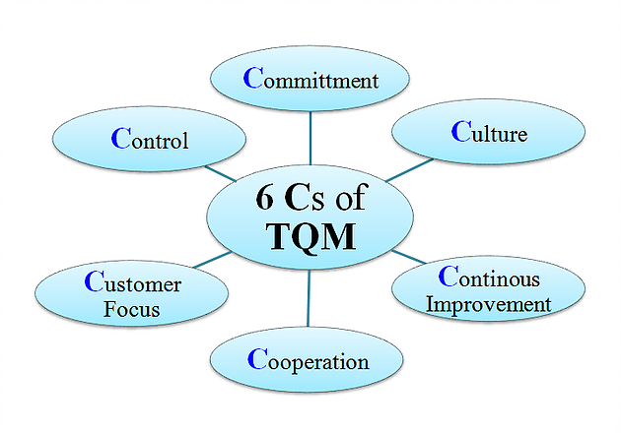
Figure 1: Total Quality Management components
(Source: Rose et al. 2012)

Analysis of the customer's experience and the factors that influence the ability of organisations to increase the customer value
Customer experience has improved over the years in Tesco. This is solely because Tesco gives importance to their customers’ demands and tries to figure out what the consumers’ are looking for. Surviving in the global market is a tough task and Tesco has been doing it for decades. A company cannot survive only if they sell cheap products. Understanding customers’ shopping experience should be taken into consideration. Tesco focuses on customer experiences and tries to fix the loopholes (Novaket al. 2010). They try to attract more new customer and retain the existing ones. A lot of schemes are created to attract customer interest. Tesco has customer management team to create various strategies. The team focuses on product promotion so that customers reach can be high. Further, from the analysis of the various retail shops in terms of customer experience the following have been found out.
- Tesco focuses to deliver a great customer experience thus gaining the trust of new customers. One can get in touch with customer executive service any time to solve their issue.
- Walmart is the largest retailer in the world through many of their consumers believes they should do more to reconnect with their customers. They hire less than what they should, which affects customer shopping experience. Therefore, one can conclude that there are loopholes in their customer service sector and can be improved certainly. If any customer sees an empty shelf and the stock of items that are kept beside are waiting to be put up, he or she will walk away as no one has got time to wait for long. This is where Walmart lacks and Tesco has been a better performer.
- Tesco gives customer-handling training to its employees to deliver a better customer experience. All the professionals who are working for Tesco need to understand what customer experience means. Customer experience can be referred to every single communication with the company, product or service (Schmitt, 2010). Tesco started Club card for their loyal customers. The best thing about the management team is that they always come up with something innovative to attract consumers’ mind. Most of the existing consumers seek out the best deals from the retailer and has been doing this for years.
- A gigantic multinational retailer company like Tesco has got its drawbacks. It is believed that Tesco’s staff per 1000 sq. ft. of an area has fallen drastically over the years. This gave Tesco’s direct rivals like ASDA; Morrison’s an upper hand in the retail business. Last year in September, Tesco’s big price drop failed and was criticised. Lastly, Tesco’s growing interest in Asian market has brought a downfall of their market capture in the UK (Robsonet al. 2016).
Tesco has now started to focus on their core business in the UK to fund their overseas expansion. Tesco is now focusing on their basic business to generate revenue and get hold of the UK market. Tesco’s head of market said in an interview that the company is focusing on rising their revenue generation in the UK and then going for the international business (Lemkeet al. 2011). But the company’s growing trend to keep in touch with their loyal customers has brought success. Tesco has always been upgrading their technology to better the customer experience. Moreover, the factors influencing the organisations to increase the customer values are:
Loyalty: To achieve more customers and to build a long-term relationship, loyalty is necessary. Companies tend to attract the customers by offering them some good discounts and offers. After the customer gets attracted, the customer should feel safe and satisfied. In order to make the customer satisfied, companies should be loyal towards them by offering after sales service.
Cost: To improve the customer value the customer should be offered cost-effective products. Nowadays due to huge competition, one has to take care of the cost. No company should charge more than they should actually charge.
Accessibility: The products that the customers using should be always accessible. The customers and find those products whenever and wherever they want to. The customer should also freely raise questions on the product.
Sales: If a company tries intelligently to re-use a customer by offering them some discounts or offers then customer value can be increased. But there is always a chance to overuse them, which will eventually lead to a negative impact on a customer (Blázquez, 2014). Sales should always be with a good approach. Hence, cross-sell and upsell should be used to sell a product to a customer.

Practical application and deployment of quality process in the workplace
Within the workplace of Tesco and other retail companies, the quality management process is an important aspect that is practically applied for deployment of delivering quality standard to the customers. The major expectations associated with the customer demands are also figured out through the implementing of the quality management processes. The companies try to set the standards high every time they launch a service. Gaining customers’ trust is a long-term process and does not happen overnight. One has to grow slowly and effectively to capture the market. Tesco now provides several important services and goods to their consumers. Tesco has given empowerment to its employees through various quality management training process over the years. Various policies were created by Tesco to meet customer satisfaction. A close competitor has been Walmart who has a dedicated team of professional who looks after the quality management process.
Cost-effectiveness is calculated at every step, this helps the company to cut its budget whenever it’s deemed not necessary. These are calculated by adopting certain tools and techniques, which are uniquely established for gaining the major influencing factor for increasing the customer value (Ibehet al. 2015). Moreover, the most common adopted tools and techniques by the retail industry along with Tesco are outlined below. These are the prime methods for determining the effectiveness of the quality management ion increasing the customer value.
1. Cause and effect diagram
This is also termed as fishbone chart that aims at identifying possible causes for an observed effect or issue. This sort of idea is utilised for useful categories that are effective in deriving the main are of improvisation within the business process.
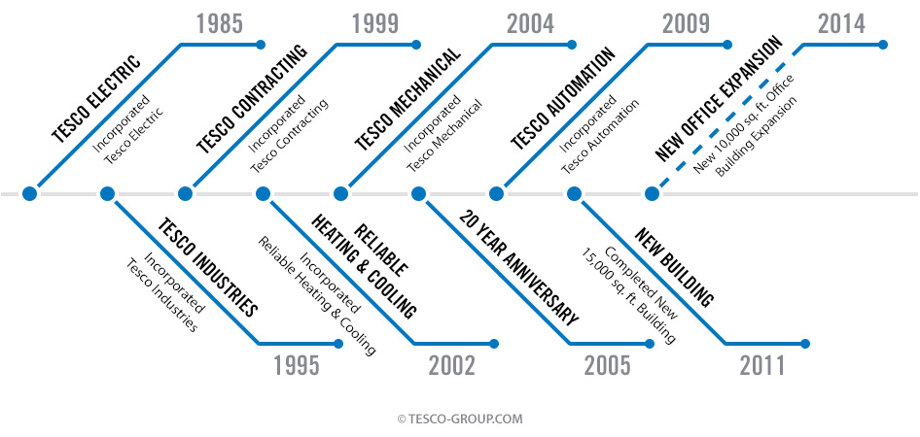
Figure 2: Data recorded for the growth of Tesco over time
(Source: Patterson, 2016)
2. Check sheet
This is generally is in the form of a structured presentation that is prepared for collecting and analysing the collected data for a certain period of time (Sachdeva and Goel, 2015). This tool is also a generic medium, which can be adopted for a variety of purposes.
3. Control charts
This is the technique to gain knowledge about the change in quality process that takes place after over time. It is generally represented in the form of a graph.
4. Histograms
Mostly adopted and used [the technique within the retail industry which critically shows the frequency distributions. This means the histogram is able to show different value for a different set of recorded data over time.
5. Pareto chart
The factors, which are most prominent and most significant, are shown in the Pareto chart in a form of bar graph. Similar to control charts it helps to monitor the change in the quality process in accordance with the demands of the customers.
6. Scatter diagram
The diagram is represented by numerical data where one variable is considered for each axis and a relationship is established.
7. Stratification
Stratification is a technique that is made to separate data in accordance with the collected source. This procedure is adopted in order to form a pattern that can be traced and used for improvising the quality management process within the organisation.
It can be concluded that the retail companies and producers try to understand the consumer needs and want to produce accordingly. It is true that gaining new customers are difficult than retaining existing loyal customers. Therefore quality is an important factor for any existing company. Maintaining the quality of a product will ensure that customers will remain loyal. The costs of gaining new customers are high than retaining the existing ones (Fatma, 2014). Quality management system benefits the consumers to a great extent. As a result, the outlined tools and techniques are majorly adopted by the leading retail organisations.

Skills for developing and maintaining a valuable customer relation
As Tesco Plc. is a British Multinational grocery giant and third largest store according to profits, it needs to possess the best skills for customer relationship management. To hold that position in this competitive market one has to come up with new and unique strategies. Customer relations is very much important in this modern time as because as customers nowadays have better knowledge of product than earlier and seeks to have a better offer. Building relationship with customers is always advantageous as it always affects in the long run or term. It always comes from a long-term marketing plan (Patterson, 2016). One company cannot simply make good relation with a customer. The company has to satisfy and attract the customer so that the customer gets attracted and make a positive approach to make a relation, which would help the company to grow for a long term. Tesco follows some values to maintain customer relations. They are:
- No one tries more other than Tesco for customers.
- Aware of customer needs.
- Teamwork.
- Respect everyone.
- Always be polite
- Takes care of every community.
The Skills for developing and maintaining valuable customer relationships that Tesco focuses on:
- Trust: Trust plays an important role to achieve success and to win a customer’s heart. Providing value things or quality products can only do this. Tesco has their own branding products and to attract customers and to win the loyalty they always try to produce the best out of anything. If the product high satisfies every customer chances are there most of the customers will be attracted and again visit the store.
- Commitment: This also plays a vital role in making relations with the customers to be successful. If customers come to know about the company who always keep their words, obviously the customers will get attracted. And commitment helps a customer to get emotionally attached to the company. Starting with the manager to staffs everyone should be committed towards their work (Cetin and Dincer, 2014). So customers get benefitted as well as the company also gets benefitted by winning the loyalty of the customer.
- Communication: It is also very important in terms of Customer Relationship Marketing. Communication from a CRM point of view is defined as giving any valuable information to the customer may it be before any sale, after a sale or during the sale. Communication is done to attract the customers to achieve their loyalty. The communication must be trustworthy also. Now a day's communication is being to the customers to spread awareness, to understand what the customer prefers and to convince them to buy again that is re-buy the product (Strakeret al. 2015). So, basically, the communication between the company and the customer is being done to gain the loyalty of the customer and to get benefitted in a long term.
- Promise fulfilment: It is also very important as because if any company promised to give any offer to the customer and fails, the customers get effects and this leads to customer loss. So to win their loyalty a big company like Tesco always fulfills its promises to the customers.
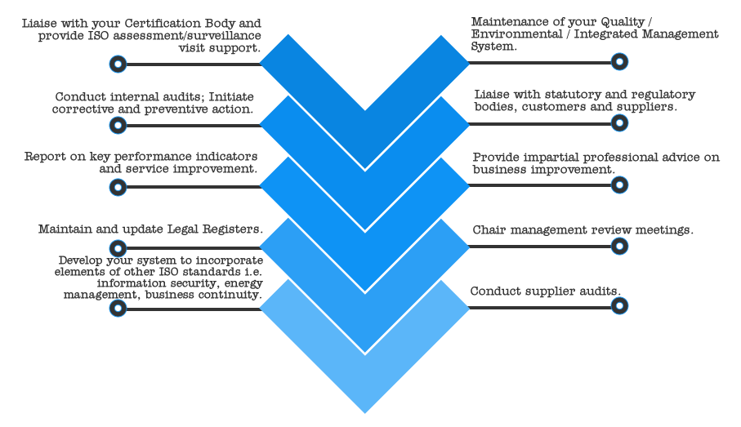
Figure 3: Elements for increasing the customer value
(Source: Strakeret al. 2015)
However, there is still scope for expanding its business opportunities through enhancing the skills so that it can gain competitive advantages over the market. The recommended strategies to increase the customer relationship for Tesco are:
- More technologies can be opted to increase their products and services: Still, they are one the multinational giants in the industry, the competition is very high. So to sustain in this industry one has to focus on more and more on technologies as for examples applications where the customers can interact with the Tesco Plc.
- Quality of satisfaction provided by the company: The more Tesco focuses on the customers, the more customer will get satisfied. So the company should try on the quality of the services they provide after the sale.
- Cost and quality of the product: In the present generation, customers always seek for the best quality and the least priced products. So to satisfy the customers and meet their needs the company needs to keep the cost lower and the quality also standard.
- Complaint management: This is one of the sectors Tesco can improve a lot in customer relationships. Many customers have complaints about many products. Each and every customer is important according to all companies. So, Tesco should always focus on every customer and give a solution or compensation for that.

Conclusion
The report has tried to attempt to gain an in-depth knowledge and understanding for engaging the customer experience over an organisation so as to present a critical understanding of the quality systems influencing the customer value. Tesco has been chosen as the organisation to derive the practical understanding of the impact of quality processes on the customer. From the study, it can be concluded that the quality processes of the organisation are proved to provide effectiveness towards gaining a competitive advantage in the market. Quality Management System takes care of the transparency in the market. Trust plays an important role to achieve success and to win a customer’s heart. Providing value things or quality products can only do this. Commitment also plays a vital role in making relations with the customers to be successful. Communication is very important in terms of Customer Relationship Marketing. Communication from a CRM point of view is defined as giving any valuable information to the customer may it be before any sale, after a sale or during the sale. More technologies can be opted to increase their products and service. Tesco is still one of the multinational giants in the industry in spite of the high competition. The organisation has been able to achieve its success through maximising its customer value by meeting the customer requirements and expectations.

References
Bhattacharya, C.B. and Sen, S., 2003. Consumer-company identification: A framework for understanding consumers’ relationships with companies. Journal of marketing, 67(2), pp.76-88.
Blázquez, M., 2014. Fashion shopping in multichannel retail: The role of technology in enhancing the customer experience. International Journal of Electronic Commerce, 18(4), pp.97-116.
Brodie, R.J., Ilic, A., Juric, B. and Hollebeek, L., 2013. Consumer engagement in a virtual brand community: An exploratory analysis. Journal of Business Research, 66(1), pp.105-114.
Cetin, G. and Dincer, F.I., 2014. Influence of customer experience on loyalty and word-of-mouth in hospitality operations. Anatolia, 25(2), pp.181-194.
Fatma, S., 2014. Antecedents and consequences of customer experience management-a literature review and research agenda. International Journal of Business and Commerce, 3(6), pp.32-49.
Green, A.G. and Hawley, G.C., 2009. Early career psychologists: Understanding, engaging, and mentoring tomorrow’s leaders. Professional Psychology: Research and Practice, 40(2), p.206.
Ibeh, K.I., Luo, Y. and Dinnie, K., 2015. E-branding strategies of internet companies: some preliminary insights from the UK. Journal of Brand Management, 12(5), pp.355-373.
Lemke, F., Clark, M. and Wilson, H., 2011. Customer experience quality: an exploration in business and consumer contexts using repertory grid technique. Journal of the Academy of Marketing Science, 39(6), pp.846-869.
Novak, T.P., Hoffman, D.L. and Yung, Y.F., 2010. Measuring the customer experience in online environments: A structural modelling approach. Marketing Science, 19(1), pp.22-42.
Pansari, A. and Kumar, V., 2017. Customer engagement: the construct, antecedents, and consequences. Journal of the Academy of Marketing Science, 45(3), pp.294-311.
Patterson, P., 2016. Retrospective: tracking the impact of communications effectiveness on client satisfaction, trust and loyalty in professional services. Journal of Services Marketing, 30(5), pp.485-489.
Puccinelli, N.M., Goodstein, R.C., Grewal, D., Price, R., Raghubir, P. and Stewart, D., 2009. Customer experience management in retailing: understanding the buying process. Journal of Retailing, 85(1), pp.15-30.
Richardson, A., 2010. Using customer journey maps to improve customer experience. Harvard Business Review, 15(1), pp.2-5.
Robson, K., Plangger, K., Kietzmann, J.H., McCarthy, I. and Pitt, L., 2016. Game on: Engaging customers and employees through gamification. Business Horizons, 59(1), pp.29-36.
Rose, S., Clark, M., Samuel, P. and Hair, N., 2012. Online customer experience in e-retailing: an empirical model of antecedents and outcomes. Journal of Retailing, 88(2), pp.308-322.
Sachdeva, I. and Goel, S., 2015. Retail store environment and customer experience: a paradigm. Journal of Fashion Marketing and Management, 19(3), pp.290-298.
Schmitt, B.H., 2010. Customer experience management: A revolutionary approach to connecting with your customers. John Wiley & Sons.
Straker, K., Wrigley, C. and Rosemann, M., 2015. The role of design in the future of digital channels: Conceptual insights and future research directions. Journal of Retailing and Consumer Services, 26, pp.133-140.
Vivek, S.D., Beatty, S.E. and Morgan, R.M., 2012. Customer engagement: Exploring customer relationships beyond purchase. Journal of marketing theory and practice, 20(2), pp.122-146.
Yakhlef, A., 2015. Customer experience within retail environments: An embodied, spatial approach. Marketing Theory, 15(4), pp.545-564.
Zablah, A.R., Bellenger, D.N. and Johnston, W.J., 2004. An evaluation of divergent perspectives on customer relationship management: Towards a common understanding of an emerging phenomenon. Industrial marketing management, 33(6), pp.475-489.

