

Cover Page

BMHP5014 Changemakers: Creativity and Value Creation
Component 1: Portfolio Report
Name: Marcia Miller
Student number: 2406690
Lecturer: Danni Dunne

Contents
Task 1 – Concept Map 3
Task 2 - Self-Reflection of Group Activity 3
Task 3 - Case Study of a UK innovation 4
Task 4 - Research Task 5
Task 5 - Podcast 6
Task 6 - NHS Leadership Framework Analysis 7
Task 7 - Self-Reflection Journal Entry 9
Reference List 9

Task 1 – Concept Map
Create a concept map that outlines the relationship between creativity, value creation, and health and social care improvement. Within the concept map explain how these concepts interact in a health and social care context (250 words).
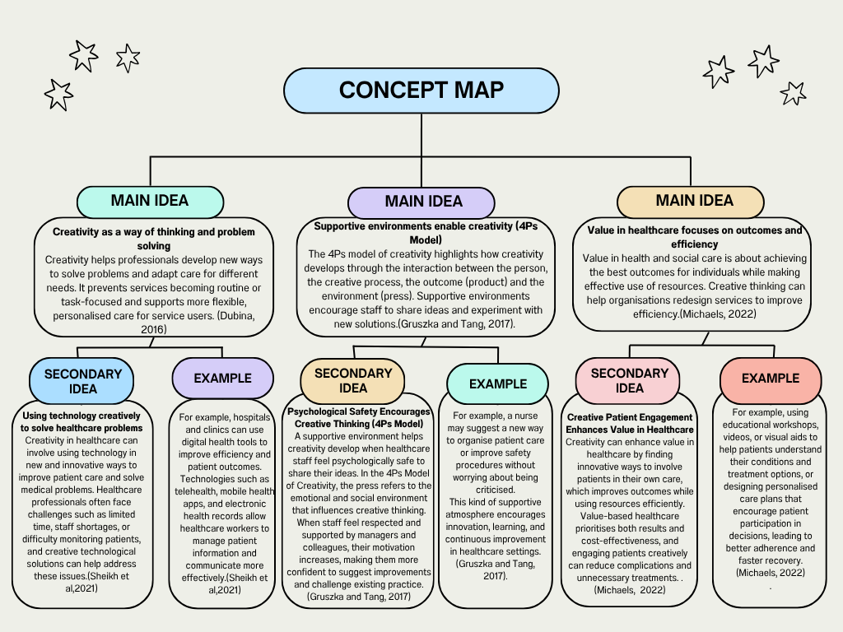

Task 2 - Self-Reflection of Group Activity
Complete a self-Reflection on the Convergent/Divergent paperclip thinking class activity using a reflective model (250 words, 1 source)
For the Paperclip activity, I worked in a small group where we had to come up with as many uses for a paperclip as possible. At first, I started thinking about everyday situations where I might realistically use one. I suggested ideas like organising papers and using it as a bookmark. As a group, we came up with about five ideas. I felt that I played a part in keeping the discussion moving, mainly by bringing up practical examples that helped the group decide which ideas would actually work and which ones might not.
At the beginning, I noticed that I was trying to make sure my ideas made sense before sharing them. I was focused on how they might be judged, which sort of limited my creativity. But once I mentioned my first idea of using a paperclip as a bookmark, I realised the group started generating ideas more freely, without judging them straight away. That’s when I started to get the concept of divergent thinking. It’s about coming up with lots of ideas without worrying about whether they’re good or not. After that, when we narrowed down our ideas, we moved into convergent thinking, where we analysed and chose the best ones.
Guilford (1956) explains that divergent thinking is about generating lots of ideas, while convergent thinking focuses on picking the best solution (Guilford, 1956; Plucker et al, 2024). This activity helped me understand how both stages work together.
Overall, the activity showed me the importance of balancing free thinking with careful decision-making.

Task 3 - Case Study of a UK innovation
Write a concise case study analysis of an innovative project or initiative within the NHS or UK social care. Focus on how creativity was used to drive change and the value it created for patients or service users (400 words, 2 sources).
The NHS launched a telemedicine initiative to improve postnatal care for new mothers. The challenge it sought to address was that many mothers find it hard to attend in-person appointments due to time, travel, or childcare issues. This initiative aimed to make postnatal care more accessible. Key stakeholders included new mothers, healthcare providers (midwives and GPs), and NHS staff.
The creative idea behind the telemedicine project was to use technology to make postnatal care more convenient. By offering video consultations, online health checks, and digital tools to track recovery, mothers could get the care they needed from the comfort of their home. This approach used existing technology, like smartphones and video calls, but applied it in a new way for postnatal care (NHS Digital, 2021).
What made this innovation stand out was how it reworked the usual service. Instead of needing to visit a healthcare centre multiple times, mothers could speak to midwives and GPs remotely. Healthcare professionals could track health progress via apps, and mothers could ask for advice whenever needed. This meant no more worrying about finding time to go to an appointment or finding someone to watch the baby, which are common barriers.
This shift was a great example of creative thinking. It solved problems like limited appointment slots and the challenge of accessing care in remote areas, while also giving mothers more flexibility. By changing the way care was delivered, it made it much easier for new mothers to get the support they needed (Nuffield Trust, 2020).
The telemedicine service created lots of value in impact for both mothers and the healthcare system. It gave mothers more access to care, especially those living in rural areas or who had a busy schedule. Mothers were much happier with the service, as they did not need to travel to appointments. For the NHS, it saved time and money by reducing the need for in-person visits. It also helped healthcare providers spot potential issues earlier, leading to better outcomes for both mothers and babies (NHS Digital, 2021).
In the end, the telemedicine project made postnatal care more accessible, flexible, and cost-effective, improving the experience for new mothers while making the healthcare system more efficient.

Task 4 - Research Task
Identify a current issue in health and social care (e.g. e.g., mental health stigma, access to care for vulnerable populations). Find two pieces of academic research (journal articles) that explain the reason for this problem. Paraphrase the findings of each article (300 words, 2 sources).
The shortage of specialist postnatal mental health professionals has become a significant issue in the UK, contributing to limited access to care for new mothers. As a result, many new mothers face delayed access to mental health support during the critical postnatal period, which can negatively affect their well-being and the development of their babies.
In this journal article, Improving Access to Perinatal Mental Health Care, Webb et al. (2022) examines the barriers to accessing perinatal mental health services and proposes strategies to improve care for new mothers. They highlight that workforce shortages in this sector are a key issue, with not enough trained professionals available to meet the growing demand for mental health support. The study also points out that many existing providers lack the specific expertise needed to address the unique challenges faced by women during and after pregnancy. One of the solutions proposed is the need for more targeted training for mental health professionals in perinatal care and a better integration of services to ensure timely access.
Next, Barriers to Accessing Disappear Health Services for Women with Perinatal Mental Illness, qualitative study. Smith et al. (2019) looked into the barriers new mothers face when trying to access specialist mental health care in the UK. It found that underfunding of maternal mental health services is a major reason why there aren’t enough specialists. In many cases, general mental health professionals are tasked with treating postnatal mothers, but they often lack the specific training needed for this. The research also pointed out that long waiting lists are a big problem, with mothers often waiting months to get the help they need. On top of this, societal stigma around mental health during pregnancy and after birth means that many women feel uncomfortable seeking help in the first place. This makes the demand for services even higher, further straining an already overburdened system. The study concludes that to improve access, there needs to be more targeted funding for maternal mental health and a better-trained workforce to meet the needs of postnatal women.

Task 5 - Podcast
Record a two-minute Podcast introducing your idea for component 2.
Marcia Miller podcast episode BMHP5014.mp3
My idea is an AI-powered tool that supports the mental health of new and expecting mums in the UK. It’s like having a 24/7 AI companion who anticipates your needs, helps with things like feeding and postpartum care, and takes some of the mental load off. The tool where they can share experiences and get real-time, tailored advice that’s aligned with NHS-approved infomation and they can also connect mums to other mums in local communities. It’s designed to fill the gap created by the shortage of mental health professionals, offering safe and personalised support whenever it's needed, without replacing medical advice.
Podcast Script:
Welcome to today’s podcast. I’m Marcia Miller, and today i am introducing an innovative solution to improve pernatal and postnatal mental health support for mothers in the UK.
Many new and expecting mothers struggle to access timely care due to a lack of mental health professionals, and delays can impact both mother and child. This AI-powered tele therapy tool aims to bridge that gap by offering 24/7, personalised support. It helps with routines like feeding and sleep while reducing mental load, providing guidance whenever it’s needed.
What sets this technology apart is its care. Instead of just reacting to concerns, the AI monitors patterns and offers tailored recommendations, managing everything from daily routines to emotional support. A key feature is the community aspect, where mothers can connect with other new mothers in local communities to help stop isolation and share experiences. The tool also includes NHS-approved information ensuring all guidance follows best practices.
Importantly, this tool is designed to complement, not replace, healthcare professionals.
A real-world example is Anya, which provides 24/7 support for new mothers with guidance on breastfeeding, sleep, and parenting for the first one thousand days of a child's life. It has supported over 40,000 mothers in the UK, with research showing improved outcomes.
Building on this success, the AI tool discussed today offers a more proactive and connected approach to maternal mental health, ensuring no mother has to navigate early parenthood alone.
Thank you for listening to today’s episode.

Task 6 - NHS Leadership Framework Analysis
Write a short summary (200 words) explaining the key components of the NHS Leadership Framework. Then, choose one component and describe (150 words) how a leader might use it to encourage creativity and improve care in the NHS (2 sources).
The NHS Leadership Framework (2011) is designed to guide leaders in improving patient care and organisational effectiveness. A core component is setting direction, where leaders create a clear, shared vision that inspires and aligns their teams. This ensures that everyone is focused on common goals and patient outcomes (NHS Leadership Academy, 2011).
Another essential component is delivering the service, which requires leaders to manage resources efficiently and ensure consistent delivery of high-quality care. Leaders must make informed decisions to ensure services operate smoothly while meeting patient needs (NHS Leadership Academy, 2011).
The framework also stresses the importance of improving the service, encouraging leaders to drive continuous improvement. Leaders must foster a culture of innovation, identifying areas for change and inspiring teams to find better ways of delivering care (NHS Leadership Academy, 2011).
Finally, working with others is fundamental to effective leadership. Strong relationships with colleagues, patients, and external stakeholders are crucial for success. Leaders should foster teamwork, open communication, and involve others in decision-making, promoting a collaborative environment (NHS Leadership Academy, 2011). These components collectively ensure patient-centred leadership and better outcomes in the NHS.
A leader in the NHS can use the setting direction component of the NHS Leadership Framework to inspire creativity and improve care by providing a clear vision for the multidisciplinary team (MDT) (Jones et al, 2022). The MDT includes professionals like doctors, nurses, allied health workers, and social workers, each offering unique perspectives on patient care. A clear, motivating direction helps foster creativity and ensures team alignment on common goals. (Jones et al, 2022)
To encourage innovation, a leader might set a vision that invites new approaches, supports novel ideas, and encourages calculated risk-taking within a supportive framework. For example, a leader could set a goal to improve mental health care by introducing a collaborative care model that integrates psychological support into primary care. This could inspire the MDT to think creatively about how to address mental health challenges in the community and develop new ways to engage patients early in their care (Jones et al, 2022).
Regular MDT meetings and case discussions allow team members to contribute ideas and suggest improvements. By promoting a shared purpose and collaboration, leaders can motivate staff to develop creative solutions, such as new care pathways or better ways to engage patients, fostering a culture of innovation and ultimately enhancing care (Jones et al, 2022).

Task 7 - Self-Reflection Journal Entry
Write a short journal entry about what you learned in this module. Focus on how your understanding of creativity and value creation withing H&SC has changed and how it has informed your professional practice (200 words).
This module has really changed how I think about creativity and value creation in health and social care.
Before, I did not fully realise how creativity could improve patient relationships and the care we provide. I used to think of creativity as something only for art or design, but exploring models that use creativity in health and social care has shown me that even small, creative changes can make a big difference. They can help us connect with patients and add real value to our work, like the 4P’s model in critical thinking. It’s about finding new ways to approach problems and improve care, rather than just sticking to the usual methods.
One task that certainly helped me was creating a content map on Canva. At first, I did not think I’d use a tool like Canva for this course, and I’d never used it before, but it opened my mind. Mapping ideas visually helped me see how creativity, value creation, and improving care all link together. I realised that creativity isn’t just about making things look good, it’s a practical way to create value and enhance patient care and relationships.
Activities like this have helped me think more flexibly and feel more confident in my approach over the seven weeks. They’ve shown me that creativity, when combined with purposeful value creation, can make care better, more effective, and more person-centred. This has definitely influenced how I approach my work in this module.

Reference List
Dubina, I.N. (2016) Creativity and the theory of innovation. Newcastle upon Tyne: Cambridge Scholars Publishing.
Gruszka, A. and Tang, M. (2017) ‘The 4P’s creativity model and its application in different fields’, in Handbook of the management of creativity and innovation: Theory and practice, pp. 51–71.
Guilford, J.P. (1956) ‘The structure of intellect’, Psychological Bulletin, 53(4), pp. 267–293.
Jones, B., Horton, T. and Home, J. (2022) Strengthening NHS management and leadership. The Health Foundation. Available at: https://www.health.org.uk (Accessed: 24 February 2023).
Michaels, J.A. (2022) ‘Value assessment frameworks: who is valuing the care in healthcare?’, Journal of Medical Ethics, 48(6), pp. 419–426.
NHS Digital (2021) Telemedicine: A new era for postnatal care. Available at: https://digital.nhs.uk (Accessed: 13 February 2026).
NHS Leadership Academy (2011) Leadership Academy Leadership Framework. Available at: https://www.nwpgmd.nhs.uk/sites/default/files/NHSLeadership-Framework.pdf (Accessed: 13 March 2026).
Nuffield Trust (2020) Virtual consultations and the future of healthcare. Available at: https://www.nuffieldtrust.org.uk (Accessed: 13 February 2026).
Plucker, J.A., Meyer, M.S. and Liu, P. (2024) ‘Divergent thinking: Early views’, in Handbook of creativity assessment, pp. 114–127.
Sheikh, A. et al. (2021) ‘Health information technology and digital innovation for national learning health and care systems’, The Lancet Digital Health, 3(6), pp. e383–e396.
Smith, M.S., Lawrence, V., Sadler, E. and Easter, A. (2019) ‘Barriers to accessing mental health services for women with perinatal mental illness: systematic review and meta-synthesis of qualitative studies in the UK’, BMJ Open, 9(1), p. e024803.
Webb, R., Ayers, S. and Shakespeare, J. (2022) ‘Improving access to perinatal mental health care’, Journal of Reproductive and Infant Psychology, 40(5), pp. 435–438.

