Unit name: Quantitative Research Method
Module code: LCDB7011
Exploring the Gender Pay Gap: Data-Driven Insights into Pay Disparities

Prepared for: Helen Lee
Written by: HUAN GENG
Student ID: 2000319
Date submitted: 7 October 2024

Abstract
This study investigates the gender pay gap within an organization, utilizing a data-driven approach to identify the factors contributing to wage disparities between male and female employees. Using a dataset of 1,000 employees sourced from Glassdoor, this analysis explores horizontal and vertical gender segregation across various roles and levels of seniority. The study adopts a regression-based methodology, incorporating descriptive statistics and multiple regression models to examine the role of job-specific factors in explaining the gender pay gap. Key findings indicate that gender segregation in both roles (horizontal) and career progression (vertical) significantly contribute to pay inequalities. Although gender is found to be a significant factor in predicting base salary according to regression models, the impact of gender diminishes when considering variables like job title and department. This suggests that wage disparities are more influenced by structural inequalities in job roles rather than direct gender-based pay discrimination. The study concludes by offering recommendations for addressing these structural barriers, such as promoting gender diversity in higher-paying roles, enhancing transparency in recruitment and promotion processes, and conducting regular pay audits. These insights provide a foundation for organizational strategies to achieve greater gender equity in the workplace.

Key words: Gender pay gap, Horizontal Segregation, Horizontal Segregation, Regression Analysis
Table of Contents
INTRODCTION 3
1.1 Overview 3
1.2 Research Objective 3
1.3 Organization of the Report 4
LITERATURE REVIEW 5
2.1 Overview of the Gender Pay Gap 5
2.1.1 Occupational Segregation 6
2.1.2 Differences in Working Hours 7
2.1.3 Educational Attainment and the Gender Pay Gap 7
2.2. Empirical Approaches to Studying the Gender Pay Gap 8
2.2.1 Regression Analysis 8
2.2.2 Oaxaca-Blinder Decomposition 9
2.3 Legal and Ethical Implications 10
2.3.1 Legal Frameworks 10
2.3.2 Ethical Considerations 11
2.4 Gaps in the Literature 12
METHODOLOGY 13
3.1 Research Questions and Hypothesis Development 13
3.2 Data Source and Variables 15
3.3 Statistical Techniques 17
3.4 Model Performance 19
FINDINGS AND DISCUSSION 22
4.1 Gender Diversity Overview 22
4.2 Independent T test 26
4.3 The Regression Analysis 29
4.4 Main Findings for the Organization 31
4.5 Discussion on Research Questions and Hypothesis 33
4.6 Ethical Concerns 35
CONCLUSION 37
5.1 summary of the Findings 37
5.2 Limitations and Ethical Concerns 38
5.3 Further Research 41
RECOMMENDATIONS 43
REFERENCES 45

INTRODCTION

1.1 Overview
Understanding labor market disparities is critical due to their wide-ranging social, economic, and psychological impacts on individuals and society(Biegert, 2019). One of the most researched forms of employment inequality is the gender pay gap, which has attracted significant global attention from researchers and policymakers alike(Sampson, 2020). In recent decades, countries like the UK have made progress in reducing the gender pay gap. However, recent data indicates that these improvements have slowed, with the gap in the UK now surpassing both OECD and EU averages(Arabadjieva, 2021). Based on the latest statistics released by the UK Office for National Statistics in April 2023, there has been a marginal rise in the disparity between full-time male and female employees' median hourly wages, with women earning approximately 7.7% less than their male counterparts. This represents a slight increase compared to the data reported in 2022.When all employees, including part-time workers, are considered, the gap widens further, with women earning 14.3% less than men (ONS, 2023). The disparity is particularly evident in higher-paying sectors and among women aged 40 and above, where the wage gap reaches 14.2% (ONS, 2023). These figures underscore the persistent and entrenched nature of gender-based pay disparities across various sectors and age groups.

1.2 Research Objective
The report uses the Glassdoor data to examine how job related and demographic factors contribute to wage disparities. The objective is to provide empirical insights and offer practical recommendations for businesses and policymakers on how to address and reduce gender-based pay differences, particularly in sectors where the disparities are most pronounced.

1.3 Organization of the Report
Report follows the academic report structure:
Section 2 provides an in-depth review of the existing literature on the gender pay gap, examining its root causes, trends, and the key methodological approaches used in prior studies. Section 3 details the methodology employed, including an explanation of the data sources and the statistical methods used in the analysis. Section 4 presents the findings from the analysis, along with their implications for businesses operating in the UK. Section 5 concludes the report, reflecting on the overall significance of the analysis and proposing potential areas for further research. Section 6 offers targeted recommendations aimed at addressing and reducing the gender pay gap.

LITERATURE REVIEW
The gender pay gap remains a widespread challenge in global labor markets(Litman et al., 2020). Despite advancements in education, labor participation, and equal pay legislation, women continue to earn less than men across nearly all sectors and job roles(Budig, Lim and Hodges, 2021). The disparity in pay between genders is commonly quantified by comparing men's earnings, and it encompasses factors beyond mere labor market disparities. It also stems from the influence of social and cultural norms that shape women’s career decisions(Ciminelli, Schwellnus and Stadler, 2021). Several factors contribute to this gap, including gender-based job segregation, differences in working hours, educational choices, and the underappreciation of work predominantly done by women(Blau and Kahn, 2017). This review examines the root causes of the gender pay gap, the methods employed in analyzing it, and the legal and ethical frameworks designed to address it. Furthermore, it highlights gaps in the existing literature and suggests areas for further study.

2.1 Overview of the Gender Pay Gap
The wage gap between genders is influenced by a variety of interrelated and cumulative factors. Key contributors include occupational segregation, working hour differences, educational attainment, and the societal undervaluation of female-dominated professions(Blau and Kahn, 2017).

2.1.1 Occupational Segregation
Occupational segregation describes the division of men and women into distinct sectors or job roles that often carry varying levels of pay and prestige(Borrowman and Klasen, 2020). Women are often seen working in lower-paid positions such as nursing assistants, and even within same industry there is vertical segregation, with men more commonly holding higher-status, better-paying managerial or executive positions (ONS, 2023).

This situation is amplified by societal and cultural expectations surrounding gender roles. For instance, women are frequently anticipated to take on caregiving responsibilities, pushing them toward part-time, flexible, or lower-wage jobs that accommodate family obligations(Landivar, Woods and Livingston, 2022). Although women constitute a large portion of the workforce, men still dominate the higher-paying, senior positions(Brown, 2019). Moreover, the work primarily performed by women is often undervalued, which further perpetuates gender wage disparities. Fields such as nursing, teaching, and caregiving are socially important but often lower paid compared to male-dominated sectors that are perceived as more specialized or valuable, like finance and technology(Müller, 2019). This societal undervaluation of female-dominated industries perpetuates income inequality across sectors(O'Connor, 2020).

2.1.2 Differences in Working Hours
The disparity in remuneration was also attributed to variations in the total number of hours worked. Women tend to be more inclined to work part-time or take career breaks, particularly for caregiving responsibilities like childcare and eldercare (Pech, Klainot-Hess and Norris, 2021). These interruptions in their careers have long-term impacts on earnings potential and career progression, a phenomenon often referred to as the “motherhood penalty”(Yu and Hara, 2021).

Research shows that the gender pay gap widens significantly after women have children. This is particularly pronounced in high-paying professions, where extended career breaks can have a more lasting impact on promotion opportunities and wage growth(Querejeta and Bucheli, 2023). In contrast, males tend to engage in full-time employment and willingly undertake additional working hours, thereby intensifying the existing income gaps(Munsch, O'Connor and Fisk, 2024). The issue has been further emphasized by the ongoing COVID-19 pandemic as women have disproportionately borne the burden of additional caregiving responsibilities, leading to reduced working hours and increased career interruptions(Collins et al., 2021). This has exacerbated pre-existing inequalities and highlighted the need for more supportive workplace policies, such as flexible working arrangements and paid parental leave, to minimize the adverse effects on women's income(Corekcioglu, Francesconi and Kunze, 2020).

2.1.3 Educational Attainment and the Gender Pay Gap
Despite the increased educational attainment of women, surpassing that of men in many developed countries, it has not proven sufficient to eliminate the gender pay gap(Forth, 2023). This gap is partly explained by the different fields of study that men and women choose. Men are more inclined to pursue degrees in higher-paying areas such as STEM (Science, Technology, Engineering, and Mathematics), while women tend to opt for disciplines like social sciences, education, and healthcare, which typically offer lower wages(Blau and Kahn, 2017).

Even within the same educational qualifications, men tend to occupy higher-paying roles. For example, Ceci and Williams (2015) found that in STEM fields, women are underrepresented in the most lucrative specializations, such as computer science and engineering. Moreover, women are often subject to gender biases and stereotypes that limit their opportunities for advancement, even in fields where they are equally qualified(Gangwani and Kolokythas, 2019). Additionally, research has indicated that despite women entering the labor market with comparable levels of education and experience as men, their potential earnings gradually decline over time due to career interruptions and a slower rate of promotion(Kucharski and Rutkowska, 2021). This implies that although education plays a crucial role in mitigating the gender pay gap, it alone cannot completely eradicate the existing disparities.

2.2. Empirical Approaches to Studying the Gender Pay Gap

2.2.1 Regression Analysis
Regression analysis enables researchers to isolate the specific effect of gender on wages while accounting for other influential variables such as education, work experience, occupation, and hours worked. By controlling for these confounding factors, regression models can more accurately estimate the portion of the gender pay gap directly attributable to gender itself, independent of other variables(Roshchin and Yemelina, 2021). However, a study by Hansen, Rand and Win (2020), it was found through regression analysis that even after accounting for factors such as education, experience, and occupation, a significant portion of the gender pay gap remains unexplained. This suggests that implicit biases or discriminatory practices may still be at play, contributing to wage disparities that cannot be attributed to observable qualifications or job-related factors.

2.2.2 Oaxaca-Blinder Decomposition
The Oaxaca-Blinder decomposition is a commonly used method for analyzing wage differences. This approach can be elucidated by observable factors such as education and work experience, alongside an unexplained component often associated with discrimination(Słoczyński, 2020).

Jewell, Razzu and Singleton (2020) employed this approach to examine the gender wage disparity in different sectors and discovered that a considerable proportion of the discrepancy remains unaccounted for, even after factoring in variances in educational background, professional experience, and job category. This unexplained portion is often interpreted as evidence of discrimination or structural barriers that prevent women from reaching the same earnings potential as men. Recent studies have applied more advanced forms of this decomposition method to analyze the gender pay gap across different periods. While the gap has decreased in some sectors, it remains prevalent in others, especially in high-paying industries like finance and technology(Roshchin and Yemelina, 2021).

2.3 Legal and Ethical Implications

2.3.1 Legal Frameworks
The UK introduced the Equal Pay Act in 1970, which mandated equal pay for equal work as a foundational step towards reducing wage disparities. This legislation was further reinforced by the Equality Act of 2010, which introduced stricter measures, such as mandatory pay transparency for companies with over 250 employees(Benedí Lahuerta, Rejchrt and Patrick, 2023). These regulations require businesses to disclose their pay structures and provide transparent gender pay gap data, helping to drive efforts aimed at reducing gender-based wage inequalities

While these legislations have a significant meaning in enhancing awareness regarding the gender pay gap, challenges persist in terms of enforcement. Although many companies comply with the obligation to disclose their pay data, they often fall short in taking substantial measures to address the underlying causes contributing to this disparity(Raghunandan and Rajgopal, 2021). This has led to calls for more robust enforcement mechanisms and the introduction of penalties for companies that fail to demonstrate progress in closing the gap.

2.3.2 Ethical Considerations
From an ethical standpoint, the gender pay gap raises critical questions about fairness and justice in the workplace. According to Equity Theory(Adams, 1965), employees expect to be compensated fairly in relation to their contributions and the compensation of others. When this expectation is unmet, it often results in dissatisfaction, lower productivity, and increased turnover rates(Blundell, 2021). Despite decades of legal reforms aimed at addressing the issue, the persistent existence of the gender pay gap signifies a failure on the part of numerous organizations to meet this fundamental ethical standard(Raghunandan and Rajgopal, 2021). Research shows that while gender pay gap reporting has led to increased transparency, it has not consistently resulted in meaningful action to close the gap, further highlighting the ethical shortcomings of many companies(Sharkey, Pontikes and Hsu, 2022).

Public awareness campaigns, such as “Equal PayDay”, have significantly contributed to raising awareness about the ethical issues surrounding the gender pay gap. These movements have put pressure on companies to take greater responsibility in ensuring pay transparency and fairness, highlighting not only the internal implications for businesses but also the broader societal consequences. For instance, they emphasize how the gender pay gap undermines women's economic independence and has long-term negative effects on their retirement security, as unequal pay throughout a woman's career can result in diminished lifetime earnings and lower pension savings(Bosch and Barit, 2020). Research has shown that gender pay gaps can persist even in sectors with high transparency, indicating that awareness alone is insufficient to fully close the gap; companies must take concrete, systemic actions to address it(Olarewaju, Gideon and Koay, 2023). Furthermore, evidence suggests that while public awareness campaigns are effective in sparking discussions, they must be accompanied by legal frameworks and organizational accountability to enact lasting change(Mwaseba, Arthur and Mnasi, 2023).

2.4 Gaps in the Literature
A key oversight is the lack of focus on intersectionality. Many gender pay gap studies emphasize gender alone, overlooking the ways in which factors like race, sexual orientation, and socioeconomic status further influence wage inequalities.

Another gap in the literature is the limited use of new data sources to study the gender pay gap. Most existing research relies on traditional labor market data, which may not capture the full complexity of the issue. Newer data sources, such as crowdsourced platforms like Glassdoor, provide employee-reported data that allows for more granular analysis of pay disparities across companies, industries, and job roles(Penz et al., 2023).

METHODOLOGY

3.1 Research Questions and Hypothesis Development
Based on the findings from existing literature and the organizational context, two key research questions and Hypothesis have been formulated:
Research questions:
- How does gender segregation, both horizontal and vertical, contribute to the gender pay gap within the organization? | - Does controlling for job-related factors such as education, seniority, and department reduce the observed gender pay gap?
Hypothesis development:
Number | Related literature(concepts)
- Horizontal and vertical gender segregation significantly contribute to the gender pay gap, with men more concentrated in higher-paying technical and managerial roles, while women are underrepresented in these positions. | This hypothesis aligns with the concept of occupational segregation as a major driver of wage inequality. It assumes that gender segregation in roles and career progression is a key determinant of the gender pay gap, particularly in organizations where recruitment and promotion processes lack transparency(Adeleken and Bussin, 2022).
- After controlling education, seniority, and department, the gender pay gap will be reduced, indicating that these job-related factors explain a substantial portion of the observed wage disparities. | This hypothesis builds on the idea that while controlling for education, seniority, and department can account for some of the wage disparities, a residual pay gap may persist, which can be attributed to gender-based discrimination or biases in the workplace(Castellano, Punzo and Rocca, 2018). This aligns with studies that suggest that structural factors alone may not fully explain gender pay disparities, and that informal practices such as "social cloning"(Delauzun, 2020)and unequal access to career development opportunities contribute to the gender wage gap.
Table 3-1: Research Questions and Hypotheses Development

3.2 Data Source and Variables
The dataset utilized for this research was sourced from Glassdoor, a widely recognized platform that aggregates employee-generated data on wages, bonuses, and job roles across various industries. This dataset provides valuable insights into the structure of salaries within organizations, with a focus on pay differentials and workforce demographics. The dataset selected for this study includes a sample of 1,000 employees working in the UK, covering a broad range of industries and professional sectors. It concludes essential variables required for a robust analysis of the gender pay gap, such as job title, department, seniority, job performance, educational qualifications, base salary, and bonus pay. In addition to these work-related variables, demographic factors such as gender and age are included to facilitate a nuanced understanding of the potential disparities between male and female employees.

After undergoing a rigorous data cleansing process, the dataset was prepared meticulously to ensure the robustness and credibility of the statistical analysis findings. This process involved addressing missing data, identifying and handling outliers, and converting non-numeric variables into formats suitable for statistical analysis. For example, categorical variables such as job title and department were transformed into dummy variables, which is a standard procedure when incorporating categorical predictors into regression models(Hosmer, Jovanovic and Lemeshow, 1989). This step is essential to avoid the "dummy variable trap" and ensure accurate interpretation of regression coefficients(Stock and Watson, 2014).

To address missing data, cases with incomplete information were either removed or imputed, depending on the proportion and importance of the missing data to the overall analysis. Additionally, the dataset was examined for outliers that could potentially skew the results, particularly in terms of extreme salary values. Outliers were identified based on statistical rules such as interquartile range (IQR) and standard deviation thresholds, and appropriate steps were taken to mitigate their impact, either through transformation or exclusion(Fields et al., 2015).

The analysis encompasses variables that can be classified as dependent and independent. In this study, the focus is on the base salary of employees as the dependent variable, which serves as a continuous measure to evaluate wage inequality. Additionally, bonus pay is analyzed separately to determine whether gender disparities exist in this aspect of compensation. The key independent variables are gender, job title (categorical, converted into dummy variables), department (categorical, converted into dummy variables), seniority level (ordinal), and educational qualifications (ordinal, ranging from high school diploma to PhD).

3.3 Statistical Techniques
This study utilizes Glassdoor's gender pay-gap data to conduct an empirical analysis, incorporating a sample of 1,000 workers from the United Kingdom. To analyze the data, a range of statistical techniques are applied. First, bar charts are used to visualize gender diversity across job titles, education levels, and seniority categories, providing an overview of how men and women are distributed across different business functions. Subsequently, the mean base salary and bonus pay are computed for each gender, followed by conducting statistical tests to evaluate the statistical significance of observed disparities between male and female employees.

If a gender pay gap is identified, a linear regression analysis is then conducted to estimate the magnitude of this gap and to investigate how job-related and demographic factors contribute to wage disparities. Categorical variables such as job title, gender, education, and department are transformed into dummy variables for inclusion in the regression models. For instance, the gender variable is coded as a binary indicator (1 for male and 0 for female). The regression coefficient for this variable provides a quantitative estimate of the gender pay gap, controlling for factors like job performance, years of experience, and the employee’s department.

Descriptive Statistics:
The initial use of descriptive statistics is to provide a comprehensive overview of the dataset. summarizing key features such as central tendencies and distributions. Measures like the mean, median, and mode are calculated for both base salary and bonus compensation across genders to offer a clear picture of how pay is distributed between male and female employees. These statistics will indicate whether pay disparities exist in aggregate form and will guide the subsequent inferential analyses.

In addition to numeric summaries, bar charts and other visual tools are employed to illustrate the gender distribution across different departments, job titles, education levels, and seniority tiers. The visualization of patterns related to gender-based segregation is of great significance, as it encompasses the distribution of males and females across distinct occupational roles as well as hierarchical positions(Gedikli, 2020). These visualizations provide preliminary insights into the structural dynamics of gender representation in the organization.

Regression Analysis:
If statistically significant gender pay gaps are detected through inferential tests, multiple regression analysis is performed to quantify these disparities and explore the contributing factors. Regression analysis trying to estimate the extent of the gender pay gap while controlling for various job-related and demographic variables such as job title, department, education, and seniority level.

By applying multiple regression models, the analysis seeks to control for potential confounders and isolate the independent effect of gender on pay. This approach ensures that any observed wage disparities are not simply the result of differing job roles, educational backgrounds, or seniority levels but are attributable to gender itself. The statistical significance of each regression coefficient is assessed using p-values and confidence intervals, ensuring the robustness and reliability of the findings(Cotilla and Campos-Soria, 2021).

3.4 Model Performance
In this study, multiple statistical models will be evaluated using standard metrics to assess their performance in explaining the gender pay gap within the organization. The following methods will be used to determine the robustness and reliability of the models:

Adjusted R-squared
The Adjusted R-squared value assesses the goodness-of-fit of regression models. Unlike regular R-squared, which increases with the introduction of more variables regardless of their relevance, Adjusted R-squared accounts for unnecessary predictors. This makes it a more reliable metric when comparing models with varying numbers of independent variables(Kutner et al., 2005). This measure will help determine how well the independent variables (e.g., gender, seniority, department, job title) explain the variance in base salary, accounting for the complexity of the models.

P-values
The p-value of each independent variable will be analyzed to determine statistical significance. The variable is considered to have a significant impact on the dependent variable (base salary) at a 5% significance level when the p-value falls below 0.05(Andrade, 2019). The key focus will be on the p-value associated with gender to assess whether it is a significant predictor of salary after accounting for factors such as seniority, department, and education.

F-statistics
The F-statistic is used to measure the overall relevance of a regression model by testing whether the independent variables, taken together, significantly affect the dependent variable. A larger F-statistic, combined with a low p-value, indicates a strong model fit, showing that the independent variables together explain a substantial part of the variation in base salary(Stock and Watson, 2014).

Model Comparison
Multiple regression models will be developed, each progressively adding additional control variables such as department, education, and job title. These models will be compared based on their Adjusted R-squared values, F-statistics, and p-values. The model that best balances explanatory power and simplicity, without introducing multicollinearity, will be selected as the preferred model for analyzing the gender pay gap.

FINDINGS AND DISCUSSION

4.1 Gender Diversity Overview
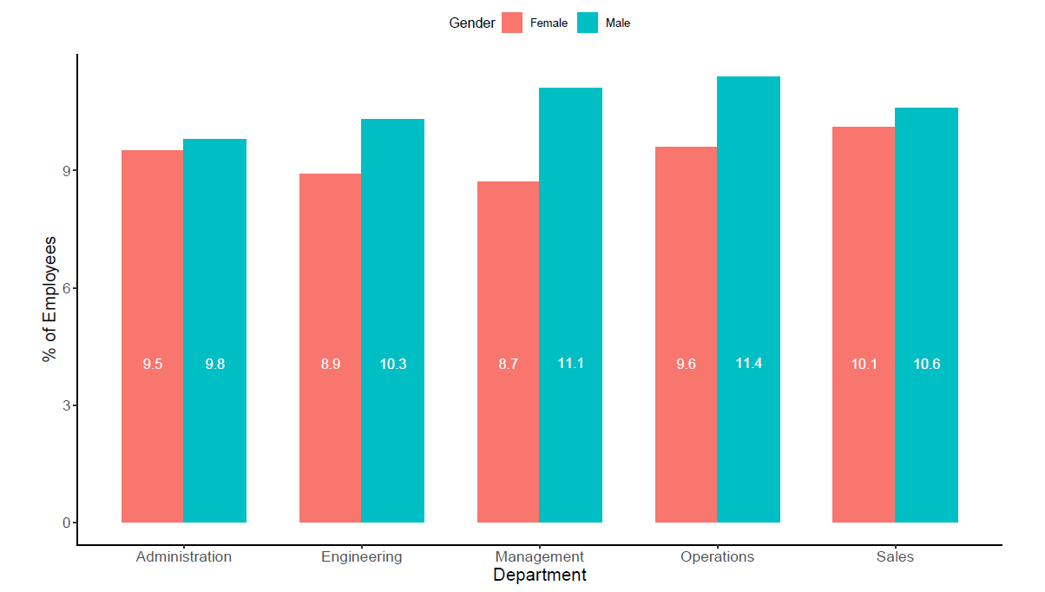
Figure 4-1: Dender Diversity in different department

The graphical representation in Figure 4-1 illustrates the dispersion of employees, categorized by gender, across different departments within the organization. In total, there are 532 men and 468 women, highlighting an overall gender disparity within the organization. This imbalance is evident across individual departments, where male workers outnumber their female counterparts in every business function.

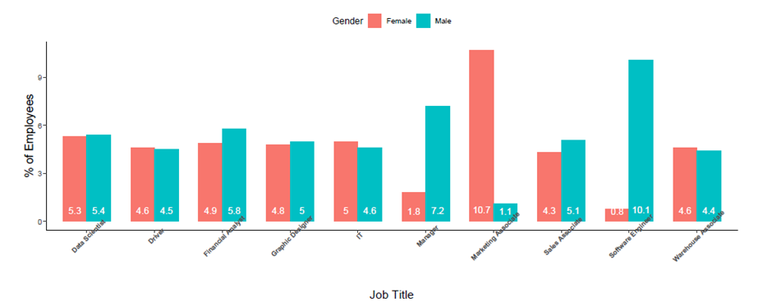
Figure 4-2: Job Title Across Gender

The dataset reveals a striking gender imbalance in job roles, with marketing associates being predominantly female, while software engineering positions are overwhelmingly filled by males. This indicates a clear pattern of occupational gender segregation within these fields. Another noteworthy observation is the underrepresentation of women in managerial roles within the organization. Specifically, 9% of the employees hold managerial positions, out of which 72 are men and only 18 are women. This highlights the significant gender disparity at the management level.

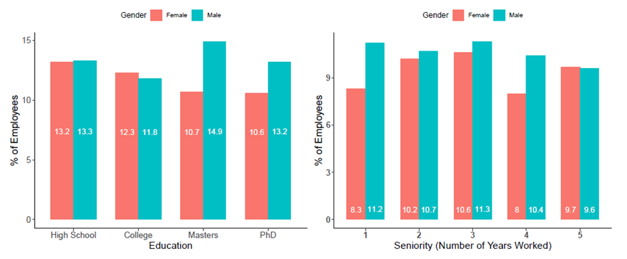
Figure 4-3: Gender Diversity Between Education and Seniority

Figure 4-3 illustrates the distribution of gender across various levels of educational attainment and seniority. The data suggests that a larger proportion of men hold advanced qualifications, such as master’s and PhD degrees, indicating that more males are engaged in professions that require higher educational qualifications, like software engineering. Conversely, the data shows a slightly higher percentage of women with a college degree compared to their male counterparts. Additionally, the figure reveals that, apart from the highest seniority tier, men generally occupy more senior positions within the workforce than women.

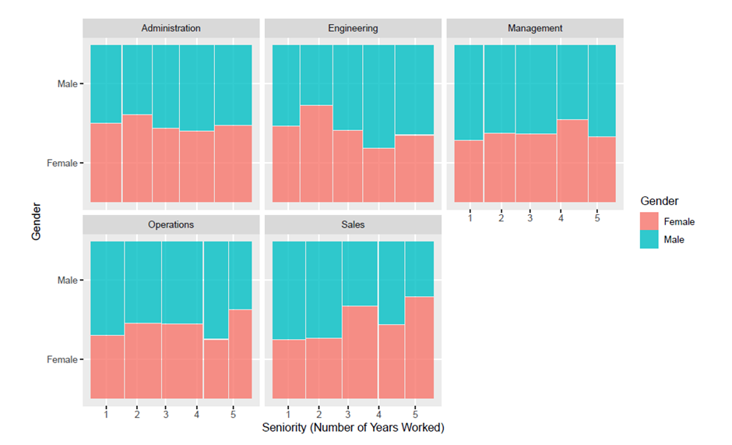
Figure 4-4: Gender Diversity Between Department and Seniority

Figure 4-4 demonstrates gender diversity across various departments and seniority levels. It is notable that men not only dominate managerial roles but also occupy more senior positions compared to women. In the operations department, a comparable trend is observed, albeit with a higher representation of experienced female employees who have been with the organization for more than five years. In contrast, women in the sales department seem to hold higher-ranking positions compared to their male counterparts.

4.2 Independent T test
Table 4-1: Gender-based differences in Average base pay

Table 4-2: Gender-based differences in Average bonus pay
As shown in Table 4-1, the average base salary for male employees is $98,457.55, while female employees have an average base salary of $89,942.82. This results in a difference of $8,514.73, with men earning more on average than their female counterparts. The t-test results, performed under both equal and unequal variance assumptions, confirm that this difference in base salary is statistically significant.

In contrast, Table 4-2 reveals that the average bonus for male employees is $6,461.13, while female employees receive a slightly higher average bonus of $6,474.01. However, the t-test conducted on independent samples does not reveal any statistically significant disparity in bonus pay between male and female employees, suggesting that gender has no impact on bonus compensation.

4.3 The Regression Analysis
Table 4-3: Gender Wage Gap Analysis
As shown in Table 4-3, four regression models were developed. Model 1 serves as the baseline, incorporating only age, seniority, performance, and gender. The subsequent models expand upon this by adding department (Model 2), education (Model 3), and job title (Model 4) as dummy variables. This multi-model approach was employed to address concerns about multicollinearity and the dummy variable trap, issues common when using many categorical variables(Stock and Watson, 2014).

The male dummy variable's coefficient in each model quantifies the pay disparity attributed to gender within the organization. In the first three models, this coefficient shows statistical significance at the 1% level. The projected gender wage disparity is £10,187.43 in Model 1, £10,149.72 in Model 2, and £9,778.02 in Model 3. Additionally, the highest average base salary is observed among employees in the sales department, with a coefficient of £6,178.64, using administration as the baseline category. Model 3 also shows an education premium, where employees holding a PhD or master's degree earn £8,073.01 and £6,128.69 more, respectively, than those with only a high school diploma.

A notable observation in Model 4 is that, after controlling for job roles, the gender pay gap becomes statistically insignificant. This suggests that the observed wage differences are more attributable to job-specific factors than to gender. In Model 4, drivers serve as the reference category for comparison. Managers are the highest earners in the organization, with an average base salary £35,604.46 higher than drivers. Software engineers also rank high, earning £17,134.55 more than drivers on average. Conversely, marketing associates are among the lowest earners, with an average income £12,675.40 lower than drivers.

4.4 Main Findings for the Organization
A significant insight from the statistical results points to a marked gender-based division in job roles within the company. As highlighted by Meulders et al. (2010), gender segregation is the phenomenon where men and women are unevenly distributed across various sectors and positions. In this company, nearly all software engineer roles are held by male employees, while female employees predominantly occupy marketing associate positions. This exemplifies horizontal segregation, where men and women are concentrated in distinct roles, with males in software engineering and females in marketing(Meulders, 2010).

Additionally, the analysis highlights significant vertical segregation. As described by Eurofound (2022), vertical segregation pertains to the restricted chances of advancement in a specific organization or industry for individuals of a certain gender. This restriction often results in gender inequalities, including pay disparities. Figure 4-2 shows that the managerial positions in the organization are overwhelmingly occupied by men, providing strong evidence of vertical segregation, as women seem to face more barriers in ascending to higher-level roles.

Both horizontal and vertical segregation contribute significantly to the organization’s gender pay gap. To address this, the company must work toward reducing the concentration of women in lower-paying roles, such as marketing associates, and men in higher-paying roles, like software engineering. Furthermore, expanding career advancement opportunities for women is crucial to increasing their representation in management positions. Organizational change is necessary to reduce gender bias in both recruitment and promotion processes.

Moratti (2020) highlights that women often face disadvantages in companies where recruitment, promotion, and salary negotiations lack formal structures and transparency. Without clear criteria, decisions may be influenced by "social cloning", where those in power favor individuals like themselves for promotion or wage increases. Moreover, informal networks, often male-dominated, can further hinder women’s access to advancement opportunities. Implementing formal human resource procedures is essential for change, including developing clear and objective criteria for recruitment and promotion(Lalanne and Seabright, 2022).

Additionally, providing clear information on salary ranges may help to reduce gender disparities during wage negotiations. Bowles et al. (2005) found that men typically achieve better outcomes in negotiations, but when both genders are given transparent information about salary ranges, this advantage disappears. This approach is expected to remove some barriers to women’s progression in the workplace.

4.5 Discussion on Research Questions and Hypothesis
Research Question 1: How do horizontal and vertical gender segregation contribute to the gender pay gap within the organization?
The descriptive analysis, as reflected in Figure 4-1 and Figure 4-2, clearly indicates the presence of horizontal segregation, with male employees dominating roles such as software engineers, while female employees are predominantly marketing associates. This occupational segregation is significant in driving the gender wage gap, as highlighted by the differences in average base salaries across job roles. In addition, the presence of vertical segregation can be observed through the inadequate representation of females in managerial roles, as shown in Figure 4-3 and Figure 4-4. With only 18 out of 90 managerial roles occupied by women, there are barriers preventing women from advancing to senior positions.

These findings align with Hypothesis 1, which suggested that gender segregation—both horizontal and vertical—would significantly contribute to the gender pay gap. The regression models, particularly Model 4, show that the gender pay gap becomes statistically insignificant once job title is controlled for, indicating that job roles are key in explaining the observed pay disparities.

Research Question 2: Does controlling job-related factors such as education, seniority, and department diminish the observed gender pay gap?
The findings from the regression analysis provide evidence that job-related variables significantly contribute to elucidating the disparity in wages between genders. As demonstrated in Model 3 and Model 4, controlling for education, department, and job title progressively reduces the effect of gender on base salary. In the earlier models (Model 1), the coefficient for the male variable was statistically significant, with male employees earning approximately £10,187 more on average. However, after controlling for job-specific factors, the gender variable becomes statistically insignificant, as shown in Model 4, where the difference drops to £1,132 and is no longer significant (p = 0.137).

This outcome aligns with Hypothesis 2, which posited that controlling for education, seniority, and department would reduce the gender pay gap. The findings validate that a considerable proportion of the wage disparity can be accounted for by variances in job responsibilities and other work-related elements, rather than any form of gender bias in compensation policies.

The findings from the descriptive and regression analyses provide substantial support for both hypotheses. Horizontal and vertical segregation play a critical role in shaping the gender pay gap within the organization, and controlling for job-related factors significantly reduces the observed disparities. These results emphasize the need to address structural inequalities, such as unequal access to higher-paying roles and limited career progression opportunities for women, to close the gender pay gap.

4.6 Ethical Concerns
This research does not require participants to engage in activities outside of their normal routines, nor does it involve any behaviors that could be considered intrusive to their personal privacy. Consequently, employee consent or authorization is not necessary for this study. The dataset is fully anonymized, containing no identifying details that could link the information back to individual employees. The researcher will securely store the data on both the university's cloud system and their personal computer, with password protection applied to ensure its safety. Moreover, the researcher will not share the dataset with any third party without prior approval from the course leader or the university. In conducting the analysis, the researcher has adhered to academic standards and regulatory guidelines. The dataset remains unaltered to fit any predetermined results, ensuring that any replication of the analytical approach used in this study would yield the same outcomes.

CONCLUSION

5.1 summary of the Findings
This study presents a comprehensive analysis of the gender pay gap within the organization, exploring the impact of horizontal and vertical gender segregation on wage disparities. Descriptive statistics show a clear pattern of horizontal segregation, where male employees are disproportionately represented in higher-paying technical roles, such as software engineering, while female employees are concentrated in lower-paying roles like marketing associates. These findings align with prior studies that highlights gender-based occupational segregation as a primary factor driving wage disparities(Finley, Hall and Marino, 2022).

Moreover, the examination uncovered evidence of vertical segregation, with a conspicuous underrepresentation of women in managerial positions. Despite constituting a significant proportion of the labor force, women hold significantly fewer leadership roles, thereby impeding their opportunities for career advancement and perpetuating persistent wage disparities. This aligns with studies suggesting that structural barriers, including limited career advancement opportunities for women, perpetuate gender wage gaps in organizations(Cortes, Oliveira and Salomons, 2020).

The regression analysis further supports the notion that gender is a significant determinant of base salary until job-related factors are controlled for. In Model 1, which does not include job-specific variables, the male coefficient indicates a statistically significant pay difference, with men earning considerably more than women on average. However, as Models 2 through 4 progressively control for variables such as department, education, and job title, the effect of gender diminishes, becoming statistically insignificant in Model 4. This suggests that job-specific factors, such as occupational role and level of education, largely explain the gender pay gap within the organization, which argues while direct gender discrimination in pay-setting has decreased, structural inequalities in job roles and career paths continue to drive wage disparities.

5.2 Limitations and Ethical Concerns
While this study provides valuable insights into the gender pay gap within the organization, several limitations should be acknowledged. The first limitation concerns the reliance on secondary data from Glassdoor, which may introduce self-reporting bias. Employees may have inaccurately reported their salaries, either intentionally or unintentionally, which could affect the validity of the wage data. Self-reported data often lacks the rigor and verification that accompanies primary data collection methods, and the resulting analysis may therefore not fully capture the actual salary structures within the organization(Gideon et al., 2019). This limitation is particularly relevant when exploring sensitive topics like wage inequality, where respondents may be influenced by social desirability bias.

Another limitation is the inability of the dataset to account for non-monetary compensation or performance-based bonuses that may vary by gender. While the regression models controlled for base salary and department-specific factors, they did not include more nuanced aspects of compensation, such as stock options, long-term incentives, or performance reviews, which are often key drivers of overall compensation. Excluding these variables from the analysis may overlook potential areas of disparity that contribute to the broader wage gap(Hirsch and Lentge, 2022).

Also, the analysis did not control for personal characteristics such as hours worked, family responsibilities, or preferences for flexible work arrangements. Research has shown that these factors can significantly impact career progression and pay disparities, particularly for women(Bear, 2021). Without access to such variables, the current study may not fully capture the complex interplay between gender, work-life balance, and compensation.

Ethical Concerns
This study adhered to ethical guidelines for the use of secondary data, ensuring that all data remained fully anonymized and that no personally identifiable information was included. The Glassdoor dataset was obtained from publicly available sources, which reduces the risk of privacy violations. However, it is essential to consider the ethical implications of using self-reported data. Since employees voluntarily submit salary information, there is a risk that their motivations for reporting may not align with the goals of the research, potentially introducing bias into the dataset(Tempini, 2023).

Furthermore, the analysis must be conducted with transparency and honesty. It is critical to avoid manipulating data to achieve desired results or conclusions, particularly when dealing with sensitive issues like gender inequality. The researcher must take care to present findings objectively, while also acknowledging potential limitations in the data and methodology(Hodgins and O’Connor, 2021). In line with the principles of academic integrity, the study-maintained transparency throughout the analytical process and did not engage in any practices that could mislead stakeholders or participants.

Lastly, there are broader ethical considerations related to the use of such findings in organizational settings. While the study highlights gender disparities, it is important that organizations use this data to promote equity rather than reinforce stereotypes. Any recommendations derived from the analysis should aim to foster inclusivity and equal opportunity, aligning with best practices in human resources and ethical decision-making(Cho et al., 2021).

5.3 Further Research
This study offers valuable insights into the gender pay gap, yet several areas warrant further exploration to deepen understanding. Future research should extend to non-monetary compensation and performance metrics, such as stock options or long-term incentives, which can provide a fuller picture of total compensation disparities between genders(Hirsch and Lentge, 2022). Moreover, an investigation into negotiation behavior and the influence of gender norms on wage negotiations would facilitate the identification of how these factors contribute to disparities in pay(Reyes, Dinh and Salas, 2021).

One important area for future investigation involves the examination of intersectionality, which examines how variables such as race, age, and ethnicity intersect with gender to impact discrepancies in wages. This would enable a more nuanced understanding of how multiple forms of inequality affect pay gaps(Budig, Lim and Hodges, 2021). Longitudinal studies tracking the effectiveness of equity initiatives over time are also crucial to evaluate whether diversity interventions lead to sustained improvements in pay equity(Wright et al., 2022).

Cross-industry and cross-country comparisons would offer broader insights into the structural drivers of wage inequality, while investigating how organizational culture and leadership impact gender disparities could inform more inclusive practices(Borrowman and Klasen, 2020).

RECOMMENDATIONS
Establish Transparent Recruitment and Promotion Processes
The organization should develop and implement transparent recruitment and promotion procedures to reduce gender bias. A formalized hiring process with clear criteria for job roles and career advancement will help ensure that all employees, regardless of gender, are evaluated based on merit. The organization should conduct regular pay equity audits to monitor compensation across departments and roles, identifying potential gender-based discrepancies. Establishing pay transparency, where salary ranges are disclosed during recruitment and performance reviews, would reduce negotiation-related disparities and ensure fairness in pay-setting.

Address Horizontal Segregation by Encouraging Gender Diversity in High-Paying Roles
To address the issue of horizontal segregation contributing to gender pay inequality, companies can implement several targeted strategies in an integrated approach. First, they should work to increase the representation of women in traditionally male-dominated fields through recruitment initiatives, mentorship programs, and partnerships with educational institutions. This will encourage more women to pursue careers in these sectors. Second, companies can establish leadership development programs specifically for women, providing training and mentorship to help them acquire the necessary skills for advancement. Finally, organizations should regularly review their promotion systems to identify and eliminate any potential barriers that may hinder women's progression into management roles. By combining these efforts, businesses can create a more equitable and inclusive workplace, helping to close the gender pay gap.

Foster an Inclusive Work Culture
Companies must stay aligned with contemporary values by fostering an inclusive workplace culture. This involves promoting diversity in work teams and ensuring that the workplace environment supports inclusion. Regular leadership training is essential, particularly for those in positions of power, to mitigate unconscious biases, especially in promotion decisions. An inclusive organizational culture should enable employees to voice concerns, share experiences, and receive mentorship and support from colleagues. To reinforce these values, organizational leaders must actively engage in these efforts, demonstrating their commitment to gender inclusion and equality. By doing so, companies can not only improve workplace culture but also make strides toward greater gender equality.

REFERENCES
Adams, J. S. (1965) 'Inequity in social exchange', Advances in experimental social psychology: Elsevier, pp. 267-299.
Adeleken, A. and Bussin, M. H. (2022) 'Occupational segregation and gender pay gap dynamics in the formal sector of South Africa', SA Journal of Human Resource Management, 20, pp. 1660.
Andrade, C. (2019) 'The P value and statistical significance: misunderstandings, explanations, challenges, and alternatives', Indian journal of psychological medicine, 41(3), pp. 210-215.
Arabadjieva, K. (2021) 'Time to Close the Gender Pay Gap: The Need for an EU Directive on Pay Transparency', ETUI Research Paper-Policy Brief, 2.
Bear, J. B. (2021) 'Forget the “Mommy Track”: Temporal flexibility increases promotion aspirations for women and reduces gender gaps', Psychology of Women Quarterly, 45(3), pp. 294-307.
Benedí Lahuerta, S., Rejchrt, P. and Patrick, A. (2023) 'The UK Pay Transparency Regulations: apparent transparency without accountability?', Legal Studies (forthcoming in 2023), UCD Working Papers in Law, Criminology & Socio-Legal Studies Research Paper, (15).
Biegert, T. (2019) 'Labor market institutions, the insider/outsider divide and social inequalities in employment in affluent countries', Socio-Economic Review, 17(2), pp. 255-281.
Blau, F. D. and Kahn, L. M. (2017) 'The gender wage gap: Extent, trends, and explanations', Journal of economic literature, 55(3), pp. 789-865.
Blundell, J. (2021) 'Wage responses to gender pay gap reporting requirements'.
Borrowman, M. and Klasen, S. (2020) 'Drivers of gendered sectoral and occupational segregation in developing countries', Feminist Economics, 26(2), pp. 62-94.
Bosch, A. and Barit, S. (2020) 'Gender pay transparency mechanisms: Future directions for South Africa', South African Journal of Science, 116(3-4), pp. 1-6.
Brown, D. (2019) 'Gender Pay Gaps, the UK Experience: How Do We Close Them, How Do We Bring Research Into Practice?', Compensation & Benefits Review, 51(4), pp. 144-161.
Budig, M. J., Lim, M. and Hodges, M. J. (2021) 'Racial and gender pay disparities: The role of education', Social science research, 98, pp. 102580.
Castellano, R., Punzo, G. and Rocca, A. (2018) 'The generational perspective of gender gap in wages and education in southern Europe', Review of Social economy, 76(2), pp. 227-258.
Cho, Y., Kim, S., You, J., Moon, H. and Sung, H. (2021) 'Application of ESG measures for gender diversity and equality at the organizational level in a Korean context', European Journal of Training and Development, 45(4/5), pp. 346-365.
Ciminelli, G., Schwellnus, C. and Stadler, B. (2021) 'Sticky floors or glass ceilings? The role of human capital, working time flexibility and discrimination in the gender wage gap'.
Collins, C., Landivar, L. C., Ruppanner, L. and Scarborough, W. J. (2021) 'COVID‐19 and the gender gap in work hours', Gender, Work & Organization, 28, pp. 101-112.
Corekcioglu, G., Francesconi, M. and Kunze, A. (2020) 'Do generous parental leave policies help top female earners?', Oxford Review of Economic Policy, 36(4), pp. 882-902.
Cortes, G. M., Oliveira, A. and Salomons, A. (2020) 'Do technological advances reduce the gender wage gap?', Oxford Review of Economic Policy, 36(4), pp. 903-924.
Cotilla, M. M. and Campos-Soria, J. A. (2021) 'Decomposing the gender wage gap in the hospitality industry: A quantile approach', International Journal of Hospitality Management, 94, pp. 102826.
Delauzun, A. (2020) 'Change it up, change the system! Exploring career development learning and social justice through action research', Journal of the National Institute for Career Education and Counselling, 44(1), pp. 13-20.
Fields, A. P., Rodriguez, E. H., Jovanovic, M., Stern-Ginossar, N., Haas, B. J., Mertins, P., Raychowdhury, R., Hacohen, N., Carr, S. A. and Ingolia, N. T. (2015) 'A regression-based analysis of ribosome-profiling data reveals a conserved complexity to mammalian translation', Molecular cell, 60(5), pp. 816-827.
Finley, A. R., Hall, C. M. and Marino, A. R. (2022) 'Negotiation and executive gender pay gaps in nonprofit organizations', Review of Accounting Studies, 27(4), pp. 1357-1388.
Forth, J. T. (2023) 'Employers and the gender wage gap', IZA World of Labor.
Gangwani, P. and Kolokythas, A. (2019) 'Gender gap in leadership in academic medicine and dentistry: what are the barriers? What can be done to correct it?', Journal of Oral and Maxillofacial Surgery, 77(8), pp. 1536-1540.
Gedikli, C. (2020) 'Occupational gender segregation in Turkey: The vertical and horizontal dimensions', Journal of Family and Economic Issues, 41(1), pp. 121-139.
Gideon, M., Heggeness, M. L., Murray-Close, M. and Myers, S. L. (2019) 'The Returns to Education and the Determinants of Race and Gender Earnings Gaps Using Self-Reported versus Employer-Reported Earnings Data', Journal of Income Distribution®.
Hansen, H., Rand, J. and Win, N. W. (2020) 'Development Economics Research Group'.
Hirsch, B. and Lentge, P. (2022) 'Non‐base compensation and the gender pay gap', Labour, 36(3), pp. 277-301.
Hodgins, M. and O’Connor, P. (2021) 'Progress, but at the expense of male power? Institutional resistance to gender equality in an Irish university', Frontiers in Sociology, 6, pp. 696446.
Hosmer, D. W., Jovanovic, B. and Lemeshow, S. (1989) 'Best subsets logistic regression', Biometrics, pp. 1265-1270.
Jewell, S. L., Razzu, G. and Singleton, C. (2020) 'Who works for whom and the UK gender pay gap', British Journal of Industrial Relations, 58(1), pp. 50-81.
Kucharski, L. and Rutkowska, A. (2021) 'The situation of women on the Polish labour market compared to the situation of men', Wiadomości Statystyczne. The Polish Statistician, 66(8), pp. 46-67.
Kutner, M. H., Nachtsheim, C. J., Neter, J. and Li, W. (2005) Applied linear statistical models. McGraw-hill.
Lalanne, M. and Seabright, P. (2022) 'The old boy network: are the professional networks of female executives less effective than men's for advancing their careers?', Journal of Institutional Economics, 18(5), pp. 725-744.
Landivar, L. C., Woods, R. A. and Livingston, G. M. (2022) 'Does part-time work offer flexibility to employed mothers?', Monthly Labor Review, pp. 1-19.
Litman, L., Robinson, J., Rosen, Z., Rosenzweig, C., Waxman, J. and Bates, L. M. (2020) 'The persistence of pay inequality: The gender pay gap in an anonymous online labor market', PloS one, 15(2), pp. e0229383.
Meulders, M. (2010) Helmholtz: from enlightenment to neuroscience. MIT Press.
Moratti, S. (2020) 'Do low-openness, low-transparency procedures in academic hiring disadvantage women?', Social Sciences, 9(6), pp. 89.
Müller, T. (2019) 'She works hard for the money: tackling low pay in sectors dominated by women–evidence from health and social care', ETUI Research Paper.
Munsch, C. L., O'Connor, L. T. and Fisk, S. R. (2024) 'Gender and the disparate payoffs of overwork', Social Psychology Quarterly, 87(1), pp. 22-43.
Mwaseba, N., Arthur, B. and Mnasi, H. (2023) 'Effectiveness of Legal Framework on the Prevalence of Malpractices in Public Procurement of LGAs: A Case of Kasulu District Council, Kigoma Tanzania', International Journal of Leadership and Governance, 3(3), pp. 1-16.
O'Connor, P. (2020) 'Why is it so difficult to reduce gender inequality in male-dominated higher educational organizations? A feminist institutional perspective', Interdisciplinary Science Reviews, 45(2), pp. 207-228.
Olarewaju, V., Gideon, J. and Koay, A. 2023. Mandatory pay gap reporting is key to achieving workforce gender equality in the global health sector. British Medical Journal Publishing Group.
Pech, C., Klainot-Hess, E. and Norris, D. (2021) 'Part-time by gender, not choice: the gender gap in involuntary part-time work', Sociological Perspectives, 64(2), pp. 280-300.
Penz, D., Almeida, M. P. d., Amorim, B. C., Cembranel, P. and Rolt, C. R. d. (2023) 'Crowdsourced employer branding: an analysis from the platform glassdoor', Revista de Administração da UFSM, 16(1), pp. e7.
Querejeta, M. and Bucheli, M. (2023) 'The effect of childbirth on women’s formal labour market trajectories: Evidence from uruguayan administrative data', The Journal of Development Studies, 59(2), pp. 209-223.
Raghunandan, A. and Rajgopal, S. (2021) 'Mandatory Gender Pay Gap Disclosure in the UK: Did Inequity Fall and Do these Disclosures Affect Firm Value?', Columbia Business School Research Paper.
Reyes, D. L., Dinh, J. and Salas, E. (2021) 'Can gender-disposed personality traits explain who initiates negotiations?', Group Decision and Negotiation, 30(5), pp. 1057-1083.
Roshchin, S. and Yemelina, N. (2021) 'Gender wage gap decomposition methods: Comparative analysis', Applied Econometrics, 62, pp. 5-31.
Sampson, D. (2020) 'Investigation On How The Gender Pay Gap Is Formed', Advances in Social Sciences Research Journal, 7(11).
Sharkey, A., Pontikes, E. and Hsu, G. (2022) 'The impact of mandated pay gap transparency on firms’ reputations as employers', Administrative science quarterly, 67(4), pp. 1136-1179.
Słoczyński, T. (2020) 'Average gaps and Oaxaca–Blinder decompositions: A cautionary tale about regression estimates of racial differences in labor market outcomes', ILR Review, 73(3), pp. 705-729.
Stock, J. H. and Watson, M. W. (2014) 'Estimating turning points using large data sets', Journal of Econometrics, 178, pp. 368-381.
Tempini, N. (2023) 'The ethics of data self-reporting: important issues and best practices', F1000Research, 12, pp. 485.
Wright, F., Malone, S. K., Wong, A., Melkus, G. D. E. and Dickson, V. V. (2022) 'Addressing challenges in recruiting diverse populations for research: practical experience from a P20 center', Nursing research, 71(3), pp. 218-226.
Yu, W.-h. and Hara, Y. (2021) 'Motherhood penalties and fatherhood premiums: Effects of parenthood on earnings growth within and across firms', Demography, 58(1), pp. 247-272.

