ARISTIDE ADAMO MARDAR
STUDENT ID:2313953
GLOBAL BUSINESS ENVIRONMENT
LCBB4010

TO IDENTIFY AND EXPLAIN THE VARIABLES IN THE EXTERNAL BUSINESS ENVIRONMENT (PESTLE) AND HOW THEY DIRECTLY AFFECT BUSINESSES WITH SOME EXAMPLES

Table of contents:
1. Introduction: definition and explanations about PESTLE factors and the importance of understanding them in business;
2.Main discussions: explanations about PESTLE analysis in more details and examples;
2.1 What is PESTLE analysis?
2.2 PESTLE analysis in Apple;
2.3 PESTLE analysis in Samsung;
2.4 Comparison of the two firms, Apple and Samsung;
3.Conclusion;
4.References.
INTRODUCTION
PESTLE analysis is a framework which helps managers or skilled people in identifying the most important externals factors namely political, economic, socio-cultural, technological, legal and environmental. The identification of these macroeconomics factors guides managers in making important decisions, they are the key to the future development of the business. By closely monitoring the external environment, PESTLE analysis can better detect and understand broad long-term business trends.
The 6 factors of the PESTLE analysis are:
- Political
- Economic
- Socio-cultural
- Technological
- Legal
- Environmental.
The thought process and study of the macroeconomics factors that make up the PESTLE analysis can generate new business ideas, new solutions for different problems, new products and services or the dangers lurking in the current business. However, there are other factors that can influence the development and future of a business, among them, I am thinking of inflation, climate change on the planet (global warming ) and pandemic times.
In the main body of this essay we will examine the two competitors, Samsung and Apple, which operate within the same market whilst producing different goods, using the details of their PESTLE analysis and how inflation affect them.
MAIN DISCUSSIONS
2.1 The political, economical, socio-cultural, technological, environmental and legal trends are influencing any business. Managers need to know very well the business market and find new solutions who grow up the company profitability.
POLITICAL factors from PESTLE analysis are government intervention on the business environment. PESTLE analysis investigated the taxes, government pressure, monetary policy, prices, area subsidies, tax relief, austerity or environmental laws. The history of SAMSUNG shows the influences of political and socio economical change in a business group. The SAMSUNG group’s performances was due the government support. Samsung Sanghoe, a trading company established in 1938 is the foundation stone of SAMSUNG. In 1953, Lee Byung-Chul, the founder of Samsung Sanghoe, established a sugar-refining company. The government lent Lee, 180.000 US dollars to eliminate the two million dollars of sugar import annually and the sugar-refining company was a huge success. After this success, Lee borrowed 58,3 million won and established a new company in 1954. In the same time the Korean economy had serious problems and bad loans increased dramatically. For this reason the Korean government decided to sold state shares of the four major banks in Korea. Lee immediately takes advantage of this, buys shares in the banks and expands his empire with seven more new companies. In 1967 the Korean government does not allow Samsung to enter in the electronics industry, because there was already LG, but to Samsung’s constant insistence, the government gives in and otherwise new electronics companies appear in Samsung’s portfolio. For Apple, too, political decisions have provided opportunities for growth. Developing countries have adopted lenient free trade policies, this has helped Apple in easy distribution of products to customers in these countries. The stable policy of developed countries influences positively Apple's business, so profit and performance increase. One of the issues that will have an impact on the Apple business is the political economical war between the USA and China. Apple has more than 13. 000 employees in China, sales in this country bring 20 percent of Apple’s profit, the political decisions of the Chinese government to ban the use of Apple products in government departments and state-owned enterprises plus the favouring of the Huawei phone company cause the production to be moved to Vietnam and India.
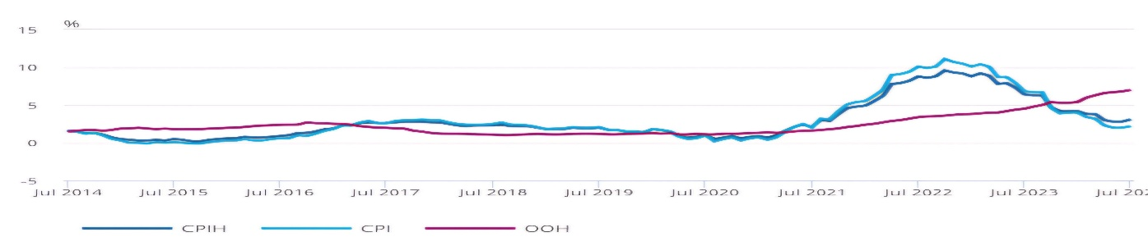
ECONOMICAL factors refers to economic growth, exchange rates, interest rates, inflation rates, disposable income, taxation and unemployment rates. Samsung's economic factors are reflected in the economic health of its cutlets, all economic indicators are studied to forecast market conditions. Samsung is influenced by economic recessions or booms in these countries, they cause the purchasing power of customers to decrease or increase, implicitly the demand for electronic products. There is a possibility that Samsung borrows money for some investments or market strategies, if the interest rates increase then the cost of borrowing increases and automatically the profit decreases. Samsung operates internationally, so all these operations and their profitability is influenced by government’s economic policies, monetary and industrial policies. Always confidence that the population has in the economy of the respective state affects spending habits which in turn has an effect on the demands for Samsung products. Both companies, Apple and Samsung have a great benefit in some of the markets, an example would be the European Union, which ensures quick access to the market and removes trade barriers. Inflation is the term we use to describe rising prices. Rate of inflation is calculated by Office for National Statistics, they record the cost of 700 things that people regularly buy. The price of the basket tell us the overall price level, Consumer Prices Index or CPI. To calculate the rate of inflation, they compare the cost of the basket with what it was a year ago, the change in the price level over the year is the rate of inflation.

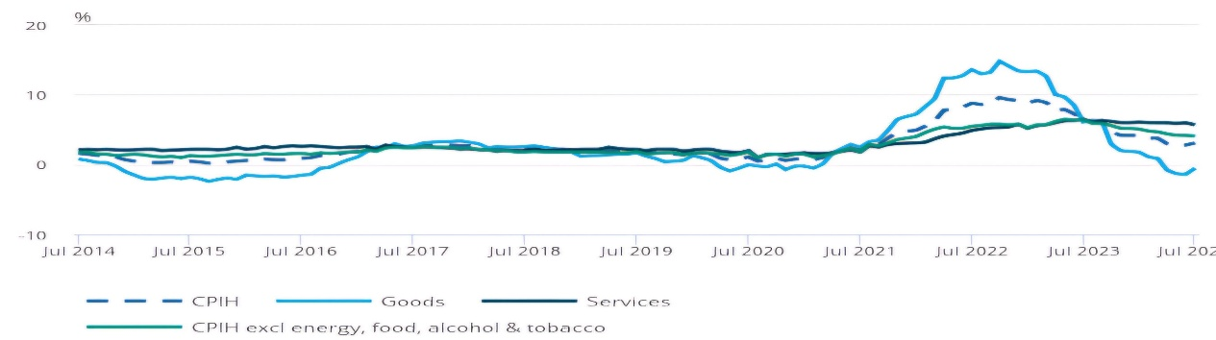
The above figure show CPI including owner occupiers housing costs CPIH, occupiers housing costs component OOH and CPI annual inflation rates, UK July 2014 to July 2024. The figure suggest that the October 2022 inflation rate was the highest in over 40 years the CPI accredited official statistic. The high inflation rate in October 2022 influenced the increase of materials, electronic components in the supply chain, labour cost, servers cost, warehousing and professional services. Samsung and Apple were forced to raise the prices of electronic products by 8%, all of which constituted a danger and a threat in the sale and in the profit.

The above figure show the lowest core CPIH inflation rate since January 2022 .
SOCIO-CULTURAL represents the values, institutions, level of education and consumption of the population. Socio-cultural factors are refers to age distribution, safety emphasis, health consciousness, career and life style attitudes and cultural barriers. All these socio-cultural factors help both companies, Apple and Samsung, to study market trend, lifestyle and consumer preferences. Different companies in the international market implement new technology differently, the speed of implementation and consumer reaction is different, so both Apple and Samsung need to understand these attitudes very well in order to succeed in promoting and innovating their products. From the point of view of the lifestyle trend, an advantage is on the side of Apple, the emphasis that consumers put on fitness and health today, makes the sales of smart watches that offer health monitoring and measurement functions increase, and the plus so as I specified it is from the Apple company. The sales of the electronic products of both companies are influenced by the age of the population, by the income and education of the consumers, always the tendency of the young people is to adopt and be in step with the technology. The current days are full of concern about the impact of electronic products on the environment and Samsung’s strong commitment to environmental sustainability can change the decision to buy their own products. During the pandemic there have been big changes in what it meant to work from the office, many of the employees have started to work remotely which has made a greater demand for computers and laptops, the advantage this time being in favour of Apple.
TECHNOLOGICAL factors are level of innovation, automation, technological awareness and technological change, r&d activity. Today, the technology is one of the most important factors for the companies development, the higher is the technological level, the higher are the chances that the quality of the products will be highly appreciated on the consumer market. From a technological point of view, both Apple and Samsung are fighting hard, making sure that the old stocks do not harm profits and continuously investing in research and development. Fast and efficient adoption of new technologies ensures market position and sales, both in terms of the final product and its production line.
LEGAL FACTORS are for many companies, the most important factors. Countries that are part of the European Community must have several legal systems in mind:
- The legislation of the country where the production system is located or takes place;
- The legal system of the countries where the products are sold;
- Additional laws that facilitate or limit business in general.
There are also countries that prohibit the advertising of certain products, such as tobacco or alcoholic products, which creates problems for managers, it takes a lot of skill to comply with the legislation in force. Typical legal factors of a PESTLE analysis include:
- Employment laws;
- Antitrust laws;
- Discrimination laws;
- Copyright and patent laws;
- Consumer protection laws;
- Health and safety laws.
ENVIRONMENTAL FACTORS are those related to the climatic and topographical conditions, but also to the availability of thr resources of each country. Geographical distances and landforms can sometimes be real obstacles in terms of products distribution and raw materials supply, so managers must think about the strategy and ambitions of their companies. The environmental factors of a PESTLE analysis can be classified as follows:
- Weather;
- Climate;
- Environmental policies;
- Climate change;
- Pressure from NGO’s.
Of the two major electronics manufacturers, Samsung is ahead of Apple when it comes to recycling responsibly. Samsung has implemented recycling programs in many of the countries where it sells its electronic products. Many companies can exchange over 6000 Samsung or non-Samsung devices, they will be properly recycled and scrapped with a certificate of scrapping issued that they have been properly disposed of. New jobs are also created for repair, recycling and renewal to create a greener galaxy.
CONCLUSION PESTLE analysis is the best concept and help companies managers to anticipate the dangers and threats, they may encounter in the activity of the companies they lead, understanding and assimilating these threats, therefore it is recommended that this analysis to be done regularly. Everything that happened in the pandemic time and the major inflation of October 2022 proves that Apple and Samsung understood, anticipated and knew how to solve the problems and return to the top of the most successful companies on the glob.
REFERENCES:
Evolution of Samsung group and its central office: imperfect market and capacity building; Choi, Philip PilSoo; London: Palgrave Macmillan UK; Asian business & management, 2016-12,Vol.15(5),p.370-398
Companies Share Political Contributions with Big Apple Funds; Giardina,Michael; New York; Source Media, Inc; Investment Management Weekly, 2010-02, Vol.23(6),p.22
Some Implications for Operational Research in the Area of Inflation as it Affects a Company’s Profitability and Liquidity; Sizer, John; Operational research quarterly (1970),1977, Vol.28(1),p.125
Global tensions in financial markets; John W. Kensinger; 1st ed.;2018; Emerald Publishing

