-
David Edwards
Analysis of an RLC network | sTUDENT nUMBER: 2405526
Electrical Engineering
Module Code

Table of Contents
Introduction 2
1. Task 1 3
1.1 RLC Circuit 3
1.2 Voltage and Current Graph 3
1.3 Calculate Active, Reactive and Apparent Power 4
1.3.1 Phase Angle 4
1.3.2 Irms 5
1.3.3 Vrms 6
1.3.4 Active Power 7
1.3.5 Reactive Power 7
1.3.6 Apparent Power 7
1.3.7 Calculate Power Factor 8
1.3.8 Calculate appropriate capacitor value to correct the power factor of the load 9
1.3.8.1 Phasor Diagrams 9
1.4 Power Factor and Capacitance Value 12
1.5 Phase Angle and Capacitance Value 13
2. Task 2 14
2.1 25Hz Below Resonance 14
2.1.1 Phase Angle 14
2.1.2 Phasor Diagram 14
2.2 Resonance (50Hz) 15
2.2.1 Phase Angle 15
2.2.2 Phasor Diagram 15
2.3 25Hz Above Resonance (75Hz) 16
2.3.1 Phase Angle 16
2.3.2 Phasor Diagram 16
3. Task 3 17
4. Task 4 18
4.1 Why Three Phase power? 18
4.2 Three Phase Machinery Within Industry 19
4.3 Efficiency/Cost 19
4.4 Flexibility 19
5. Task 5 20
5.1 Power Factor 20
5.2 Power Factor Correction 21
6. Conclusion 22
Bibliography 23

Introduction

AC distribution systems are a vitally important part of society. Domestic dwellings, commercial and industrial settings all require a stable reliable cheap form of energy to provide the outcomes demanded of them.
Power generation and transmission is just one part of electrical energy. In industrial settings there are inductive loads such as motors, transformers, reactors and chokes. These types of loads have a detrimental effect on their supplies. These inductive components draw reactive power; this results in lagging power factor that creates an inefficient system. This increases current demands, higher transmission losses and greater expense to the consumers. Tailoring capacitive reactance at the industrial consumer end is a vital part in keeping costs down and decreasing reactive power.
With proper power factor correction, the consumer has lower bills and even require smaller conductors and transformers etc. In large high energy demand industries such as steel, this adds up to a large amount of money.
This report investigates the principles of power factor and power factor correction. It also then sees the simulation of an inductive load and the calculation of appropriate power factor correction. Proteus simulation software is used to achieve a simulated circuit with simulated capacitance, resistance and inductance. With this the behaviours of voltages, current and phase angle is analysed before and after power factor correction implementation.
This study documents a theoretical approach to calculating and engineering a solution for an inductive circuit to manage the power factor to ≥ 0.95. The effects that different frequencies would have on the same circuit are also analysed with appropriate phasor diagrams to document these key changes.

Through this systems-based approach, the report demonstrates how power factor correction improves the efficiency and reliability of AC electrical systems, reinforcing its importance in both theoretical analysis and real-world engineering applications.

Task 1

RLC Circuit

Figure 1 - Original Circuit, Capacitor out of circuit

Voltage and Current Graph

Figure 2 - Current vs Voltage waveforms (before power factor correction)

Calculate Active, Reactive and Apparent Power

1.3.1 Phase Angle
$$Ф=\frac{t}{T} ×360$$
$$Ф=\frac{2×{10}^{-3}}{20×{10}^{-3}} ×360$$
$$Ф=36°$$

1.3.2 Irms
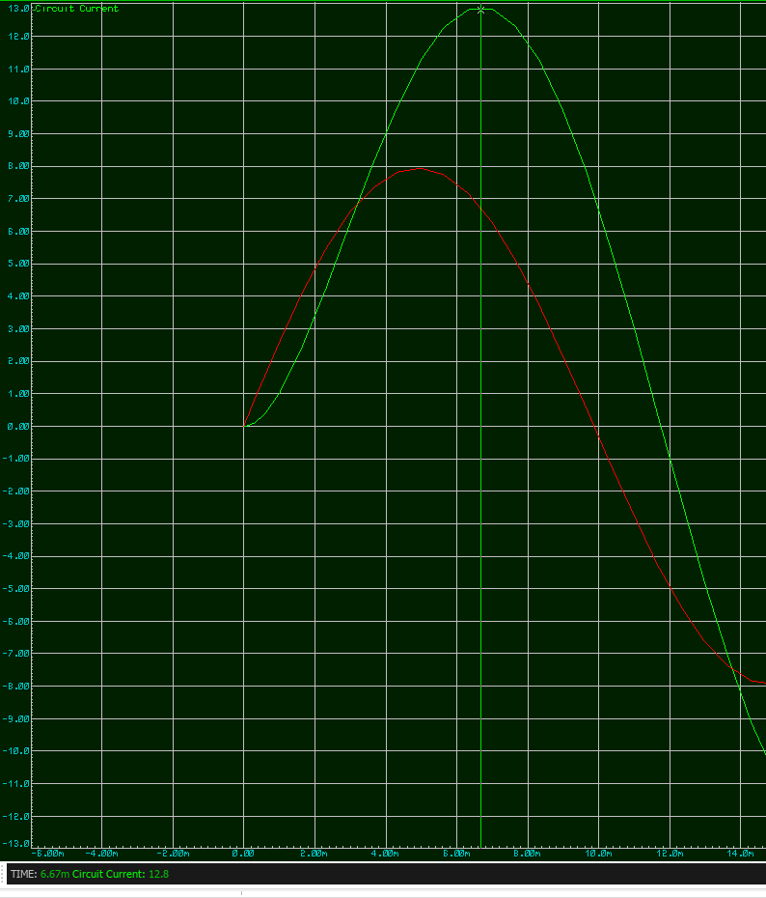
Figure 3 - IRMS Max, and time value
$Im=12.8A$ , $Vm=398V$

$$Irms = \frac{Im}{\sqrt{2}}=\frac{12.8}{\sqrt{2}}=9.05A rms$$

1.3.3 Vrms
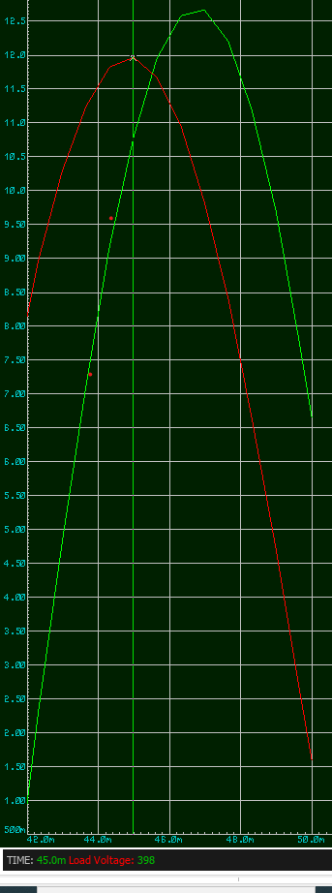
Figure 4 - VRMS max and time value

$$Vrms = \frac{Vm}{\sqrt{2}}=\frac{398}{\sqrt{2}}=281.43V rms$$

1.3.4 Active Power

$$P=VI\cos{Ф}$$
$$P=281.43 ×9.05\cos{36°}=524.76 W=2.06KW$$

1.3.5 Reactive Power

$$Q=VI \sin{Ф}$$
$$Q=281.43 ×9.05 \sin{36°}=2492.3 VAR=1.497KVAR$$

1.3.6 Apparent Power

$$S=VI$$
$$S=281.43 ×9.05=2546.94VA=2.546KVA$$

Calculate Power Factor

$$PF=\cos{Ф}$$

$$PF=\cos{36}°$$
$$PF=0.81$$

1.3.8 Calculate appropriate capacitor value to correct the power factor of the load

$$XL=2πFL$$
$XL=2π×50×55{×10}^{-3}$
$$XL=17.28Ω$$

$Z_{Total}=R_{SRC}+R+XL$

$Z_{Total}=2.4+26+17.28$
$Z_{Total}=45.68$

$V=IR$
$$I=\frac{V}{R}$$
$$I=\frac{300}{45.68}=6.567A$$

1.3.8.1 Phasor Diagrams
V=300V
Im=6.567A
$Ф$ =36$°$

Figure 5 - Phasor diagram of original circuit

To get a PF of unity :
$$\cos{Ф}=1$$
$$Ф=\cos^{-1}{(1)}=0°$$

V=300V
Im=6.567A
$Ф$ =36$°$
$$IC$$
$$I$$

Figure 6 - Phasor Diagram IC

$$IC$$
V=300V
Im=6.567A
$Ф$ =36$°$
$$I$$

Figure 7 - Phasor Diagram IC_2

$$\sin{Ф}=\frac{opposite}{hypotenuse}$$
$$\sin{Ф}=\frac{IC}{IM}$$
$$\sin{36}=\frac{IC}{6.567}$$
$$IC=6.567\sin{36}$$
$$IC=3.86A$$

If the current across the capacitor is 3.86A, XC can now be calculated.

$$IC=\frac{V}{XC}$$
$$XC=\frac{V}{I}$$
$$XC=\frac{300}{3.86}=77.72Ω$$
$$XC=\frac{1}{2π F C}$$
$$C=\frac{1}{2π F XC}$$
$$C=\frac{1}{2π ×50× 77.72}$$
$$C=40.956{×10}^{-6}$$

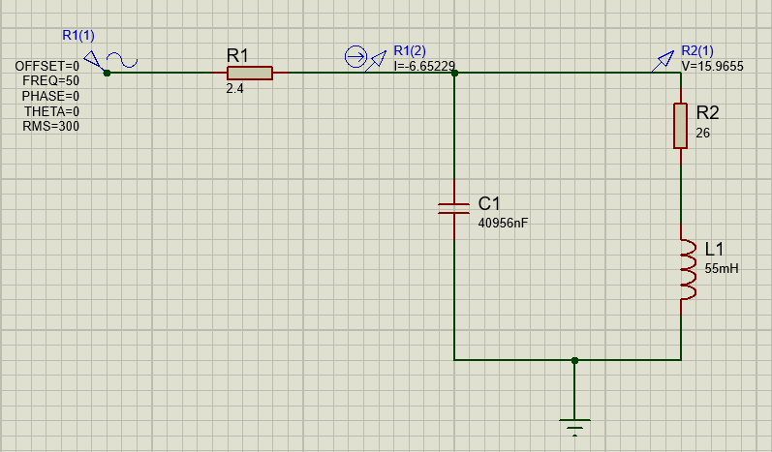
Figure 8 - Circuit with calculated PF capacitor

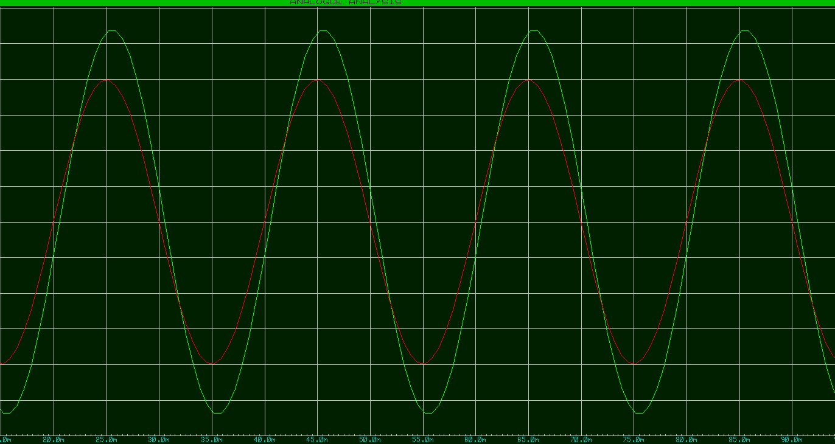
Figure 9- Voltage and current waveforms after PF

1.4 Power Factor and Capacitance Value

Figure 10 - PF vs Capacitance Graph

1.5 Phase Angle and Capacitance Value

Figure 11 - Phase Angle vs Capacitance Graph

Task 2

2.1 25Hz Below Resonance

2.1.1 Phase Angle
$$Ф=\frac{t}{T} ×360$$
$$Ф=\frac{1×{10}^{-3}}{20×{10}^{-3}} ×360$$
$Ф=18°$
$Z_{Total}=R_{SRC}+R+XL$
$XL=2πFL$
$XL=2π×25×{55×10}^{-3}$
$XL=8.64Ω$
$Z_{Total}=2.4+26+8.64$
$Z_{Total}=37.04Ω$

$$V=IR$$
$$I=\frac{V}{R}$$
$$I=\frac{300}{37.04}$$
$$I=8.1A$$

2.1.2 Phasor Diagram
Figure 12 - Phasor Diagram 25Hz
V=300V
Im=8.1A
$Ф$ =18$°$

2.2 Resonance (50Hz)

As resonance has been achieved with power factor correction, resonance is at 50Hz Phase Angle

2.2.1 Phase Angle

$$Ф=\frac{t}{T} ×360$$
$$Ф=\frac{2×{10}^{-3}}{20×{10}^{-3}} ×360$$
$Ф=36°$
$Z_{Total}=R_{SRC}+R+XL$
$XL=2πFL$
$XL=2π×50×{55×10}^{-3}$
$XL=17.28Ω$
$Z_{Total}=2.4+26+17.28$
$Z_{Total}=45.68Ω$

$$V=IR$$
$$I=\frac{V}{R}$$
$$I=\frac{300}{45.68}$$
$$I=6.57A$$

2.2.2 Phasor Diagram
V=300V
Im=6.57A
$Ф$ =36$°$

Figure 13 - Phasor Diagram 50 Hz

2.3 25Hz Above Resonance (75Hz)

2.3.1 Phase Angle

$$Ф=\frac{t}{T} ×360$$
$$Ф=\frac{3×{10}^{-3}}{20×{10}^{-3}} ×360$$
$Ф=54°$
$Z_{Total}=R_{SRC}+R+XL$
$XL=2πFL$
$XL=2π×75×{55×10}^{-3}$
$XL=25.92Ω$
$Z_{Total}=2.4+26+25.92$
$Z_{Total}=54.32Ω$

$$V=IR$$
$$I=\frac{V}{R}$$
$$I=\frac{300}{54.32}$$
$$I=5.52A$$

2.3.2 Phasor Diagram
V=300V
Im=5.52A
$Ф$ =54$°$

Figure 14 - Phasor Diagram 75Hz

From the calculated phasors the current being supplied can be seen to be getting smaller as the frequency increases.

Task 3

The capacitor value calculated in task one is calculated to give a PF as close to 1 as reasonably possible. There are accounts of rounding errors that need to be considered. In real world scenarios the power factor within an industrial setting is not fixed. Reactive components are continuously switched in and out of circuit while variable frequency drives are in place varying the frequency motors are driven by to suit the process. Taking this into account there is little achieved by going to a high decimal place when carrying out these calculations.
The addition of this capacitance into the circuit means that the circuit approaches resonance. This means that the reactance’s $X_{L}≈X_{C}$. The closer these reactance’s match up the more desirable the power factor [1]. If they were equal the power factor would be at unity (1). With reduction in reactive power, a decrease in apparent power can be observed. This means that a greater portion of the apparent power is real power. With a theoretical PF of one the apparent power and real power would equal 1 which would mean a 100% efficient system. In a real-world system with changing reactance’s this isn’t a very realistic​event [2].
If less power is required to achieve an outcome from an electrical supply, then the consumer saves money. This is also important in a world where there is growing demand for less energy consumption. If maximum power transfer is achieved, then smaller cross-sectional area conductors can be used in the transfer of power. This all saves money on huge scale when calculated.
Energy efficiency is an important factor in electrical engineering. In all forms of engineering, total costs are important. If a system can supply the necessary outcomes demanded of it while saving energy at a generation level, this is something that is necessary to ensure a cheaper and greener outcome.

Task 4

Electricity supplies throughout the developed world are transmitted as three phase supplies. Historically, particularly in the transmission of electrical supplies, the use of AC as opposed to DC is much cheaper.
AC electricity allows the use of transformers to step-up voltages to far greater levels than that used at a domestic level. The use of a step-up transformer allows a generated supply to be transmitted at a higher voltage which inversely means lower current. In transformer theory, if the transformer is thought of as 100% efficient, then the current is stepped down in the same ratio the voltage is stepped up. These lower currents mean smaller cross-sectional area cables can be used

4.1 Why Three Phase power?

Three phase supplies mean that a very constant source of supply is delivered. An AC waveform is sinusoidal. In the image below a single-phase sinusoidal waveform and a three-phase sinusoidal waveform are both shown.

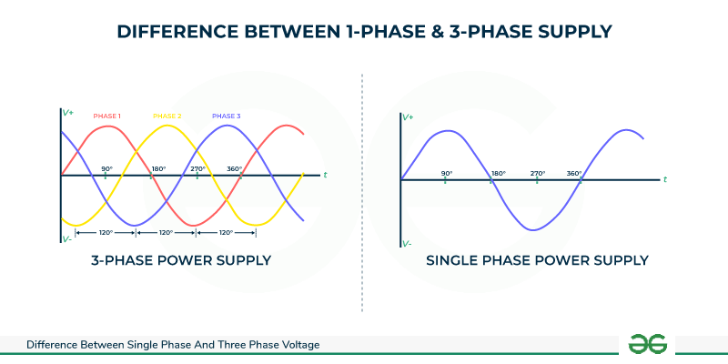
Figure 15 - 3 phase waveform vs single phase waveform [3]

A single-phase sinusoidal waveform has a positive half cycle 0° - 180° and negative half cycle 180° - 360°.
A three-phase sinusoidal waveform is like a single-phase waveform in that each phase is also sinusoidal.
Phase one is just as the single-phase waveform, a positive half cycle 0° - 180° and negative half cycle 180° - 360°. Phase two is as phase one, but it is staggered by 120° and phase three is as phase two but staggered by a further 120°. The staggering of individual phases provides a great many advantages.

4.2 Three Phase Machinery Within Industry

In industrial settings a vital component seen regularly is a three phase AC motor. By creating a three-phase supply, this means that three-phase motors can run smoothly without fluctuations in torque or speed created by a varying supply. In industrial applications this helps create reliable processes and reduce mechanical stresses on machinery [4].
Single-phase motors are typically more complex; they require auxiliary components like starting capacitors and centrifugal switches to switch out these capacitors. Single-phase motors are also less efficient in comparison to a three-phase motor. More simple machines that are power cost effective are both obvious advantages when comparing to single-phase systems.

4.3 Efficiency/Cost

A three-phase system requires the smaller conductors to transfer the same transmitted power. By maximising the power by these conductors can transmit, cross sectional area of cables and transformer sizes are minimised. This means the grid is cheaper to build and maintain, overhead lines are lighter which means pylons and their insulators can be built smaller.

4.4 Flexibility

Greater flexibility is achieved with three-phase systems in comparison to single-phase systems.

Task 5

Power factor and power factor correction hold a great significance within Electrical Engineering Systems. Power factor is a measure of how effectively electrical power in converted into useful working energy.

5.1 Power Factor
$Power Factor (PF)=SP​=cosϕ$

$P$= Real power (W)
$S$= Apparent power (VA)
$ϕ$= Phase angle between voltage and current

In real terms P real power is the power that is being used that is considered useful work. It is the electrical energy that at work directly creating the output expected from electrical devices.
Reactive power is the power that is used in oscillation between the source and the reactive components withing these electrical and electronic devices. The electronic components that have reactive responses are capacitors and inductors. However, any capacitance or inductance will influence the power factor of a given system. The most obvious examples of components effecting power factor is within industry. Large induction motors, transformers, reactors and chokes are all examples of equipment that can affect power factor. The inductive loads that are created within industry will cause current to lag voltage, creating the lagging power factor that is undesirable.
The inductive components within domestic dwellings are so small that the influence is minimal, particularly as more electronics become greater portions of the devices used at home.
Apparent Power is the total power supplied. This is the real power and reactive power in total. It is not possible to simply add real power and reactive power together as they are different units out of phase with each other. If the reactive power within an electrical system is higher than desired, a higher apparent power and lower power factor can be observed. In simple language, reactive power is wasted energy that ideally needs to be mitigated as much as possible to achieve greater efficiencies within electrical systems.
Low power factor leads to higher line current for the same real power. As the power factor gets lower increased I²R losses are to be expected, voltage drops and increased cable and transformer heating.

$$I=\frac{P}{V×PF}​$$
[5]

The capacity of a system to do work is reduced. Electrical supply systems are only able to supply the currents they are designed for. If no power factor correction is applied, then the capability of that system to carry out work is not maximized. It comes down to increasing efficiency, maximising reliability and reducing cost for energy consumer.

5.2 Power Factor Correction

Power factor correction is practice of improving the power factor of electrical systems. By engineering the power factor closer to unity (1), the reactive power demand can be minimised which decreases the apparent power. With decreased reactive and apparent power, lesser costs and greater efficiency is achieved.
Power factor correction is typically done by adding capacitors to achieve the offset of inducive reactance necessary.

Inductors use reactive power
$$QL​=I^{2}×2XL​$$
[5]

Capacitors supply reactive power
$$Qc​=\frac{V^{2}}{X_{C}}​$$
[5]
By applying capacitors that achieve the used reactive power of the inductive components, the net reactive power gets closer to 0 achieving a desirable power factor.
$$QC​≈QL​$$
[5]

Within industry the power factor correction is typically seen as capacitor banks within the incoming substations for that plant.

Conclusion

This report has investigated Power Factor and Power Factor correction. The causes and consequences of poor power factor have been considered and the appropriate approach to mitigating these consequences considered. The use of proteus help to carry out calculations that could then be proven in a simulated system. The effects of inductive loads on voltage, current and phase angle have all been considered. With the initial circuit before any power factor correction was applied, all necessary calculations to determine the necessary capacitor for power factor correction were carried out. Before these changes were implemented a lagging power factor caused by the inductive load could be observed. The considerations of why poor power factor matters have been discussed at great length throughout this report.
In calculating and implementing the correct sized power factor correction capacitor the reactive power drawn by the inductive load was compensated. The reduced phase angle achieved by implementing this capacitance improved power factor to a value approaching unity, the phase angle between voltage and current was greatly reduced.
With these changes in place a clear reduction in reactive and apparent power could be observed. This circuit proves the necessities of power factor correction within electrical distribution.
The further investigations into circuit resonance and changes in frequency showed the supply current dropping therefore reducing apparent power. These findings have all been displayed in appropriate phasor diagrams.
The report has considered power factor correction within a wider engineering context. Industrial loads have been particularly considered in their effects on power factor. The importance and advantages of three phase systems has been documented with the key point being the reduction in costs to the consumer being a major factor. This exercise has proven that power factor correction is a critical engineering practice that delivers significant advantages to all who us use electrical power.

Bibliography

[1] | C. M. Coman, “Improving the Efficiency and Sustainability of Power Systems Using Distributed Power Factor Correction Methods,” 2020.
[2] | J. Sebastian, “An overview of power factor correction in single-phase off-line power supply systems,” IEEE, Bologna, 1994.
[3] | Geeks for Geeks, “https://www.geeksforgeeks.org,” geeksforgeeks, [Online]. Available: https://www.geeksforgeeks.org/electronics-engineering/difference-between-single-phase-and-three-phase-voltage/. [Accessed 01 01 2026].
[4] | J. E. Fleckenstein, “Three-Phase Electrical Power,” CRC Press, Boca Raton, 2016.

