

Data Handling and Business Intelligence
Component 1: Individual Report
LCBB5014
Dumitru Adrian Cirjan
2319495

Table of Contents
1. Introduction 3
2. Understanding Business Intelligence Concepts 3
2.1 Core Components of BI 3
2.1.1 Data Acquisition and Integration 3
2.1.2 Data Warehousing and Storage 4
2.1.3 Data Mining and Statistical Modelling 4
2.1.4 Analytics 4
2.1.5 Visualisation and Reporting 5
2.2 Evolution from Traditional BI to Modern Analytics 5
3. Business Intelligence Applications 6
3.1 BI Tools and Analytical Platforms 6
3.1.1 Dashboards and Reporting Tools 6
3.2.2 Online Analytical Processing (OLAP) 6
3.3.3 Predictive Analytics Engines and Self-Service BI Platforms 7
3.2 Industry Use Cases 7
3.2.1 Retail 7
3.2.2 Finance and Banking 7
3.2.3 Healthcare 8
3.2.4 Manufacturing 8
3.3 Specific BI software or platforms 8
4. Real-World Examples or Case Studies 9
4.1 Case Study 1: Amazon (Retail) 9
4.2 Case Study 2: HSBC (Finance) 10
4.2 Case Study 3: NHS (Healthcare) 11
4.4 Measurable Impact 12
5. Benefits and Challenges of Business Intelligence 13
5.1 Benefits 13
5.2 Challenges 13
5.3 Strategies for Overcoming Challenges 14
6. Conclusion 14
References 15
Appendix: AI declaration 18

1. Introduction
Business Intelligence (BI) is a collection of technologies, processes and analytical strategies that collect, unify, examine and display organisational information to make real-time strategic and operational choices (Zamil, 2024). Unlike basic reporting systems, the current BI models synthesise vast amounts of data into actionable insights, which allows organisations to predict trends, streamline processes and make business strategies with measurable outcomes. This shift in descriptive reporting to predictive and prescriptive analytics represents BI as one of the most essential assets of the digital economy.
The significance of BI value is reflected through market demand and organisational adoption. The market size of global BI is estimated at USD 34.82 billion in 2025 and is expected to be valued at USD 72.21 billion by 2034 (Fortune Business Insights, 2026). BI adoption is escalating the performance of industries by supporting through customer analytics, risk evaluation, and operational optimisation. Also, additional features like machine learning, augmented analytics and natural language query are now standard components of BI platforms, reflecting the shift towards intelligent, automated decision systems.
In this report, there will be a critical analysis of the BI concepts, key elements and development, reviews of industry uses and real-time examples, as well as a review of its advantages and challenges in implementation. It will also examine the current trends in BI and give recommendations to organisations to use BI as a strategic asset.

2. Understanding Business Intelligence Concepts
Business Intelligence combines data technologies and organisational processes to aid evidence-based decision-making, transforming raw data into a competitive business strategy (Talakola, 2022). It transcends traditional reporting to model future outcomes and inform strategic action by enabling organisations to generate insights.

2.1 Core Components of BI

2.1.1 Data Acquisition and Integration
The initial step in the process of BI is the extraction of information out of any internal systems, such as ERP, CRM, POS and external sources like market feeds, social media. Recent BI is based on the ETL (Extract, Transform, and Load) model that unifies and standardises disparate data. At this point, quality and consistency are essential since data governance is a core element of analytical reliability (Kothamaram, 2023).

2.1.2 Data Warehousing and Storage
Data warehouses and data lakes are centralised data repositories that allow both historical and current data to be optimally stored for analytics. Cloud-BI architecture is also gaining popularity because of their scalability and cost-efficiency, enabling real-time querying and access by cross-departments (Zamil, 2024). This transition to the use of cloud-based BI platforms accounts for the majority of deployments, reflecting this shift away from traditional on-premises systems.

2.1.3 Data Mining and Statistical Modelling
The data mining algorithms, including clustering, classification and association helps in identifying hidden correlations and patterns within large datasets. As an illustration, association rule mining is applied in retail organisations to learn about co-purchase behaviour, influencing both inventory and promotional strategy.

2.1.4 Analytics
BI analytics is at four levels:
- Descriptive: Overviews and summarisation of past performance.
- Diagnostic: Interpret and explain causal relationships.
- Predictive Forecasts the future trends based on machine learning models.
- Prescriptive: Recommendations based on simulations and optimisation.
Huu (2025) has opined that predictive and prescriptive capabilities are increasingly integrated into BI tools, enabling organisations to test scenarios (A/B testing, generating consumer persona, assessing consumer journey) rather than merely observing trends.
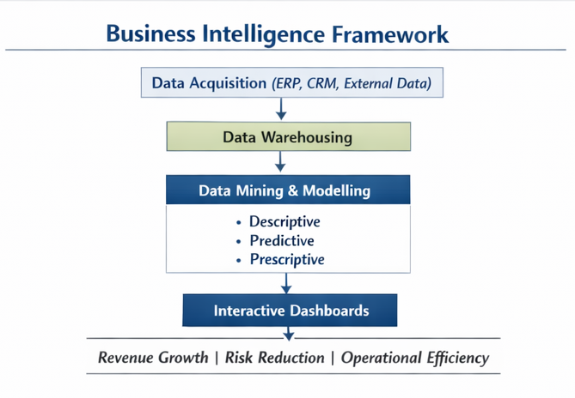
Figure 1: BI framework
(Source: self-developed)

2.1.5 Visualisation and Reporting
BI dashboard and interactive report transform the results of the analytics into easy-to-understand formats, enabling the decision-makers to make faster and more accurate decisions (Gonçalves et al., 2023). It works as a visualisation model, reduces cognitive load, and enhances strategic communication across organisational levels.

2.2 Evolution from Traditional BI to Modern Analytics
In conventional BI systems, most reports were generated using historical databases as a single instance of the traditional BI systems. Smolander (2024) has stated that the need to have real-time insights, predictive features and AI integration has revolutionised the BI landscape. Modern BI uses augmented analytics systems that integrate machine learning and natural language processing to activate automated generation of insights so that non-technical users can also create advanced analyses without the assistance of specialists.
The developments have expanded BI beyond a back-office reporting initiative to a strategic part of enterprise decision models. However, with progress, there is also stress that technological sophistication needs to be combined with data governance and organisational alignment to achieve sustainable value in terms of trust and privacy as well.

3. Business Intelligence Applications

3.1 BI Tools and Analytical Platforms

3.1.1 Dashboards and Reporting Tools
KPIs and trends can be displayed now in real-time interactive dashboards. Microsoft Power BI and Tableau are such examples where the dashboard allow custom visualisations with automatic notifications (Talakola, 2022).
Component | Description
Data Source Integration | Connecting to Excel, CSV, or SQL databases containing customer data, sales records, and financial metrics (Obuse et al., 2023).
KPI | Displaying total revenue, profit margins, and YoY growth alongside visual comparison with market rivals
Trend Lines | Visualising sales growth over the past year.
Bar Charts/Maps | Comparison of performance by region or product line.
Interactivity | Slicing the filter data by region, target audience, or time period.

3.2.2 Online Analytical Processing (OLAP)
As opined by Patel and Sharma (2020), OLAP is useful in analysing complex data sets by time, regional, functional and divisional business dimensions.

OLAP Action | What Happens in Power BI | Example
Slice | Filter by one dimension | View only 2025 sales
Dice | Filter by multiple dimensions | View Electronics sales in the North region for Q1 2025
Drill Down | Go from summary to detail | Click Year → Quarter → Month
Roll Up | Aggregate data | View total sales by Year instead of Month

3.3.3 Predictive Analytics Engines and Self-Service BI Platforms
Odinaka et al. (2021) have highlighted that the predicted outcomes using these platforms include demand, churn and financial risk, analysed through statistical models and machine learning. Self-service BI systems allow business units to create insights without any involvement of IT departments, which enhances responsiveness and minimises cost.

3.2 Industry Use Cases

3.2.1 Retail
Retailers have seasonal demand, disjointed consumer behaviour and inventory control. BI supports in the ways discussed below:
Demand forecasting: Predictive models are based on historical sales, external variables (promotions, seasonality) and trend data to forecast the amount of sales that can be made in the future (Maulana and Wulandari, 2019).
Inventory optimisation: Real-time analytics minimise stockouts and overstock, and capital efficiency.
Customer segmentation and personalisation: Behavioural analytics are used to segment the customer to market to them specifically, within loyalty programmes and personalised promotions.

3.2.2 Finance and Banking
Obozokhai et al. (2025) have highlighted that BI has been applying financial services risk models, detecting fraud and satisfying regulatory requirements. Real-time transaction analytics identify anomalies that are the result of fraud or money-laundering risk. Stress testing and credit risk scoring are also done with the assistance of BI systems to enhance better risk governance and regulatory reporting.

3.2.3 Healthcare
According to Jayaraman and Jain (2024), in medical facilities, BI helps in controlling the flow of patients, minimising waiting time and optimising resource use. Analytics predict the rate of admission and are used to roster the staff. Also, cost management and outcome analytics enhance the efficiency of service delivery.

3.2.4 Manufacturing
BI is used by manufacturers with IoT sensors to perform predictive maintenance in order to minimise machine downtimes and increase the lifecycles of assets (Patil et al., 2024). BI is also useful in quality control and optimisation of the supply chain by scheduling production to demand forecasts, lean efficacy, and total quality control and specifically in just-in-time management.

3.3 Specific BI software or platforms
Specific BI software and platforms vary by analytical capability and the need for enterprise resource planning or customer relationship management. Tableau have very robust visual analysis and a user-friendly interface, enabling analysts to investigate multidimensional data quickly (Singh, 2025). SAP Analytics Cloud incorporates BI with both ERP and business analytics and planning. Oracle Analytics incorporates the principles of AI into the conventional BI processes, boosting the predictive model creation and massive data integration. Qlik Sense has an associative data format that facilitates dynamic exploration of intricate data interrelations, which is useful in profound diagnostic analysis in healthcare, retail, finance, mnufacturing and operations (Frank, 2025). The focus on collaborative analytics in Yellowfin BI and other systems offers automated insight creation and easy reporting to support decentralised business unit decision-making.
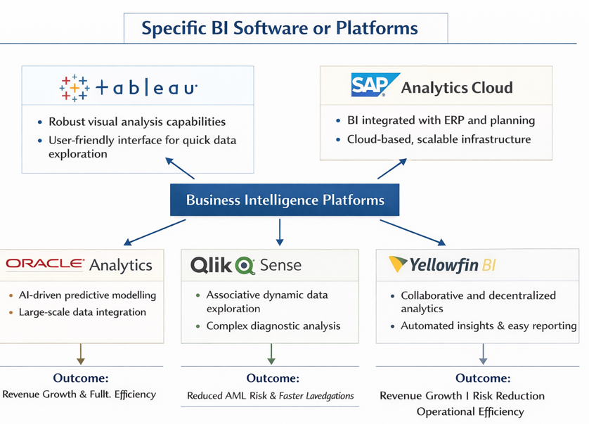
Figure 2: BI software and platforms
(Source: self-developed)

4. Real-World Examples or Case Studies

4.1 Case Study 1: Amazon (Retail)
The BI ecosystem is pivotal to Amazon’s retail strategy. It applies real-time analytics and machine learning to its recommendation engine. Purchase history, browsing, and search preferences of customers are studied to give personalised product recommendations, boosting average order value and conversion rates. Amazon also relies on predictive analytics as the foundation of dynamic pricing strategies that adjust to the changes in competitive prices and the quantity of items sold in real time.
In addition, Amazon leans on BI in optimising the supply chain, making predictions of demand in regional fulfilment centres and stocking against high demand (Amazon, 2026). The practices minimise the fulfilment time and total logistics costs, which add to the increased customer satisfaction and reduced operating costs. These BI applications help underline the role of embedding analytics capabilities into the core business processes as a strategic benefit.
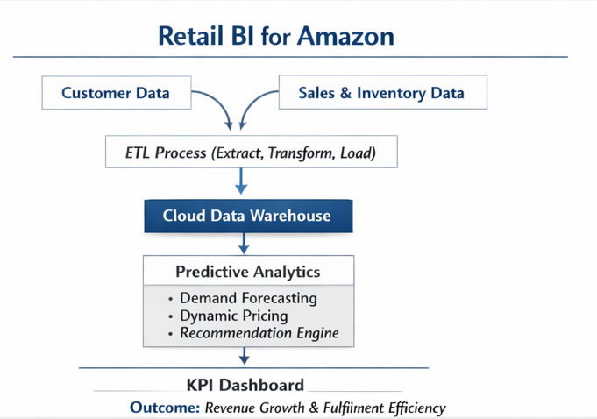
Figure 3: Use of BI Retail
(Source: self-developed)

4.2 Case Study 2: HSBC (Finance)
To enhance the monitoring of the Anti-Money Laundering (AML), HSBC used Business Intelligence (BI) and advanced analytics. The bank applied real-time risk scoring and anomaly detection to detect suspicious patterns in its global transaction data by integrating it into centralised dashboards where the brand checks 900 million transactions in a month, covering 40 million customer accounts (HSBC, 2024). BI tools minimised false positives and enhanced regulatory reporting accuracy, and compliance efficiency in various countries, which minimised AML-related operational risks to a significant extent.
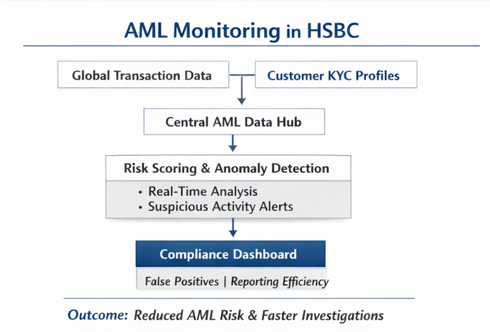
Figure 4: Use of BI Finance
(Source: self-developed)

4.2 Case Study 3: NHS (Healthcare)
The National Health Service uses Business intelligence to combine Electronic Health Records (EHR) and telemedicine platforms. By participating in a real-time video consultation, patients and their clinicians can access live EHR data, including medical history, laboratory outcomes, and orders, via built-in dashboards (NHS, 2021). BI analytics track waiting times, remote vital signs, and consultation outcomes in real-time and allow accelerating the diagnosis process, enhancing triage decisions and improving doctor allocation in NHS Trusts.
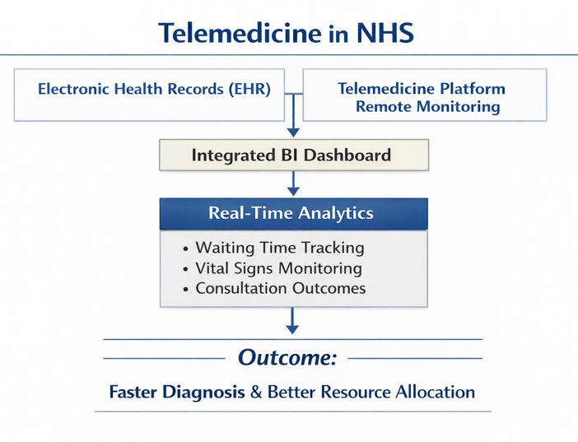
Figure 5: Use of BI Healthcare
(Source: self-developed)

4.4 Measurable Impact
Organisation | Key BI Applications | Measurable KPIs | Overall Impact
Amazon | Dynamic pricing, supply chain analytics, and recommendation engine. | 15 to 25% upliftment in conversion rate with 10 to 20% cost cut in logistics. | Higher revenue, improved operational efficiency, and greater customer satisfaction (Gonçalves, 2023)
HSBC | AML risk scoring, anomaly detection, making through regulatory dashboards | 20 to 30% reduction in false positives and approx. 25% improvement in reporting efficiency | Lower compliance risk, with faster investigations (Huu, 2025)
NHS | EHR-integrated telemedicine dashboards, real-time patient monitoring | 25 to 30% reduction in waiting times and  35 % improvement in resource utilisation | Faster diagnosis, better healthcare delivery (Patel and Sharma, 2020)

5. Benefits and Challenges of Business Intelligence

5.1 Benefits
Enhanced Decision-Making: BI systems helps organisations in taking accurate decisions in a timely manner, and the result is outcome driven decision based rather than assumption (Obuse et al., 2023).
Operational Efficiency: Predictive forecasting and automated reporting decrease task jeopardy, data silos and operational error.
Increased Customer Understanding: Analytics aids in segmentation and targeted marketing, which improves interaction (Jayaraman and Jain, 2024).
Competitive Advantage: BI-enabled organisations have been shown to outdo their competitors in terms of strategic responsiveness.

5.2 Challenges
Data Quality and Integration Problems: Scattered and inaccurate data sources may lead to inaccurate analytics and decrease trust.
Costs of implementation: Advanced BI platforms, in particular those that incorporate AI and predictive modules, are costly to implement.
Skills Gap: skill gap, challenges in upskilling, change readiness and resource constraints can be challenges (Hung et al., 2023).
Privacy and Compliance: As vast amount of consumer data is been using then the threat of cybersecurity imposes greater emphasis on regulation, ethics and governance.

5.3 Strategies for Overcoming Challenges
To eliminate these constraints, organisations ought to:
- Create a strong data governance model which has standardised data quality measures.
- Invest in workforce improvement and BI training programmes.
- Implement with incremental modular BI architectures.
- Add privacy-by-design practices to analytics processes (Moraru, Ţapcov, and Căpăţînă, 2025).
These plans will help to harmonise BI implementation, organisational preparedness and value creation over time through benefits, trust and security.

6. Conclusion
The concept of Business Intelligence has emerged as a strategic capability that helps to combine both data management and analytics and organisational operations to enhance decision-making processes in industries. The example of Amazon (retail), HSBC (finance) and NHS (healthcare) have shown that the application is vast, diverse and 360-degree operational. Although it has benefits, organisations have issues concerning data governance, skill gaps, and compliance with regulations that need further strategy. The role of BI in empowering competitive and data-driven organisations has continued to grow in the future in the form of cloud and AI-powered and self-service analytics.

References
- Amazon (2026). Introduction - Using Microsoft Power BI with the AWS Cloud. Available at:https://docs.aws.amazon.com/whitepapers/latest/using-power-bi-with-aws-cloud/introduction.html [Accessed 26 February 2026].
- Fortune Business Insights (2026). Business Intelligence [BI] Market Size & Share Growth, 2034. Available at: https://www.fortunebusinessinsights.com/business-intelligence-bi-market-103742 [Accessed 26 February 2026].
- Frank, F. (2025). 10 Best Enterprise Business Intelligence Tools. Premium WordPress Themes & Plugins. Available at: https://wpfrank.com/10-best-enterprise-business-intelligence-tools/ [Accessed 26 February 2026].
- Gonçalves, C.T., Gonçalves, M.J.A. and Campante, M.I., 2023. Developing integrated performance dashboards visualisations using Power BI as a platform. Information, 14(11), p.614.
- HSBC (2024). Harnessing the power of AI to fight financial crime Available at: https://www.hsbc.com/news-and-views/views/hsbc-views/harnessing-the-power-of-ai-to-fight-financial-crime [Accessed 26 February 2026].
- Hung, B.K., To, C.C., Fung, R.K. and Chan, C.C., 2023. Addressing proficiency gaps in future skills between employers and learners through data visualization. SN computer science, 4(3), p.308.
- Huu, D.A.N.G., 2025. Appling Power BI for improved retail business analytics and decision-making. Applied Computer Science, 21(2), pp.154-163.
- Jayaraman, K.D. and Jain, S., 2024. Leveraging Power BI for advanced business intelligence and reporting. International Journal for Research in Management and Pharmacy, 13(11), pp.21-36.
- Kothamaram, R.R., Rajendran, D., Namburi, V.D., Tamilmani, V., Singh, A.A. and Maniar, V., 2023. Exploring the Influence of ERP-Supported Business Intelligence on Customer Relationship Management Strategies. International Journal of Technology, Management and Humanities, 9(04), pp.179-191.
- Maulana, A. and Wulandari, D.A.N., 2019. Business intelligence implementation to analyze perfect store data using the OLAP method. Sinkron: jurnal dan penelitian teknik informatika, 3(2), pp.103-111.
- Moraru, M., Ţapcov, V. and Căpăţînă, V., 2025. Data security and access management in microsoft tools: excel, power query and power bi. In Technological innovations in digital security (pp. 175-183).
- NHS (2021). Power BI – NHSmail Support. Available at: https://support.nhs.net/knowledge-base/power-bi/ [Accessed 26 February 2026].
- Obozokhai, L.I., Godswill, J.M., Balogun, I.O. and Akanbi, O.O., 2025. Real-Time Business Intelligence: A Review of Applications in Finance, Healthcare, and Retail. Journal of Economics, Business, and Commerce, 2(2), pp.119-128.
- Obuse, E., Ajayi, J., Akindemowo, A., Erigha, E., Adebayo, A., Afuwape, A. and Soneye, O., 2023. Advances in analytics engineering for operational Decision-Making using Tableau, Astrato, and Power BI. International Journal of Multidisciplinary Research and Growth Evaluation, 4(1), pp.1318-1335.
- Odinaka, N., Okolo, C.H., Chima, O.K. And Adeyelu, O.O., 2021. Accelerating Financial Close Cycles In Multinational Enterprises: A Digital Optimization Model Using Power Bi And Sql Automation. Power, 3(4).
- Patel, J.A. and Sharma, P., 2020. Online analytical processing for business intelligence in big data. Big data, 8(6), pp.501-518.
- Patil, P.S., Patil, S.S., Patil, S.M. and Dhanvijay, M.R., 2024. Development of MS Excel and power BI integrated production scheduling system for an MSME. Engineering Access, 10(2), pp.124-142.
- Singh, A. (2025). 15 Business Intelligence Tools You Should Know in 2025. Available at: https://www.appliedaicourse.com/blog/business-intelligence-tools/ [Accessed 26 February 2026].
- Smolander, M.A., 2024. Analyzing the impact of transforming from a traditional business intelligence tool to a modern BI solution.
- Talakola, S., 2022. Analytics and reporting with Google Cloud platform and Microsoft Power BI. International Journal of Artificial Intelligence, Data Science, and Machine Learning, 3(2), pp.43-52.
- Zamil, H., 2024. Business intelligence systems in finance and accounting: A review of real-time dashboarding using Power BI & Tableau. American Journal of Scholarly Research and Innovation.

