Electrical and Electronic Systems
Log Book
L4 Fundamentals of electrical and Electronic Systems – ACDA4018
Alex Lamdin
10th July 2023

Table of Contents
- Introduction
- Task 1 – DC Circuit Characteristics
2.1 - Initial Circuit
2.2 - Finding the Internal Resistance of the Circuit
2.3 – Measuring Power Transferred Within the Circuit
2.4 – Analysis of results
2.5 – Calculations and Comparison
- Task 2
3.1 – Initial Circuit and Introduction
3.2 – Component Voltage Measurements
3.3 – Analysis of Results
3.4 – Calculations and Comparison
- 4. Conclusion

Table of Figures
  - Initial Circuit
  - The open circuit following removal of the load resistor
  - The circuit after removal and short-circuiting of the voltage source
  - The modified circuit with the ohmmeter connected prior to reading
  - Circuit with ammeter inserted to measure load current
  - [Table] showing load current readings and calculated power figures
  - Graph showing power transferred (y-axis) against load resistance (x-axis)

2.1 Initial “RLC” Circuit
2.2 Initial Signal Generator Settings
2.3 Oscilloscope Screen
2.4 [Table] showing component voltage measurements
2.5 Graph showing capacitor voltage (y-axis) against frequency (x-axis)

1. Introduction

The “Fundamentals of Electrical and Electronic Systems” Module is designed to give students a basic understanding of AC and DC current, circuit construction, common electrical components, important electrical theorems and troubleshooting. This is aimed to give the OME students the knowledge required if they were later working on WOME with inbuilt electrical systems.

The two task contained within this report are designed to ensure students have grasped the electro-technical knowledge required via simulating two circuits using the Proteus® Electronic Simulation Software Suite.

Task 1 was a simple resistor-based DC circuit requiring the student to calculate the internal resistances of the circuit using the simulation software and analyse the data. This data could then be compared to calculated figures, requiring the use of thevenin’s theorem and the maximum power transfer theorem amongst knowledge of parallel and series components and fundamental electrical equations.

Task 2 was based around an AC circuit, requiring the use of a (simulated) oscilloscope and signal generator to investigate the resonant frequency of a circuit consisting of a Resistor, an Inductor and a capacitor in series, otherwise known as an “RLC” circuit.

2. Task 1 – DC Circuit Characteristics

2.1 – Initial Circuit

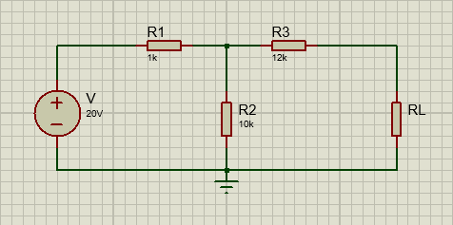
Task 1 was performed using a simple DC circuit which was constructed according to the instructions given. It consisted of two branches, one with a 10kΩ (R₂) resistor and one with a 12kΩ resistor (R₃) in series with an unknown variable load resistor (R_{L}). These two branches were connected in parallel to a single Voltage source with an EMF of 20V, in series with a 1kΩ Resistor (R₁).
Fig. 1.1 – Task 1 Initial Circuit

2.2 – Finding the Internal Resistance of the Circuit

To find the internal resistance of the circuit, suitable modifications were made to the initial circuit in a procedure very similar to that used in applying Thevenin’s theorem. Thus, the following steps were followed:
  - The Load Resistor (R_{L}) was removed to create an open circuit. (Fig. 1.2)
  - The Voltage Source (V) was removed and replaced with a short circuit. (Fig. 1.3)
  - An ohmmeter was connected to the two now-open terminals in place of R_{L}. (Fig. 1.4)

This procedure can be seen in the figures below:
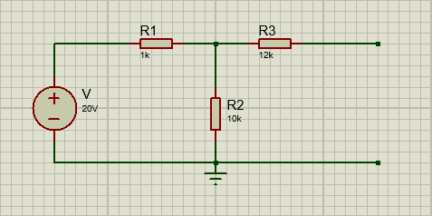
Fig. 1.2 – The open circuit following removal of the load resistor

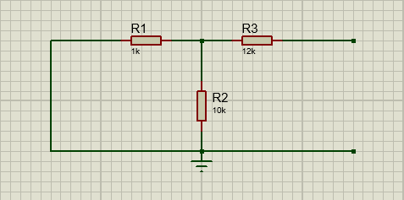
Fig. 1.3 – The circuit after removal and short-circuiting of the voltage source
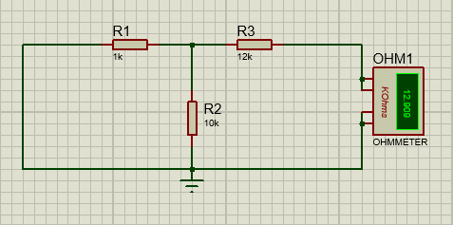
Fig. 1.4 – The modified circuit with the ohmmeter connected prior to reading

With the ohmmeter connected, a reading was taken, which gave the internal resistance of the circuit to be 12.909 kΩ. (Simulated Value)

2.3 – Measuring Power of the load resistor within the Circuit

An ammeter was inserted in series with the load resistor (Fig. 1.5). This allowed the load current to be recorded for a range of load resistance values between 1kΩ and 20kΩ. Using these two values, the Power transferred through the load was also calculated. These figures can be found in the table below. (Fig. 1.6) As expected, due to ohms law, the current across the load resistor decreases as the load resistance increases.
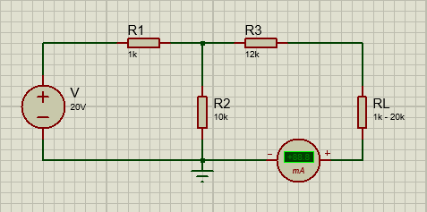
Fig. 1.5 – Circuit with ammeter inserted to measure load current

Load Resistance - R_{L} (kΩ) | Load Current - I_{L} (mA) | Power (mW) (Calculated)
1 | 1.31 | 1.7161
2 | 1.22 | 2.9768
3 | 1.14 | 3.8988
4 | 1.08 | 4.6656
5 | 1.02 | 5.2020
6 | 0.96 | 5.5296
7 | 0.91 | 5.7967
8 | 0.87 | 6.0552
9 | 0.83 | 6.2001
10 | 0.79 | 6.2410
11 | 0.76 | 6.3536
12 | 0.73 | 6.3948
13 | 0.70 | 6.3700
14 | 0.68 | 6.4736
15 | 0.65 | 6.3375
16 | 0.63 | 6.3504
17 | 0.61 | 6.3257
18 | 0.59 | 6.2658
19 | 0.57 | 6.1731
20 | 0.55 | 6.0500
Fig. 1.6. – [Table] showing load current readings and calculated power figures.

2.4 - Analysis of results

The calculated power figures were plotted against the increasing load resistance values using Microsoft Excel. This can be seen below. (Fig. 1.7)
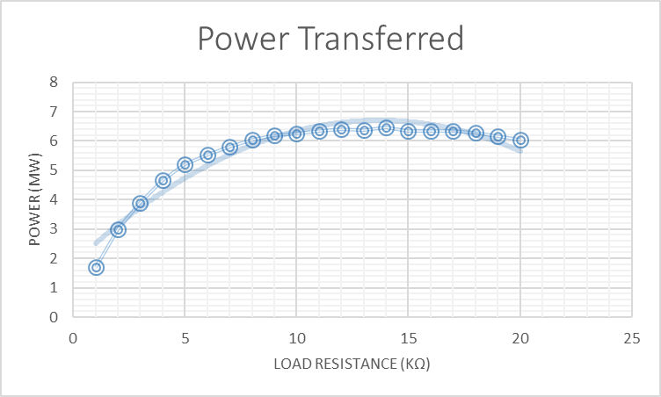
Fig. 1.7 – Graph showing power (y-axis) against load resistance (x-axis)

As can be seen from the graph, the power initially increases as the load resistance increases, however upon reaching a point the power begins to decrease again. If we apply the maximum power transfer theorem, this peak should indicate when the load resistance has equalled the load resistance.

The graph trend line shows that the peak is when the load resistance is approximately 13.75Ω. This is higher than the simulated value, and upon further inspection the data points near the peak actually fluctuate, with the power increasing until the 13kΩ value, then dropping for the 12kΩ before increasing to a new high at 14kΩ.

This fluctuation likely indicates the presence of an anomaly within the 12-14kΩ data points. This will be established within the theoretical calculations.

2.5 – Calculations and Comparison

To calculate the internal resistance, Thevenin’s theorem is applied using a circuit such as that in section 2.2 (Fig. 1.3) to find Thevenin’s equivalent resistance (R_{TH}).

R_{TH} | = | R3 | + | R2 | + | R1
 |  |  |  | 1
 | = | 12k | + | 1 | + | 1
 |  |  |  | 10k | + | 1k
 | = | 12909.09 Ω (2dp)

As shown, the calculated value for the internal resistance matches that of the simulation at
12.909 kΩ. This can then be used to calculate the load current (below).

I_{L} | = | V_{TH}
 |  | REQ | + | RL
 | = | 20
 |  | 12909.09 | + | 12909.09
 |  | 20
 |  | 25818.18
 | = | 0.00077465 A
 | = | 0.775 mA
This load current can then be used to confirm the theoretical maximum load power (below).
P | = | I² | x | R
 | = | (0.00077465)² | x | 25818.18
 | = | 0.015493…
 | = | 0.0155 W

This result was unexpected, as it is significantly away from the current range of the data collected. The calculation shows that the power of the load resistor should be a significant peak of approx. 15.5 mW at 12.9kΩ, yet the collected data from the simulation is instead showing a slight dip from the trend to approx. 6.4 mW.

Using this, it can be established that there is an anomaly present, in particular the value corresponding to the 13kΩ load resistance. This is likely due to some form of experimental error. This could be down to the precision of instrumentation, or as is quite possible, an error in the set up and/or measurement of the simulated circuit.

3. Task 2

3.1 – Initial Circuit and Introduction

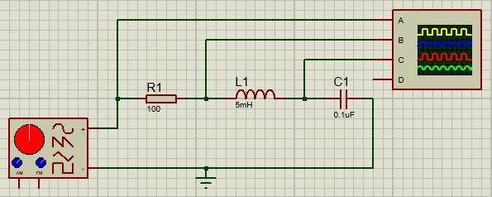
Task 2 was performed using a simple AC circuit again constructed according to the instructions given. It consisted of a 100Ω Resistor (R1), 5mH inductor (L1) and 0.1µF Capacitor in series, connected to a signal generator. An oscilloscope was attached to three branches for each component. This combination of components is known as an “RLC” circuit, which is a harmonic oscillator for AC current, and as such has a resonate frequency. This task was to find this resonant frequency.
Fig. 2.1 – Initial “RLC” Circuit

3.2 - Component Voltage Measurements

The signal generator was initially set to output a sine wave of 5V amplitude (from centre – 10V peak to peak) at 1 kHz frequency (Fig. 2.2). The Voltages across the Resistor (V_{R}), Inductor (V_{L}) and Capacitor (V_{C}) were then taken. The frequency was then increased at intervals of 2 kHz, with the Voltages being read off the oscilloscope (Fig. 2.3) and recorded each time, the results of which are below (Fig. 2.3)

The values for VC were monitored and an additional reading was taken either side of the peak voltage, as these were to be used to investigate the resonant frequency. The peak voltage, and the additional reading either side have been highlighted in blue.
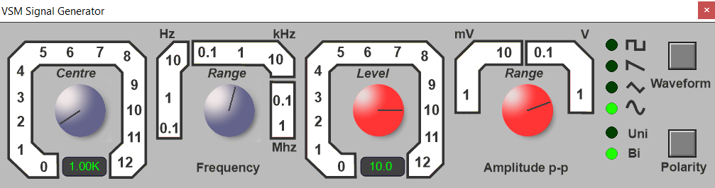
Fig. 2.2 – Initial signal generator settings.
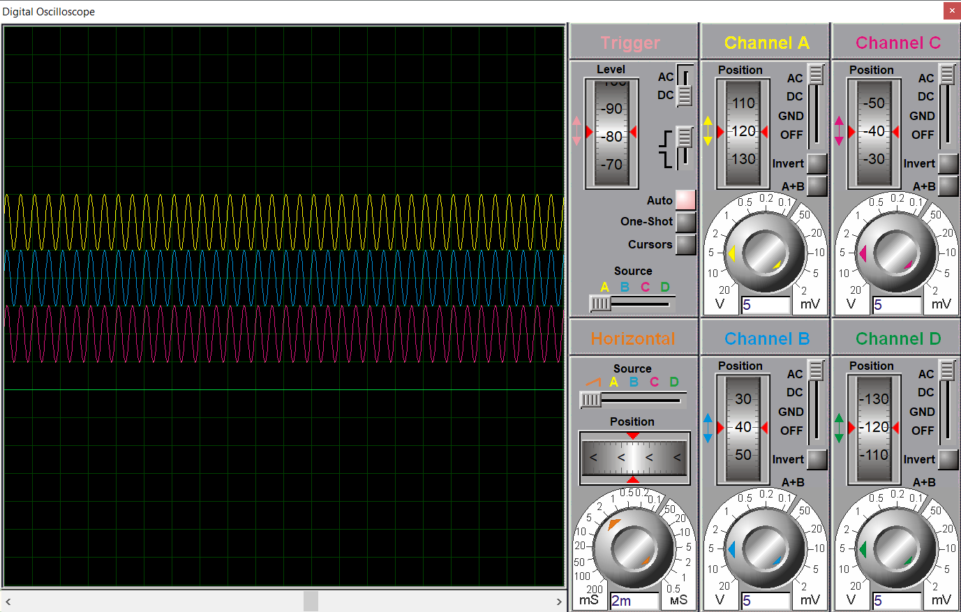
Fig. 2.3 – Oscilloscope Screen

V_{R} (V) | V_{L} (V) | V_{C} (V) | f (kHz)
10 | 10.00 | 9.94 | 1.0
10 | 10.40 | 10.00 | 2.0
10 | 13.50 | 9.12 | 4.0
10 | 21.20 | 5.64 | 6.0
 |  | 2.22 | 6.6
 |  | 1.30 | 6.8
10 | 22.00 | 0.15 | 7.0
 |  | 1.16 | 7.2
 |  | 2.04 | 7.4
10 | 16.50 | 5.00 | 8.0
10 | 8.30 | 8.46 | 10.0
10 | 4.76 | 9.28 | 12.0
10 | 3.14 | 9.50 | 14.0
10 | 2.26 | 9.68 | 16.0
10 | 9.840 | 9.84 | 18.0
10 | 9.840 | 9.84 | 20.0
Fig 2.4 – [Table] showing component voltage measurements

3.3 – Analysis of Results

A resistor has no reactance when AC current flows through it. As such the voltage across it (R_{L}) remains constant throughout at the full EMF of 10V.

As the frequency approached the circuit’s resonant frequency, the voltage across the inductor increased rapidly, resulting in a sharp positive spike with a maximum of approx. 22V.

The voltage across the capacitor was seen to do the opposite, with a rapid decrease apparent as the frequency approached resonance, resulting in a sharp negative spike with a minimum of approx. 0.15V. This is illustrated on the graph below. (Fig. 2.5)
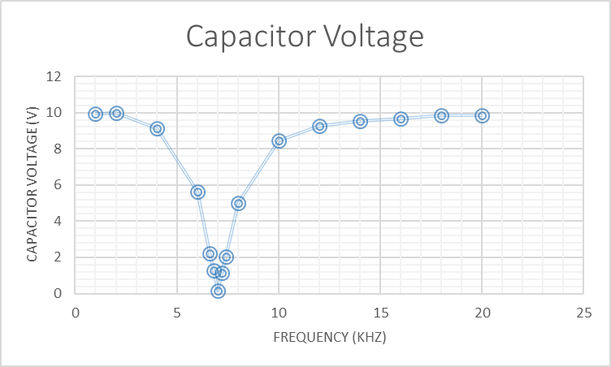
Fig. 2.5 – Graph showing capacitor voltage (y-axis) against frequency (x-axis)

As is apparent from the results, this particular RLC circuit would appear to have a resonant frequency of 7 kHz.

3.4 – Calculations and Comparison

By calculating the theoretical value for the resonant frequency of this circuit, the validity of the simulation result can be assessed.

f_{R} | = | 1
 |  | 2π√LC
 | = | 1
 |  | 2 | x | π | x |  | √((5 x10⁻³) x (0.1 x10⁻⁶))
 |  | 1
 |  | 2 | x | π | x |  | √(5 x10⁻¹⁰)
 | = | 7117.6254…
 | = | 7.117 kHz

The (simulated) experimental value is well within 10% of this calculated value, and as such if it had been performed using components it could have been stated that it was the same “within the limits of experimental uncertainty”. However, this difference is likely to be due to rounding errors, as well as parallax error/human factor when reading from the oscilloscope.

4. Conclusion

Both simulated circuits performed mostly as expected, which supports the use of simulation software such as Proteus® when electronic components aren’t available, or if a digital prototype is preferred.
In Task 1, the power across the load resistor increased to a maximum at a value near to the calculated internal resistance, as expected. Whilst the Sharp peak was lost for reasons unknown, the data collected still allowed the approximate internal resistance to be seen in the data.
In Task 2, the circuit performed as expected and clearly showed the maximum resonant frequency of the AC “RLC” circuit, with a large positive spike in the voltage across the capacitor, and a large negative spike in the voltage across the inductor. This value was approximately the same as the calculated value.
As with physical experiments, care needs to be taken when simulating circuits to ensure that the digital instruments are of a high enough precision, that rounding errors are avoided where possible, and that graphical instrumentation is read correctly.

