STRUCTURE AND CULTURE

Student name: Ciprian Simpliceanu
Student ID: 1817169
Course: Introducing the Modern Workplace
Lecturer: DR. Gregory Cowan
DR. Molly Jack
DR. Rula Alousi
DR. John-Paul Okeke

Table of Contents
Introduction 3
Cultural Analysis and Organisational Performance 3
Functions of Managerial Work 4
Leadership Communication 6
Behavioural Management 7
Conclusion 8
Reference List 10
Appendices 12
Appendix 1: Group sales performance of Mercedes-Benz from 2015 to 2019 12
Appendix 2: Group revenue of Mercedes (2015-2019) 13
Appendix 3: Seven aspects of behavioural management in Mercedes 14

Introduction
Organisational cultures are significant markers of organisational performances. Values, ideologies, principles and beliefs of organisations attribute in developing organisational cultures. It also controls workplace behaviours of employees in framing productivity and profit. Similarly, unique and employee-friendly organisational cultures are beneficial for ensuring sustainability. Therefore, this essay aims to analyse organisational structure and cultural aspects of Mercedes Benz, for analysing its performance in global context. It also demonstrates functions of managerial works in this company and leadership considerations for understanding core values of organisation. Further, this essay outlines behavioural management aspects of Mercedes Benz for aligning them with productivity and sustainability.

Cultural Analysis and Organisational Performance
Mercedes-Benz is a German Automobile company, which includes over 173,000 employees across the world (Forbes.com, 2020). Daimler-Motoren-Gesellschaft (DMG) and Benz & Cie merged in 1926 to form the lucky star; Mercedes-Benz. It is world's one of the largest manufacturer of premium passenger cars with the use of high-quality technologies for electric mobility (Mercedes-benz.com, 2020). Mercedes-Benz includes a functional hierarchical structure within organisations that is dependent on product divisions.
According to functional organisational structure model, every production and functional unit of company has its reporting hierarchy and decision-making system. It enables a company for efficient and fast decision-making according to internal resources of that unit (Behmer et al. 2016). Mercedes has two main functional divisions, being car and van division. Based on these considerations, Mercedes observed record selling of 2,385,432 cars and 438,386 vans in 2019 (Mercedes-benz.com, 2020)[Refer to Appendix 1]. Not only Mercedes focused on unit sales; instead, it also launched a wide range of products according to customer demands. Such aspects supported around $121.7 billion sales in 2020, predominantly in China, followed by US, Germany and other parts of world (Forbes.com, 2020)[Refer to Appendix 2].
Theory of organisational culture states that seven elements of companies shape organisational cultures. They are “structural stability, breadth, depth, pattern of integration, visible artefacts, beliefs and values and underlying assumptions”. Mercedes has a functionally stable working structure, which helps employees in reflecting optimised productivity (Oyewobi et al. 2016). Mercedes aimed to support sustainable and eco-friendly mobility in future, which is noted in their R&D, van and car production sections. It undertook “Ambition 2039” for supporting mobility path across all parts of organisation (Mercedes-benz.com, 2020). According to theory of Organisational behaviour, if employees share a shared vision and goal for a more extended period, then they reflect a consistent and stable culture. Such aspects always lead to productivity and innovation (Cropley and Cropley, 2017). Mercedes supported this approach in designing sustainability strategies. Employees share an open environment for supporting innovation and knowledge sharing. All departments across the organisation aim to shift towards electrifying models and to establish a CO2-neutral environment (Mercedes-benz.com, 2020).
Mercedes-Benz believes in teamwork for accomplishing goals of business. Top management of every department provides freedom to employees for sharing their views in decision-making processes. Thus, organisational culture of Mercedes also depends on transformational leadership theory (Shafique and Kalyar, 2018). Employees get remunerations and incentives according to industry standards (Mercedes-benz.com, 2020). HR training, scopes of employment benefits and professional development are evident within Mercedes, which are strong points of their success. Supervisory boards, audit committee and quality control board are there in Mercedes, which controls entire operations across the company (Daimler.com, 2020). Thus, it is clear that Mercedes believes in multiple theories and models within organisational culture development, which is the crucial factor for their success. Such concept connected with the Contingency theory of organisational behaviour, which states that there is no fixed cultural model for organisations to reflect success (McAdam et al. 2019).

Functions of Managerial Work
Work as well as role of managerial perspectives in “Mercedes Benz”, has enabled effective and efficient business performance in global aspects. It is to be noted PLEASE AVOID USING PASSIVE VOICE that development of business standards is an integral part of organisational perspective that helps in behaving and structuring of an organisation (Stewart, 2019). Managers in this organisation enhance proper response towards establishing result experience that further “Managerial Work”, has been further primarily ensuring appropriate goals along with targets of "Mercedes". It is also to be noted PLEASE AVOID USING PASSIVE VOICE that it further includes functions as well as processes that structure a business performance in marketing dynamics.
The "Functions" of proper managerial supervisor are further plentiful, which involves adequate planning along with direction towards achieving business goals and targets. The managers are considered PLEASE AVOID USING PASSIVE VOICE as “Figurehead”, along with establishing proper monitoring and control on different forms of team management (Stewart, 2019). This also helps them to disseminate a piece of appropriate information along with data for people working in their leadership. It also enhances proper cultural analysis while explaining different aspects of their performance based on business standards in organisational perspectives. This is also the same scenario for the managers to manage "non-routine and routine events”, which involves proper “decision-making process and directing" the organisation towards achieving organisational success in marketing dynamics (Bouty and Drucker-Godard, 2019).
This is also to be noted PLEASE AVOID USING PASSIVE VOICE that it enhances different managing forms of work performance and to improve communication with team members for bringing out the best performance in organisational perspectives (Mercedes-benz, 2020). This also helps in the managers for developing potential standards along with effective and efficient processes for measuring performance along with the determination of an effective decision-making process. This also enhances a proper illustration of an organisational capability for establishing appropriate and clear standards along with methods to measure an appropriate performance.
They also help in establishing proper "Training and Development" performance, thereby enhancing proper concerning the measurement of potential return. It helps in regular width along with providing substantial data and information for improving adjustments towards necessary protocols (Willmott, 2019). It is essential for the managers for enhancing “Proper Determination of Business Performance”, towards establishing a proper performance comparison between team members to monitor their adequate performance analysis. It also increases in deciding types of training along with development practices that can enhance appropriate business standards.
It also illustrates the fact that the performance standards of different organisational participants must meet the organisational requirements (Willmott, 2019). It certain cases, it becomes their decision for reviewing specific policies and guidelines towards enabling needed change related to different forms of significant tasks along with modifying them.
It also enhances “Corrective Action”, for utilising potential information towards sustaining proper control process. It also involves in properly promoting schedule related to a different form of employees along with enabling strategic coordination with various participants and employees in organisational standards (Johnson and Dobni, 2016). This also enhances properly maintaining along with managing potential budgets along with creating proper organisational awareness and further establishing proper "Problem-Solving" techniques towards improving proper business performance in marketing dynamics.

Leadership Communication
“Managers”, in “Mercedes Benz”, requires potential sharing of information along with data related to organisational standards for enhancing proper levels of communication. This organisation generally follows “Participative Leadership Management”, which further enhances decent ability towards delivering needed information towards inspiring team members for enhancing business action and activities (Johnson and Dobni, 2016).
This also establishes “Self Esteem and Confidence”, among different company stakeholders towards presenting ideologies along with ensuring organisational vision in team perspective in organisational standards. This also enhances efficiently “Conveying Insights”, along with potential recommendations for establishing better business performance.
It also enhances proper communication standards towards delivering adequate information and data towards strengthening proper comprehensive understanding. It also enhances better communication with a different form of communication towards assisting proper accessibility of different employees towards following up with creativity and different ideologies (Fosteret al. 2019).
This also enables proper “Visibility”, concerning organisational standards towards enhancing spending "face-to-face meetings", with different employees along with other potential organisational members in business standards (Mercedes-benz, 2020). This also helps in strengthening a strategic approach towards enhancing business communications while establishing proper standards of visibility among organisational measures. This also leads to the next step, which enables "Empathise”, which helps for identifying along with comprehensively understanding different emotions, thereby imagining them in a different position. This also helps in the managers for developing potential standards along with effective and efficient processes for measuring performance along with the determination of an effective decision-making process. It also enhances managers for enhancing favourable conditions for organisational standards towards agreeing to different action plan related to employees in business standards.
It also involves in "Implementation decision of Advance Technologies", that enhances breaking down of various forms of complex thinking-process along with other potential strategic approaches into different simple concepts towards employees (Fosteret al. 2019). This help in having proper distillation of complexities into their essence and enhancing a comprehensive and potential understanding and knowledge in business dynamics (Willmott, 2019).
This also helps in improving expectation standards related to the working performance of different employees and enable them to enhancing proper productivity standards in business marketing dynamics. It also helps the managers for enhancing proper leadership practices along with an increasing proper focus towards improving "Feedback Systems” that helps in working on it along with enhancing business performance.

Behavioural Management
Behaviour management is a systematic process of maintaining law and order in an organisation for supporting growth and productivity. It focuses on existing behavioural practices, resources and focuses of organisation for enhancing efficiency in business (Griffin et al. 2020). Organisational behaviour depends on individual and team-related behaviours, which depend on human relations and employee wellbeing aspects. Thus, aligning employees with a specific type of behaviour is necessary for obtaining optimal performance of a company.
Managerial board of Mercedes follow optimists and trusting types of behaviours with their employees. For instance, company entirely relies on employees regarding research, innovation and new technologies for future. Managers also involve with several project groups for reviewing decisions related to principle and additional supports (Daimler.com, 2020). Thus, internal operational environment for Mercedes shares collaborative approaches with all stakeholders for visualising a big picture on their future productivity. Such aspects are similar to considerations of "Bureaucratic Management theory” of behavioural management (Sturdy et al. 2016). According to this theory, an organisation is considered as a Bureaucratic system, which has distinct classification of labour, chain of command, personalised and organisational assets record-keeping activities, promotional and qualified performance and consistent regulations (Taylor, 2018). Such a behavioural management aspect helps Mercedes to keep a stable working environment, which is supportive of innovation and growth.
Furthermore, Mercedes has a strict “Compliance management system” what aims to establish ethical business behaviours through compliance activities. It incorporates seven components within employee management and behavioural control system for driving towards sustainability [Refer to Appendix 3]. Firstly, it focuses on values and then aligns them with organisational objectives (Sanders and Lin, 2016). Next, this system integrates them within operational environment and evaluates any risks of non-compliance. Then, based on evaluated risks and probability of risks, they develop a compliance program. Employees participate in communication and training activities under those compliance programs for ensuring safety, integrated and ethical organisational behaviour (Daimler.com, 2020). Finally, Compliance committee monitors entire activities and develops plans for improvements.
Therefore, by maintaining all those considerations, Mercedes implemented and managed anti-corruption behaviours. It always believes in fair competitions, thus, aligns all products with International technical-regulatory frameworks. Mercedes shares a diverse and integrated workforce, which always respect for human rights protection. In case of innovation, Mercedes aligns with "Data Protection Laws" (Daimler.com, 2020). Prevention of money laundering and compliance with sanctions are also some potential behavioural management aspects of Mercedes.

Conclusion
This assignment enhances the proper description of the structure, along with culture related to organisational standards. This further illustrates a proper strategic analysis that involves "Mercedes Benz" and its organisational operation in marketing dynamics. It also enhances proper cultural analysis while explaining different aspects of their performance based on business standards in organisational perspectives. It also establishes proper functions related to the manager's work operations. This also helps them to disseminate a piece of appropriate information along with data for people working in their leadership. This also illustrates a description about proper establishment of “managerial leadership”, along with enhancing potential behavioural management. Furthermore, it illustrates proper “organisational performance”, of “Mercedes Benz”, in business marketing dynamics.

Reference List
Book
Griffin, R.W., Phillips, J.M., Gully, S.M., Creed, A., Gribble, L. and Watson, M., 2020. Organisational Behaviour: Engaging People and Organisations. Melbourne: Cengage AU.
Stewart, R. ed., 2019. Managerial work. Abingdon: Routledge.
Journals
Behmer, F., Jochem, R. and Hanke, H., 2016. Planning and reorganising quality management organisations–an empirical analysis of current practice. Total Quality Management & Business Excellence, 27(7-8), pp.963-978.
Bouty, I. and Drucker-Godard, C., 2019. Managerial work and coordination: A practice-based approach onboard a racing sailboat. Human Relations, 72(3), pp.565-587.
Cropley, D. and Cropley, A., 2017. Innovation capacity, organisational culture and gender. European journal of innovation management, 20(3), pp.493-510.
Foster, W.M., Hassard, J.S., Morris, J. and Wolfram Cox, J., 2019. The changing nature of managerial work: The effects of corporate restructuring on management jobs and careers. Human Relations, 72(3), pp.473-504.
Johnson, B. and Dobni, D., 2016. Is managerial work in the public and private sectors really “different”? A comparative study of managerial work activities. International Journal of Public Administration, 39(6), pp.459-469.
McAdam, R., Miller, K. and McSorley, C., 2019. Towards a contingency theory perspective of quality management in enabling strategic alignment. International Journal of Production Economics, 207, pp.195-209.
Oyewobi, L.O., Abiola-Falemu, O. and Ibironke, O.T., 2016. The impact of rework and organisational culture on project delivery. Journal of Engineering, Design and Technology, 14(2), pp.214-237.
Sanders, K. and Lin, C.H., 2016. Human resource management and innovative behaviour: considering interactive, informal learning activities. Human resource management, innovation and performance, pp. 32-47.
Shafique, I. and Kalyar, M.N., 2018. Linking transformational leadership, absorptive capacity, and corporate entrepreneurship. Administrative Sciences, 8(2), p.9.
Sturdy, A., Wright, C. and Wylie, N., 2016. Managers as consultants: The hybridity and tensions of neo-bureaucratic management. Organization, 23(2), pp.184-205.
Taylor, S.P., 2018. Organisational behaviour, leadership and change. International Journal of Housing and Human Settlement Planning, 4(1), pp.21-36.
Willmott, H., 2019. Studying Managerial Work: A Critique And A Proposal. Managerial Work, 24(3), p.305.
Websites
Daimler.com, 2020. Annual Report and Full Year Results 2019. Viewed on 22/08/2020 <https://www.daimler.com/investors/reports-news/annual-reports/2019/>
Daimler.com, 2020. Daimler's Compliance Management System. Viewed on 22/08/2020 <https://www.daimler.com/company/compliance/compliance-management-system.html>
Mercedes-benz.com, 2020. The Mercedes-Benz AG at a glance. Viewed on 22/08/2020 <https://www.mercedes-benz.com/en/company/>
Forbes.com, 2020. Mercedes-Benz. Viewed on 22/08/2020 <https://www.forbes.com/companies/mercedes-benz/#140e768f1efa>

Appendices

Appendix 1: Group sales performance of Mercedes-Benz from 2015 to 2019
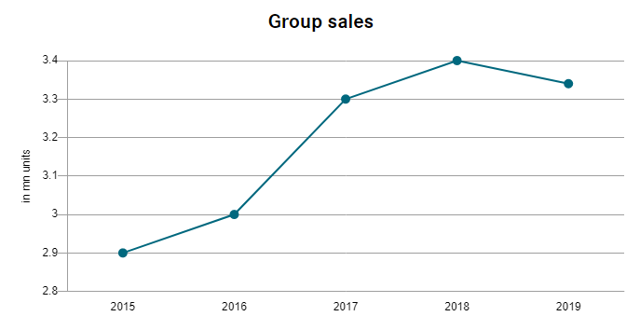
(Source: Daimler.com, 2020)

Appendix 2: Group revenue of Mercedes (2015-2019)
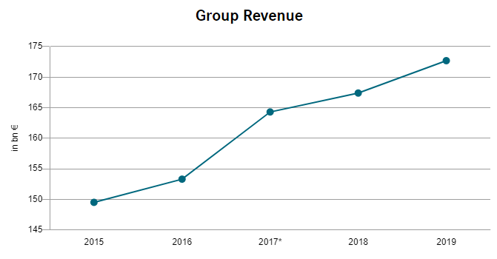
(Source: Daimler.com, 2020)

Appendix 3: Seven aspects of behavioural management in Mercedes

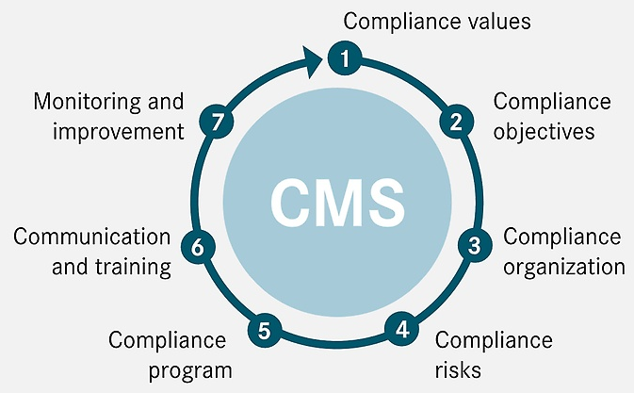
(Source: Daimler.com, 2020)

