Landscape of strata Florida

Grid reference: 52.281025, -3.812701

Adam Mackelden (1600926)
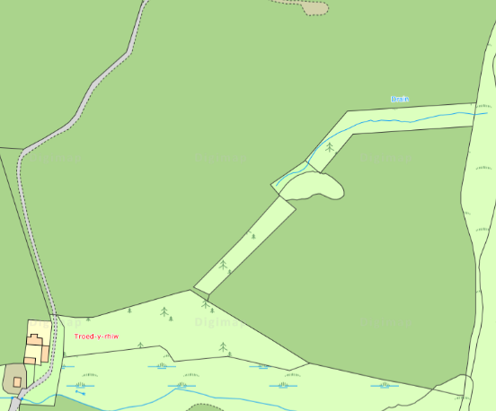

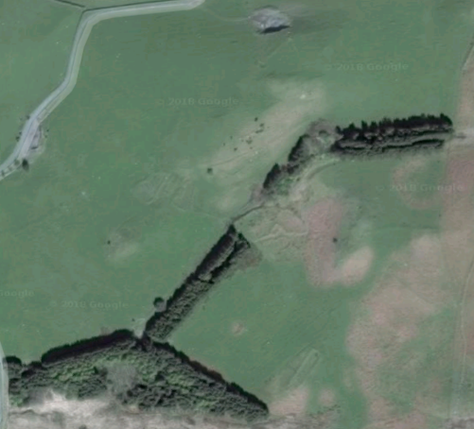

Introduction
The site surveyed for this report forms part of the uplands of Strata Florida. Situated within a picturesque part of Ceredigion close to the ruins of medieval Cistercian Abbey, this site would have controlled the surrounding area. The site has been divided into left and right as shown on the title page.
Wildlife.
The presence of sheep on the land indicates a long period of sheep grazing on the land, affecting its condition. We would later discover that the structures identify a historic practice on the site, thus potentially influencing the “natural landscape” due to the sheep’s cultural significance. This can also be seen as an indicator to the land use in the area as it suggests that this area has been used for grazing and rearing sheep. Red Kites also can be seen frequenting the area suggesting the presence of small vermin within the landscape, for example the common wood mouse would thrive within the area due to the vegetation of the landscape. However, the presence of Red Kite in the area can also be related to human interference as in the past 25 years the Red Kite has seen a resurgence due to a human interaction in relation to conservation projects.
Ecology.
There is a lack of macro flora within the left side of the site bar a singular tree. Dividing the site are pine trees, which were identified to have been grown in the past 30-40 years. This can be seen in figure 3 and throughout the majority of the other figures. The presence of moss, like that shown in figure 1, on freestanding stone indicated possible building material as the moss on the freestanding stone matched with the moss growing on the raised features within the landscape hinting that these features were stonewalls and not earth works. On the right side of the site, on the second structure, there are a number of dead and dying ferns indicating that during the summer and autumn month’s ferns would cover the surrounding area shown in figure 7. Running along the border between the left and right side of the site there is a small stream, which is surrounded by flora.
Manmade Features.
There are a number of man-made features on the site namely from the medieval period from the C14th century through to the 16th century ranging from small farming settlements through to Monastic sheep sheds (see appendix for more details on manmade features). The material for their construction was mined from the immediate area, showing evidence of their exploitation of their surroundings. The location of these farming settlements suggests that there were intensive agricultural practices taking place in the lowlands forcing people into the uplands. There are also modern features such as modern ridge and furrow from the Second World War. (See appendix for more details on manmade features).
Possible heritage aspect.
If this site were to be marketed as a heritage site or trail, a number of factors would need to be addressed. Firstly, the protection of the site, due to the fact that if this site did become a heritage site, which is, open to the public it would increase footfall which may have a negative effect on the preservation of these structures. Another factor, which must be taken into account, is the removal of the wire fence. This would create problems for the local farmer who uses the land for his sheep they would be allowed to run free throughout the site meaning a gate would need to be erected as well as a bridge to allow movement across the small stream between the two sides of the site. Again with this increased footfall appears on the site so does the amount of litter which would be created. This would mean that the site would need employees to manage the site, as you cannot rely on members of the public to take their litter with them. All of this means when looking at this site with the intent to turn it into a heritage site there would be much work needed to protect the site.

Figures

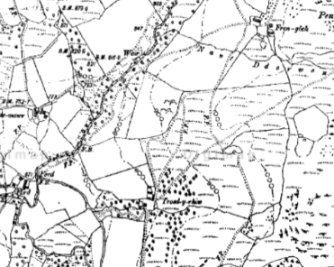
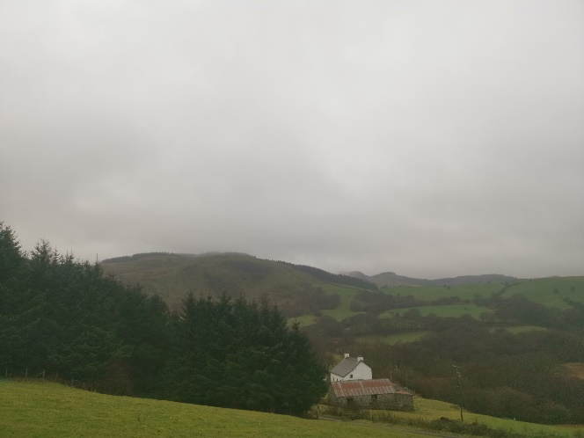
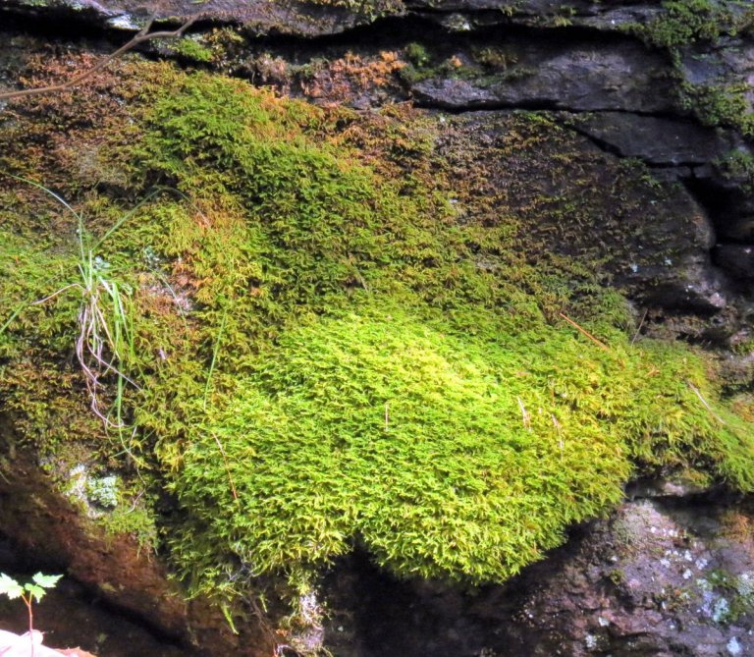
Figure 3: Historical map of the Site

Figure 2: showing the pine trees dividing the site

Figure 1: showing the type of moss located on the stone found at Strata Florida

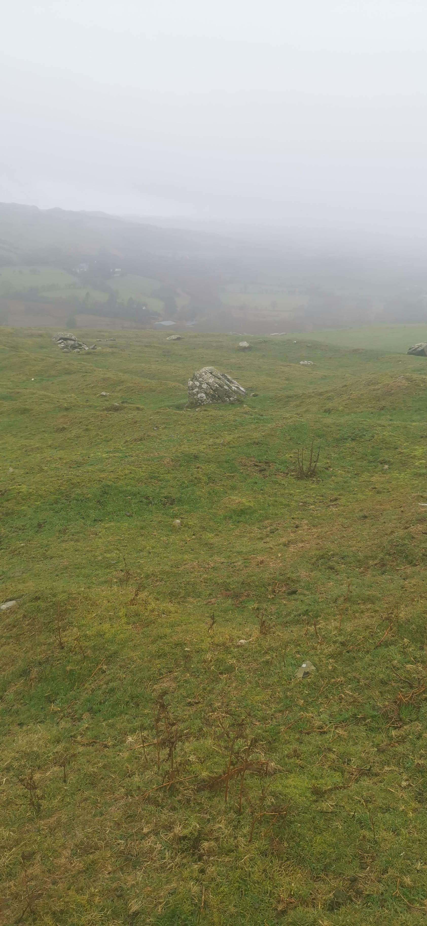
Figure 4: Image of the enclosure with ridge and Furrow markings

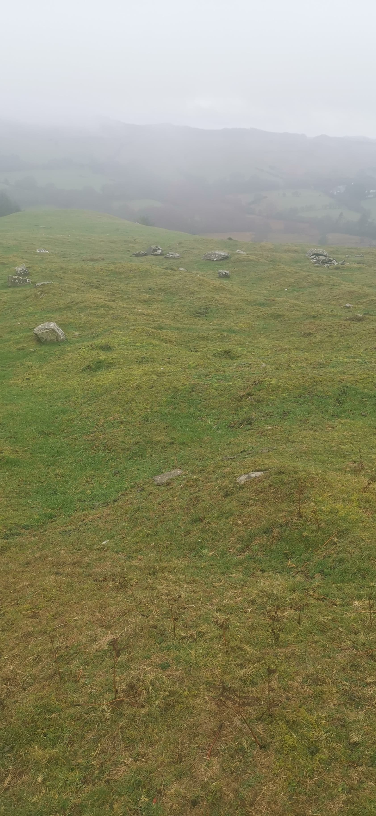
Figure 5: Image showing the living structure

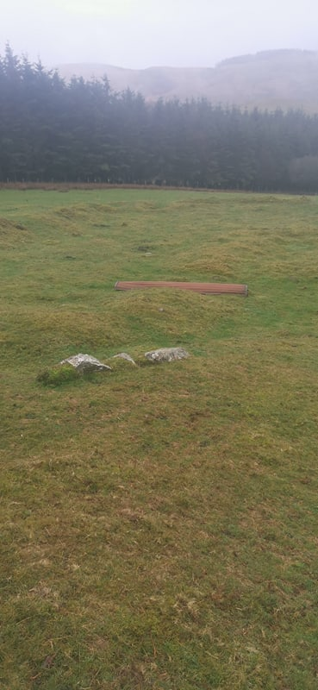
Figure 6: Image showing the large enclosure

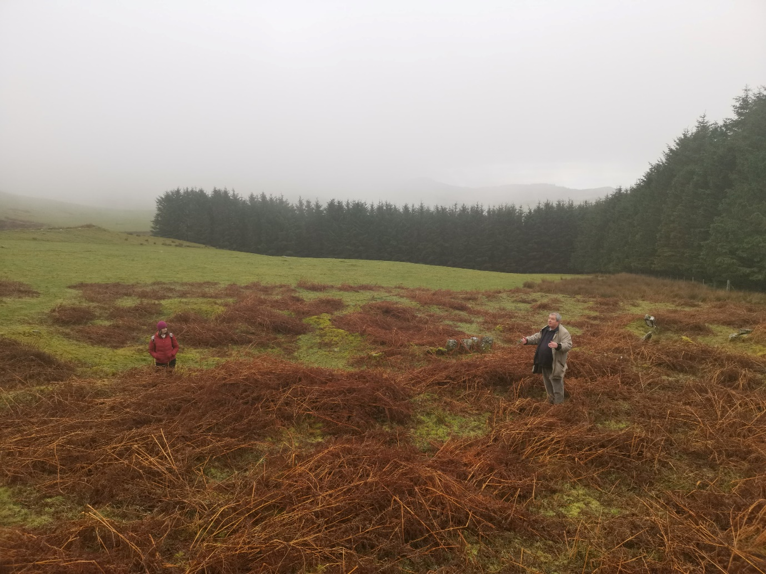
Figure 7: Image showing the settlement and dead ferns on the right side.

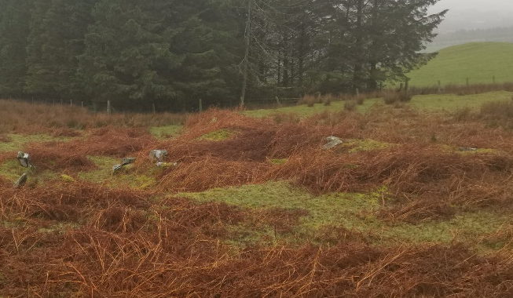
Figure 8: Image showing the living structure of the settlement on the right side of the site.

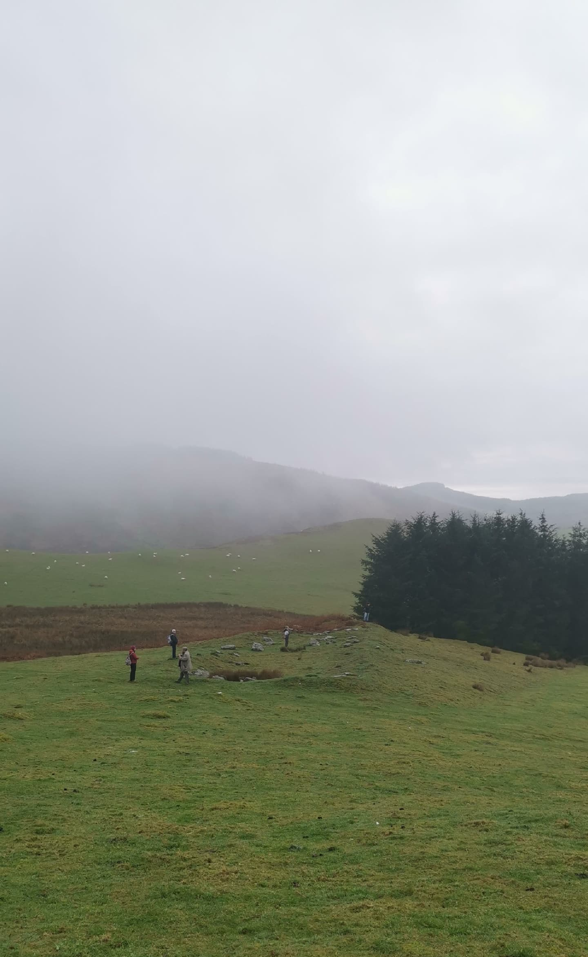
Figure 9: Image showing the Monastic “Sheep shed”

Title page
- https://www.google.com/maps/@52.2811714,-3.8128037,337m/data=!3m1!1e3 Date accessed 14/01/19
- https://digimap.edina.ac.uk/roam/map/os Date accessed 14/01/19

Figure list
- https://nhgardensolutions.wordpress.com/category/mosses-liverworts/ Date accessed 14/01/19
- Adam Mackelden taken 11/01/19
- https://digimap.edina.ac.uk/roam/map/historic Date accessed 14/01/19
- Adam Mackelden taken 11/01/19
- Adam Mackelden taken 11/01/19
- Adam Mackelden taken 11/01/19
- Adam Mackelden taken 11/01/19
- Adam Mackelden taken 11/01/19
- Adam Mackelden taken 11/01/19
Bibliography
https://digimap.edina.ac.uk/ Date accessed 14/01/19

Appendix
Gird reference 52.281025, -3.812701
there are three structures on the left side, which make up a small self-sufficient C14th “farmstead” with a walled enclosure shown in figure 6 a small living structure shown in figure 5 and another small enclosure with evidence of agriculture practices signified by the ridge and farrow marks within the enclosure as shown in figure 4. Moving to the right side of the field, there are set of features as shown in figures 7 and 8. Again, with a walled enclosure and small living structure combined with multiple holding pens. However, due to the size of the enclosure and the presence of slate it is believed that this set of structures date from the C15th. Again, on the right side of the site there is another stone structure, longer and larger than the other structures. This was identified as a Monastic “sheep shed” from the late medieval period as shown in figure 9. On the left side of the site, there is evidence of mining for the building materials used in the construction of these structures.
All of these structures sit on a levelled area, which was created for these structures to be erected. All of these structures and their location can provide an insight into the activities that were being conducted within the low lands as shown in figure. The location of these farming settlements suggests that there were intensive agricultural practices taking place forcing people into the uplands.
There are a number of post medieval manmade features within the right side of the site, for example, there is a modern wire fence running across the division, which I have implemented, between the left and right side of the site. There is also evidence of the farming practices taking place from the Second World War due to the presence of wider ridge and furrow as a by-product of ploughing.

