
Assessment Component 1
Children, Young People and Families: (BMHP5004_LON)

Case study – Supporting paper
Student name: Elena Ruseva
Student ID:2008341
Lecturer name: Bianca Sanfilippo
Word count: 1051

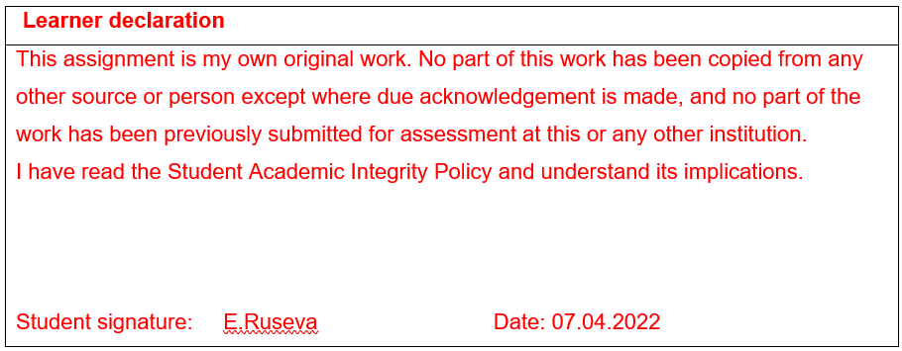

Table of Contents

Introduction 3
Case study 3
The risk factors of vulnerability 3
Analysis and legal frame of interventions taken 4
Evaluation of the responses of various agencies 5
Recommendations 5
Conclusion 5
References 15

Introduction
Having a family is an important life milestone for many, however, it can sometimes be a challenge to some resulting in poor parenting. Studies from the UK report that many children today are living with unmet needs, which burdens social services (Leeds Trinity University, 2022). This burden could be reduced if preventive measures are taken, using the “whole-family” support approach as failure to support the parents first could in turn impact their children negatively (Leeds Trinity University, 2022). Families become vulnerable for various reasons including financial issues, physical abuse, poor parenting, and poor health. This paper is based on the presentation (Appendix A) of the case study, identifying the specific elements of vulnerability in a family and the impact of health and social care agencies involved in the case. Recommendations on how to improve future interventions will be provided.

Case study
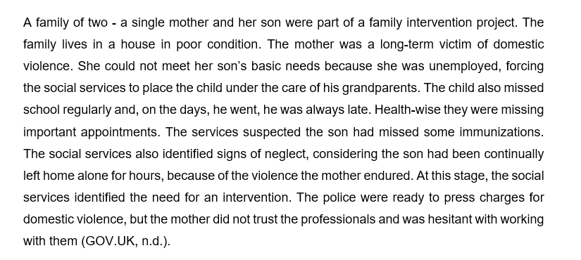

The risk factors of vulnerability
Children are considered at risk of poor outcomes when their environment, community, guardians, or background have a negative impact on them. As defined by GOV.UK. (n.d.). “Being vulnerable is defined as in need of special care, support, or protection because of age, disability, risk of abuse or neglect.” Neglect and domestic abuse of a child can often result in long term psychological consequences, such as phobias, anxiety, emotional detachment, and personality issues (Edwards, 2019).
In the Wandsworth case, there are key identifiers that both the mother and son are vulnerable to. The child could be classified as a child in need according to the Children Act 1989 because:
- The mother has been a victim of domestic violence (DV). Such events are known risk factors for mental health conditions such as depression, and post-traumatic stress (Parker, 2019).
- The mother being unemployed suggests she likely cannot meet her and her son’s basic needs.
- The child witnessed DV. A CDC report suggests that up to 80% of children witness DV, and those children are 15 times liker to become victims of maltreatment themselves (Edwards, 2019).
- The son’s health being neglected by missing immunizations, makes him vulnerable to some diseases. Chronic child neglect can be defined as hindering the child’s growth and development, by ignoring their physical and emotional needs (ICFI, 2013).
- Failure to attend school negatively impacts the child’s education, which can have economic and health consequences in future. Education has been strongly linked to health outcomes and employment chances. (Ferguson, Bovaird and Mueller, 2007).
- The living conditions of the family are miserable, which puts their health at risk. Housing conditions have been found to influence health status (Braveman et al., 2011).

Analysis and legal frame of interventions taken
The child was assessed because he was identified as “in need” under the Children Act of 1989, which states that a child in need would not be able to live a high-quality life without the intervention of the local authority. The social services applied various interventions to provide support and safeguarding to the family.
- Furst the social worker established a positive relationship with the family.
- During the first weeks, the social worker provided practical assistance while observing the family’s routine. Their living and housing situation improved. Children’s physical needs must be addressed first (Maslow,1954).
- The family received help with booking appointments and school routines for the son. According to the UN Convention, one of the basic rights of a child is to be educated (UNCRC, 1991). The first impact of the current intervention was observable when the child’s school attendance improved. The son also received up-to-date vaccinations.
- The mother began communicating with the social worker by expressing her mental state and her desire to be a good mother. She was placed on anti-depressants, which stabilized her mental health. She is now volunteering in a local primary school while looking for a job.
- The abusive ex-partner was imprisoned. The family worker later also organized a house transfer for the affected family, because of fear the imprisoned man could be a danger upon his release. In this case, the social workers took into consideration the Children Act 1989, as it suggests that a child in need should have a safe accommodation (Section 20 or Section 31A Children Act 1989).
- Ofsted’s safeguarding policy applies to the case study, as it promotes the welfare of vulnerable children and adults (OFSTED, 2018). The policy framework is guided by the Care Act 2014 on how they prevent child maltreatment and impaired development, ensuring opportunities for the child, e.g., schooling (OFSTED, 2018).

Multidisciplinary working (Actions taken)
The Children Act of 2004 and the official guidance 'Working Together to Safeguard Children' apply to practitioners. They are required to work in collaboration with other agencies, to provide optimal care for the children in need (2018). Examples include the family worker who was selected to help the family with daily life and establish a routine. The nearby primary school invited the mother to volunteer there. Health professionals were involved in handling issues like mental health and vaccinations. The police were involved in pressing charges against the ex-partner.

Evaluation of the responses of various agencies
All the interventions proved effective. The problems were tackled at different levels and points, including the home, health, and safety of the family. The abovementioned stakeholders and the family itself contributed to the overall positive outcome.

Recommendations
The intervention succeeded in meeting the needs of the family. However, it might have also been appropriate to assess the various factors that were leading to the mother’s toxic relationship. Her strained relationship with her family, for example, could have affected her psychologically, making her more susceptible to abuse. According to Healthline (2020), being a victim of domestic abuse presents a higher risk of being assaulted again. Therefore, it is important to focus more on the mother’s mental health and traumas, apart from just prescribing antidepressants, to maximize the chance she gets better and to prevent future abusive relationships. Counselling and psychotherapy are applicable interventions in this case.

Conclusion
This paper discussed how a vulnerable family can be assisted by social services. The analysis focused on why the family classifies as vulnerable - the various risk factors that could have contributed. The social services interventions have been presented taking into consideration the guiding policy and multi-disciplinary working. The responses by the involved agencies have been critically analyzed, and recommendations were provided to ensure better care in the future.

Appendix A
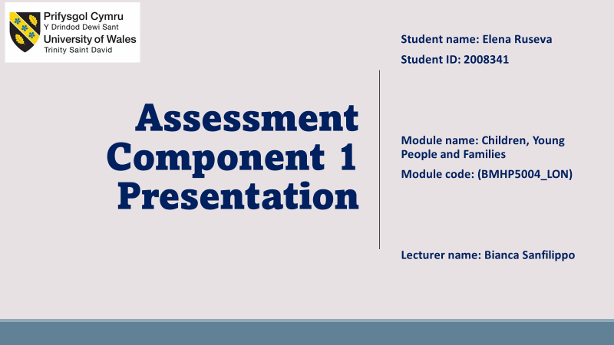
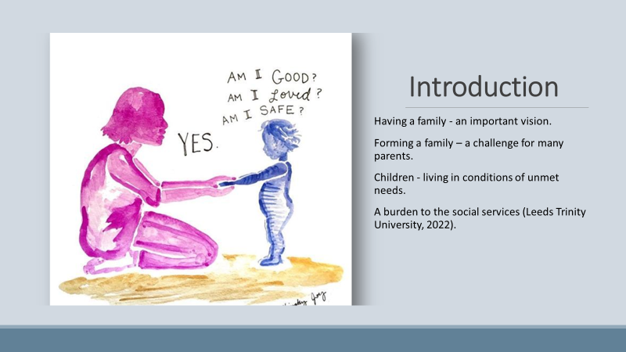
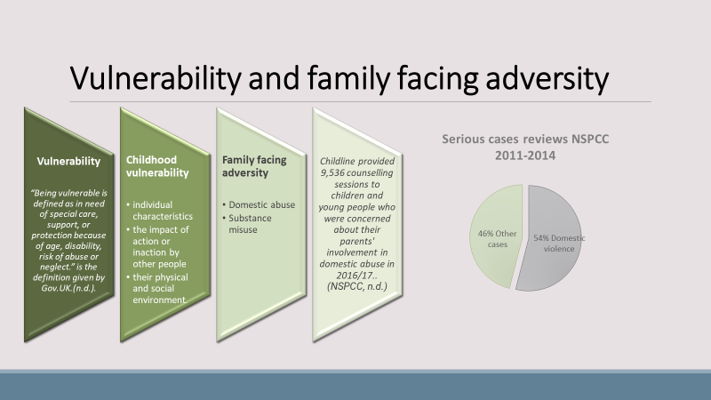
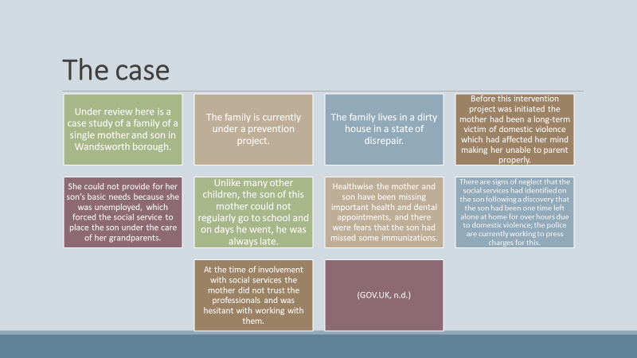
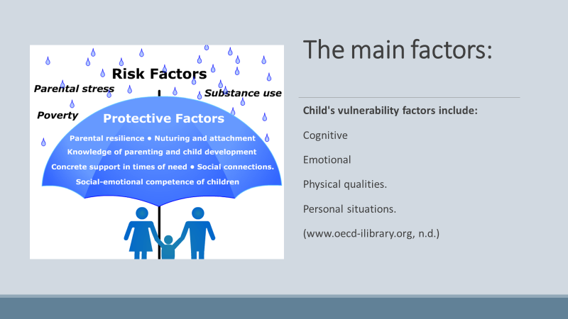
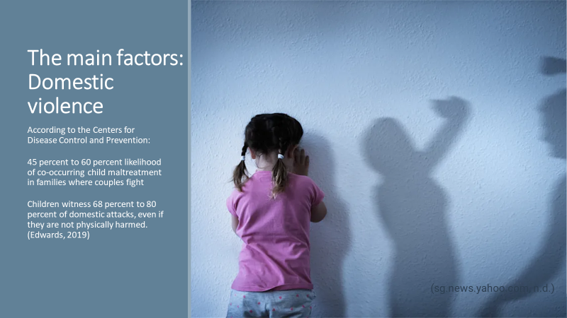
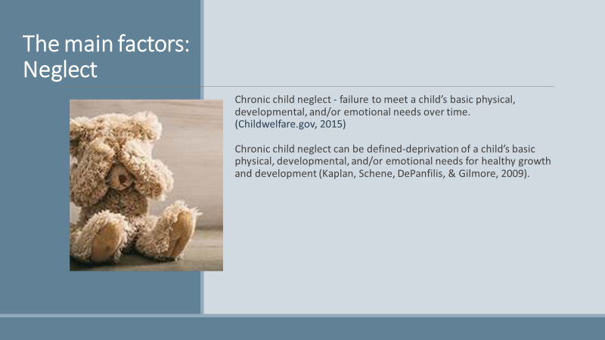
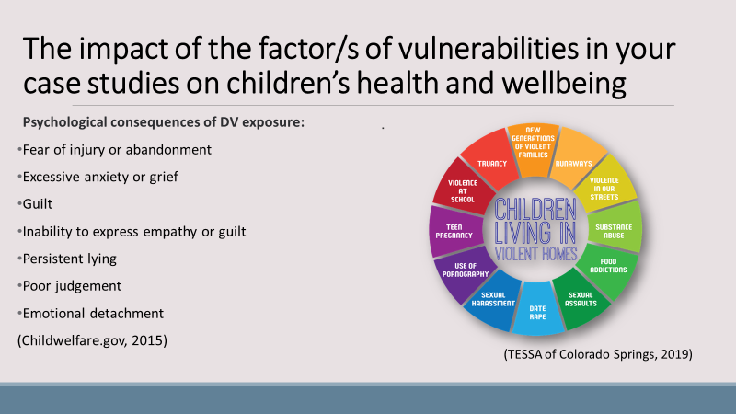
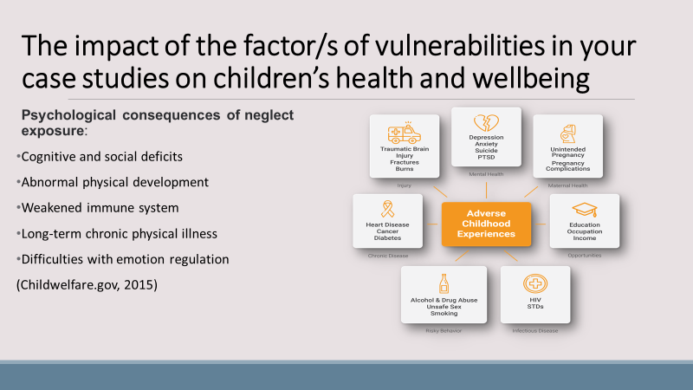
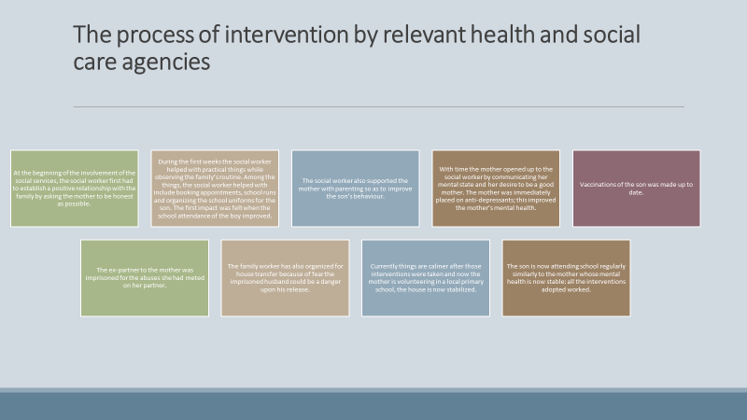
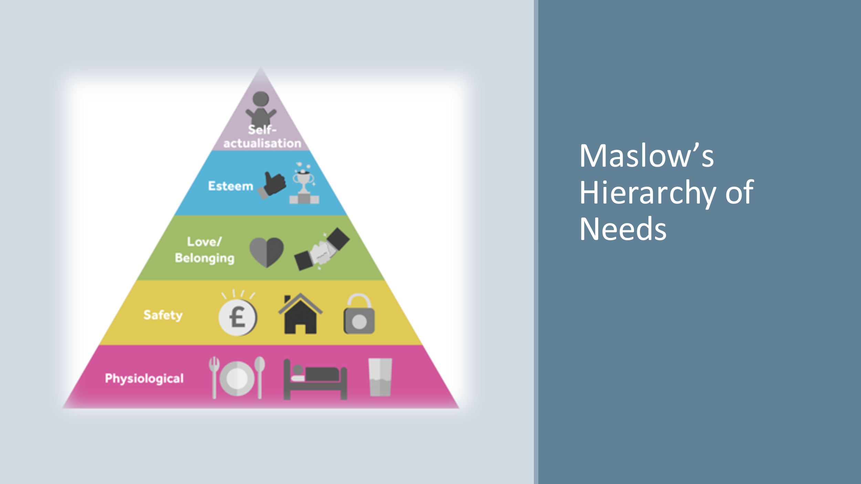
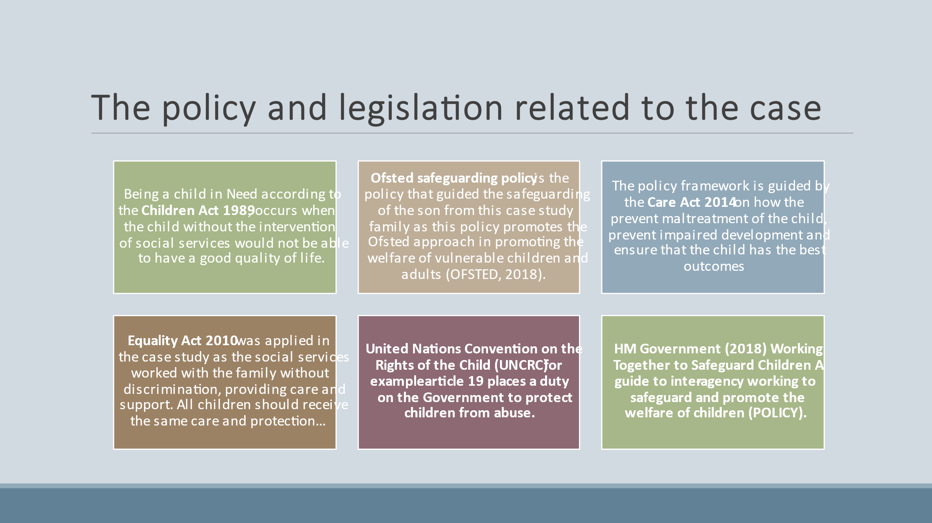
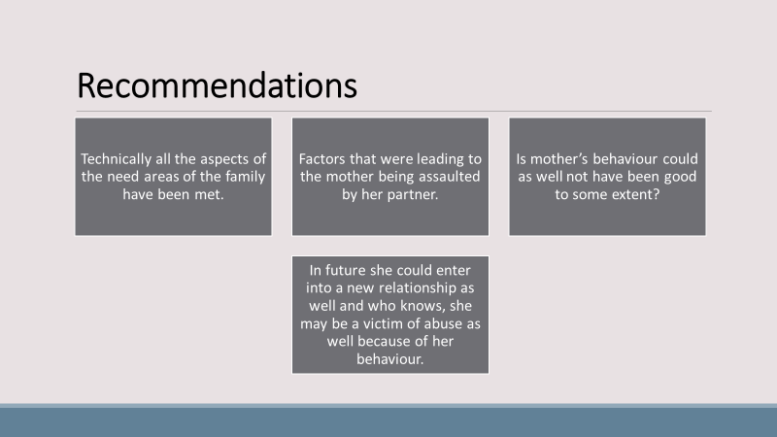
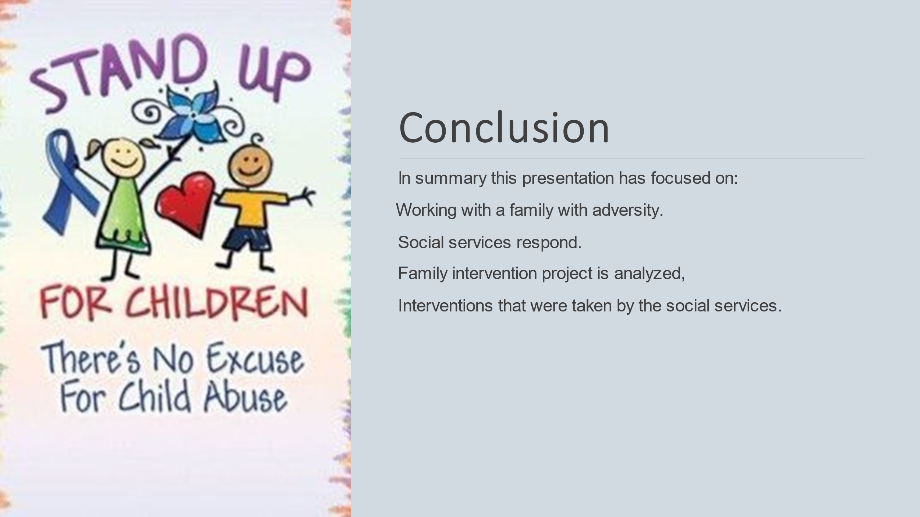
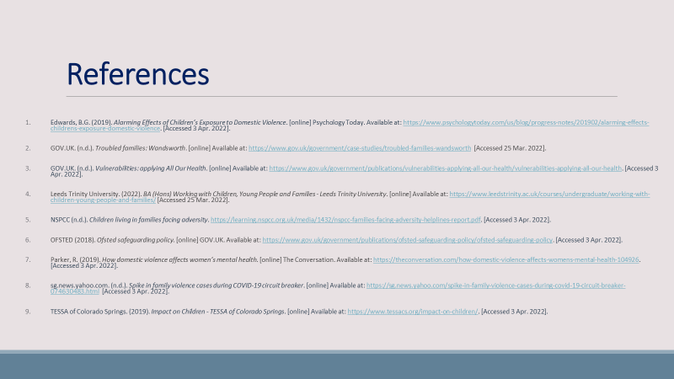

References
- ‌Braveman P, Dekker M, Egerter S, Sadegh-Nobari T, and Pollack C, (2011). Housing and Health. [online] RWJF. Available at: https://www.rwjf.org/en/library/research/2011/05/housing-and-health.html. (Date accessed: 1 April 2022).
- Children Act 1989, (Online). Available at: Children Act 1989 (legislation.gov.uk) (Date accessed: 28 March 2022).
- Children Act 2004, c. 31. (Online). Available at: http://www.legislation.gov.uk/ukpga/2004/31/contents (Date accessed: 28 March 2022).
- Edwards, B.G. (2019). Alarming Effects of Children’s Exposure to Domestic Violence. [online] Psychology Today. Available at: https://www.psychologytoday.com/us/blog/progress-notes/201902/alarming-effects-childrens-exposure-domestic-violence (Date accessed: 1 April 2022).
- Ferguson, H., Bovaird, S. and Mueller, M. (2007). The impact of poverty on educational outcomes for children. Paediatrics & child health, [online] 12(8), pp.701–6. Available at: https://www.ncbi.nlm.nih.gov/pmc/articles/PMC2528798/. (Date accessed: 1 April 2022).
- GOV.UK. (n.d.). Troubled families: Wandsworth. [online] Available at: https://www.gov.uk/government/case-studies/troubled-families-wandsworth (Date accessed: 1 April 2022).
- GOV.UK. (n.d.). Vulnerabilities: applying All Our Health. [online] Available at: https://www.gov.uk/government/publications/vulnerabilities-applying-all-our-health/vulnerabilities-applying-all-our-health. (Date accessed: 1 April 2022).
- Healthline. (2020). Revictimization: What It Means and How It Happens. [online] Available at: https://www.healthline.com/health/revictimization. (Date accessed: 1 April 2022).
- HM Government (2018) Working Together to Safeguard Children A guide to inter-agency working to safeguard and promote the welfare of children (Online). Available at: https://assets.publishing.service.gov.uk/government/uploads/system/uploads/attachment_data/file/942454/Working_together_to_safeguard_children_inter_agency_guidance.pdf (Date accessed: 21 March 2022).
- ICFI (2013). Chronic Child Neglect. [online] Available at: https://www.childwelfare.gov/pubPDFs/chronic_neglect.pdf. (Date accessed: 1 April 2022).
- Leeds Trinity University. (2022). BA (Hons) Working with Children, Young People and Families - Leeds Trinity University. [online] Available at: https://www.leedstrinity.ac.uk/courses/undergraduate/working-with-children-young-people-and-families/ (Date accessed: 1 April 2022).
- Maslow, A.H. (1954) Motivation and personality. New York, NY: Harper & Row Publishers. (Date accessed: 1 April 2022).
- NSPCC (2019) Children living in families facing adversity. (online) Available at: https://learning.nspcc.org.uk/media/1432/nspcc-families-facing-adversity-helplines-report.pdf (Date accessed: 21 March 2022)
- NSPCC (n.d.). Children living in families facing adversity. https://learning.nspcc.org.uk/media/1432/nspcc-families-facing-adversity-helplines-report.pdf. (Date accessed: 1 April 2022).
- OFSTED (2018). Ofsted safeguarding policy. [online] GOV.UK. Available at: https://www.gov.uk/government/publications/ofsted-safeguarding-policy/ofsted-safeguarding-policy. (Date accessed: 1 April 2022).
- Parker, R. (2019). How domestic violence affects women’s mental health. [online] The Conversation. Available at: https://theconversation.com/how-domestic-violence-affects-womens-mental-health-104926. (Date accessed: 1 April 2022).
- United Nations (1989) The United Nations Convention on the Rights of the Child (Online). Available at: Layout 1 (unicef.org.uk) (Date accessed: 21 March 2022).

