
Skills for the Workplace
Module Assignment Submission
Student Name: | Louise Puresevic
Student Number: | 2005324
Module No: | BMSK4006
Module Title: | Managing Enterprise in the 21st Century  Part 1 Business Plan

Statement of Confirmation of Authenticity
By the act of making this submission, the student declares that this is the work of the student named above. The work has not, in whole or in part, been knowingly presented elsewhere for assessment, or where assessment has been built on a previous assessment, this has been identified. Where materials have been used from other sources it has been properly acknowledged. If this statement is untrue, the student acknowledges that an assessment offence has been committed.
Attention is drawn to the plagiarism and unfair practice policies of both the University and of ILM.

Lou’s
One Stop
Beauty Shop



Louise Puresevic
The Body Shop at Home Consultant
18 Primrose Close
Cowbridge
Vale of Glamorgaan
CF71 7DZ

Company Registration:
VAT Registration:

Tel: 07530 183183
Email: louise.ackland@hotmail.co.uk
Website: www.thebodyshop.com



Table of Contents

Executive Summary 4
Business Overview 5
Markets and Competition 10
Target Markets 10
Competition 12
Sales and Marketing 14
Product Positioning 14
Marketing 16
Sales 16
Management 17
Key Personnel 17
Advisors and support services 17
Operations 18
Premises and Equipment 20
Employees 20
Suppliers 20
Financial Forecast 24
Sales 24
Cashflow 24
Profitability 24
Financing 25

Executive Summary

I had a number of choices in my mind about what sort of business I should look into. I looked at a Cake Making business, a Photography business and a Body Shop at Home Consultant. All had a wide variety of their own pro’s and con’s, but my choice eventually was to become a Consultant with The Body Shop at Home,

The Body Shop at Home is a unique way for a shopping experience, right at home. A branch out from the high street store, The Body Shop, this is a chance for customers the have a wonderful experience of sampling products and having some pamper time, in the comfort of their own homes. My target market is to be aimed at initially a female customer base, however, the Body Shop products along with pamper events are becoming increasingly popular with men also. I would also look to target customers to provide larger events outside of home, such as schools and other educational facilities. I would also look to offer business to events such as Christmas Fayres and Wedding Fayres. Marketing these events would be by using products supplied by The Body Shop at Home, such as leaflets, business cards and catalogues. However, I would also look to produce my own advertising, and also look to use every online facility, such as Facebook or Instagram. I would initially work alone, being supported by a Senior Consultant and Area Manager, however this would progress to myself becoming a Senior Consultant, and I would look to build my own team of Consultants.

Business Overview

Background

The Body Shop was founded in Brighton in 1976 by Anita Roddick, a name that became famous worldwide for her love of her products, and for the values and campaigns that she felt so passionate about. Originally selling her items in urine bottles sourced from a local hospital, with handwritten labels, Roddick sold her products through local press.


Dame Anita Lucia Roddick, DBE
(23 October 1942 – 10 September 2007)

The Body Shop at Home was launched in 1994, offering customers the opportunity to be able to shop at home, normally as an event such as a party, giving groups of people the benefit of trying products, watching makeovers, and purchasing products, in the comfort of their own living room. Run by consultants who would demonstrate the products, gain sales and commission, and hopefully look to recruit new salespeople along the way.

Anita continued as Managing Director over the years with huge success, alongside her husband Gordon. Tragically, Anita passed away in 2007 due to a brain haemorrhage

Today there are around 3,000 stores worldwide and franchise outlets in over 60 countries. The company is famous for its ethical approach to its products, using natural ingredients, and its cruelty free outlook regarding animal testing.

Today, with over 1,000 products available for market, the Company offers everything for Face, Body, Make-Up and much more. With a relatively reasonable price range it appeals to a wide customer market.

The huge popularity of The Body Shop products has led to many years of success. From the initial small shop in Brighton, leading to many stores on the high streets and shopping complexes, and eventually taking the products into the customer at home. Below is listed a table of some of the most notable dates in The Body Shop history.

The History of The Body Shop

The Business Idea that I would like to put forward in this assignment, is to become a Body Shop at Home Consultant. This is something that I pursued about 15 years ago. At the time, I ran my business, holding client parties, private events, and events such as Christmas Fayres and Wedding Fayres. Over the course of two years, becoming a Senior Consultant, I also looked after a team of fourteen Consultants, who I would work alongside, to train and share events. I would also acquire a percentage of the commissions made by the Consultants.

Therefore, in setting up this franchise once again, I would anticipate that I would initially look to start with basic parties and catalogue selling, and then progress to build my customer profile, and bring as many consultants on board as I can in order to boost my sales and my commission package.

I have anticipated that I would currently have various strengths that would hold me in good stead to set up this role once again. To make a success of it, I realise that unfortunately I do have weaknesses also, so I have listed them below in a SWOT diagram (Cottrell 2015) , to evaluate how I can proceed.

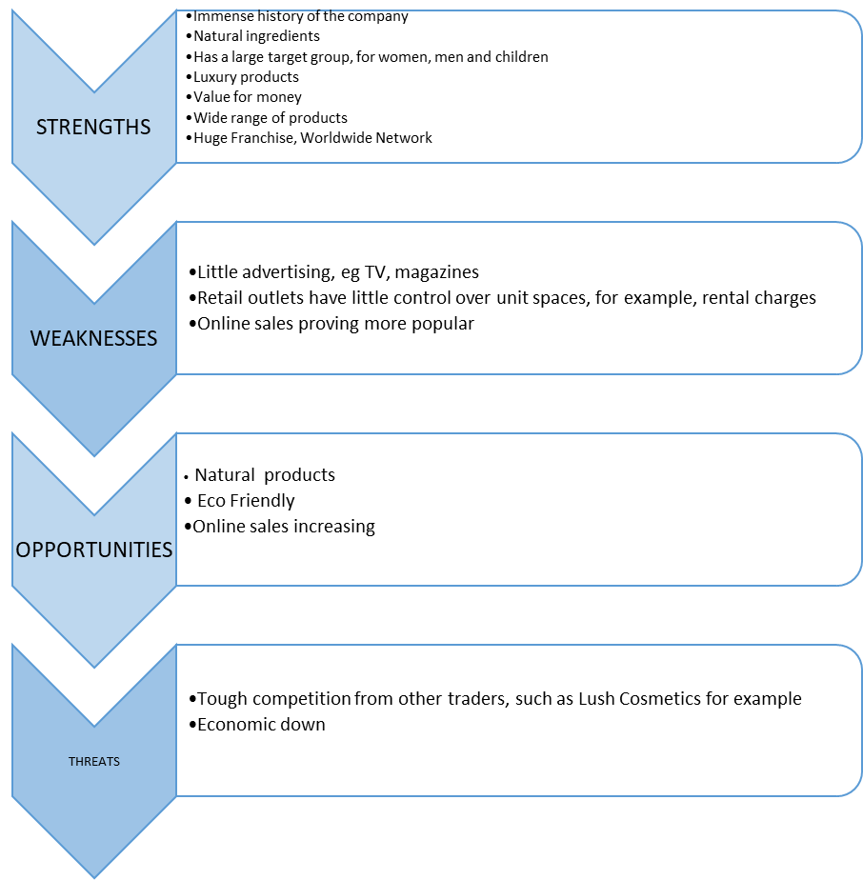

Hopefully by securing any additional funding along the way, either from a loan or from competitive events, I would be able to purchase additional stock at a reduced rate, either catalogue items or incentive products. I can then sell these items to my customers or offer items as prizes in competition-based events such as raffles.

Of course, there may be many hurdles along the way that may pose a threat to the business. This could be from various factors such as other competitors like Lush Cosmetics and Neal’s Yard. In order to beat the competition, it would have to be a committed effort in securing my client base, making sure that they are given the best customer service, such as being able to look after their needs e.g. advise them when their favourite items are on offer.

To provide an insight into the business idea, and how I can run it smoothly and productively, I have detailed in a PESTLE diagram, to provide a strategic analysis of my intention to run a smooth business.

In order to determine a good turnout at a home party, I would recommend a hostess to handout between 20 – 30 invitations included in the party pack that is given by the Consultant. This would encourage as many people to attend as possible. Those who are unable to attend may be interested in placing a catalogue sale that can be added to the party total. This offers a higher benefit to the hostess, as a party value offers a higher reward in personal gifts, and also offers a higher commission rate to the Consultant. In addition, it can also offer more recruitment opportunities for the hostess at the party, to speak to the party guest’s bout the benefits of working for The Body Shop at Home.

Markets and Competition

Target Markets

My main customers for The Body Shop at Home would initially be people at home, mainly women but also men. Home parties have been very popular throughout the years, with companies such as Tupperware providing a door-to-door sales service to housewives. Salespeople would offer products and catalogues. This popularity in such events became the new way of shopping for The Body Shop. It is an easy and fun way to be able to get together with friends and family in the comfort of home, to try products and shop, and to have food and a drink. The popularity then grew to the option to host larger events outside the home, such as school fundraisers, hospital charity events, summer fayres and coffee mornings. In addition to being able to take entire commission from events, consultants are often asked at large events to pay a ‘table fee’ or offer a donation of commission or a gift as a raffle prize.

Customers like to tell you what they like and what they want. However, they also like to be shown new and exciting products, or products that they may never have tried before. So being able to be one step ahead of them and offer the potential to gain new sales is so important. Know your products, know your customers, and sell the products to them instead of them approaching you to buy them.

I have looked at the travelling distance that I would anticipate covering for my business. On a personal level, I would start locally and focus on a specific radius, in order to bring in the sales and be able to encourage more business within my immediate location. This would also give me the opportunity to be able to recruit suitable consultants to my business.

Following from this, with encouraged sales and word of mouth, the sales target can be extended to a larger distance, and in time, can be stretched to a distance that I would be comfortable with in order to manage the business well. I could also look to team up with other consultants to attend larger gatherings, and thus to potentially take more sales and potential recruitment leads. I have detailed the following maps, to give an idea of areas that I would cover, as shown overleaf;

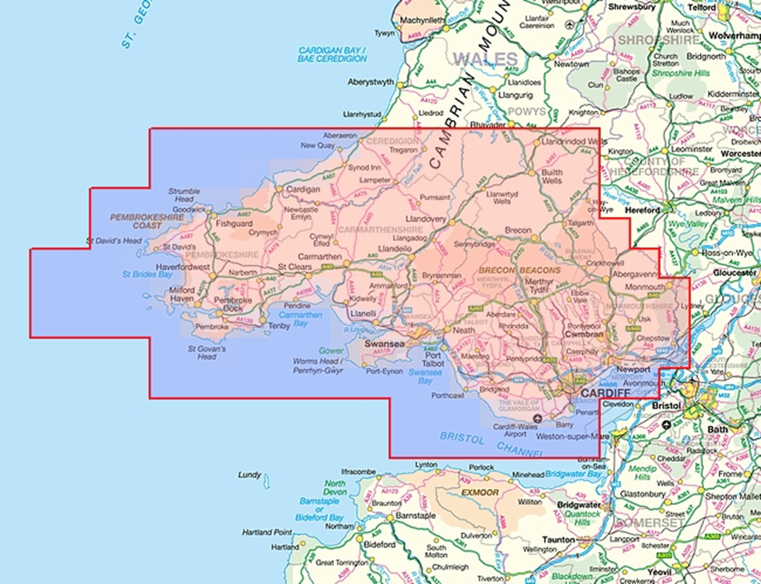

Using the Snipping Tool, I have added the following maps.

This first map shows the area of South Wales and the surrounding coastline across into the area of Bristol, Bath and beyond. It is deemed an accessible area in which to trade. My business plan to accommodate as much trade into each area, would be to focus on particular areas on particular days, with a rota basis.

My team of consultants would hopefully be employed in these areas, if I was to recruit, and so this would be my plan to expand further afield.

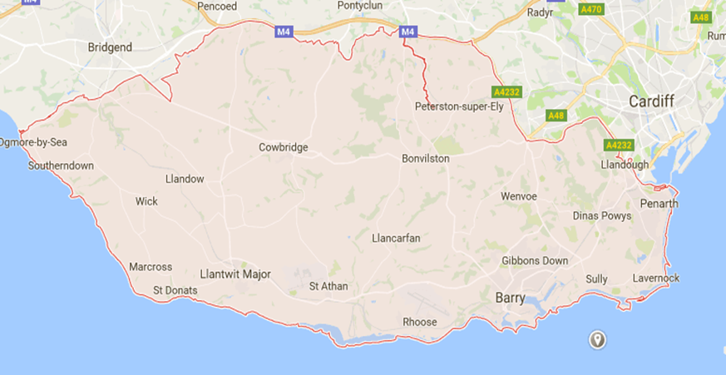

This second map shows the initial locality of towns and villages that I would target as my initial sales areas. As before, I would look to add a weekly schedule for these areas, targeting specific areas on certain days. This would enable maximum input from me in the areas and my customers. I would be able to deliver orders and make new sales. I would also take the opportunity to canvas for potential parties, contact schools and offices for larger events and fayres. Also, contacting hotels in those areas for events such as Wedding Fayres and Fashion Shows.

Competition
As mentioned previously, my main competitors for my business would be primarily Neal’s Yard Products which offers high street stores, online sales, and home events. In addition to this, Lush Cosmetics who trade on the high street also, online, and offer events instore.
Both Lush Cosmetics and Neal’s Yard Remedies are seen to be very different from each other, and from The Body Shop products. All companies benefit from using organic, natural, and ethically produced ingredients. However, the pricing range for both Lush Cosmetics and Neal’s Yard is substantially higher than that of The Body Shop. I feel also that customers are not only swayed by perhaps not purchasing solely for that reason, they are more inclined to use The Body Shop as they know that it is a well-known and widely used brand, and that they are guaranteed to have excellent value for money and are less likely to be dissatisfied with any purchase they make (Medlin & Ellegaard 2015).
The advantages that I feel I would hold with my business would be that customers seem to be able to relate more widely with The Body Shop products. It is a company that we have all pretty much grown up with, many women would have started their perfume collection with White Musk, for example. People tend to put their trust in the products that they are familiar with and know that they will always get value for money. They are aware that in today’s market, anything sold today has a higher value, but they trust the brand and the labels, and will therefore return time and time again. It is vial therefore to keep them happy, and to make sure that they are offered value for money at every opportunity.
I have detailed in a comparison table the main factors that would potentially pose a threat to my business.
Pricing Strategies

Obviously, I would be unable to offer my exact pricing, as I would have to follow the pricing guidelines as drawn out by The Body Shop. The pricing set out in the stores and in the catalogues is a fixed one, and therefore the ability to change any of this would be out of my hands.

However, in order to make this work to my potential, I would make sure that I follow the guidelines and rules as set out by The Body Shop, offer any selected lines that are presented by the company. But I would also put together my own offers, such as facial cleansing packages, make up packages, fragrance packages. In addition to this I would offer perhaps a gift as an incentive, for the customer to buy the selected items altogether, or perhaps offer the items to be gift-wrapped or boxed.

Sales and Marketing

Product Positioning
In terms of competition against the other leading sales brands, The Body Shop leads in all aspects of quality and value. In addition, by being able to offer services at home and in outside venues, all customers’ needs, and requirements are met. The personal service of the consultant is very welcomed.
Looking at the products available to a customer in a basic party makeover, I have detailed the following products, using just a small selection as an example of how I would offer my products. I could increase my sales by promoting additional items as a form of ‘power selling’, known as link - selling, such as Vitamin E products. I would look to promote the night cream and the facial spray as well as the regular day cream. This would offer maximum sales potential. Usually, the company would offer special deals to customers such as buying a selection of items in a range at a reduced price or offer incentives to attract custom (Crane, 2017).
An example of Combined selling at a home party event– using several items during a makeover session, and offering to the customer, perhaps as a special offer package if purchased together. Or an incentive can be offered such as a free headband or face mask sample.

Part 1 of the makeover session – the skin cleansing routine – Camomile Eye Make-up remover, Organic Cotton Wool Pads, Vitamin E Moisture Cream

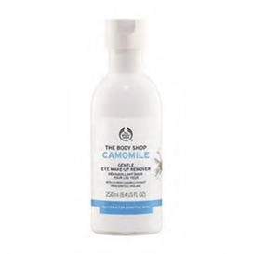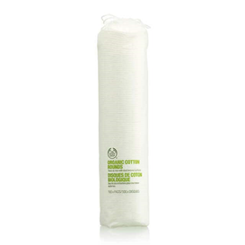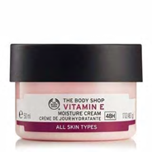

Part 2 of the makeover session – the make-up. The sales boost here would be to sell the make up brushes as well as the make-up. If the customer can see how well the make-up is applied with the tools being used, then they may be inclined to purchase new.
Remember to include as many items as possible, including items such as powders to set make-up, pencil sharpeners and make up bags, all small extras that can add to boost your sales.
Shown below is just a small selection of the make-up selection – Make Up Brush selection, Foundation, Eyeshadow, Lipstick

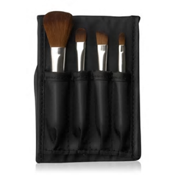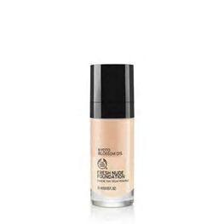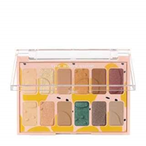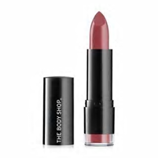

Part 3, in addition to the smaller extras that are suggested to boost sales, I would also offer higher priced items. For example, from the Vitamin E range that I had used in the initial cleansing routine prior to make over, I would offer the Vitamin E Face Mist, which is a very popular product for the Body Shop. This product can be used alone on the face as a refresher or can be used the spray over the face over make-up, to set the products and produce a glow. I would also offer the Vitamin E Lip Balm, as a product that can be used throughout the day as a lip conditioner. These two products offer a very high sales turnover.

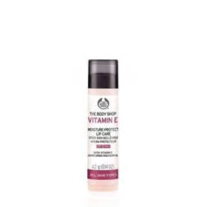

Marketing

The Body Shop is a worldwide brand and is famous throughout. Therefore, it is very easy to be able to promote the business with the very minimum effort. However, it is not wise to rely on this as personal progress relies solely on the individual, and it is vital to be able to talk, demonstrate, offer every opportunity to get your voice heard.

This can be done in so many ways in this day. From simple technological methods such as Facebook, Instagram and Twitter, to trade and general press, local door to door catalogues. Door to door canvassing is probably the simplest way to network. Offer opportunities to visit local businesses or schools with free demonstrations, perhaps leaving leaflets and free samples. Leave behind some catalogues with order forms also. And get business cards printed, either through The Body Shop press department or from a personal level.

Sales

To develop, maintain and keep a successful and continuous customer database, it is essential to keep each and every customer happy from the start. As with everything else in life, first impressions count, and it is that that a customer will remember, and will pass on to the next potential customer, and so on.

Networking and canvassing is the vital basis of any business. So it is essential to target to right client. Who, where, why? The obvious clients would be female, to offer home parties in the home. However, those people may be school mums, so what about the school summer or Christmas fete? And what about charity coffee mornings? Has someone experienced illness, would they be interested in a fundraising opportunity? By contacting local schools, clinics, hospitals, the opportunities for sales, parties and potential new recruits can be endless.

Only by offering a first-class service first time, will the customer be happy to return a second time. And if they stay loyal, be sure to offer them incentives to stay.

Management

I would not be looking to recruit anybody on a personal level with this business venture. As this is a Franchise, I would be working solely initially, and from home. Over time, once I have gained sufficient experience and I am able to provide suitable information to people to offer the benefits of The Body Shop at Home as a career, I would then be able to have Consultants on board as part of the team. Once I have recruited a personal level of approximately six to eight people, I would be able to establish my own team. I would become a Senior Consultant at that level, and so my role would change significantly by being responsible for the team by means of maintaining their weekly sales figures and providing support and training. I can share the larger events with other Consultants, encouraging more opportunities to offer pamper sessions and encourage larger sales figures.

I have put together a diagram to show the management structure of The Body Shop at Home,

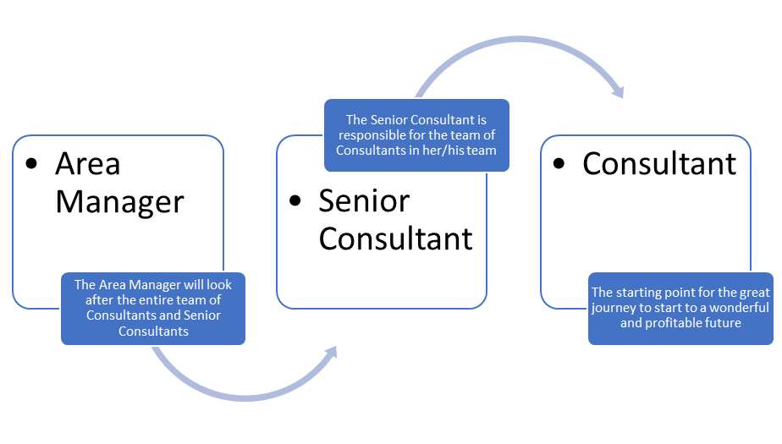

I would not look to employ an Accountant for this business. I would not look to employ a Business Advisor, as any business information such as training and new product information, along with any other company information, would be fed down from Head Office. Any legal requirements, including Insurance, would also be covered by The Body Shop at Home. This information is detailed and communicated with the Consultant when signing with the company. I have included a copy of the Consultant Application Form for The Body Shop at Home, which I have attached at the end of this assignment in the Appendix. I have also attached a copy of my personal CV, also in the Appendix, so that this can be provided if my suitability for any further potential job opportunities should become available relating to this business venture.

Operations
I have compared various computers and printers on an online store (Curry’s). Using the Snipping Tool, I have transferred the information that I have compared onto this assignment document.
Firstly, looking at the computers, I have decided to opt for a laptop. A laptop computer is the most widely used today, as it is very versatile and portable. I have always used laptops myself, so they are very user friendly, especially for me.
By looking at these products, most seem to be very similar in what they offer. The prices also seem to be very similar in range, offering an average of around £421.50.

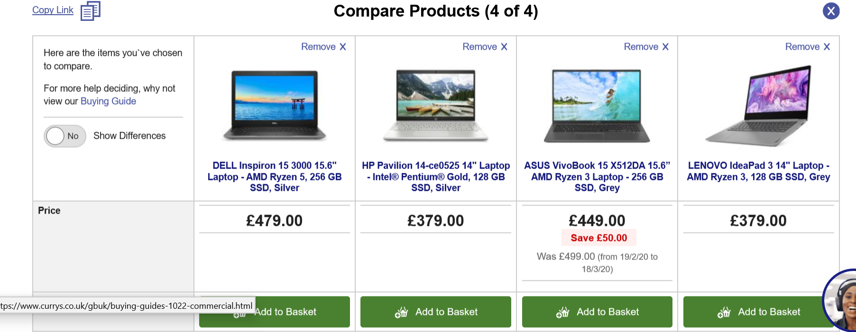

Secondly, I have looked at prices of printers for my business. I am focusing on a wireless printer as I believe that provides a better performance and ease of use. I am looking to have a piece of equipment that can do the whole process for me, in printing, scanning, and copying. I am also conscious of the consumables of the machine, and therefore it must be a printer that I could purchase reasonably priced ink for. I can see from my choice of selection of comparable above, that there are specific makes and models that prove to be very popular in purchase, so I am also aware of what may be available.

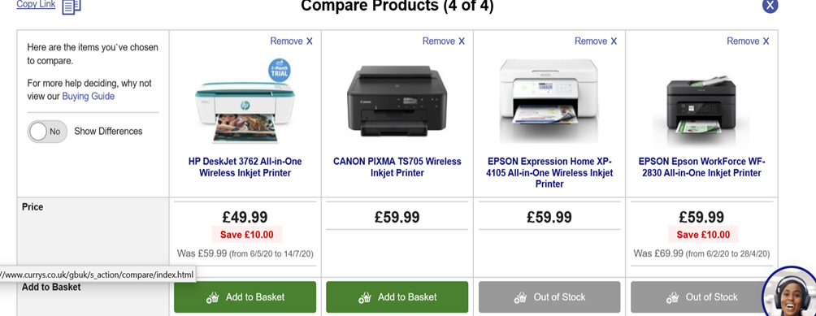

I would also need to use a room at home to use as an office space. Using a room at home would enable me to be able to save on costs of renting a premises to run my business. The rental of my home, along with household bills such as gas and electric would remain the same, so I would not look to spend any additional costs, except perhaps in winter months when I would perhaps run the heating a little more during the day whilst I was working. The only additional cost would be fuel and maintenance costs for my car.

Initially I would look to equip the office with the essentials for my office, including furniture. I have looked at a comparison of furniture at two high profile retailers, Dunelm Mill and Ikea. I have looked at various items of furniture and have compared the items, and placed in a comparison table, shown overleaf;

OFFICE FURNITURE PRICE COMPARISON

TOTAL PRICE OF FURNITURE FROM DUNELM MILL = £258.00
TOTAL PRICE OF FURNITURE FROM IKEA = £185.00

Based upon these costs, I have concluded that I would purchase my furniture items from Ikea, based on the following reasons:
• It is good value for money
• Products are well built
• Customer service is excellent
• The items that I have chosen to complement each other so would look good in the workplace
• The filing cabinet is better value as it is larger and is lockable, which would be very important in a home business, as I would hold customer information which would need to be kept locked away and out of sight.

I have compiled a list to determine exactly what products I may need altogether for my business. I have detailed everything from household bills, through to electrical equipment if I decided to purchase new, stationery, and vehicle costs;

 |  | HobbyCraft | Asda | Amazon
Site/Office Space | Foc
Work from home | Foc
House rental | £550 pcm
Electricity/Gas | £77 pcm
Home Insurance | £12 pcm
Bank account | Already open
Desk | Ikea
Office chair | Ikea
Computer | N/A
Printer | N/A
Telephone | N/A
Bank Card machine |  |  |  | 9.99
Cash tin |  |  |  | 4.99
Filing Cabinet (lockable) | Ikea
Printer Paper |  |  | 2.99
Printer Ink |  |  | 14.99
Pens |  |  | 1.5
Pencils |  |  | 0.79
Ruler/Eraser/sharpener set |  |  | 0.49
Envelopes |  |  | 2.99
Additional Items
Table cloths | Provided by | The Body Shop
Table tealights |  | 3.99
Table decorations |  | Various
Bowls for treatments | Provided by | The Body Shop
Towels | Provided by | The Body Shop
Mirrors | Provided by | The Body Shop
Advertising | Provided by | The Body Shop
Business Cards | Provided by | The Body Shop
Leaflets - Main | Provided by | The Body Shop
Leaflets - Offers | Provided by | The Body Shop
Motoring Fees
Petrol | 25.00 p/w
Vehicle - MOT | Various
Vehicle - Tax | 140.00 p/a
Vehicle - Insurance | 13.00 p/m

I have detailed in the following PDP Analysis a structured outlook of my progression throughout one year with The Body Shop at Home. As I would initially be working alone, I have tried to focus on what skills I already hold and the timescale that I would give myself to achieve these goals.
Time Plan | Core Organisational Objectives | Working with | Deadline
Short Term  1-3 months | - Attend Training Courses  - Advertise new venture  - Gain rewards to boost Kit levels  - Collect orders to gain commission  - Collect a regular database of customers  - Determine a sales plan  - Determine customer offers  - Utilise customer communication skills  - Use available resources to grow business and learn about products available for sale  - Networking  - Canvassing | - Fellow consultants  - Customers  - Sales Managers  - Area Manager | Sep 2020
Mid Term  3-6 months | - Knowledge of the company should be building well by now  - Start to discuss opportunities in depth with customers, to attract new consultants  - Continue management situation to build commission levels  - Continue to build larger selection of products | - Fellow consultants  - Customers  - Sales Managers  - Area Manager | Mar 2021
Long Term  6-12 months | - Have a team of consultants on board, minimum of 10 to produce satisfactory commission levels  - Own a large selection of gifts, which can be used as customer incentives  - Be able to offer services more towards larger events, such as fund raisers, fayres, hospital events such as ante-natal clinics (offering treatments to new mums, hopefully leading to sales)  - Providing continuing training events to my team | - Fellow consultants  - Customers  - Sales Managers  - Area Manager | Feb 2022

Financial Forecast

The Body Shop at Home will be whatever I make it. If I put the 100% effort into the business, I can make it a success, and can enjoy the benefit of a generous turnover and a very enjoyable career. However if I do not put in the work and effort, it can quickly fail, and I would not only fail myself, but would potentially upset a lot of customers, and of course the name of The Body Shop. Having my own business could be very rewarding in many ways. As well as the financial side of this project, I could also enjoy the benefit of working from home, thus being able to manage my own diary, and choosing my own working hours to suit my home life. I would enjoy a reward from my sales of between 25 and 30% commission from my sales each month, if I manage to reach a predicted sales target set each month. I would also gain additional commission from consultants that I have introduced into my team as my business grows. I would also look to gain fantastic rewards, some of which I could add to my demonstration kit to build my products that I can show at parties and events.

I can also enjoy the benefit of sharing my knowledge of the Body Shop products and their ethical projects with my customers.

Financing

I have determined that I would potentially need a very small amount of money to set up my business. I would only look to access a minimal loan to purchase items such as furniture, items to use as display props at my events, and various stationery items. I have decided that I will not purchase a new computer for this project but may possibly invest in a new printer. I have looked at a small loan of £2000 to purchase the basic equipment and furniture for my business. My plan is to repay this loan in full as soon as possible, hopefully within the given time period.

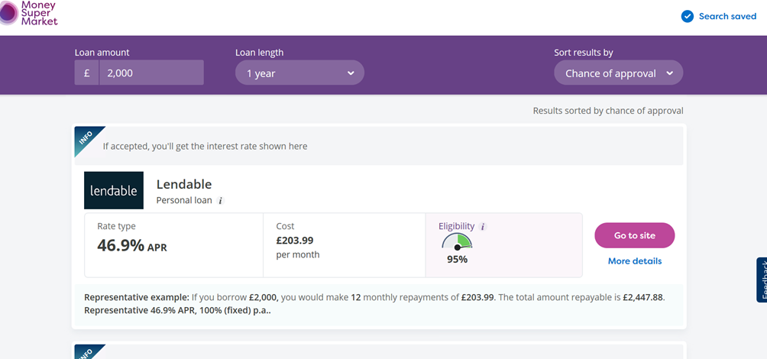

An alternative to this would be to add an overdraft facility to my bank account.

I would keep a small amount to one side to purchase stock such as incentive products, so that I can offer as gifts with purchases or raffle gifts.

References

COTTRELL, S., (2015). Skills for success: personal development and employability. 3rd ed. edn. Basingstoke: Basingstoke: Palgrave Macmillan. (SWOT, PDP)

CRANE, S.P., (2017). The Five Operational Keys to Maximizing Business Profitability. The Journal of Business Forecasting, 36(1), pp. 10-16.

MEDLIN, C.J. and ELLEGAARD, C., (2015). Conceptualizing competition and rivalry in a networking business market.

https://www.thebodyshop.com/
(28/6/20)

https://uk.lush.com/
(28/6/20)

https://www.nealsyardremedies.com/
(28/6/20)

https://www.hobbycraft.co.uk
(3/7/20)

https://www.currys.co.uk/
(19/7/20)

https://www.ikea.com/
(18/7/20)

https://www.dunelm.com/
(18/7/20)

https://www.amazon.co.uk/
(24/7/20)

https://www.bing.com/images/search?view=detailV2&ccid=oyLJFmgk&id=4B18BEE4084120CE48B5DF03DFA87B82040D4E37&thid=OIP.oyLJFmgkTRGh1xKvtT65bwAAAA&mediaurl=https%3a%2f%2fupload.wikimedia.org%2fwikipedia%2fen%2f3%2f33%2fThe_Body_Shop_logo.png&exph=195&expw=199&q=the+body+shop&simid=608033722498355175&ck=29B79A86EF81AA01CE8007E4816E9AE2&selectedIndex=1
(27/6/20)

https://www.bing.com/images/search?view=detailV2&ccid=0riYRQZy&id=DB3243F95D7C50054580F4D648C7E8CEABA4352D&thid=OIP.0riYRQZyjADT7Z9obMhOJAHaE-&mediaurl=https%3a%2f%2fwww.borderfree.com%2fwp-content%2fuploads%2f2018%2f04%2fhero-beauty-2.jpg&exph=1289&expw=1920&q=beauty&simid=608029496201250740&ck=A2797A50D03B1CF130C4033A60389F1E&selectedIndex=62
(20/6/20)

https://www.bing.com/images/search?view=detailV2&ccid=7JIAd88j&id=D7AF70FA4E2BDEACB193F7A798CFFCAE8FF9B60E&thid=OIP.7JIAd88jfhENiuDGTQHttQHaFs&mediaurl=http%3a%2f%2fwww.viewranger.com%2fpreview%2fSouth_Wales_coverage_50k.jpg&exph=500&expw=650&q=south++wales+map&simid=608054303924486805&ck=A8E2C30CF7B89DECF00A2273D8EE243A&selectedIndex=2
(3/7/20)

Appendix

- Original Business ideas, process of elimination to decide on my chosen business.
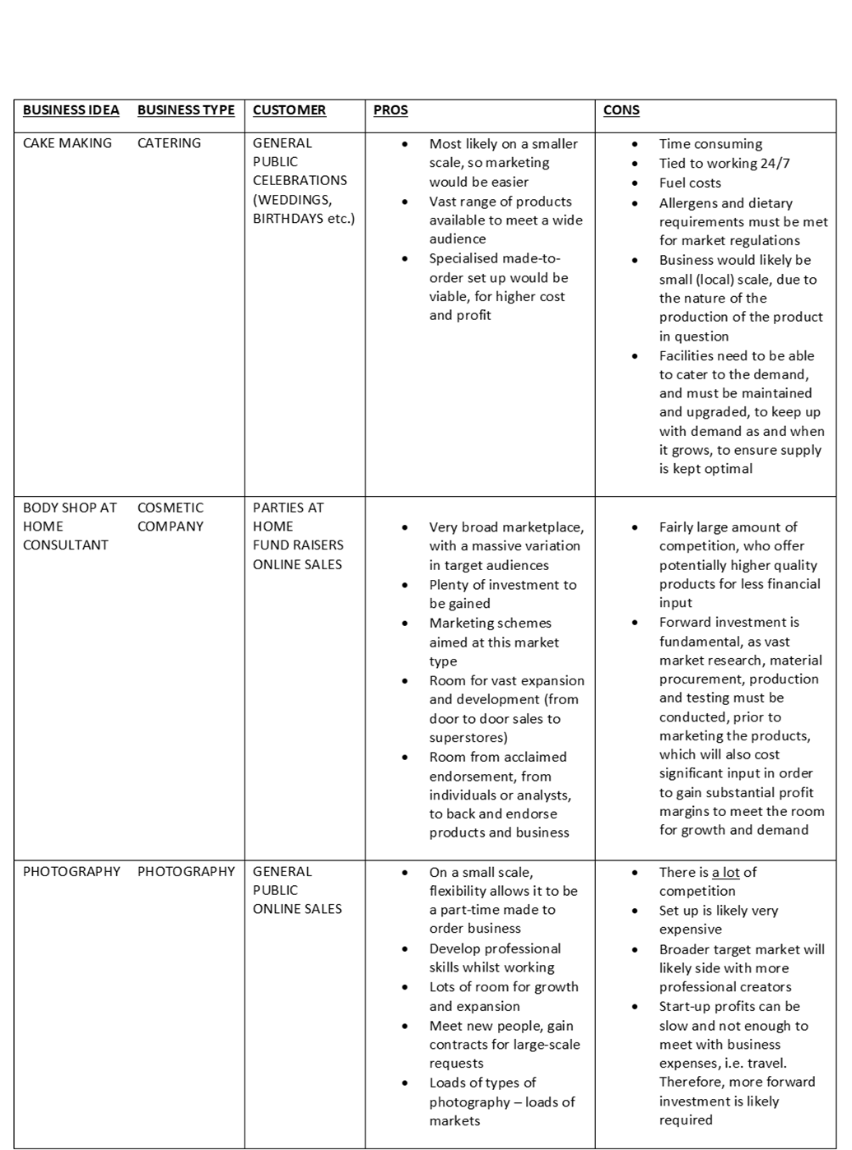

- The Body Shop at Home Consultant Application Form
- Louise Jane Puresevic – Curriculum Vitae

Louise Jane Puresevic
18 Primrose Close  Cowbridge  Vale of Glamorgan  CF71 7DZ |       Louise J Ackland  07530 183183  louise.ackland@hotmail.co.uk
About Myself | I am an efficient, hardworking individual with extensive administrative experience gained from private and health service sectors, specialising in reception / front of house operations. An enthusiastic and committed team player with a high capability of working across projects and with excellent customer facing and people skills. Flexible, self-motivated, and conscientious, with a strong ability to work under pressure and to deadline whilst maintaining attention to detail.  During my time with the NHS, I have gained a vast amount of knowledge of systems, procedures, and policies. I have taken various work-related courses including Manual Handling, Fire Safety (department Fire Warden), and Violence & Aggression. I am also a departmental First Aider. I have completed the European Computer Driving Licence (ECDL) award (an IT related award), undertaken the Institute of Leadership and Management (ILM) Level 3 Management award, and have an introductory knowledge of Sage 50 Accounting. I am also currently working on my Business Admin Level 2 course.  I have previously worked as a Body Shop at Home consultant, to the level of Team Manager. Therefore, I do have the skills and capabilities in order to re-visit this venture. My aim is to consider working on a part-time basis with The Body Shop at Home, along with my full-time career with the NHS, and would hopefully look to be able to concentrate on The Body Shop at Home, once I have gained suitable experience, customer portfolio and a team of consultants who would be a part of a team rum by myself.
Skills & Abilities | - Being able to work well with a greater team, using prior and ever-expanding teamwork skills  - Variable communication skills, which are adaptable across many situations, with both colleagues and patients  - Being able to adapt to any change, or mitigate to achieve the next best outcome, where necessary  - Proficient use and understanding of Office 365 and similar software  - Confidently able to meet any deadlines laid ahead of me, and ensure I can pull my own weight as part of a greater team
Education | Barry College of Further Education, 1989:  Diploma in Hotel and office, Pass in Personal Grooming/Healthcare, and RSA Typing Level I/II  Cowbridge Comprehensive, 1987:  4 O-Levels (incl. Mathematics and English), 3 CSE Levels
Experience  (Most Recent  First)  References | Patient Pathway Co-Ordinator – Cwm Taf University Health Board  (8/2019 – current)  Roles and Duties:  Responsible for maintaining the patient waiting list for approximately 400 patients, working with four Trauma & Orthopaedic Consultants  Answering telephone calls from patients, internal and external colleagues  Handling daily running of the Consultant clinics and the surgery Pre-Assessment clinics  Helping to work as a team  Receiving mail  Team Secretary - Cardiff and Vale University Health Board  (03/2017 – 8/2019)  Roles and Duties:  Acting as point of contact for all visitors to the VLMHT  Maintaining confidentiality of data at all times  Helping to work as a team  Receiving and sorting incoming mail and faxes  Answering telephone calls from internal and external bodies  Handling daily running of out-patient clinics  Undertaking typing duties including reports, letters, notes  Ordering including all stationery items, furniture and electrical  Co-ordinating booking of meeting rooms  Reason for Leaving – Career Progression  Temporary PA to Directors - Herbert R Thomas Estate Agents  (10/2016 – 12/2016)  Roles and Duties:  Secretarial duties, including typing and fielding telephone enquiries  Managing the Directors team diaries.  Meeting attendance for minute taking  Reason for Leaving – Temporary Position  Personal/Character Referee:  Lindsay Hague-Morgan – Family Friend  Contact Information:  Glebe Farm,  Shackerstone Walk,  Carlton,  Leicstershire,  CV13 0BY  07870 270852  Professional Referee:  Sonia O’Loughlin – Admin Manager  Contact Information:  Vale Locality MHT,  Barry Hospital,  Colcot Rd.,  Barry,  Vale of Glamorgan,  CF62 8YH  01446 454300

