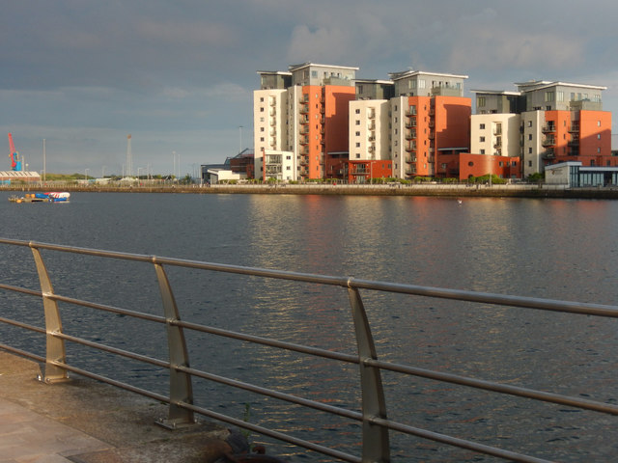

Social Aspects Report
Prince of Wales Dock Footbridge
May 2022
Produced by: Rhydian Preece

SCS Sustainable Civil Solutions Ltd

Contents
List of Figures..……………………………………………………………………….…………………………………………3

- Introduction..………………………………………………………………………………………………………..4

- Findings.…………………………………………………………………….…………………………………………..4
  - What is Corporate Social Responsibility?..........................................................4
  - Corporate Social Responsibility in Construction...............................................5
  - Strategies that construction companies can take.............................................5
  - Conclusion.........................................................................................................8

- References..………………………………………………………………………..…………………………………9

List of Figures
Figure 1 – Image of the site. [Online]. [Accessed 20 March 2022]. Google Earth (2022)

- Introduction
Social aspects are a big factor when working on a construction project, and this report will focus on what corporate social responsibility is, how this is related to the construction industry and how we can improve this when working on our project.
The project that we are working on is close to many public places which can be shown in the image below. Such as the Sancta Maria hospital, residential flats, and a walkway that goes along the perimeter of the dock.
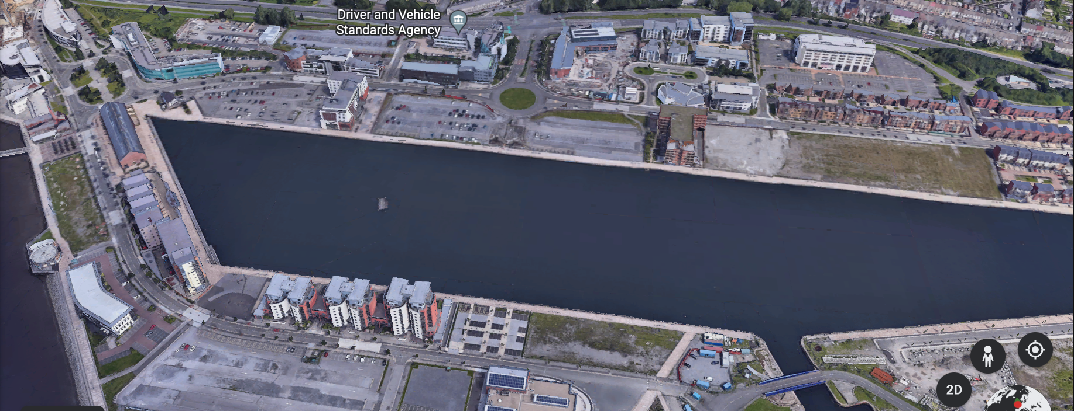
Figure 1 – Image of the site. Google Earth (2022)
The lines in yellow show where the bridge will be placed and the box in red is where the main base of operations will be taking place. This site will be affecting the people around the area, so it is of utmost importance that we accommodate to the best of our abilities. Corporate Social Responsibility (CSR) has become an important focus for businesses in all industries, especially the construction industry. People and businesses these days are starting to make more conscious decisions when it comes to what businesses they’d like to support. Preferences go down to whether the company is taking steps to both minimise the impact their operations have on people and, where possible, have a positive impact on their lives.
- Findings
2.1 What is Corporate Social Responsibility?
This type of responsibility is all about minimising the negative impact that your business operations have, not just on workers and customers/clients, but on all people that might be affected by your business and the wider environment. The other people can include members of the public and local communities. By minimising negative impacts, the business should also look to increase positive outcomes such as:
- Increasing social impact through employment and workplace equal opportunity practices.
- Reducing the risk of modern slavery or human rights abuses in your supply chain.
- Reducing fossil fuel consumption and the contribution to climate change or
- Providing a boost to biodiversity.
2.2 Corporate Social Responsibility in Construction
CSR strategies aren’t a legal requirement for business, but corporate social responsibility is something that should be taken seriously in construction. Construction projects have the potential to negatively impact people’s mental and physical health, so businesses must take extra care when planning their strategies.
In the short term, these projects can disrupt people's lives with noisy operations, disruptions to utility services and the need for access to be restricted which would cause diversions. Long term, the building of new structures may improve people's lives but also have the potential to have the opposite effect due to the longevity of projects and other factors.
CHAS (2021) has provided me with information on what Corporate Social Responsibility is and how it is important in the construction industry.
2.3 Strategies that construction companies can take
There are many ways in which we could effectively improve our construction approach to minimise negative impacts and where possible have a positive impact. These strategies can be found on the next page where I have created a mind map using Mind Meister.

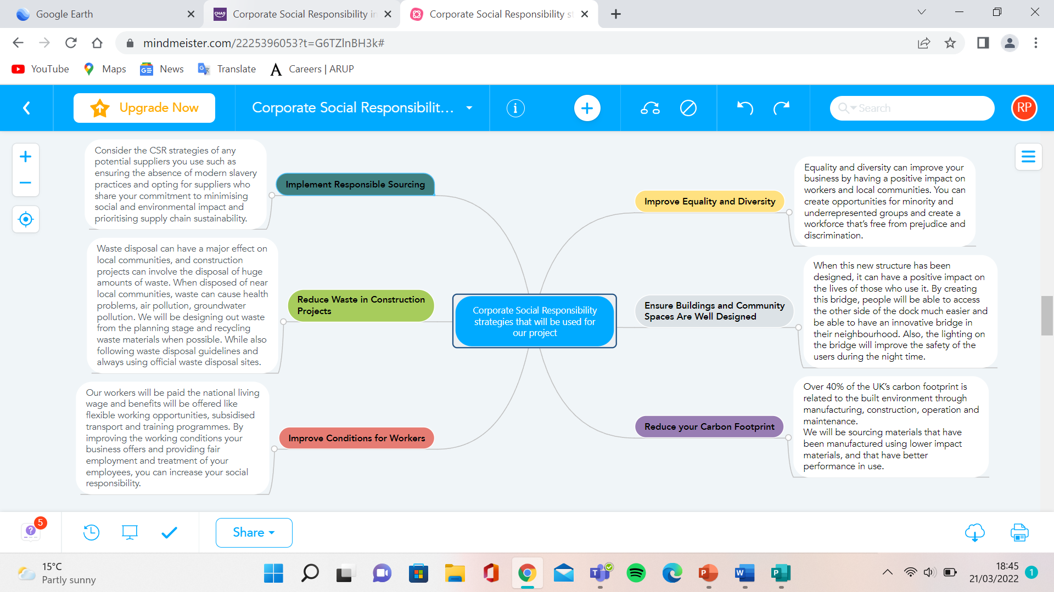
The mind map outlines the different strategies, but the table below shows how these will be implemented in our project.
CSR Strategies | How they will be implemented into our works
Implement Responsible Sourcing | - Opting for suppliers who share our commitment to minimising social and environmental impact.  - Ensure the suppliers we choose are prioritising supply chain sustainability.  - Map our supply chain.  - Our standards of sustainability will be communicated to our suppliers.
Reduce Waste in Construction Projects | - We will ensure to design out waste from the planning stage and recycle waste materials where possible.  - While also ensuring to follow waste disposal guidelines and always using official waste disposal areas.  - The material choice will also be chosen to ensure the least amount of waste on-site.  - Where possible, we will try to reuse materials to reduce waste.  - For materials that we don’t use, we will try to donate them.
Improve Conditions for Workers | - Workers will be paid the national living wage and benefits will be offered like flexible working opportunities, subsidised transport, and training programmes.  - Facilitate learning opportunities.  - Hold team meetings twice a week to catch up on progress and to answer any concerns that workers may have.  - Ensure employees have access to high-quality PPE and when replacements are needed, we will provide them.
Improve Equality and Diversity | - Ensuring opportunities are created for minorities and underrepresented groups.  - Creating a workforce that’s free from prejudice and discrimination.  - We will offer our staff appropriate diversity and inclusion training.  - We will always be aware of indirect discrimination.  - Diversity and equality will also be used within the recruitment process.
Ensure Buildings and Community Spaces are Well Designed | - When the bridge has been constructed, people will be able to access the other side of the dock much easier.  - The lighting on the bridge will also improve the safety of the users during the nighttime.
Reduce your Carbon Footprint | - We will ensure to source materials that have been manufactured using lower impact materials, and that have better performance in use.  - We will ensure to measure our embodied carbon emissions so we can monitor our carbon footprint. Then we can establish a baseline and establish reduction targets and a way toward NetZero.  - We will be designing with a low carbon approach. This will include the performance of the project such as material, water, and energy across the lifecycle of the project.

2.4 Conclusion
Corporate social responsibility in construction is big on the rise, as businesses within this sphere are facing increasing pressure to improve CSR strategies. Construction projects aren’t exactly discreet or low-impact — they can have a huge impact on workers and local communities. So, taking a positive and proactive approach to corporate social responsibility is something that all businesses within the industry should be doing.
Social aspects are something SCS Sustainable Civil Solutions Ltd takes very seriously, which is why we have many strategies in place to ensure we are as ethical as possible.

- References

- CHAS (2021) - Corporate Social Responsibility in Construction. CHAS.

- Google Earth (2022) – Image of the site. [Online]. [Accessed 20 March 2022]. Available from: https://earth.google.com/web/@51.61909487,-3.92620548,3.33440101a,655.160274d,35y,-6.0071878h,43.82463883t,0r

