Part One
AC 1.1
Evidence based practice (EBP) is systematic approach to decision making which uses reliable data to inform decisions, minimising reliance on fads and bias (CIPD, 2025). EBP uses four sources of data for evidence, organisational evidence including metrics and perceptions of culture, scientific evidence including academic research, stakeholder evidence including interviews and focus groups and professional judgment including expertise and knowledge of leaders and managers based on their reflection of past activities (Rousseau & Have, 2022). This enables managers to consider problems and their impact supported by qualitative and quantitative data across various sources to develop more effective solutions and build employee trust (Rousseau & Have, 2022). The CIPD six-step model provides a structured method for gathering and applying evidence from these sources, shown in Figure 1.
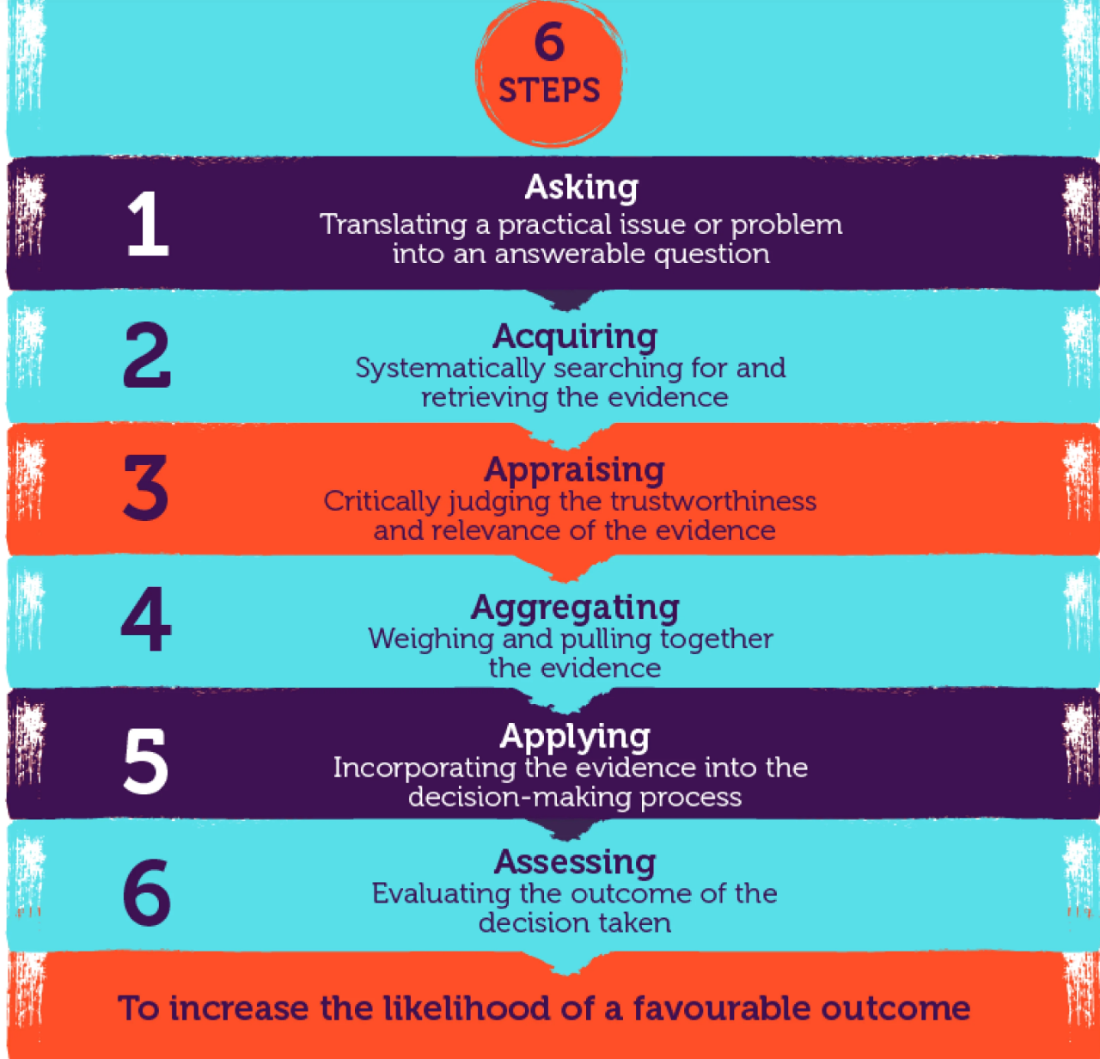
Figure 1: 6 Steps (CIPD, 2025)
Using the six steps supports organisations in incorporating evidence into practice, maximising its value (Chowdhury, Hossain & Rahman, 2026). EBP is beneficial for Technivara as reliance on paper-driven processes limits available data and offers and increased susceptibility to bias compared to digital driven data which encourages diversity and informed insights that align decision making with strategy (Tessema, Yang & Chen, 2025). Furthermore, EBP supports risk mitigation by helping organisations anticipate future challenges which is critical for Technivara’s expansion (Briner, 2024).
However, successful implementation requires digital investment and analytical skills, and so Technivara’s resistance to change may create a barrier (CEBMA, 2026).
One area EBP could be implemented at Technivara is pay and reward. Armstrong, Brown & Reilly, 2011) explain how pay and reward add value to businesses, however often offered benefits misalign with employee needs. To overcome this, alongside academic research on employee motivation, Technivara could acquire data through employee feedback, turnover, and engagement (Hacking HR, 2024). Aggregating this data allows trends to be identified, such as differing reward priorities amongst age groups and roles, enabling the creation of a total rewards program (Hacking HR, 2024). However, pay and reward are influenced by organisational culture and strategy and so these must align and fit regardless of feedback suggestion received (Armstrong, Brown & Reilly, 2011).
Another area for applying EBP is training and development. Omoigui (2022) explains that 99% of employees have seen a training plan that was ineffective, with organisations justifying it as established practice. Technivara’s avoidance of change can make this a risk. Elugbaju, Okeke, & Alabi (2024) explain how data-driven businesses create tailored employee development plans and strong talent pools. Analysis of external trends and forecasts allow for identification of skills gaps, ensuring Technivara remain competitive during growth (Elugbaju, Okeke, & Alabi, 2024). Braun et al. (2025) explain how quickly external markets change, widening skills gaps and creating the need for rapid adaptability. Technivara should consider the time-consuming element of EBP which may be less favourable under pressure (Pitsillidou, Noula, Roupa & Farmakas, 2023).

AC 1.2

One analysis tool that Technivara may apply to recognise and diagnose issues, challenges and opportunities is PESTLE analysis. This tool analyses the external market for political, economic, social, technological, legal and environmental factors to understand trends and aid business planning (CIPD 2021). Technivara has benefited from long term growth and is now at a turning point of moving away from paper-based processes and introducing new technologies to support EBP, making external analysis critical to locate and exploit opportunities (CIPD, 2021). The use of PESTLE for Technivara could demonstrate the availability of HR software to extract workforce data, with the HR and Payroll market set to grow 4.5% between 2025 and 2026 (Business Money, 2025). This highlights their outdated paper driven processes and provides opportunities to align with modern data driven HR practice. An analysis of social factors may highlight challenges such as employee desire for greater flexibility with 77% employees valuing flexible working over pay increases (Mayne, 2024). This trend may clash with Technivara’s traditionally run business, highlighting to the people practice team the need to implement flexibility policies to ensure employee engagement and promote expansion. While PESTLE can identify risks, opportunities and assist in business planning, it can result in misleading results as it treats each factor separately, not accounting for how they are interdependent (Ramsudeen, 2025). Furthermore, PESTLE relies heavily on qualitative data and so Technivara should combine this with metric data to ensure an evidence-based approach to designing solutions (Karadzhov & Patarchanova, 2025).
Technivara could use semi-structured employee interviews as an analysis method to collect qualitative internal findings. Semi-structured interviews allow employees to share their views, with research arguing it provides greater depth and context than quantitative data (Dunwoodie,Macaulay & Newman, 2023). By conducting interviews, Sue can better understand employee thoughts on organisational structure and processes, gain insight into motivation levels and compare employee’s readiness for change compared to Bill’s. Presenting this data to Bill and other senior leaders can encourage Technivara to become more data driven and strengthen people practices. One benefit of semi-structured interviews is their flexibility as they are not fixed in structure like questionnaires and so the interviewer can adjust interview questions based on respondent answers (Xu, Wang & Qian, 2025). Interviews also increase the likelihood of complete responses compared to online methods, maximising analysis (Monday, 2020). However, interviewer attributes such as job role or values may impact respondent’s answers and so insights may lack depth or truthfulness, highlighting the importance of a neutral interviewer (Xu, Wang & Qian, 2025). Lastly, semi-structured interviews require greater interviewer skill to probe further questions and avoid bias (McLeod, 2024). By combining the external findings from PESTLE with the internal data from semi-structured interviews, Technivara has a comprehensive set of qualitative data which can be used to drive planned expansion.

AC 1.3
Critical thinking is a reflective process which enables people professionals to have a greater understanding of information through deeper analysis and objective evaluation, reducing cognitive bias and resulting in production of logical solutions (Dwyer, 2023). This is a beneficial approach for Technivara where there is reliance on traditional processes and limited data because it ensures people practice decisions are made using the best evidence instead of habit.
One principle of critical thinking is the validity of sources and evidence. Digitalisation has made an infinite amount of information readily available, allowing anyone to post content, resulting in fake news or inaccurate data (Van Zyl, Turpin & Mattee, 2020). Therefore, people practitioners must ensure data they use to make decisions is correct and valid. Tools such as the CRAAP method can assess the creditability, relevance, authority, accuracy and purpose of information and data to ensure sources and evidence can be trusted (Esparrago-Kalidas, 2021). Due to limited data in Technivara, ensuring validity of evidence is crucial to avoid poor decisions based on weak data.
Another principle is objective rational thinking which evaluates information logically by considering alternative perspectives, being open to change if the data suggests differently and weighing benefits and limitations of options (Bandal, 2023). This is beneficial for Sue when assessing the practicality of current processes and potential of implementing new people practices as it allows her to weigh up multiple options in a structured way, minimising familiarity-based choices.
A final principle is the awareness of bias which can occur both consciously and unconsciously making it difficult to mitigate leading to filtered and influenced decision making (Smith & Peloghitis, 2023). The awareness of bias enables individuals to better understand other perspectives, creating fairer judgement and more informed decisions (OR Briefings, 2026). This is relevant to Technivara were long standing traditions shape perceptions.
Applying critical feedback to one’s own ideas would use a data driven approach to ensure decisions are based on reputable information and facts, avoiding social media and news outlets which fuel fake news and fads (Marr, 2022). Furthermore, triangulation can ensure multiple sources of data are considered such as quantitative metrics and feedback to ensure accurate decisions (CIPD, 2022) For Technivara, one could use feedback from managers to understand how efficient they find the HR team and pull data such as average time taken to complete tasks to present the need for change to Bill
Applying critical thinking to other’s ideas allows individuals to question credibility, recognise bias and challenge assumptions to promote an open and rational conversation (Deschamps, 2024). Sue can apply this to Bill when presenting proposed changes to better understand and recognise Bill’s bias of historical operations and encourage a debate to support more open and evidence-based discussions.

AC 1.4
A decision-making process to ensure an effective outcome for Technivara is Edward de Bono’s Six Thinking Hats, whereby a group of individuals mentally wear a different coloured hat with each hat representing a different perspective and thought process allowing for consideration of all possibilities and comprehensive analysis (De Bono, 2026). The six hats are White for facts, Yellow for optimism, Black for risks, Red for emotion and intuition, Green for creativity and Blue to manage the process (De Bono, 2026). By splitting a decision into six different modes of thought, individuals can create a well-rounded solution underpinned by informed decision making which offers a broad and comprehensive view of the issue, helping to identify threats or gaps before action is implemented (Gupta & Bodhankar, 2023). Sue could use this to present her case to improve current people practice. For example, the White hat uses data from employee feedback and PESTLE analysis to display the facts. The yellow hat showcases the benefits of updated people systems such as greater availability of data for decision making. The Black hat identifies the risk such as cost of implementing new systems and resistance to change. The Green hat enables Sue to consider all possibilities, such as use of automation or personalised software. By using the Six Hats, Sue can foster collaboration, encourage dialogue and reduce conflict ensuring an evidence-based solution to the People Practice Team (Serrat, 2017).

Another decision-making process is Action Learning which is an interactive approach were individuals tackle real organisational problems, take meaningful actions and learn by solving them. This promotes deeper understanding by actively involving individuals in problem solving and decision making. By addressing real problems, individuals can exercise critical thinking and build valuable skills (Routledge, 2024). Technivara could participate in Action Learning to move from a paper-based to digital systems. The HR team could group with other functions such as IT and line managers to test a new HR system and identify requirements such as improved absence management or appraisals. Involving other departments allows for outcomes to be reviewed and reflected upon to ensure the new system is refined before rolling out. Sue has identified the need for change which may face resistance in an archaic environment, however, a cross functional approach to action learning allows employees to adapt by envisioning the new change, increasing their openness (Young, 2025). Combining Six Thinking Hats and Action Learning enables Sue to take an evidence-based approach allowing Technivara to modernise the People Practice function, mitigate resistance to change and deliver and improved processes that align with company growth.

AC 1.5
Ethical perspectives are key to effective people practice decision making, especially when modernising established practices like Technivara. People Practice decision making should be guided by the CIPD Code of Conduct which includes positive impact on working lives, civic virtue and stewardship, good character, professional service and personal responsibility (CIPD, 2026). One influential ethical perspective is utilitarianism which suggests the correct decision is one which benefits the greatest number of people (Naithani & Goyal, 2022). At Technivara, a utilitarian approach to decision making could allow for modernisation of people practice processes, however, ethical issues may arise if this negatively impacts employees for example changing or making job roles redundant due to digitalisation and enhanced efficiency. In this event, a utilitarian perspective would prioritise the solution for the greater good and so digitalisation to enhance efficiency and growth would outweigh a small number of job role impacts (Mishra, Newey & Spee, 2024). A common task in People Practice is managing underperforming teams, especially when a business such as Technivara is focussing on growth.Research shows that underperforming employees leads to revenue leaks and employee engagement (Brandt, 2024). Therefore, a utilitarian leader may be more inclined to take disciplinary action even if it conflicts with an individual’s support needs as it does not always concern with justice, only the option that benefits the majority (Olanipekun & Jayeoba, 2021). Utilitarianism promotes an outcome driven leadership style; however, it requires employee trust and communication to ensure elements of the CIPD Code of Conduct such as positive impact on working lives and good character is followed. While designed for the greater good, it carries risks as individual employee wellbeing is overlooked, questioning fairness and reducing morale (Leontis, 2025).

Another ethical perspective that contrasts with Utilitarianism is Deontology. This perspective focuses on moral duties, rules, individual rights and neglects the consequences of individual actions (Barrow & Khandhar, 2023). Deontology could challenge the hierarchical and traditional leadership style from Bill as the perspective emphasises fairness and respect, for example through greater transparency and involvement of employees during periods of change and growth. Under Deontology, this fairness is the right thing to do regardless of if quicker decisions would generate faster organisational results. Furthermore, if Technivara collect employee data to argue the need for digital HR systems, a deontological perspective would emphasise privacy of personal information and ensure it is only used for the intended purpose, even if data was useful in other organisational areas (Naithani & Goyal, 2022). In terms of performance management, Deontology would favour coaching and support to under performers with disciplinary action only required if integrity is questioned such as falsifying expenses, not to achieve organisational efficiency (VQ Solutions, 2025). One benefit is employees may feel more motivated by leadership that fosters respect and equality. However, while compliance of rules such as honesty set moral minimums, it may produce worse results than alternative actions if followed too strongly (Marcus & Hargrave, 2021).

AC 3.1
Organisational performance is a combination of financial and non-financial indicators that measure how well an organisation has achieved its goals (Singh, Darwish & Potočnik, 2016). One measure Technivara could use to assess financial performance is cash flow which measures cash and cash equivalents move in and out of a business to determine liquidity (Sunday & Nsentip, 2025). Strong cash flow is particularly important for private sector companies such as Technivara who often rely on bank finance and investments (Liu & Skerratt, 2025). JP Morgan (2026) explains how monitoring cash flow can assess if current activities such as product development are generating strong liquidity to help fund further expansion and identify areas for improvement. This could be beneficial for Technivara, not only to see if they are producing liquidity for growth, but because cash flow can identify inefficiencies, such as late payments due to manual record keeping, further strengthening the need for a modern approach (GOV UK, 2024). Lastly, cash flow provides a reliable indicator of a firm’s financial performance compared to accrual-based earnings, allowing future profitability, expected performance and risk to be analysed (Ferri et al. 2020). While beneficial, cash flow requires every cash transaction to be tracked closely, making it difficult for larger organisations, time consuming and increased risk of human error (Embat, 2024).

In contrast, a measure of non-financial performance is the Balanced Scorecard (BSC) which allows managers to evaluate non-financial performance against four perspectives, financial, customer views, internal processes and learning and growth (Tawse & Tabesh, 2023). Using the BSC would enable Technivara to conduct a holistic, data driven approach to performance, moving away from archaic processes and moving towards a modern thinking workplace. Larsson, Ratnayake & Samarakoon (2025) explain the importance of engineering organisations adopting the BSC as financial data is often prioritised over human elements and quality of processes and so the BSC allows employees to better align day-to-day operations and overall strategy. An advantage of the BSC is alignment through ensuring the organisation understands the business model and works towards the same goals. Integrating financial and non-financial BSC measures allows organisations to compare plans with outcomes, share insights and drive continuous improvement (Das, 2019). However, the BSC can be complex and time-consuming meaning employees may need training to implement it correctly, creating additional costs. Furthermore, it is a not a complete picture as it neglects factors such as the external environment which ultimately have an impact on an organisations position and performance within the market (Yawson & Paros,

AC 3.2
People practices add value to organisations through aligning people and capabilities to long term organisational goals, driving stronger workforce planning, sustaining growth and maintaining engaged employees (Hacking HR, 2025). Arora, Malhotra & Ruhil (2024) explain how the alignment of People Practice to organisational objectives improves performance, thus adding value to intangible outcomes such as higher engagement and strong culture and tangible outcomes such as higher profitability and retention rates. In relation to Technivara, updating paper-based systems allow for the introduction of modern systems and evidence-based practices which align workforce capability and the organisational goal of growth by using data to inform employment, development and performance decisions, resulting in improved performance and long-term growth (McCartney & Fu, 2022).
Another way People Practice could add value to Technivara is through improved employee engagement and commitment. People Practice can improve engagement through promoting employee voice, establishing wellbeing programmes and training (CIDP, 2025). Urbini et al. (2021) explain how People Practice is viewed as a resource to ensure good quality working conditions enabling employees to feel more involved, creating a positive workplace mindset. Technivara could add value by modernising HR processes that strengthen onboarding and reward performance, fostering employee motivation and business growth.
One effective method to measure the impact of the People Practices is Return on Investment (ROI). ROI calculates profitability of an investment using the monetary value of the investment’s benefits against its cost to see if the decision was justified (Armstrong & Taylor, 2014). Research shows that using an ROI approach to HR system implementation helps business such as Technivara to evaluate their impact and make evidenced based decision of value relative to investment cost (Chalutz Ben-Gal , 2019). Therefore, Technivara could use reduced absence data, streamlined ecruitment or onboarding costs minus the implementation and running costs of a new system to measure it’s value and ROI. Another method to capture value is measuring employee thoughts via surveys. Power (2024) explains how engaged employees increase profitability by 23%. Therefore, gathering employee feedback gains insight into how motivated and committed staff are, which act as an important link between people practice and organisational performance (HR Support, 2024). Therefore, Technivara could run employee surveys throughout the year to identify trends over time, indicate improvements and identify emerging issues (People Insight, 2026). Using ROI to evaluate financial aspects and surveys to evaluate the human aspect of people practice impact ensures the alignment of organisational strategy and contribution to business success.

Part Two
AC 2.1
Table 1 – Turnover and recruitment take up for Technivara 2024
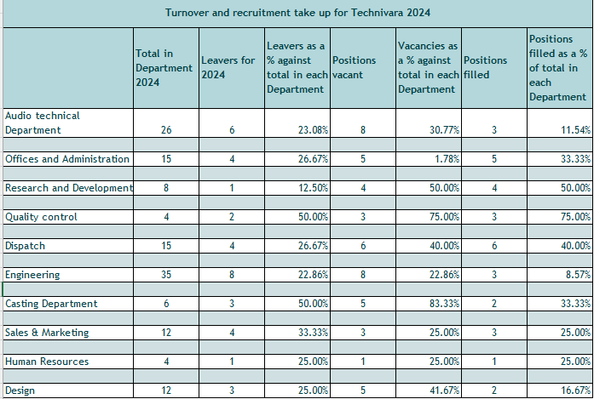

AC 2.2
Diagram 1 – Leavers as a % against total in each department
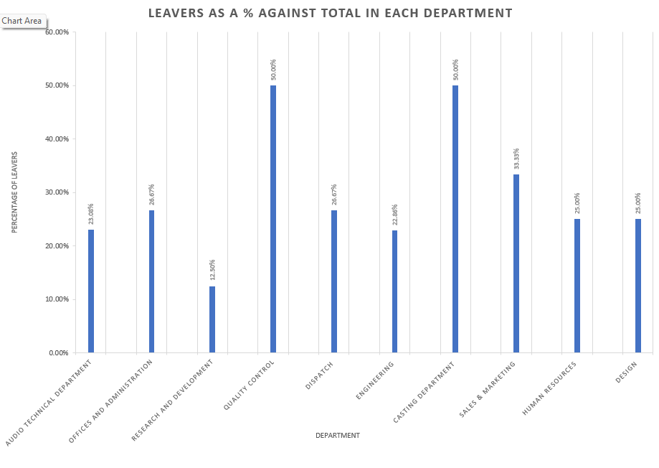

Diagram 2 – Vacancies as a % against total in each department

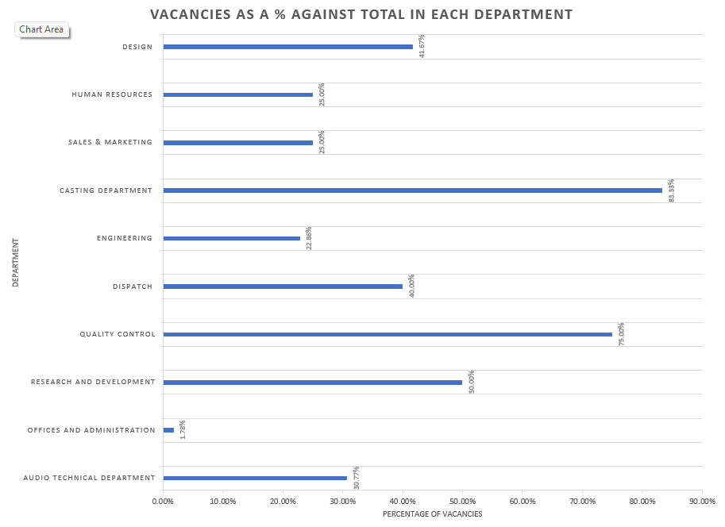

Diagram 3 – Positions filled as a % against total in each department

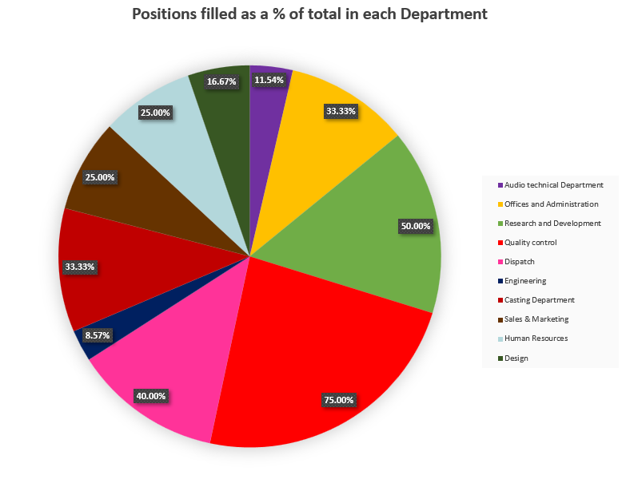

AC 2.3
Conducting feedback following an L&D initiative is a beneficial way to determine the success of the session and identify improvements. The quantitative data allows for the creation of patterns, themes and recommendations.
Pattern 1: High facilitator knowledge
There is a clear pattern of agreement that the facilitator was knowledgeable in what was being taught.
- 93% of learners either strongly agreed or agreed that the facilitator was knowledgeable.
- 93% either strongly agreed or agreed that the facilitator provided clear set objectives.
- 79% either strong agreed or agreed that the facilitator provided a clear explanation of the topics.
This indicates the facilitator had strong subject expertise and was able to communicate effectively. Research shows that facilitator knowledge and communication are vital for a positive learner experience (Wisshak & Hochholdinger, 2018). Therefore, issues learners experienced were likely linked to areas such as design and interactivity.

Pattern 2: Positive learning materials with poor achievement of learning outcomes
Despite strong agreement that good quality resources were used, learning outcomes were poorly achieved.
- 86% of learners agreed that resources used were good quality
- Over half of learners either strongly agreed or agreed that the session was well structured.
- 79% of learners either strongly disagreed or disagreed that learning outcomes were achieved.
This highlights that preparation alone did not achieve effective learning, suggesting weaknesses in the learning style used. The quality of resources cannot be fully relied upon for successful learning, other considerations such as learning styles and encouraging participation are important for effective training (CPD, 2024).

Theme 1: Low engagement
Engagement of the L&D activity amongst learners was low.
- 5% of learners agreed that they were able to engage with questions and answers.
This suggests a facilitator-led session with little interactivity. Deslauriers et al. (2019) explain that passive instruction whereby the facilitator communicates one-way to learners delivers low engagement. For successful learning implementation, learners must engage through active participation (Blue, 2022).

Theme 2: Little consideration of individual learning needs
Learners felt that the learning did not target their learning preferences and were unsure on the relevancy to their job.
- Only 24% of learners agreed that their learning preferences were considered
- 53% of leaners were unsure if they could apply the learning to their current role.
This theme suggests a standardised session. Research has shown personalised learning improves learner competence and experience compared to generic approaches (Gunawardena, Bishop & Aviruppola, 2024).
Recommendations
Analysis of data has highlighted two key concerns which are the relevance of the learning to job roles and the lack of learner engagement
Recommendation 1: Learning Needs Analysis
Technivara should conduct a Learning Needs Analysis (LNA) before L&D activities. A LNA considers organisational goals and reviews these against existing knowledge and skills gaps to guide further and relevant leaning initiatives (CIPD, 2025).
One benefit is that it identifies any deficiencies in learning and allows for consideration of the best way to fill the gap (Merriman, et al. 2023). This is beneficial for Technivara, as to expand, they must ensure employees have the right skills to meet the targets and are aligned with their growth objective. Additionally, employees are likely to feel more engaged in training if they believe it is relevant to them with research suggesting that learners are more committed to learning sessions if a LNA was conducted prior, resulting in high motivation (Raj, 2024). A more engaged and motivated workforce will keep retention rates and productivity high for Technivara’s growth.
A risk of a LNA is the resistance to change from those involved in the training for example a change in learning material may not be accepted or leaders may deem it unnecessary (Trivedi, 2024). This is particularly relevant to Technivara who operate in an archaic, change adverse way. Another risk is that current People Practice resources may be insufficient to support the LNA. Othayman et al. (2022) explain how weak HR systems can prevent businesses from identifying training requirements resulting in an inability to select relevant learning. This could be a large risk to Technivara where the capture of People Practice information is poor.
Financially a LNA involves costs associated with data collection such as interviews and employee time for analysis(CIPD, 2025). This cost may not be justified by Technivara if they want to invest in growth. However, research shows that global enterprises waste £2.7 million on ineffective training and so while a LNA may be a high upfront cost it could have a positive cost benefit (Denny, 2025).
Recommendation 2: Diversify Learning Methods
To better accommodate learner needs and enhance engagement, Technviara should combine different learning formats such as introducing technology, on-the-job training, and team sessions rather than a single training session to enable a more learner centred approach (CIPD, 2025).
One benefit is improved learner engagement. Research supports that when employees see their individual learning needs are met, they feel greater engagement in the process and learning outcomes are achieved (Goyibova. Et al, 2025). This ensures that Technviara maximise L&D and that employees are engaged in the process, encouraging them to use the learning in the workplace. Another benefit of diversifying learning methods is better alignment with organisational outcomes. CIPD (2023) explain that organisations that incorporate a range of technology into their L&D benefit from a positive correlation between learning delivery and organisational goals.
A risk of this is the complexity of organising multiple learning methods. Ms et al. (2025) explain that while organisations need to adopt more personalised learning, it involves reworking training strategies, facilitator development and supporting technology. This makes the approach time consuming and involves multiple changes of which Technivara are adverse.
A financial implication for this is a high upfront cost. Lingio (2025) explains costing of training including technology required, trainer travel costs and training material which all bear company costs and so combining these to deliver multiple learning formats will only increase these further. However, in time, costs will reduce as learning material and software are in place.
Together, these recommendations address issues from the L&D evaluation by improving relevancy using a LNA and engagement through the incorporation of different delivery methods, ultimately improving learning effectiveness.

Reference List
Armstrong, M. & Taylor, S. (2014). Armstrong’s handbook of human resource management practice. 11th ed. Kogan Page.
Armstrong, M., Brown, D. & Reilly, P. (2011) ‘Increasing the effectiveness of reward management: an evidence‐based approach’, Employee Relations, 33(2), pp.106-120. https://doi.org/10.1108/01425451111096668
Arora, S., Malhotra, L. and Ruhil, M. (2024) ‘Aligning strategic HR management with business objectives: Examining the effect on organizational effectiveness and performance’, ShodhKosh: Journal of Visual and Performing Arts, 5(3), pp.31-42. https://doi.org/10.29121/shodhkosh.v5.i3.2024.1657
Bandal, M. (2023) Rational Thinking: The Key to Making Better Decisions and Solving Problems. Available at: https://www.linkedin.com/pulse/rational-thinking-key-making-better-decisions-solving-manasi-bandal/ (Accessed: 22nd January 2026).
Barrow J.M. & Khandhar, P.B. (2023) Deontology. In: StatPearls. StatPearls Publishing.
Bin Othayman, M., Mulyata, J., Meshari, A. and Debrah, Y. (2022) ‘The challenges confronting the training needs assessment in Saudi Arabian higher education’, International Journal of Engineering Business Management, 14, p.18479790211049706. https://doi.org/10.1177/18479790211049706
Blue, J. (2022) What’s it got to do with me? The role of relevance in learner engagement. Available at: https://www.cambridge.org/elt/blog/2022/02/10/role-relevance-learner-engagement/ (Accessed: 1st February 2026).
Brandt, K. (2024). Why Low Performance Is Costing Your Business More Than You Think. Available at: https://nationalcioreview.com/articles-insights/extra-bytes/why-low-performance-is-costing-your-business-more-than-you-think/ (Accessed: 31st January 2026).
Braun, G., Räty, P., Bokinge, M., Rikala, P., Hämäläinen, R., Syberfeldt, A. and Stahre, J. (2025) ‘The skill bridge–A global qualitative analysis of skill gap management’, Journal of Environmental Management, 395, p.127738. https://doi.org/10.1016/j.jenvman.2025.127738
Briner, R. (2024) EVIDENCE-BASED HR: A NEW PARADIGM. Available at: https://www.crforum.co.uk/wp-content/uploads/2024/01/Evidence-Based-HR-A-New-Paradigm.pdf (Accessed: 22nd January 2026).
Business Money (2025) UK Payroll and HR Market to hit £1.58bn by 2026. Available at: https://www.business-money.com/announcements/uk-payroll-hr-market-to-hit-1-58bn-by-2026/ (Accessed 23rd January 2026).
CEBMA (2026) What are the limitations of evidence based practice? Available at: https://cebma.org/resources/frequently-asked-questions/what-are-the-limitations-of-evidence-based-practice/ (Accessed 22nd January 2026).
Chalutz Ben-Gal, H. (2019) ‘An ROI-based review of HR analytics: practical implementation tools’, Personnel Review, 48(6), pp.1429-1448. https://doi.org/10.1108/PR-11-2017-0362
Chowdhury, T.N., Hossain, M.J. & Rahman, M.A. (2026) ‘Using Evidence-Based Management and HR Analytics in Bangladesh: How These Affect Organizational Performance’, Global Journal of Human Resource Management, 14(1), pp.19-41. https://doi.org/10.37745/gjhrm.2013/vol14n11941
CIPD (2021) PESTLE Analysis. Available at: https://www.cipd.org/globalassets/media/knowledge/knowledge-hub/factsheets/pestle-analysis-factsheet_20221230T092611.pdf (Accessed 23rd January 2023).
CIPD (2022) People Performance: an evidence review. Available at: https://www.cipd.org/globalassets/media/knowledge/knowledge-hub/evidence-reviews/people-performance-practice-summary_tcm18-109854.pdf (Accessed: 22nd January 2026.
CIPD (2023) Learning at work 2023. Available at: https://www.cipd.org/globalassets/media/knowledge/knowledge-hub/reports/2023-pdfs/2023-learning-at-work-survey-report-8378.pdf (Accessed: 2nd January 2026).
CIPD (2025) Employee Engagement and Motivation. Available at: https://www.cipd.org/uk/knowledge/factsheets/engagement-factsheet/#how-to-build-an-engaged-and-motivated-workforce (Accessed 30th January 2026).
CIPD (2025) Learning needs analysis. Available at: https://www.cipd.org/uk/knowledge/factsheets/learning-needs-factsheet/#How (Accessed: 1st February 2026).
CIPD (2025) Methods of delivering learning interventions. Available at: https://www.cipd.org/uk/knowledge/factsheets/learning-methods-factsheet/#choosing-learning-and-training-methods (Accessed: 1st February 2026).
CIPD (2025) Evidence-based practice for effective decision-making. Available at: Evidence-based practice for effective decision-making | Factsheets | CIPD ) (Accessed: 22nd January 2026).
CIPD (2026) Code of conduct and ethics. Available at: https://www.cipd.org/uk/membership/professional-standards/code-of-conduct/ (Accessed: 26th January 2026).
CPD (2024) CPD tips - 10 ways to improve your training sessions. Available at: https://www.cpduk.co.uk/news/cpd-tips-10-ways-to-improve-your-training-sessions (Accessed: 1st February 2026).
Das, P.K., 2019. Impact of BSC on Corporate performance. American Journal of Humanities and Social Sciences, 7(1), pp.1-9. https://doi.org/10.11634/232907811705967
De Bono, E. (2026) Six thinking hats. Available at: https://www.debonogroup.com/services/core-programs/six-thinking-hats/ (Accessed 24th January 2026).
Denny, J. (2025) The Cost of Ineffective Training Needs Analysis. Available at: https://www.linkedin.com/pulse/cost-ineffective-training-needs-analysis-juliette-denny-ud1bf/ (Accessed: 1st February 2026).
Deschamps, E. (2024) Being aware of our biases makes us better humans. Available at: https://www.linkedin.com/pulse/being-aware-our-biases-makes-us-better-humans-evelyne-deschamps-ofpme (Accessed: 22nd January 2026).
Deslauriers, L., McCarty, L.S., Miller, K., Callaghan, K. & Kestin, G. (2019) ‘Measuring actual learning versus feeling of learning in response to being actively engaged in the classroom’, Proceedings of the National Academy of Sciences, 116(39), pp.19251-19257. https://doi.org/10.1073/pnas.1821936116
Dunwoodie, K., Macaulay, L. and Newman, A. (2023) ‘Qualitative interviewing in the field of work and organisational psychology: Benefits, challenges and guidelines for researchers and reviewers’, Applied Psychology, 72(2), pp.863-889. https://doi.org/10.1111/apps.12414
Dwyer, C.P. (2023) ‘An evaluative review of barriers to critical thinking in educational and real-world settings’, Journal of Intelligence, 11(6), p.105. https://doi.org/10.3390/jintelligence11060105
Elugbaju, W.K., Okeke, N.I. & Alabi, O.A. (2024) ‘Human resource analytics as a strategic tool for workforce planning and succession management’, International Journal of Engineering Research and Development, 20(11), pp.744-756. (PDF) Human Resource Analytics as a Strategic Tool for Workforce Planning and Succession Management
Embat (2024) Direct and indirect cash flow: advantages and disadvantages. Available at: https://www.embat.io/en/blog/direct-and-indirect-cash-forecasting-advantages-and-disadvantages (Accessed: 1st February 2026).
Esparrago-Kalidas, A.J., 2021. The effectiveness of CRAAP test in evaluating credibility of sources. International Journal of TESOL & Education, 1(2), pp.1-14. https://www.i-jte.org/index.php/journal/article/view/25
Ferri, S., Tron, A., Fiume, R. & Della Corte, G. (2020) The relation between cash flows and economic performance in the digital age: an empirical analysis. Corporate Ownership & Control, 17(3), pp.84-91. https://doi.org/10.22495/cocv17i3art6
Gov UK (2024) Late payments research: understanding variations in payment performance and practices across business sectors and sizes (HTML executive summary). Available at: https://www.gov.uk/government/publications/late-payments-research-performance-and-practices-across-business/late-payments-research-understanding-variations-in-payment-performance-and-practices-across-business-sectors-and-sizes-html-executive-summary (Accessed: 1st February 2026).
Goyibova, N., Muslimov, N., Sabirova, G., Kadirova, N. & Samatova, B. (2025) ‘Differentiation approach in education: Tailoring instruction for diverse learner needs’, MethodsX, 14, p.103163. https://doi.org/10.1016/j.mex.2025.103163
Gunawardena, M., Bishop, P. & Aviruppola, K. (2024) ‘Personalized learning: The simple, the complicated, the complex and the chaotic’, Teaching and Teacher Education, 139, p.104429. https://doi.org/10.1016/j.tate.2023.104429
Gupta, R. and Bodhankar, A. (2023) ‘Impact of six thinking hats techniques on the legitimate decision-making skills of managers’, Russian Law Journal, 11(5S), pp.449-456. https://doi.org/10.52783/rlj.v11i5s.963.
Hacking HR (2024) Designing a Competitive Total Rewards Strategy: Definitions, Fundamentals and Strategies. Available at: https://www.linkedin.com/pulse/designing-competitive-total-rewards-strategy-definitions-fundamentals-ri8jc/ (Accessed: 22nd January 2026).
Hacking HR (2025) How HR Strategy contributes to business strategy. Available at: https://www.linkedin.com/pulse/how-hr-contributes-business-strategy-hacking-hr-vyt4f/ (Accessed: 31st January 2026).
HR Support (2024) https://hrsupportdesk.co.uk/value-and-impact-of-peoples-practice-and-how-it-can-be-measured/ (Accessed: 31st January 2026).
JP Morgan (2026) Enhance your business’s financial health with effective cash flow management. Available at: https://www.jpmorgan.com/insights/treasury/forecasting-planning/cash-flow-management-and-reporting-guide-for-businesses (Accessed: 31st January 2026).
Karadzhov, V. and Patarchanova, E. (2025) ‘How to create the best PESTEL analysis’, International Journal of Digital Research, 1(3), pp.8-20. https://doi.org/10.63711/ijdr.net20250301
Larsson, D., Ratnayake, R.C. and Samarakoon, S.S.M. (2025) ‘Agile Balanced Scorecard and Strategy Map Framework for Engineering-to-Order Projects: Enhancing Adaptability and Performance’, Engineering Management Journal, pp.1-22. https://doi.org/10.1080/10429247.2025.2538065
Leontis, A. (2025) Understanding utilitarianism. Available at: https://www.philosophos.org/ethical-terms-utilitarianism (Accessed 26th Janaury 2026).
Lingio (2025) Cost of training employees: Clear breakdown & saving tips for 2025. Available at: https://www.lingio.com/blog/cost-of-training-employees (Accessed: 1st February 2026).
Liu, S. and Skerratt, L. (2025) ‘Accuracy in private company financial reporting for prediction of future cash flow’, Journal of the International Council for Small Business, pp.1-22. https://doi.org/10.1080/26437015.2025.2461028
Marcus, A.A. & Hargrave, T.J. (2021). Managing business ethics: Making ethical decisions. Sage Publications.
Marr, B. (2022) 13 easy steps to improve your critical thinking skills. Available at: https://www.forbes.com/sites/bernardmarr/2022/08/05/13-easy-steps-to-improve-your-critical-thinking-skills/ (Accessed: 22nd January 2026).
McCartney, S. and Fu, N. (2022) Bridging the gap: why, how and when HR analytics can impact organizational performance. Management Decision, 60(13), pp.25-47. https://doi.org/10.1108/MD-12-2020-1581
McLeod, S. (2024) The Interview Method In Psychology. Available at: https://www.simplypsychology.org/interviews.html (Accessed: 28th January 2026).
Merriman, S.E., Plant, K.L., Revell, K.M. & Stanton, N.A. (2023) ‘A new approach for Training Needs Analysis: A case study using an Automated Vehicle’, Applied Ergonomics, 111, p.104014. https://doi.org/10.1016/j.apergo.2023.104014
Mishra, A., Newey, L. and Spee, P. (2025) ‘Greatest Good for the Greatest Number–the Role of Managers’ Ethical Meaning-Making and Subjective Wellbeing Complexity’, Journal of Business Ethics, 197(3), pp.557-579. doi.org/10.1007/s10551-024-05748-2
Monday, T.U. (2020) ‘Impacts of interview as research instrument of data collection in social sciences’, Journal of Digital Art & Humanities, 1(1), pp.15-24. https://doi.org/10.33847/2712-8148.1.1_2
Ms, M.M., Bili, D.M., Begu, E., Lak’apu, R.I. & Poa, I.G. (2025) ‘Challenges in Human Resource Training in the Hybrid Working Era’, Formosa Journal of Multidisciplinary Research, 4(4), pp.1779-1792. https://doi.org/10.55927/fjmr.v4i4.163
Naithani, V. and Goyal, A. (2022) ‘Ethics in Human Resource Management: A Conceptual and Theoretical Analysis’, Res Militaris, 12(5), pp.1820-1832. Available at: https://www.researchgate.net/publication/379053618_Ethics_in_Human_Resource_Management_A_Conceptual_and_Theoretical_Analysis
Olanipekun, L.O. and Jayeoba, F., 2021. ‘Ethics in human resource management: A conceptual and theoretical analysis’, American Journal of Business Management, Economics and Banking, 1, pp. 23-31. https://doi.org/10.5281/zenodo.6547247
Omoigui, N. (2022) Businesses investing heavily in ineffective training. Available at: https://www.hrmagazine.co.uk/content/news/businesses-investing-heavily-in-ineffective-training (Accessed: 23rd January 2026).
OR Briefings (2026) Bias Awareness – Defintiion and explanation. Available at: https://oxford-review.com/the-oxford-review-dei-diversity-equity-and-inclusion-dictionary/bias-awareness-definition-and-explanation/ (Accessed: 22nd January 2026).
People Insight (2026) What is a pulse survey and what are the benefits? Available at: https://peopleinsight.co.uk/benefits-employee-pulse-survey/ (Accessed: 31st January 2026).
Pitsillidou, M., Noula, M., Roupa, Z. & Farmakas, A. (2023) ‘Barriers to the adoption of evidence based practice in nursing: a focus group study.’, Acta Informatica Medica, 31(4), p.306. https://doi.org/10.5455/aim.2023.31.306-311
Power, R. (2024) Employees In Action: Unlocking Profit Through An Engaged Workforce. Available at: https://www.forbes.com/sites/rhettpower/2024/07/21/employees-in-action-unlocking-profit-through-an-engaged-workforce/ (Accessed: 31st January 2026).
Projects&co (2025) Traditional versus Modern Transformation Leadership style. Available at: https://projectsnco.com/blog/modern-transformation-leadership-style/ (Accessed: 23rd January 2026).
Raj, A. (2024) ‘The Impact of Training Need Analysis (TNA) on Employee’s Performance: An Analysis Made on Five-Point Likert Scale’, Internation Journal of multidisciplinary research, 2(8), pp. 40-52. https://doi.org/10.5281/zenodo.13743037
Ramsudeen, R. (2025) ‘A Theoretical, Diagnostic Review of SWOT, PESTLE, Porter’s 5 Five Forces Models, as a Strategic Analytical Planning Tools for the Business Environment’, Texila International Journal of Management, 11(2). DOI: 10.21522/TIJMG.2015.11.02.Art047
Rousseau, D.M. and Ten Have, S. (2022) ‘Evidence-based change management’, Organizational Dynamics, 51(3), https://doi.org/10.1016/j.orgdyn.2022.100899.
Routledge, H. (2024) From theory to practice: Boosting productivity with action learning. Available at: https://www.trainingjournal.com/2024/content-type/features/from-theory-to-practice-boosting-productivity-with-action-learning/ (Accessed: 24th January 2026.
Serrat, O. (2017) Knowledge solutions: Tools, methods, and approaches to drive organizational performance. Springer Nature.
Singh, S., Darwish, T.K. & Potočnik, K. (2016) ‘Measuring organizational performance: A case for subjective measures, British journal of management, 27(1), pp.214-224. https://doi.org/10.1111/1467-8551.12126
Smith, G. and Peloghitis, J. (2023) ‘Approaching Cognitive Bias in Critical Thinking Instruction’, JALT Postconference Publication, pp.339-346. https://jalt-publications.org/sites/default/files/pdf-article/jalt2023-pcp-039.pdf
Sunday, M.N. & Nsentip, E.B. (2025). ‘Effect of Cash Flow on Going Concern of Technology Industry: A Study of Amazon Inc’, Journal of Accounting and Financial Management, 11(9), pp.18-29. DOI: 10.56201/jafm.vol.11.no9.2025.pg18.29
Tawse, A. and Tabesh, P., 2023. Thirty years with the balanced scorecard: What we have learned. Business Horizons, 66(1), pp.123-132. https://doi.org/10.1016/j.bushor.2022.03.005
Tessema, S.A., Yang, S. & Chen, C. (2025) ‘The Effect of Human Resource Analytics on Organizational Performance: Insights from Ethiopia.’, Systems, 13(2), p.134. https://doi.org/10.3390/systems13020134
Trivedi, K. (2024) What are the common challenges to avoid during a learning needs analysis?. Available at: https://www.linkedin.com/advice/0/what-common-challenges-avoid-during-learning-needs-analysis-75xhf (Accessed: 1st February 2026).
Urbini, F., Chirumbolo, A., Giorgi, G., Caracuzzo, E. and Callea, A. (2021) ‘HRM practices and work engagement relationship: differences concerning individual adaptability’, Sustainability, 13(19), p.10666. https://doi.org/10.3390/su131910666
VQ Solutions (2025) Ethical Perspectives in People Practice: Informing and Influencing Decision-Making. Available at: https://vqsolutions.co.uk/blog/ethical-perspectives-in-people-practice-informing-and-influencing-decision-making (Accessed: 30th January 2026).
Wisshak, S. & Hochholdinger, S. (2018) ‘Trainers’ knowledge and skills from the perspective of trainers, trainees and human resource development practitioners’, International Journal of Training Research 16(3), pp. 218-231. https://doi.org/10.1080/14480220.2018.1576327
Xu, Z., Wang, Y. and Qian, Y. (2025) ‘The design and application of in-depth interviews in primary care research’, Chinese General Practice Journal, 2(2), p.100062. https://doi.org/10.1016/j.cgpj.2025.100062
Yawson, R.M. and Paros, A.K. (2023) ‘Systems perspective of the use of the balanced scorecard for organization development and change’, Sage Open, 13(4), p.21582440231218064. https://doi.org/10.1177/21582440231218064
Young, R. A. (2025) ‘Account of Practice: Action Learning as an Organizational Change Vector’, International Journal of Management and Applied Research, 12(2), pp. 87-97, https://doi.org/10.18646/2056.121.25-006

