

Counselling Skills and Approaches Placement Portfolio
Mind- Swansea



Table Of Contents:

Evidence One: Charity Information………………………………………………………….3

Section A: Information ………………………………………………………………5

Section B: Mission Statement………………………………………………………..4

Evidence 2: Placement Logs…………………………………………………………………9

Evidence 3: The Volunteering Process………………………………………………………6

Section A: Training…………………………………………………………………………….7-8

Section B: Initial application for volunteering emails and meetings………………...6

Reflection……………………………………………………………………………………12

Appendix…………………………………………………………………………………….16

References …………………………………………………………………………………..19

Apart of my module Counselling skills and Approaches, it was mandatory to take part in a 120-hour placement. I was able to attend placement in a registered charity called Mind. Mind is an England and Wales based charity, who offer support to those expiring mental health problems with their many different services. Minds provide advice and support to empower individuals that are experiencing any mental health problems. Campaigning to improve services, raise awareness and promote understanding to others of mental health problems and ways to get support. Any members of the public can use this charity for support through during difficult by using may of their different service times, whether that's counselling, group walks, learning disability support, housing, money or even just someone to talk to. Minds aim is to change the outlook on mental health within England and Wales, by creating an environment where everyone’s mental health is treated as a priority. Mind’s goal is to ensure those who are struggling in difficult situations can receive extra care and support, by the offering of advice, aid from local charities, guides to local service and many more.
Firstly, I started by researching the background of the charity, I was able to find their website and read through their website, I was able to understand the mission of the charity and the goals they set to what to help others in need. I believe this fit perfectly with my module counselling skills and approaches and volunteering at this charity would largely benefit my academic skills as well as my own personal experience within this sector of mental health support.
As seen on their website, mind Swansea show what their vision of the charity includes by helping those with metal health problems by showing support and respect through many different services.

They also state their what their mission statement includes by working or volunteering with the charity. Such as giving advice and support in a respectful and empowering way. Linking with the counselling approaches such as the person centred, and the core conditions are widely used throughout this charity’s services (Rogers 1989).
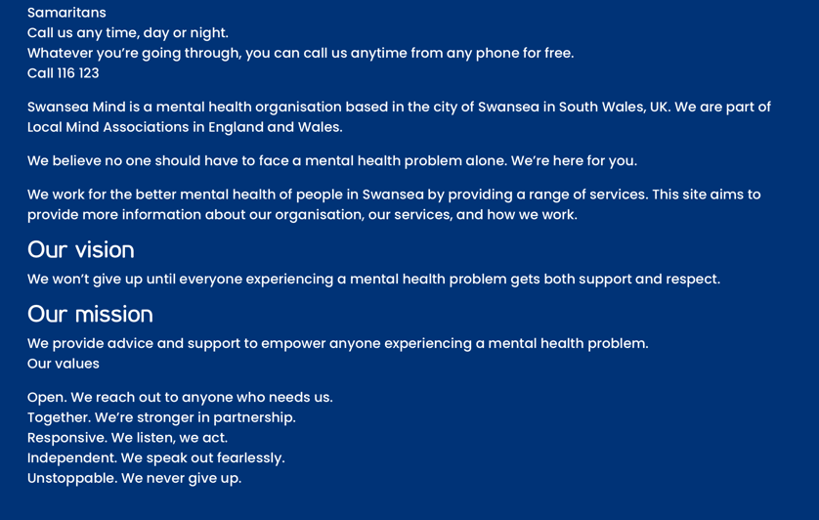

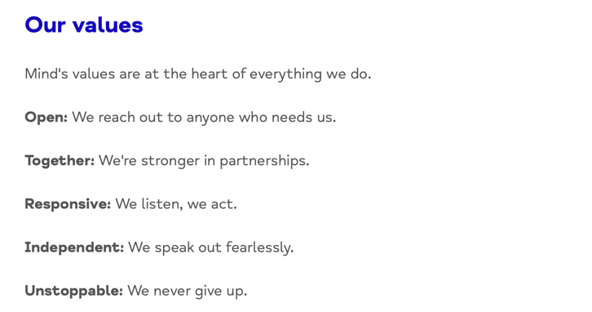
The values and mission’s organisation align with what I believed would be a great opportunity to experience, learn and practise skills that are linked to my module counselling skills and approaches.

Such as the empowering choice goal, this would help deepen my practical experience of using skills to help with mental health support, especially when preforming different counselling practises in the future.

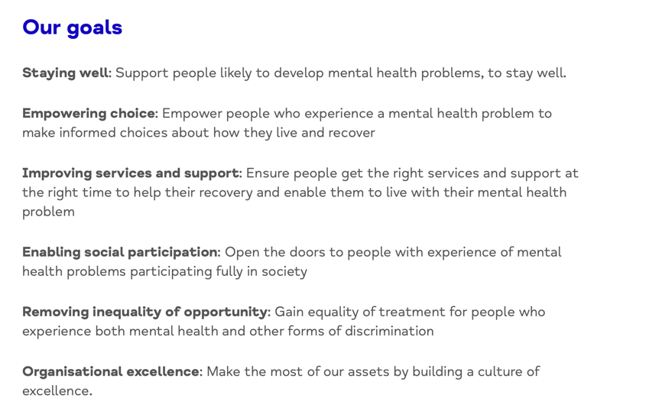

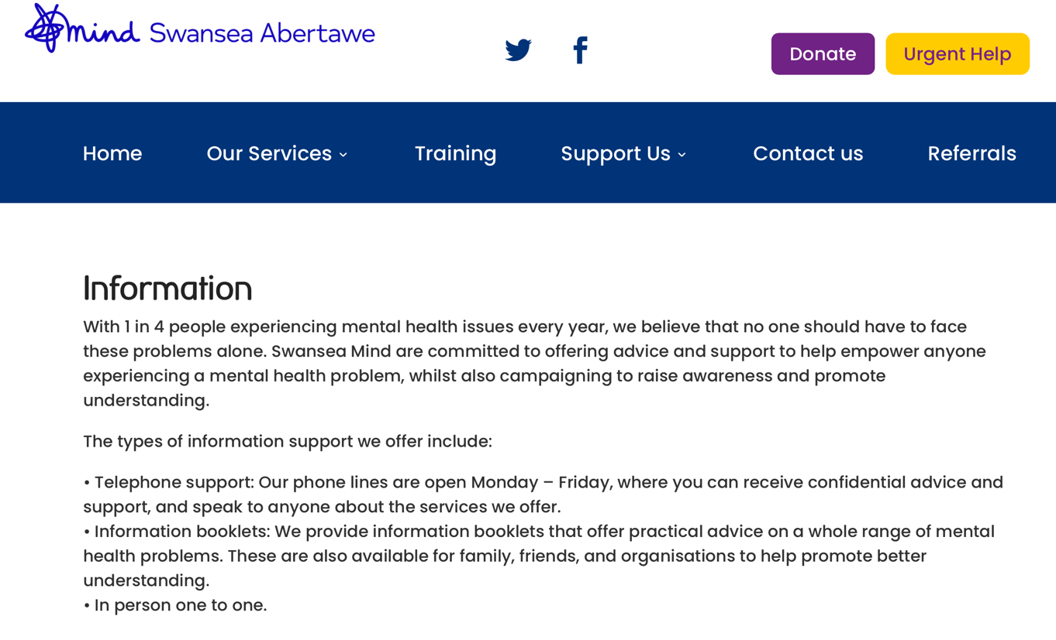
Mind Swansea offers many different services within its charity, this includes in person (face-face sessions), Walk and Talk, Counselling, Active Monitoring, Information and Telephone support and group support. All these services shown on the website are suitable for individuals with varied mental health problems, including the severity or the circumstances of their situation. While volunteering at mind Swansea my role was to often help induvial understand what services are available, what they include and what may best suit them personally in their circumstances. For example, if an individual may be suffering from loneliness, I would recommend the service of walk and talk and group support, as this involves them into a community of other individuals who may also be feeling similar ways.

With each service that Mind Swansea provides for those who want to volunteer include many compulsory trainings sessions are required. Although no experience is necessary when volunteering with mind, it is essential to stay trained and educated within the field of mental health, to be able to give the best level of support as possible to the service users. as well as extra training courses seen on the website. Especially when dealing with more severe mental illnesses.
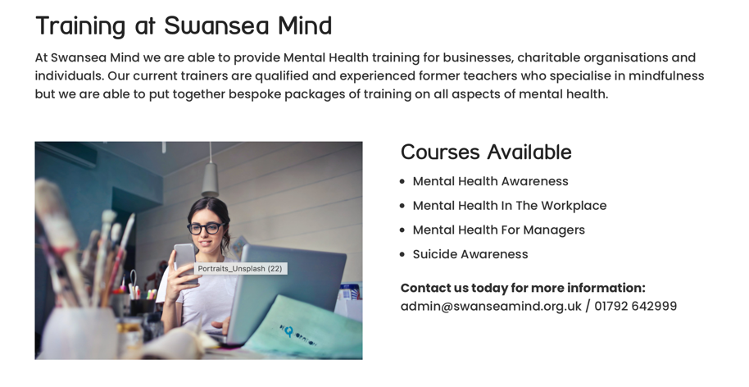
As seen on Mind’s website they offer training courses to
Those who volunteer to provide extra education when
working with this service. Often when I was dealing with
befriending calls, service users may be struggling with suicidal thoughts, having specific training in this sector hugely benefited my knowledge on how to deal with supporting this user to my best ability, also providing me confidence and comfort that I knew how to appropriately deal with this situation
When first starting with mind, I spend a few of my first session observing, taking notes and listing other volunteers take phone calls. This helped me understand the position of what I was going to be put into and what was expected of me to carry out.

To begin my application to mind Swansea I contacted the service to ask the availability for volunteer work. This was set up through email, where my first steps were to apply for a volunteer position then later it was set up to visit the mind Swansea office for a chat about the role its responsibilities, tasks and requirements such as a DBS and training. Once this had been discussed I was given a starting date. My role in this placement was to work within the befriending service. This service offers a weekly phone call update requested by a service user. This can be to discuss mental health problems, housing, family, money, and personal struggles.

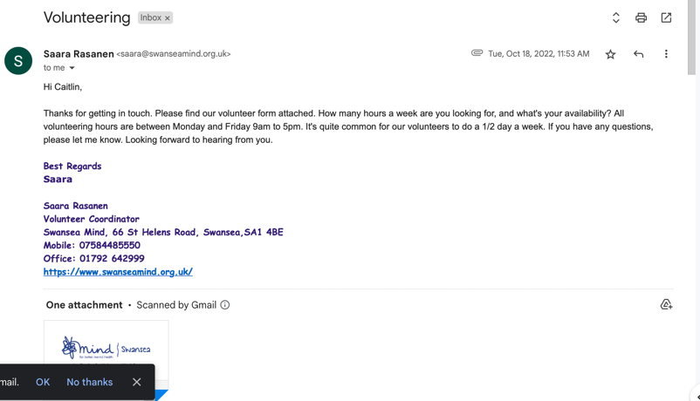

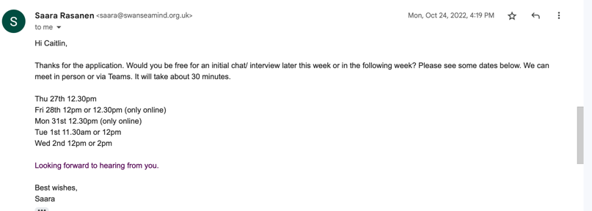

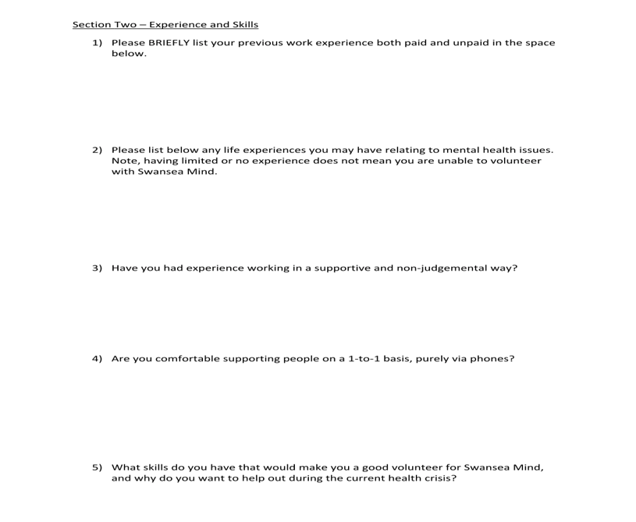
The application included answering questions about my previous experiences linked to this role, as well as personal experiences I have been through.

Training

Before beginning my placement, I made sure to take part in all the necessary training session, this included training in mental health acts, legislation and rights, then practical training such as supporting mental health workshops, suicide prevention, managing mental health at work and family, role plays and many more. This was to make sure I was fully prepared to start my befriending phone calls. Not only was in trained in these aspects, but I was also taught about confidentiality within working with others, diversity, equality, respect, communication, safety, health and security. This training ensured I was equipped with the knowledge and skills to start my placement confidently and to the best of my ability.

I also completed online training courses in deaf, blind awareness and LGBTQ+ language. These courses were incredibly valuable, and I am grateful I had the opportunity to take part in them broaden my knowledge.

This training also included computer-based activities, such as appropriate and correct data collection and recording on their database, Lamplight. This training involved learning about the importance of recording data for each service user correctly and its benefits.

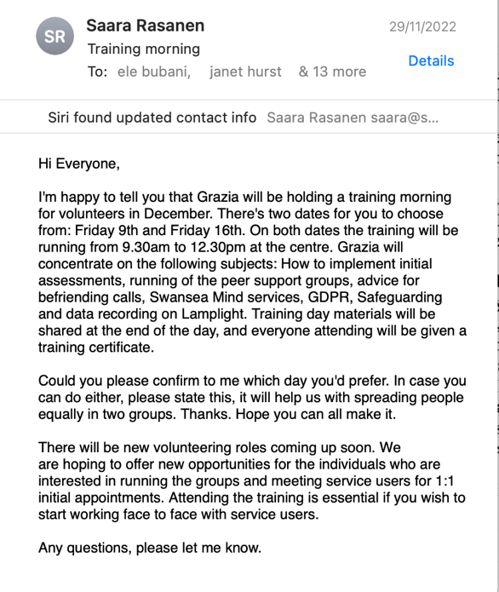

Before starting my volunteering role, I need to know what to do in the event of a problem, emergency or risk assessment, so it was very important that I was well trained and informed. I knew my rights, my safety, and the procedures to follow for my role within the charity. I have not only completed the mandatory training course on Confidentiality, Working with Others, Diversity and Equality, Protection and Communication, Security and Health and Safety but I have been taught the understanding of patients, understanding, empowerment, values and empathy. I was able to link approaches and skills I have learnt through my module of counselling skills and approaches to transfer into my training and all throughout my placement. Such as core beliefs by Carl Rodgers (1989) and Motivational interviewing by William R. Miller (1983).

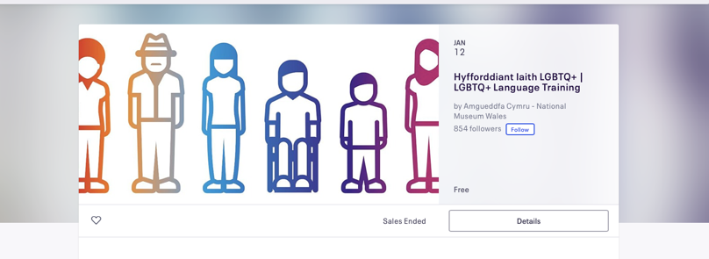
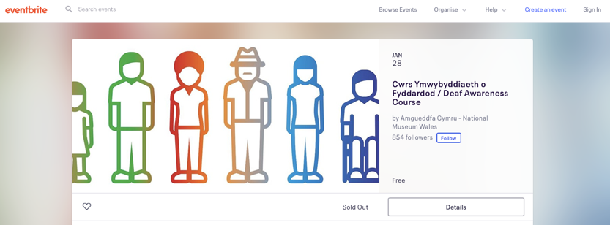

Evidence 2: Placement Logs

Throughout my placement I kept a log of each week of placements experience, I reflected on tasks I had completed that week. This has helped me able to review all the different tasks I was able to experience throughout my placement so far.

Student Name: | Caitlin Ridgway
Name of Host Employer: | Mind Swansea Befriending Service

Record of project work carried out (add more entries as needed)
Date: | ^{8th} November 2022
Tasks completed: | Training/ 1-1 meeting with team manager before starting placement.
Reflection: | In today’s session was my first training session. This was a one-to-one meeting with Saara. Firstly, we discussed my previous experience I have had in this position, such as working with venerable individuals, talking 1 to 1 with clients and support. After we discussed this, we went on to talk about certain approaches to use when carrying out befriending calls, Saara made sure I was comfortable with who to talk to, how to talk to them and what about. She gave me tips on conversation starters, questions to ask and different services I was able to recommend to the callers if they wanted extra support, for example, housing numbers, finical support emails and may more. Although I have not started my befriending calls yet, and have little experience in doing it, I felt so much more comfortable and relaxed on what to do in my next session as this is when ill be starting my calls. I was able to learn some conversation starters, how their database works, this includes all clients, their previous history/note with the charity and what they would like to talk about. I was taught how to access this database and how to add my own notes and logs into it once I start making my own calls.  We also went through what different approaches to use if I was ever in a position where a problem arose or if I felt uncomfortable or unable to help the caller, such as referring numbers and emails for other services, as well as who to contact on the team if I need extra support or guidance through difficult calls.  Going through this made me more relieved about taking calls, as I was worried about difficult calls and If was able to handle it well or say the right things. I was taught there was always more support and guidance available by all the other workers.

Date: | ^{15h} of November 2022
Tasks completed: | Observing/ taking notes/ helping with Befriending calls
Reflection: | In today’s session I was partner with a volunteer to observe and gain some knowledge with the befriending phone calls. I was able to take notes on what to say when calling, how to log it in the data base.  The first call I observed I listened to how the volunteer properly introduced themselves and started the conversation by using previous notes that had been logged on the data base about the client. Watching the volunteer do this made me less anxious for when I must do this myself, it was very simple and clear to start the conversation.  Although there were often where the volunteer would struggle to know what to say or reply to the client due to the difficulty of the call, but all the other staff members in the room helped support and guide him through what to say next or how to provide them with more help, in this circumstance we were able to give council help line numbers.  This gave me more guidance as I knew I had a room full of extra help if I was every struggling with a call.  I was able to make helpful notes for my future calls on such as questions to ask, and how to log my phone calls into the data base lamplight to then use for next time.

Date: | 29th November 2022
Tasks completed: | First befriending calls by myself
Reflection: | Today I completed my first day of befriending calls myself. At first it was very daunting, I felt extremely anxious but once I was able to think about all the training and support, I had been given It allowed me to feel a lot more confident in my ability to make the phone calls with ease. Using the notes, I had made last session I was able to use to guide me with how to introduce myself and start having a conversation with the service user. Instantly I felt more comfortable with the phone call and was able to gain more confidence to ask questions and to make notes of our conversation. My first phone call went very smoothly, I displayed my approval learned skills of listening, empathy, empowerment and display of rights and values. From this session I am overall feeling happier with how I have performed, and I am looking forward to taking more calls and talking to other service users.

Student Name: | Caitlin Ridgway
Name of Host Employer:

Record of project work carried out (add more entries as needed)
Date: | 6/12/22
Tasks completed: | Befriending calls, organising information sheets.
Reflection: | In today’s session I was able to take 2 befriending calls. I am becoming very confident in talking over the phone, I can use my skills while talking to the service user in a proactive helpful way. In one of my calls, I was able to recommend different local services as well as contact details for other services such as housing, money support and council email addresses.  For the second part of today’s session, I helped organise information sheets in the office that are given to 1-1 sessions, group walks and counselling sessions. These leaflets include different services contact details, urgent contact details as well as more information about the aims, values and goals of the charity mind. It was important these were organised and clear as they are given to every service user that visits the office.

Reflection

Reflecting over the past three months of participating in a placement at mind I able to clearly see how much I have been able to develop not only skills and experience but myself and my confidence with others. This placement this been extremely beneficial to my confidence when working closely with service users, and brough me great development on my counselling skills. Although I have continuously been improving on me perforce in this role, have been able to thoroughly understand where my improvements lie and what my next steps of improvement will be in the future. Using the Gibbs reflective cycle of learning (1988) has allowed me to look over my experience in this placement and analysis my learning, achievements, adaption and improvements I will continue to make into the future of other placements, my academic work and personally.

At the start of my placement, I felt very out of region and nervous. Although I had been learning about counselling in my module of counselling skills and approach, I had never been in a position of working within a mental health charity to support and help others closely. Especially being 1-1 phone calls with serviced users, I had the fear of not being confident in what to say or how to support the user with their personal issue. But this is what I began to realise was the purpose of this placement, to put myself out of my comfort zone to gain new knowledge, experience and understanding of a new work placement in a mental health setting, that links to my module counselling skills and approaches. The role itself was a very new setting, an office/phone calls isn’t a role I had experienced before, so being trained and taught on how to do this from the beginning has allowed me to gain an entire new set of skills from this placement alone.
Already from participating I feel a broader knowledge of a counselling setting than I did before. Many skills I have learnt have been transferable to not only my work but my academic studies in modules such as counselling skills and approaches. On one hand I have been able to transfer some of the most importantly needed counselling skills from my module to my placement such as active listening, non-verbal gestures, open questions, empathy and unconditional positive regard, I have also been able to now link these back into my work. For example, for assignments or practical work I feel more confident in the skills I am presenting now as I have used them practically on others in my placement.
From this placement I have also been able to develop my computer literacy skills. After every phone call it was important to log all data collected from the phone call into a database called lamplight, this needed to be correctly done after every phone call, so any data recorded was able to be used for their next weekly phone call. I was able to efficiently learn and adapt to lamplight, quickly learning how to store data was very beneficial for the role.

Going into the befriending service at mind felt very new and scary at first, I did not know what to expect to experience throughout this placement, but once receiving training brought me large amounts of confidence. Although I was new from my counselling skills and approaches module, I was able to use what I have previously learnt to guide me through the basic support needed for this role. Such as counselling skills but by advancing my communication skills as well as, problem solving, adaptability, and helping skills in training allowed me to transfer all I have been taught to use in my phone calls provide service users with as much support as I could. Once I started my befriending calls, it took some sessions for new callers who had previously used the service to open to me as they had not heard from me before, instead of this knocking my confidence I took it as an opportunity to use the skills I had been taught through counselling. I used knowledge I had about client-centred therapy and based my phone calls from these skills. I introduced who I was, where I came from and my aim of me and the service users weekly phone call. I allowed to caller to talk freely and openly about their struggles while I often just listened for as long as possible. After time, I found the callers to open to me more, discussing further about their feelings or struggles as well as looking forward to our weekly phone calls. This brought me great amounts of confidence in my own previous studies and proved my capability of using them.

Once my befriending phone calls had started, I felt very venerable and nervous, but considering the amount of training I had received as well as previously knowledge I was able to go into my first call with a clear and confident mindset, using notes I had taken from training and lectures to guide me through the call. From here, I have been able to form relationships with service use over the past couple weeks, from having regular weekly phone calls the more I am able to provide the service of advice, problem solving and support.

I was surprised at how easily I was able to adapt to my placement environment, I was able to quickly form relationships with other volunteers I was working with as well as the service users I was phoning each week. Being in an environment where I was able to communicate comfortably with those around me made me my time as mind Swansea enjoyable and fulfilling, not only was I able to develop a large scale of skills that can continuously be used throughout my studies and into the future, but I was able to develop myself. I have come out of this placement feeling extremely confident in myself and my abilities, at not only helping others with their struggles but also my own struggles with confidence and asking when having problems arise either during a call or uncertainty on how to use the database. Importantly, through my struggles and uncertainties I was able to learn where to improve. In the future this placement has shown me I would like to improve on my organisation skills, such as keep all notes from each session clear and organised in a folder so I can easily use it for the next session. I would often miss place notes from phone calls, or training sheets so I was unable to use them in future sessions.
My overall experience of this placement was extremely positive and beneficial, the experience I gained from working in such a professional environment has prepared me for a career in a mental health environment in the future. I have gained new interests and opportunities for my future from this course as a result of this experience. During this placement, I discovered a passion for working with venerable people struggling with mental health problems. I'm looking forward to continuing to take part in future placements like this so I can learn more about this career path by continue my placement into the future.

Appendix

Information Form

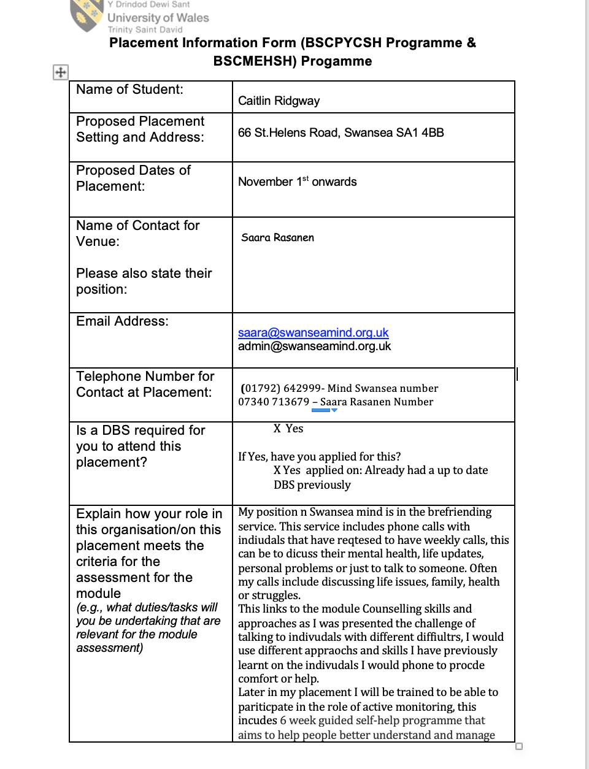

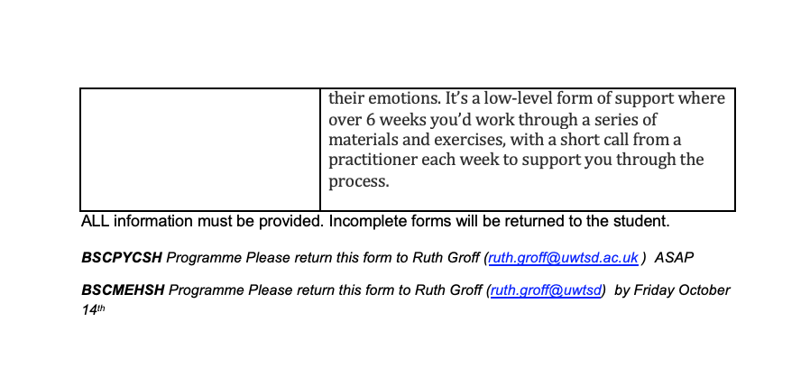

Attendance

Date | Time | Number of Hours
8th November 2022 | 2-4:30 | 3 and half hours
15th November 2022 | 2-4:30 | 3 and half hours
22nd November 2022 | 2-4:30 | 3 and half hours
29th November 2022 | 2-4:30 | 3 and half hours
^{6th} December 2022 | 2-4:30 | 3 and half hours
^{13th December 2022} | 2-4:30 | 3 and half hours

Organisation Confirming Role

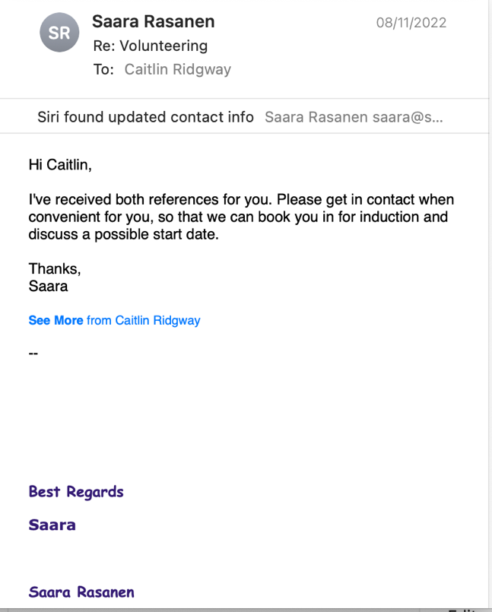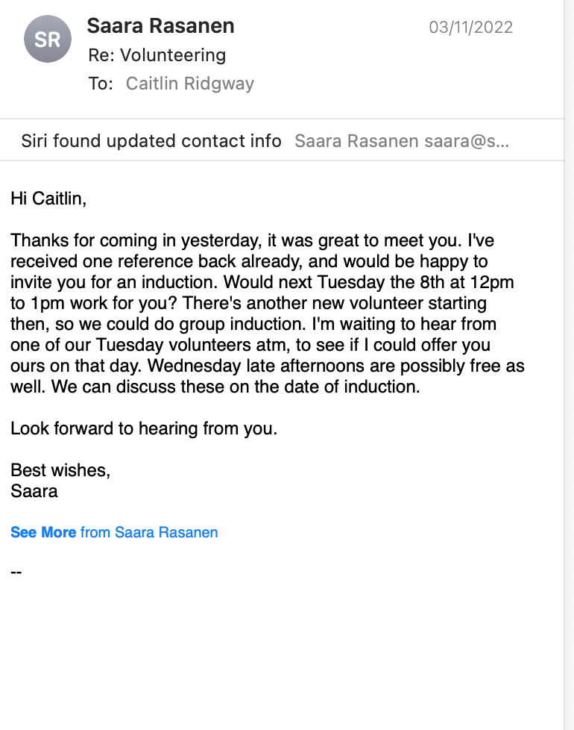

References

‌
‌ Gibbs, Graham, and Claire Andrew. Learning by Doing: A Guide to Teaching and Learning Methods. 1988. 1st ed., Geography Discipline Network, 2001, www.google.co.uk/books/edition/Learning_by_Doing/xVv4SAAACAAJ?hl=en. Accessed 28 Dec. 2022.
Mind. “Home | Mind, the Mental Health Charity - Help for Mental Health Problems.” Mind.org.uk, 2019, www.mind.org.uk.
Rogers, Carl. Client-Centered Therapy: Its Current Practice, Implications and Theory. Vol. 1, London, Houghton Miffin, 1989, pp. 59–60, www.google.co.uk/books/edition/The_Carl_Rogers_Reader/CRnR87UQbMwC?hl=en&gbpv=0&kptab=overview. Accessed 1 Jan. 2023.
‌

