  Component One:  What are the key skills required when working in the housekeeping team? 750 words (+/- 10%)  Contribution to Overall Module Assessment: 25% | Student No: | 2129004
 | Module Title: | Operating Hotel Facilities
 | Module Code: | BMIH4006
 | Lecturer: | Placement
In this log I will reflect on skills essential for the housekeeping team as well as I will focus to apply theoretical knowledge in practice, and why this topic is essential in the hospitality industry. Working in a housekeeping team requires unique skills beyond simply cleaning and maintaining a space (Chétrite et al., 2019). As someone with experience in the hospitality industry, I understand the importance of having a skilled and efficient housekeeping team to ensure guests have a pleasant and comfortable stay. During my placement and also through this module, I came to know that there are variety of essential skills required when working in a housekeeping team.
First and foremost, attention to detail is a crucial skill for anyone working in housekeeping team (Raghubalan and Raghubalan, 2016). It's essential to spot the most minor imperfections, from stray hair on a pillowcase to a fingerprint on a mirror (Navarro and Martínez, 2018). Guests often notice even the slightest issue, and it is the job of the housekeeping team to make sure that every detail is taken care of to create a clean and welcoming environment. Another essential skill in housekeeping is time management. Cleaning and maintaining a space require a lot of planning and organization to ensure that everything is completed in a timely manner (Thébaud et al., 2021). It is important to prioritize tasks based on their importance and urgency and work efficiently to ensure everything is completed within the allocated time. In my experience working in housekeeping, I found that creating a checklist or a to-do list helped keep me on track and ensure I did not miss anything. Communication is also crucial in housekeeping, mainly when working in a team (Horst and Sinanan, 2021). It is essential to communicate effectively with colleagues to ensure that tasks are assigned and completed efficiently.
Communicating with guests is also essential to meet their needs and requests (Casado, 2012). In my experience, listening carefully to guest requests and communicating any issues or concerns with my team leader was key to providing excellent service. Flexibility is another skill that is crucial when working in housekeeping (Chétrite et al., 2019). The needs of guests and the hotel can change quickly, and it's essential to adapt and adjust to meet these changing needs (Firth, 2021). Whether it's working overtime to ensure that a room is ready for a last-minute booking or adjusting cleaning schedules to accommodate a guest's request, being flexible is critical to ensuring that guests have a positive experience. Finally, a positive attitude and a willingness to go above and beyond are essential skills for anyone working in housekeeping. Providing excellent service to guests often requires going the extra mile, whether it is leaving a handwritten note to welcome them to their room or taking the time to chat and make them feel at home (Vallen and Vallen, 2012). A positive attitude can go a long way in creating a welcoming and comfortable atmosphere for guests.
In terms of applying theoretical knowledge in practice, my education in hospitality management provided a strong foundation for my work in housekeeping. Learning about the importance of guest satisfaction and the role of housekeeping in creating a positive experience helped me understand the value of my work and how it contributed to the hotel's overall success. Furthermore, my education in time management and communication skills helped me to work efficiently and effectively in a team setting. One example of how I applied theoretical knowledge in practice was when a guest complained about the cleanliness of their room. Using my communication skills, I spoke with the guest to understand their concerns and apologized for any inconvenience caused. I then communicated the issue to my team leader, who immediately sent a member of the team to address the issue. By applying my knowledge of guest satisfaction and communication, I quickly resolved the issue and ensured the guest was satisfied with their stay. The topic of housekeeping is important in the hospitality industry for several reasons (Zhang et al., 2015).
The cleanliness and maintenance of a hotel play a crucial role in guest satisfaction. A clean and comfortable room can make a guest's stay more enjoyable and memorable, while a dirty or poorly maintained room can leave a negative impression (Firth, 2021). These skills are essential for housekeeping staff to ensure that all areas of the hotel are clean and safe and that all guests are satisfied with their stay (Chétrite et al., 2019). Furthermore, housekeeping staff needs to apply theoretical knowledge to practical situations to identify and resolve issues quickly and efficiently. The importance of the housekeeping team in the hospitality industry cannot be overstated, as they are the key to ensuring a satisfactory experience for all guests (Zhang et al., 2015).
Word Count | 793

References
Casado, M. (2012) Housekeeping Management. London: Wiley.
Chétrite, R., Gupta, S., Neri, I. and Roldán, É., 2019. Martingale theory for housekeeping heat. Europhysics Letters, 124(6), p.60006.
Firth, R., 2021. Housekeeping among Malay peasants. Routledge.
Horst, H. and Sinanan, J., 2021. Digital housekeeping: Living with data. New Media and Society, 23(4), pp.834-852.
Navarro, A. and Martínez‐Murcia, A., 2018. Phylogenetic analyses of the genus Aeromonas based on housekeeping gene sequencing and its influence on systematics. Journal of applied microbiology, 125(3), pp.622-631.
Raghubalan, G. and Raghubalan, S. (2016) Hotel Housekeeping - Operations And Management. 3rd ed. India: Oxford University Press.
Thébaud, S., Kornrich, S. and Ruppanner, L., 2021. Good housekeeping, great expectations: Gender and housework norms. Sociological Methods and Research, 50(3), pp.1186-1214.
Vallen, G. and Vallen, J. (2012) Managing Hotel Operations. London: Pearson.
Zhang, Y., Li, D. and Sun, B., 2015. Do housekeeping genes exist?. PloS one, 10(5), p.e0123691.

Component Two:
Here is a table format for the five problems that could have led to the guest's room not being properly cleaned.
Problem | Why did it happen? | What are you going to do? | How will you prevent this from happening in the future? | What measures would you introduce to improve team effectiveness?
Lack of attention to detail by housekeeping staff | It could be due to housekeeping staff needing to be more relaxed and adequately trained on cleaning standards. | I will be speaking to the housekeeping staff who worked on the room and reviewing the cleaning checklist to identify areas that may have been missed. | I will provide additional training to the housekeeping staff on cleaning standards and procedures, paying particular attention to the steps involved in cleaning each type of room.The housekeeping staff to use when cleaning each room and require that the checklist be completed before the room is deemed clean (Cottrell, 2019). | I will hold regular team meetings to discuss any issues or concerns and provide updates on new cleaning procedures or standards.Hold weekly team meetings to discuss any problems or concerns, provide updates on new cleaning procedures or means, and review any feedback or suggestions from team members. Encourage team members to share ideas and ask questions to ensure everyone is on the same page (Fallon Rutherford, 201).
Breakdown in Communication between team members | Miscommunication or lack of Communication between housekeeping staff, supervisors or front desk staff could lead to missed cleaning tasks. | I will be investigating the communication breakdown and identifying ways to improve Communication between team members. | I will encourage open Communication between team members and provide regular feedback to the staff on their performance. Open Communication between team members is essential for the success of any team (Ferdinand and Kitchin, 2017). | I will provide ongoing training and development opportunities for the housekeeping staff to help them improve their communication skills through coaching on how to effectively communicate with guests, such as using a friendly tone of voice, appropriate body language, and polite language (Johnston, et al 2012).
Inadequate cleaning supplies or equipment | If the housekeeping staff does not have the necessary cleaning supplies or equipment, it can lead to a poor cleaning job. | I will conduct an inventory of cleaning supplies and equipment to ensure that the. The housekeeping staff has all the necessary tools. | I will regularly restock cleaning supplies and equipment to ensure the housekeeping staff always has what they need.They follow established safety protocols when handling and disposing of hazardous materials (Jones, 2010). | I am Introducing a system of incentives and recognition to motivate the staff and reward them for their hard work and dedication.Bonuses should be based on measurable goals and objectives that are set for each employee(Fallon Rutherford, 2010) ).
Lack of supervision or quality control | Without regular supervision or quality control checks, housekeeping staff may miss cleaning tasks or not meet cleaning standards. | I will Implement a system of regular quality checks to ensure each room is cleaned to the required standard. | I will provide regular feedback to the housekeeping staff on their performance. They give timely and specific feedback on their positive and constructive  undertaking (Cottrell, 2019). | I hold regular team meetings to discuss any issues or concerns and provide updates on new cleaning procedures or standards.This allows for open dialogue and discussion among team members to ensure everyone is heard and their opinions are considered (Leiter and Bakker, 2010).
Insufficient time allocated for cleaning tasks | If housekeeping staff are given inadequate time to complete cleaning tasks, they may rush or miss lessons. | I will review and adjust the cleaning schedule to ensure that housekeeping staff have adequate time to complete their tasks. | If necessary, I will provide additional support, such as other staff or equipment.To provide extra training to existing staff and access to specialized resources (Bridger, 2018). | I am Introducing a system of incentives and recognition to motivate the staff and reward them for their hard work and dedication.Implement a peer-to-peer recognition program that allows employees to recognize and reward each other for their hard work (Leiter and Bakker, 2010).

I am addressing these five problems and implementing measures to improve team effectiveness, and I can prevent similar incidents from happening in the future and ensure that guests receive the high standard of cleanliness and service that they expect from the hotel.

Component Three:

Introduction
A hotel's housekeeping manager is in charge of overseeing the cleaning staff and making sure that everyone staying there is in a clean and secure environment. Heserves as the team's leader, trainer, and supervisor while ensuring that all housekeeping personnel adhere to the correct safety and hygienic requirements for guest rooms and public areas(Tesone, 2010). This presentation will discuss about the variety of different localities within the facilities management, and significance of work based skills with in the area of hotel operation. Also,the aim of this presentation is to understand the development knowledge of guests’ services and competencies appropriate to each departmental area of operation.

Effective communication
In this training sessionthe housekeeping manager will explained about the effective communication skills, including how to communicate with colleagues and supervisors, and how to listen actively to guests' needs and concerns. Housekeeping manager highlight the importance of effective communication using clear and concise language, and asking for clarification when needed(Sharma et al., 2019).
The housekeeping manager of Hotel Trinity will explain the purpose of effective communication in the trainingsession and he will ensure brand standards are met and Health and Safety procedures are followed.
A best practice industry example of implementing this model is Hotel Trinity. They use the effective communication to gather feedback from employees, and then use the results to make improvements and implement changes that positively impact employee engagement. For example, they implemented a recognition program called "Catch Me at My Best," where employees can nominate each other for outstanding performance.
By implementing the Gallup Q12 Employee Engagement Survey and learning from the best practices of companies like Hotel Trinity, the team can create a framework for improving effective communication in the housekeeping department. This can lead to improved morale, job satisfaction, and overall performance(Rogers, 2008).
Training Notes:I learn about the focus of the training session that will be given by the housekeeping manager on effective communication skills in the background of the hospitality industry. From the training session,I have learnabout how to communicate effectively with colleagues and supervisors, how to listen actively to guests' needs and concerns, and the importance of clear and concise language.
Quality Control
In this training session, the housekeeping manager explains about how to perform quality control checks to ensure that all rooms meet the hotel's standards before they are released for guest occupancy. Emphasize the importance of paying attention to detail, and of addressing any issues immediately. The housekeeping manger of Trinity Hotelwillexplain how to pay attention to detail, address any issues immediately, and ensure that all cleaning tasks are completed to the highest standards and housekeeping manager ensure that team members understand the importance of quality control in maintaining the hotel's reputation and providing a positive guest experience and met health and safety measures(Mullins and Dossor, 2013).
Training Notes:I want tolearn that how quality control helps in becoming good at seeing minor details, inquiring and how to amplify the proficiency. This sessionhighlights the importance of paying attention to detail and addressing any issues immediately in maintaining the hotel's reputation and providing a positive guest experience. It also highlights the significance of quality control in ensuring that all rooms meet the hotel's standards and met health and safety procedures before they are released for guest occupancy.
Time Management:
The housekeeping manager covers time management skills in this session to ensure that team members can complete their tasks within the allotted time frame. Also, the housekeeping manager cover prioritising tasks, staying organised, and working efficiently to ensure that all rooms are cleaned to the hotel's standards. The housekeeping manager of Hotel Trinity ensure that colleagues understand the importance of time management in housekeeping work, to maintain a high level of productivity and they complete their cleaning tasks within the allotted time frame(Raghubalan and Raghubalan, 2016).
Training Notes:From this training sessionI havelearned about the importance of time management in the context of housekeeping work, and how it can affect productivity and efficiency. Moreover I want to learnabout how to prioritise tasks, stay organised, and work efficiently to ensure that all rooms are cleaned to the hotel's standards within the health and safety measures.
Cleaning Procedures:
The housekeeping manager will be familiar with all cleaning procedures, products, and equipment used in the hotel. The training cover proper cleaning techniques, safety procedures, and how to use and maintain equipment.The housekeeping team will learn how to clean different areas of the hotel, such as guest rooms, public areas, and back-of-house areas(Mullins and Dossor, 2013). They will learn the correct cleaning techniques and products to use, as well as how to maintain cleanliness and hygiene.
Training Notes:From this session, I will learn about the importance of following specific cleaning procedures and adhering to disinfecting protocols in maintaining guest satisfaction and safety. By following cleaning procedures I want to ensure a clean and comfortable environment for guests, and to prevent the spread of germs and bacteria that could cause illness.
How to Use Tools and Equipment?
The hotel's equipment and supplies for cleaning should be present at all times, according to the housekeeping manager. The people who do the cleaning may not be knowledgeable with the tools, supplies, or techniques. There is always a better method to utilise the tools and equipment, even if they have been used before, to maintain in good condition and increase their lifetime. The cleaning staff has to be skilled in using certain tools and equipment if they are to keep the hotel tidy. With the right tools and supplies, the cleaning staff at Premier Inn Hotels did a fantastic job maintaining the property(Leiter and Bakker, 2010).
Training Notes:In order to clean hotels as efficiently as possible, I want to learn how to utilise the tools and equipment that hotel housekeepers use. When the person in charge of cleaning makes sure that every member of the staff uses tools and equipment while doing housekeeping responsibilities, this will be evaluated.

Inventory Management:
The housekeeping manager trainthe team on how to manage inventory efficiently, including linen and cleaning supplies. Housekeeping manager emphasize the importance of maintaining appropriate stock levels, proper storage and handling, and minimising waste. The housekeeping manager of hotel Trinity must will ensure that supplies and equipment’s are stored in a safe and organised manner, and that they are distributed efficiently to housekeeping staff as needed(Leiter and Bakker, 2010).
Training Notes:I want to learn about how to track inventory from purchase to the sales of goods. This will identifies and responds to ensure there always stock to fulfil customers’ orders and proper warning of a shortage. I will learn about different types of inventory management systems, including manual systems and automated systems, and how to choose the right system for hotels or resorts.
Safety and Security:
The housekeeping manager should be familiar with all safety and security procedures in the hotel. This training should cover emergency procedures, health and safety regulations, and how to handle guest complaints.The housekeeping manager explain colleagues with the knowledge and skills required to respond effectively in emergency situations, such as a fire or a medical emergency(Jones, 2010). The housekeeping manager of Hotel Trinity will train them on evacuation procedures, how to use emergency equipment such as fire extinguishers, and how to communicate with other staff and guests during an emergency. Emphasize the importance of safety and staying calm during such situations(Hotel Owner, 2021).
Training Notes:From this training session I want to learn about the specific emergency procedures that are in place at hotel or resort, including evacuation plans, emergency contacts, and protocols for different types of emergencies such as fires, medical emergencies, or natural disasters. Moreover I have learned about how to handle guest complaints related to safety and security issues, including how to respond to guests who may be upset or scared during an emergency situation.
Technology:
Housekeeping technology has an essential part in hotel industry. In this session the housekeeping manager of hotel Trinity will explain about the importance of technology in housekeeping. He will explain the use of these technologies used in housekeeping including mobile phones, management software, automated cleaning equipment and Smart room technology.
The housekeeping manager of Hotel Trinity should be familiar with the latest technology used in the hotel industry. This training will cover software used for room assignments, inventory management, and guest communication(Hospitality Net, 2023).
Training Notes:In this session I want to learnabout the role of technology in hotel industry. I want to learn how technology can boost the industry and how housekeeping software is important in hotel. I want to learn more about the latest trends in technology in the hospitality industry, including emerging technologies such as IoT, artificial intelligence, and robotics.
Work at height:
The individual in charge of housekeeping must give training to employees who work at heights. The manager of the housekeeping staff is responsible for ensuring that everyone has the proper safety attire, tools, and equipment. Anyone who do housekeeping duties that require them to work at a height must wear protective clothing, equipment, and gear to avoid injury(Fallon & Rutherford, 2010). The housekeeping supervisors of the Hotel Trinity ensure that every employee has the proper safety equipment. When working at a height, janitors must ensure that the ladders are properly positioned. Employee accidents and injuries are so prevented. The housekeeping managers of Premier Inn ensure that all of their employees have the necessary safety equipment.(Cottrell, 2019)
Training Notes:From working at height I will learn how to implement safety measures to prevent accidents, including using appropriate personal protective equipment, securing tools and equipment, and implementing barriers and guardrails.
How to Interact with and Handle Visitors:
Typically, housekeeping manager will either pass by or engage with visitors. The way they welcome and engage with visitors has a big impact on how much fun they had and whether or not they would return. If people are impolite and uncaring, this will be much more difficult. The hotel may instruct its staff members on how to manage body language and etiquette, create a good first impression, and understand cultural differences during training. These seemingly little changes will have a significant influence on how the cleaning team sees itself and interacts with clients. This could make it easier for the hotel to draw in new guests. The goal of this cleaning strategy was to draw hotel visitors' attention(Bridger, 2018).
Training Notes:Through effective communication, I want to learn how to interact with and work effectively with visitors. I'll get more customer information as a result of this. When the housekeeping manager offers training on how to engage with clients and cooperate, this will be taken into account.
Conclusion
In this presentation, the attention is on the role of the housekeeping manager in maintaining a clean and secure environment for guests. Effective communication, quality control, time management, cleaning procedures, and the use of tools and equipment are the key areas covered in the training session. The housekeeping manager of Hotel Trinity provides an example of best practices, which includes implementing effective communication through a recognition program and using quality control checks to ensure that all rooms meet the hotel's standards. Additionally, the training session emphasizes the importance of paying attention to detail, adhering to health and safety measures, and utilizing tools and equipment efficiently to maintain cleanliness and hygiene in the hotel. Overall, this training session highlights the significance of work-based skills within the area of hotel operation and the development of knowledge of guest services and competencies appropriate to each departmental area of operation.

References
Bridger, E.,2018. Employee engagement: a practical introduction. 2nd ed. HR Fundamentals. London: CIPD and Kogan Page.
Cottrell, S,.2019. The Study Skills Handbook. 5th ed. London: Red Globe Press.
Fallon, M. &Rutherford, D.,2010. Hotel Management and Operations. London: Pearson.
Ferdinand, N. and Kitchin, P.,2017. Events Management - An International Approach. 2nd ed. London:Hove [England]: Psychology Press.India: Oxford University Press.
Johnston, R., Clark, G. & Shulver, M.,2012. Service Operations Management. London: Pearson.
Jones, T.,2010. Professional Management of Housekeeping Operations. London: Wiley
Leiter, M. P. and Bakker, A. B.,2010. Work Engagement: A Handbook of Essential Theory and Research.
Mullins, L. and Dossor, P.,2013. Hospitality Management and Organisational Behaviour. 5th ed. Harlow:Oxford ; Boston: Butterworth-Heinemann.
Pearson.
Raghubalan, G. and Raghubalan, S., 2016.Hotel Housekeeping - Operations And Management. 3rd ed.
Rogers, T., 2008.Conferences and conventions a global industry (2nd ed., Events management series).
Sharma, N., Chaudhary, N. and Singh, V.,2019. Management Techniques For Employee Engagement In
Tesone, D.,2010) Principles Of Management For The Hospitality Industry. 1st ed. London: Routledge.

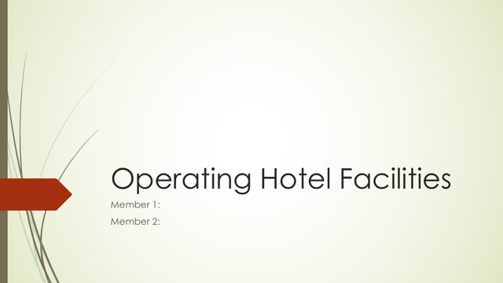

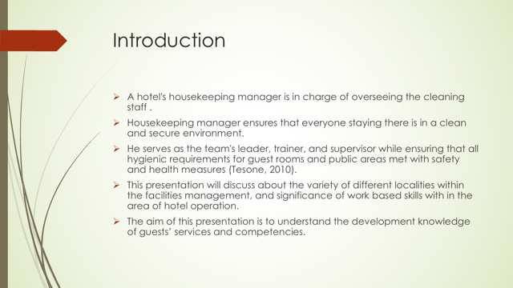
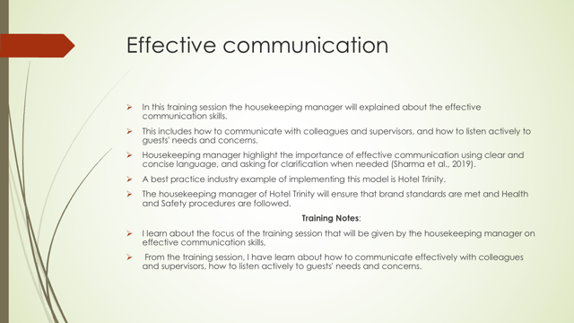

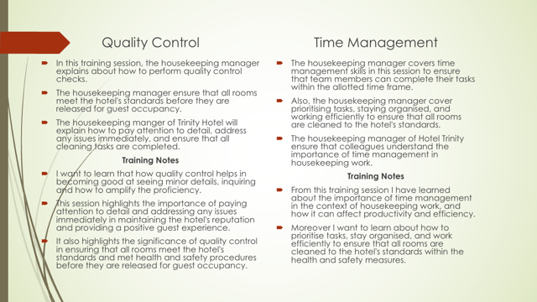

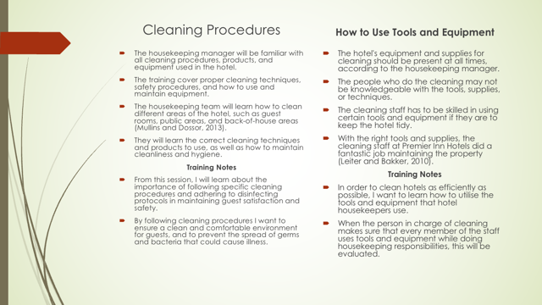
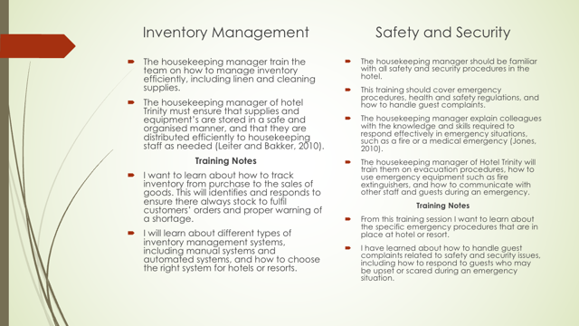
Dar


