

LOCATION: Swansea | LLEOLIAD: abertawe
LEVEL 7 | LEFEL 7
EXAMINATION PERIOD | CYFNOD ARHOLIADAU
November 2019 | tachwedd 2019

MODULE CODE: ACCA7017
IMPLEMENTING IP ROUTING
PRACTICAL TEST 1

Name :

Student ID :

Date & Time :

This is an individual practical lab-test, held under examination conditions. You will be assigned four Routers, you should configure these Routers based on the following specifications.

The routers that you will configure are: R1, R2, and R3.

This paper is marked out of 100.

You will have 2 hours to complete this task.

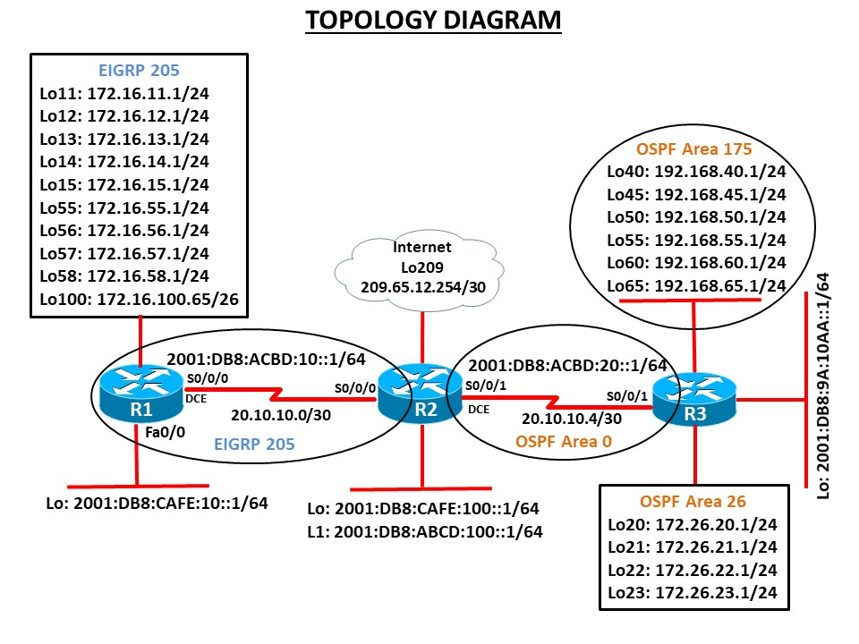

Task 1 – Network Connections

- Physically cable the network as shown in the topology diagram.

- Configure the router with hostname.

- Configure all interfaces with the IP addresses shown in the topology diagram. Set the bandwidth to 128 kbps on the links between R1, R2 and R3, set the clock rate on the DCE connections as appropriate.

- On IPv6 interfaces, configure global unicast and Link Local address.

Task 2 – Configure Routing (80 marks)

- Configure the routers R1 and R2 to be in EIGRP AS 205. Add all networks as shown in the diagram. Ensure that your network statements are as specific as possible. Disable automatic summarisation.
- On R2 and R3 configure the OSPFv2. Advertise appropriate networks in Area 0 with most efficient wildcard mask.
- On R3, enable OSPF Area 26 and 175 and add all loopback interfaces to appropriate area.
- Use the router identifier 1.1.1.1 on R1, 2.2.2.2 on R2 and 3.3.3.3 on R3.
- Change the OSPF network type on the loopback interfaces so that they are advertised with the correct subnet.
- Configure passive interfaces as required.
- Enable authentication for EIGRP and OSPF links.
- Configure IPv6 routing on all routers. Enable EIGRPv6 between R1 and R2. OSPFv3 between R2 and R3. Advertise networks as appropriate.
- On R2, configure mutual redistribution between OSPF and EIGRP for both IPv4 and IPv6. Assign appropriate metrics where required.
- On R3, configure manual summarization for Area 175.
- On R1, summarise loopback interfaces in its EIGRP update to R2 using manual summarization.
- Configure default route on R2 with exit interface as Lo209. Advertise the default route to all router in the topology.
- On R2, stop advertising the 172.26.20.0 network to R1 using a distribute list and ACL.
Note: Copy the routing table before and after route filter.
- Configure EIGRP for IPv6 for networks shown in the topology.

Task 3 – Network Connectivity (20 marks)

- Verify network connectivity using ping command. Show the ping results to exam invigilator to get verified. __________________________________(Invigilator sign off)
Note: If the ping results are not signed off by invigilator, would be considered as unsuccessful.
- Verify all routes are present on routing table
- Verify that filtered routes are not present in routing tables of the correct routers.

Submission Requirements:

On each Router the following outputs should be copied on to a text file. The file name should be Surname_Sno_routername.txt

Show running-configuration
Show ip interface brief
Show ip route
Show ipv6 interface brief
Show ipv6 route

All documentation for your solution should be submitted electronically on Moodle.
It is your responsibility that you copy all the files correctly.

