Properties of Framing Materials

3. Introduction
4.1 concrete framed building
5.2a Analyse the framing material
6.2b. Time, Labour, Programme and Cost when compared to steel framing.
2c. The frames ease of assembly and the potential ease of its adaptation to different building shape and building use, within the life cycle of the building.
7.2d. The problems faced by the integration of services provision, and how these problems are overcome.
2e. The specific challenges faced at the point of the building’s potential demolition, at end of life.
8.3 Discuss the negative impact of the concrete production process,
in terms of community and the environment.
9. 4a) Particle size table
4b) Percentage of fine aggregate
10. 4c) Particle size graph
4d) Comment on the result of grading
11. References

Introduction
In this Construction portfolio case study, I will be talking about a concrete framed building, its design origin and analyse the framing material and construction process, along with analysing concrete aggregate sieve test and determine the result of the particle size.
The building that has been chosen for this case study is the Burj Khalifa tower Fig 1, photo of Burj Khalifa, which is situated in Downtown Dubai, Dubai, United Arab Emirates (UAE).
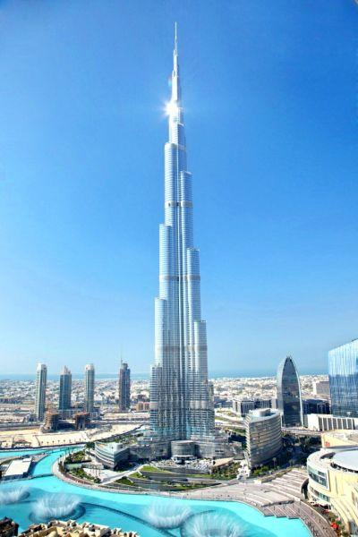
Fig 1: Burj Khalifa (Original from Emaar 2013)

- Report on the elements of its original design and the method of its construction.
The Burj Khalifa is the world’s tallest building and stand at 828m high, it was designed by an American architect Adrian Smyth which at the time worked for Skidmore, Owings and Merrill (SOM). According to Wikipedia, (2026) in 2006 he founded Adrian Smith + Gordon Gill along with Gordon Gill and Robert Foster.
The original concept for the Burj Khalifa, according to Specuwin (2025), was inspired by the Hymenocallis flower, whose three-petal form influenced the tower’s distinctive Y-shaped layout. This arrangement works much like a tripod, giving the building a naturally balanced structure that spreads forces evenly across all three sides. As a result, the tower experiences less wind-induced movement and operates more efficiently overall.
The skyscraper relies on a buttressed core system, where a strong central concrete core is supported by three extending wings arranged in the same Y-shaped pattern. Each wing braces the others, forming a unified structural network that directs loads down into the foundation. This system offers several major advantages:
- It provides exceptional resistance to wind pressure and seismic activity.
- It reduces the amount of steel reinforcement needed, helping to keep construction costs manageable.
- It allows the building to reach heights that would be difficult to achieve with more traditional skyscraper designs.
Information from Burj Khalifa EMAAR (undated), The Burj Khalifa stands on a foundation engineered to carry the enormous weight of the tower. Its base is formed by a thick reinforced-concrete mat, which rests on a series of deep bored concrete piles. The mat itself is 3.7 metres thick and was placed in four separate concrete pours, adding up to 12,500 cubic metres of high-density, low-permeability concrete. This makes the mat roughly as tall as two adults standing one on top of the other.
Specuwin (2025), States that the mix used for the concrete foundations was C80 and C60 grade making it the strongest mix available

- Analyse the framing material in the following specific areas

a. The framing materials strength, durability and climatic resistance, given the environmental conditions it is exposed to at the site of the build.
During the design phase over 40 wind tunnel tests were carried out on small scale models to examine the effects the wind had on the tower, determining if the structure could withstand the harsh environment that the UAE is well known for. see fig 2.

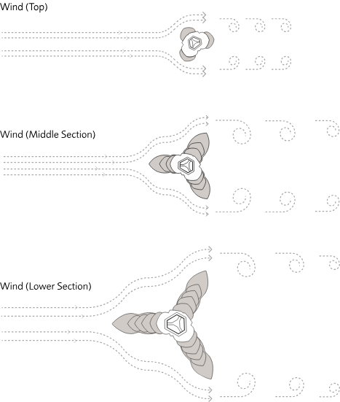
Fig.2 Burj Khalifa Emmar
As described by Burj Khalifa EMAAR (Undated), Another concern was a phenomenon called stack effect which affects tall buildings, this phenomenon is a change in pressure and temperature at height, Special studies were conducted on the tower to determine the magnitude of changes it would have on the Burj Khalifa’s design so to ensure its resistance to vibration, high heat and wind load.

2b. Time, Labour, Programme and Cost when compared to steel framing.
BERIGHT Properties (2025), A large share of the Burj Khalifa’s overall cost came from the enormous amount of labour required to build it. More than 12,000 people contributed over 22 million working hours, covering everything from concrete pouring and steel installation to façade assembly, high-rise operations, and mechanical systems. To keep the construction cycle moving, crews worked around the clock in alternating day and night shifts. As the tower climbed higher, progress naturally slowed and the work became more hazardous and physically demanding. Managing such a vast, multinational workforce also added complexity: communication barriers, strict safety requirements, and the scale of coordination needed all pushed labour costs even higher.

2c. The frames ease of assembly and the potential ease of its adaptation to different building shape and building use, within the life cycle of the building.
Fahimfmk (2024). The Burj Khalifa was designed so that its structure could be assembled efficiently while still supporting a wide range of uses throughout its lifetime. Its distinctive Y-shaped floor plan and the reinforced-concrete buttressed core give the tower exceptional stability, but they also create a highly repetitive structural layout that made construction and later maintenance more manageable. The project relied heavily on high-strength concrete and advanced steel reinforcement to achieve the stiffness and durability required for a building of this height and complexity. The tower is also organised into vertical zones, allowing different sections to function as residential, commercial, or hotel spaces. This mixed-use arrangement gives the Burj Khalifa long-term flexibility and helps it to adapt to the changing demands of time.

2d. The problems faced by the integration of services provision, and how these problems are overcome.
The integration of services in the Burj Khalifa—water, power, cooling, vertical transportation, waste management, and safety systems—faced a series of unprecedented engineering and logistical problems. These arose mainly because the building’s height (828 m) pushed every known system beyond conventional limits. The solutions required new technologies, new coordination methods, and new construction practices.
The Burj Khalifa overcame its service‑integration challenges by dividing the tower into mechanical zones, using multi‑stage pumping and electrical distribution, adopting advanced elevator systems with sky lobbies, installing flexible and movement‑tolerant service lines, developing specialised concrete and cooling methods for construction, implementing zoned fire‑safety and refuge floors, and coordinating all trades through detailed digital modelling and phased project management.

2e. The specific challenges faced at the point of the building’s potential demolition, at end of life.
The demolition of a high-rise concrete framed building presents challenges, these include Safety, Environment impact and Community impact.
With safety at the top of the list, ensuring the safety of the workforce and the surrounding public is high priority. The dangers of demolition of a high-rise is falling debris, structural instability and exposure to harmful air born particles and dust which could cause health issues in the future.
Demolition can cause high environmental impact issues theses can be in the form of dust pollution, waste management and noise pollution. With the dust pollution water suppressant hoses can lower the impact of dust pollution but with noise pollution it is harder to control. Waste management can also be an issue all depending on the area and size of the work site, larger sites have more storage room for the debris but with smaller sites that have less storage will potentially have a longer time frame.
Demolition can also impact the surrounding communities this being in terms of dust pollution, noise pollution and increased construction traffic which can impact and disrupt daily life.
With large scale demolitions project managing and planning is crucial so that safety to workforce and public is kept at a high standard, lower environmental impact and the community impact can be minimized.

- Discuss the negative impact of the concrete production process, in terms of community and the environment.

According to Fair Planet (2024) Producing cement is the most carbon-heavy stage of making concrete, mainly because of two processes: heating limestone during calcination and running the high-temperature cement kilns. When limestone is heated to create Portland cement, it breaks down chemically and releases a large amount of carbon dioxide. This single step is the biggest polluter in the entire concrete industry, responsible for as much as half of its total emissions.
On top of that, turning raw materials into clinker the key ingredient in cement demands extremely high temperatures. Keeping the kilns hot enough to process, mix, and cool the materials uses huge amounts of energy, most of which still comes from fossil fuels.
Traditional kilns are so inefficient that producing one tonne of cement can generate roughly one tonne of CO₂. Although newer plants have introduced technologies that reduce this ratio, the process remains highly carbon-intensive.
Concrete production can also cause vast scaring on the landscape from quarrying, this in turn can cause increased traffic flow in the community from hauling the products to its delivery destination prior to mixing.

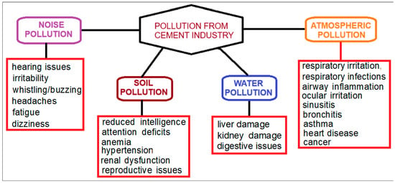
Fig.3 MDPI. Cement Industry Pollution and Its Impact on the Environment and Population Health: A Review
6.a) Sieve size table sample size of 1250g
Sieve Size  (mm) | Mass(g) | % on  sieve | % Passing
125 | 0 | 0 | 100
75 | 0 | 0 | 100
63 | 0 | 0 | 100
37.5 | 120 | 9.6 | 90.4
20 | 137 | 10.96 | 79.44
10 | 143 | 11.44 | 68
6.3 | 105 | 8.4 | 59.6
3.35 | 45 | 3.6 | 56
2 | 130 | 10.4 | 45.6
1.18 | 63 | 5.04 | 40.56
0.6 | 105 | 8.4 | 32.16
0.3 | 102 | 8.16 | 24
0.212 | 109 | 8.72 | 15.28
0.15 | 98 | 7.84 | 7.44
0.063 | 55 | 4.4 | 3.04

b). The percentage of the fine aggregate that was obtained from the sieve analysis was 56.56% and the percentage of the coarse aggregate in the mix was 40.4%

c). Particle size distribution chart
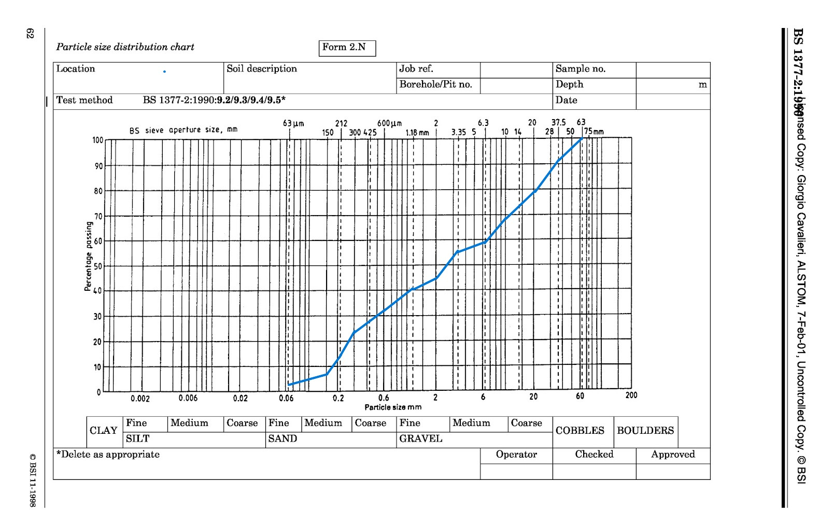
d). From the above sample it has been determined that the sample is well-graded which means the space between the larger particles is effectively filled and will create a strong concrete mix.

Figure List
Fig 1 World’s coolest futuristic buildings – Rediff.com Business
Fig 2 Burj Khalifa Constructions & Architecture in UAE
Fig 3 Cement Industry Pollution and Its Impact on the Environment and Population Health: A Review | MDPI

Reference List
Wikipedia (2026) Adrian Smith + Gordon Gill Architecture. Available at Adrian Smith + Gordon Gill Architecture - Wikipedia. (Accessed 09th March 2026)

Nishchay (2025) Case Study: Burj Khalifa – The Tallest Skyscraper. Available at Case Study: Burj Khalifa – The Tallest Skyscraper (Accessed 9th March 2026)

Burj Khalifa EMAAR Structure: Design and Construction. Available at Burj Khalifa Structure: Design and Construction (Accessed 10th March 2026).

ArchEyes | Timeless Architecture: Burj Khalifa by SOM: Engineering the World’s Tallest Skyscraper. Available at Burj Khalifa by SOM: Engineering the World’s Tallest Skyscraper | ArchEyes (Accessed 10th March 2026).

BERIGHT Properties Cost of Burj Khalifa: Complete Construction Breakdown. Available at Cost of Burj Khalifa: Complete Construction Breakdown | BeRight Properties (Accessed 12th March 2026).

Fahimfmk (2024). The tale of Burj Khalifa: why it remains the world’s tallest building. Available at The Tale of Burj Khalifa: Why It Remains the World’s Tallest Building! | by Fahimfmk | Medium (Accessed 12th March 2026).

Fair Planet Read, Debate: Engage. Why is concrete so damaging to the environment? Available at Why is concrete so damaging to the environment? | FairPlanet (Accessed 19th March 2026).

