

Assignment Title: Improving Data Centre Energy Efficiency with Adaptive Cooling Systems
Module Name: Integrated Project
Module Code: ACHA4008
Program of Study: Certificate in Higher Education: Digital Skills
Student Name: Sharanjeet Kaur
Student ID #: 2232229
Lecturer Name: Irina Neaga

Table of Contents
Abstract 3
CHAPTER 1: INTRODUCTION/ THE PROBLEM 4
CHAPTER TWO: LITERATURE REVIEW 5
CHAPTER THREE: METHODOLOGY 6
Different types of cooling systems 6
Things to consider while choosing cooling system 9
GANTT CHART 10
CHAPTER FOUR: CONCLUSION 11
References 12
Bibliography 13

Abstract
The aim of this report is to identify measures which can improve the data center efficiency. Technology is evolving with time and so are the data centers. Back in the days there were data centers that were cooled down with air technology and the equal proportion of heat was produced and cooled down. But with the passage of time and evolution of new methods and technology things have changed and now industries are finding ways to increase data center efficiency adaptive cooling systems.
The report talks about various cooling systems and their ability to perform, their pros and cons. This report presents thoroughly searched qualitative secondary data which involves a review of several well-written literatures. After that, a brief introduction of different types of cooling system is provided which will make the decision process easier. The process of selecting cooling system and methods of implementing it is also presented with the help of a GANTT chart.

CHAPTER 1: INTRODUCTION/ THE PROBLEM
Data centers are the centralized hub where all the material related to digital products has been stored. A large amount of computers used in the organization, information stored all needs a back place to store, access and disseminate their digital information and services.

The data centre can be located in a small room or can be built in a giant purpose fill complex. The purpose of data centres is to ensure high availability, security, and scalability for large amounts of data that are generated on a day to day basis in an organization.

Data centers are an essential part of any organization and also have some limitations. Data centers consume a large amount of energy. The servers are constantly working and they are machines, they must be cooled down for efficient and long-term use. Which is why organizations being in constant research for substitutes for energy efficient facilities to maximize their productivity.

Research Question: What adaptive cooling methods should be adapted to offer the most efficient and sustainable solution for data centers?

Research Aim: The purpose of this report is to identify adaptive cooling systems for data centers.

Research objectives: ·
- To provide data centers with a dynamic cooling system that can adjust to changing thermal demands.
- To maximize the cooling system’s energy, use in data centers while maintaining hardware performance and dependability.
- To find out how adaptive cooling might help data centers save money on operations and lessen their environmental effect.

CHAPTER TWO: LITERATURE REVIEW
Before dwelling further into research, let’s discover some market insight on the importance of cooling systems, the need of these and which cooling systems are the best to optimize performance. This literature review presents the findings from various credible courses that satisfy the need for dynamic cooling systems.

The Data centre is an essential part of computing and network and computing and networking is pivotal to every organization today. The energy consumed by these data centers is quite high. The cooling systems which are used to cool down these data centers also account for 30% of total energy consumption. Therefore, a need for a better and dynamic cooling system is there. Currently, some of the cooling systems that have been used today are air-cooling, liquid cooling and free cooling systems. While air-cooling is widely used, the other two also offer a sustainable and better alternative [1]. Each industry is different and adapts cooling methods which suits best as per their needs.

The global demand of data centers is contributing to environmental pollution. The high amount of energy generated and consumed by data centers needs to be cooled down and that cooling procedure or heat emission process proves to be harmful to society and nature. Therefore the researchers are undergoing extensive research to generate environmentally friendly cooling systems. It is evident from the research that installing state-of-the art cooling systems and energy efficient alternatives are extremely beneficial in the long run in terms of cutting costs and maintaining a healthy and green environment [2].

The energy that is produced and the carbon print that is emitted brings a challenge to the sustainable establishment of human civilization. Free cooling is one of the alternatives which is better than the others. Free cooling also comes in three different types which are airside, waterside and heat pipe cooling system [3].

CHAPTER THREE: METHODOLOGY
To identify the cooling systems with thermal adjustments first we have to be informed about the choices we have in terms of cooling systems. Every organization is different and has their own data centers, some are big and some are small. One type of cooling system can be fixed in every organization. But, to find out which cooling system produces minimum heat and maximum output search should begin by reviewing secondary data.

Reviewing the published literature is a great source of insight and information. Much knowledge can be extracted from them. Apart from them, let’s review some of the cooling systems used today;

Different types of cooling systems

Types of cooling system | Definition | Pros | Cons | Decision
Air cooling | As the name suggests, the cooling is done by absorbing heat in the air and replacing it by cooler air. | - Simple and affordable  - Easy maintenance  - Easy availability of cooling material (fans, etc.) | - High noise levels  - Limited cooling efficiency  - Environmental impact | Air cooling is the widely used and is one of the oldest methods, which now has been replaced by several other cooling systems.
Water cooling system | The heat is cooled down with the help of chilled water. This system uses chilled water to cool down the hot air brought in by air handlers. | High efficiency:  Lower operating temperatures | - Complex installation  - Leakage issues  - Maintenance cost  - Need a larger space  - Higher cost | Water cooling systems have better efficiency than the air because water has a higher heat capacity. But, the cost and additional space requirement are the key components which should be looked at.
AI driven cooling system | These systems use AI and machine learning algorithms to optimize the cooling process | - Capable of working and adjusting to different thermal demands.  - Less power consumption  - Predictive maintenance  - Optimized performance | - Complex  - Demands continuous improvements and updating. | So far what we have studied, AI driven cooling systems seem to be best suited as they satisfy all our research objectives that are to maximize productivity, adjustment to thermal changes and minimizing the harmful environmental effect as well.
Liquid cooling system | Liquid cooling is further divided into direct chip or immersion cooling system, where, pipes are spread out and cooling process is done directly to the machine heat dispenser. | - Efficient heat dispersion  - Low noise  - Increases productivity | Larger space required  Installation cost  Risk of leaks | Liquid cooling system has also proven to be a good option for cooling system. The cooling is done with the help of the pipes and directly to the heated part.

To further understand which type of cooling system will benefit the organization most, the researchers should engage in case studies and on-site visit, then they will be able to understand which one of the cooling system should suit better for the organization. One cannot engage in experiential research as it might involve huge R&D and implementation cost and the trial and error process might take a good amount of time. Which is why visiting organizations with similar interest and interviewing industry specialist might do the job. Hence, the research study which will be used here is the case study.
One the case that we look here is about Google. Google is a web search engine giant and the market leader of the industry. Google has set up many data centres as Google has been accessed worldwide, and millions of users are searching for things every minute and second which is why data centres are necessary for efficient workflow and streamlines processes. Google uses a mix of cooling systems which includes AI driven cooling systems, advanced water cooled systems and custom built cooling infrastructure as well. Google defines its cooling system as one and half time energy efficient as compared to other cooling systems.

Things to consider while choosing cooling system
To develop and implement an adaptive cooling system that caters need to thermal demand we need to be informed about the following things;
- Analyze thermal dynamics: Understand the heat and thermal energy dispersion of your data center. You must be aware of how much energy your data center is generating and what capacity you are looking for in a cooling system.
- Technology evaluation: Accessing and evaluating various cooling technologies which we will cover later in this report.
- Prototyping: Designing, installing or implementing a scalable cooling system that responds to your need of cooling and thermal changes as well.
- Performance assessment: carefully reviewing the performance of your selected cooling system. This can be done in a stimulated or in a real-world data center environment to measure its effectiveness, energy efficiency and adaptability.
- Continuous monitoring and improvement framework: Creation of a team for ongoing monitoring, feedback integration and improvements to make sure that the system remains adaptive to evolving thermal demands.

GANTT CHART
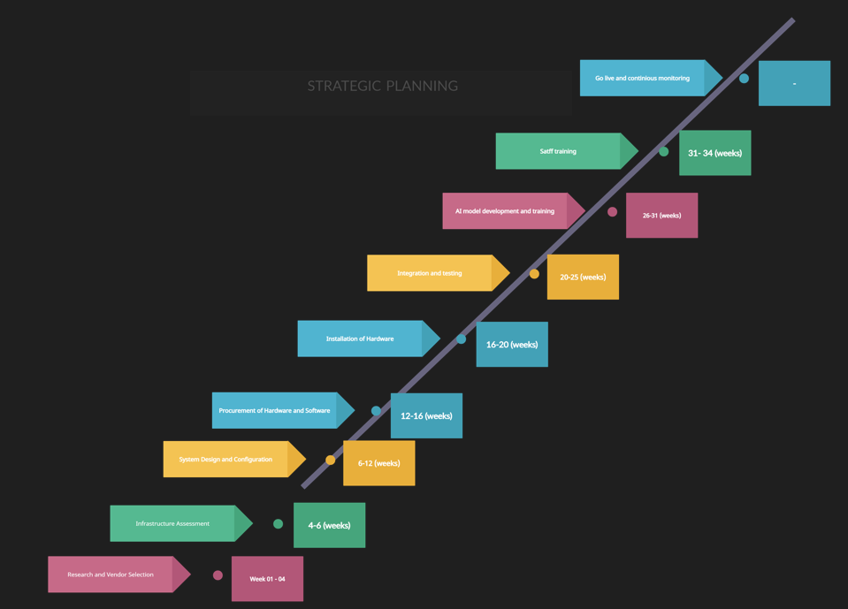

CHAPTER FOUR: CONCLUSION
Everything is digitalized in the world we are living in today. This gadget that we use in our homes dissipates a less amount of energy. For example; the laptops we use also generate energy and fan installed in it works to cool it off and forbids it to heat up. Now, picturize it with multiple computer operating systems Of course to cool it down a hefty amount of cooling systems is required. To identify and select a cooling system is difficult and a sensitive task. Since heavy costs are involved, one cannot just pick it on the basis of their choice.
After carefully reviewing the types of cooling systems, their pros and cons AI driven cooling systems are considered to be best. Technology is everywhere and almost everything today works on the basis of machine learning. AI augmented cooling system are predictable and adaptable. The algorithms will work in the same pattern as you have designed them to be.
The AI cooling system is controllable and predictable as the algorithms/coding all is done by the humans themselves, so making changes in any of the process will be an easier than the rest of the cooling system procedures and also productivity and efficiency will increase.
The cost of creation, installation, implementation and evaluation will be high, but as compare to the other benefits and its long term sustainability it is proving to be one of the best options among various other cooling systems.
The AI integrated system is also environment free and sustainable which is another point to ponder on while taking a decision.
- The AI cooling system satisfies all of our research objectives that are
- To provide data centers with a dynamic cooling system that can adjust to changing thermal demands.
- To maximize the cooling system’s energy, use in data centers while maintaining hardware performance and dependability.
- To find out how adaptive cooling might help data centers save money on operations and lessen their environmental effect.

References
[1]A. Habibi Khalaj and S. K. Halgamuge, “A Review on efficient thermal management of air- and liquid-cooled data centers: From chip to the cooling system,” Applied Energy, vol. 205, pp. 1165–1188, Nov. (2017), doi: https://doi.org/10.1016/j.apenergy.2017.08.037.
[2]Q. Zhang et al., “A survey on data center cooling systems: Technology, power consumption modeling and control strategy optimization,” Journal of Systems Architecture, vol. 119, p. 102253, Oct. (2021), doi: https://doi.org/10.1016/j.sysarc.2021.102253.
[3]H. Zhang, S. Shao, H. Xu, H. Zou, and C. Tian, “Free cooling of data centers: A review,” Renewable and Sustainable Energy Reviews, vol. 35, pp. 171–182, Jul. (2014), doi: https://doi.org/10.1016/j.rser.2014.04.017.

Bibliography
H.M. Asfahan, U. Sajjad, M. Sultan, M., I. Hussain, K. Hamid, M. Ali, C.C. Wang, R.R. Shamshiri, and M.U. Khan, “Artificial intelligence for the prediction of the thermal performance of evaporative cooling systems”. Energies, 14(13), p.3946. (2021). doi.org/10.3390/en14133946.
Q. Zhang et al., “A survey on data center cooling systems: Technology, power consumption modeling and control strategy optimization,” Journal of Systems Architecture, vol. 119, p. 102253, Oct. (2021), doi: https://doi.org/10.1016/j.sysarc.2021.102253.
A. Capozzoli and G. Primiceri, “Cooling Systems in Data Centers: State of Art and Emerging Technologies,” Energy Procedia, vol. 83, pp. 484–493, Dec. (2015), doi: https://doi.org/10.1016/j.egypro.2015.12.168.
J. Dai, M. M. Ohadi, D. Das, and M. G. Pecht, Optimum Cooling of Data Centers. New York, NY: Springer New York, 2014. doi: https://doi.org/10.1007/978-1-4614-5602-5.
Q. Zhang et al., “A survey on data center cooling systems: Technology, power consumption modeling and control strategy optimization,” Journal of Systems Architecture, vol. 119, p. 102253, Oct. (2021), doi: https://doi.org/10.1016/j.sysarc.2021.102253.
H. M. Asfahan et al., “Artificial Intelligence for the Prediction of the Thermal Performance of Evaporative Cooling Systems,” Energies, vol. 14, no. 13, p. 3946, Jul. (2021), doi: https://doi.org/10.3390/en14133946.
T. Schreiber et al., “Application of data-driven methods for energy system modelling demonstrated on an adaptive cooling supply system,” Energy, vol. 230, p. 120894, Sep. 2021, doi: https://doi.org/10.1016/j.energy.(2021).120894.

