
Programme: Master of Business Administration

Module code: LCMB7024

Assignment Title: Marketing Environment Analysis

Name: keshavala Nisha Lakhubhai

Student I'd:2538593

Table of Contents
Task 1: Marketing Environmental Analysis 3
1.1 Factor 1: The Natural (Environmental) factors 4
1.2 Factor 2: The political/legal factors 8
1.3 SWOT analysis 9
Task 2: Strategic Growth and Competitive Positioning 12
2.1 Industry Structure: Porter’s five forces 12
2.2 Applying the pioneer/ follower model to tactic selection 14
2.3 Strategic growth approach (Ansoff Matrix) 15
2.4 Achieving competitive positioning (Porter’s Generic Strategies and Positioning) 16
Task 3: Critical Reflection on AI Usage 18
3.1 Tool disclosure 18
3.2 Critical evaluation on AI output 19
3.3 Contribution analysis 19
3.4 Ethical and professional reflection 20
Reference list 21

Task 1: Marketing Environmental Analysis
According to Neolaka et al. (2023), the external environment includes the macro external and micro external environment. PESTLE framework is an effective tool for analysing the external marketing environment (Amega et al., 2024). The analysis of the natural (environmental) and political actor can be effective for understanding the transition of the Chilean state-owned copper producer, Coldelco, toward lower-carbon producer. As per Bracken (2024), mining and metals sector is responsible for 11% of global scope 1 and 2 GHG (greenhouse gas) emissions in 2024. Metal production generates 8% of the total emissions and mining makes up 3%. Codelco reduced its Scope 1 and 2 emissions by 27% in 2024 in comparison to 2019, focusing on neutrality by 2050 (Codelco, 2025). The firm is also aiming to reducing Scope 3 emissions by 25% by 2030 through electrification of vehicles by 2040.
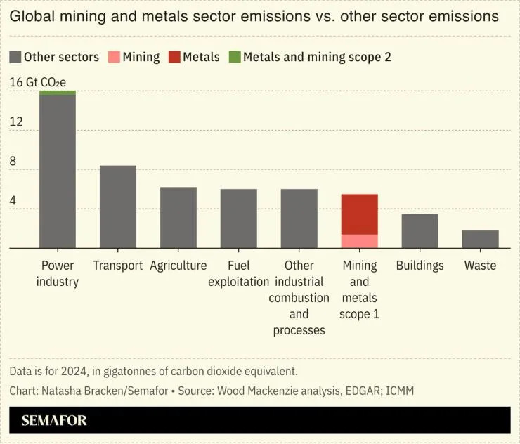
Figure 1: GHG emissions by different sectors
(Source: Bracken, 2024)

1.1 Factor 1: The Natural (Environmental) factors
Chilean government’s initiative for GHG emissions
The natural environment factor consists of climate risks, environmental impact, ecological constraints, and physical resources (Kotler et al., 2024). Declining ore grades, dual role of copper in the energy transition, and acute water scarcity in the Atacama Desert are some of the key factors that are creating issues for Codelco. The Atacama Desert, the core area for copper extraction is facing drought for 14 years and water reservoir storage has fallen to 30% signifying issue for mining (SMM, 2026). The target of being net-zero by 2050, by the Chilean government is rated almost sufficient. Lack of effective transparency reduces the target’s efficiency, as fairness or equity is not referenced. The government is reinforcing carbon pricing and energy transition framework through higher carbon taxes and new measures to expand renewables, improve storage, transmission infrastructure, and promote community energy (Climate Action Tracker, 2025). Chile’s emission reduction target focuses on 95 Mt CO₂e or a budget of 1,100 Mt CO₂e for 2020-2030 and emission reduction up to 45% net GHG.
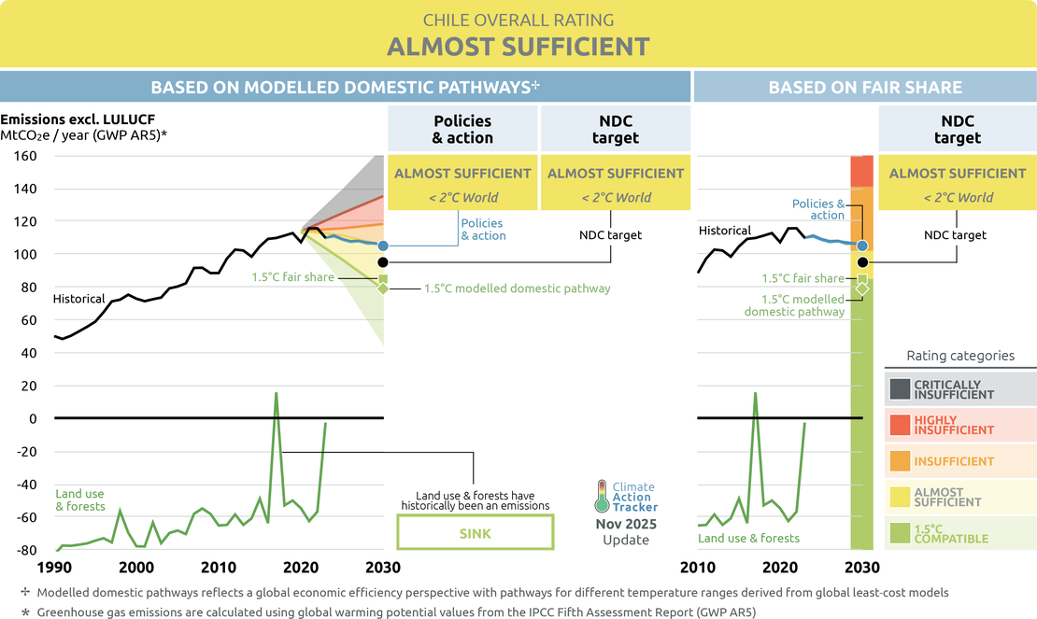
Figure 2: Chile’s net-zero target rating
(Source: Climate Action Tracker, 2025)
The energy roadmap of Chile 2026-30 introduces a pilot sectoral ETS and Article 6 carbon market approach that targets $100 million of funding (Gurrero, 2026). About 100% of renewable energy matrix is targeted by 2030. Chile solar energy market size is 19.75 gigawatt in 2026, expected to reach 48.49 gigawatt by 2031 with 19.68% CAGR (Mordor Intelligence, 2026). Mining-sector have 3.50% of impact on the CAGR forecast regarding renewable energy. Codelco contracted 1,825 GWh of renewable supply in 2024 inlcuding a 1,100 GWh deal with Colbún. On the other hand, curtailment hiked to 6 TWh in 2024 as generation is concentrated in the north while 60% of demand in in central Chile. Battery Energy Storage System (BESS) assists in overcoming this loss but adds $150-200 per kWh of capex and lengthens payback by 2 years. Hence, these exposes Coldeco to a hostile operating context characterised by tightening resource constraints.
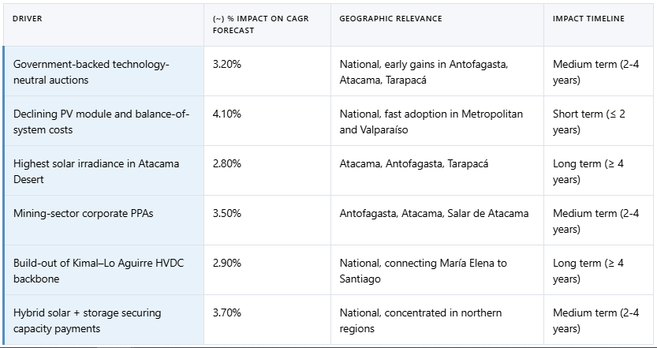
Figure 3: Key sectors driving renewable energy market growth in Chile
(Source: Mordor Intelligence, 2026)
Chinese government’s initiative for GHG emissions
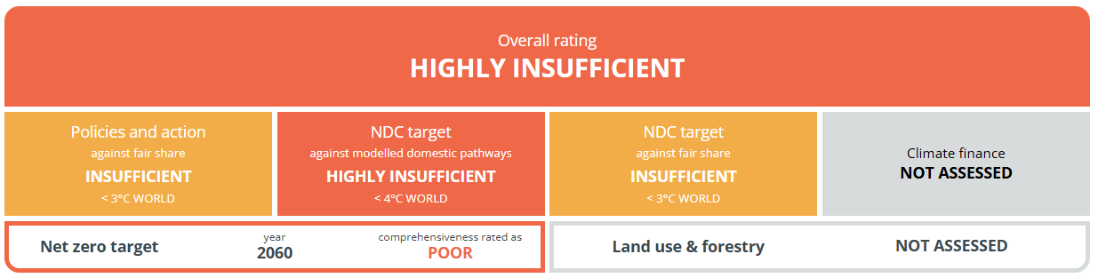
Figure 4: China’s net-zero target rating
(Source: Climate Action Tracker, 2026)
The sustainability initiatives of the Chinese government regarding 2060 net-zero target is rated highly insufficient (Climate Action Tracker, 2026). China is aiming at cutting CO₂ emission intensity by 17% from 2025 levels and non-fossil fuels reaching 25% by 2030 and 30% by 2035. The nation is following a shortfall on the previous 18% of target attaining only 12%.
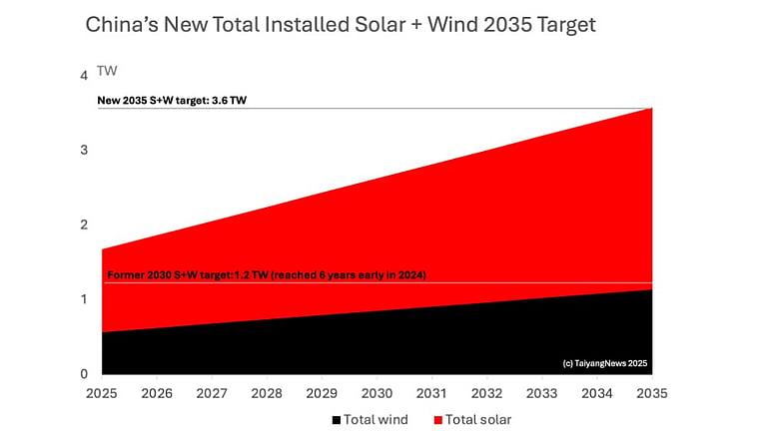
Figure 5: China’s solar and wind capacity target
(Source: Bhabhani, 2025)
Chine needs a 23% intensity cut for aligning with the Paris Agreement as per CREA research (Howe, 2026). The nation committed to 7-10% of GHG reduction by 2035 (WRI, 2025). China raised its solar and wind capacity target to 3.6TW by 2035 (>6 times 2020 levels) (Bhabhani, 2025).
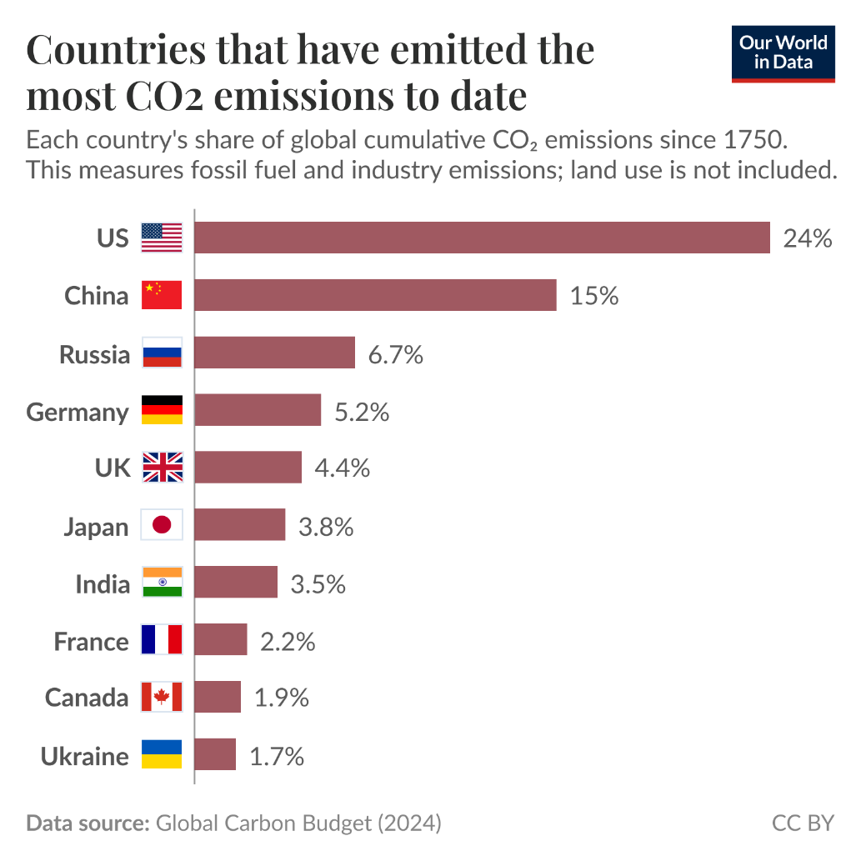
Figure 6: Leading CO₂ emitters
(Source: Bhabhani, 2025)
China is the 2nd top CO₂ emitter with 15% of the world’s total CO₂ emission (Ritchie, 2025). The copper market size is 13.56 million tons in 2026 in China and is expected to reach 17.54 million tons, with renewable energy having +1.8% of impact on CAGR as a driver (Mordor Intelligence, 2026 a). Hence, pressuring verified low-carbon supply chains and Scope 3 reductions while creating opportunities regarding clean energy expansion.
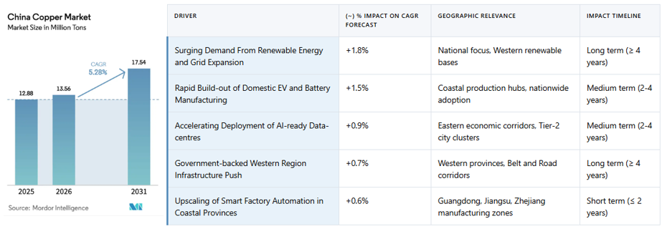
Figure 6: Copper market of China
(Source: Mordor Intelligence, 2026 a)

1.2 Factor 2: The political/legal factors
In Chile, the 2023 Mining Royalty Law imposes ad-valorem and margin-based taxes (tax burden set at 46.5%), increasing state revenue but constraining reinvestment capital. Mining exploiters with over 50% income through copper (producing over 50,000 MTFC) will pay tax rate from 8%-26% (EY, 2023). The decarbonisation plan in Chile focuses on increasing carbon tax to $35/tCO₂ by 2030 and $80/tCO₂ by 2040 (Climate Action Tracker, 2026). The Framework Law on Climate Change mandates carbon neutrality by 2050.
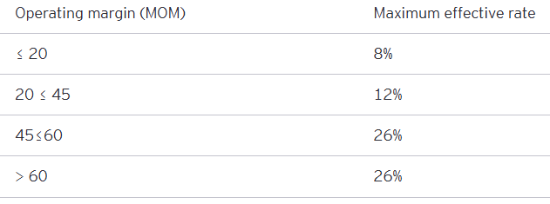
Figure 7: Tax rate in Chile for mining exploiters
(Source: EY, 2023)
Political stability in Chile is 0.12 (90th) and -0.15 in China (109th), indicating moderate to low impact in home nation and high in China (The Global Economy, 2026). Codelco’s largest market, China is targeting a massive renewable expansion, showcasing increasing demand for sustainability. China’s goods import reached RMB 10.39 trillion ($1.45 trillion) a Y-o-Y decline of 1.6% (Shang, 2025). China has 0% import tariff on Chile goods due to China-Chile free trade agreement (IEA, 2024).
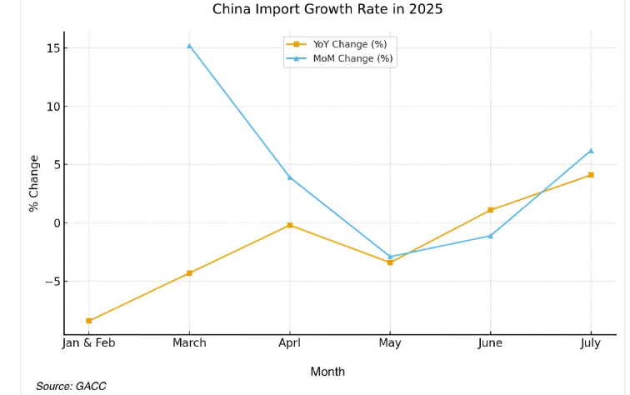
Figure 8: Import growth rate of China
(Source: Shang, 2025)

1.3 SWOT analysis
- Strengths: Codelco is the largest copper producer globally with 1,441,886 fmt copper (consists of 1,3334,445 tons fine copper) of own production in 2025 (Codelco, 2024: Codelco, 2026). It have state-backed access to concessional climate financing of $1.132 billion providing financial flexibility (Hidayat, 2026).
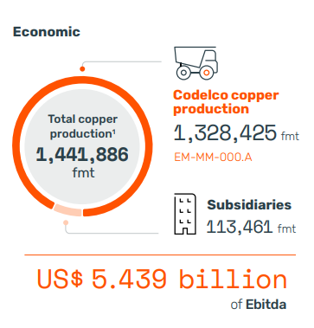
Figure 9: Economic growth of Codelco
(Source: Codelco, 2024)
- Weaknesses: Codelco’s ore grade is declining as it is was 1.2% in 2000 and 0.7% in 2025 (Zadeh, 2025). The debt-to-equity ratio of the firm is now 3:1, limiting its access to favourable financing for critical projects such as $7 billion Rajo Inca.
- Opportunities: The global copper market value is $304,95 billion in 2026 and is expected to reach $442.04 billion by 2034 with a 4.75% CAGR, with transition to renewable energy and electrification being the key driver (Market Data Forecast, 2026).
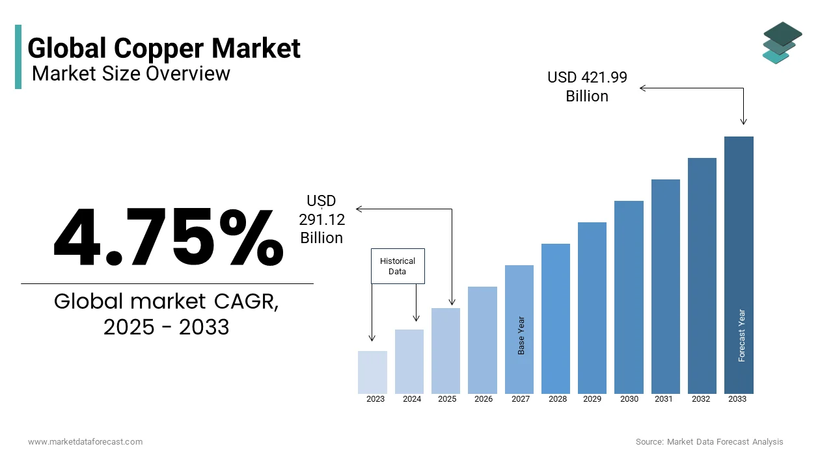
Figure 10: Global copper market
(Source: Market Data Forecast, 2026)
- Threats: Environmental condition of the Atacama region can impact operations. Policy gaps in carbon intensity targets and political stability in China can cause issue (Climate Action Tracker, 2026).

Task 2: Strategic Growth and Competitive Positioning
This section discusses a growth strategy for Codelco as per the issues identified in the above-section through the usage of Ansoff matrix and various other relevant approaches (Kotler et al., 2024). Informed first through the analysis of the industry structure with Porter’s five force, and the pioneer/follower tactics. Later, Porter’s generic strategies assists in creating effective method for developing competitive edge.

2.1 Industry Structure: Porter’s five forces
- Competitive rivalry: It is high due to global output being concentrated among a small number of large producers such as BHP, Codelco, Freeport-McMoRan, and Southern Copper. BHP is leading copper producer in the world with 1,470,225 metrics tons in 2025 in comparison to 1,439,799 metrics tons by Codelco (Belder, 2026). Copper is a largely undifferentiated commodity, and price is set on international exchange.
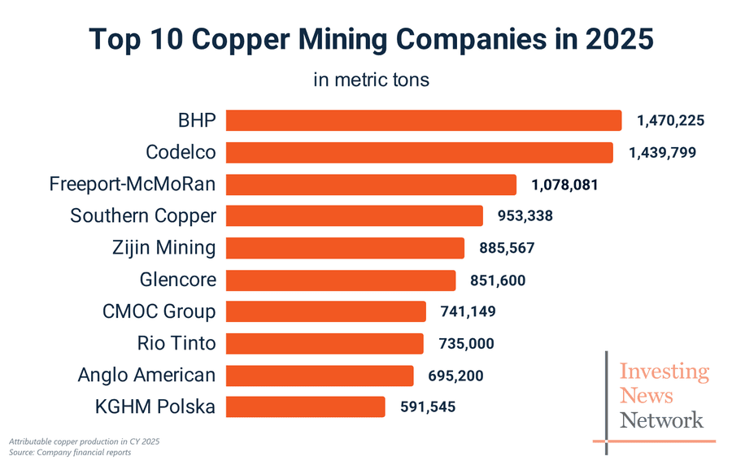
Figure 11: Global copper market
(Source: Market Data Forecast, 2026)
- Buyer power: It is also high as large industrial consumers can switch suppliers easily and underlying cost of copper is globally same with additional regional premium that can change price.
- Supplier power: It is moderate as specialists inputs (such as reagents and energy) have few substitute providers that results in Scope 3 suppliers dominating the emission power of Codelco, as it represents over 60% of total emission. Codelco aims at reducing Scope 3 emission by 25% by 2030 (IM, 2025).
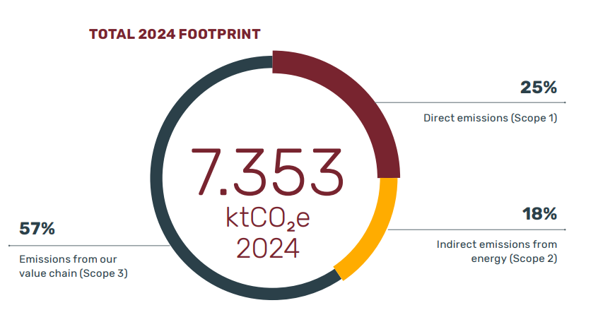
Figure 12: Scope 1, 2, and 3 emission of Codelco
(Source: Codelco, 2025 a)
- Threat of new entrants: It is low due to being capital intensive, multi-decade project horizons, and the constitutional reservation of mineral ownership to the stet (Chile).
- Threat of substitutes: It is moderate and rising as there are various companies that can provide the same product. China is ready to opt out in next year’s term due to high copper premium cost ($350 a ton over London Metal Exchange prices) by Codelco, as copper imports to China from Chile feel to 10% (Mining, 2025).
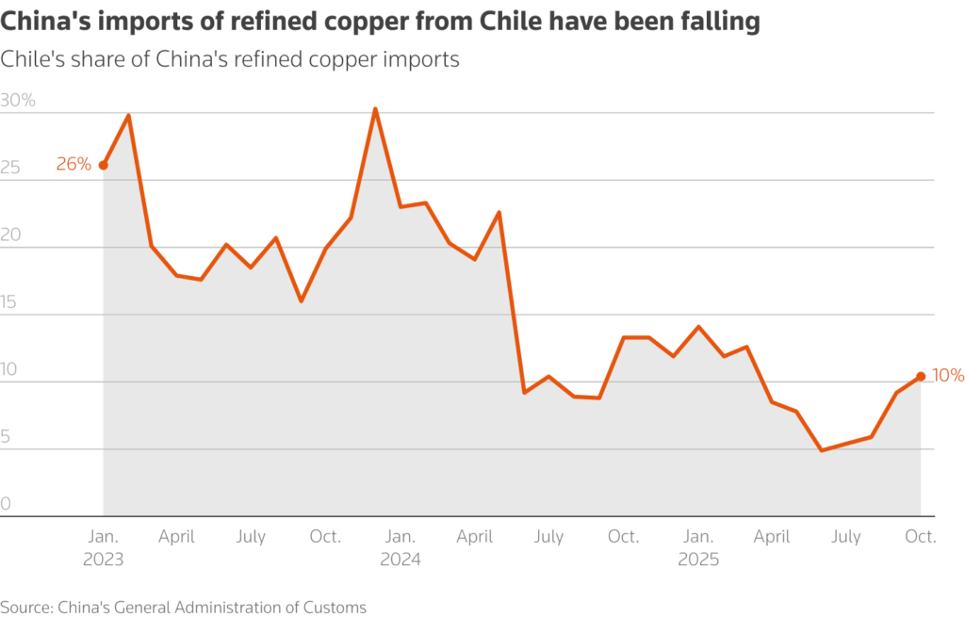
Figure 13: Copper import from Chile to China
(Source: Mining, 2025)
The competitive analysis in the above framework will not inly make Codelco able to understand the strengths and weaknesses of its competitors but also adapt itself to th current market situations at the same time.

2.2 Applying the pioneer/ follower model to tactic selection
Commodity copper mining is a hostile market environment that has low margins, resource constraints, global price rivalry, and declining ore grades. According to Covin, Slevin, Heeley (2000), pioneers in hostile settings grow faster through high prices, broad markets, and narrow product lines. On the other hand, followers benefit from advanced procedure technology and purchasing advantages for cost leadership. Codelco can focus on the adoption of pioneer posture for penetrating markets through certified low-carbon copper. The frim can charge premium for green practices, circular economy activities, and narrow tightly-specified traceable lines for tight product-market fit. Codelco can leverage broad distribution expansion across existing marketplaces such as China, US, Brazil, South Korea, and Taiwan for promoting higher volumes of certified output amid $442.04 billion of copper market by 2034 (Market Data Forecast, 2026). Maintaining follower cost-leadership through AI adaptation and purchasing advantages can support deeper penetration and efficiency.

2.3 Strategic growth approach (Ansoff Matrix)
Considering the Ansoff Matrix model, it can be observed that Codelco will have to focus on market penetration as the company will be using its existing product in the existing market. There are several benefits of market penetration that Codelco will be able to secure by penetrating the markets of Chile and China such as increasing the lifetime value, ensuring cost efficiency and earning the trust of the consumers at the same time. According to the statements by Harahap, Soemitra and Rahma (2025), proper market penetration can be effective in enhancing the lifetime value and ensuring cost efficiency. In this case, strategies such as price adjustments and low carbon copper through circular economy, expansion of distributions and increased promotions can be used by Codelco in order to penetrate the markets of Chile and China in the best possible ways. These strategies will not only allow the company to reach out to the remote customers but also attract their attention by offering them affordable products. In this context, He (2024) has argued that competitive pricing can help in ensuring affordable products for the customers. Hence, Codelco will certainly become able to maintain its competitive positioning in the markets of Chile and China in an effective way in future.
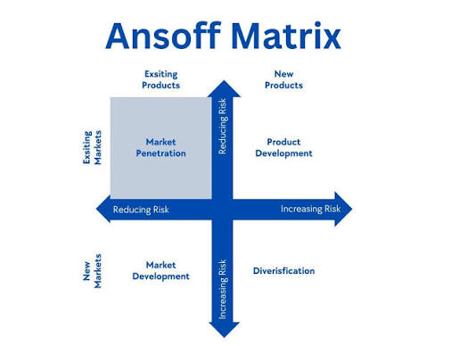
Figure 14: Ansoff Matrix
(Source: Inspired from Aditiya and Kirana, 2025)

2.4 Achieving competitive positioning (Porter’s Generic Strategies and Positioning)
Taking the generic forces by Porter into consideration, the focus of Codelco will be on differentiating its product from that of its competitors such as BHP, Freeport McMoran and Southern Copper. In the words of Tojiri (2023), differentiation strategy can help a brand to earn competitive advantage in the market. In this case, Codelco will focus on producing low-carbon copper so that the emission levels can be reduced and controlled, hence differentiating its product from the competitors in the Chile and the Chinese markets. Here, strategies such as ethical sourcing and adoption of a circular economy will certainly become quite beneficial for Codelco in terms of ensuring a differentiated product in the market. Both these strategies will not only help Codelco in reducing its carbon emissions in future but also ensure trust and loyalty from the consumers’ end simultaneously. In this regard, Odeh and Ezenta (2024) have stated that differentiation strategy can be helpful for a brand in earning consumer trust and loyalty. Therefore, this strategy of differentiation will certainly benefit Codelco in terms of earning a competitive edge over the rivals, hence strengthening its position in the concerned markets of Chile and China in the long run. Considering all the above strategies for Codelco, it can be stated that the company will certainly become able to enhance its corporate social responsibilities in the mining industry while securing a strong position for itself in the international level in the upcoming days.
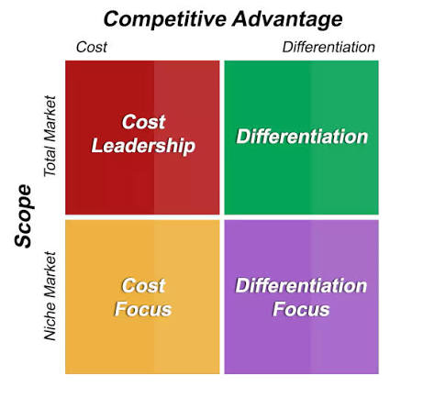
Figure 15: Porter's Generic Forces
(Source: Inspired from lecture 11, slide 15)

Task 3: Critical Reflection on AI Usage

3.1 Tool disclosure
In order to execute this project, proper help and guidance were sought from a reliable AI tool such as ChatGPT. In this case, ChatGPT has turned out to be extremely beneficial in making the search process much easier. Here, executing the basic searches such as policies and initiatives of the Chile government and the Chinese government regarding reducing the greenhouse gas emissions in the mining sector. The main rationale behind choosing ChatGPT is to reduce time consumption in searching facts so that the project can be finished within the stipulated time. On the other hand, it is also observed in certain cases that the information provided by the AI-tool was not absolutely accurate, hence required a cross-checking for maintenance of authenticity in every form.
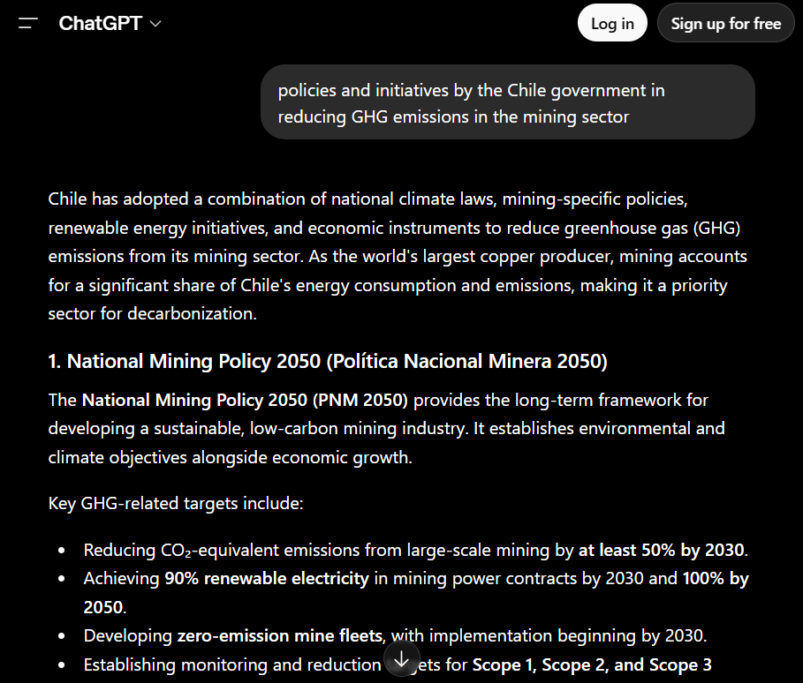
Figure 16: Search prompts in AI-tools
(Source: ChatGPT, 2026)

3.2 Critical evaluation on AI output
On one hand, using ChatGPT has proven to be quite beneficial in accessing the basic information on the topic such as benefits of low carbon emission business models and benefits of differentiated business models. In this case, a proper pathway for initiating the search method was identified with the help of ChatGPT. Considering the negative side of using the AI-tool is that it requires proper login and subscription for generating accurate data and information during the searches. Here, it is observed that there are several flaws and shortcomings in the information generated by the AI-tool which can have a negative influence on the entire report. In such a situation, extra time and effort were required for initiating cross-checking by accessing authentic sources such as news websites, annual reports and journals.

3.3 Contribution analysis
Initially, the entire assignment brief was uploaded on Google Gemini with an aim to develop an appropriate structure for the report. In this case, I have observed that Gemini has suggested an Introduction and Conclusion of 200 words and 300 words respectively whereas there was no such mention in the assignment brief. Therefore, it is clearly evident that there are some flaws in the suggestions provided in the AI-tools that can create breaches of instructions mentioned in the assignment brief, resulting in marks deduction in the end. In such a situation, proper manual effort was required for developing the structure where frameworks such as Ansoff Matrix, Porter’s Generic Forces and Porter’s Five Forces have been used for determining the appropriate strategy for Codelco in future for better business operations.
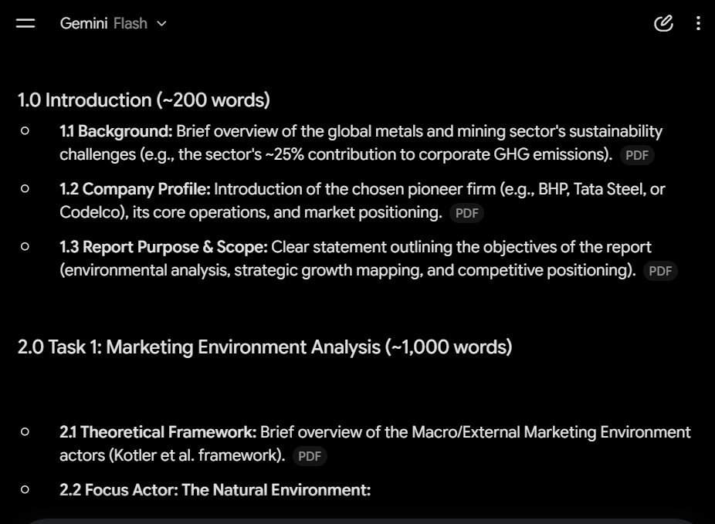
Figure 17: Development of project structure using Google Gemini
(Source: Google Gemini, 2026)

3.4 Ethical and professional reflection
Ethics and professionality have been extensively prioritised in this report and the information generated by the AI-tools such as ChatGPT and Google Gemini were blindly trusted. Here, independent research has been prioritised by accessing different news websites, journals, articles, annual reports so that proper authenticity and reliability can be maintained in every possible form. Further, every author and researcher have been properly acknowledged throughout this report so that their due credits can be given for their contributions.

Reference list
Aditiya, S. and Kirana, D.H.K. (2025). Smarteye. id’s Business Expansion Strategy for Global Market Penetration through the Ansoff Matrix. International Journal of Management and Business Economics, 3(2), pp.60-65. https://www.putrapublisher.org/ojs/index.php/jamis/article/download/705/868
Amega, K., Moumouni, Y., Laré, Y., Bhandari, R., Takouda, P. and Madougou, S. (2024). Power system transformation in emerging countries: A SWOT/PESTLE analysis approach towards resiliency and reliability. Heliyon, 10(12). https://doi.org/10.1016/j.heliyon.2024.e33018
Belder, D. (2026). Top 10 Copper-producing Companies. [Online]. Available at: https://investingnews.com/daily/resource-investing/base-metals-investing/copper-investing/top-copper-producing-companies/ [Accessed on: 03 July 2026]
Bhabhani, A. (2025). China Announces 3.6 TW AC Solar & Wind Target For 2035. [Online]. Available at: https://climateactiontracker.org/countries/chile/targets/ [Accessed https://taiyangnews.info/markets/china-announces-36-tw-ac-solar-wind-energy-target [Accessed on: 09 July 2026]
Bracken, N. (2026). Exclusive / Mining, metals sector account for 11% of global emissions, report finds. [Online]. Available at: https://www.semafor.com/article/03/10/2026/mining-metals-sector-account-for-11-of-global-emissions-report-finds [Accessed on: 08 July 2026]
Climate Action Tracker (2025). Chile. [Online]. Available at: https://climateactiontracker.org/countries/chile/targets/ [Accessed on: 02 July 2026]
Climate Action Tracker (2026). China. [Online]. Available at: https://climateactiontracker.org/countries/china/net-zero-targets/ [Accessed on: 09 July 2026]
Codelco (2024). SUSTAINABILITY REPORT 2024. [Online]. Available at: https://www.codelco.com/prontus_codelco/site/docs/20250610/20250610162815/250717_codelco_alta.pdf [Accessed on: 09 July 2026]
Codelco (2025 a). CLIMATE CHANGE REPORT 2025. [Online]. Available at: https://www.codelco.com/prontus_codelco/site/docs/20251002/20251002120038/climate_change_report.pdf [Accessed on: 11 July 2026]
Codelco (2025). Codelco launches its first Climate Change Report and consolidates its strategy toward more resilient and low-emission mining. [Online]. Available at: https://www.codelco.com/en/prensa/2025/codelco-lanza-su-primer-reporte-de-cambio-climatico-y-consolida-su [Accessed on: 08 July 2026]
Codelco (2026). Codelco reaffirms operational strength and strategic role for the development of Chile. [Online]. Available at: https://www.codelco.com/en/prensa/2026/codelco-reafirma-solidez-operativa-y-rol-estrategico-para-el-desarrollo [Accessed on: 10 July 2026]
Covin, J.G., Slevin, D.P. and Heeley, M.B. (2000). Pioneers and followers: Competitive tactics, environment, and firm growth. Journal of business venturing, 15(2), pp.175-210. https://doi.org/10.1016/S0883-9026(98)00015-9
EY (2023). Chile | New mining royalty is approved and ready to become law. [Online]. Available at: https://www.ey.com/en_gl/technical/tax-alerts/chile---new-mining-royalty-is-approved-and-ready-to-become-law [Accessed on: 09 July 2026]
Gurrero, J. (2026). Chile approves 2026-30 energy roadmap with pilot ETS, $100 mln Article 6 funding target. [Online]. Available at: https://carbon-pulse.com/528455/ [Accessed on: 08 July 2026]
Harahap, M.A.D., Soemitra, A. and Rahma, T.I.F. (2025). Market penetration strategy by increasing firm competitiveness. Golden Ratio of Marketing and Applied Psychology of Business, 5(1), pp.44-52. https://goldenratio.id/index.php/grmapb/article/download/712/450
He, W. (2024, July). The Nexus of Market Competition and Pricing Strategies. In 2024 9th International Conference on Social Sciences and Economic Development (ICSSED 2024) (pp. 32-38). Atlantis Press. https://www.atlantis-press.com/article/126001655.pdf
Hidayat, M. (2026). Codelco Secures Climate Financing from HSBC for Mining Decarbonisation. [Online]. Available at: https://discoveryalert.com.au/mining-climate-finance-opportunities-2025/ [Accessed on: 09 July 2026]
Howe, C. (2026). China's decarbonisation plan takes cautious steps as world backtracks on climate. [Online]. Available at: https://www.reuters.com/sustainability/climate-energy/china-plans-cut-carbon-dioxide-emissions-per-unit-gdp-by-around-38-2026-2026-03-05/ [Accessed on: 09 July 2026]
IEA (2024). Chile-China Free Trade Agreement. [Online]. Available at: https://www.iea.org/policies/18368-chile-china-free-trade-agr [Accessed on: 09 July 2026]
IM (2025). Codelco sets specific goal to reduce Scope 3 emissions and advances value chain decarbonisation. [Online]. Available at: https://im-mining.com/2025/01/28/codelco-sets-specific-goal-to-reduce-scope-3-emissions-and-advances-value-chain-decarbonisation/ [Accessed on: 11 July 2026]
Kotler, P., Armstrong, G., Harris, L.C. and He, H. (2024). Principles of marketing. 19th edn. Harlow: Pearson.
Market Data Forecast (2026). Global Copper Market Report. [Online]. Available at: https://www.marketdataforecast.com/market-reports/global-copper-market [Accessed on: 10 July 2026]
Mining (2025). Codelco’s record China copper offer sparks threats to walk away. [Online]. Available at: https://www.mining.com/web/codelcos-record-china-copper-price-offer-sparks-threats-to-walk-away-sources-say/ [Accessed on: 11 July 2026]
Mordor Intelligence (2026 a). CHINA COPPER MARKET SIZE & SHARE ANALYSIS - GROWTH TRENDS AND FORECAST (2026 - 2031). [Online]. Available at: https://www.mordorintelligence.com/industry-reports/china-copper-market [Accessed on: 09 July 2026]
Mordor Intelligence (2026). CHILE SOLAR ENERGY MARKET SIZE & SHARE ANALYSIS - GROWTH TRENDS AND FORECAST (2026 – 2031). [Online]. Available at: https://www.mordorintelligence.com/industry-reports/chile-solar-energy-market [Accessed on: 08 July 2026]
Neolaka, A.M.Y., Faulina, M., Akromah, P., Novilasari, T.A. and Napitupulu, R.H.M. (2023). Marketing strategy using swot analysis (case study: stima IMMI). Jurnal Ekonomi, 12(02), pp.1650-1659. https://www.ejournal.seaninstitute.or.id/index.php/Ekonomi/article/view/1975 \
Odeh, J. and Ezenta, O.N. (2024). Product Differentiation Strategies and Customer Loyalty to the Brands of Selected Flour Milling Firms in Northwest, Nigeria. International Journal of Humanities Social Science and Management (IJHSSM), 4(6), pp.240-251. https://www.researchgate.net/profile/Joseph-Odeh/publication/389276933_Product_Differentiation_Strategies_and_Customer_Loyalty_to_the_Brands_of_Selected_Flour_Milling_Firms_in_Northwest_Nigeria/links/67bca6ce207c0c20fa9582f9/Product-Differentiation-Strategies-and-Customer-Loyalty-to-the-Brands-of-Selected-Flour-Milling-Firms-in-Northwest-Nigeria.pdf
Ritchie, H. (2025). Which countries have contributed the most to historical CO₂ emissions?. [Online]. Available at: https://ourworldindata.org/data-insights/which-countries-have-contributed-the-most-to-historical-co-emissions [Accessed on: 08 July 2026]
Shang, Y. (2025). Decoding China’s Imports in 2025: January–July Data Breakdown. [Online]. Available at: https://www.china-briefing.com/news/chinas-imports-2025-trends-implications/ [Accessed on: 09 July 2026]
SMM (2026). Chile's Water Crisis Threatens Atacama's Copper and Lithium Mining Amid 14-Year Drought. [Online]. Available at: https://news.metal.com/newscontent/103842203-chiles-water-crisis-threatens-atacamas-copper-and-lithium-mining-amid-14-year-drought [Accessed on: 08 July 2026]
The Global Economy (2026). Political stability - Country rankings. [Online]. Available at: https://www.theglobaleconomy.com/rankings/wb_political_stability/ [Accessed on: 09 July 2026]
Tojiri, Y. (2023). Product differentiation strategy for organizational financial profitability: Enchancing market share and profitability-A comprehensive literature review. Atestasi: Jurnal Ilmiah Akuntansi, 6(2), pp.856-876. https://jurnal.feb-umi.id/index.php/ATESTASI/article/download/821/638
WRI (2025). STATEMENT: China Announces New Climate Target. [Online]. Available at: https://www.wri.org/news/statement-china-announces-new-climate-target [Accessed on: 09 July 2026]
Zadeh, J. (2025). Codelco’s Copper Production Falls 6% Amid Industry Challenges. [Online]. Available at: https://discoveryalert.com.au/codelco-copper-production-decline-2025-industry-impact/ [Accessed on: 10 July 2026]

