

ACCC4002
Internet Protocols

Student Name:Cristian Biza
Student ID:1815957

Table of Contents
Introduction 2
Part 1 3
IPv6: 3
IPv6 deployed by 4
Types of IPv6 Addresses 5
Unicast Addresses: 5
Multicast Addresses 5
Anycast Addresses 6
Benefits of IPv6: 7
Disadvantages of IPv6 8
Issues in Security 8
Intricacy in the Drawings of Network Topology 8
Updating the devices 8
The changes in local networking 8
Part 2 9
Conclusion 10
References 11
Appendix 12

List of Figures
Figure 1 IPv6 3
Figure 2: Shows that the device can reach IPv6 server (email, DNS) 9
Figure 3: Shows that the device can reach IPv6 email and can send and receive emails 9

Introduction
This assignment is based on IPv6 addressing. The aim of this assignment that students will know about internet protocol and get detailed knowledge of IP versions. Nowadays, various hardware devices are utilized the modern designs of the network. So, It is necessary to understand the basic protocol principle which is utilized in various IP addressing and the network layers of the OSI Model. Moreover it discusses the versions of Internet Protocol which is IPv6 utilized in networking. There are various kinds of addressing existing in the version of Internet Protocol that is also described in this assignment. This assignment is also describes the benefits of IPv6 with the disadvantages that will occur during the utilization of IPv6. This assignment gives a brief overview of version 6 of Internet Protocol which is very important in networking in the upcoming years. This assignment will help to understand the uses of IPv6 in the field of networking. In last a network system for School of Management and Engineering will be designed according to the specified network requirements and capacity.

Part 1

IPv6:
The version 6 Internet Protocol or IPv6 is the protocol of the next generation for the Internet. It is intended to give some advantages over the recent IPv4 (or Internet Protocol Version 4). Both IPv4 and IPv6 classifies the protocol layer of network i.e., how data or information is transferred from one PC to another PC over the networks of packet-switching, for example, the Internet. Version 6 of Internet protocol contains the information of control and addressing for the packets of the route for the future invention Internet. Sometimes, the development of the Internet is significant and updates are justified. The process of gathering the information is concern about each phase of IPv6 that would be planned to give information about this innovation, so each person can get the benefits of this technology. This is also known as Internet protocol for next-generation or IPng.
IPv6 is archived in a few requests for comments (or RFCs) beginning from RFC 2460. Despite this fact, IPv6 is the descendant of IPv4 in both versions of the protocol. It will maintain to be the protocols of data-oriented for the Internet in the upcoming duration (IPV6 2018).
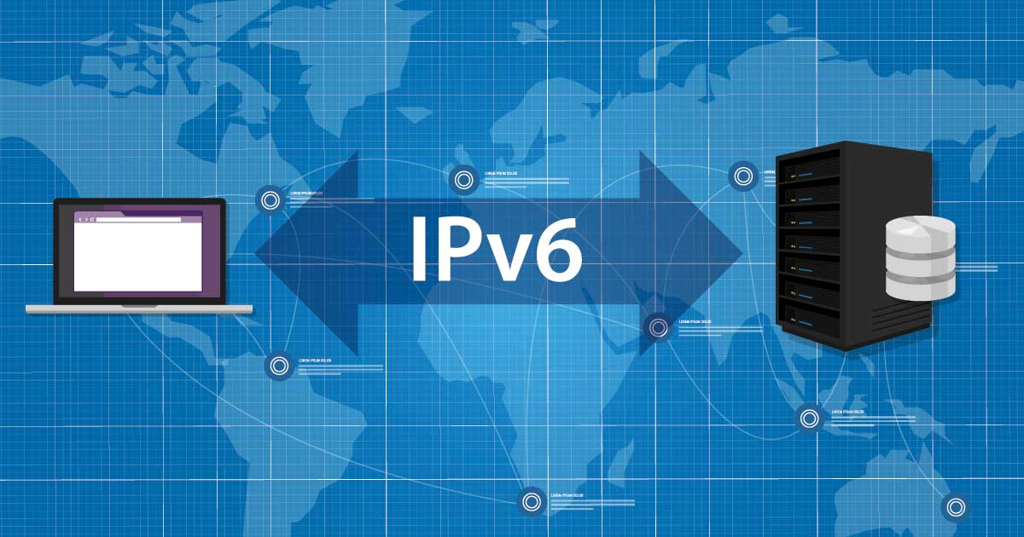
Figure 1 IPv6

IPv6 deployed by
IPv6 is deployed by Google in August 2019, which is 29 percent of those searches on Google that were undertaking over IPv6. The FCC (Federal Communications Commission) takes note that the progress will belong in years. During the progress, some steps will be engaged by the service providers for the Internet. The providers of application and content guarantees that the addresses of IPv4 will keep on maintained. Moreover, during the progress, the FCC cautions, service of online that could be hindered or corrupted, and security could be undermined due to expanded isolating and moving of addresses for IPv4.

Types of IPv6 Addresses
There are three main types of IPv6 addressing. Those are defined as:
- Unicast Addresses
- Multicast Addresses
- Anycast Addresses

Unicast Addresses:
The unicast address distinguishes a solitary interface. At the point, when devices of the network send a bundle to the unicast address, bundle goes just to the particular interface recognized by a unicast address. Unicast addresses maintain scope for worldwide addresses and two kinds of local addresses. The unicast address comprises of n bits for the affix, and 128 – the id of the interface that has n bits.
There are some kinds of unicast addresses that can be utilized to access the network, such as:
The Address of Global Unicast: The distinctive address of IPv6 doled out to host interfaces. These addresses have the scope of global and importantly, indistinguishable purposes for the public IPv4 addresses. The address of global unicast is routable on the network via the internet.
The Address of local-link IPv6: An IPv6 addresses that permits connection between neighboring hosts that dwell on a similar connection. The address of link-local has scope for local, and can't be utilized outside the connection. They constantly have the affix FE80::/10.
The Address of Loopback IPv6: An IPv6 address utilized on an interface of loopback. The loopback address for IPv6 is 0:0:0:0:0:0:0:1 that can be recorded as:: 1/128.
The Address of Unspecified: An unspecified address of IPv6 is 0:0:0:0:0:0:0:0 that can be recorded as:: /128.

Multicast Addresses
The multicast address recognizes a group of interfaces that commonly have a place with various nodes. At the point, when devices of the network send a bundle to a multicast address, devices transmit bundle to all interfaces distinguished by the multicast address.
The multicast address supports the sixteen various kinds of address scope, as well as organization, link, global scope, and node. The field of 4-bit in the affix distinguishes the address. Some kinds of multicast addresses are utilized in the access network for IPv6 subscriber:
Multicast Address for Solicited-node: The NS (Neighbour Solicitation) communications are transmitting to Solicited-node address.
Multicast address for All-nodes: The RA (Router Advertisement) communications are transmitting to all-node address.
Multicast address for All-switches: The RS (Router Solicitation) communications are transmitting to all-switches addresses.
Multicast addresses utilize the affix FF00:: /8.

Anycast Addresses
The anycast address recognizes a group of interfaces that regularly have a place with various nodes. The Anycast addresses are like multicast addresses, anticipate that bundles are transmitted distinctly to one and all interface. The protocol for routing is utilized in the network generally figures out the interface that is the nearest inside the arrangement of anycast addresses, and routes the bundles along the briefest way to its goal. There is no contrast between unicast addresses and anycast addresses except for the address of subnet-switch. For the anycast address of subnet-switch, ordinarily at least 64, the bits for low-request, are zero.

Benefits of IPv6:
- An IPv6 supports starting and ending addresses, which are 16 bytes (128 bits) in length
- An Ipv6 utilizes a multicast address which is the multicast address for all-nodes and scope for link-local.
- Version 6 for internet protocol doesn't need DHCP or manual configuration.
- It utilizes the address of the host (AAAA) source data or records in DNS to outline the names of the host to the version 6 for IP address.
- It utilizes the records for pointer source in the domain of IP6. ARPA DNS to outline the version 6 for IP address to the name for the host.
- It supports the bundle which has a 1280-byte size (without fragments).
- It utilizes the field for Flow Label to recognize bundle stream for QoS (quality of service) dealing with by switch.
- It uses the ICMPv6 (Internet Control Message Protocol Version 6) Advertisement for Router and Solicitation for Router messages to decide the address for Internet Protocol of the greatest defaulting gateway.
- It utilizes the Solicitation messages for Multicast Neighbour to determine the addresses of IP to addresses of the interface layer.
- It utilizes MLD (Multicast Listener Discovery) communicates to dealing with membership in subnet locally (Rouse 2019).

Disadvantages of IPv6

Issues in Security
The routing in IPv6 is to be empowered by the systems that have been executed. At the point, when the data or information is entering physically, the long address for IP must be composed. The IP addresses at that point would need to be recollected, because the main addresses for IP are lengthy, which include numbers and letters.

Intricacy in the Drawings of Network Topology
The addresses of IPv4 had a short in length, which was simple but difficult to lay on the topology drawing. With the protocol for IPv6, it gets entangled to fit the affixes. The content is scarcely intelligible if there should be an occurrence of IPv6.

Updating the devices
Business associations should upgrade their devices for networking as they are not intended for the adoption of IPv6. This isn't restricted to the substances that routinely upgrade their devices. Numerous organizations must carry expertise estimation. i.e., an advisor to create the change as simple as conceivable as dependable programming may require an exorbitant overhaul.

The changes in local networking
Doling out new addresses of IP physically is a confusing undertaking, as the management of Local Network includes relegating the addresses of IP to explicit devices.

Part 2
We’ve used here VLSM ‘Variable Length Subnet Mask’, so we can subnet the same network ID to multiple subnets with different subnet masks.
Main Subnet: - 172.16.0.0/32
Network ID | Subnet Mask | Supported No of IPs For Hosts | Location
172.16.1.0 | 255.255.255.224 | 30 | Applied Computing Staff
172.16.2.0 | 255.255.254.0 | 510 | Applied Computing Labs
172.16.5.0 | 255.255.255.224 | 30 | Engineering Staff
172.16.6.0 | 255.255.254.0 | 510 | Engineering Labs
172.16.9.0 | 255.255.255.224 | 30 | Automotive Eng staff
172.16.10.0 | 255.255.254.0 | 510 | Automotive Eng Lab
172.16.12.0 | 255.255.255.224 | 30 | Test Center PC
172.16.12.32 | 255.255.255.248 | 14 | Test Center Phone
172.16.12.40 | 255.255.255.248 | 14 | Teste Phone Printer
172.16.13.0 | 255.255.255.0 | 254 | Open Access LAB PC
172.16.14.0 | 255.255.255.240 | 14 | Open Access Printer

Servers IPv6 Addresses: -
IPV6 Subnet: -2005: :/64
Server Name | Server IPv6Address
DNS | 2005::20C:CFFF:FE1A:5688
Registry | 2005::20C:CFFF:FE1A:5698
Email | 2005::20C:CFFF:FE1A:5689
File Server | 2005::20C:CFFF:FE1A:5699
Printer Server | 2005::20C:CFFF:FE1A:5888
Finance | 2005::20C:CFFF:FE1A:5999

IPv6 Router, University Router and ISP: -
Subnet:- 2007::/64
University Router: - 2007::207:ECFF:FEB7:A902
ISP Router: - 2006::202:17FF:FEC9:701

Designed System:

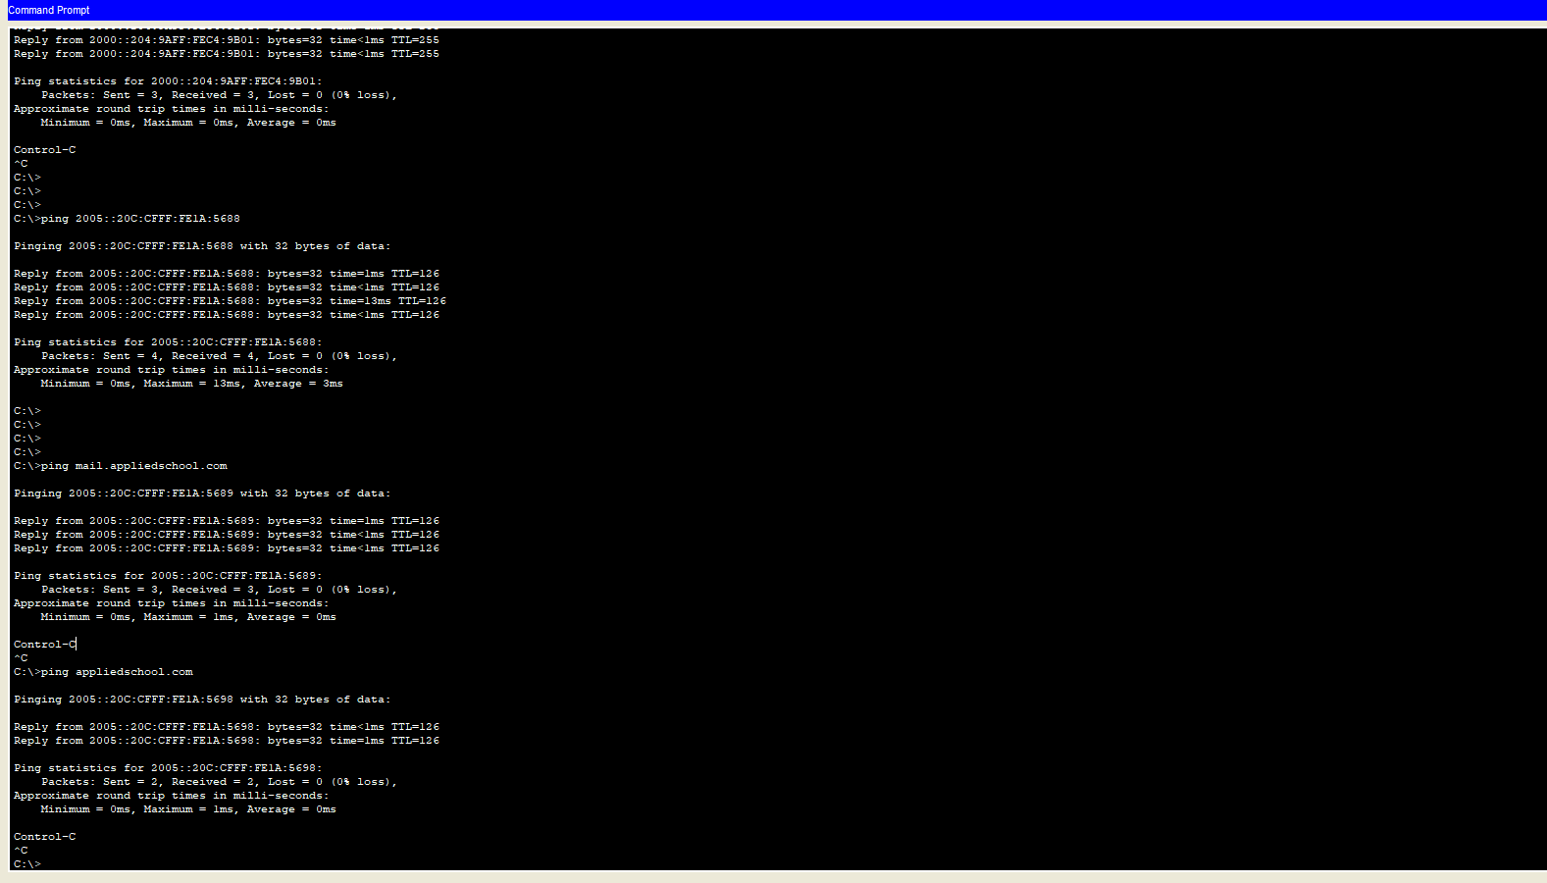
Figure 2: Shows that the device can reach IPv6 server (email, DNS)
test
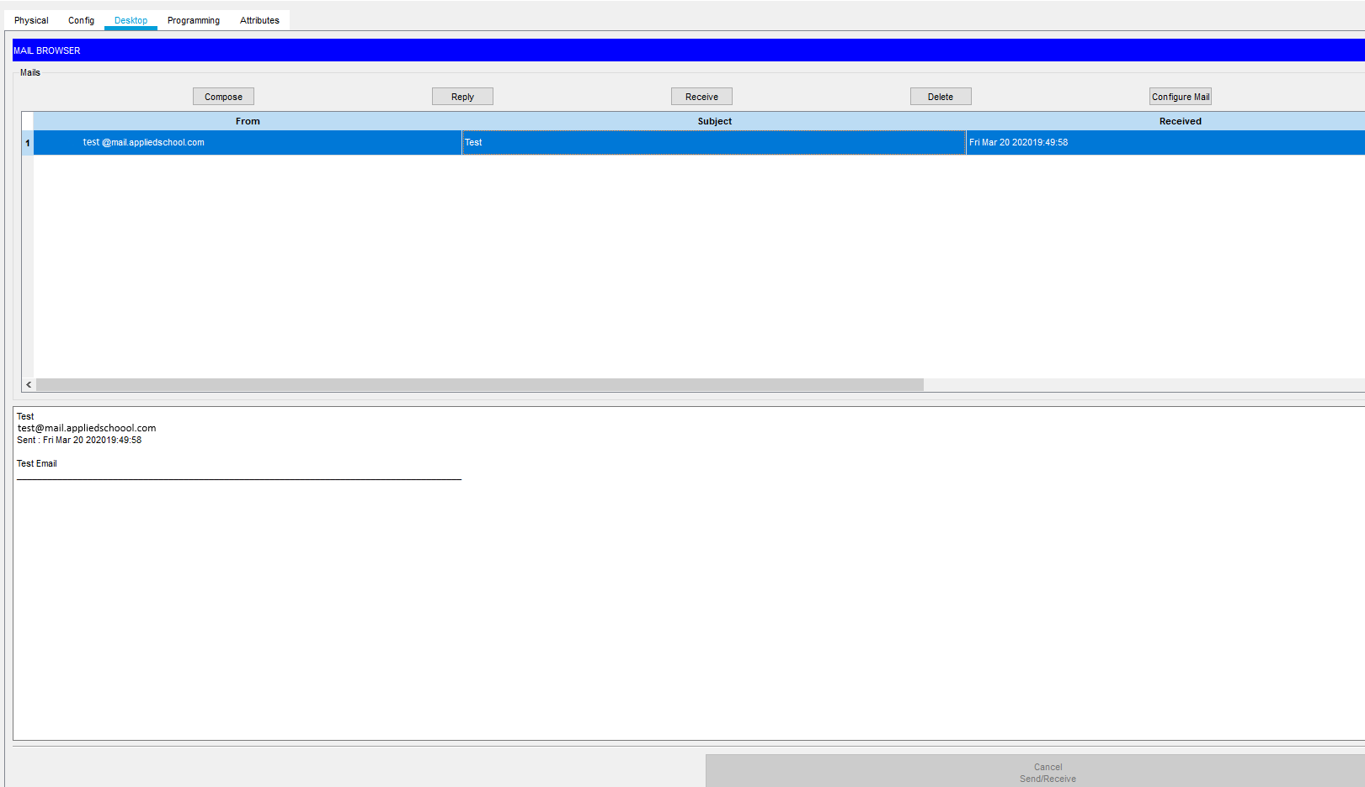
Figure 3: Shows that the device can reach IPv6 email and can send and receive emails

Conclusion
Here, this assignment concluded by describing the version 6 of Internet Protocol in detail. The Ipv6 is a very important part of the network on the internet which holds the address of the system and provides good facilities. It is also the best Internet protocol version for the next generation. It was developed to overcome the problems that are faced in version 4 of Internet Protocol. This assignment described the benefits of version 6 of Internet protocol. It also discusses the disadvantages of IPv6 which will be overcome in the future. There are many features and functionalities of IPv6 that can be utilized in the upcoming year that provides high security to the data on the internet. There are various kinds of addressing Internet Protocol that is discussed above in detail. These addresses named as Unicast addressing, multicast addressing, and anycast addressing, that also has subparts, described above. In last a network is designed according to the given requirements.

References
IPV6 (2018). IPV6 – THE NEXT GENERATION INTERNET. viewed. Available at: https://www.ipv6.com/general/ipv6-the-next-generation-internet/ (Accessed: 21 March 2020).
Juniper (2018). IPv6 Address Types. viewed. Available at: https://www.juniper.net/documentation/en_US/junos/topics/concept/subscriber-management-dual-stack-ipv6-address-types.html (Accessed: 21 March 2020).
Rouse, M. (2019). IPv6 (Internet Protocol Version 6). viewed. Available at: https://searchnetworking.techtarget.com/definition/IPv6-Internet-Protocol-Version-6 (Accessed: 21 March 2020)

Appendix

