Six Sigma Green Belt
Kurtis Russ
2116773

Contents
Introduction 3
What is six sigma? 4
Define Phase 5
Problem statement 6
Project Flow Chart 6
Timescale for project 7
SIPOC Overview 13
External example 13
Related SIPOC 14
Current process Flow 15
Measure 16
Measurement Variation 16
Data Collection Plan 16
Measurement System Analysis (MSA) 17
Data Collection 17
Voice of the customer 17
Report time taken 18
Right first time 19
Analyse 20
Process Analysis Methods 20
Fishbone Diagram 20
Pareto Analysis 21
Graphical Analysis Tools 22
Improve 23
Alternative improvements 23
Option 1: Staff Training and Manual Process Standardisation 23
Option 2: Improve Existing Templates, Spreadsheets, and Manual Logs 23
Option 3: Implement a new software into CRM System (Agile Base was selected) 23
Option 4: Partial Software Upgrade (Excel Automation, Email Templates) 23
FMEA 24
Cost/Benefit Analysis 25
Workings 25
Benefits 25
Labour Savings from Report Automation: 25
Total Annual Benefit 25
Net Annual Gain 25
Pilot Proposal 27
Validated Improvements 28
Improved Process 33
Control 34
Control measures 34
Conclusion 35

Introduction
This green belt project will be done through a company called R-Tech materials; they are a test house in Port Talbot. Within the company there are different departments, these being: Steel, Composites, Water, Consultancy and Analytical. They have recently invested in a software that will improve their overall CRM (customer relationship management) and I am the lead employee in the project. The software is called Agile Base and the goal is to use it for several purposes. Some of the main ones include automatic updates to customers about the progress of their work, automatic generation of reports, create a standard in each department so that their processes aren’t different (Payne and Frow, 2013), make the company’s job process paperless, improve ‘right first time’ (Pyzdek and Keller, 2014) and speed up the process. This project goes into detail about how this will be implemented and how it will improve the company’s overall customer relationships management. This project is started through the steel department but after it is complete and it is proven that it works it is planned to be implemented across the whole company so everything seen in this assignment is steel department based.

What is six sigma?
Six Sigma is a structured and data-driven method that helps organisations find and eliminate flaws, reduce variation, and improve overall performance in their processes. Initially created by Motorola in the 1980s, Six Sigma’s goal is to attain almost perfect process performance.
In order to find the causes of inefficiencies or quality problems and apply long-term improvements, Six Sigma combines statistical analysis, process mapping, and problem-solving techniques. A wide range of industries, including manufacturing, engineering, healthcare, finance, and services, use it extensively. (Pyzdek and Keller, 2000)

The DMAIC methodology which stands for Define, Measure, Analyse, Improve, and Control is most frequently used in Six Sigma. Teams can follow this method as a structure in their six-sigma projects, this includes five-phase process to identify an issue, measure performance, analyse data to determine the underlying cause, improve the process, and put controls in place to preserve the gains made. This is used within the assignment. (De Mast and Lokkerbol, 2012)
Six Sigma also uses a belt-based certification system to indicate different levels of proficiency. White Belt, Yellow Belt, Green Belt, Black Belt, and Master Black Belt are among them. For instance, a Green Belt is usually in charge of overseeing smaller projects or assisting with larger ones while being supervised by a Black Belt. (Markarian, 2004)

Overall, Six Sigma helps businesses reduce costs, boost customer satisfaction, become more efficient, and operate more consistently. It promotes a culture of ongoing development and data-driven decision-making, which is highly compatible with the goals of strategic business planning and quality management. (Pyzdek and Keller, 2000)

Define Phase
The Define phase is the first and arguably most important step in the DMAIC methodology, as it creates the framework for the entire improvement project. Its purpose is to clearly understand the issue that needs improvement, align the project with organisational priorities, and establish a focused project scope to ensure efforts remain achievable within the available time and resources. Engaging key management and stakeholders, identifying internal and external customers, and understanding their specific needs are all crucial parts of this process (De Mast and Lokkerbol, 2012). A structured project plan, often developed as a project charter, is produced by the end of the Define phase and acts as a guide for the remainder of the DMAIC cycle, helping ensure the team is working on the right problem with the right resources and people (Monday, 2022).

Problem statement
There are several different problems that the company have that needs to be addressed, the first one is that they are giving companies an estimated finishing time for their jobs, they would rather be honest but sometimes are unsure of how long a job will take. Customers need to have accurate lead times so that they know how long a job will take, Customers are receiving unreliable estimates due to process variations (Antony, 2014). Also, they would like to be able to give them an easy way to access what ‘stage’ their job is at. Another problem is each department has a different process of doing a job, R-Tech want to make it so if a department is quiet, then one of the employees in that department can go help another without the need for excessive training. If the process is the same all the employee needs to learn is the different tests or applications of the department, the rest of the job should be the same, for example booking jobs on, giving results etc, but now a lack of standardized workflows hinders cross-department collaboration (George et al., 2005). Right first time is a priority for a testing house as well because results need to be correct to give to customers, so anything that can reduce human errors would be very beneficial (AIAG, 2010). Also, calibrations, training, procedures, drawings and documents are in our management system and need to be referred to when performing tests which isn’t always the case. We need to find a solution to all the above.

Project Flow Chart
Determine the problem
Implement into day-to-day work
No

Find potential solutions and pick one
Does it work?

Yes

Design working system for one department
Training on how to make/code new system
Plan project
Testing and user feedback
Train employees on using the new system

Further development
Testing and user feedback

Design customer portal
Train department specific employees

Implement automatic report generating

Design working system for other departments

Customer feedback and admin training

Yes

Make any adjustments
Does it work?

(Antony, 2014)
Finish
No

Timescale for project
This was done in R-Tech using a system called ‘Monday.com’ which is used for keeping records, customer relationship management, visitors, projects, orders etc. This allows us to keep track of what has been done and what is being worked on throughout the project. This is sort of a check list of planned actions to be done.

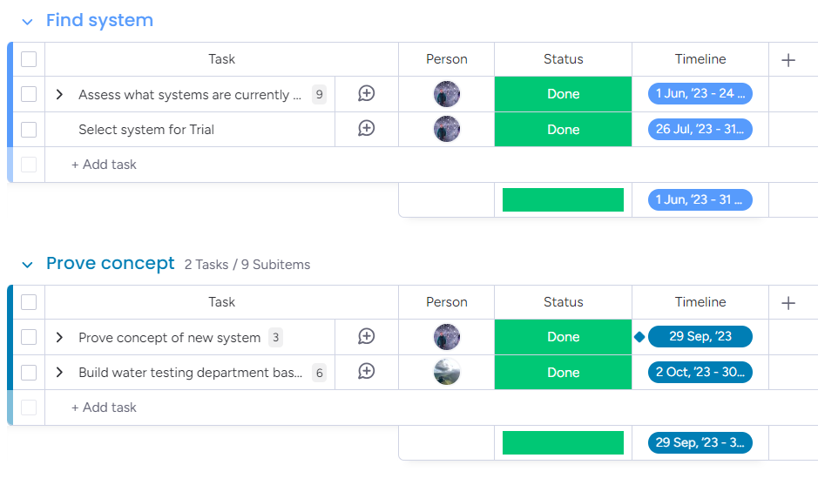

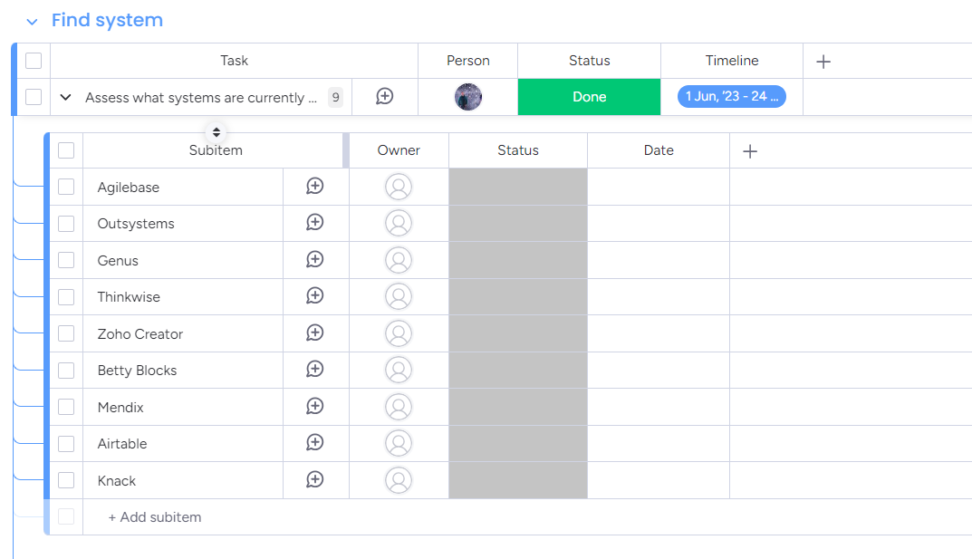

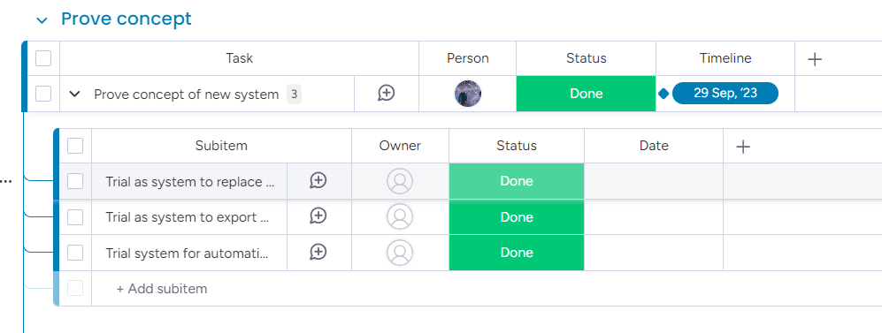

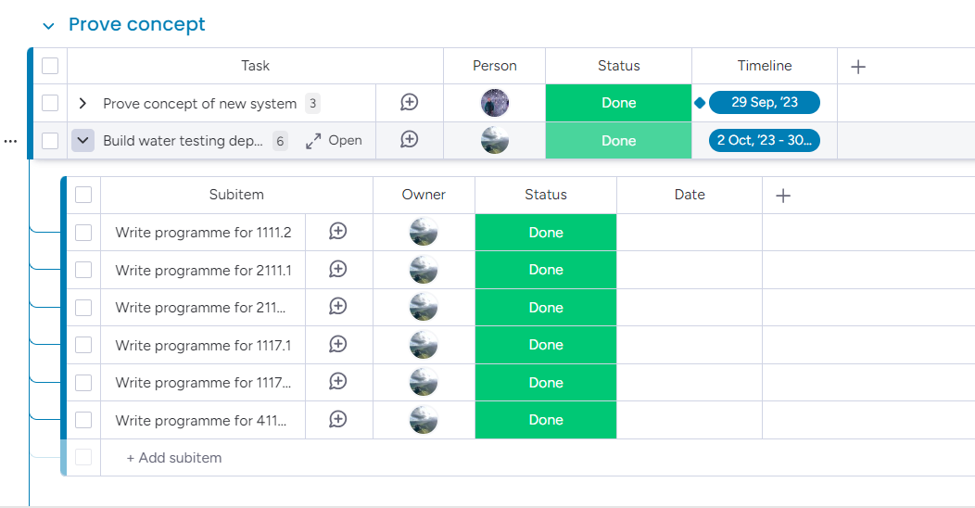
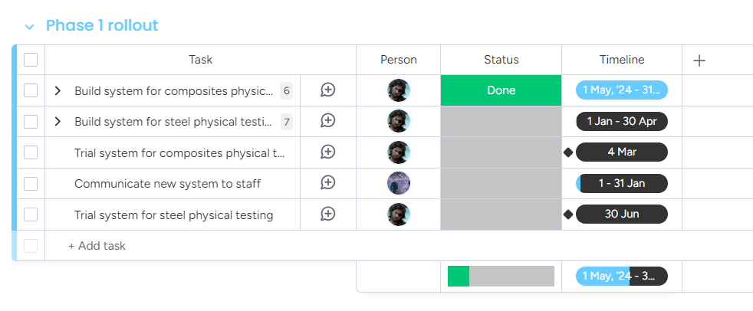
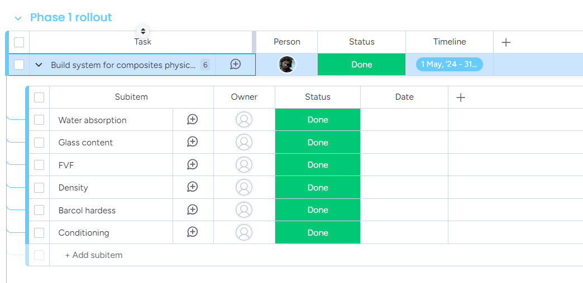
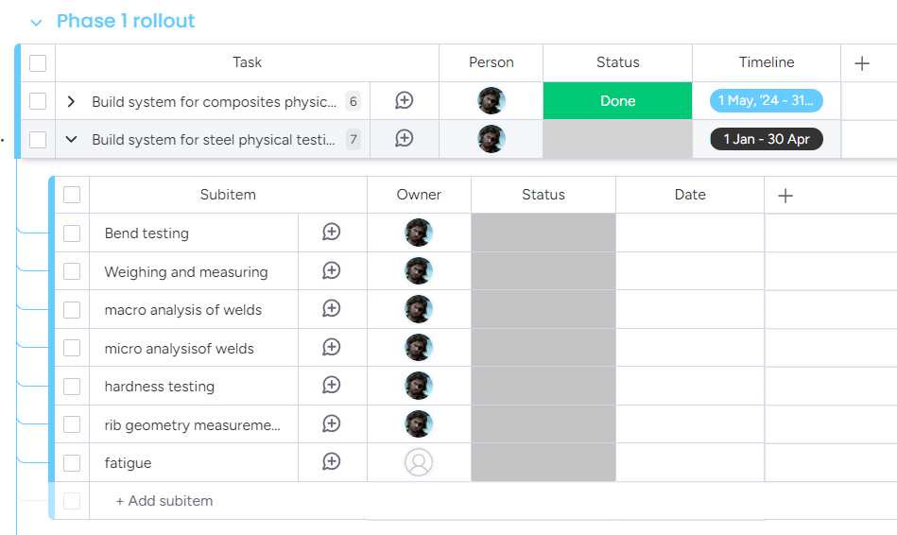

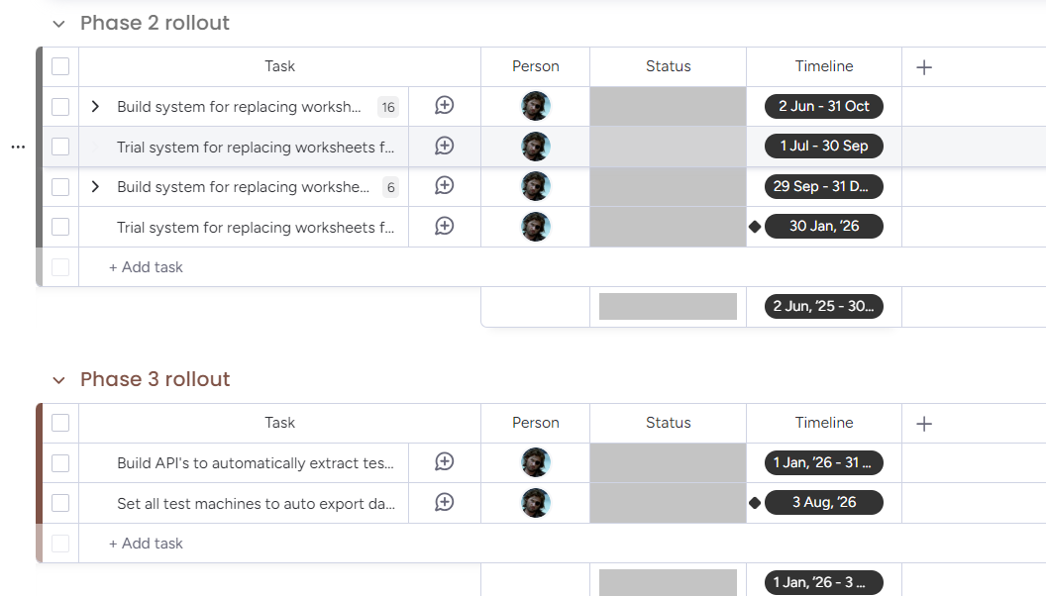

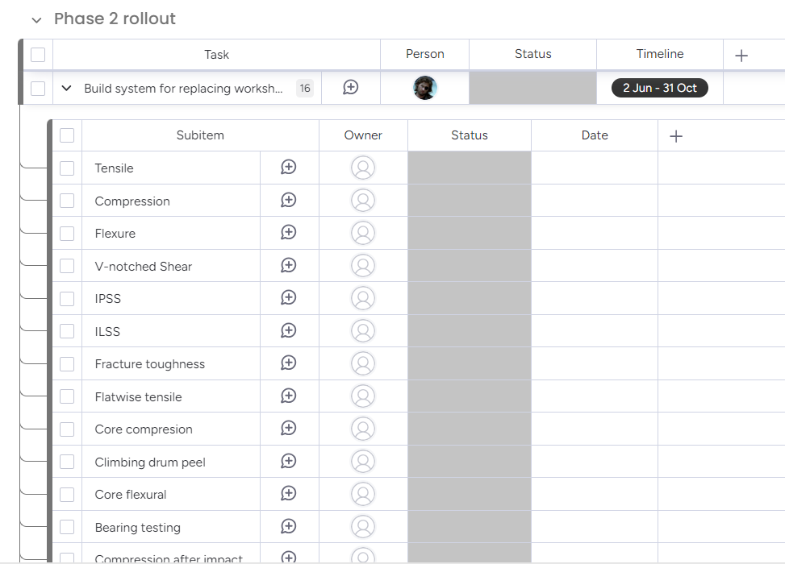

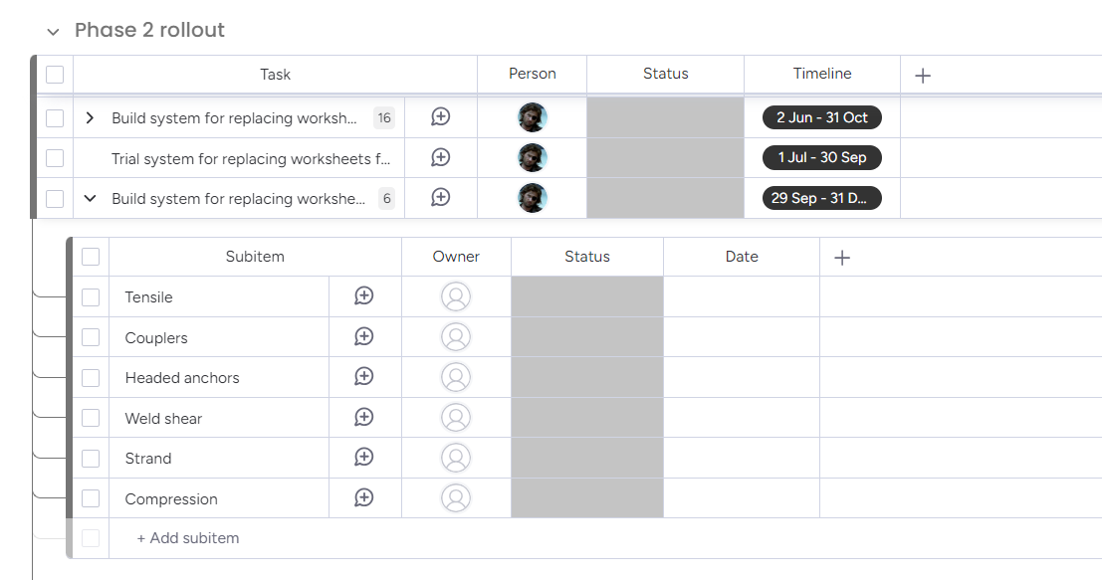

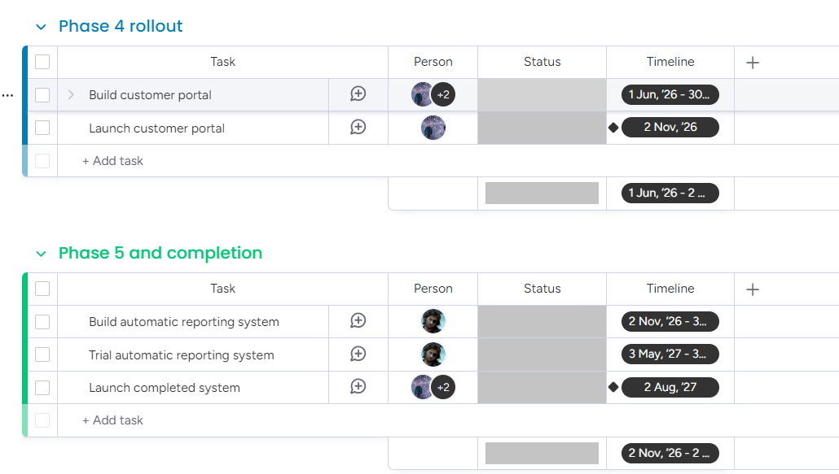
(Monday.com, 2025)

SIPOC Overview
In Six Sigma, a SIPOC is a process mapping tool that provides an overview of a process from beginning to end. It helps teams to understand the essential components of a process before in-depth analysis starts. The acronym stands for Suppliers, Inputs, Process, Outputs, and Customers.
Usually used in the Define phase of the DMAIC process, a SIPOC diagram shows the main steps of the process, the inputs that are provided (Suppliers), the outputs, and the recipients (Customers). Determining the process's scope, defining roles, and bringing the team together on what needs improvement are all beneficial. SIPOC is helpful for complex processes because it makes sure that the customer needs and expectations are considered right away and shows how various process components are connected. (More, No date)

External example
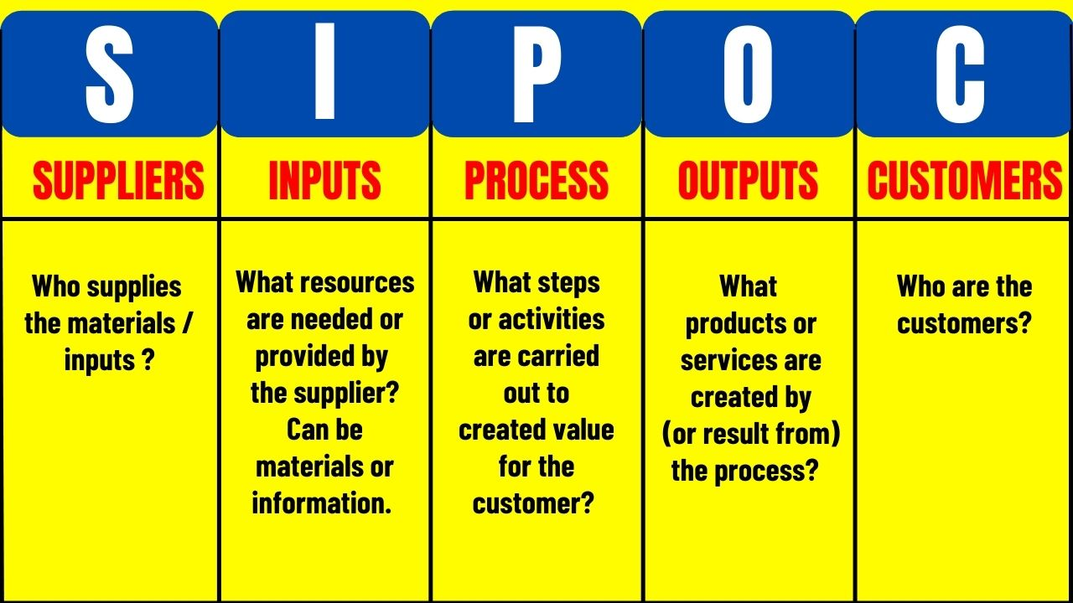

(More, No date)

Related SIPOC

Supplier | Input | Process | Output | Customer
Customers | Job requests, requirements | Sample received, testing, reporting | Test reports, progress updates | Customers
Technicians | Equipment, test methods, Results | Perform tests, record results | Test data, completed analysis | Admin/reporting team
Admin Staff | Report templates, Reports, customer info | Compile and issue reports | Finalised reports, customer communication | Customers, management

Current process Flow
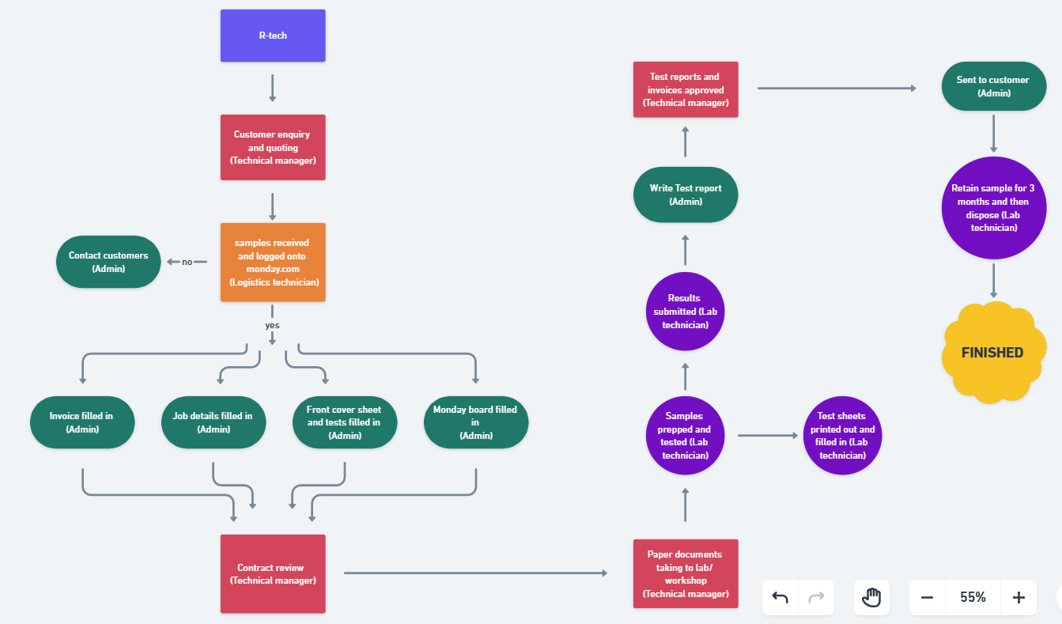

https://whimsical.com/r-tech-current-process-flow-ESxW7u7oTBMJh9a7gDehN4

The current process flow at R-Tech Materials (Whimsical, 2024) highlights inefficiencies mainly in the admin process of the company, this role entails a very time-consuming process when there is really no need for it. Through agile it is hoped that the green sections of the process flow can be heavily reduced to make it more time efficient. The admin team need to contact customers for information, book the job onto ‘Monday.com’, fill out the ‘xero’ invoice, produce a front cover sheet and ‘job details’ sheet to fully complete the initial ‘first step’ of their process, this step allows all information for testing to be passed on whilst also creating traceability of each job. There needs to be a way to find all information through one system rather than doing it three times in different location which is tripling the workload. For example, you would type out the standard for testing three time, once on ‘Monday.com’, another on the front cover sheet and again on the job details form which is unnecessary and this is done for other pieces of information. This is only to get the job into testing but once testing is completed there is still the need to write out the whole report and send it to the customer which takes another chunk of time. The drive is to reduce the admin section of the process whilst also making it harder to make errors (RFT) across the whole company and applying a standard way for each process to be done. A side benefit to this would also be a paperless process which has more benefits of its own. (Damelio, 2011)

Measure
The Measure phase establishes a reliable baseline by collecting accurate data on the current process. It focuses on defining key metrics, validating measurement systems, and ensuring that data is consistent and relevant to the process's real performance. This phase provides the foundation for meaningful analysis and future improvements.

Measurement Variation
This section focuses on understanding factors that might impact the accuracy and consistency of results. Measurement variation must be identified and addressed to ensure reliable data collection. In this project, variations may stem from human error, such as inconsistencies in use of measuring equipment (AIAG, 2010), device inaccuracies due to uncalibrated equipment (ISO, 2015), Inconsistency in engagement with customers due to lack of knowledge for example one employee gives a week for testing to be done but another gives a different timescale, or mistakes due to the incorrect process being used. These variations can produce false readings or results which can lead to loss in time. This could mean the test needs to be performed again which would result in a loss of money as this time could be spent doing the next job. If variations can be identified it would allow for highlighting when calibrations are needed, employee training is needed, if the preparation or testing process differs from the standard process that needs to be adhered to, and overall, where any errors are coming from.

Data Collection Plan
A clear and detailed plan ensures that all necessary data for meaningful analysis is collected, the purpose is to collect the right data from the right source, at the right time. Mistakes (right first time), time spent on testing/booking on jobs and customer relations will need to be measured. Right first time is done by a weekly meeting where mistakes are brought up using an excel spreadsheet and a ‘Monday.com’ data sheet of mistakes caught in that week (Pyzdek and Keller, 2014), this is done to try and make less errors rather than point out individuals. To assess customer satisfaction, a questionnaire will be sent to several customers, allowing them to respond directly. This will be a one-time survey to identify any issues customers may be experiencing with the service provided. To determine the time, it takes to write out a report for each customer, the process will be timed from the start to the end of the report creation. This procedure will be repeated 10 times to account for variability, and the results will be averaged to calculate an estimated time for completing a report.

Measurement System Analysis (MSA)
A simple Measurement System Analysis (MSA) was performed to make sure the data was consistent and dependable. A selection of Agile Base data entries from various users and at different times was made. Three team members independently examined a set of ten customer records. Important information like project status, due dates, and assigned personnel were noted by each member. After that, the outcomes were evaluated and compared to find any differences.
Good reproducibility was indicated by the analysis, which revealed that the recorded information matched for all users in more than 90% of cases. Standard data entry procedures were clarified to address minor discrepancies, such as minor variations in how project stages were interpreted by each member, these instructions were defined clearly to the team to prevent future confusion.

Data Collection

Voice of the customer
Below is a link to the questionnaire used to gather customer feedback and some of the feedback we received. The ‘how can R-TECH improve its services’ column was focused on the most as it was felt that it was the part of the questionnaire that gave us the most information. From the information gathered we realised that one of the problems is customers not knowing what stage their job was in, this was beneficial to understand what was one of the new capabilities that we need from the new software. (Griffin and Hauser, 1993)
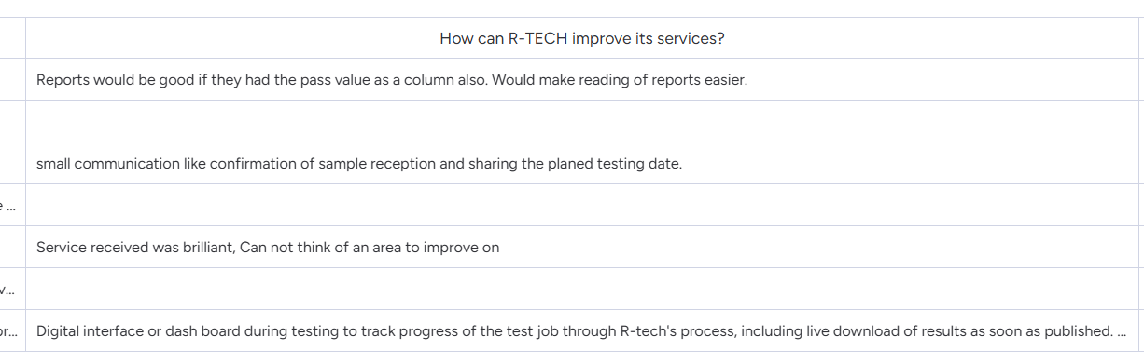
https://wkf.ms/3CCbUfI

Report time taken
Below is a table of how long it took to write up 10 of the reports, as you can see it varies depending on how big the job is, the individual writing it, process used and department/customer it’s for.

Test Name or Customer | Time Taken
3 Caster | 60 minutes
Fatigue | 15 minutes
Coil/decoil | 10 minutes
ISO 15835 | 90 minutes
TA1-C | 15 minutes
ECS | 50 minutes
Jushi | 85 minutes
Trident Foams | 70 minutes
McMurtry Silotank | 195 minutes
Silotank | 195 minutes
Average | 78.5 minutes  = 1 hour 18 minutes 30 seconds

Information was gathered regarding the time required to generate customer reports prior to and following the implementation of Agile Base in order to evaluate the current process capability.
Prior to Agile Base, reports were written manually, taking an average of 78.5 minutes to complete.
Following Agile Base, reports could be created automatically with a single click, cutting the average time per report to 5 minutes once everything was checked and the button could be pressed. This resulted in an approximate 94% (Rounded up) reduction in report writing time, demonstrating an improvement in efficiency. Depending on the report's complexity and the person writing it, the initial manual process was found to be a bottleneck and a source of variation. Now the time taken is all in the testing sections and not carried across to the reporting process as it’s ‘automatically’ done.

Right first time
Below is a link to the RFT log that has been collected across the business, capturing key performance and process data. This data will continue to be collected monthly as part of ongoing performance tracking. After the implementation of Agile Base, the same log will be updated to reflect the changes. This will allow for a direct comparison of business performance before and after the system’s implementation, helping to assess the impact of the improvements over time. (McCormack, 1992)

RFT Stats
Screen shot example if link doesn’t work, this is used across the business.
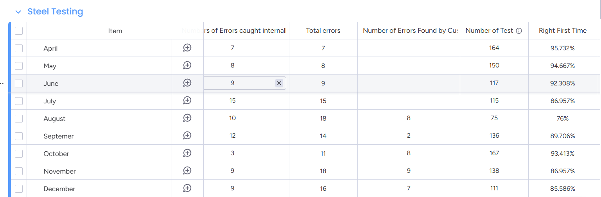
(Monday.com, 2025)

Analyse
The Analyse phase uses collected data to identify and validate the root causes of performance problems. By distinguishing symptoms from real issues, this phase ensures that improvements target the true sources of inefficiency or variation rather than surface-level problems.

Process Analysis Methods
With reliable baseline data now collected during the Measure phase, the project moved into root cause analysis to identify true sources of inefficiencies, rather than surface-level symptoms. To analyse the current processes and identify areas for improvement, the processes below were employed.

Fishbone Diagram
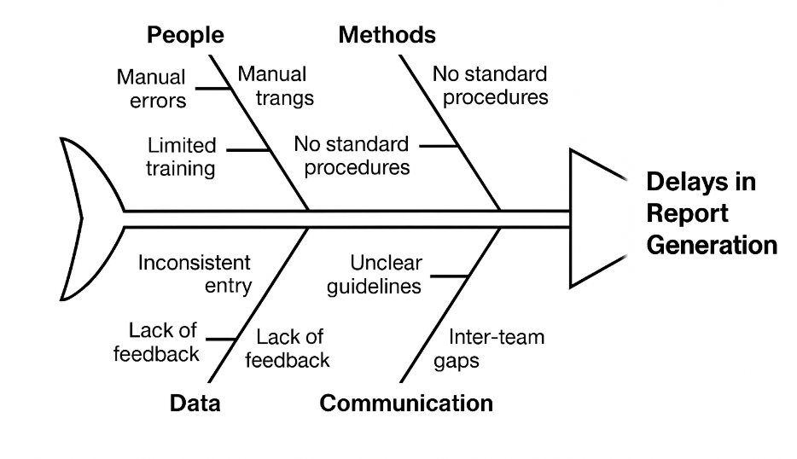
(R-Tech materials,2025)

The main reasons for the delays in the report generation process were investigated using a fishbone diagram. This aided in identifying problems such as human error, inconsistent data entry practices, and inter-team communication breakdowns. A primary goal of the improvements was to address these underlying causes using Agile Base's automated reporting and data consistency features. (Ilie and Ciocoiu, 2010)

Pareto Analysis
A Pareto Analysis was carried out to identify the main contributors to delays and inefficiencies in the report generation process. Data was collected on the types of issues occurring over a three-month period. The results showed that a small number of causes accounted for most problems, aligning with the 80/20 rule (i.e., 80% of the problems come from 20% of the causes). (Karuppusami and Gandhinathan, 2006)

The top issues identified were:

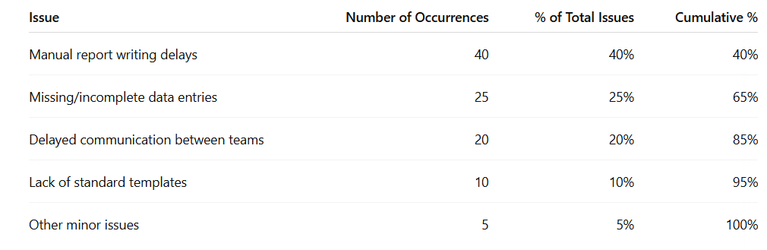

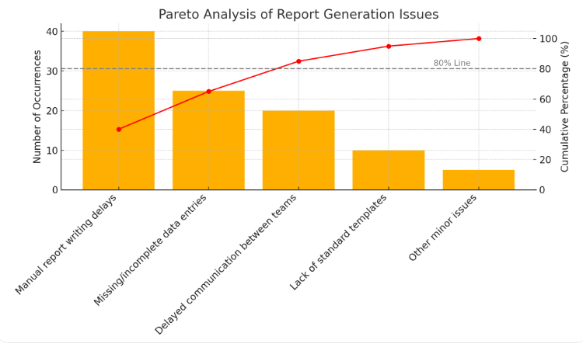

(R-Tech materials, 2025)

The Pareto Analysis highlighted that manual report writing delays and missing/incomplete data entries made up 65% of the total issues. Focusing on these two key problems was therefore likely to produce the greatest improvement, which supported the decision to automate report writing and standardise data entry using Agile Base. (Karuppusami and Gandhinathan, 2006)

Graphical Analysis Tools
The Graphical analysis tools used were:
- Bar Charts
- Process flows
- Fishbone
- Pareto
- Tables
- Screenshots

Using a range of graphical tools made it easier to analyse the existing process, communicate the need for change, and demonstrate the benefits achieved through the improvements.

Improve
The Improve phase translates analysis into practical solutions aimed at reducing inefficiencies and variation. Techniques such as cost/benefit analysis and brainstorming were used to identify the best improvement, leading to the decision to implement Agile Base CRM.

Alternative improvements
To address the inefficiencies found across the company several improvement options were taken into consideration:
Option 1: Staff Training and Manual Process Standardisation
Provide training sessions for all employees and draft guidelines for customer updates, report writing, and RFT logging to increase consistency and lower errors.
Option 2: Improve Existing Templates, Spreadsheets, and Manual Logs
Standardise spreadsheet templates for RFT tracking, customer updates, and reports. To guarantee that data is updated on a regular basis, implement manual checklists and scheduled reminders.
Option 3: Implement a new software into CRM System (Agile Base was selected)
Agile Base CRM can automate report generation, RFT data collect, track customer progress in real-time, and save a significant amount of administrative time. With the benefit of a paperless process.

Option 4: Partial Software Upgrade (Excel Automation, Email Templates)
Instead of using a complete CRM system, use smaller automation tools like email templates, Excel functions, and manual file-sharing enhancements. less impact but at a lower cost.
Agile Base was chosen for implementation after these options were assessed for cost, usability, scalability, and long-term benefits. It provided the most complete solution for standardising information handling throughout the company, automating procedures, enhancing customer communication, and saving staff time.

FMEA
A Failure Modes and Effects Analysis was conducted to identify potential risks associated with the implementation of Agile Base CRM. The FMEA helped prioritise actions to minimise errors, system failures, and customer dissatisfaction before full rollout.
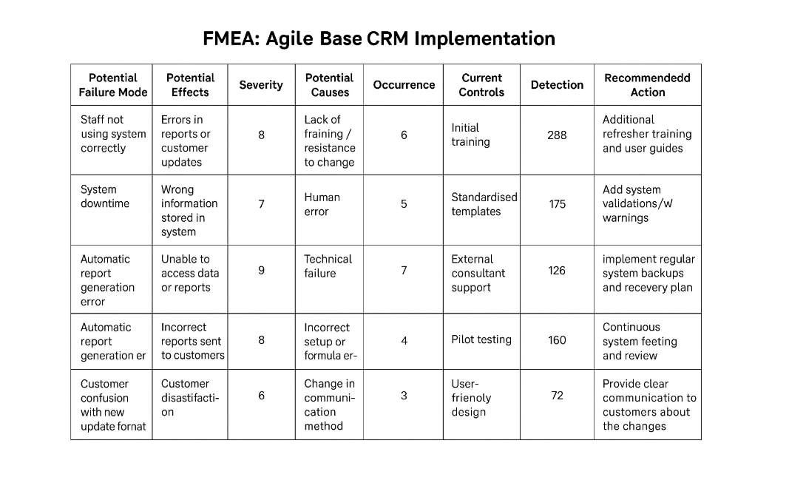
Following the FMEA assessment, key mitigation actions were identified and implemented to minimise the highest risks associated with the Agile Base system rollout. These included:
- Standardised data entry guidelines to reduce input errors.
- Regular system backups scheduled to protect against data loss.
- System training sessions for staff to ensure correct and consistent use of Agile Base.
- Early pilot testing to identify and fix usability issues before full deployment.
These actions helped ensure a smoother implementation and reduced the chances of the main failure modes occurring during and after the project rollout.

Cost/Benefit Analysis

Workings
Costs:
Agile Base Subscription:
£600 per month × 12 = £7,200 per year

Consultant Setup Fee:
5 hours × £70/hour = £350 (one-off payment)

Total Annual Cost:
£7,200 + £350 = £7,550

Benefits
Removal of Monday.com Subscription:
Annual saving of £10,000

Labour Savings from Report Automation:
Old method:
78.5 minutes per report ≈ 1.31 hours × £14/hour = £18.34 per report

New method:
5 minutes per report ≈ 0.08 hours × £14/hour = £1.12 per report

Labour saving per report:
£18.34 – £1.12 = £17.22 per report

Estimated 160 reports per month:
160 × £17.22 = £2,755.20 saved per month
£2,755.20 × 12 = £33,062.40 saved per year

Total Annual Benefit
£10,000 (Monday.com saving) + £33,062.40 (labour saving) = £43,062.40

Net Annual Gain
£43,062.40 (Total Benefit) – £7,550 (Total Cost) = £35,512.40

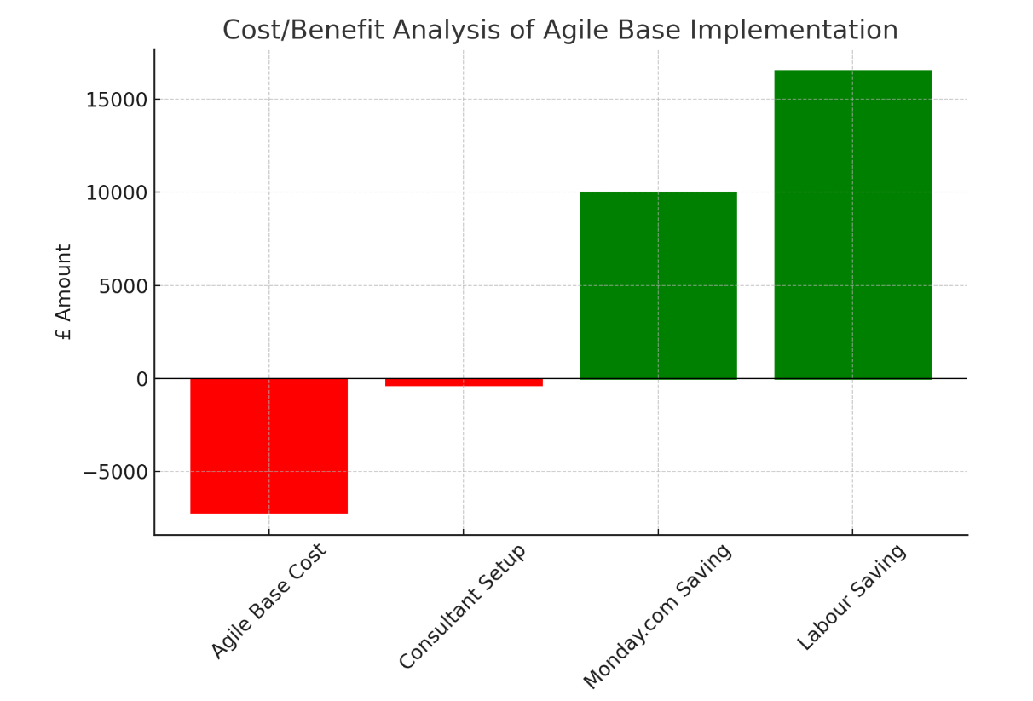
(R-Tech materials, 2025)
(Mishan and Quah, 2020)

Additionally, this calculation does not include the further benefits of improved Right First Time (RFT) rates, reduced paper usage due to digital workflows, and enhanced customer communication. If these factors were quantified, the overall business value of the project would be even greater.

Pilot Proposal
Before full implementation, it was proposed to pilot Agile Base CRM with a selected sample of customer reports and internal tracking activities. The included:
- automating the creation of reports for a single, important service line (mechanical testing reports, for example).
- tracking RFT information and client progress reports for a limited number of ongoing projects using Agile Base.
- Initially, two team members are trained to use the system to collect feedback and make any necessary modifications.
- Monitor RFT whilst the pilot is happening

The pilot's success included:

- Shorter report generation time than with manual techniques.

- The proportion of Right First Time (RFT) reporting has increased and less errors are being made.

- Accuracy and comprehensiveness of the recorded customer progress updates.

- User comments about system functionality, dependability, and ease of use.

- Also allowed for minor improvements to be made before the system was fully integrated for user friendliness, images for reference, graphs needed, calculations needed etc.

Validated Improvements
To validate the improvements delivered by implementing Agile Base CRM, a comparison was made between the process performance before and after the changes.
- Report generation time reduced from an average of 78.5 minutes to 5 minutes per report, a reduction of approximately 93.6%.
- Right First Time (RFT) tracking improved through automated, standardised data entry and reporting, with early indications showing a reduction in customer clarification queries.
- Customer progress tracking was improved with real-time updates available through Agile Base, reducing the need for manual updates and communication gaps.
- User feedback from the pilot phase was positive, highlighting improvements in efficiency, standardisation, and ease of use.
See below screenshots of Agile Base system and its functions.
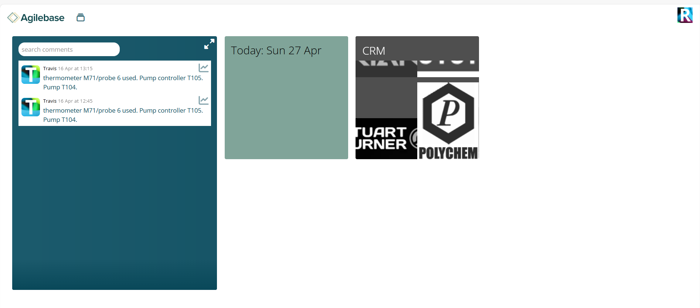This is the front page which has tiles for each department to track their work, book jobs on and find tests required.
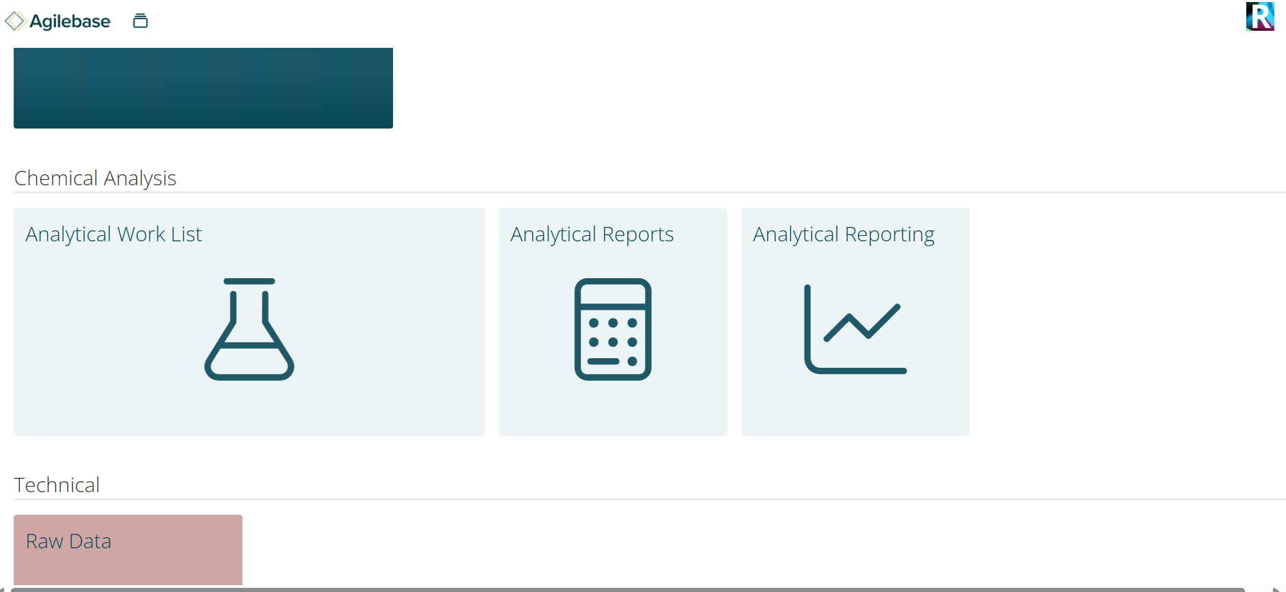
This is what the tiles look like using the analytical departments as an example.

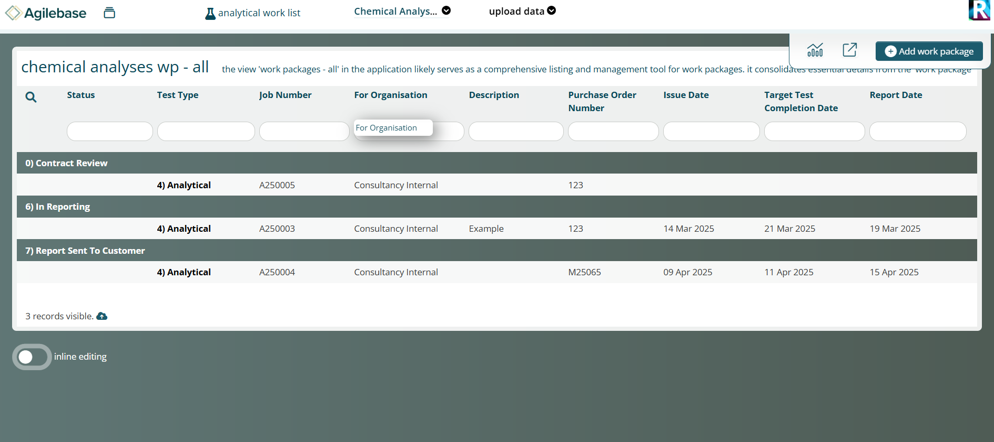
Above is what is inside the work list tiles and each job has a ‘status’ to show what stage the job is in which is now easily traceable and enables us to give accurate lead times for jobs.
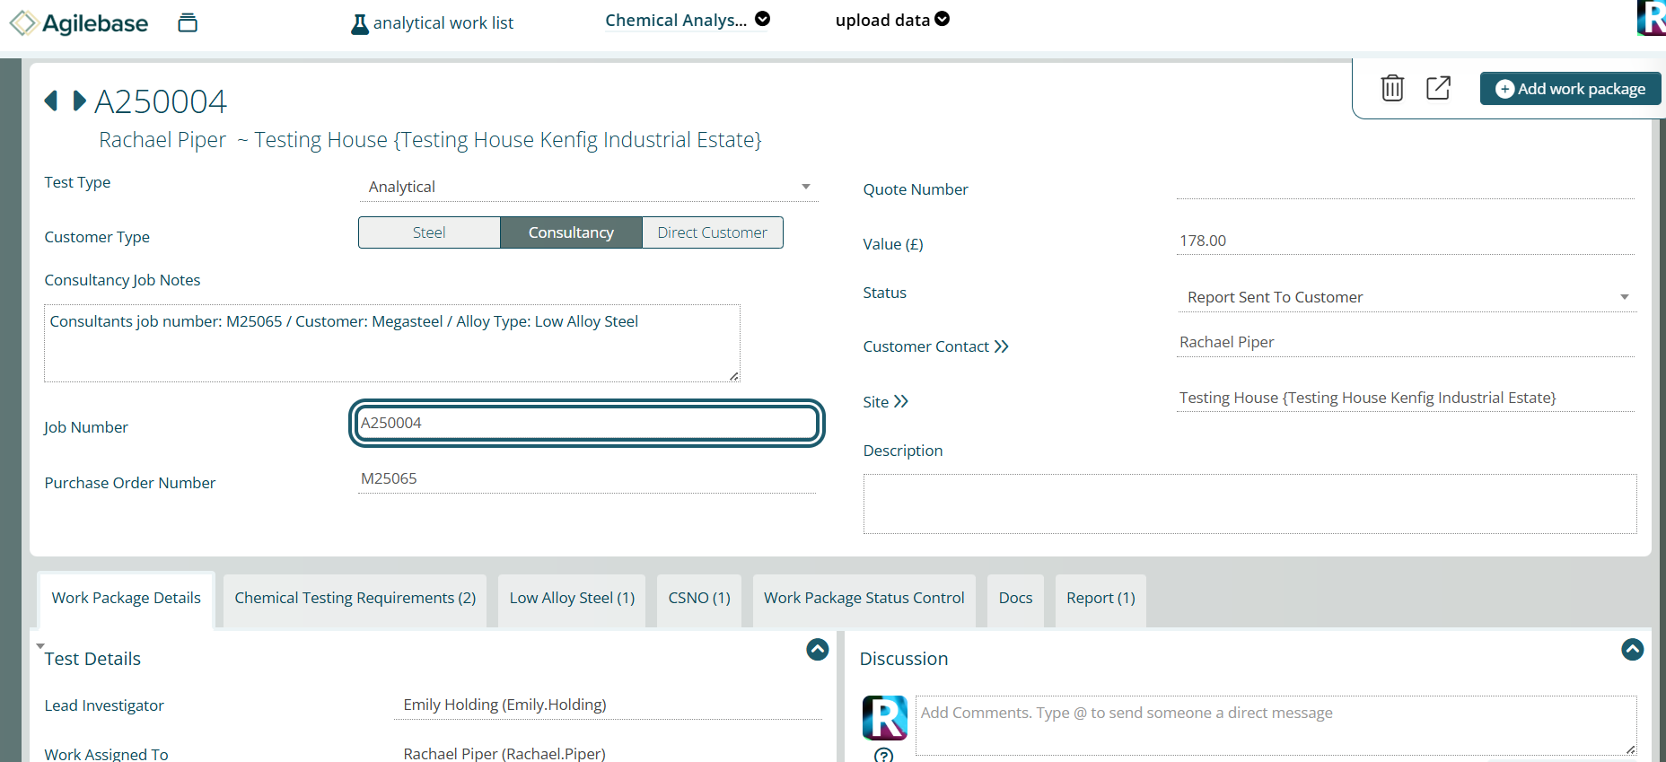
Inside a job you can see all the information for that job and what tests are needed to be done, also whilst it’s moving through the stages of status it is automatically sending an email to the customer to let them know using the coding behind the system which is postgres SQL.

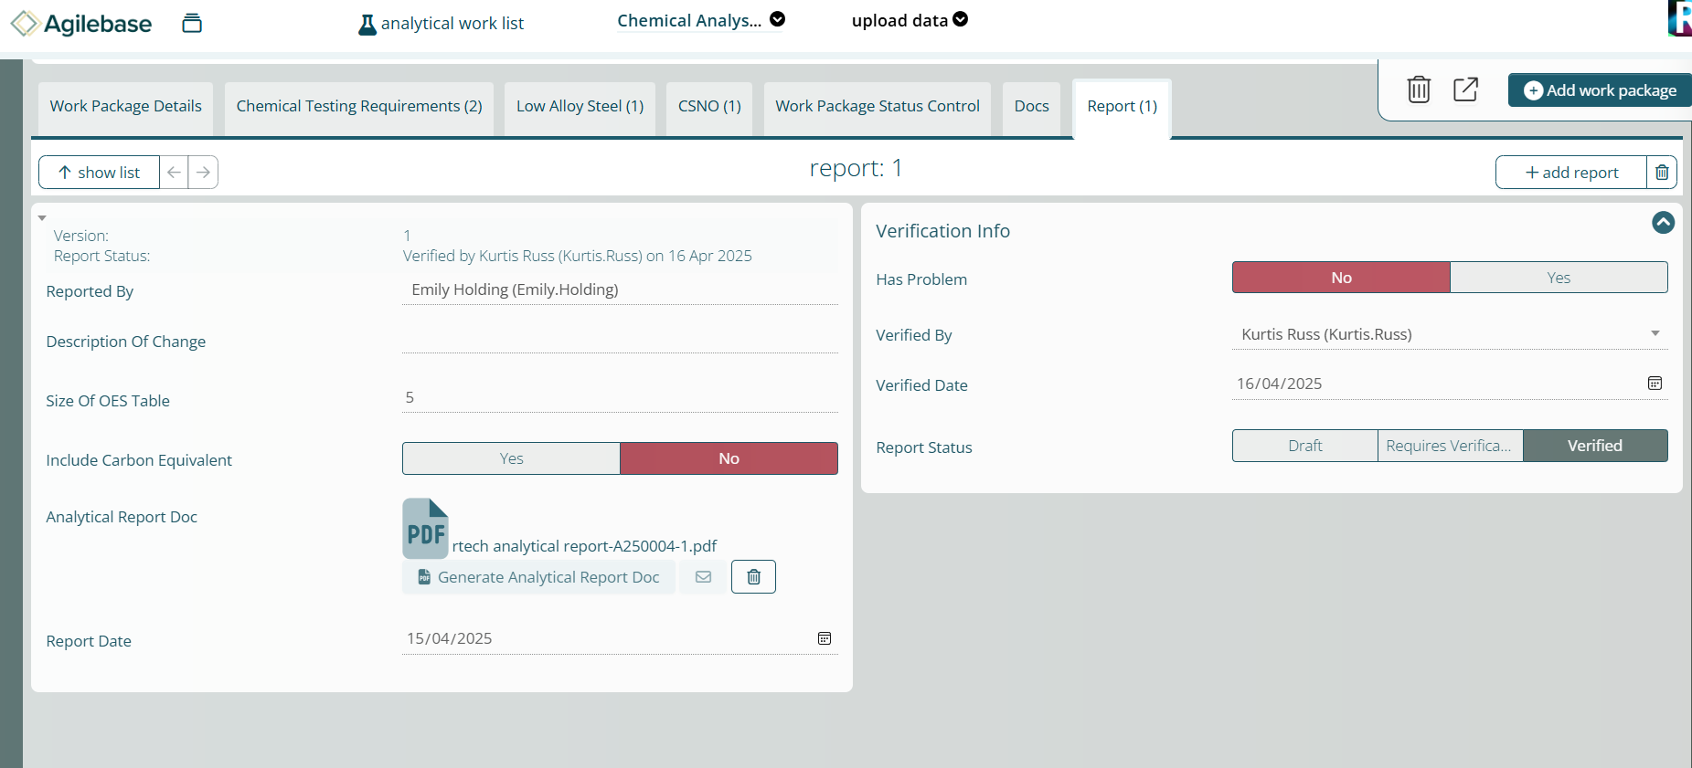
This is the report section which has a highlighted button which when pressed automatically creates the report using the results from the tests that the technicians have filled in. It is using HTML coding in the background to produce the reports.

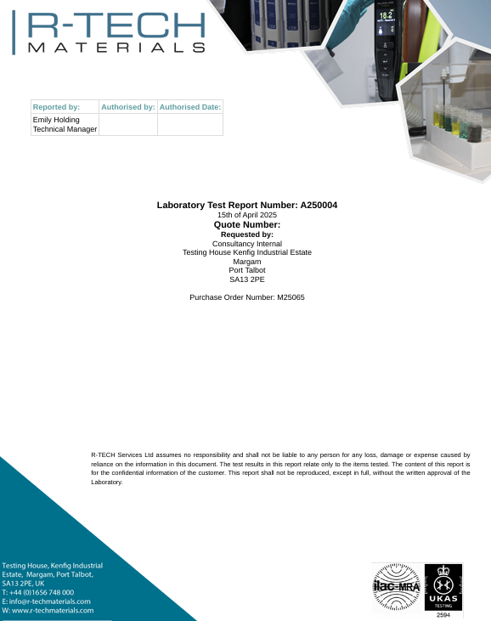

Example of the report front cover that it generates.
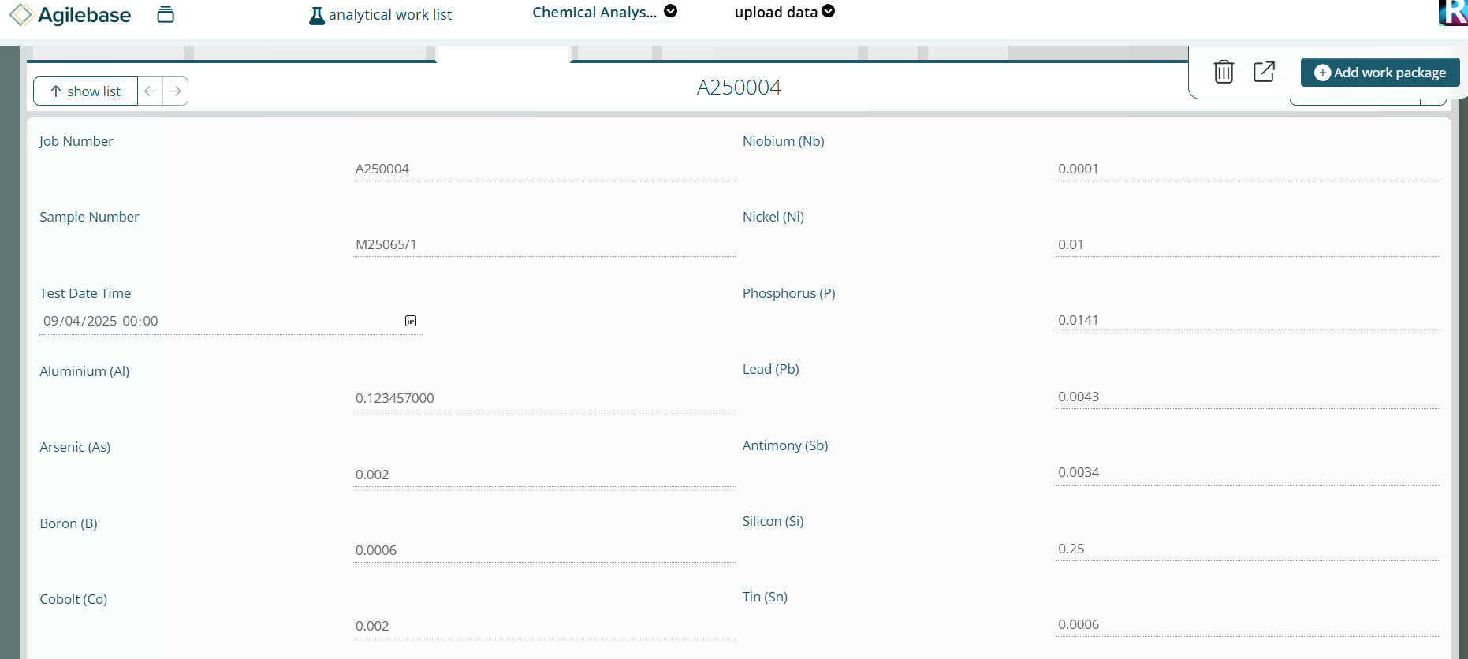
Example of some results that the technicians would have filled in instead of on paper. This is ICP-OES data.

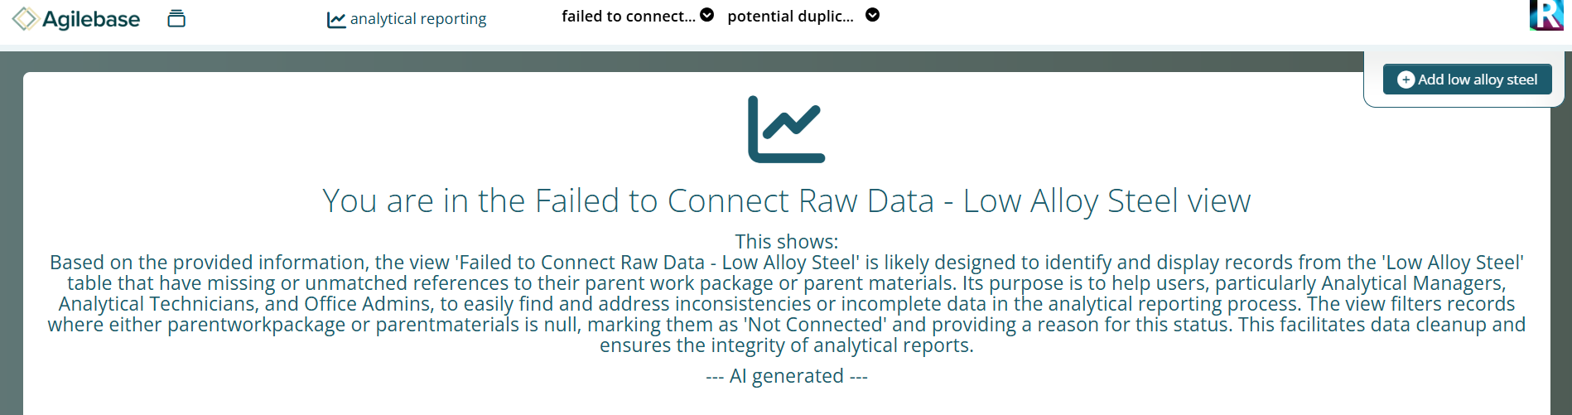

This is an example of a page where results have failed and warnings are made to improve our RFT.

All above images were on the R-Tech materials AgileBase system (AgileBase, 2025)

Improved Process
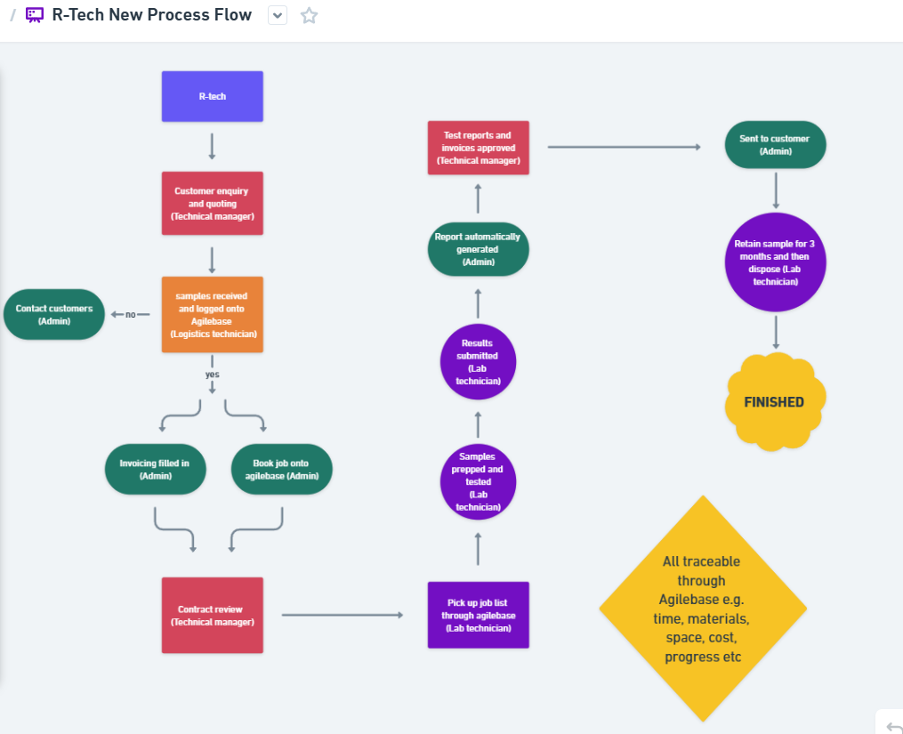

https://whimsical.com/r-tech-new-process-flow-5dnDGS4Dhu7dbvf3e5uaww
This new process flow (Whimsical, 2024) shows how the admin teams process has been heavily reduced due to the fact there is now one system to work everything through, they still need to contact customers and fill in the invoice but now all traceability, job information and test information is filled in once through Agile Base. Also, the report is now automatically generated through the system which saves time on writing it out. On ‘Agile’ a job will get given a technician so it will appear on their workload, this is now paperless as the technician will fill in all the results through the system and not on a worksheet. (Damelio, 2011)

Control
The Control phase ensures that process improvements are sustained over time. Through monitoring, standardisation, training, and corrective actions, this phase embeds the changes into everyday operations and prevents regression to old practices. (Goh and Xie, 2003)

Control measures
Several steps were taken to maintain and manage the advancements made possible by Agile Base. To keep an eye on report accuracy and guarantee that quality standards are upheld, Right First Time (RFT) tracking is continuously conducted. To ensure system stability, meetings with outside consultants are scheduled as needed to address technical problems that are beyond the scope of internal resources. Regular meetings for continuous improvement are planned to gather user input and guide upcoming system improvements. System warnings were also developed to notify users when information is lacking or when data entries deviate from predetermined tolerance levels.
Additional control measures include establishing user access controls to safeguard important data, performing recurring system audits to confirm data integrity, providing system users with frequent training refreshers, and creating performance dashboards to track important process metrics in real time. Feedback from customers regarding the quality of reporting is also welcomed to confirm that external expectations are still being fulfilled.

To further support standardisation, the team used scribe software to automatically generate Standard Operating Procedures (SOPs) for key tasks within Agile Base. These SOPs capture step-by-step workflows and screenshots, helping to ensure that all staff follow consistent processes, minimising future errors and supporting efficient onboarding for new employees.
All these actions work together to guarantee that gains are long-lasting, quantifiable, and embedded. (Goh and Xie, 2003)

Below is an example of a scribe (SOP) made with an example of one of the steps as well.
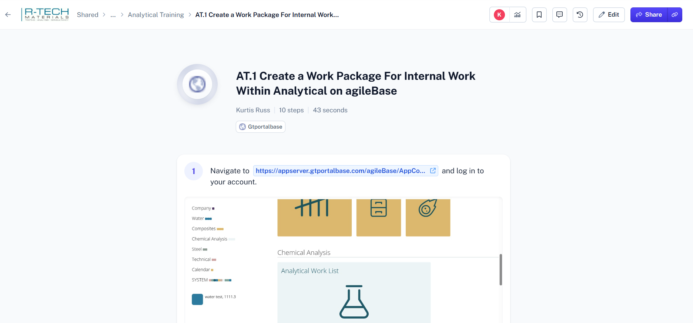
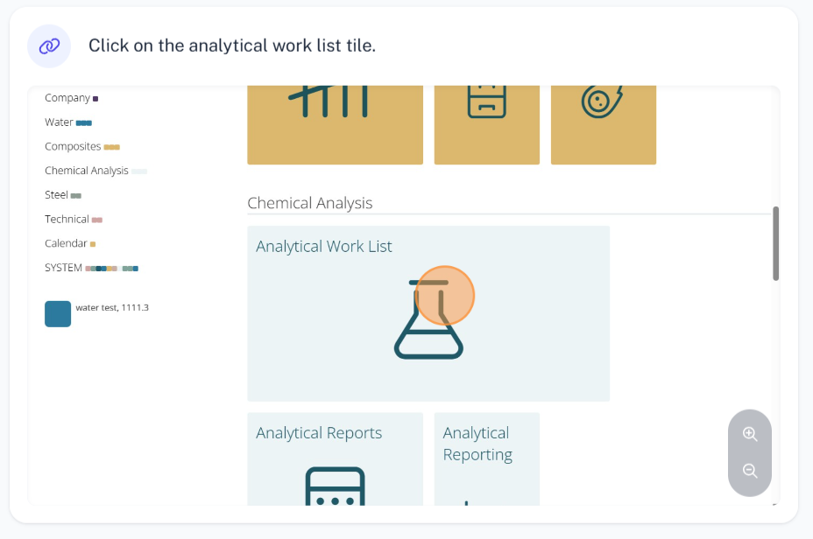
(Scribe, 2025)

Conclusion
This Six Sigma Green Belt project successfully applied the DMAIC methodology to improve report generation, customer communication, and workflow standardisation within R-Tech Materials. Implementing Agile Base CRM reduced report writing time by approximately 94%, saving an estimated £35,512 per year with a payback period of less than five months. Additional benefits included improved Right First Time (RFT) tracking, reduced administrative workload, real-time customer progress updates, and a move towards a paperless system. Control measures such as continuous RFT monitoring, system alerts, regular improvement meetings, and external technical support have been established to sustain the improvements. The success of this project provides a strong foundation for rolling out Agile Base company-wide, enhancing operational efficiency, customer satisfaction, and long-term competitiveness. If this project were repeated, earlier system integration trials and wider staff feedback could have been sought sooner. Additionally, while Agile Base significantly improved administrative efficiency, future reviews should assess whether further automation can be applied across testing phases. These lessons provide opportunities for continuous improvement beyond this project’s initial scope.

References
Agile Base (2025) Agile Base Platform. Available at: Home - Agilebase
AIAG (2010) Measurement Systems Analysis (MSA). 4th edn. Automotive Industry Action Group. Available at: AIAG | Driving Automotive Excellence Through Collaboration & Innovation
Antony, J. (2014) Readiness factors for the implementation of Six Sigma projects in organisations. International Journal of Quality & Reliability Management, 31(2), pp. 117–134.
ASQ (2020) Six Sigma Green Belt Certification Handbook. American Society for Quality. Available at: Excellence Through Quality | ASQ
Brace, I. (2018) Questionnaire Design. 4th edn. Kogan Page.
By, R.T., (2005). Organisational change management: A critical review. Journal of change management, 5(4), pp.369-380. Available at Organisational change management: A critical review: Journal of Change Management: Vol 5, No 4
Damelio, R., (2011). The basics of process mapping. Productivity Press. Available at: The Basics of Process Mapping | Robert Damelio | Taylor & Francis eBoo
De Mast, J. and Lokkerbol, J., (2012) An analysis of the Six Sigma DMAIC method from the perspective of problem solving. International Journal of Production Economics, Available at: An analysis of the Six Sigma DMAIC method from the perspective of problem solving - ScienceDirect
George, M.L. et al. (2005) Lean Six Sigma for Service. New York: McGraw-Hill.
Goh, T.N. and Xie, M., (2003). Statistical control of a six-sigma process. Quality Engineering, 15(4), pp.587-592. Available at: Statistical Control of a Six Sigma Process: Quality Engineering: Vol 15, No 4
Griffin, A. and Hauser, J.R., 1993. The voice of the customer. Marketing science, 12(1), pp.1-27. Available at: The Voice of the Customer | Marketing Science
Ilie, G. and Ciocoiu, C.N., (2010). Application of fishbone diagram to determine the risk of an event with multiple causes. Management research and practice, 2(1), pp.1-20. Available at Microsoft Word - 1nadia.doc
ISO (2015) Quality Management Systems – Requirements (ISO 9001:2015). International Organization for Standardization. Available at: ISO - International Organization for Standardization
Karuppusami, G. and Gandhinathan, R., (2006). Pareto analysis of critical success factors of total quality management: A literature review and analysis. The TQM magazine, 18(4), pp.372-385. Available at: Pareto analysis of critical success factors of total quality management: A literature review and analysis | Emerald Insight
Keller, P. (2014) The Six Sigma Handbook. 4th edn. McGraw-Hill.
Markarian, J. (2004) ‘What is six sigma’, Journal of Financial Economics. Available at: What is Six Sigma? - ScienceDirect
McCormack, S.P., (1992). Getting It Right the First Time. Training & Development, p.43. Available at: TQM Getting It Right the First Time.
Mishan, E.J. and Quah, E., (2020). Cost-benefit analysis. Routledge. Available at: Cost-Benefit Analysis | E.J. Mishan, Euston Quah | Taylor & Francis eB
Monday, L.M., (2022) Define, measure, analyze, improve, control (DMAIC) methodology as a roadmap in quality improvement. Global journal on quality and safety in healthcare, Available At: Define, Measure, Analyze, Improve, Control (DMAIC) Methodology as a Roadmap in Quality Improvement - PMC
Monday.com (2025) Monday.com Work OS. Available at: monday - Home
More, A. (No date) What is SIPOC Diagram? Understand with Example. Available at: What is SIPOC diagram? Understand with example
Scribe (2025) Scribe, Document and share any process. Available at: https://scribehow.com/
Payne, A. and Frow, P. (2013) Strategic Customer Management. Cambridge University Press.
Pyzdek, T. and Keller, P. (2000) The Six Sigma Revolution. Available at: The Six Sigma Revolution
Sharma, K.D. and Srivastava, S., (2018). Failure mode and effect analysis (FMEA) implementation: a literature review. Journal of Advance Research in Aeronautics and Space Science, 5(1), pp.1-17. Available at: Failure-Mode-and-Effect-Analysis-FMEA-Implementation-A-Literature-Review.pdf
Whimsical (2025) R-Tech Current Process Flow. Available at: R-Tech Current Process Flow

