Accounting Fundamentals
LCBB4001

Student:
Cristian Fedorca (1815964)

Executive Summary

This assignment describe about the fundamental concepts of accounting. We explain the purpose, nature, behavior and methods of cost accounting. We also analyze the general principles of cost accounting for interpretation of information with whole management. Company prepare a financial statement for provide information about the position of business to investor or other people. This assignment defines revenue and expanses of the company.

Table of Contents

Introduction 4
Fundamental Accounting Concepts 5
Principles of Accounting 12
Financial Statement 13
Task 1 13
Task 2 13
Task3 13
Task4 13
Task 5 13
Conclusion 15
Reference List 16

Introduction

We used fundamental principles for maintaining records with appropriate format. Financial statement records all the transaction of company to provide information to outside parties or for developing new strategies and policies for a successful organization. Annual report play important role for the success of company, it also provides information about the company position in market. Nature, Behavior, purpose and principles of cost accounting are defined under this assignment (Loughran, 2011).

Fundamental Accounting Concepts
Cost Accounting
The word cost accounting is derived from two words ‘cost’ and ‘accounting’. Cost accounting refers to the art and science for recording, summarizing, analyzing and classifying the costs for help to management in business decisions. It is the tool of management process and which calculates monetary and non monetary data so that it can provide important information for the essential plan and control of functioning, and also for decisions of management and analysis.
The technique of accounting in which the cost is acquired for bear out an operation or ascertaining the purpose which are submitted, recoded and analyzed. The data again checked and collected for appearing at a selling price or to make the savings where they are possible. It starts where costing ends. The work is related with the cost employee. It can also be referred in some following points:
- To regulate the cost of products, production processes, projects etc. so that it can make a detail of the amounts in the financial statement of the company.
- To assist for the management in plan and control of the business.
- To make best analyses that is helpful to make decisions of business.

“Cost accounting is the operation of principles, methods or techniques of accounting and costing for the art and science and process of cost control and determines the profitability. It involves the information derived which is presented and for objective of managerial decision-making.”
Nature of cost accounting
- Cost accounting is collection of knowledge :
It is the branch of knowledge which includes the principles, methods, concepts, principles and system which are engaged in the organization for planning and controlling the application of its resources.
- It is an art :
Cost accounting includes the skills, knowledge, talents, and ability of cost accountant for applying the methods, principles, techniques of cost accounting to different management problems.

- Special branch of accounting:
It is known as the special branch of accounting which includes collection, recording, determination and control of cost. It is established on double entry system but it is also having some concepts and conventions also.
- Accepted as a profession:
Cost accounting is the collection of knowledge because it is recognized as profession. Costs and works accountants institute of India gives professional advices to the accountants of cost. It also makes the regulations for the professional work.

- Helpful for management:
The cost accounting system makes available the information and measures for the different management for controlling and directing.

- Assurance of different factors of total cost:
By the process of accumulation, classification, and recording the cost accounting makes the ascertainment of production cost and services cost. The factors of cost which are included in this such as labor, material, expenses. The scope of cost accounting is to explains per unit and total cost per unit.

Behavior of Cost
Cost behavior refers as when any variation in operational activities, then organization analyzes the operating cost. Direct material, direct cost and overheads cost are several cost included in cost of product. The behavior of cost analyze through performance of mathematical cost function. It maintains a good relation among the total cost and operating level of company. Fixed, variable and mixed cost is sub part of cost behavior.
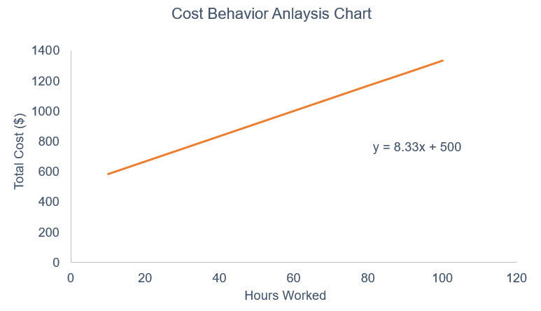
Fixed Cost: Increased in production level cannot change the fixed cost of the product. It cost is stable at specific level of operation. Fixed cost is also generating when company does not produce goods. When the production is increased, fixed cost per unit is decrease.

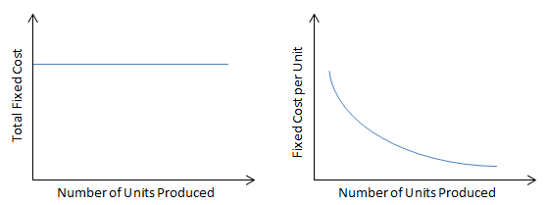

Variable Cost: It maintains a direct or good relationship with the production level. Variable cost is increased when the company reduces the production unit and variable cost descries when they enhance the production units.

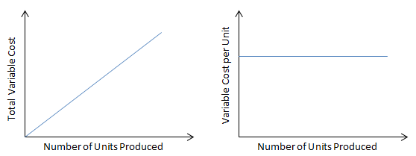

Mixed Costs: It is the combination of fixed cost and variable cost, so it also known as semi-variable cost. In other words, when the cost varies with production volume such as variable cost or fixed cost is not completely eliminated.

Purpose of cost accounting
The main purpose of cost accounting is defined below:

- Cost Control: The first most important purpose of cost accounting is to control the cost with the help of budgetary management. It provides effective allocation of scare resources for a particular project or manufacturing process.

- Computation of Cost: It is the main source of entire functioning of cost accounting. In this, we understand how to calculate the cost of sales per unit of the specific product.

- Cost Reduction: Computation of cost provide assistance for reducing the cost on specific report and process. Company used new technology for reducing the cost of the product and provides effective quality to consumer.

- Profitability: company main aim is to ascertain the profit through reducing the cost of product. Accountant provides advice to management as how they increase the profit of the company.

- They provide accurate data which provide guidance for fixing the price of product and services are manufactured under company.

Methods of cost accounting for business transactions:
We describe several costing method means for ascertaining method for cost for product or services. We describe several methods of costing are as under:

- Job costing: This method describe about the ascertainment of cost for a specific project. This kind of costing also covered the tailor made products. Some examples are building repairing and painting. Job costing is depending on the performance of the units or job nature.

- Contract costing: Heavy expenditures are required under this costing method, these types of job perform for a long period of time and it performs on various sites. It is also called terminal costing. Some examples are road construction, bridges and building.

- Batch costing: In this method, units are produce in batches; they produce a product in same nature or design. They also mention the detail of batch such as batch number and code of batch, so if any types of defect find they easily solved it. Some examples of batch costing are medicines and pharmaceuticals.

- Process costing: When the product goes through several processes is known as batch costing. Such as cloth manufacturing, it include spinning, weaving and final product. Each and every manufacturing process gives output which used as input for next process. It difficult to ascertain the cost of the product and services. Vegetable ghee, paints and varnishes are some example of process costing.

- Multiple costing: there are several parts are assembled such as car, T.V., electronic gadgets for ascertainment of cost for element then get the final product. This method involves several costing methods.

- Operating costing: Industries use this costing method for rendering their services for production. In hospitals, hostels, municipal services, power supply companies where the operating costing method applied. They ascertain the cost of services provided to consumers.

Techniques of cost accounting:
- Historical costing: It refers as value of the asset, so it easily proves by company. It becomes easy to look the property and easily determine the cost of the property. Replacement cost and current cost vary from the market or economical condition. So, company determines the different cost of the part of the property every year in current market.

- Standard cost: In this method, the cost of the product is pre-defined the standards. It requires effective and efficient system for cost accounting. All the cost such as material, labor and overhead are determined in advance. They standard set by the company used for comparision with the actual output of company.

- Marginal cost: In this technique, allocation is restricted for those expense of product which are output of product such as material, labor and expenses. In production industries, marginal costing techniques are useful for varies output. They analyze the cost volume profit analysis for increment in profit margin.

- Direct cost: when company charges directly for operations, process or product and restrict for indirect cost included in product. It is different from marginal cost, some cost is not considered as direct cost. Direct materials, labor and overheads are considered as direct cost.

- Uniform costing: Some similar techniques and methods are employee in number of companies, so it is known as uniform costing. Costing method, codes, charging depreciation and allocation are used for extend of standardization. With the help of uniform costing, provide a facility of inter-firm comparison, which helps in pricing policies.

Principles of Accounting

In principles of accounting GAAP is founded, the manager has to know the principles of accounting for filling the GAAP in accounting principles. The following principles are described as below:

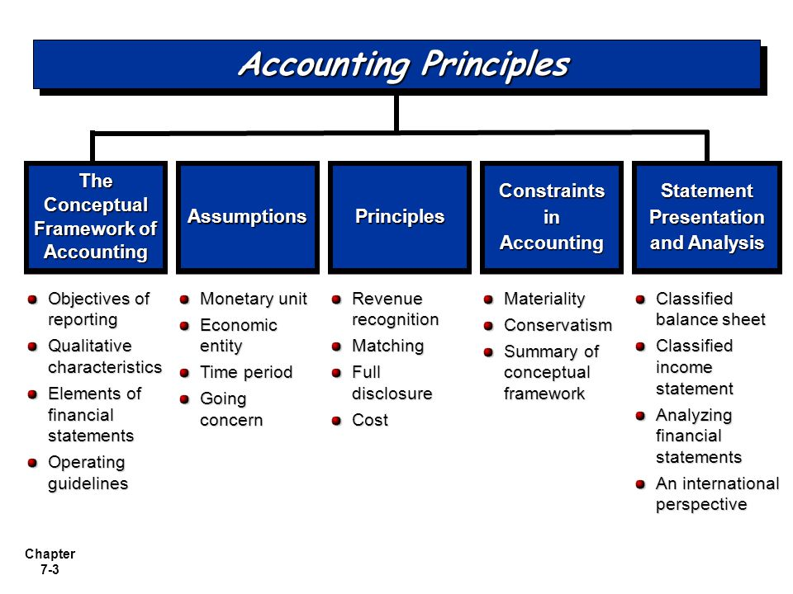
- Principle of conservation:
Accounting is the system which makes the records of liabilities and expenses. But for make the record of assets and revenues you are surely have to come. This principle contributes to encourage the losses of earlier not of the later.
- Principle of cost:
In this principle the business makes the records of the liabilities, assets and investments equity at the same cost of purchase. This cost principle is less important as the standard cost is made in heading for the direction of assets and liabilities for their values of fair nature.

- Principle of economic entity:
This principle makes the transactions that the business organizations must be placed separately from the managers and other workers of the organization. This protects assets and liabilities among entities, which have many problems also when it is, audited the financial statements.
- Principle of full disclosure:
This principle concept is involved in financial statements of organization which influence all the understanding of the statements. The standards of accounting have amplified on the principle of full disclosure in determining many number of informational disclosures.

Financial Statement

Task 1

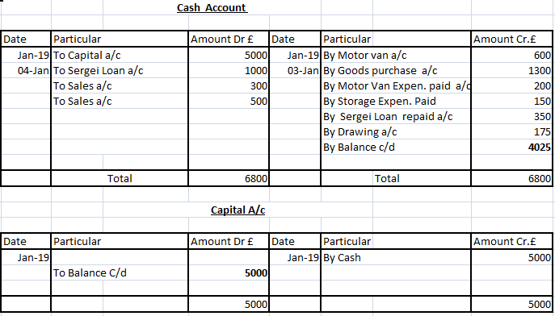

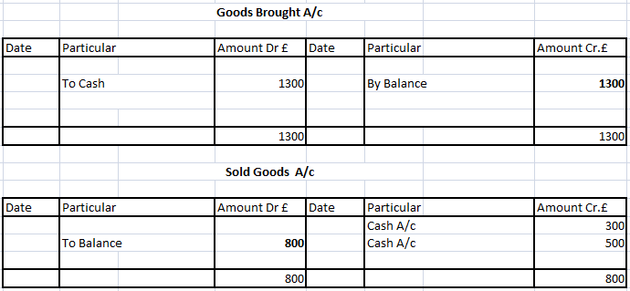

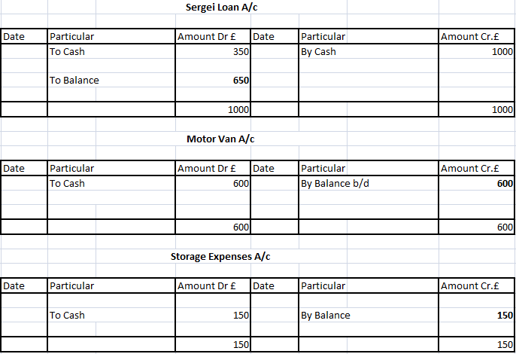

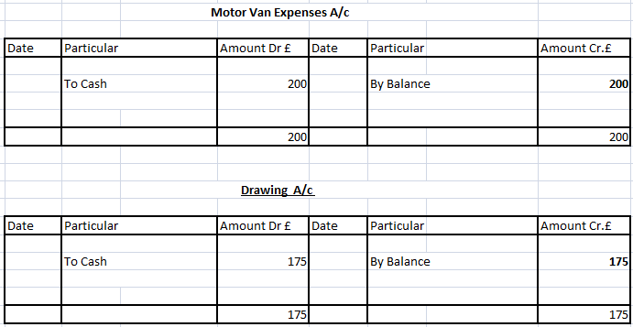

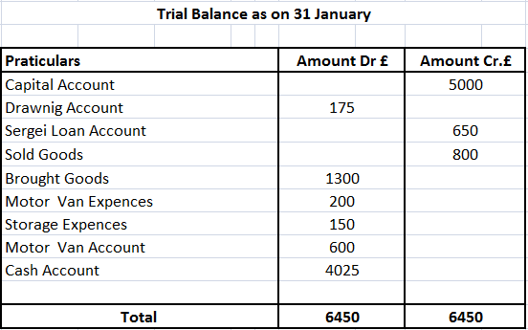

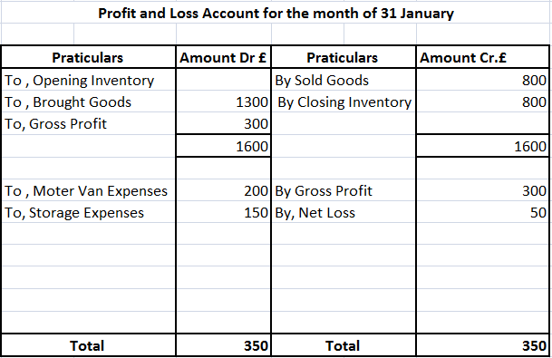

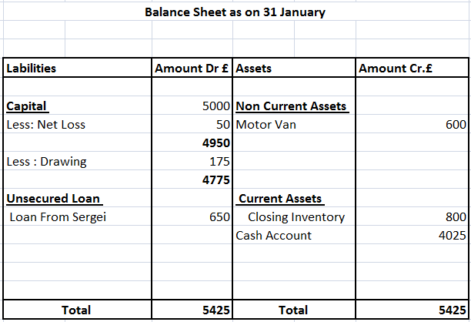

Task 2

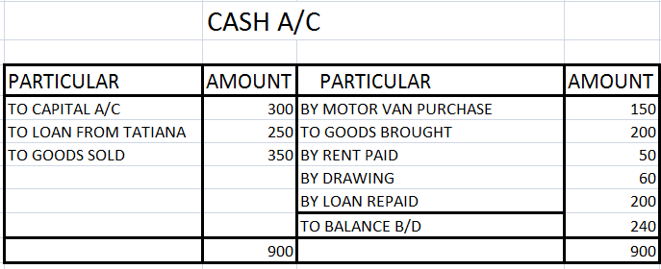

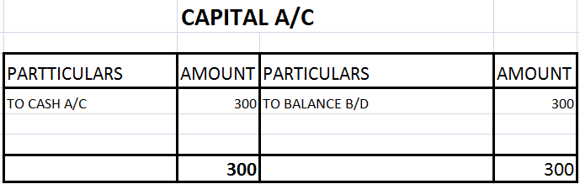

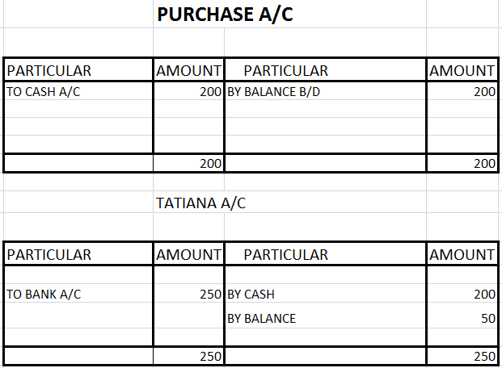

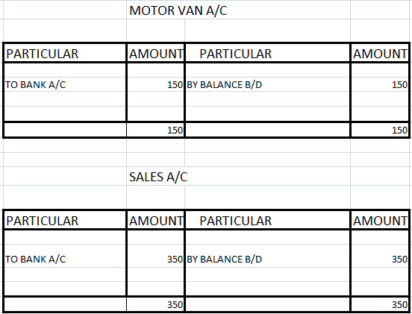

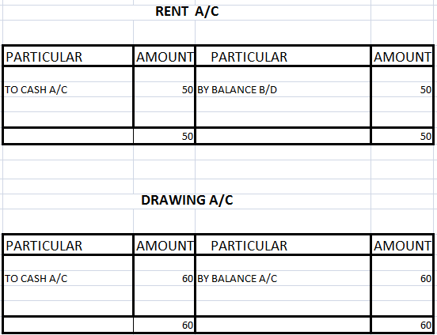

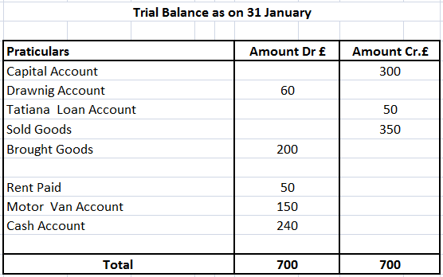

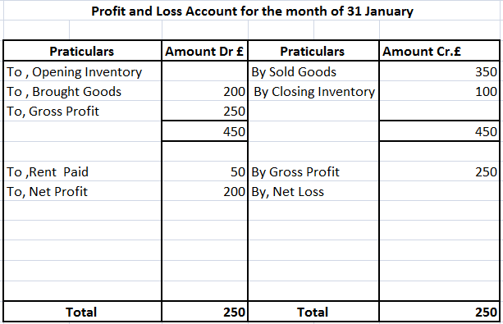

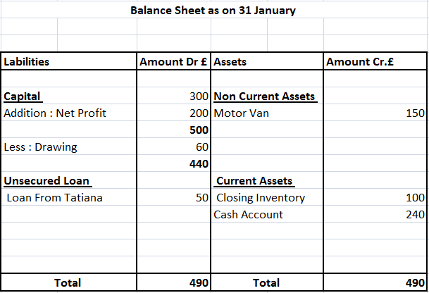

Task3

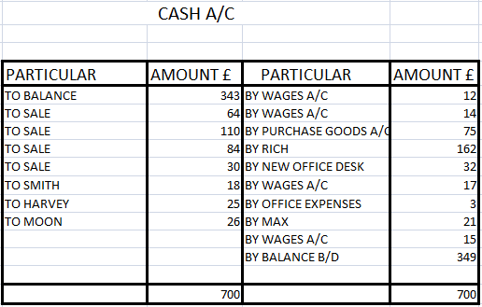

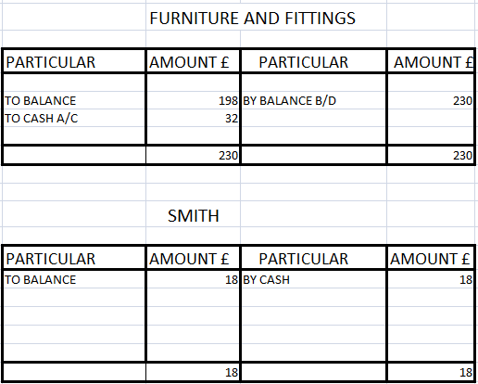

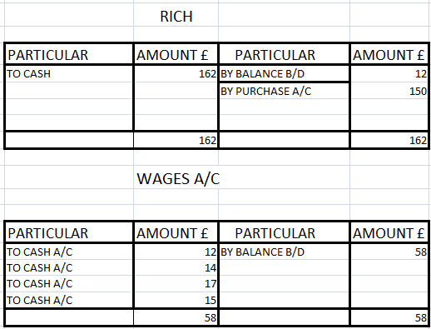

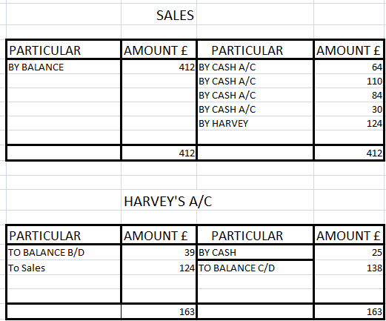

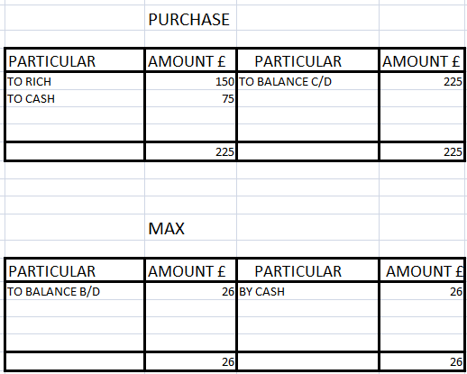

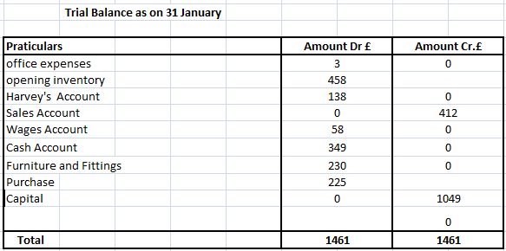

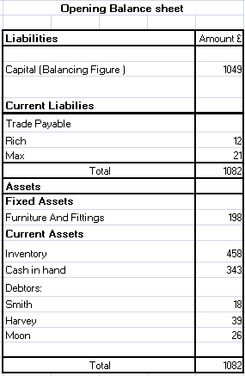

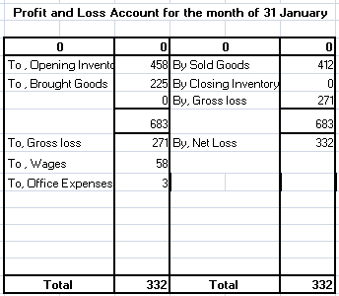

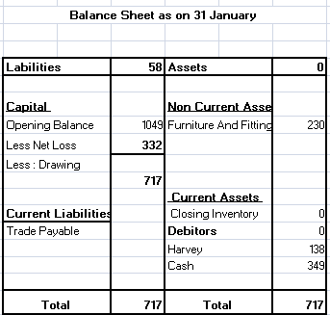

Task4

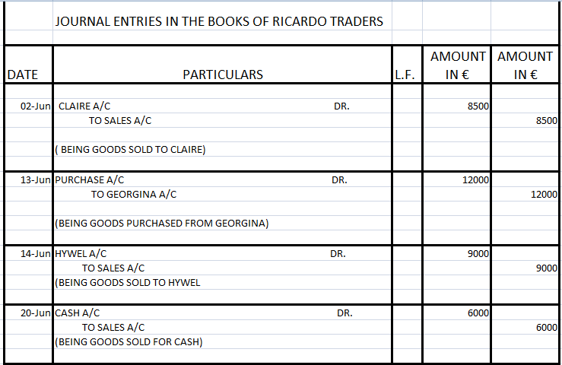

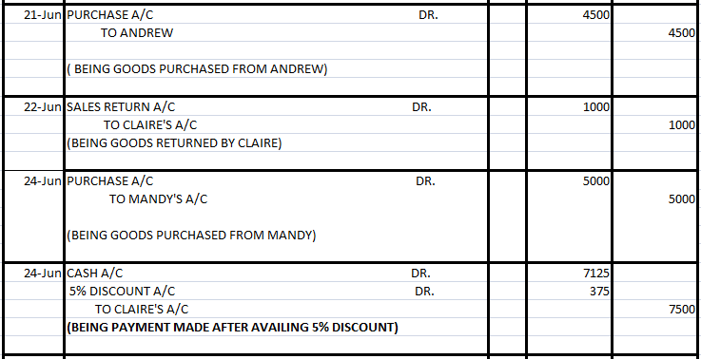

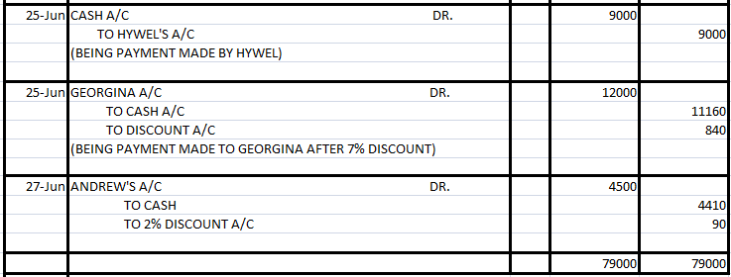

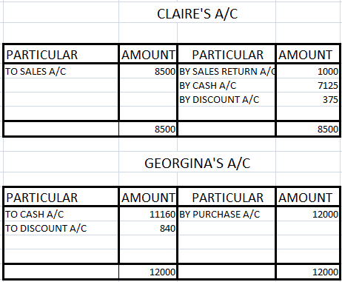

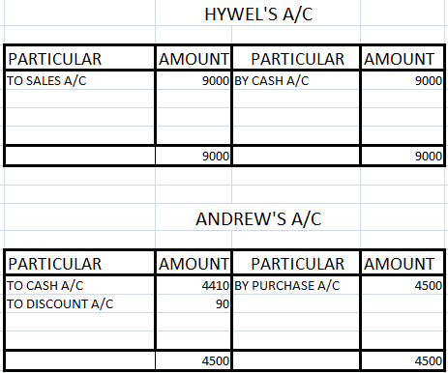

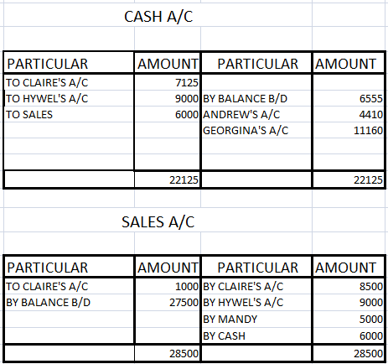

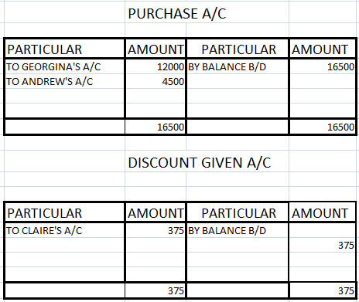

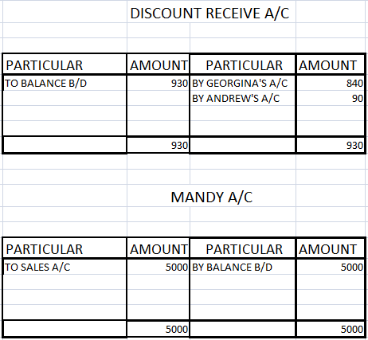

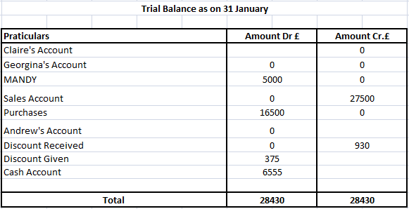

Task 5
Revenue Expenditure
An expense which is incurred in the accounting period when expenditure takes place is referred to as revenue expenditure. In the concept of fixed assets discussion of revenue expenditure takes place. In other words, all the expenses which are incurred on daily basis for the purpose of running the business are referred to as revenue expenditure. The examples of revenue expenditure can be trading of inventory, expense on carriage and freight. These are also referred to as income statement expenditure. As this is related with assets related costs which are not capitalized because these do not provide any benefit related to finance in future. For more description, all the extra expense which is incurred in business because of assets is referred to as revenue expenditure. But these do not add additional values to the assets or increase its productivity or its usefulness.

Capital Expenditure
Major investments of capital are explained under the concept of capital expenditure. This helps the company to maintain the status of business and also expands the level of business, as this generates the additional profits to the business. All the expenses related to capital are for longer period. These include equipment facilities or its manufacturing. As these assets provide opportunity for income generation to a company for many years, in this company don’t have the permission to deduct the full cost of the assets which is incurred in the year, these costs are recovered year by year through the technique of depreciation till the life of assets. To cover the substantial cost company use the method of debt financing or equity financing as this helps the business in the increment of their business.

Difference between Capital and Revenue Expenditure
Points of Distinction | Capital Expenditure | Revenue Expenditure
Concept | Expenditures which are incurred on valuable things which are for longer period are known as capital expenditure. | Expenditures which are included in the goods which are less valuable and are for short period are referred to revenue expenditure.
Time Limit | These expenditures have a time limit of more than one year. | These expenditures have a time limit of within one year
Financial statements | These types of expenditure are posted on balance sheet. | While these types of expenditures are posted in trading account and as well as in profit and loss account.
Capitalized | Capitalization is done in this type of expenditure. | In this type of expenditure capitalization is not done.
Nature | These expenditures are of recurring nature. | These expenditures are of non recurring nature.
Requirement | To Increase the growth of the business. | To execute the daily activities of the business.
Sub Components | There is no sub category in the capital expenditure. | It is divided into two sub categories:  - Expenses related to directed activities  - Expenses related to indirect activities

Conclusion

By the end of this assignment, we understood different concept of cost accounting such as its nature, behaviors, and its purposes. We have also learned the facilities identified by different tools and techniques to the company. By monitoring inventories of the company and its products and services, it has increases the accuracy of the company. It also provides company to sell their products in an appropriate manner which helps business to grow and develop. For clarifying the concept of cost accounting we solved some practical questions related to it. This will help us in brief study.

Reference List

Brown, M.W., Dutta, R., Paolini, M.A. and Smith Jr, N.J., International Business Machines Corp, 2003. Cash register and method of accounting for cash transactions. U.S. Patent 6,550,671.

Dearden, J., 1978. Cost accounting comes to service industries. Harvard business review, 56(5), pp.132-140.

DRURY, C.M., 2013. Management and cost accounting. Springer.

Graves, J.H., 1971. Commission on accounting principles. Journal of Accountancy (pre-1986), 131(000005), p.61.

Horngren, C.T., 2009. Cost accounting: A managerial emphasis, 13/e. Pearson Education India.

