Name: Ben Brown

Student Number: 2419961
__________________________________________________________

WORKSHEET 3 – TESTING (Lap Times)

- Original code:
[Copy and paste your original code from Moodle into this box. Do not change it.]

lap_times = []
for lap in range (1, 6):
time = float(input(f"Enter the time for lap {lap}:"))
lap_times.append(time)
target_time = float(input("Enter your target time:"))
print("\nLap times entered:")
for i, time in enumerate(lap_times, start=1):
print(f" lap {i}: {time}")
print (f"\nTarget lap time: {target_time}")
total_time = sum(lap_times)
average_time = total_time / len(lap_times)
fastest_time = min(lap_times)
fastest_lap = lap_times.index(fastest_time) + 1
slowest_time = max(lap_times)
slowest_lap = lap_times.index(slowest_time) + 1
laps_beating_target = 0
for time in lap_times:
if time <= target_time:
laps_beating_target += 1
print("\nLap Statistics: ")
print(f"1. Overall time: {total_time:.2f}")
print(f"2. Average lap time: {average_time:.2f}")
print(f"3. Fastest lap: Lap {fastest_lap} ({fastest_time:.2f})")
print(f"4. Slowest lap: Lap {slowest_lap} ({slowest_time:.2f})")
print(f"5. Laps equal to or faster than target: {laps_beating_target}")
print("\n6. Lap comparison with previous lap:")
for i in range(1, len(lap_times)):
if lap_times[i] < lap_times[i - 1]:
print(f"Lap {i+1} was faster than Lap {i}")
elif lap_times[i] > lap_times[i - 1]:
print(f"Lap {i+1} was slower than Lap {i}")
else:
print(f"Lap {i+1} was the same as Lap {i}")

- Code Testing
For each test below, run your code and show the results of the scenarios below. Present a screenshot of what happened when the programme ran. Did the programme behave correctly or did it do something unexpected, and if so, why?

- Test a lap time for your programme:
- 42 seconds
- 2 seconds
- -4 seconds
- 53444 seconds
- Test the target lap time – show that the values entered are reasonable

- Using the same five lap times as the sample output ie

Lap 1: 42.3
Lap 2: 42.1
Lap 3: 44
Lap 4: 44
Lap 5: 39.4

Examine each statistic (1-6) and comment on whether the correct answer(s) are displayed or not. (If any statistics were incomplete after Phase 1 (code completed in class) simply write “Unfinished”)

- Test two further sets of lap times of your own choice.

Template for tests:
Test: a) i. – 42 seconds

Screenshot(s) of output:
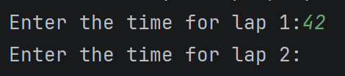
Result: Did the programme behave as expected ie syntactically and logically correct?
YES
The programme worked as expected, allowing the user to continue to enter the next lap time.

(Copy and paste box above for each of the rest of the tests)

Test: a) ii. – 2 seconds

Screenshot(s) of output:
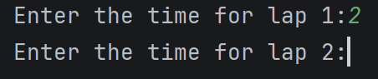
Result: Did the programme behave as expected ie syntactically and logically correct?
YES
The code ran as expected, however, a lack of validation didn’t stop the code from working, as 2 seconds is unrealistic. Validation should be implemented.

Test: a) iii. – -4 seconds

Screenshot(s) of output:
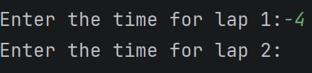
Result: Did the programme behave as expected ie syntactically and logically correct?
NO
The code lacked validation to allow the user to enter their realistic lap time. -2 is impossible. Validation should be implemented.

Test: a) iv. – 53444 seconds

Screenshot(s) of output:
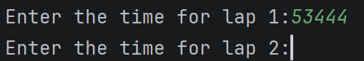
Result: Did the programme behave as expected ie syntactically and logically correct?
NO
Again, the code lacked validation to prevent the user from entering unrealistic numbers. Validation should be implemented.

Test: a) v. – Test the target lap time – show that the values entered are reasonable

Screenshot(s) of output:
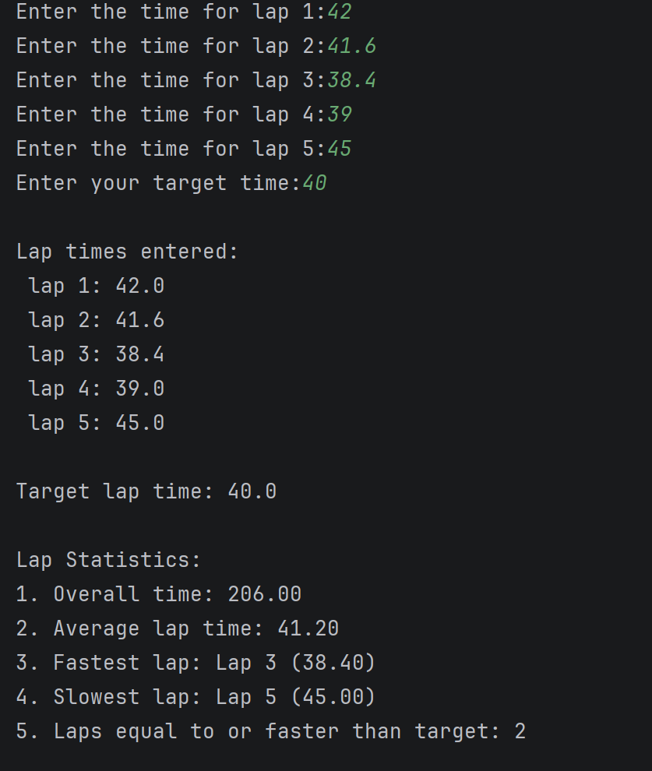
Result: Did the programme behave as expected ie syntactically and logically correct?
YES
The code ran correctly, proving that 2 laps that were entered were quicker than or equal to the target time.

Test: b) - Using the same five lap times as the sample output ie

Screenshot(s) of output:
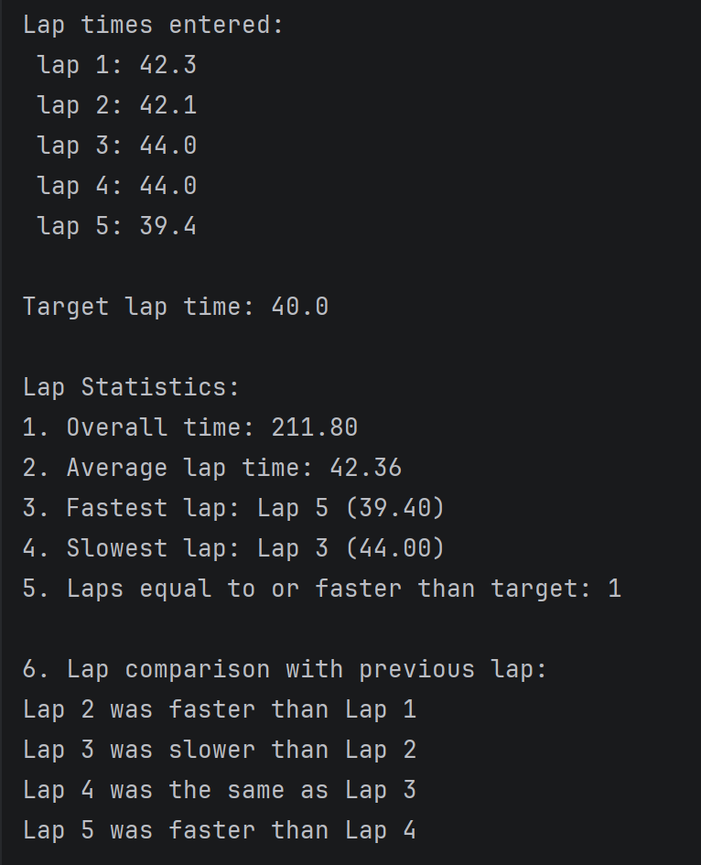
Result: Did the programme behave as expected ie syntactically and logically correct?
YES
The programme functioned as expected, with all the correct information/no errors.

Test: c) - Test two further sets of lap times of your own choice.

Screenshot(s) of output:
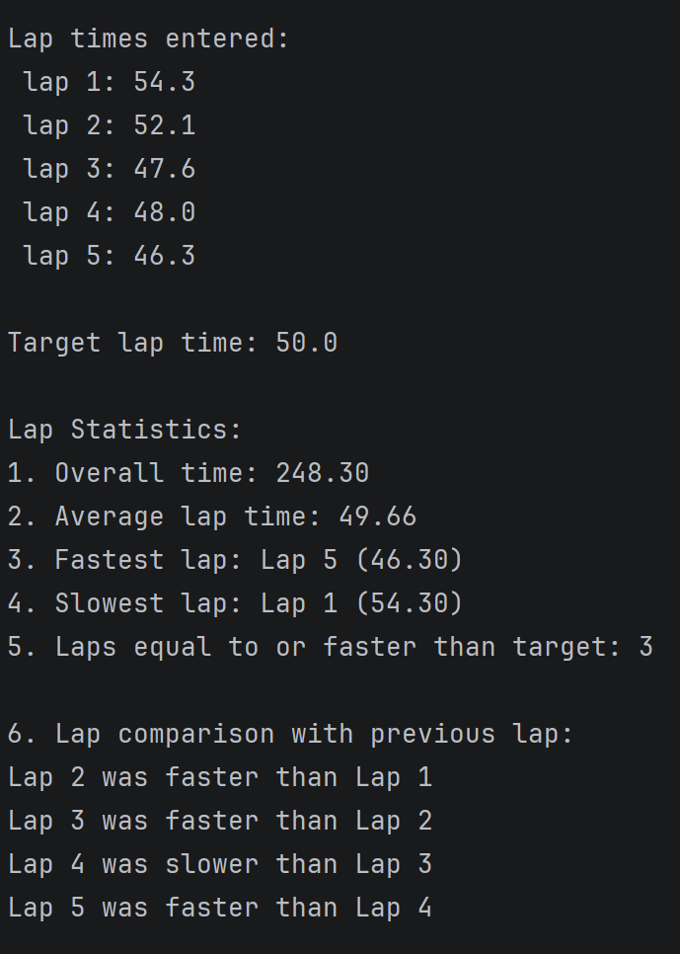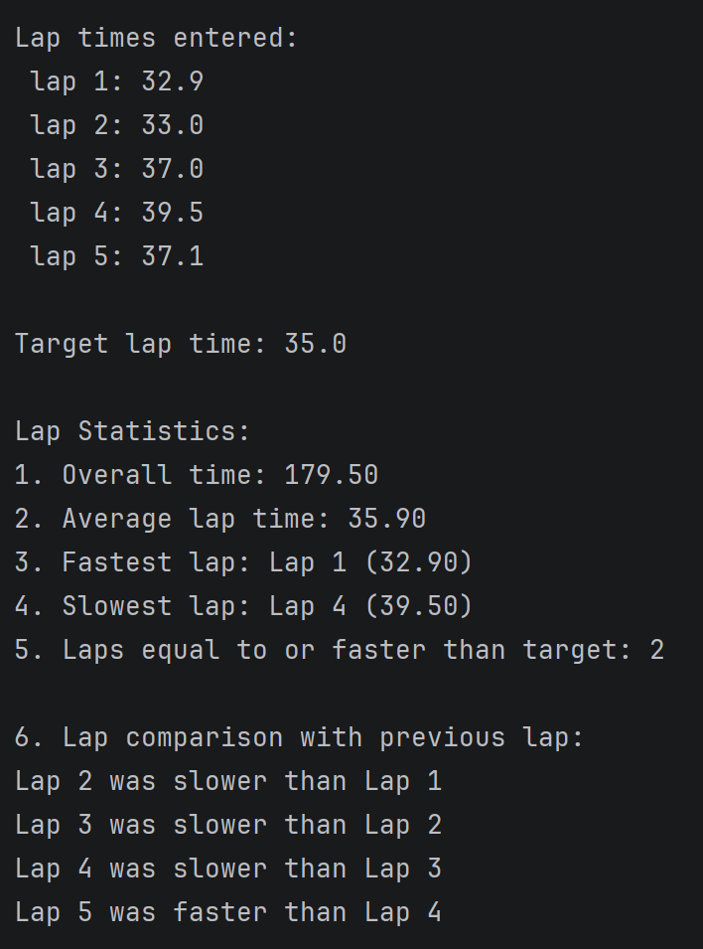
Result: Did the programme behave as expected ie syntactically and logically correct?
YES
The programme worked as expected, no errors, all information is correct.

- Consider the results of the above tests and revisit your original code in order to address any tests that failed and/or improve code efficiency.

(Note: you may not be able to solve all of the problems that were encountered, but solve as many as you can.)

Paste your full revised code here :

[Copy and paste your full revised code here – note, do not use a screenshot]
lap_times = []
for lap in range(1, 6):
while True:
try:
time = float(input(f"Enter the time for lap {lap}: "))
if 20 <= time <= 100:
lap_times.append(time)
break
else:
print("Error: Lap time must be between 20 and 100 seconds.")
except ValueError:
print("Error: Please enter a valid number.")
target_time = float(input("Enter your target time: "))
print("\nLap times entered:")
for i, time in enumerate(lap_times, start=1):
print(f"Lap {i}: {time}")
print(f"\nTarget lap time: {target_time}")
total_time = sum(lap_times)
average_time = total_time / len(lap_times)
fastest_time = min(lap_times)
fastest_lap = lap_times.index(fastest_time) + 1
slowest_time = max(lap_times)
slowest_lap = lap_times.index(slowest_time) + 1
laps_beating_target = 0
for time in lap_times:
if time <= target_time:
laps_beating_target += 1
print("\nLap Statistics:")
print(f"1. Overall time: {total_time:.2f}")
print(f"2. Average lap time: {average_time:.2f}")
print(f"3. Fastest lap: Lap {fastest_lap} ({fastest_time:.2f})")
print(f"4. Slowest lap: Lap {slowest_lap} ({slowest_time:.2f})")
print(f"5. Laps equal to or faster than target: {laps_beating_target}")
print("\n6. Lap comparison with previous lap:")
for i in range(1, len(lap_times)):
if lap_times[i] < lap_times[i - 1]:
print(f"Lap {i+1} was faster than Lap {i}")
elif lap_times[i] > lap_times[i - 1]:
print(f"Lap {i+1} was slower than Lap {i}")
else:
print(f"Lap {i+1} was the same as Lap {i}")

