BEng Advanced Manufacturing Operations



University of Wales Trinity Saint David

Stuart Jones

1909136

ACMA 6013

Independent Major Project

Proposal to introduce Lean Manufacturing
methods to the G7 Shell coatings process
at Zimmer Biomet Bridgend

MAY 2023

DECLARATION OF AUTHENTICITY

This dissertation is the result of the author’s original research. It has been composed by the author and has not been previously submitted for examination which has led to the award of a degree.

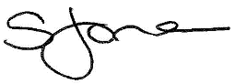
Signed: Date: 19th May 2023

ABSTRACT

OTIF (on time in full) is a supply chain KPI that measures a supplier’s ability to fulfil its delivery obligations; if the business fails to supply a product on time, it can result in the customer losing trust in the supplier.

In 2022, the Zimmer Biomet manufacturing facility in Bridgend achieved an OTIF result of 30% for the G7 shell product. The risk of a frequent low OTIF result could lead to healthcare trusts across the world losing faith in the business to supply its product with consistency, or even patients suffering extended pain due to delayed operations. The business has a moral responsibility to improve its internal processes to improve the G7 shell product OTIF result. Healthcare trusts around the world rely on these products being delivered on time and in full.

This report documents the investigation into the G7 shell OTIF result using the Six Sigma DMAIC methodology to evaluate and investigate the issue, analyse to establish root causes, and propose a well-researched proposal to improve the internal process, thus improving the OTIF result for the G7 product.

It was discovered that the G7 shell porous coating process was suffering from several lean wastes, impacting on the OTIF result and increased costs and lead times.

During the investigation and solution proposal, it was discovered that by increasing efficiencies in the process, further cost savings can be achieved in addition to improving the G7 shell OTIF result.

ACKNOWLEDGEMENTS

I wish to express my gratitude to Andrew Thorn for his assistance and guidance during the development of my dissertation. Additionally, I am grateful to Arnaud Marotin, Phil Holden, Richard Morgan, Gary Jones, Rob Goodson, and Chris Wyatt for imparting their knowledge and insights throughout my journey pursuing a BEng Degree at the University of Wales Trinity Saint David. Their invaluable advice and feedback have been immensely helpful.

Furthermore, I appreciate the support of my colleagues and managers at Zimmer Biomet Bridgend while I conducted my research. I am also thankful to the Continuous Improvement team for sharing their expertise and providing me with the necessary resources to complete my study. The cooperation and guidance of these professionals have been instrumental in completing my dissertation.

Lastly, but definitely not least, I extend my thanks to my wife, children, family, friends, and in particular my U10’s boys football team for their patience and understanding while I was occupied with my study; now I can return to coaching the lads again.

TABLE OF CONTENTS

DECLARATION OF AUTHENTICITY 2
ABSTRACT 3
ACKNOWLEDGEMENTS 4
CHAPTER 1: INTRODUCTION 9
1.1 PURPOSE OF STUDY 10
1.2 THE COMPANY 10
1.3 THE PRODUCT 11
1.4 RESEARCH NATURE 12
1.5 ORGANISATION OF STUDY 13
CHAPTER 2: LITERATURE REVIEW 14
2.1 LEAN 14
2.1.1 WHAT IS LEAN 14
2.1.2 HISTORY OF LEAN 15
2.1.3 WHY GO LEAN? 16
2.1.4 FIVE LEAN PRINCIPLES 17
2.2 LEAN TOOLS & TECHNIQUES 18
2.2.1 MUDA, MURI, and MURA 19
2.2.2 THE 7 WASTES OF LEAN 20
2.2.3 VALUE STREAM MAPPING 22
2.2.4 DMAIC METHODOLOGY 22
2.3 LINE BALANCING 25
2.3.1 BENEFITS OF LINE BALANCING 25
2.3.2 TAKT TIME 26
2.4 OTIF 27
2.5 KAIZEN 28
CHAPTER 3: THE MANUFACTURING PROCESS 29
3.1 THE MANUFACTURING PROCESS 29
3.3.1 ULTRASONIC WASH 29
3.3.2 POROUS COAT PREP & COATING OPERATION (VPS3) 30
3.3.3 CERAMIC BLAST & TRIM 31
3.3.4 WATERPICK 32
3.3.5 POLISH RIM & FACE 33
3.2 VALUE STREAM MAP 34
CHAPTER 4: DMAIC METHODOLOGY 36
4.1 DEFINE 36
4.1.1 PROBLEM STATEMENT 36
4.1.2 GOAL STATEMENT 36
4.1.3 SIPOC 37
4.1.4 PROCESS MAPPING 38
4.1.5 VOICE OF THE CUSTOMER (VOC) 38
4.1.6 PROJECT CHARTER 39
4.1.7 PROJECT PLAN 42
4.2 MEASURE 43
4.2.1 POROUS COATING PROCESS LAYOUT 43
4.2.2 PRODUCT TRANSPORTATION 45
4.2.3 SPAGHETTI DIAGRAM 46
4.2.4 DATA COLLECTION PLAN 48
4.2.5 OTIF 49
4.2.6 STEP COUNT 50
4.2.7 TAKT TIME 51
4.2.8 VALUE STREAM MAP 52
4.2.9 EQUIPMENT AVAILABILITY 53
4.3 ANALYSE 55
4.3.1 KAIZEN EVENT 55
4.3.2 FMEA 56
4.3.3 STEP COUNT ANALYSIS 56
4.3.4 OTIF ANALYSIS 58
4.3.5 TAKT TIME 60
4.3.6 ISHIKAWA DIAGRAM 62
4.3.7 5-WHY ANALYSIS 64
4.3.8 EQUIPMENT AVAILABILITY 65
4.3.9 MUDA (WASTES) 67
4.4 IMPROVE 69
4.4.1 BRAINSTORMING 69
4.4.2 FUTURE STATE FLOOR PLAN 70
4.4.3 FUTURE STATE STEP COUNT ANALYSIS 71
4.4.4 FUTURE STATE OTIF 74
4.4.5 FUTURE STATE VALUE STREAM MAP 75
4.4.6 PROPOSED BENEFITS 77
CHAPTER 5: CONCLUSION 79
5.1 FURTHER WORK 80
5.2 REFERENCES 81
5.3 APPENDICES 84

TABLE OF FIGURES

Figure 1 - Zimmer Biomet products (Zimmer Biomet, 2023) 10
Figure 2 - G7 Shell (Tesera Trabecular, 2022) 11
Figure 3 - Full Hip replacement assembly (Zimmer Biomet, 2016) 12
Figure 4 - Five Lean Principles (Womack & Jones, 2003) 18
Figure 5 - Seven Wastes (King, 2019) 21
Figure 6 - Examples of symbols used in a VSM (Hobbs, 2004) 22
Figure 7 - Define and Measure (Go Lean Six Sigma, n.d.) 24
Figure 8 - Analyse and Improve (Go Lean Six Sigma, n.d.) 24
Figure 9 – Control (Go Lean Six Sigma, n.d.) 24
Figure 10 - SAP Transaction 29
Figure 11 - G7 Shells before and after coating 30
Figure 12 - Schematic illustration of plasma spraying (Yang & Suo, 2019) 31
Figure 13 - Microscopic image of porous coating (Medicalexpo, 2022) 31
Figure 14 - Ceramic Bead Blast Shells 32
Figure 15 - polished rim/face 33
Figure 16 - G7 Shells VSM (Zimmer Biomet, 2019) 34
Figure 17 - G7 Shell VSM close-up 35
Figure 18 - SIPOC Diagram 37
Figure 19 - High level Process Flow 38
Figure 20 - Project Charter Summary (Thomas, 2023) 40
Figure 21 - Project Charter - Part A (Thomas, 2023) 41
Figure 22 - Project Plan 42
Figure 23 - Drawing of shopfloor (Zimmer Biomet, 2023) 44
Figure 24 - Transport trolley 45
Figure 25 - Spaghetti Diagram of Porous Process (Zimmer Biomet, 2023) 47
Figure 26 - Section of G7 Shell Value Stream Map 52
Figure 27 - Ultrasonic Wash 2022 availability (Thomas, 2023) 54
Figure 28 - VPS3 2022 availability (Thomas, 2023) 54
Figure 29 - Kaizen event photos 55
Figure 30 - Run Chart of 2022 OTIF data 59
Figure 31 - Ishikawa Diagram A (Template Lab, 2022) 62
Figure 32 - Ishikawa Diagram B (Template Lab, 2022) 63
Figure 33 - 5-Why Analysis diagram 64
Figure 34 - Availability data (Thomas, 2023) 65
Figure 35 - WIP at VPS3 during breakdown 66
Figure 36 - Second Kaizen event 69
Figure 37 - Proposed Floor Plan (Thomas, 2023) 70
Figure 38 - Routes inbetween workstations (Thomas, 2023) 71
Figure 39 - Future state VSM 75

LIST OF TABLES

Table 1 - Letters identifying workstations 46
Table 2 - Data Collection Plan 48
Table 3 - OTIF data for 2022 49
Table 4 - Batch transportation – current state 50
Table 5 - VSM process times 53
Table 6 - Porous Coating FMEA (Thomas, 2023) 56
Table 7 - Step count data 57
Table 8 - 2022 OTIF data 58
Table 9 – VSM bottleneck management 61
Table 10 - 7-Wastes comparison 67
Table 11 – batch transportation - future state 71
Table 12 - Current vs Future States 72
Table 13 - OTIF potential 74
Table 14 - Revised cycle time summary 76
Table 15 - VPS chamber cycle time 76
Table 16 - Summary of costs 78

LIST OF ABBREVIATIONS
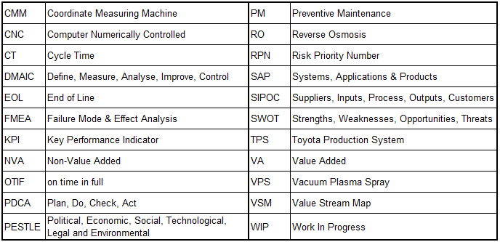

CHAPTER 1: INTRODUCTION

The productivity of a manufacturing system can be characterised as the amount of work that can be accomplished per unit time using the available resources. Production lead time and line capacity, number of value added (VA) and non-value added (NVA) activities, operator motion distances and line configuration, material handling, along with the throughput and utilisation rate, define the performance of a production process. By optimising all these factors, a production line can achieve its optimal performance (Womack & Jones, 2003).

Lean manufacturing is a production method that strives to boost efficiency by creating flow, minimising waste, and augments profitability. This comprehensive methodology promotes teamwork and cooperation, emphasising continuous improvement at every level of the organisation. Many prosperous companies have implemented lean manufacturing to streamline their operations, increase productivity, and improve customer satisfaction
(Womack & Jones, 2003).

The origins of lean manufacturing can be traced back to the Toyota Production System (TPS), which was developed by Toyota in the 1950s. The TPS aimed to eliminate waste and enhance efficiency by concentrating on continuous improvement and removing non-value-added activities. Over time, the principles of the TPS have been customised and implemented by corporations globally, resulting in the evolution of modern-day lean manufacturing (Hobbs, 2004).

By understanding and incorporating the principles of lean manufacturing, waste can be systematically and consistently eliminated at every level of a production system. This can result in a more efficient and effective production process that benefits all stakeholders within a company.

1.1 PURPOSE OF STUDY

To improve the company OTIF result for the G7 shell product by reviewing the porous coating process for potential improvements. Researching lean manufacturing material to aid in the analysis of process wastes, and propose improvements based on lean manufacturing principles to improve the G7 shell OTIF result.

To enhance the efficiency of the G7 shell porous coating process by reviewing the current production model, and propose efficiency gains to improve on costs.

1.2 THE COMPANY

Zimmer Biomet is a large global enterprise that supplies healthcare industries worldwide. Zimmer was founded in 1927, and Biomet (a separate company) was founded in 1977; the two American companies merged to become Zimmer Biomet in 2015.

For over 40 years the business has operated a manufacturing facility in Bridgend, South Wales, producing premium medical device implants for healthcare trusts located in many countries across the world. They employ approximately 600 people at the facility, whom all contribute to the manufacture of products that are of the highest calibre in terms of performance, safety, and dependability.

The facility produces medical device implants for the human musculoskeletal system; their main products are the Taperloc Stem, G7 Acetabular shell, Oxford Partial Knee, and Vanguard full knee implants. Image of the main products in figure 1.

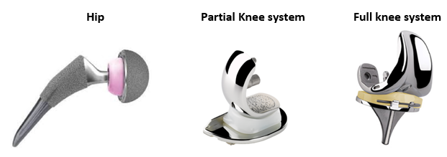
Figure 1 - Zimmer Biomet products (Zimmer Biomet, 2023)

1.3 THE PRODUCT

The scope of this study focuses principally on the G7 Acetabular Shell, which is a component of the assembled hip replacement product. The Taperloc Stem and knee products are NOT in the scope of this study.

The G7® ACETABULAR SHELL

“The G7 acetabular system is specifically designed to simplify implant and instrument delivery for optimized operative efficiency and maximized clinical performance. The interchangeability of the system enables you to use any liner with any shell, with consistent sizes throughout the system while providing offerings that cover the full continuum of constraint. The G7 shell maximizes treatment options through a highly flexible, system-based approach to patient specific hip replacement”. (Zimmer Biomet, 2023).

The facility in Bridgend produces approximately 4,000 G7 Shells each week, and supply them to health trusts across the globe, including the Princess of Wales Hospital in Bridgend.

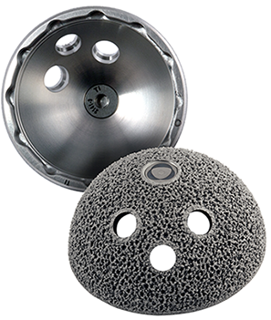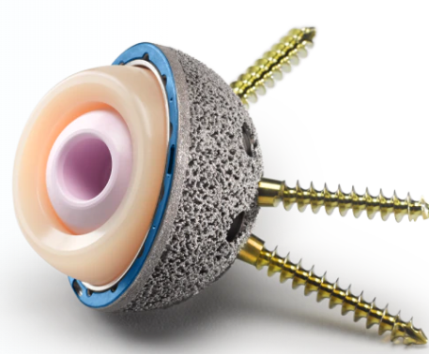
Figure 2 - G7 Shell (Tesera Trabecular, 2022)

Figure 3 overleaf shows the shell located in the pelvic bone when implanted with the full hip replacement product.

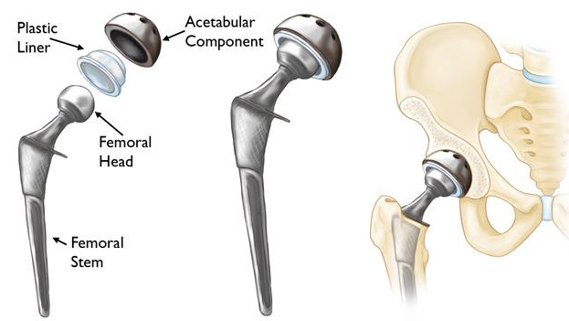
Figure 3 - Full Hip replacement assembly (Zimmer Biomet, 2016)

1.4 RESEARCH NATURE

Qualitative research definition
“Qualitative research is a means for exploring and understanding the meaning individuals ascribe to a social or human problem. The process of research involves emerging questions and procedures, data typically collected in the participant’s setting, data analysis inductively building from particulars to general themes, and the researcher making interpretations of the meaning of the data” (Creswell & Creswell, 2017).

Quantitative research definition
“Quantitative research is a means for testing objective theories by examining the relationship among variables. These variables, in turn, can be measured so that numbered data can be analysed using statistical procedures. The final written report has a set structure consisting of introduction, literature and theory, methods, results and discussion.”
(Creswell & Creswell, 2017)

For this project, the nature of the research is quantitative; almost everything can be measured directly by going on the shop floor. The purpose of this dissertation is to review the data of the existing process, and see how implementing Lean techniques can improve lead times, OTIF and remove waste from the process.

1.5 ORGANISATION OF STUDY

This dissertation is organised into five chapters; each chapter plays a vital role in presenting the study:

- The first chapter provides an introduction to the report.
- The second chapter is the literature review that explores the idea about the history of lean, lean principles and line balancing.
- The third chapter describes the manufacturing process in detail.
- The fourth chapter details the DMAIC methodology that was used is this study.
- The fifth chapter presents the conclusions, further work, references and appendices.

CHAPTER 2: LITERATURE REVIEW

This literature review will analyse relevant literature on the topic of Lean Manufacturing, Lean Principles, and line balancing, to identify key themes that can be applied to the case study.

2.1 LEAN

2.1.1 WHAT IS LEAN

Lean, known by various names such as Lean Management, Lean Manufacturing, Lean Enterprise, or Lean Production, encompasses a robust collection of tools and techniques utilized by numerous companies to enhance production efficiency, customer value, and waste elimination. The importance of creating an organised production system based on lean manufacturing is enormous (Drew, et al., 2004).

Lean is anything not contributing value, but instead raises a company's expenses is waste. In Lean management, the following seven wastes are typically listed: waiting, transit, overproduction, inventory, movement, over-processing, and rework. Lean is a concept that is frequently used in manufacturing and supply chain management, but it can be applied to any industry organisation (King, 2019).

(Womack & Jones, 2003) cite the main points of lean manufacturing are:

• Eliminate waste in the production process
• Build quality into the production process
• Reduce costs.
• Create and formulate tools that will add value to the organisation’s functional performance.

The introduction of lean thinking in business is composed of five discrete phases that form a continuous process since lean embeds the notion of continuous improvement:

1. Analysing and documenting the current process and measuring performance.
2. Accurately defining value and the value stream network.
3. Identifying undesirable effects, suggesting changes to eliminate source of these effects.
4. Applying recommended changes.
5. Measure the achieved performance.

These 5 phases are discussed in greater detail in section 2.4 Five Lean Principles.

2.1.2 HISTORY OF LEAN

In their book The Machine That Changed The World (1990), Womack, Jones & Roos explain that the idea of Lean Management can be traced as far back in history as the industrial revolution when machines, operating with greater efficiency, began replacing humans.

One of the most famous Lean concepts is the assembly line, which was pioneered by Henry Ford. He, devised a model for mass production that simplified the process of car manufacturing, replacing individual production with a more efficient assembly line. This eliminated wastes such as time, resources, and space associated with individual production. However, this system lacked variety in the cars manufactured by Henry Ford.
(Womack, et al., 1990).

Meanwhile, in Japan, the Toyota Company was founded at a time when General Motors and Ford were leading the automobile field. The second World War caused some disruption in the Toyota production system and there was economic hardship post war as inventories of unsold cars increased (Womack, et al., 1990)

Toyota initiated a cost management-focused manufacturing system that eventually evolved into targeting and eliminating all forms of waste. This innovative approach led to Toyota being recognised as the birthplace of lean manufacturing (Hobbs, 2004).

In 1988 Krafcik was the first to use the term Lean production, and later, Womack, Jones & Roos used the term in their book The Machine That Changed the World to compare Toyota's approach to the Western mass production system. The term Lean originated from this contrast (Bicheno & Holweg, 2016).

2.1.3 WHY GO LEAN?

Improved quality
The lean process uses problem-solving techniques to enhance the production process and gradually eliminate defects, thus improving the quality of the product.

Faster delivery times
The application of just-in-time and pull principles results in production orders being executed as needed, leading to faster delivery to customers and a reduction in lead time.

Improved visual management
Lean Management improves management by implementing visual controls in the manufacturing process, which enables easy identification of any problems that may arise.

Improved efficiency of human resources
Increase workers skill set and involvement in the production process, resulting in greater productivity and requiring fewer workers to accomplish the same amount of work.

Easier to manage work areas
Standardised work instructions make it easier for workers to understand their tasks and the expected timelines, resulting in more efficient management of a work area.

Problem elimination
Lean manufacturing employs a root cause analysis approach that involves a cross-functional team investigating a problem until it is fully resolved.

Increased space utilisation
By optimising floor planning, streamlining processes, and lowering inventory, more space can be used for parts storage.

Safer work environment
A Lean process results in a more organised work environment by removing unnecessary elements, thereby contributing to a safer workplace.
(Tsigkas, 2013)

2.1.4 FIVE LEAN PRINCIPLES

Ptack, et al. (2015) define Lean as ‘A never-ending, systematic approach for identifying and eliminating wastes and improving flow of a process while engaging employees’.

While Lean was initially implemented in the manufacturing industry, its principles can be applied to any industry. Lean's primary objective is to enhance the quality of products and services provided to customers since "the customer determines the value and price they are willing to pay for the product or service." (Ptacek, et al., 2015).

Lean thinking can be summarised in five principles: specify value by specific product, identify the value stream for each product, make value flow without interruptions, let the customer pull the value from the producer, and pursue perfection.
(Womack & Jones, 2003).

Identify Value
The customer is the only one who can define value, and it only makes sense when a particular product meets their needs at a specific price and time. Therefore, Lean thinking begins with a deliberate effort to accurately determine value through communication with customers regarding specific products with specific features, offered at specific prices. (Womack & Jones, 2003).

Map Value Stream
The value stream mapping encompasses all activities involved in producing a product or service from beginning to end. It is to identify the entire value stream, which will unveil three types of actions taking place along the value stream: steps that create value, steps that add no value but are necessary, and steps that add no value and are avoidable.
(Womack & Jones, 2003).

Create Flow
To establish flow by making the remaining value-adding steps flow smoothly. To achieve this, the producer should review both the work-in-progress and work-in-process, examine the queue times where batches might pause for the subsequent step in the process, identify any obstructions in the process, and track and analyse lead times (Womack & Jones, 2003).

Establish Pull
Instead of pushing products onto the customer, Lean Thinking involves letting the customer pull the products as needed. This helps stabilise customer demands as they can get what they want right away, without the producer overproducing and having to sell unwanted products at reduced rates (Womack & Jones, 2003).

Seek Perfection
Only after the first four principles have been successfully applied can the fifth and concluding Lean Thinking principle be applied. As producers delve deeper and deeper into the first four principles, they will discover that there is no end to the process of reducing waste, time, effort, expense, and scrap/rework (Womack & Jones, 2003).

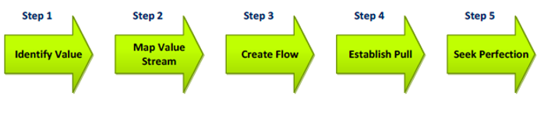
Figure 4 - Five Lean Principles (Womack & Jones, 2003)

2.2 LEAN TOOLS & TECHNIQUES

Some companies begin their Lean journey by perceiving it merely as a collection of tools to execute. Occasionally, these tools are employed independently, however this approach may be advantageous for a certain period, it is insufficient in the long run.
(Bicheno & Holweg, 2016).

The Lean tool and techniques are, however, the backbone of Lean management and the most common tools that are implemented are explained in this chapter.

2.2.1 MUDA, MURI, and MURA

During the development of Lean by Toyota, three Japanese words, Muda, Muri, and Mura, were frequently used. Muda refers to waste, which was further classified into seven types of waste by Taiichi Ohno in the Toyota Production System. Muri means overburden, while Mura means unevenness. Understanding these three concepts is essential for a comprehensive understanding of Lean (Liker, 2004).

Muri (overburden)
When workers and machines are overloaded it can be considered a waste, pushing machines beyond their limits can cause them to break down. Overloading people and machines can also lead to queues and missed targets. Workers should not be overloaded with work as it can lead to stress and potential injury (Liker, 2004).

Mura (unevenness)
Employ methods to enhance overall production consistency, such as urging suppliers/customers to order and manufacture uniformly, which can benefit both parties.
The occurrence of wastes within a company can stem from Mura, which can trigger further unevenness, leading to a vicious cycle that requires prompt resolution (Liker, 2004).

Muda (waste)
Muda refers to any task that utilises resources but does not add value to the end consumer. Only a small fraction of the work process generates value for customers, while the rest is wasteful. However, not all non-value adding activities can be eliminated from the workflow as some are necessary (Liker, 2004). There are two major types of ‘non value added’ wastes:

Necessary waste
This type of waste is usually necessary to get things done in a quality manner. Such activities can be testing, planning, reporting, etc. (Liker, 2004).

Unnecessary waste
Anything that doesn’t bring value and can be removed from the process immediately. Any form of waiting (known as "waiting waste") can be described as unnecessary waste
(Liker, 2004).

2.2.2 THE 7 WASTES OF LEAN

Eliminating waste through process optimisation is essential for success. Wasteful activities can cause reduced profitability, higher customer expenses, lower quality standards, and even decreased employee satisfaction. Hence, it is crucial to identify non-value adding tasks and strive to enhance the relevant processes or remove them entirely (King, 2019).

Overproduction
Overproduction results in surpassing customer demand, thereby incurring additional expenses. In fact, overproduction leads to the emergence of the other six wastes. This is due to the fact that excessive products or tasks necessitate extra transportation, unwarranted movements, extended wait times, and so forth (Kanbanzie.com, 2023).

Waiting
This is perhaps the most straightforward waste to identify. It occurs when goods or tasks are at a standstill, leading to lost time, which is the most conspicuous sign of this waste. Some instances of waiting waste include goods awaiting delivery, equipment awaiting repair, or a document awaiting approval from executives (Kanbanzie.com, 2023).

Transportation
This form of waste occurs when materials are relocated without contributing value to the end product. Excessive material movement can incur significant expenses for your business and compromise product quality (Kanbanzie.com, 2023).

Over-processing
This waste usually entails performing work that does not generate added value or adds more value than necessary. Such tasks might include incorporating supplementary features into a product that nobody utilises. Over-processing increases the final product cost for something that customers are unwilling to pay for (Kanbanzie.com, 2023).

Inventory
Accumulating excessive inventory due to the practice of holding "just in case" inventories. This approach involves overstocking to cope with unexpected demand, production delays, poor quality, and other issues. However, such excessive inventory does not add value, instead, it increases storage and depreciation expenses (Kanbanzie.com, 2023).

Motion
This waste type pertains to employee movements that are unnecessary. Such movements can result in injuries, prolonged production time, and other issues. The objective is to devise a process that minimises the amount of work employees need to perform to complete their tasks. (Kanbanzie.com, 2023).

Defects
Defects can result in rework and scrap. Typically, defective work needs to be returned to production, incurring significant time costs. Furthermore, additional reworking may be necessary, requiring further use of labour and equipment (Kanbanzie.com, 2023).

Figure 5 summarises the 7 wastes in one table. These wastes, if left unchallenged, are toxic to any manufacturing process. However, there exists many opportunities to improve work processes and, most importantly, optimise resources.

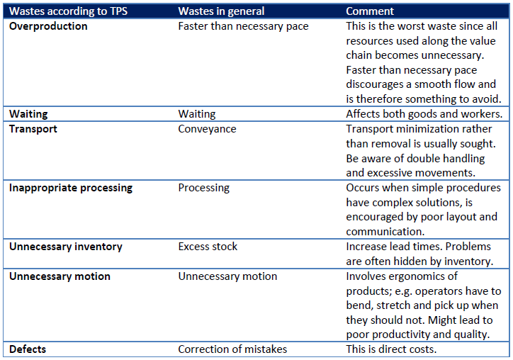
Figure 5 - Seven Wastes (King, 2019)

2.2.3 VALUE STREAM MAPPING

Value Stream Mapping (VSM) is a visual tool for improvement that involves creating maps to depict the Current State and Future State of a company. It is crucial that the mapping process results in action, or else it will be considered wasteful (Womack & Jones, 2003).

The goal of utilising VSM is to recognise the processes that contribute, or do not contribute value, to the final product. It involves defining the flow of information and materials of a product, and documenting the connections between them. The tasks within these connections are then categorised into those that add value and those that do not. The future state map is created based solely on the value-adding tasks. Non-value-adding tasks are evaluated for potential elimination (Bicheno & Holweg, 2016).

To conduct value stream mapping, a team is assembled and dedicated to the task for a specified period. Using simple tools such as Post-It notes to record all the processes involved in producing a product, which are then posted on a wall. After identifying all the processes, the team separates and posts the value-adding tasks on another part of the wall to distinguish them from non-value-adding tasks. The team will rearrange the notes based on their value-adding status. The value-adding tasks are then used to create a future state map while the non-value-adding tasks are targeted for elimination (Hobbs, 2004).

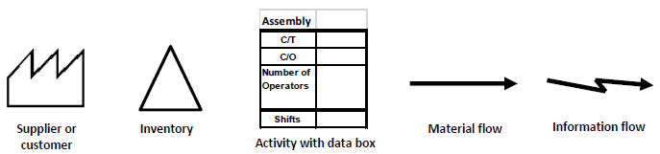
Figure 6 - Examples of symbols used in a VSM (Hobbs, 2004)

2.2.4 DMAIC METHODOLOGY

(Ptacek, et al., 2015) explain that the Six Sigma methodology uses a variation of PDCA known as DMAIC. However unlike PDCA, DMAIC has expanded on the ‘Plan’ stage, which is often viewed as the critical stage of the process.

Define
Leaders of a DMAIC project will identify a process in need of improvement and establish a Project Charter, which outlines the project's scope and provides a clear perspective on the process. This phase also aids the project team in comprehending the process's customers and their requirements (Go Lean Six Sigma, n.d.).

Measure
The existing state of the process is determined without implementing any modifications. This current state, also known as the baseline, serves as the benchmark against which any improvement measures will be evaluated. Additionally, during this phase, the project team initiates efforts to uncover the root cause of the process problems (Go Lean Six Sigma, n.d.).

Analyse
This phase is commonly associated with the measure phase, where the project team analyses the information gathered from the measure phase. They may also adjust their data collection by including additional data as they extract insights from the Measure phase. The primary objective is to identify the root cause of waste and defects in the process based on the data collected (Go Lean Six Sigma, n.d.).

Improve
After identifying the root cause of the problems, the team can initiate the elimination of waste or repair of machines responsible for defects. The team engages in a brainstorming session to determine the most suitable solution to implement. It is crucial for the proposed solution to demonstrate measurable improvement when compared to the data collected during the Measure phase (Go Lean Six Sigma, n.d.).

Control
Control entails maintaining the implemented solution(s) within the process. The project team finalises their documentation and communicates the changes made to the workers involved, providing instructions on how to sustain them. Given that DMAIC is an iterative improvement cycle, it is crucial to establish continuity, as continuous improvement lies at the heart of Lean principles (Go Lean Six Sigma, n.d.).

Figures 7-11 overleaf summarise the 5 steps of DMAIC which include some valuable points on how to execute each phase successfully.
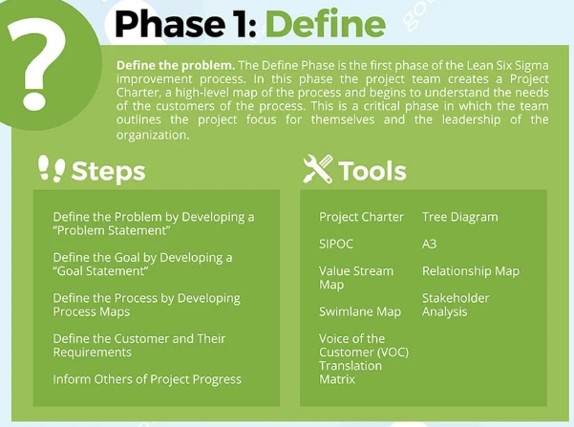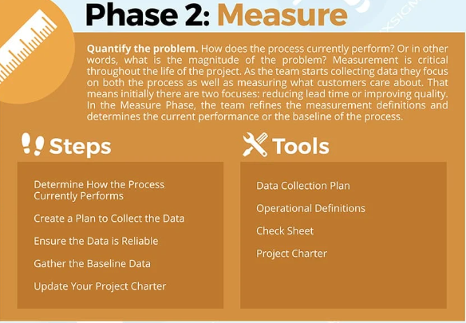
Figure 7 - Define and Measure (Go Lean Six Sigma, n.d.)

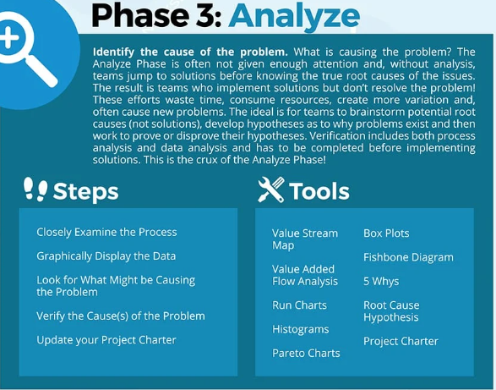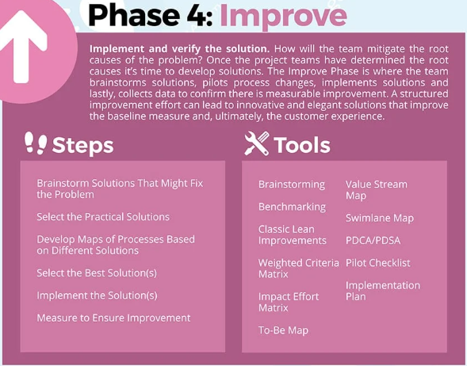
Figure 8 - Analyse and Improve (Go Lean Six Sigma, n.d.)

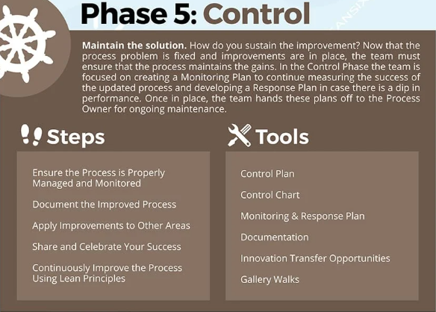
Figure 9 – Control (Go Lean Six Sigma, n.d.)

2.3 LINE BALANCING

Line balancing as a production strategy that involves balancing operator and machine time to match the production rate to the takt time. Takt time is the rate at which parts or products must be produced in order to meet customer demand (Thomopoulos, 2014).

If the production time of a specific line does not match the takt time, the line is not perfectly balanced. In this case, resources should be reassigned or reorganised to eliminate bottlenecks or surplus capacity. This means that the number of workers and machines assigned to each task in the line should be reallocated to achieve the optimal production rate. By enhancing the efficiency of their production lines, companies can minimise Lean manufacturing wastes and create additional value (Hyer & Wemmerlov, 2002).

2.3.1 BENEFITS OF LINE BALANCING

Reduce waiting waste
Waiting waste is one of the 7 forms of waste in Lean manufacturing, it pertains to any instance of idle time that arises from unsynchronised operations, such as operators waiting for another person to finish their work. Line balancing aims to achieve a balanced workflow among all operators and machines (Chow, 1990).

Reduce inventory waste
Inventory waste is another category of waste in Lean manufacturing, which arises from an excessive accumulation of raw materials, work in progress, or finished goods. This type of waste signals an inefficient allocation of capital. Line balancing can aid in preventing the build-up of excess inventory by standardising production (Chow, 1990).

Absorb internal and external irregularities
A balanced production line reduces variations within the production process, fostering stability and flexibility to adjust to changes. With line balancing, it is possible to quickly reorganise operations in response to alterations in customer demand or takt time, and adjustments to the production rate can be easily implemented (Chow, 1990).

Reduce production costs and increase profits
Achieving perfect line balancing enables operators and machines to work in complete synchronisation, eliminating idle time and optimising their capacity. As a result, no operator is paid for being idle, and all machines are utilised to their full potential, maximising both manpower and machine capacity (Chow, 1990).

2.3.2 TAKT TIME

Takt time derives from the German word Taktzeit and translates to either measure, cycle or pulse time (Thomopoulos, 2014). The term refers to the amount of time a manufacturer has per unit to produce enough goods to fulfil customer demand; it is an essential tool in ensuring that goods flow through each build station in the most efficient manner.

The equation used to calculate takt time:

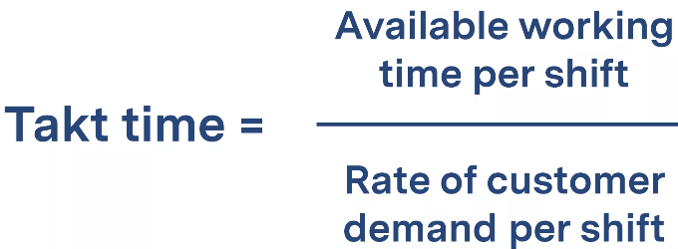

(Thomopoulos, 2014)

Example:

8hr shift x 60 minutes = 480 minutes/shift.

Remove breaks and end-of-shift clean down from the "available" time, leaves us with 410 minutes/shift. Customer requires supplier to produce 100 units per day, so:

Takt time = 410 minutes = 4.1 minutes
100

This means a completed unit must be finished every 4.1 minutes or there is a risk the manufacturer will not meet their customer's demand. Of course, a manufacturer should seek to produce in less time, 4.1 minutes is not a target, it is a limit.

Collect process data
Next, determine how long operators and machines spend on each part of a process, collect all data points about the time required to complete each task along a production line.

Identify process bottlenecks and excess capacity
Process bottlenecks: these are the steps that exceed takt time.
Excess capacity: process steps that take less than takt time.

Optimise process sequences and reassign resources
Move workers and equipment from parts of the production line with excess capacity to areas where bottlenecks have been identified. This will eliminate waiting waste and improve production flow. Distribute activities among operators in the most efficient way to synchronise their workloads. (Thomopoulos, 2014)

2.4 OTIF

What is OTIF? (Waters, 2021) explains: “OTIF, on time in full, measures a supplier’s ability to fulfill its delivery promises, meaning a customer receives exactly what was ordered, in the amount requested, at the correct location, and within the agreed upon timeframe.”

The formulas for the OTIF elements:
- On time in full = number of batches matching the criteria / total number of batches.
- On time = actual delivery time - expected delivery time.
- In full = actual delivered amount - expected delivered amount.
(Waters, 2021)

A poor OTIF score can be problematic for the supplier, a low OTIF score could lead to OTIF fines, unhappy customers, reputational damage, and possibly an impact of profits.

2.5 KAIZEN

The practice of continuous improvement is commonly associated with the term Kaizen within lean manufacturing. Kaizen, derived from the Sino-Japanese word meaning "change for better," originated as an approach to manufacturing developed and refined by Japanese manufacturers during the 1960s and 1970s. This approach played a significant role in the worldwide success of Japanese manufacturers and their renowned reputation for quality.
(Miller, et al., 2014).

Why is Kaizen of interest to lean manufacturers? The phrase lean manufacturing defines an approach to manufacturing that focuses on eliminating waste and also improving and focusing on quality. (Miller, et al., 2014).

Kaizen Events
Kaizen events are typically designated for addressing persistent manufacturing or workflow issues. These events involve a collaborative effort between managers and workers to analyse a known problem within the manufacturing process and generate potential solutions.
(Kato & Smalley, 2015)

CHAPTER 3: THE MANUFACTURING PROCESS

3.1 THE MANUFACTURING PROCESS

The Bridgend manufacturing process at Bridgend is divided into three areas:

- CNC machining: Converting a forged or cast raw material into an intermediate product;
- Porous Coating: Applying a porous coat via a Vacuum Plasma Spray chamber;
- End of Line: inspecting the final product, pack and seal, box, label, ship/export.

Figure 10 below is a screenshot from SAP of the G7 shell manufacturing route, the porous coating section (the scope of this study) is highlighted in the red box.

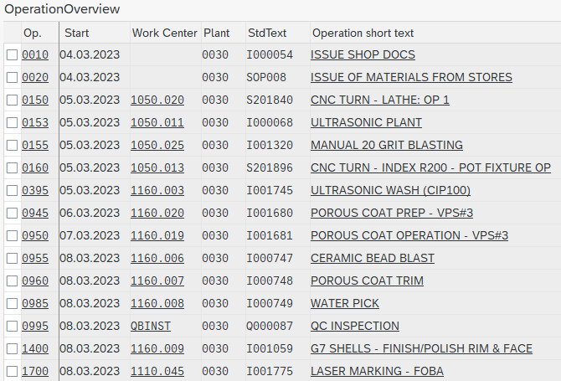
Figure 10 - SAP Transaction (SAP, 2023)

3.3.1 ULTRASONIC WASH

Following the CNC process, the G7 shell will go through an 8-minute wash cycle in the Ultrasonic Wash. The machine compromises of 2 water tanks, the first tank is an ultrasonic bath which contains a concentration of CIP100 detergent. This tank cleans the product, removing any coolant or oil residue from the CNC machine. The second tank is a simple rinse tank and contains purified water supplied from the RO water plant (Reverse Osmosis).

3.3.2 POROUS COAT PREP & COATING OPERATION (VPS3)

Before coating, the parts are ‘prepped’ for the chamber as there are sections of the G7 shells that aren’t coated with titanium powder in the VPS chamber. The operator will prep the G7 shells ready for coating by fitting rubber bungs to the shell to protect the areas that are not coated. Once prepped, the shells go into the Vacuum Plasma Spray chamber where titanium powder is sprayed onto the external surface of the G7 shell via a plasma spraying process.

The spraying process is fully automated and lasts approximately 3 hours and is commonly known as ‘a run’, 144 shells will be coated in one run.

BEFORE AFTER
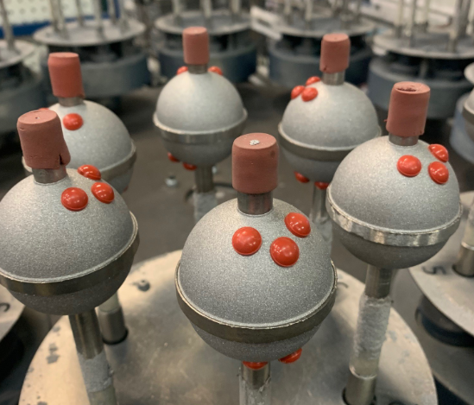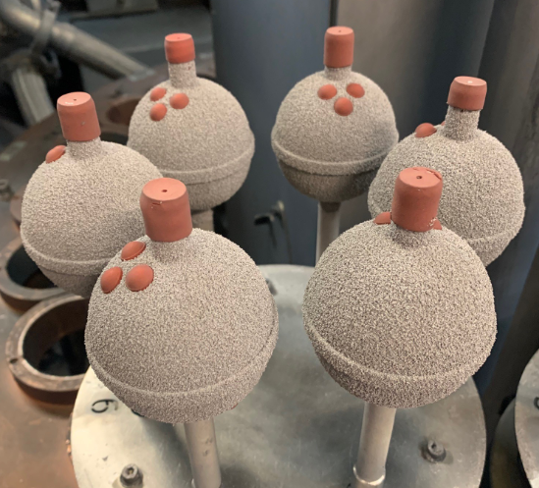
Figure 11 - G7 Shells before and after coating

Plasma spraying is a versatile process that can deposit coatings of various material types such as metals, ceramics, and composites. The deposition process is shown in figure 16 below, which depicts a typical plasma spray gun. The process involves introducing feedstock powder into a plasma stream, which then forms molten or semi molten particles. These particles are projected onto a substrate, flattened, rapidly solidified, and cooled, resulting in overlapping splats that coat the substrate.

Plasma spraying can be carried out in air, low pressure, or vacuum. Due to the presence of multiple pores or cracks, plasma-sprayed coatings have unique porous structures. This highly cost-effective process is widely used to create protective coatings that offer wear, corrosion, and heat resistance (Yang & Suo, 2019).

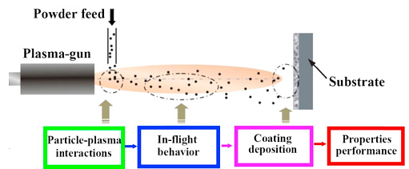
Figure 12 - Schematic illustration of plasma spraying (Yang & Suo, 2019)

According to the website (Medicalexpo, 2022): ”applying a porous coating consisting of a layer of commercially pure titanium, deposited through Vacuum Plasma Spray technique (VPS), offers a high friction coefficient for enhanced initial stability, and long term fixation thanks to an optimised porosity” Microscopic image of the porous coating below.

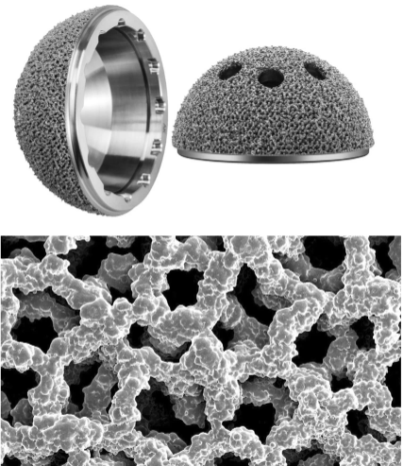
Figure 13 - Microscopic image of porous coating (Medicalexpo, 2022)

3.3.3 CERAMIC BLAST & TRIM

Although separate on the SAP route, the same operator will perform both the ceramic bead blast and trim operations. The operator will ceramic bead blast the shells by placing the G7 shell in a blasting cabinet and introduce into a flow of ceramic bead blast media to the porous coating surface.

The purpose of ceramic bead blasting the porous coating is to remove any loose titanium fragments that haven’t adhered to the shell surface, and also to smoothen the porous coating surface, as the coating needs refining after the VPS process. Figure 14 illustrates what the shell coating looks before and after ceramic bead blasting. Shell on the left is prior to bead blasting, the coating is rougher. Shell on the right is post bead blasting, the coating imperfections have been removed by the blasting process.

BEFORE AFTER
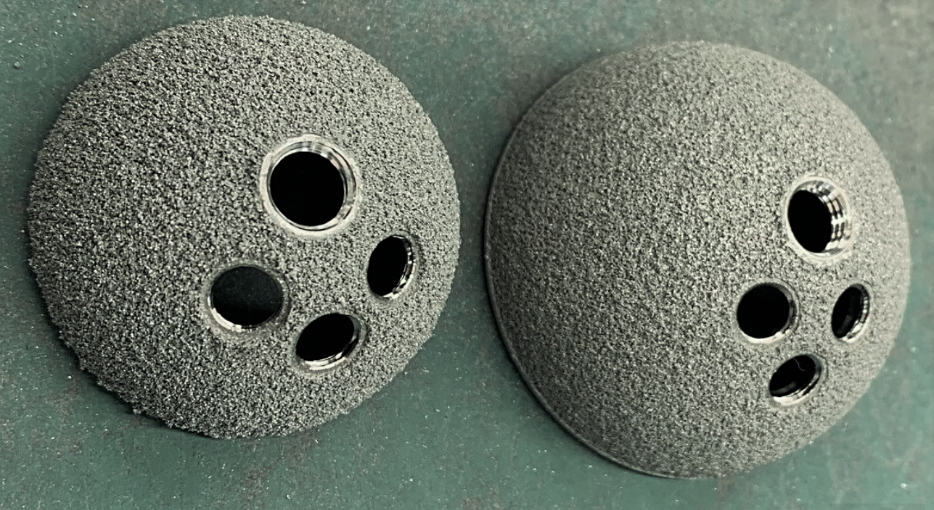
Figure 14 - Ceramic Bead Blast Shells

The Shells then proceed to a work bench to begin the process of removing the tape and bungs that were applied during the prep stage before coating. This is known as the Porous Coat Trim stage.

During the trim stage, the operator will strip the shells of all rubber bungs. Then the operator will tentatively run a stainless-steel blade over the porous coated surface to again attempt to remove any loose titanium fragments, and smooth over any anomalies the bead blasting process may have missed. Once completed, the shells will advance to the next process.

3.3.4 WATERPICK

The purpose of water-picking the porous coated shells is to clean the product through pressurised flow, as opposed to cleaning through submersion. Even though the Waterpick is conducted in a standard blasting cabinet, the process does not alter the surface of the coating like a blast media would (Raptor Blaster, 2023).
The operator will place the shells in a blasting cabinet and operate a hose-style gun to direct a flow of low-pressure clean water over the shell surface. Once completed, the shells are placed into an oven set at 40ºc - 60ºc to dry, then moved to the next stage of the process, the CMM room.

3.3.5 POLISH RIM & FACE

The shell surface needs to be smooth and free of any imperfections, so the operator will polish the face of each shell to remove scratches picked up in the porous coating process. The shell face is tentatively introduced to a rotating disc which polishes the face, leaving the shell with a smooth and mirror-like finish, ready for anodising.

Examples in figure 15 below depicts a shell prior to polishing (left shell), and the right-hand shell is post polishing. Visual scratches on the rim of the left shell are present, which will be removed by the polishing process. After polishing, the shells proceed to End Of Line.

BEFORE AFTER
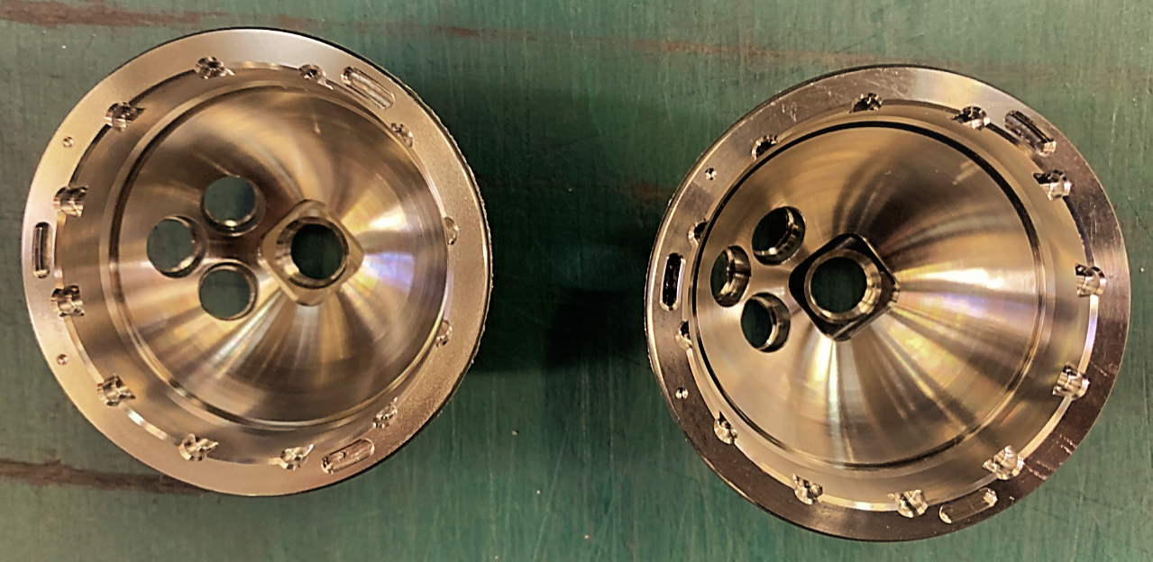
Figure 15 - polished rim/face

3.2 VALUE STREAM MAP

Value stream mapping (VSM) is a tool used to visualise and analyse the flow of materials required to bring a product from its initial creation to its delivery to the customer. It helps identify and eliminate waste, reduce lead times, and improve overall process efficiency (Hobbs, 2004).

The process involves creating a map of the current state of the value stream, including all the steps involved in the process, the lead times, and the bottlenecks. By doing this, organisations can gain a better understanding of their processes and identify areas for improvement, leading to increased efficiency, better quality, and ultimately, improved customer satisfaction.

Figure 16 below is the VSM for the G7 shell product, from CNC machining through to the last Coating operation Polishing. It then goes to the Internal Customer; End Of Line.

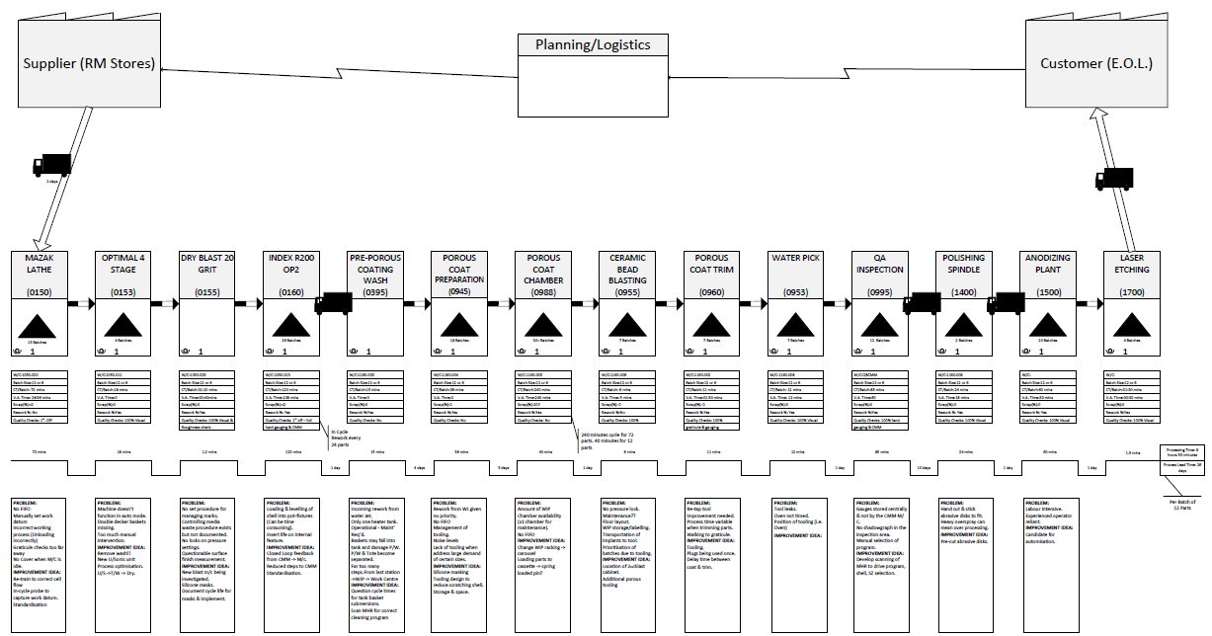
Figure 16 - G7 Shells VSM (Zimmer Biomet, 2019)

For illustrative purposes, figure 17 overleaf is a close-up of the G7 Shell VSM.

Figure 17 - G7 Shell VSM close-up

CHAPTER 4: DMAIC METHODOLOGY

4.1 DEFINE

The DMAIC process starts by defining the problem using tools and techniques outlined in the literature review.

4.1.1 PROBLEM STATEMENT

In 2022, the Bridgend OTIF (on time in full) result for the manufacture and supply of G7 Shell product averaged 30%.

The 2022 OTIF data revealed that the score failed on the ‘On Time’ part of the calculation, there were no concerns with the ‘In Full’ part of the calculation. The site metric is affected by batch management through the G7 shell porous coating process; the cell harbours high WIP levels and is haemorrhaging waste. Poor flow through the G7 shell area is creating higher inventory levels, cultivating increased lead times and impacting on the OTIF result.

4.1.2 GOAL STATEMENT

The goal of this study is to improve the company OTIF score and reduce process wastes by optimising the productivity of the G7 shell porous coating process. Following a literature review of lean manufacturing and a full review of the current process, improvement initiatives based on lean manufacturing principles and supporting data will be proposed.

4.1.3 SIPOC

A SIPOC diagram is a high-level process map that illustrates the complete process in 6-8 steps or less. The diagram identifies the required inputs for the process to function and the suppliers of these inputs, along with the outputs of the process and their consumers.
(Rother & Harris, 2001).

The overall scope is established in a very high-level birds-eye view, where the process begins and ends, who are the stakeholders, who is affected by this project (suppliers and customers), what are the inputs, outputs and key process steps, etc.

Figure 18 depicts the G7 porous coating process in a SIPOC diagram.

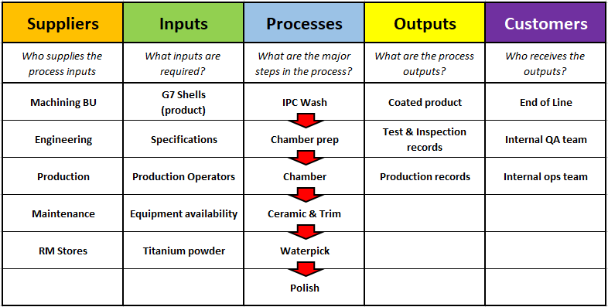
Figure 18 - SIPOC Diagram

4.1.4 PROCESS MAPPING

Although the Value Stream Map is a good tool to detail the process (figure 19), it is just that, very detailed. Following on from the SIPOC diagram, below is a very high-level interpretation of the VSM. The grey operations are outside of the scope of this study; they are NOT part of the Coatings process.

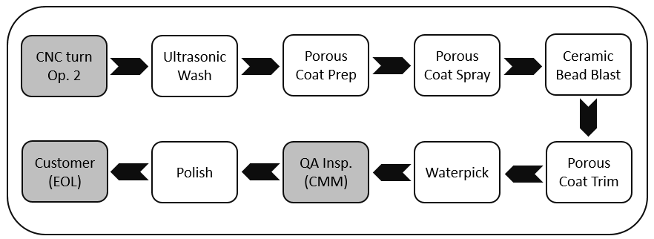
Figure 19 - High level Process Flow

It is important to understand that each operation is a customer to its previous operation, and this is where the problem lies. The end customer, EOL, is not receiving appropriately dated product, due to a lack of flow and understanding between each porous coating operation.

As simple as the above diagram looks, the physical locations of each operation do NOT flow in a straight line. This causes increases in WIP levels at each location, which increases lead times, and reduces OTIF results.

4.1.5 VOICE OF THE CUSTOMER (VOC)

(George, et al., 2005) define an internal customer is anyone within a business system who is impacted by the development of a product or service. For the G7 shell porous coating process, the internal customer is the End Of Line process (EOL).

EOL need a constant and reliable flow of work, in date order, so they can manage their own processes; any inconsistencies in the supply will impact their productivity and efficiency. There are some issues with the G7 shell porous coating process that are impacting on the flow to EOL in date order, which ultimately impacts on the overall site OTIF score.

(Drew, et al., 2004) state that the activities of internal customers have a significant impact on the subsequent process within the system. This is true for the porous coating process, the poor OTIF results tell a story, that the porous coating process cannot manage batches of WIP through each operation on time. A poor OTIF result suggests a poorly managed process, and what customer wants to rely on a supplier with a poor OTIF result?

This report does not seek to increase production or reduce scrap, it is focused solely on improving the efficiency of the porous coating process so that the healthcare trusts across the world are confident that Bridgend can meet their demands.

4.1.6 PROJECT CHARTER

(Miller, et al., 2014) state that The Project Charter serves as a guide for a Six Sigma Process Improvement or Problem-solving Project, presented in the form of a high level document.

The product and the process have been clarified; the team and basic plans are all documented in a Project Charter.

Figures 20 and 21 below are copies of the Project Charters documenting the team, scope, problem, reasons, and finally goals and objectives.

Figure 20 - Project Charter Summary (Thomas, 2023)

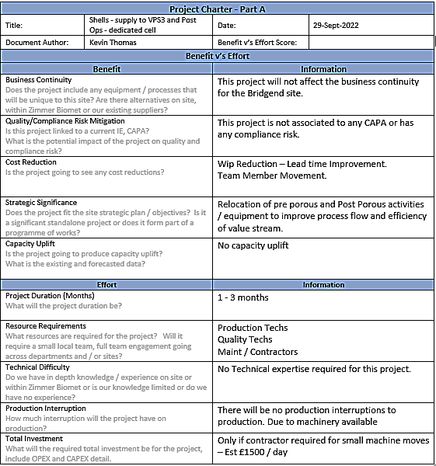
Figure 21 - Project Charter - Part A (Thomas, 2023)

4.1.7 PROJECT PLAN

Finally, a plan of the work below. This plan provides a very high-level visual representation of the project timeline, including the start and end dates of each task and those tasked with each objective.

The project was supported by the Continuous Improvement team (CI), and some of the team members named in the Project Charter assisted with some data collection tasks.

The plan allows provides clear visibility to identify the critical path, track progress, and make adjustments to the schedule as needed. It’s an effective tool for communicating project status and identifying potential delays or issues before they occur.

Figure 22 details the plan.

Figure 22 - Project Plan

4.2 MEASURE

The purpose of this phase is to measure the current state of the process to identify the baseline.

4.2.1 POROUS COATING PROCESS LAYOUT

All G7 shells are coated in chamber no.3 (VPS3), which was installed in the CNC machining area. This chamber was a late addition to the porous coating cell, there was no room to accommodate it, so it was installed where there was room.

VPS3 stands alone, there are no other coatings equipment in the surrounding area, only CNC. The preparation of G7 shells for porous coating is done in the porous coating cell, which is on the other side of the factory.

Once prepped, the shells are manually transported to VPS3 for coating, then manually transported back to the porous coating cell for Ceramic Bead Blasting, Trimming and Waterpicking. The batches are then manually transported to the CMM room for dimensional checks, and finally returned back to the porous coating cell for Polishing.

It is quite difficult to appreciate the distances walked when manually transporting batches around the porous coating process, so a spaghetti diagram was completed highlighted the steps taken.

Figure 23 shows VPS1 and VPS2 together in the porous coating cell, and VPS3 quite a distance away in the CNC cell.

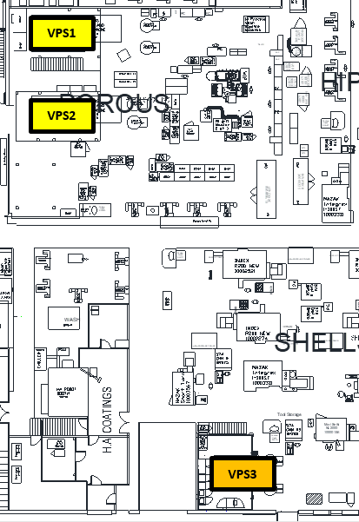
Figure 23 - Drawing of shopfloor (Zimmer Biomet, 2023)

4.2.2 PRODUCT TRANSPORTATION

The site production model is based on batch production, each 12-hour shift has a target of processing a minimum of 24 batches through their respective workstations to ensure the weekly target is achieved.

Batches are manually transported through the process on trollies, figure 24 shows a typical trolley that can hold up to eight batches at a time. An operator will fill the trolley then transport it to the next step of the process, deposit it there and walk back to their original workstation.

The shift target is 24 batches, if a trolley can hold 8 batches, an operator will walk to the next step of the process 3 times throughout the 12-hour shift to deliver the total 24 batches required. And this transportation method is repeated throughout the whole process for all operators at every workstation.

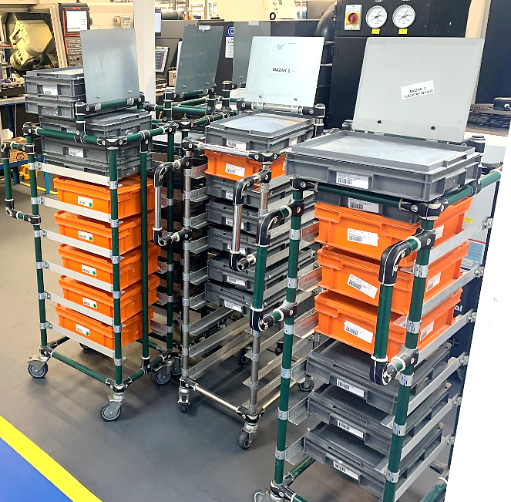
Figure 24 - Transport trolley

The process layout has been defined, and the transportation of the batches has been defined. Next, the physical routes inbetween each workstation need to be defined by use of a Spaghetti Diagram.

4.2.3 SPAGHETTI DIAGRAM

Spaghetti diagrams are used to expose inefficient layouts and identify large distances travelled between key steps in a process. It is a visual tool that shows the flow of activities through a process using a continuous flow line. The continuous flow line is a technique for process analysis, that enables process teams to find redundant tasks and chances to optimise process flow (Alukal & Manos, 2006).

The production operators created a hand-drawn spaghetti diagram during a Kaizen event, but the many sketched lines on the drawing made it appear quite busy and complicated, so a more refined spaghetti diagram was created electronically, focusing on the porous coating operations specific to this report, refer to figure 25 overleaf.

The letters in orange squares represent the locations of each workstation, and the blue arrows represent the routes an operator walks inbetween workstations. The written description of each workstation can be found in table 1 below.

Table 1 - Letters identifying workstations
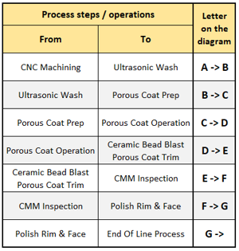

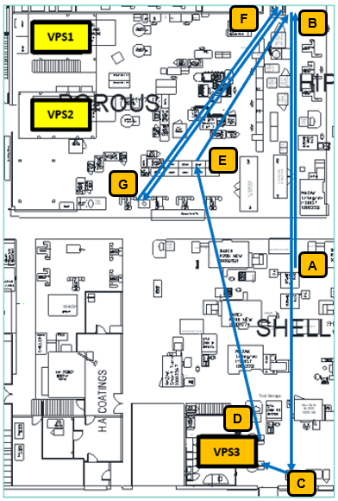
Figure 25 - Spaghetti Diagram of Porous Process (Zimmer Biomet, 2023)

4.2.4 DATA COLLECTION PLAN

In manufacturing, an abundance of data can be overwhelming and lack meaningful insights. To derive valuable conclusions, it is essential to establish a data collection strategy. This approach helps guide the team towards relevant data, allowing businesses to prioritise critical issues (George, et al., 2005).

The objective of this project is to identify parts of the overall process that are affecting the OTIF result. Based on this, it was determined that the most useful data to collate for this project was:
- Site OTIF score and associated data,
- Process times (Takt, value added tasks, etc),
- Distance between all porous coating workstations,
- Equipment availability/uptime.

A data collection plan was created to collate this data deemed relevant to this project, refer to table 2 below which details the plan to collate the appropriate data.

Table 2 - Data Collection Plan

4.2.5 OTIF

The OTIF result in 2022 for the G7 shell product was 30%. The OTIF data was downloaded from the company OTIF data collection software and sorted into a simple spreadsheet to make it easier to interpret, which is presented in table 3 below. The data is split into:

- Batches completed On Time In Full,
- Batches completed On Time, but not in Full (batches with scrapped parts),
- Batches completed Not On Time, but in Full (late batches with no scrapped parts),
- Batches Not Completed (batches that STILL remain in the process).

This data is known as the baseline OTIF data.

Table 3 - OTIF data for 2022
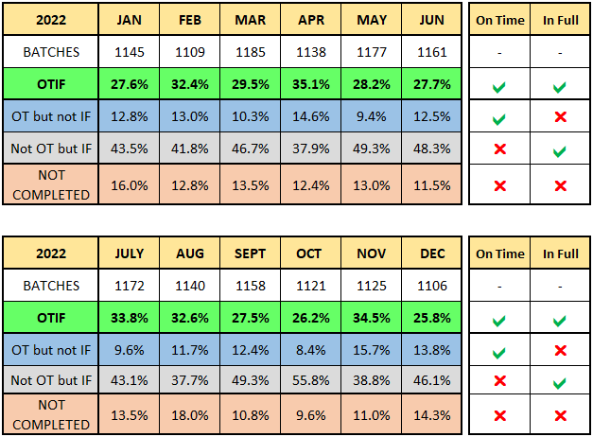

4.2.6 STEP COUNT

Why use step count? The distances between the porous coating equipment and workstations are not linear, operators will follow a path of twists and turns as they weave inbetween obstacles to reach their destination. Therefore to avoid complicating the process, step count was considered appropriate for this project.

(WW, 2013) noted that “steps are a fundamental unit of human locomotion, and thus are a preferred metric for quantifying physical activity”. Measurement of steps has a number of other advantages:
- Steps are intuitive, and readily understandable to the layperson,
- Steps can be measured easily and accurately,
- Steps/day has strong associations with physical health variables.

The Cambridge dictionary defines a step as “the act of lifting one foot and putting it down on a different part of the ground, such as when you walk or run” (Cambridge Dictionary, 2023), so each individual step was counted to measure the distances.

The physical distances of each batch transport path was measured by step count, the time taken to complete each full route, and the employee salary was used to calculate the cost of all the movements inbetween operations. All of this data was collected and entered into a table for further analysis.

Table 4 - Batch transportation – current state
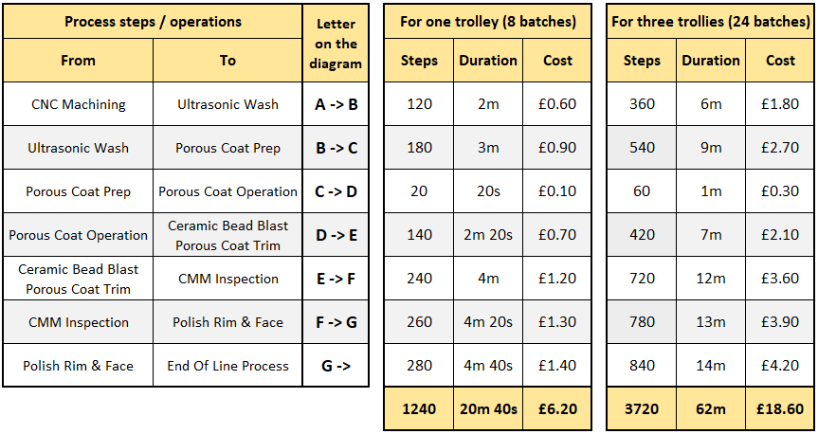

4.2.7 TAKT TIME

As per section 2.3.3 of this report, author Thomopoulos (2014) tells that takt time refers to the amount of time a manufacturer has per unit to produce enough goods to fulfil customer demand.

This is the equation to calculate takt time:

(Thomopoulos, 2014)

12hr shift x 60 minutes = 720 minutes/shift.

Remove breaks (60 mins) and also end-of-shift clean down (30 mins), leaves us with
630 minutes/shift.

The Customer demands means we need to process 24 batches per shift, so:

Takt time = 630 mins = 26.25 minutes / batch
24

This means a batch of 12 G7 shells must leave the porous coating cell every 26 minutes to satisfy the production plan.

As established in section 4.2.2, operators do not transport single batches around the shopfloor, they transport 8 batches at a time by trolley:

8 batches x 26 minutes = 208 mins, or 3hrs and 28 mins.

So the internal customer (EOL) should expect a trolley of 8 batches delivered to them from the porous coating cell every 3 hours and 28 minutes throughout each 12-hr shift.

4.2.8 VALUE STREAM MAP

At each workstation on the Value Stream Map there are cycle times at each workstation, represented by the phrase CT/Batch. These times have been calculated during time and motion studies, and are the expected times a batch should be processed at that specific workstation. Figure 26 - Section of G7 Shell Value Stream Map below is a screenshot of a section of the Value Stream Map for illustration purposes.

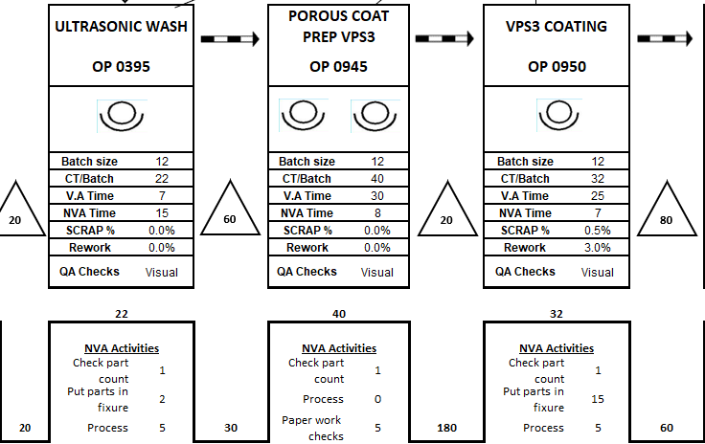
Figure 26 - Section of G7 Shell Value Stream Map

All the cycle times/batch for the porous coating operations were collated and captured in a spreadsheet for later analysis. Table 5 displays all the timings for each specific operation throughout the porous coating cell.

Table 5 - VSM process times
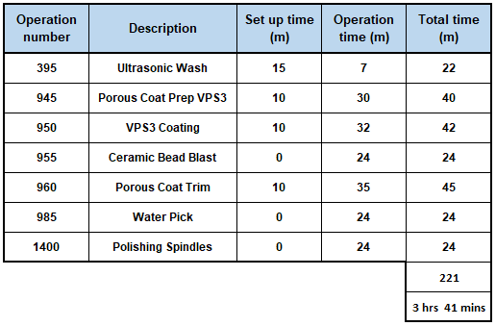

If the process was single piece flow, and there was one operator at each workstation, operating one machine or sitting at one workbench, then the total time for a batch to be processed through all the porous coating operations would be 3 hours and 41 minutes. Further analysis of the process flow is conducted in the Analysis chapter.

4.2.9 EQUIPMENT AVAILABILITY

(Worximity, 2019) explains that “Equipment availability is a metric used to measure the percentage of time a machine can be used. It is the amount of time in which a machine actually runs and is available for production. Availability can also be called ‘uptime’, and it is one of the key metrics that give us insight into our production efficiency”.

The equipment used in the porous coating process are described in sections 3.3.1 through to 3.3.5. There are only 2 fully automated machines in the porous coating process, the Ultrasonic Wash and the coating chamber VPS3, the remaining processes are manual based with operators using handtools.

The Maintenance department supplied the data for the Ultrasonic Wash and the chamber (VPS3). The Ultrasonic Wash is a basic two-tank wash, there are several of the units in Bridgend due to their reputation of consistency and reliability. In 2022, the availability of the wash was 96%, where the expectation was 95%. Refer to figure 27 for a high-level summary by month.

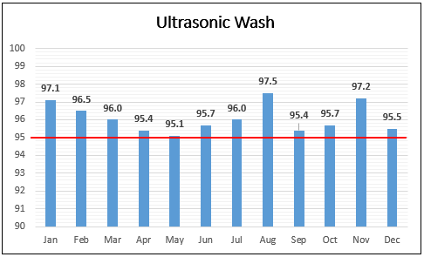
Figure 27 - Ultrasonic Wash 2022 availability (Thomas, 2023)

The coating Chamber (VPS3) is a far more complex machine and it 2022 it suffered several problems with various auxiliary equipment causing many interruptions to process flow. In 2022, the availability of VPS3 was 80%, where the expectation was 90%. Refer to figure 28 for a high-level summary by month. Obviously this is a cause for concern which is discussed further in the Analyse phase of the project.

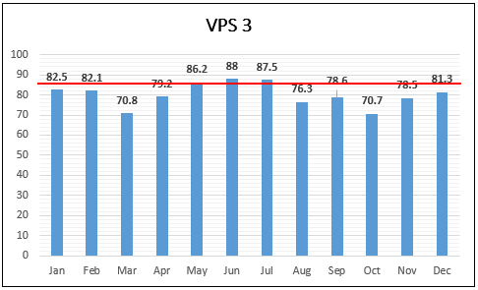
Figure 28 - VPS3 2022 availability (Thomas, 2023)

4.3 ANALYSE

In this section the data collated in the current state of the process is analysed for trends and potential root causes of the problem.

4.3.1 KAIZEN EVENT

The porous coating operators were invited to a Kaizen event to assist with the analysis of the process, to establish reasons why the OTIF result failed to meet the company requirements. As mentioned in 2.5 of this report, managers and workers collaborate to analyse a known problem in the manufacturing process and generate possible solutions.
(Kato & Smalley, 2015).

Hosted by the Continuous Improvement department, production operators engaged in several Kaizen event tasks such as labelling VA and NVA activities (Post-It notes in figure 29), identifying necessary and unnecessary wastes, and creating spaghetti diagrams. Some of the detail in this Analyse section was discussed in the Kaizen event.

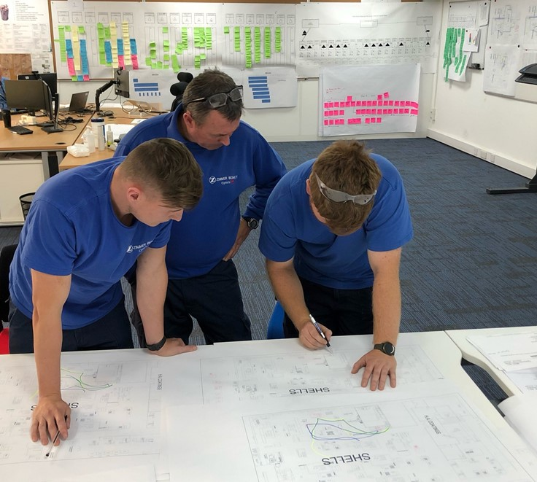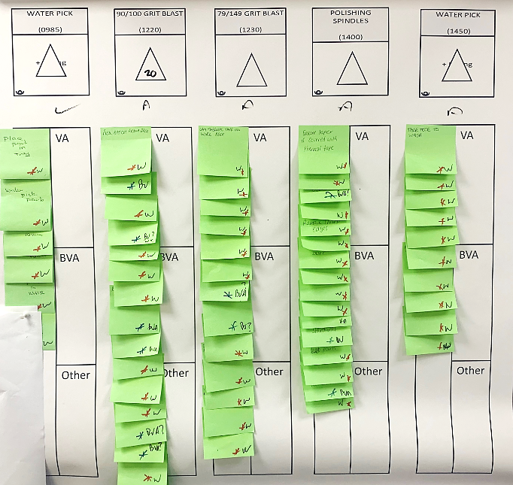
Figure 29 - Kaizen event photos

4.3.2 FMEA

Before any changes to the process are considered, the process Failure Mode and Effects Analysis was sourced and analysed, to ensure there were no issues with the existing process that could cause potential problems with a future state proposal. Table 6 below is a section of the porous coating FMEA, the full image can be reviewed in the appendices.

Table 6 - Porous Coating FMEA (Thomas, 2023)

Note there is one activity with a Risk Priority Number (RPN) of 24, highlighted in yellow. This activity is grease on blasted area, which already has some risk controls in place (training, visual inspection, operators wear gloves). The FMEA states that Additional Risk Control Measure is required if RPN is 28 or greater, Therefore the existing controls to combat grease on the parts are considered adequate. Conclusion, the FMEA details no issues that could hinder a proposal of lean improvements.

4.3.3 STEP COUNT ANALYSIS

It was noted during the Kaizen Event that the process layout was not lean; VPS3 was placed quite some distance away from the porous coating cell, and the distance between some workstations is extreme. The process of measuring each transportation path by step count was conducted in section 4.2.6 and recorded a table. Table 7 is a duplicate that serves to assist with the calculations below.

Table 7 - Step count data

Further analysis of this data was done to ascertain the following facts. As defined in section 4.2.2., porous coating operators will deliver 3 trollies each to the next operation throughout their 12hr shift:

- CNC operator completes 360 steps, losing 6 minutes, costing the business £1.80.
- Wash operator completes 540 steps, losing 9 minutes, costing the business £2.70.
- Prep operator completes 60 steps, losing 1 minute, costing the business £0.30.
- Chamber operator completes 420 steps, losing 7 minutes, costing the business £2.10.
- Trimming operator completes 720 steps, losing 12 minutes, costing the business £3.60.
- The CMM operator completes 780 steps, losing 13 minutes, costing the business £3.90.
- The polisher completes 840 steps, losing 14 minutes, costing the business £4.20.

Time
It takes a combined total of 62 minutes every shift to transport the 24 batches from one workstation to another within the porous coating cell.

- 62 mins x 14 shifts = 868 minutes / 14 hours and 28 minutes each week.
- 868 minutes x 50 weeks = 43,400 minutes / 723 hours and 20 minutes a year

The business is losing a shift a week in transporting batches between workstations.
Cost
Based on the employees salary, the total cost of operators transporting batches across the shopfloor to the next operation.

- Weekly: 14hrs 28 mins x £18 p/h = £260 every week.
- Annually: 723hrs 20mins x £18 p/h = £13,020 every year.

All of this is non-value-added waste that the customer won’t pay for. In addition to the non-value added time and cost, there is an impact on the operators walking these distances; employees with existing medical issues with knee joints can find this part of the role quite uncomfortable.

4.3.4 OTIF ANALYSIS

The OTIF score is used for more than merely assessing delivery performance, it is closely related to the efficiency and execution of the suppliers overall business (Miller, et al., 2014).

The 2022 OTIF data, when displayed in a spreadsheet, as it was for data collection purposes in table 8 below, is difficult to analyse. Presenting the data in a run chart can graphically display the OTIF performance in date order, which can be analysed visually.

Table 8 - 2022 OTIF data

Figure 30 below presents the above 2022 OTIF data in a run chart illustration. The 2022 averages of the 4 criteria are:

OTIF: 30%
OT: 12%
IF: 45%
NC: 13%

The run chart displays 3 types of data:
- On time in full = Batches delivered on the date expected, with all 12 parts present.
- On time = Batches delivered on the date expected, but not all 12 parts present.
- In full = Batches delivered not on the date expected, but with all 12 parts present.

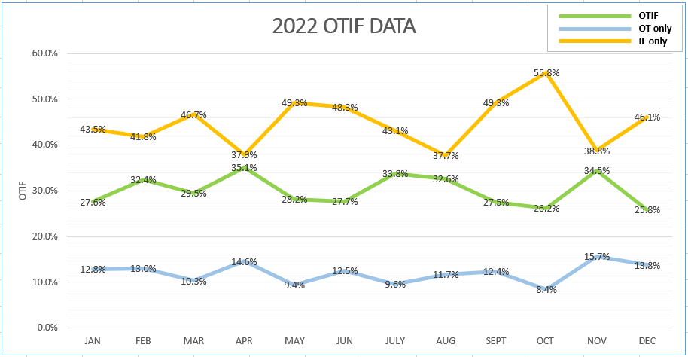
On Time & In Full
On Time NOT In Full
Full batches, NOT on time
Figure 30 - Run Chart of 2022 OTIF data

The data in the graph presents the following facts to consider:
- A high percentage of batches with all 12 parts present were not delivered on time.
- A low percentage of batches without all 12 parts present are delivered on time.

If the In Full criteria is not met, it is because the batch doesn’t contain 12 parts, which means part(s) have been scrapped off somewhere in the process, leading to the conclusion:

Point 1
An average of 45% of batches failed the delivery date, but were in full. This strongly suggests they were not delayed due to scrapping off parts, they were delayed due to reasons that exist in the process preventing them from being on time.

Point 2
An average of 12% of batches were delivered on time, but were missing parts. This accounts for very few batches, meaning that batches failing the In Full part of the calculation make up the least amount of batches affecting the OTIF result.

Based on this analysis, the In Full part of the OTIF calculation is ruled out. Analysis of the process flow is required to gain a better understanding of why batches are failing to be delivered on time.

4.3.5 TAKT TIME

In section 4.2.7 the Takt Time calculation determined that a batch of G7 shells must be processed through the porous coating cell every 26 minutes. However as mentioned in section 4.2.7, the production model is not single piece flow, it is mass batch production where 24 batches must be processed through porous coating cell every 12-hour shift to ensure the weekly production target is achieved. The transportation of batches is done using a trolley that can hold 8 batches at a time.

Based on 8-batches being delivered to EOL on one trolley, the Takt Time equation was adjusted to reflect this and a new Takt Time of 3 hours and 28 minutes was calculated for a trolley of 8 batches to be delivered to EOL.

For example, if a 12-hour shift starts at 06:00hrs, EOL should expect a trolley of 8 batches around 09:30, 13:00 and 16:30 respectively. Due to many variables in manufacturing processes, trollies may not be delivered exactly on these times, but they should be reasonably close.

In section 4.2.8 the cycle times per batch per workstation were taken from the VSM and recorded in a table, which equated to 3 hours and 41 minutes. Obviously this would be the case if the process was operating single piece flow, and there was one machine and one operator at each workstation. However, the porous coating cell has multiple machines and multiple operators at some workstations to overcome bottleneck areas, thus supplying EOL with a trolley of 8 batches every 3 hours 30 minutes, which satisfies the production plan.

According to (Kanbanize, 2023) “At times, you can easily resolve the bottlenecks by allocating more resources or people to that work stage or process”.

Table 9 below shows where additional operators and equipment are placed to overcome the longer operations, to stabilise the processing of WIP. The workstation that takes the longest time to prepare a trolley of 8 batches is operation 0950 VPS3 coating, it is a fully automated process that takes 3 hours and 20 minutes complete a run. A run consists of 10 batches; 144 shells.

This is the bottleneck of the process, with only 1 chamber available, there are no options available to improve on the time at this workstation.

Table 9 – VSM bottleneck management
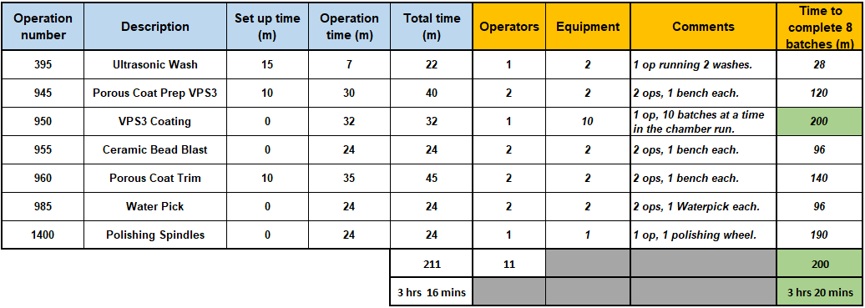

With the exception of the Ultrasonic Wash and VPS3 chamber, all of the other porous coating operations are manual, that is, operators physically working on the parts with hand tools. Whilst the washes and chamber are running, the operator can utilise that time to set up batches in readiness for the next run. Therefore, the total time to complete 8 batches is based on the ‘operation time’ only, it does not include the set up time.

Based on the analysis of each process time, there doesn’t appear to be any delays with the actual processing of batches at each workstation that could jeopardise the supply of 24 batches per shift to the internal customer EOL. However the cycle time of the chamber is close to the Takt Time calculation, so if the chamber suffers downtime then it has the capacity to cause significant interruption to the flow of product to EOL.

4.3.6 ISHIKAWA DIAGRAM

The Ishikawa diagram is a tool used to illustrate the probable factors contributing to a particular occurrence or operation. Named after its creator Kaoru Ishikawa, it is frequently employed to generate ideas and map out various stages of a process, in order to establish a potential root cause of a known problem (Barsalou, 2015).

The Kaizen event facilitated the Ishikawa process, under the headings Measurement, Materials, Manpower, Machines, Method and Environment (Mother Nature), team members from Production, Maintenance, and Engineering listed all issues related to the process. Figure 31 was the first assessment of the whole process.

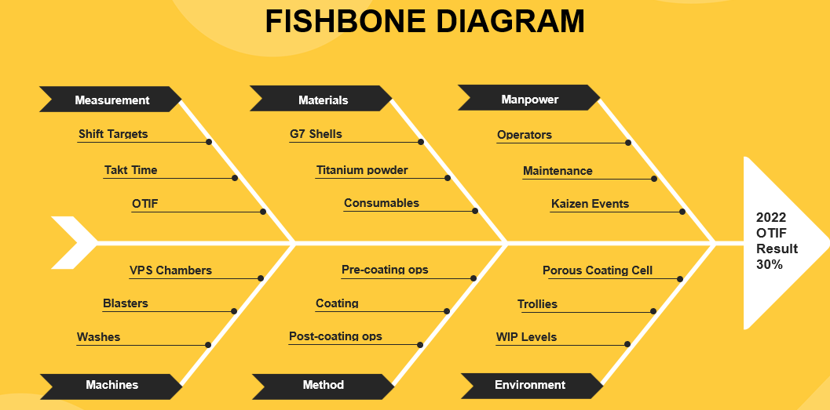
Figure 31 - Ishikawa Diagram A (Template Lab, 2022)

Next, the team were asked to review the Ishikawa Diagram again and consider what could impact the OTIF score. Further detail was added to the Ishikawa Diagram based on the groups discussions. Figure 32 shows additional information, again nothing discarded.

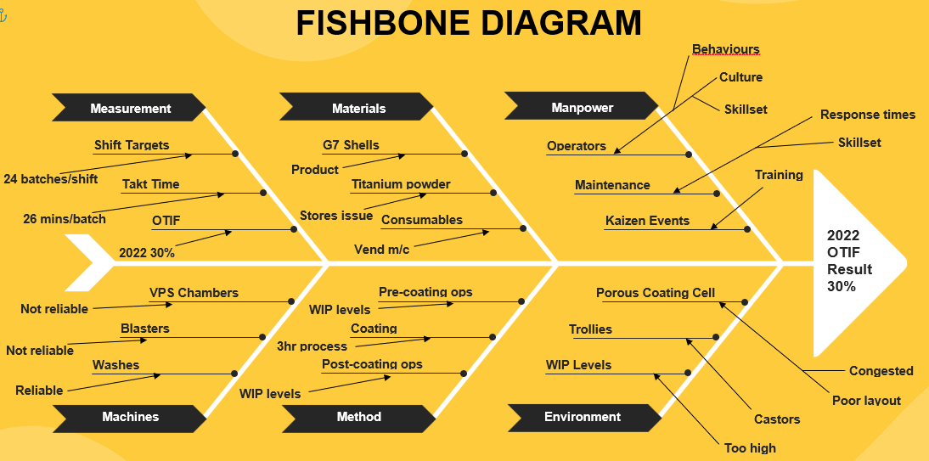
Figure 32 - Ishikawa Diagram B (Template Lab, 2022)

Analysis of Ishikawa Diagram

All avenues were considered and discussed amongst the team. There were some items listed in the diagram that did not immediately impact on the OTIF result, and there were some that the team thought was significantly impacting on the flow of product through the cell.

High WIP levels were discussed at length, they don’t cause any flow restrictions, quite the opposite in fact as the product is readily available throughout the process. The internal customer was receiving the amount of product as per plan, however, it was noted that operators were not selecting batches by date. They are overwhelmed by high WIP levels and do not take the time to select date sensitive batches, which directly impacts OTIF.

And here lies the problem. High WIP levels overwhelm the operator, they don’t have the time or space to go looking through high WIP levels for date sensitive batches.

But why do we have high WIP levels in the porous coating cell?

4.3.7 5-WHY ANALYSIS

Why conduct a 5-Why analysis? Author Liker (2004) captures the words of Taiichi Ohno: “The basis of Toyota’s scientific approach is to ask why five times whenever we find a problem. By repeating why five times, the nature of the problem as well as its solution becomes clear“ (Liker, 2004).

We need to understand why we are seeing high WIP levels at certain work stations throughout the Porous Coating process. Figurer 33 is a 5-why analysis that was conducted with the same team assembled for the Ishikawa Diagram event. At each stage the question ‘why’ was asked to ensure the process would eventually lead us to the root cause.

Figure 33 - 5-Why Analysis diagram

The team explained their concerns with the physical distances between particular work stations, causing WIP levels to increase, which would impact on batch selection. The operators know they need to deliver 24 batches a shift to EOL, and whilst they work at their respective workstations, isolated from their pre and post operations due to distance, they will continue to churn out the work, almost completely impervious to any issues that could interrupt flow.

If the following operation is down due to equipment failure, the previous operation will not be aware and continue to supply them with trollies of WIP. So if the VPS3 chamber suffered at 24hr breakdown, how does that affect the flow of product to EOL?

4.3.8 EQUIPMENT AVAILABILITY

(Worximity, 2019) explains that “Equipment availability is a metric used to measure the percentage of time a machine can be used. It is the amount of time in which a machine actually runs and is available for production. Availability can also be called ‘uptime’, and it is one of the key metrics that give us insight into our production efficiency”.

Figure 34 - Availability data (Thomas, 2023)

To recap, figure 34 above is data representing equipment availability, which was presented in section 4.2.9 of this report.

The two automated machines in the porous coating process recorded an availability of:
- Ultrasonic Wash 96% against an expectation of 95%
- VPS3 chamber 80% against an expectation of 90%

Cycle times to process a batch through these two stages of the process were reviewed, as the Ultrasonic Wash performed above expectations, and the process time is 7 minutes a batch, there is no concern that this machine can impact on product flow. However, as VPS3 performed 10% lower than expectation, and with a single cycle time of 200 minutes (for 10 batches in one run), this lack of availability can cause significant disruption to product flow, which is difficult to recover.

Here is where the WIP builds up, inventory levels increase at the chamber due to lack of visibility and communication between the pre and post workstations. Operators continue to churn out the batches required to achieve their shift targets, and WIP will build up at the chamber. Figure 35 shows how quick inventory can build up when the chamber is down.

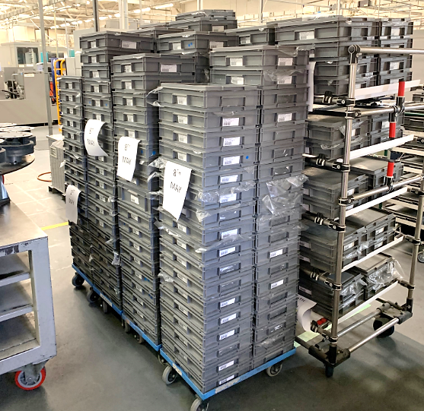
Figure 35 - WIP at VPS3 during breakdown

When the VPS3 chamber is repaired, the operator is under pressure to ensure they run the chamber at maximum capacity and efficiency. In this situation, with high inventory levels, the operator will not select date sensitive batches. VPS3 chamber will flood the post workstations with work, their inventory levels increase, and the problem of not selecting date sensitive batches is repeated.

In section 2.1.3 Why go lean?, (Tsigkas, 2013) states that Lean Management improves management by implementing visual controls in the manufacturing process, which enables easy identification of any problems that may arise.

One solution to improve the visual awareness and management of batch flow through the porous coating process is to remove the awkward distances by moving workstations closer together. This would improve the visibility, improve communication, and improve the overall management of WIP levels by moving from a push system to a pull system. A pull system would control the flow of WIP pre and post chamber, preventing a rapid build up of WIP when the chamber is down.

4.3.9 MUDA (WASTES)

As stated in section 2.2 of this report, wastes exist in production processes. Liker (2004) tells us that not all non-value adding activities can be eliminated from the workflow as some are necessary (Liker, 2004). However in this case the distances travelled inbetween work stations can be considered as non-value added parts of the process.

The transportation of batches is unnecessary waste and needs to be removed (or reduced) from the process.

Peter L King (2019) explains that eliminating waste through process optimisation is essential for your company's success. So with that in mind, the 7-wastes were referred to and compared against the current Porous Coating process in order to establish where we have issues with waste. Table 10 shows the porous coating process

Table 10 - 7-Wastes comparison
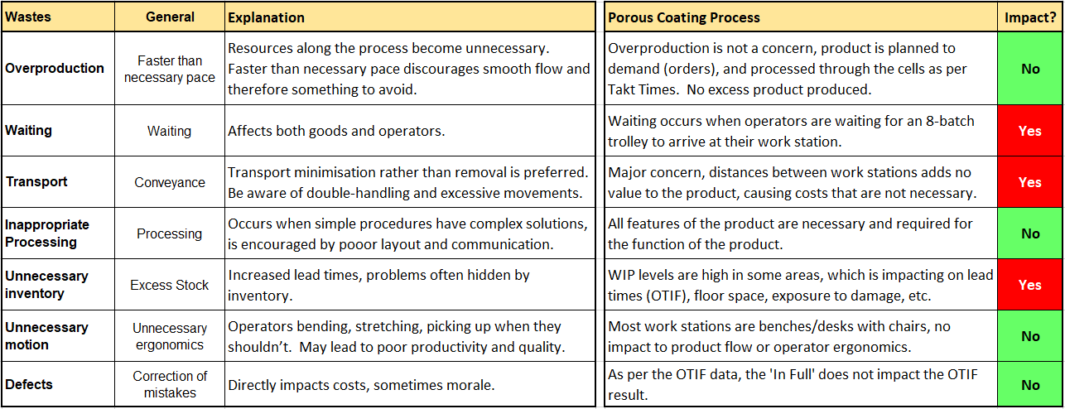

The current porous coating process layout is causing unnecessary waste with regards to:

Waiting
When the VPS3 chamber breaks down, the operations post chamber will dry up of WIP and the operators will be waiting for batches. The maintenance records show that the chamber was available for production to use 80% of the time, this is 10% below what the production loadings are based on. This prevents work reaching workstations post coating, and operators waiting around for work.

Transport
Distances between workstations mean that the business is losing 723 hours / £13k a year of unnecessary waste due to transporting product between each workstation.

Inventory
Whenever the chamber VPS3 breaks down, the WIP will continue to flow to that workstation, which will accumulate a significant amount of inventory thus impacting on lead times.
Reviewing the chamber availability graph, October 2022 was its worst month for availability. Likewise, the OTIF result for October was 26.2%, yet the amount of batches late in October (in full) was 55.8%. There is a direct correlation between chamber availability and OTIF.

Improvements will be proposed in section 4.4 to eliminate or significantly reduce these unnecessary wastes in the porous coating process.

4.4 IMPROVE

This phase identifies the potential solutions based on the analysis in the previous phase, reviews and selects the best solution, and implements it to measure improvement.

4.4.1 BRAINSTORMING

A second Kaizen event was arranged and the data reviewed in the Analysis phase was presented to the team of operators, engineering and maintenance. During the Brainstorming sessions the team were encouraged to make proposals to address the problem, to find ‘objective not subjective’ solutions based on the data collated and analysed.

The team reviewed floorplans, value stream map, how the OTIF can be improved, how the process can be more efficient, etc. It became apparent that moving equipment closer to VPS3 chamber would offer several benefits to the business.

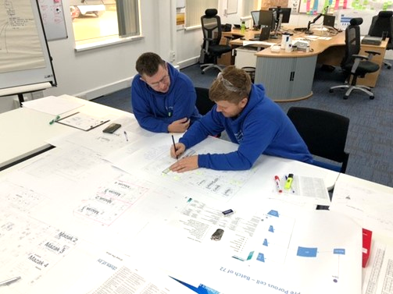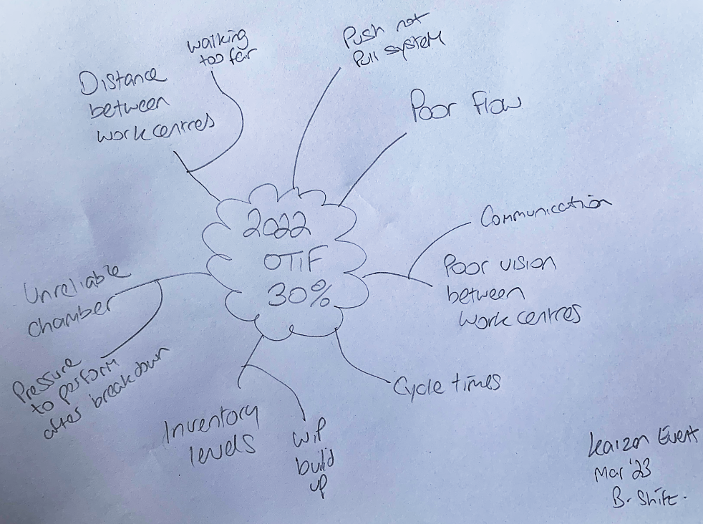
Figure 36 - Second Kaizen event

If the equipment was in close proximity to the VPS3 chamber, visual awareness would improve significantly and WIP could be pulled through the system, which would prevent rapid increases in inventory when the chamber is down.

4.4.2 FUTURE STATE FLOOR PLAN

The team reviewed the floor plan drawings and suggested pre and post coating equipment could be moved closer to the chamber. In front of the chamber is some space currently used to store batches of WIP for the CNC machining operations. The team measured the size of some porous coating desks, Ultrasonic Wash and some Blasting Cabinets, and using simulation software with the Continuous Improvement team, they confirmed the equipment would fit in the current WIP storage space proposed.

Figure 37 is a floor plan of the area in front of VPS3, the GREEN OBJECTS are the new additions to the area: some desks, 2 blasting cabinets and an Ultrasonic Wash added into the space in front of the chamber.

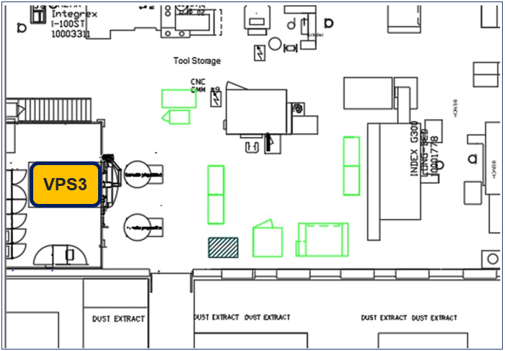
Figure 37 - Proposed Floor Plan (Thomas, 2023)

Once it was confirmed the equipment would fit into the space in front of VPS3, the operators began to plan the new routes inbetween workstations. Figure 38 overleaf details the new proposed routes.

The first and obvious observation is that the distances inbetween each operation is significantly less than the current state.

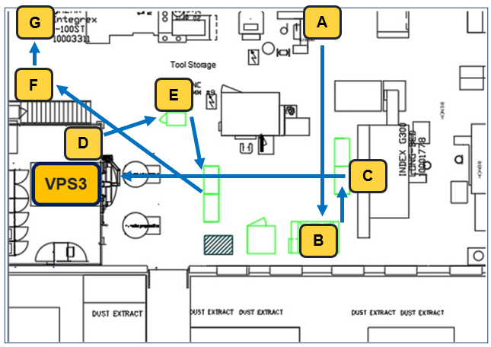
Figure 38 - Routes inbetween workstations (Thomas, 2023)

4.4.3 FUTURE STATE STEP COUNT ANALYSIS

The same methodology was used to record the steps as the data collection collated in table 4 in section 4.2.6 of this report. Step count data was collated for the new proposed future state layout, which is detailed in table 11 below.

Table 11 – batch transportation - future state
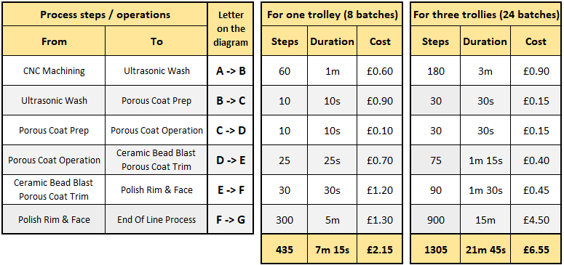

Comparing the current state to the proposed future state data, there is an obvious reduction in steps, time and cost. Both states are compared side-by-side in table 12 below, where the improvements are more obvious.

Table 12 - Current vs Future States
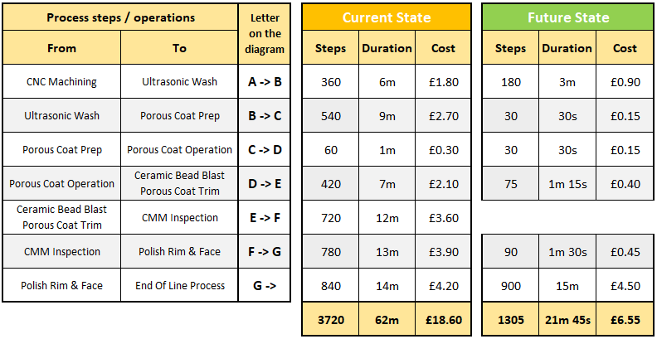

Where is the E->F route in the future state? Outside the scope of this report, the CMM Inspection operation will be phased out in Q3 2023. During CNC machining stage, the shells are run through a CMM programme to confirm dimensions are in specification. Then, after the shells have been coated in VPS3, the shells are checked again in the CMM room to confirm that exposure to the plasma gun heat has not altered the cone angle dimension.

The CNC Engineering team have analysed the historical CMM data to develop an adjustment to the CNC programme, so they cut the G7 shell in preparation for any cone angle alterations. The trials have proved successful so the CMM Inspection check will be removed, so the porous coating operator will no longer need to walk to and from the CMM Room.

A full analysis of the step count was done and compared to data from section 4.3.3 of this report, to understand the benefits of moving the equipment closer together.

Time
It takes a combined total of 21 minutes and 45 seconds every shift to transport the 24 batches throughout the porous coating cell.

- 21m 45s x 14 shifts = 304 minutes / 5 hours each week.
- 304 minutes x 50 weeks = 15,200 minutes / 253 hours and 20 minutes a year

The difference between current state and future state:
- 14hrs 28mins – 5hrs = 8hrs and 28mins each week
- 723hrs 20mins – 253hrs 20 mins = 470 hours per year

In its current state, the business is losing 8 hours and 28 minutes a week on unnecessary transportation of product, this is time that can be either used to produce more G7 shells, or invest in another process in the plant, to cover absence for example.

Cost
Based on the employees salary, the total cost of operators transporting batches across the shopfloor to the next operation.

- Weekly: 5hrs x £18 p/h = £90 every week.
- Annually: 253hrs 20mins x £18 p/h = £4,555 every year.

The difference between current state and future state:
- £13,020 – £4,555 = £8,465 per year.

In its current state, the business is spending £8,465 per year on unnecessary transportation of product, this is time and money that can be saved and has no impact on the quality of the product, it only serves to improve the overall efficiency and cost of the process.

4.4.4 FUTURE STATE OTIF

In 2022 the OTIF result for the G7 shell averaged 30%. It has been widely spoken about in the Kaizen events that the management of time sensitive batches is hugely affected when the VPS3 chamber fails. When the chamber is on a breakdown, the WIP will continue to flow to that workstation regardless, causing a significant increase in inventory levels at the chamber. When the chamber is back in service, the pressure to maximise production through that workstation causes operators to avoid searching through inventory for time sensitive batches.

With all the workstations positioned in the same area, visibility and communication will be hugely improved, better management of the WIP levels can be achieved by simply switching from a push system to a pull system. When the chamber fails, the process flow pre coating can be halted and the operators be moved to other areas in the site to cover absence and add value to the business. When the chamber returns to production, the pull system can recommence.

Table 13 below shows the 2022 OTIF result (in green), and the not on time, in full batches (in grey). If the porous coating cell can avoid the accumulation of WIP at the chamber when it is not in service, the operator has an increased chance of processing time sensitive batches when the chamber is returned to service. This can be done if all equipment is within close proximity to the chamber. An opportunity exists to increase the OTIF result from 30% up to a potential 70% if the management of batches through the porous coating cell is improved, as displayed in the yellow column in table 13 below.

Table 13 - OTIF potential
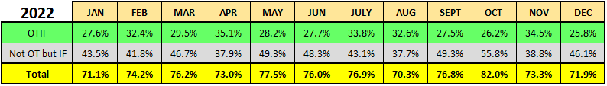

The yellow band is the potential OTIF result; it is the actual OTIF result (green) and the late batches not on time (grey) added together to give an indication of how much opportunity there is.

4.4.5 FUTURE STATE VALUE STREAM MAP

The proposed equipment moves will have no impact on the process flow, cycle times, or improve the value added times. However, there will be a reduction in WIP at the workstations, and also the time inbetween each workstation to transport batches is also reduced, thus improving on the overall lead time through the porous coating cell. Figure 39 has been updated with the anticipated reductions to WIP levels and WIP lead times.

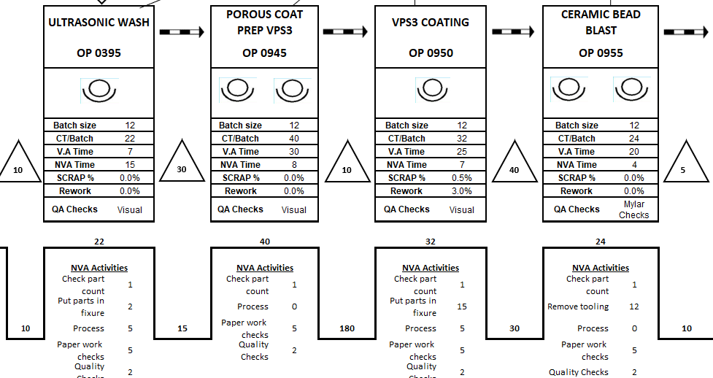
Figure 39 - Future state VSM

Moving the equipment closer together reduces the transport waste, and those hours saved, 470 per year, can be used within the process coating cell to improve efficiency, or possibly used elsewhere in the plant. There is further potential to utilise operators more efficiently in the proposed model. A review of the process times reveals that operators in workstations that consume less time, could be running simultaneous workstations, thus reducing the number of operators needed.

Table 14 has been updated with the only change to the Ultrasonic Wash. The space in front of the chamber will only allow one wash, the current state has two. This means the operator will now take 56 minutes instead of 28 minutes to complete 8 batches.

Table 14 - Revised cycle time summary
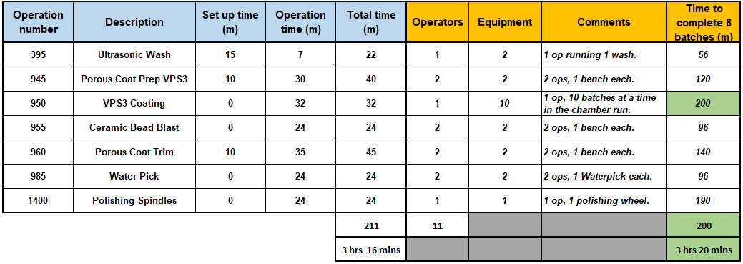

Cost saving opportunity

See Table 15 below, the VPS3 chamber operator loads 3 runs each 12-hour shift, and each run/cycle lasts 3 hours 20 minutes, where the chamber is fully automated during that time (orange). The chamber operator uses the cycle time to remove tooling from the G7 shells of the previous run, inspects the parts and passes them onto the next operator at Ceramic Bead Blast (green). That takes approximately 1 hour 30 minutes, therefore during each 3 hour 20 minute cycle, the chamber operator has approximately 1 hour 40 minutes available, or 100 minutes. This is enough time for the chamber operator to cycle 8 batches through the Ultrasonic Wash, which will take an operator 56 minutes to wash 8 batches (blue).

Table 15 - VPS chamber cycle time
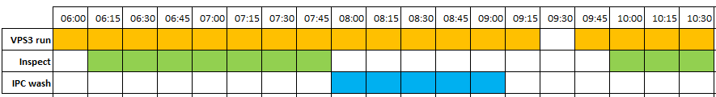

For example, the chamber operator loads the chamber for a 3hr 20min cycle, then during the automated cycle they strip the previous run of tooling (1hr 30mins), then goes to the Ultrasonic Wash and processes 8 batches (60mins), The chamber driver can then return to the chamber as it finishes its automated run. So if the Ultrasonic Wash is near the chamber, there is no need for an Ultrasonic Wash operator.

This would allow for a reduction in headcount by one operator per shift, a potential saving of £160,000 a year. In addition to this, the productivity of the VPS chamber operator would increase significantly, which is another site metric measured globally.

4.4.6 PROPOSED BENEFITS

Financial benefit
From section 4.4.3 of this report, the unnecessary waste of transportation would be significantly reduced, providing an annual saving of £8,465 annually. It can also provide the company with 470 hours per year that can be re-invested elsewhere in the business, either in the existing porous coating cell, or another value stream in the plant.

From section 4.4.5 of this report, there is scope to remove an operator from each shift from the process, and still maintain the same outputs based on operator efficiency within the cell.
This will provide an annual saving of approximately £160,000 for the porous coating value stream (£40k x 4 operators). In addition to that, the operators can be used elsewhere in the plant to combat bottlenecks, or cover absence and staff turnover to reduce overtime costs.

Switching from a push to a pull system will reduce inventory levels (high WIP) throughout the porous coating process, which can improve on inventory costs, financial costs, and holding costs.

Reputational Benefit
From section 4.4.4 of this report, there exists an opportunity to improve the OTIF result from 30% up to (and including) 70%. The data shows that 40% of batches reaching the end customer were in full, but not on time. Improving the process flow through porous coating will allow batches to move through the process far more efficiently, thus achieving the On Time metric. This would have a significant impact on the business reputation for being a reliable and trusted partner, which cannot be underestimated in the medical device sector.

Initial costs
The Project Charter (figure 26) documents the costs of hiring a contractor to move the equipment from the porous coating cell to the VPS3 chamber area, which is £1,500 a day.

The moves can be achieved in one day and will entail:
- Relocation of a single Ultrasonic Wash,
- Relocation of 1 Ceramic Bead Blasting cabinet,
- Relocation of 4 general work benches/desks,
- Relocation of 2 Waterpick cabinets,
- Relocation of 1 polishing spindle with desk.
The equipment will need to be set up ready for validating. Power supply, water, drainage and compressed air will need to be connected to the Ultrasonic Wash, waterpick, blasting cabinets and polishing spindles, and lighting will be required for the benches/desks. All of this work can be done internally using the company maintenance and facilities teams.

Last, all equipment will need to be checked, calibrated and validated. Again this work can be done internally by the engineering department.

Maintenance, facilities and engineering are all direct employees of the business, the costs are already factored into the business costs. Add £500 to the budget to cover consumables, fittings, pipework or cable, etc.

Total outgoing costs: £2,000.

Summary of financials

The above financial details are summarised in table 16 below. The costs to move the equipment are far outweighed by the benefits. It is difficult to quantify the financial savings of reduced inventory, increase in OTIF and also the benefit of a spare operator, but the details in this section are convincing enough to justify this proposal.

Table 16 - Summary of costs
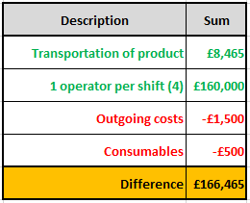

CHAPTER 5: CONCLUSION

The goal of this project is to focus on improving the 2022 OTIF result by introducing lean improvements to the porous coating process. Applying the Six Sigma DMAIC methodology provided this study with the necessary tools to be able to analyse the process adequately, and provide data-backed proposals for improvement.

The proposed solution, moving porous coating process equipment closer to the VPS3 chamber significantly reduces three of the seven wastes in manufacturing; Transport, Waiting and Increased Inventory. Changing the product flow through the porous coating cell from a push to a pull system will reduce inventory levels when the chamber is down, which will allow the chamber operator to select time sensitive batches when the chamber is back in service, thus improving the OTIF result.

In addition to improving the OTIF result, additional benefits were realised when analysing the benefits of moving the process equipment closer to the chamber. Analysis of the proposed VSM suggested that some operators could be utilised more efficiently, releasing one operator per shift from the value stream can be possible with the shift targets still achieved.

To summarise, the DMAIC methodology provided the appropriate tools of analysis to be able to propose a solution that claims the following benefits:

- Reduction in WIP levels when the chamber fails (changing to a pull system), which will improve lead times, and increase OTIF result for G7 shells.
- Reduction in transportation of product inbetween workstations, providing significant time and cost savings, and frees up resources that can be used elsewhere.
- Reduction in headcount based on utilising operators more efficiently in a more confined process cell.
- Significant reduction in step count, having a positive impact on the morale of the production operators, especially as it was the operators that requested this project.
- Increased OTIF result will stabilise the reputation of the business in the medical device sector, allowing surgeons to plan surgeries based on the business supply chain reliability.

5.1 FURTHER WORK

Once the equipment has been relocated to the VPS3 chamber area and is in full production, the VSM timings need to be checked and confirmed. The operators need to be involved in the process to ensure the timings are a true reflection across all shifts.
Following confirmation, the proposed reduction of one operator per shift will take effect. This will need to be done sensitively and with the full involvement of the operators. It is advised that the senior management undertake a PESTLE analysis, SWOT analysis, or Scenario Planning to ensure all risks of change are considered.

Finally, once all proposals have been completed, the final stage of DMAIC must take place on order to sustain the improvements; Control.

Other task that should be considered:
- A monitoring plan should be created and introduced to continue measuring the success of the improvements.
- Consider implementing the improvements to other similar value streams within the business that are suffering similar problems.
- Maintenance department to review the existing maintenance PMs for the VPS3 chamber, and to consider introducing alternative maintenance techniques to improve the overall availability of the chamber, to reduce WIP levels.
- Continually review the process improvements to ensure stability.
- The business should consider interviewing surgeons and healthcare trusts to measure their customer satisfaction, and to determine if the product supply has improved following the introduction of equipment closer to VPS3.
- Finally, celebrate the success.

5.2 REFERENCES

Alukal, G. & Manos, A., 2006. Lean Kaizen: A simplified approach to process improvements.. 1st ed. Milwaukee, Wisconsin: ASQ Quality Press Inc.
Barsalou, M. A., 2015. Root Cause Analysis: Step by step guide to using the right tool at the right time. 1st ed. Boca Raton: Taylor & Francis Group.
Bicheno, J. & Holweg, M., 2016. The Lean Toolbox: A Handbook For Lean Transformation. 05th ed. Buckingham: PICSIE Books.
Cambridge Dictionary, 2023. Cambridge Dictionary. [Online]
Available at: https://dictionary.cambridge.org/dictionary/english/step
[Accessed 02 May 2023].
Chow, W.-M., 1990. Assembly Line Design. 01 ed. San Jose: Marcel Dekker Inc.
Creswell, J. W. & Creswell, J. D., 2017. Research Design: Qualitative, Quantitative, and Mixed Methods Approaches. 5th ed. Michigan: SAGE Publications.
Derward, K., II, S. & Smalley, A., 2008. Understanding A3 Thinking. 2nd ed. New York: Taylor & Francis Group.
Drew, J., McCallum, B. & Rogenhofer, S., 2004. Journey To Lean: Making Operational Change Stick. 01st ed. Basingstoke: Palgrave Macmillan.
George, M. L., Rowlands, D., Price, M. & Maxey, J., 2005. The Lean Six Sigma Pocket toolbook. 01st ed. Chicago: McGraw-Hill Publications.
Go Lean Six Sigma, n.d.. Go Lean Six Sigma. [Online]
Available at: https://goleansixsigma.com/dmaic-five-basic-phases-of-lean-six-sigma/
[Accessed 28 February 2023].
Hobbs, D. P., 2004. Lean Manufacturing Implementation: A Complete Execution Manual For Any Size Manufacturer. 01st ed. Florida: J Ross Publishing Inc..
Hyer, N. & Wemmerlov, U., 2002. Reorganizing the Factory: Competing through Cellular Manufacturing. 01st ed. Portland: Productivity Press Inc.
Kanbanize, 2023. What Is a Bottleneck. [Online]
Available at: https://kanbanize.com/lean-management/pull/what-is-bottleneck
[Accessed 05 May 2023].
Kanbanzie.com, 2023. 7 Wastes of Lean. [Online]
Available at: https://kanbanize.com/lean-management/value-waste/7-wastes-of-lean
[Accessed 25 February 2023].
Kato, I. & Smalley, A., 2015. Toyota Kaizen Methods - Six Steps To Improvement. 01st ed. Boca Raton: Taylor & Francis Group.
King, P. L., 2019. Lean For The Process Industries. 02nd ed. New York: Taylor & Francis Group LLC.
Liker, J. K., 2004. The Toyota Way. 01st ed. New York: McGraw-Hill Publications.
Medicalexpo, 2022. Medicalexpo. [Online]
Available at: https://www.medicalexpo.com/prod/medacta/product-94141-814864.html
[Accessed 05 March 2023].
Miller, J., Wroblewski, M. & Villafuerte, J., 2014. Creating a Kaizen Culture. 2nd ed. Berlin: McGraw-Hill Education.
Ptacek, R., Sperl, T., Trewn, J. & PhD, 2015. What is Six Sigma. 1st ed. Chelsea, Michigan: MCS Media, Inc..
Raptor Blaster, 2023. Wet Blasting. [Online]
Available at: https://www.raptorblaster.com/buy-wet-blast-or-dry-blast-cabinet/
[Accessed 28 March 2023].
Rother, M. & Harris, R., 2001. Creating Continuous Flow: An Action Guide for Managers, Engineers & Production Associates. 1st ed. Lancashire: Lean Enterprise Institute.
SAP, 2023. Product Master Route, Bridgend: SAP.
Template Lab, 2022. Template Lab Fishbone Diagram. [Online]
Available at: https://templatelab.com/fishbone-diagram-templates/
[Accessed 18 April 2023].
Tesera Trabecular, 2022. kyocera-medical.com. [Online]
Available at: https://kyocera-medical.com/2014/10/tesera-trabecular-technology-acetabular-system/
[Accessed 04 March 2023].
Thomas, K., 2023. Continuous Improvement documentation. Bridgend: Zimmer Biomet.
Thomopoulos, N. T., 2014. Assembly Line Planning and Control. 01st ed. Chicago: Springer International Publishing Switzerland.
Tsigkas, A. C., 2013. The Lean Enterprise. 01st ed. Xanthi, Greece: Springer Heidelberg.
Waters, J., 2021. Tive. [Online]
Available at: https://www.tive.com/blog/on-time-in-full-otif-what-is-otif-and-how-to-improve-metrics-with-technology
[Accessed 11 March 2023].
Womack, J. & Jones, D., 2003. Lean Thinking. 1st ed. London: Simon & Schuster UK Ltd.
Womack, J. P., Jones, D. T. & Roos, D., 1990. The Machine That Changed The World. 01st ed. Cambridge: Simon & Schuster.
Worximity, 2019. Equipment Availability. [Online]
Available at: https://www.worximity.com/blog/oee-overall-equipment-effectiveness-availability-reliability-maintainability#:~:text=Equipment%20availability%20is%20a%20metric,insight%20into%20our%20production%20efficiency.
[Accessed 15 May 2023].
WW, T., 2013. Activity measurement in psychology and medicine. 1st ed. New York: Springer Science & Business Media.

Yang, G.-J. & Suo, ‎., 2019. Advanced Nanomaterials and Coatings by Thermal Spray. 01st ed. Ningbo, China: Elsevier Inc.
Zimmer Biomet, 2016. G7 Acetabular system brochure. [Online]
Available at: https://www.zimmerbiomet.com/content/dam/zimmer-biomet-OUS-Surg-techniques/hip/g7-surgical-technique-ous.pdf
[Accessed 04 March 2023].
Zimmer Biomet, 2019. G7 Shell VSM, Bridgend: Zimmer Biomet.
Zimmer Biomet, 2023. Drawing of Shopfloor. Bridgend: Zimmer Biomet.
Zimmer Biomet, 2023. Zimmer Biomet. [Online]
Available at: https://www.zimmerbiomet.com/en/products-and-solutions/specialties/hip.html
[Accessed 04 March 2023].

5.3 APPENDICES

Appendix 01 - Porous Coating FMEA

Appendix 02 - G7 shell Value Stream Map

Appendix 03 - First Kaizen Event

Appendix 04 - Kaizen second event

