 NAME: ADITH KUNIMMAL
STUDENT NUMBER: 2132665
MODULE CODE: LCMB7000
LECTURER: Gladius David Kulothungan
COURSE: MASTER’s in business administration
TITLE: Human Resource Management Assessment 1

Table of Contents
a. Current Status of Labor Market in UK 3
1. Introduction 3
2. Employment, Unemployment and Economic Inactivity 3
2.1 Job Vacancies and Working Hours 4
2.2 Current Wages and Pay Outlook 5
2.3 Redundancy and Recruitment 6
3. Conclusion 7
b. The Emerging Changes in Human Resourcing Strategies in the Post Covid, Post Brexit External Environment 8
1. Introduction 8
2. Brexit and HR Implications 8
2.1 Shifts in Talent Requirements 8
2.2 Brain Drain and Workforce Shortages 9
3. Emerging HR Strategies Post Covid-19 10
3.1 Remote Work 10
3.2 Data-driven Decision Making 11
3.3 Technology and Automation 11
4. Conclusion 11
References 13
Appendix 16

Current Status of Labor Market in UK

Introduction
The stalling growth of economy has not impacted the UK labor market based on official data, which highlighted a surge in number of full-time employees and number of vacancies. The early signs indicated the turn of the job market with the proliferation of unemployment and slow hiring (Financial Times, 2022). The rise of unemployment and slow earnings growth does not highlight the collapse of the labor market but they may be referred to as a sign of the collapse. The start of the year 2020, had recorded a high employment rate when an economic crisis is caused by the coronavirus pandemic. A significant effect has been observed in the labor market in the UK since the pandemic. Thus, the current labor market in UK is identified as a tight market with the HR professionals experiencing complexities in recruiting and retaining employees (CIPD, 2022). This report encompasses the details on the fluctuations faced by the labor market in UK, the current status of the labor market, the problems identified and some recommendations for overcoming those issues.

Employment, Unemployment and Economic Inactivity
The employment rate in UK has been raised by 0.2%, which is 75.6%in the quarter, which is beyond the Covid-19 levels of the pandemic (Office for National Statistics, 2022). There is an increase in the economic inactivity and employment rate in the previous quarter (January 2022- April 2022). The latest data on the UK labor market from the period November 2021- January 2022 reveals about the continued recovery of the UK labor market post pandemic. There is a drop in the unemployment rate by 0.2% and in increase in employment rate by 0.1%, which is a measure of hope for the growth of the UK labor market (Wood, 2022). The estimates from April 2022- June 2022 highlights a small decline in the rate of employment when compared to the previous months from January 2022- March 2022 with a corresponding surge in the unemployment rate. Estimates show a 21.4% economic inactivity rate in the U.K that is highly unchanged when compared to the past three months, which are 1.2% higher than the pre-Covid levels. The number of people, who are employed over 16 years of age were 33.79 million and the rate of employment was 75.5%, which is 0.1% less when compared with the previous quarter. There is a surge in the employment levels, which are 1,92,000 beyond the pre-Covid level (Powell, Francis-Devine and Clark, 2022). 8.89 million people were economically inactive and are of the age 16-64 years. The levels of economic inactivity surged over the year and the quarter and are above the pre-Covid levels.

2.1 Job Vacancies and Working Hours
Estimates reveals that there is a surge in number of full-time employees and a fall in number of part-time employees in the present scenario. There is a fall in number of job vacancies by 1.2 million and are over the pre-pandemic levels (Powell, Francis-Devine and Clark, 2022). The total weekly working hours has been raised by 12.2 million hours-1.04 billion hours by April 2022, while compared with the past quarter. The decrease in total working hours is low to the minimized employment numbers. The following figures indicate the total weekly working hours and job vacancies in UK as of April 2022- July 2022.
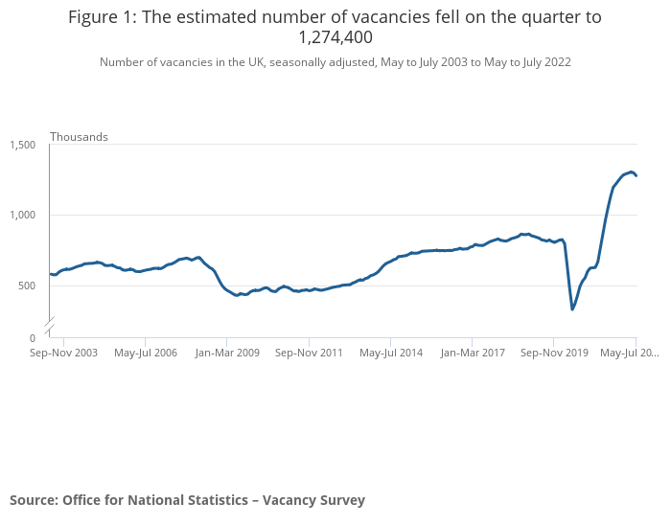
Figure 1: Job Vacancies
Source: (Office for National Statistics, 2022b)

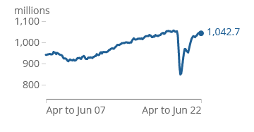
Figure 2: Total Weekly Working Hours
Source: (Office for National Statistics, 2022a)
There is an increase in the total working hours since the past three months and is increased from 4.3 million to 10.3 billion. This value is below the pre-pandemic levels. The lockdown policies are implemented for mitigating the profound impacts of Covid-19 on the labor market. The nursing and care vacancies increased during the lockdown (Arthur, 2021).

2.2 Current Wages and Pay Outlook
The rising inflation has an effect on the wages and pay of the employees. Contemplated on the data revealed by the Office for National Statistics, there is a stagnation in the real wages. There is no fast growth of earnings, which could stabilize the rising inflation. All these are the long-run impacts of the Covid-19 pandemic. Figure 1 indicates the average weekly earnings of UK employees, excluding the bonuses.
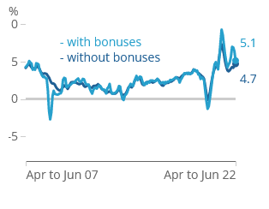
Figure 3: Average Weekly Earnings of UK Employees
Source: (Office for National Statistics, 2022a)
According to the recent data as of August 2022, the growth in the average total pays of the employees including the bonuses was found as 5.1% and regular pay excluding the bonuses were 4.7% from April 2022- June 2022. There is a fall in the regular pay by 3% and total pay by 2.5% (Office for National Statistics, 2022). The strong growth rates of the previous months were upwardly impacted by compositional and base effects and these base effects still prevails among specific sectors during the lockdown period. There is a fall of annual pay growth from 7-6.8% (The Guardian, 2022). The total wages are more prevalent in business and financial sectors. Bonuses are paid to the employees more in private sector, when compared with the public sector. A low base in wages indicates that the year-by-year growth may outsource the improvement in pay.

2.3 Redundancy and Recruitment
There are severe shortages in staff, which has to be resolved for getting the growth of the economy. About 1.69 million jobs are advertised by the employers as of June 12, 2022 (Aldrick, 2022). There is a striking demand for employees in the construction industry. Post Covid-19, the country has been facing more shortages in staffs, which urges the demand for recruitment in the country. In the last quarter, there is a fall in number of redundancies in UK by 21%, which represents the interests of the businesses and the employers in retaining their employees, even though the interest rates have been rising (McCulloch, 2022). Further redundancies are planned by businesses with the cause of factors such as borrowing costs, rise in energy costs and uncertainty over supply chains of many firms. The shortages in staffs are due to the retention of underemployed staffs than making them as redundant staffs. To resolve the current economic crisis, the UK companies are aware that to survive the economic crisis, they are in a situation to retain their own valued employees. Figure shows the redundancy rate per 1000 employees of the quarter.
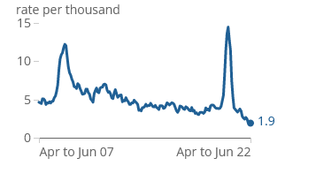
Figure 4: Redundancy Rate per 1000 Employees
Source: (Office for National Statistics, 2022a)
The latest data reveals that the intentions of recruitment are higher than the pre-pandemic levels. About 74% of the employers states that they are planning on new recruitment by the upcoming quarter (Signature, 2021). The shortages in staff are about 45% and the employers are still struggling to fill those vacancies. The employers in UK have planned some solutions to the retention and recruitment difficulties. These solutions encompass upskilling of existing staffs, advertising many flexible jobs and increasing wages. Figure shows the planned response of the employers to retention and recruitment complexities.
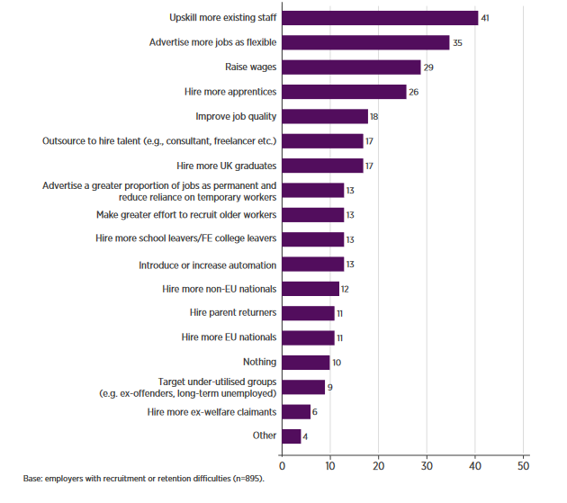
Figure 5: Response of Employers to Retention and Recruitment Complexities
Source: (CIPD, 2022)

Conclusion
The present economy status of UK reveals that the prices of products and services are higher than the wages and pay of the UK employees. The employment rate and the pay scale have to be increased to achieve an economic growth. Also, the shortages in workforce have to be minimized. Some labor reforms have to be planned for increasing welfare of the employees and for enhancing the economic performance. Some changes have to be brought in the employment laws, which minimizes the hiring costs of workers and should create more jobs during firing of employees to assist the firms in recovering from economic shocks. Furthermore, retention strategies have to be effectively planned by the employers for retaining their top employees and enhance the labor market. Costs has to be spent by the employers on educating, training the employees based on their skills and provide them guidance in their career.

The Emerging Changes in Human Resourcing Strategies in the Post Covid, Post Brexit External Environment

Introduction
Brexit and Covid-19 are two complex issues faced by businesses in UK. Brexit happened in 2019 and was the center of focus for the firms in UK and these firms were reluctant on creating contingency plans for their firms post Brexit. There was a diversion in the business attention post the Covid-19 pandemic and firms were creating plans to tackle the immediate effect of the pandemic (Deloitte, 2020). The economic context of Brexit has been entirely fluctuated by the Covid-19 pandemic. The employers must take into consideration, the interaction between Brexit and Covid-19 in all their business operations most importantly in human resource management. The economic shock caused by Covid-19 is strikingly higher than the effect of Brexit. Both Covid-19 and Brexit have longer term and pervasive impacts on businesses. The HR professionals are struck in the cross fire between the Brexit that led to the disruption of demand and supply for talent and covid-19 that created the demand for immediate new working skills and digital transformation (Bizdevdynamics, 2020). This paper is contemplated on the interaction between Covid-19 and Brexit in human resource management and the emerging changes occurring in human resourcing strategies in the post Brexit and post Covid-19 environment.

Brexit and HR Implications
The occurrence of Brexit has inevitably created an uncertainty period, where the uncertainties caused by it cannot be coped up by businesses. The recent vote of the United Kingdom to withdraw from the European Union have caused implications for HR teams and their global organizations, which leads to a potential impact on the employer brand, hiring and recruiting processes in these organizations. Brexit happened to retain the sovereignty of UK over the regulations of the European Union (EU) to minimize the high immigration caused due to the free movement of labor of the European Union (EU) (Gurcheik, 2016). The end of U.K Brexit transition period was 31st December 2020. The rules and regulations in hiring and retaining employees changed post Brexit (ICAEW, 2022). Rapid shifts in talent requirements happens because of relocation, potential brain drain and worker shortages.

2.1 Shifts in Talent Requirements
Disruption is caused by Brexit has influenced the companies to redefine their talent approach. Data suggests that the U.K talent pool is already affected by Brexit with a shift in the migration patterns. The recruitment of top talents has become a complex issue post Brexit. Increase in workforce turnover and difficulty in accessing talent are other complex challenges created by Brexit (Ferens et.al, 2019). Post Brexit, companies are taking actions on both long-term and short-term talent strategy and planning. Some of the emerging strategies in HR adopted by companies include automation, investment in digitalization and next wave of recruitment. For attracting and retaining workers in low-skilled roles, reskilling of such roles are needed for creating a flexible working environment (Ridgway, 2019).

2.2 Brain Drain and Workforce Shortages
Brain drain is fueled by Brexit as most of the skilled Britain workers migrate to the European Union. The migration of these workers to the European Union from U.K is over 30% when compared to the pre-Brexit environment (The Guardian, 2020). By identifying the factors, which are causes for the outflow of the skilled human capital from UK are found as attractive salaries and the indirect role of internationalization policies for encouraging permanent mobility (Khan, 2021). The employee benefit policies must be revised to tackle this issue. The labor supply is highly constrained for the previous year, for the low skilled vacancies. One among the merging HR strategies in the post Brexit and post Covid-19 is the people value chain operating model, which answers all the factors affecting the human resource management. Figure 1 shows the people value chain operating model. With this model a digital team can make up to 50% of work (Ferron and Lomas, 2020).
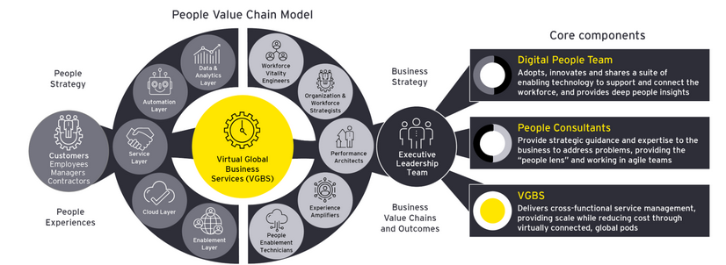
Figure 6: People Value Chain Operating Model
Source: (Vasey, 2021)

Emerging HR Strategies Post Covid-19
Generally, the labor market and in particular, the HR market has been undergoing biggest challenges since the outbreak of the Covid-19 pandemic. The existing priorities and work trends have been reset completely in the past year. Some of the HR strategies for recovering from Covid-19 are remote work, automation, hiring of contingent workers and contractors, management on payroll and finances and emphasis on inclusiveness, treatment and experiences of the employees (Ye, 2021). The HR strategies, which have been emerged due to the uncertainties caused by Covid-19 can be depicted in the below figure 2. In UK, the pandemic has compelled many businesses to urgently construct, adapt and enhance the work procedures and policies.
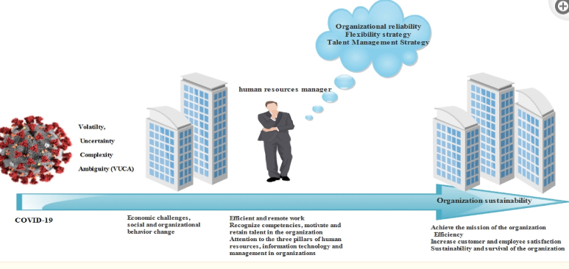
Figure 7: Emerged HR Strategies due to uncertainties caused by Covid-19
Source: (Azizi et.al, 2021)

3.1 Remote Work
During the pandemic, most of the employees have adjusted quickly to remote work and are likely to continue working remotely in the future. The remote work varies among businesses and because of the existing technology and infrastructure, the remote work is done successfully (Guilford, 2020). But there are also some challenges associated with remote work, which include the ability to train the staffs, invest in digital connectivity and equipment for remote workers, monitor productivity, compensation, diversity, staff development, training, retention and recruitment. The scope for remote work has been increased substantially. Some employers fear lac of equipment and distractions in the remote work (Bamieh and Ziegler, 2022).

3.2 Data-driven Decision Making
The data-driven decision-making process has been prevailing from the last decade and has its foot print in the HR department as well. Workforce analytics helps the HR for gauging satisfaction, engagement and experience of an employee. Post Covid-19, leverage analytics are employed by organizations for optimizing their revenues and minimizing their costs. By frequently monitoring and analyzing the employee engagement and performance metrics, the management decisions and the strategic talent development and acquisition are needed to overcome the issues faced by the HR departments post Covid-19 (PwC, 2020).

3.3 Technology and Automation
Digital technology plays a vital role in assisting the organizations in UK for managing the combined effect of Covid-19 and Brexit. Contemplated on the Mendix report, the organizations in UK around various sectors have invested in digital and IT technologies for preparing the EU transition and for overcoming the pandemic (Velocity, 2021). Human-centric automation assists in building a better experience for the employees. The urgent challenges such as Covid-19 and Brexit could be possibly solved with the automation in HR, which creates a future-focused, efficient and an agile HR function. Based on a new study, about 68% of the employers employed automation to respond to the impacts of Covid-19. The use of automation technologies in organizations increased from 58% in 2019 to 73% in 2020 (Cutura, 2022).

Conclusion
The second wave of Covid-19 has an interaction with the end of Brexit and has impacted the various departments such as HR in significant and diverse ways. Despite these challenges have led to the loss of many jobs, the staffing pressures and vacancies are retained as significant. These workforce shortages are estimated to rise during drain of surplus of workers and reopening of the hospitality sector (CMM, 2022). In one way, Brexit created the challenge of drawing the migrants of the European Union, who are exercising their free mobility rights to shift to UK and join the British labor force. On the other hand, many borders have been closed due to Covid-19, which led to the losing of jobs by all categories of the workers. Working with international recruitment agencies, experts and partners, attracting young workers from UK, attracting diverse talents, a different approach in recruitment and a proper workforce planning to retain the employees are some HR strategies, which can be adopted to overcome the Brexit issues.

References
Arthur, R. (2021). Studying the UK job market during the COVID-19 crisis with online job ads. PLOS ONE, 16(5), p.e0251431. doi:10.1371/journal.pone.0251431.

Aldrick, P. (2022). UK Job Vacancies Hit Another High in Sign of Tight Labor Market. Bloomberg.com. [online] 16 Jun. Available at: https://www.bloomberg.com/news/articles/2022-06-16/uk-job-vacancies-hit-another-high-in-sign-of-tight-labor-market [Accessed 24 Aug. 2022].
Azizi, M.R., Atlasi, R., Ziapour, A., Abbas, J. and Naemi, R. (2021). Innovative human resource management strategies during the COVID-19 pandemic: A systematic narrative review approach. Heliyon, [online] 7(6), p.e07233. doi:10.1016/j.heliyon.2021.e07233.
Bamieh, O. and Ziegler, L. (2022). Are Remote Work Options the New Standard? Evidence from Vacancy Postings During the COVID-19 Crisis. Labour Economics, 1, p.102179. doi:10.1016/j.labeco.2022.102179.

Bizdevdynamics (2020). Talent Management in The UK: A Cross-Fire Between COVID-19 And Brexit. [online] bizdevdynamics.com. Available at: https://www.bizdevdynamics.com/post/uk-hr-managers-caught-in-the-crossfire-between-covid-19-and-brexit [Accessed 25 Aug. 2022].
CMM (2022). Navigating change: The impact of COVID-19 and Brexit on the workforce | CMM. [online] Care Management Matters. Available at: https://www.caremanagementmatters.co.uk/feature/navigating-change-the-impact-of-covid-19-and-brexit-on-the-workforce/.
CIPD (2022). Labour Market Outlook. [online] Available at: https://www.cipd.co.uk/Images/labour-market-outlook-summer-2022_tcm18-106241.pdf [Accessed 27 Aug. 2022].
‌
Cutura, S. (2022). COVID, Brexit, IR35: How to solve the UK automation skills gap. [online] info.convedo.com. Available at: https://info.convedo.com/covid-brexit-ir35-how-to-solve-the-uk-automation-skills-gap [Accessed 25 Aug. 2022].
Deloitte (2020). Tackling Brexit and COVID-19 together. [online] Available at: https://www2.deloitte.com/content/dam/Deloitte/uk/Documents/international-markets/deloitte-uk-tackling-brexit-and-covid-19-together.pdf.
Ferens, N., Hoang, K., McLetchie, J. and Walker, P. (2019). Brexit: The bigger picture—Rethinking talent for the long term | McKinsey. [online] www.mckinsey.com. Available at: https://www.mckinsey.com/featured-insights/europe/brexit-the-bigger-picture-rethinking-talent-for-the-long-term.
Ferron, D. and Lomas, A. (2020). Will HR transformation be the thread that ties value to experiences? [online] www.ey.com. Available at: https://www.ey.com/en_gl/workforce/future-hr.
Financial Times (2022). UK labour market remains hot despite stalling economy. Financial Times. [online] 14 Jun. Available at: https://www.ft.com/content/812f3177-2d4d-47df-9c8a-919681f56946.
Guilford, G. (2020). How will COVID-19 change the role of HR? | Coronavirus. [online] HR Solutions. Available at: https://www.hrsolutions-uk.com/covid-19-change-role-of-hr/.
Gurchiek, K. (2016). How HR Can Prepare for Brexit’s Impact. [online] SHRM. Available at: https://www.shrm.org/resourcesandtools/hr-topics/global-hr/pages/brexit-fallout.aspx.
ICAEW (2022). Brexit and HR issues. [online] www.icaew.com. Available at: https://www.icaew.com/brexit/hr [Accessed 25 Aug. 2022].
Khan, J. (2021). European academic brain drain: A meta‐synthesis. European Journal of Education, 1(1). doi:10.1111/ejed.12449.
McCulloch, A. (2022). Number of planned redundancies in UK falls by 21% in last quarter. [online] Personnel Today. Available at: https://www.personneltoday.com/hr/number-of-planned-redundancies-in-uk-falls-by-21-in-last-quarter/ [Accessed 24 Aug. 2022].
Mckinsey (2019). Brexit: The bigger picture—Rethinking talent for the long term | McKinsey. [online] www.mckinsey.com. Available at: https://www.mckinsey.com/featured-insights/europe/brexit-the-bigger-picture-rethinking-talent-for-the-long-term.
ONS (2021). Changing trends and recent shortages in the labour market, UK - Office for National Statistics. [online] www.ons.gov.uk. Available at: https://www.ons.gov.uk/employmentandlabourmarket/peopleinwork/employmentandemployeetypes/articles/changingtrendsandrecentshortagesinthelabourmarketuk/2016to2021.
Office for National Statistics (2022a). Labour market overview, UK - Office for National Statistics. [online] www.ons.gov.uk. Available at: https://www.ons.gov.uk/employmentandlabourmarket/peopleinwork/employmentandemployeetypes/bulletins/uklabourmarket/august2022.
‌
Office for National Statistics (2022b). Vacancies and jobs in the UK - Office for National Statistics. [online] www.ons.gov.uk. Available at: https://www.ons.gov.uk/employmentandlabourmarket/peopleinwork/employmentandemployeetypes/bulletins/jobsandvacanciesintheuk/august2022 [Accessed 31 Aug. 2022].
‌
Powell, A., Francis-Devine, B. and Clark, H. (2022). UK Labour Market Statistics. commonslibrary.parliament.uk, [online] 1(1). Available at: https://commonslibrary.parliament.uk/research-briefings/cbp-9366/.
‌
PwC (2020). How the new normal is shaping the future of HR. [online] PwC. Available at: https://www.pwc.com/m1/en/publications/how-the-new-normal-shaping-future-hr.html.
Ridgway, M. (2019). Brexit: human resourcing implications. Employee Relations: The International Journal, 41(5), pp.1033–1045. doi:10.1108/er-11-2018-0310.
‌
Signature (2021). Recruitment Market Update. [online] Signature Recruitment. Available at: https://www.signaturerecruitment.co.uk/recruitment-market-update/.
The Guardian (2020). Brexit fuels brain drain as skilled Britons head to the EU. [online] the Guardian. Available at: https://www.theguardian.com/world/2020/aug/02/brexit-fuels-brain-drain-as-skilled-britons-head-to-the-eu.
The Guardian (2022). UK real pay falls by record 3%, as job vacancies also decline – as it happened. [online] the Guardian. Available at: https://www.theguardian.com/business/live/2022/aug/16/uk-real-pay-falls-record-3-inflation-job-vacancies-decline-business-live [Accessed 24 Aug. 2022].

Vasey, K. (2021). Reimagining HR: where is your organization in the People Value Chain? [online] www.ey.com. Available at: https://www.ey.com/en_ch/workforce/reimagining-hr-where-is-your-organization-in-the-people-value-ch [Accessed 31 Aug. 2022].

Velocity (2021). Rethinking the role of IT in a post-Brexit, post-COVID landscape. [online] Velocity IT. Available at: https://www.velocity-it.com/knowledge-hub/rethinking-the-role-of-it-in-a-post-brexit-post-covid-landscape/ [Accessed 25 Aug. 2022].
Wood, M. (2022). What do the latest UK labour market data reveal? [online] Economics Observatory. Available at: https://www.economicsobservatory.com/what-do-the-latest-uk-labour-market-data-reveal.

Appendix
Workforce Shortages
The shortage of workers was over 50% in businesses, who are not able to fulfill the demands.
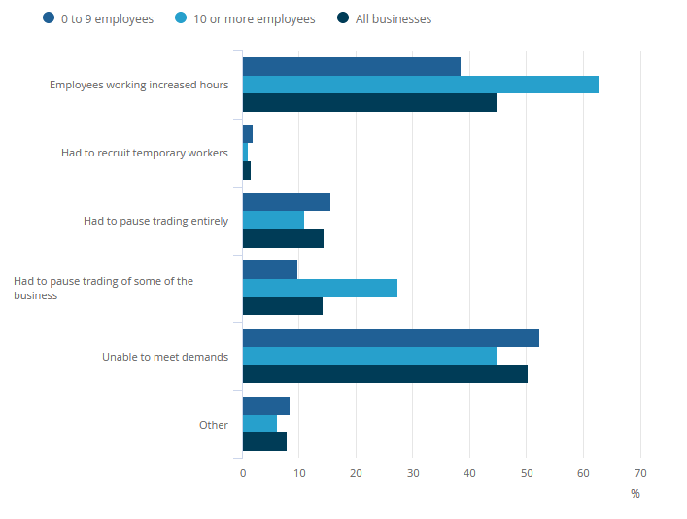
Figure: Employment size based on count
Source: (ONS, 2021)

Loss of Jobs due to Covid-19 Pandemic
The loss of jobs faced by employees in terms of region, nationality and age are depicted in the below figures.
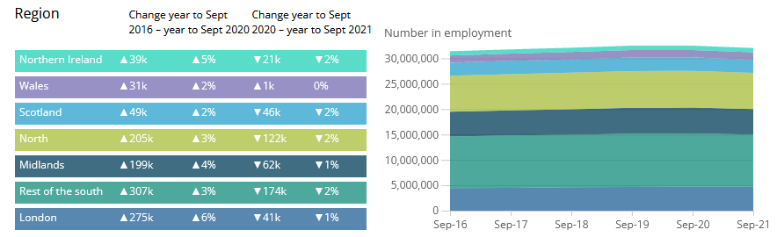
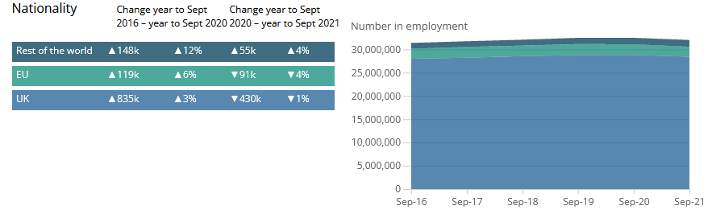
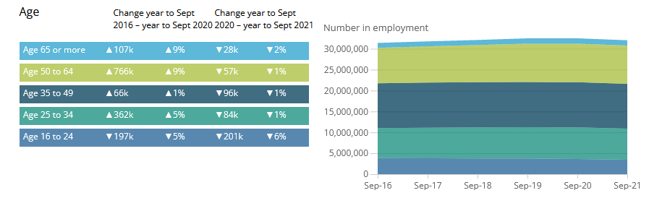
Figure A1: Loss of Employment based on region, nation and age
Source: (ONS, 2021)

Strategic Response to Brexit by Companies
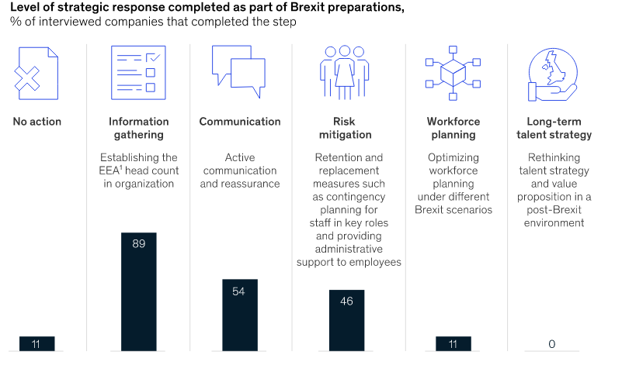
Figure A2: Strategic Response to Brexit by Companies
Source: (Mckinsey, 2019)

