Celebrating Language and Cultural Belonging to Wales

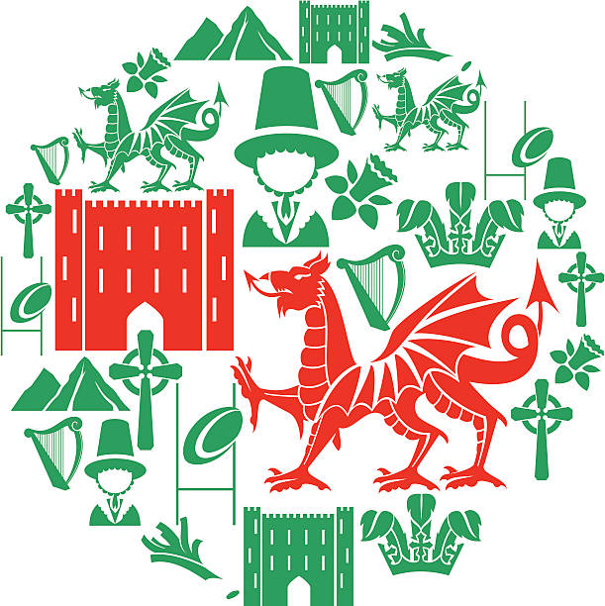

Contents

Rationale 3-4
Overview 5-7
Evaluation 8-9
Appendices 10-22
References 23

The roots of the Welsh language are Celtic and date back to thousands of years ago. The Welsh language is part of tradition and culture to the people living in Wales, yet throughout history the language has come under considerable threat. To understand the importance of the language today in education it is important to acknowledge the struggle and numerous challenges that Welsh has faced throughout time. Under the reign of King Henry VIII the use of Welsh was largely banned under the Act of Union 1536 when laws were passed that removed the official status of the Welsh language, this suppression extended to education in parliamentary reports known as The Blue Book, it stated ‘The Welsh language is a vast drawback to Wales, and is a manifold barrier to the moral progress and prosperity of the people’ Jacob (2017) . During a period in the 19th Century schools punished children for using the Welsh language as it was deemed as a kind of sickness that was harming the nation. Children caught speaking Welsh were made to wear a wooden sign around their necks called the Welsh Not, in the hope that another child was caught and then the sign could be passed on. The child who was wearing it at the end of the school day was punished, usually with a physical beating.
During the 20th Century there was a growing recognition that the Welsh language and Welsh speakers were discriminated against and the beginnings of change began to form. New laws were introduced, importantly The Welsh Language Act 1993 that gave back the language official status, and Welsh began to be widely promoted once more. Then in 1997 Wales historically voted by the narrowest of margins in favour of devolution in the referendum, thereby creating the National Assembly for Wales. Under the Government of Wales Act 1998 the National Assembly set out rules that meant that the Welsh and English languages were to be treated equally and all business was to be conducted bilingually as far as practically possible. Promoting the Welsh language was a key strategy for the Welsh Assembly and the Welsh Language (Wales) Measure 2011 established a new framework for imposing duties on organisations to use Welsh. It also brought in the status of Welsh Commissioner whose principle aim was to promote and facilitate the use of the Welsh language. From the early beginnings of the Welsh Assembly being formed, raising the amount of Welsh speakers in Wales was public policy and the education system was to play a key role.
Jones (2016) expressed that ‘The advent of the assembly in 1999 meant Wales could go its own way and create its own, distinctive education system, rather than being an extension of the system in England’, and since then pupils in Wales have had a very different educational experience to others in the UK. They no longer sit SAT’s (Scholastic Assessment Tests) as they were phased out and replaced with annual reading and numeracy tests, the introduction of the Foundation Phase in 2010 changed the way early years children were taught and importantly for the sustainability of the Welsh language the teaching of Welsh was made compulsory up to the age of 16 in 2000. In 2014 the curriculum in Wales was reviewed by Professor Graham Donaldson, amongst his many recommendations in the Successful Futures report he reported on the use of Welsh in schools stating that:
‘There remains, however, a need to improve the quality and relevance of teaching and learning of the Welsh language in English-medium schools, particularly for older children. We therefore propose greater focus on children and young people’s ability to communicate confidently in everyday settings in the Welsh language, with an emphasis on its increasing role in workplace settings’ Donaldson (2015 p. 108) .
The new Curriculum Cymreig 2022 has taken all the recommendations made by the Donaldson Report and has a strong focus on aiming to help pupils understand what makes living, learning and working in Wales distinctive. It also focuses on increasing the amount of Welsh that children learn, recognising the importance of early years setting and the need for progression that must be consistent through further and higher education.

School A is an English medium, small, semi-rural primary school on the outskirts of Swansea and has made a commitment in its vision to ‘promote the Welsh language through an enriched curriculum that gives pupils a sense of place and heritages as well as a sense of belonging and Welshness’ School A (2019) . Pupils from nursery through to year 6 are provided with opportunities to speak, write and listen to Welsh, as well as being exposed to many displays that contain Welsh both in class and around the school (see Appendix 1). This full exposure according to the linguist Noam Chompsky is particularly influential on primary school aged children. His Universal Grammar Theory suggests that children should see language all around them as well as hear it, he states that ‘If children are frequently exposed to numerous languages during this formative period, they are usually able to express multilingual capabilities’ Bates (2019 p. 210). School A believe it is vitally important that Welsh is used in all areas of the curriculum and in all parts of school life, and the importance of using language naturally in the everyday life of the school is emphasised at all times. The register, date, weather chart (see Appendix 2) and greetings are all done bilingually at the start of each school day, led in each class by the Helpwr Y Dydd. Classroom commands are also spoken in Welsh and English by pupils, teacher and support staff and a Welsh school prayer is spoken by all classes at the end of each school day (see Appendix 3). Welsh songs are sung in assembly and in singing times, and form an important part of all school concerts.
An integral strategy that School A have utilised in the raising of Welsh language standards has been the undertaking of the Siarter Iaith Cymraeg project from ERW (see Appendix 4). This project aims to ‘instil in pupils positive attitudes towards the language which translates into active use’ Welsh Assembly Government (2019, p.3) and does so by providing ideas and targets for the school to work towards with the aim of achieving a Bronze, Silver and then Gold whole school award. As Part of the project one of the most fundamental changes was the setting up of Criw Cymraeg (see Appendix 5) a pupil voice group that aims to encourage and promote the use of Welsh throughout all areas of school life and across the curriculum. Criw Cymraeg is a group of selected children representing every class in the school that meet regularly and are fully involved in planning new and exciting ways to develop and encourage fellow pupils and adults to speak Welsh as much as possible in school. They each have a badge (see Appendix 6) so that they are easily identified and they play an active role in motivating pupils and staff to speak more Welsh. They lead assemblies every fortnight where they have taught the whole school to sing the Welsh National Anthem, Hen Wlad Fy Nhadau (see Appendix 7). Allowing pupils in School A to take ownership and a lead in their learning has proven to have a positive impact with growing numbers of children engaging in the activities that Criw Cymraeg initiate for example on the yard. This peer influence has been studied and fits Bandura’s social learning theory that ‘children’s learning is influenced by observation’ Aubrey and Riley (2019 p. 141), this is backed up by McDonald (2016) who reports that ‘Several research studies have illustrated the significant role that peers play not only in forming supportive networks, but also in enhancing learning and personal development’. It should be noted that this influence can also work negatively so pupils placed in positions of responsibility need adult support and guidance to fulfil such roles.

Another important role that Criw Cymraeg fulfil is to speak to children and staff about cross curricular use of the Welsh language or learning about the culture of Wales. Twice a year they interview subject lead teachers to ask them how they monitor that Welshness is being incorporated into their subjects whilst at the same time speaking to groups of children (see appendix 8) to ask them about the use of Welsh and Welsh culture in their class lessons. This responsibility covers Articles 29 and 30 in the Rights of the Child UNICEF where it states that children have the right to an education that fulfils their potential and develops respect for others as well as allowing them access to the language of their own culture UNIICE (2017). Allowing the children to question adults fits with the new Relationship First policy that school A has adopted that states ‘mutually respectful relationships with all stakeholders is what we strive for, children must feel that they can speak to adults openly and honestly and will be heard’ School A2019). This policy has taken the place of a behaviour policy striving to show the importance of relationships in learning, this approach links with the thinking of the humanist Dewey who championed equal worth to all people, Graham- Matheson (2015 p. 177) stipulates that ‘teachers should relate to students with acceptance, respect, empathy and humanity and as a real person not hiding behind their authority’. It should be acknowledged that this has not been an easy transition as some adults have struggled with the change of being a primarily authoritative figure to taking a more holistic approach to teaching, although this transition has been supported through training during INSET days.
Every March School A hosts a Welsh Week to coincide with St. David’s Day, Criw Cymraeg play an important role in organising fun activities for pupils during this period. The whole school comes off their normal timetable to be replaced with activities that are solely based around Welshness and Wales. Criw Cymraeg run fun competitions both in school and also the wider community, last year for example there was a community competition for the best decorated leek. This wider community involvement supports Bronfenbrenner’s Theory that claims that children thrive when their communities around them all work together, he asserted that ‘a child’s ability to learn depends no less on the existence and nature of ties between the school and the home’ Bronfenbrenner (1979: 51). The local community are invited into school for Welsh coffee morning that the children host and sell Welsh cakes that they have made. This opportunity for cross generational interaction is always a highlight of the week where pupils get to hear of past stories from grandparents that were miners in the old local coal mines and how school life today differs from that years ago.
Importantly Criw Cymraeg with the help of their lead adult ensure that progression is made throughout the school with Welsh learning (see Appendix 9). Children in Foundation Phase are all provided with what Vygotsky called scaffolding to help with any written Welsh work that is gradually reduced as they progress through school years with the exception of any children that have additional learning needs. According to Child (2007, p 67) scaffolding is ‘a matter of judging how much, and when support is needed’ and in School A this is provided on individual need through differentiation. School A has an overarching aim, for all pupils to fulfil their full potential across the curriculum, and endeavour to ensure that all children are given the necessary support to access learning in line with their Equal Opportunities Policy, SEN Policy and Inclusion Policy. Ensuring progression in Welsh throughout the school is a key component of gaining awards from the Siarter Iaith Cymraeg project. Progression needs to be evidenced and documented and ‘a clear commitment to the development of the Welsh language and culture at a whole-school level’ WAG (2019) needs to be shown .

School A has shown a significant commitment to the promotion of the Welsh language. By signing up to the Siarter Iaith Cymraeg project they have benefitted from a clear set of targets to work towards that aim to increase the use of social Welsh used by all stakeholders in the school. The introduction of a Criw Cymraeg as part of the project has had a positive impact on engagement of pupils in school, they have had a direct influence of some of the Welsh that is now seen around School A for example Welsh game posters on the yard (see Appendix 10) and Criw Cymraeg areas in classes (see Appendix 11). The children clearly enjoy the responsibility that comes with being a member of the Criw and have built confident, less formal relationships with the staff that help to lead them. Whitebread claims that these more informal interactions lead to ‘the teacher being able to rely on pupils to act responsibly and will be able to relate to them on a more equal basis in the knowledge that they will not overstep the mark’ (Whitebread 2000 p.53), this is evidenced when the Criw are given tasks that they are able to complete independently. There is however an expectation that staff have a reasonable level of Welsh themselves in order to support and challenge pupils in their learning of Welsh, and there is limited funding for staff training for those that lack confidence.
Whilst School A have achieved success through the implementation of Siarter Iaith and Criw Cymraeg as commented on by Estyn in their last inspection, it has required a significant level of input. The planning, organising and delivering of activities to achieve awards is a considerable undertaking that comes with no financial support, when school supplies and resources are limited this has been a challenge at times. Criw Cymraeg have organised fundraising events for example to fund the outdoor posters on the yard, and whilst School A pride itself on Pupil Voice there is still the need for substantial adult support for them to achieve such results. The Welsh Government have shown a real commitment to keeping the language alive and thriving with an ambitious target of 1 million Welsh speakers by 2050 and to achieve this state in their Welsh in Education Plan 2017-21 that ‘key transformational changes will be required within the education sector in order to achieve the vision’ (WAG 2017). It also emphasises the need for quality training for all educational staff, this requires a commitment from local authorities to provide the funding to schools to upskill their workforce which in turn upskills future generations of Welsh speakers in schools.
With the implementation of the new Curriculum Cymreig 2022 that aims to ‘help pupils to understand and celebrate the distinctive quality of living and learning in Wales in the twenty-first century’ (ACCAC 2003) it is important that schools engage pupils in the rich history of Wales and the Welsh language. Flexibility of the new curriculum will allow a more creative approach to learning that aims to be better suited to learners. Nevertheless as School A has found developing new initiatives needs support from management, and an investment of time, money and resources from those in positions of power to make change happen. Schools in Wales have a large part to play in ensuring that future generations not only get taught Welsh and Welsh history but also enjoy the process of learning along the way. But, to enable this to happen successfully school staff must be supported through efficient training, effective resources and management that allows time for planning. Then pupils will benefit from adults who are enjoying learning alongside them.

Appendices

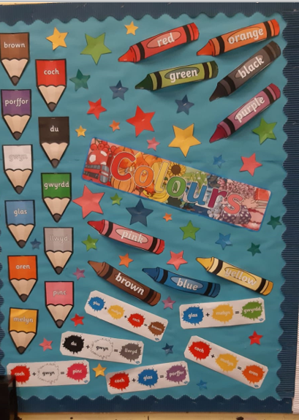
Appendix 1

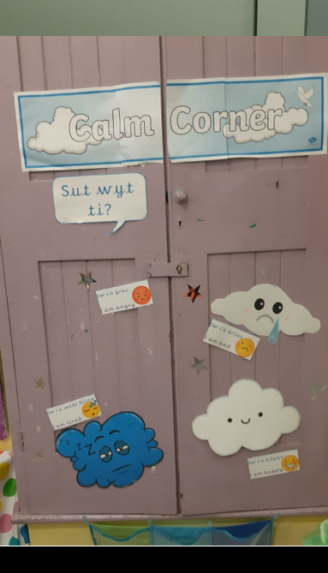

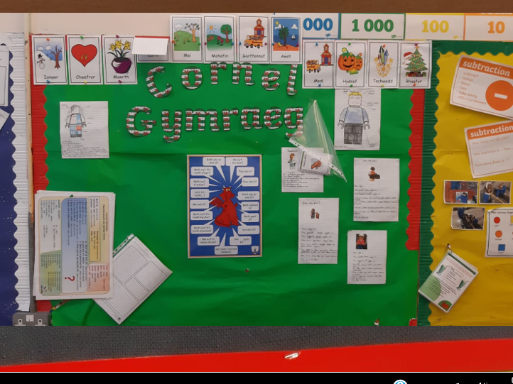

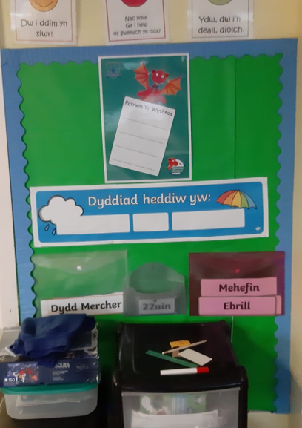
Appendix 2

Appendix 3
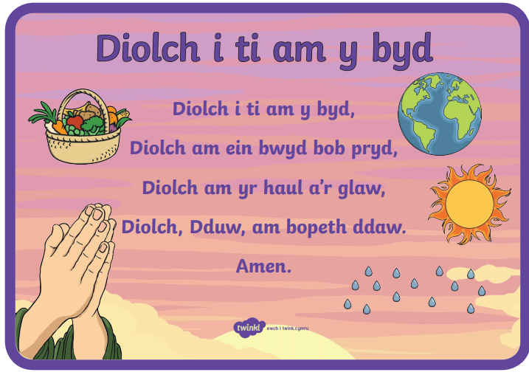
Appendix 4

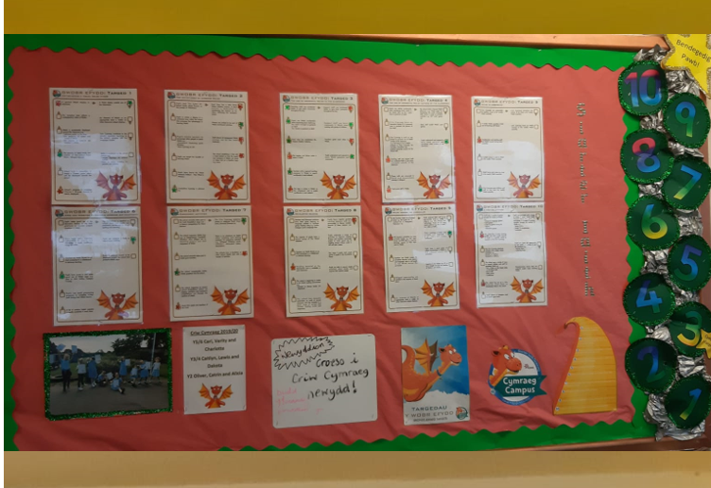

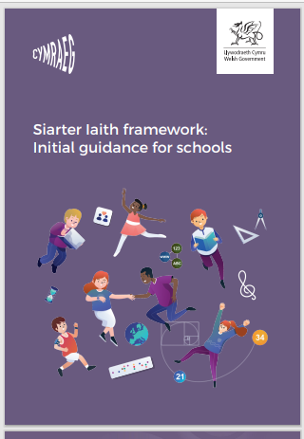

Appendix 5

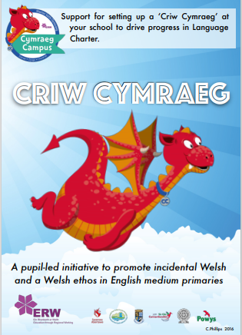

Appendix 6


Appendix 7

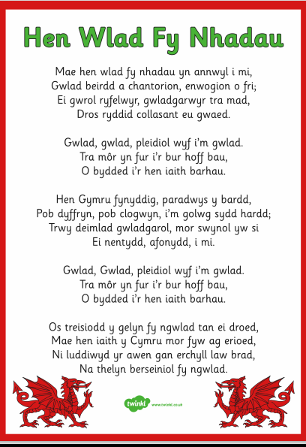

Appendix 8

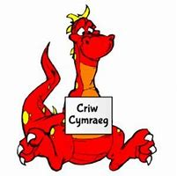
Pengelli Primary School Criw Cymraeg Questionnaire

- Do you see Welsh signs and displays around school? Where are they?
- Do you speak Welsh in class during lessons?
- Does your teacher speak Welsh to you during lessons?
- Do you think that learning Welsh is important?
- Do you hear Welsh in assemblies? What do you hear?
- Does your teacher use Welsh in lots of lessons, for example in geography or maths?
- Do you learn about Wales? What have you learned?
- Do you enjoy learning Welsh and learning about
Wales? What do you like learning best?

Appendix 9

Sample year 1 work
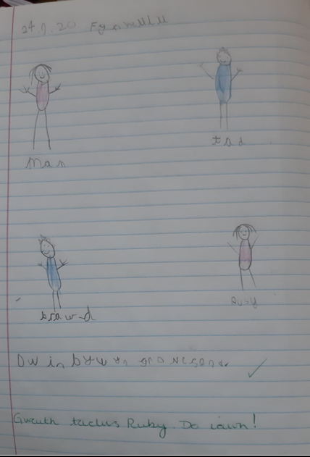
Sample Year 2 work

#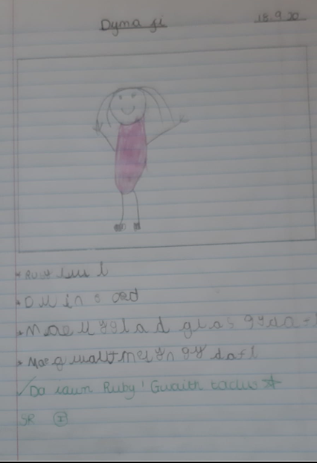

Sample Year 5 work

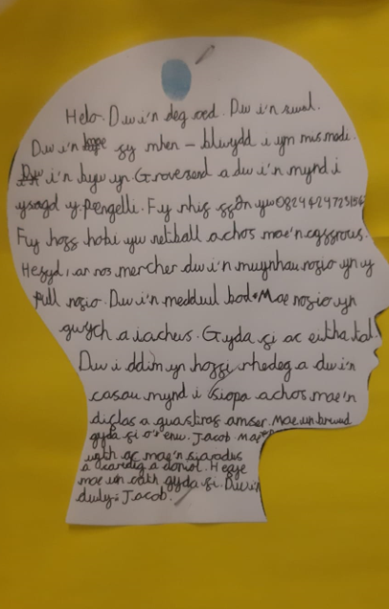

Appendix 10
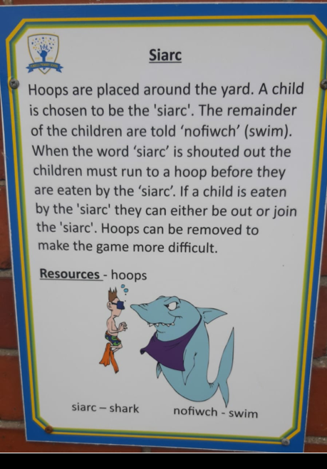
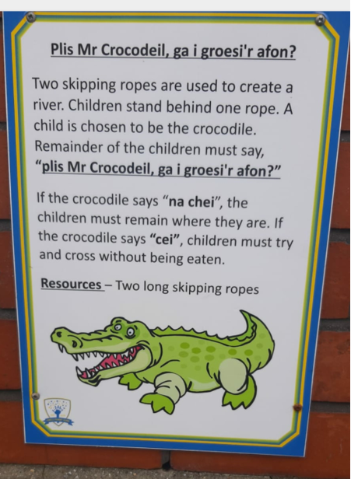

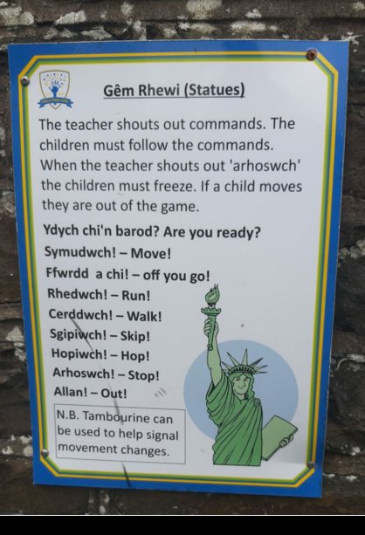

Appendix 11

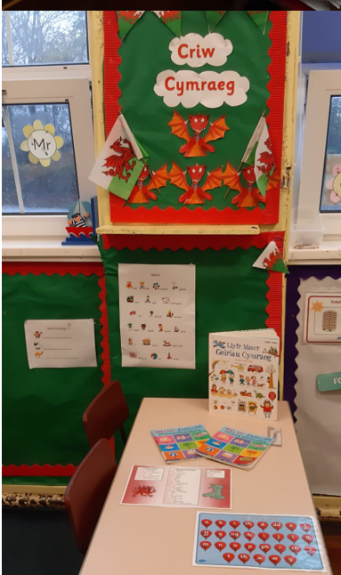
References

ACCAC (2003) Developing the Curriculum Cymreig Available at: http://wasacre.org.uk/publications/wag/E-developingthecurriculumcymreig.pdf Accessed on: 8th November 2020

Aubrey, K and Riley, A. (2019) ‘Understanding and Using Educational Theories’ Sage Publications Ltd. London.

Bates, B. (2019) ‘Learning Theories Simplified’ SAGE Publications Ltd, London.

Bronfenbrenner, U. (1979) ‘The Ecology of Human Development’. MA: Havard University Press, Cambridge.

Child, D. (2007) ‘Psychology and the Teacher’ Continuum International Publishing Group, York.

Donaldson, G. (2015) Successful Futures Report Independent Review of Curriculum and Assessment Arrangements in Wales. Available at: https://gov.wales/sites/default/files/publications/2018-03/successful-futures.pdf Accessed on: 3rd November 2020

Graham-Matheson, L. (2015) ‘Essential Theory for Primary Teachers’. Routledge, Oxon.

Jacob, P. (2017) A Brief History of the Welsh Language Available at: https://theculturetrip.com/europe/united-kingdom/wales/articles/a-brief-history-of-the-welsh-language/ Accessed on: 1st November 2020

Jones, A. (2016) How Wales Works: Changes to Welsh Schools Post Devolution Available at: https://www.bbc.co.uk/news/uk-wales-35323992 Accessed on: 4th November 2020

Mcdonald, K. (2016) Building an Effective Mentoring Scheme Available at: https://www.sec-ed.co.uk/best-practice/building-an-effective-peer-mentoring-scheme-1/ Accessed on: 5th November 2020

Qazimi, S. (2014) Sense of place and place identity European Journal of Social Sciences. Volume 1 Issue 1 p.307

School A (2019) Vision Statement. Anonymous, Swansea.

UNICEF (2017) Our Rights Available at: https://www.unicef.org.uk/wp-content/uploads/2017/09/Our-rights_UNCRC.pdf Accessed on: 5th November 2020

WAG (2017) Welsh in Education Plan 2017-2021 Available at: https://gov.wales/sites/default/files/publications/2018-02/welsh-in-education-action-plan-2017%E2%80%9321.pdf Accessed on: 8th November 2020

WAG (2019) Siarter Iaith framework: Initial guidance for schools Available at: https://hwb.gov.wales/api/storage/3b73bf7c-640d-4c34-855d-9586b0b30c80/siarter-iaith-framework.pdf Accessed on: 4th November 2020

Whitebread, D. (2000) ‘The Psychology of Teaching and Learning in the Primary School’ Routledgefalmer, London.

