1901768
Network Programmability

Contents
Introduction 2
Using git+github 2
GIT 2
GitHub 3
Purpose 4
Scope 5
Functions/loops : 5
Inputs: 5
IFS/ELSES 5
Implementation 6
Starting of code 6
Further development 7
The final development of code and program 9
Screenshots of the program 12

Introduction
This report shows the analysis, design, implantation and testing of the application. It also shows using GIT, and restful API. The application should pull information from the API and come back with the data. I had to use an API key for it to be able to search by author which was quite confusing to do. It also shows the starting of the code to a further deeper of code expanding to the final product. Created this program in Visual Studio Code.
When creating an application the API that was used is Google Book API - https://developers.google.com/books/

Using git+github

GIT
Creating username, and email for GIT.
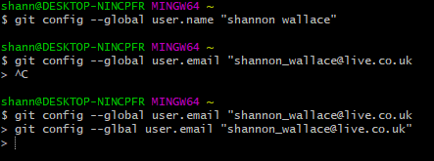
Screenshot below shows creating a folder in GIT.
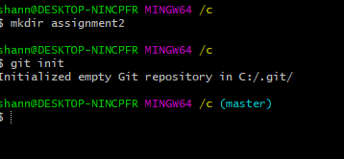
Screenshot below shows the folder in C drive
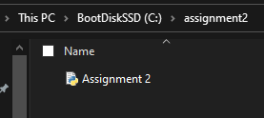

GitHub
This the readme file. It tells you about the program application.
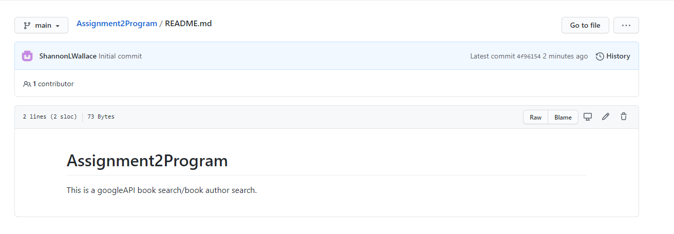
This is the code below. It is shown on github and accessible.
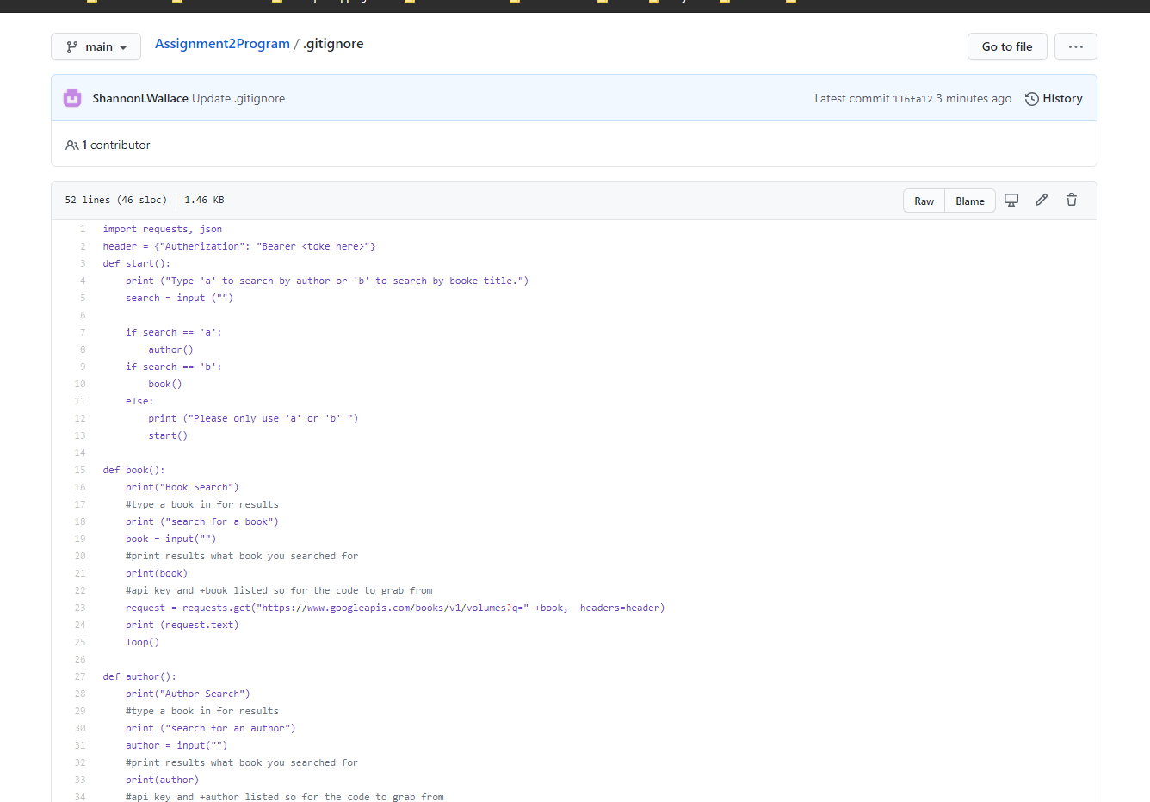
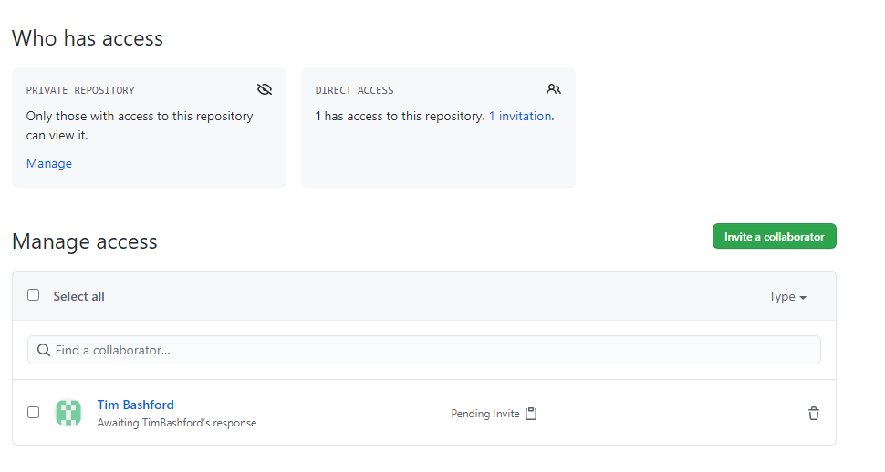

Purpose
The purpose of my application is that a user can find a book by typing in a book title or either by author. It is using googles API BOOK. The purpose of the application is that a user can easily find a book by typing in the name of the book. The user can either type in “A” or “b” to search for either author or book. After getting the information they can either restart or exit the program.

Scope
The scope is for an application to search by name or by author. The program should show description of the book details if search by the book title. Details which are shown are: author, description, published date, subtitle, link, kind, and id. Same as author search however it is searched by the author name.
The functions, inputs, and ifs are down below to show what were used in the application to make it work. The loops were used to restart or exit the program instead of getting it back up again.

Functions/loops :
DEF Start
DEF book
DEF author
DEF loop

Inputs:
Book search = b
A to search or B to search
Author Search = a
Y to restart or N to exit

IFS/ELSES
If Search a
If Search b
Else a or b
If restart Y
If restart no
Else y or no

Implementation

Starting of code
The starting of the code was basic. It had to do the simplest thing which was to search for a book specifically by user input.
The starting of the code. Screenshot below shows:
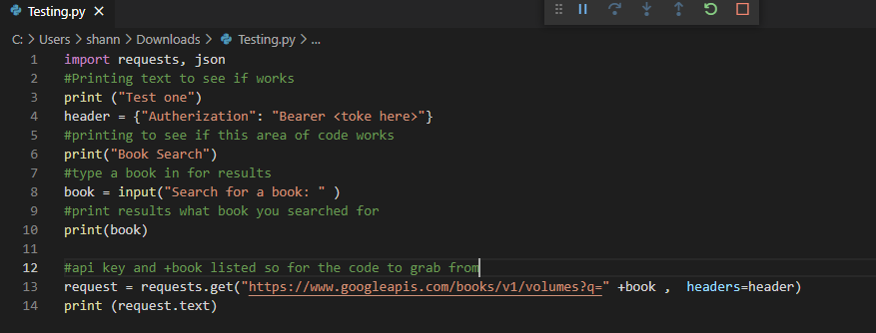
The screenshots show the API, and searching for a book. Basically, this is the code just for the application to grab data, and then to end.
The screenshot below shows the results of the program.
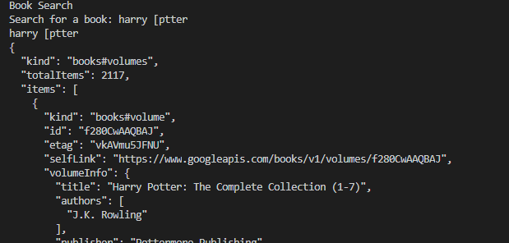

Further development
Before setting up the code had an issue which the code wasn’t working because of the issue had to put (request.text) before instead of after the API. The screenshot below shows the issue. To solve this had to put it after the request.
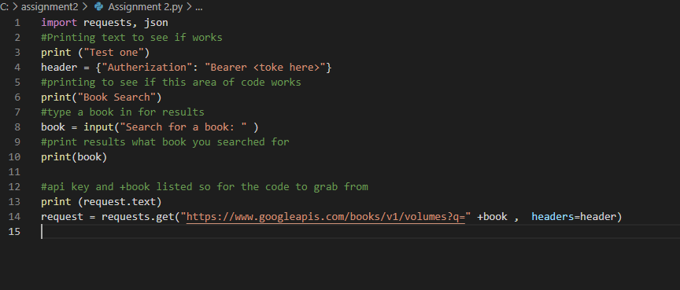
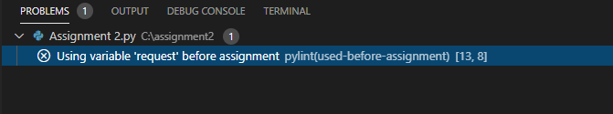
After this problem checked to see if it worked in windows exe. The program would automatically close after results so you would not be able to see results. To solve this issue had a loop to either restart the search or to exit the search.
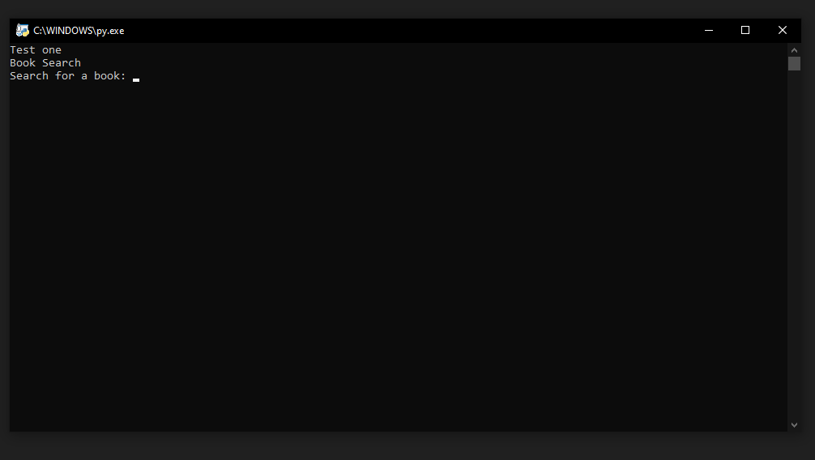

Further expanding into the coding wanted the search to be more specific. Such as searching for author or book. Screenshot below shows author search.
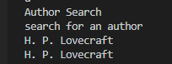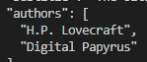
The screenshot below shows the book search being used. The book search works differently it picks up the key words any book with the name “Harry Potter” in the book title or description.
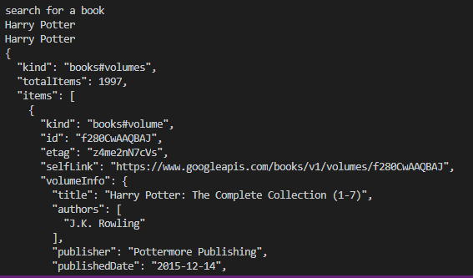

The final development of code and program
The screenshot below shows the first 13 lines of the code. It has a loop to start the search. The code shown below basically allows the user to see and to search either by Author or Book Title. It also has IF statements so then the program knows what to do and if they don’t use the requirements which are needed to search then it will say “Please only use a or b”
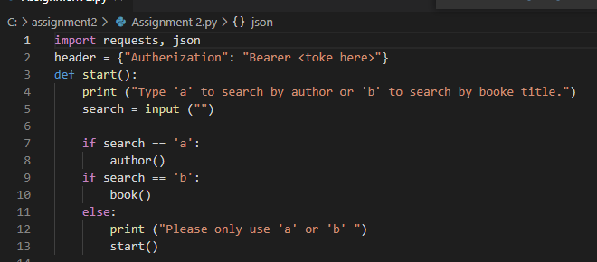
The screenshot below shows a loop for book search. For the program to restart it had to be in a loop. So book has input, print, and request which allows to get the specific data that is needed for the book search.
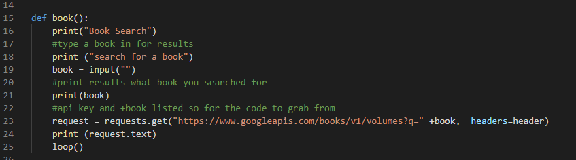
The screenshot below shows a loop for author search. This code was a bit different to the book search code due to having a APIKEY as well as specifically searching for +author. This code allows the user to type in author and then have results showing books made by that specific author.
HAD TO CREATE A GOOGLE API key for this part!!
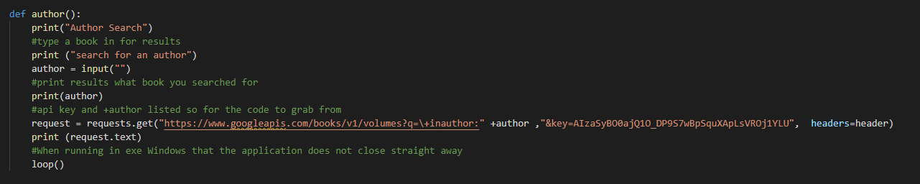

The screenshot below shows another loop. This loop is specifically for the user to either search again or to exit the program. It requires user to type in Y OR N. Y= is to restart and N to exit.
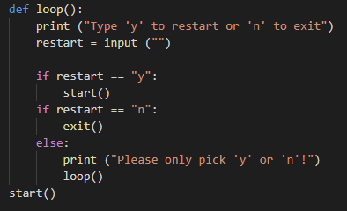

The screenshot below shows the code working:
Searched for an author.
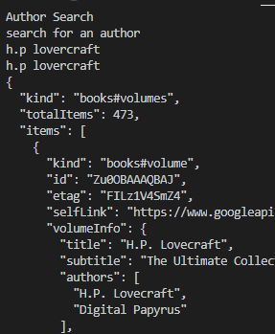
Got results and then asked to restart or to exit.
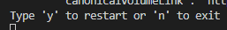

Typed Y screenshot below shows what happens next.

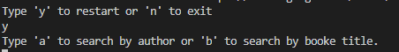
Then typed B for book search.
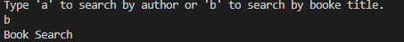
Searched for Oliver twist. Results are shown below
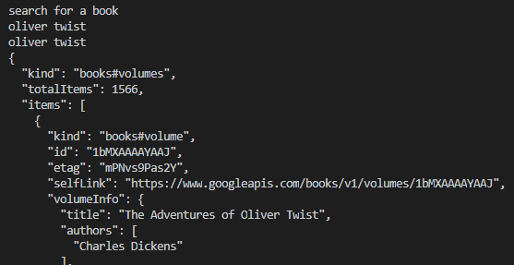
Then quit the application by input N.
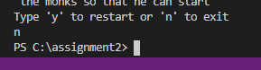

Screenshots of the program
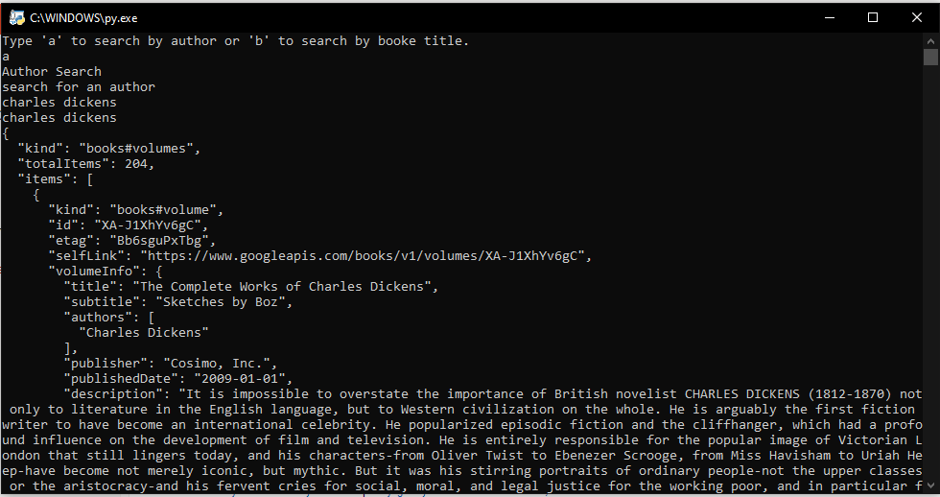


Conclusion
When creating the application ran into a few issues such as forgetting the brackets, colons, and placing the code in the wrong place as the screenshots above shows you. They were easily fixed due to the software called Visual Studio Code. The software show where there are problems and sometimes tell you the solution. The application works fine and does what I expect it should do. When creating the application I also ran into issues such as the BASE of google API was accessible to use however to get what you specifically wanted I then had to set up an API key for the application to work.

