
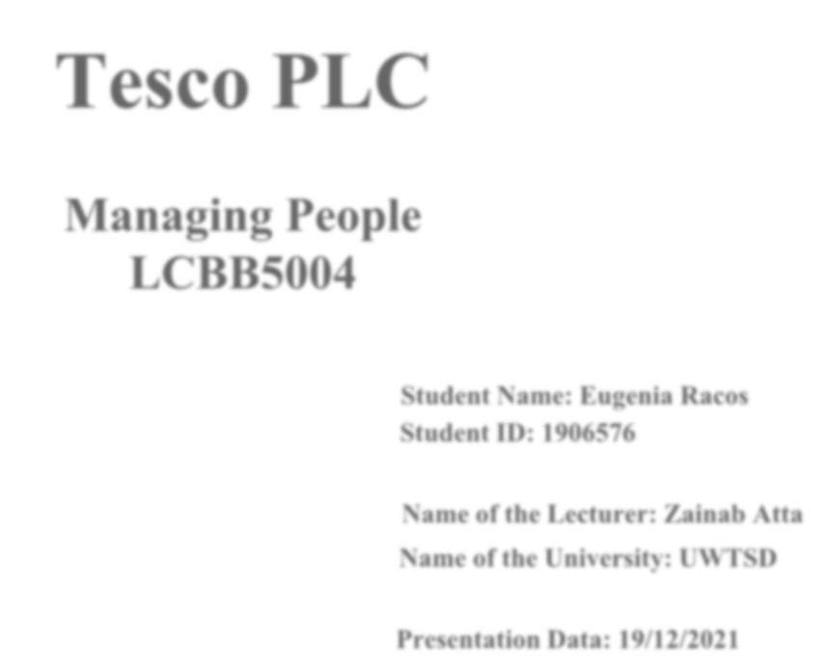

Tesco PLC
Managing People LCBB5004

Student Name: Eugenia Racos Student ID: 1906576

Name of the Lecturer: Zainab Atta Name of the University: UWTSD

Presentation Data: 19/12/2021



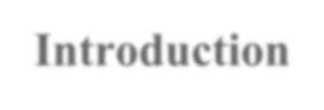
Introduction

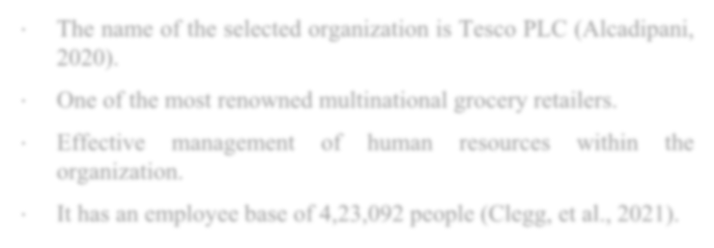

- The name of the selected organization is Tesco PLC (Alcadipani,
2020).
- One of the most renowned multinational grocery retailers.
- Effective management of human resources within the organization.
- It has an employee base of 4,23,092 people (Clegg, et al., 2021).

Figure 1
Source:(Ter Hoeven, and Van Zoonen, 2020)

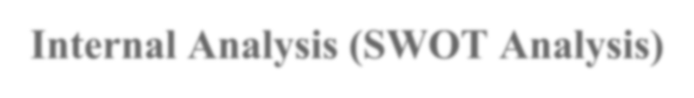
Internal Analysis (SWOT Analysis)



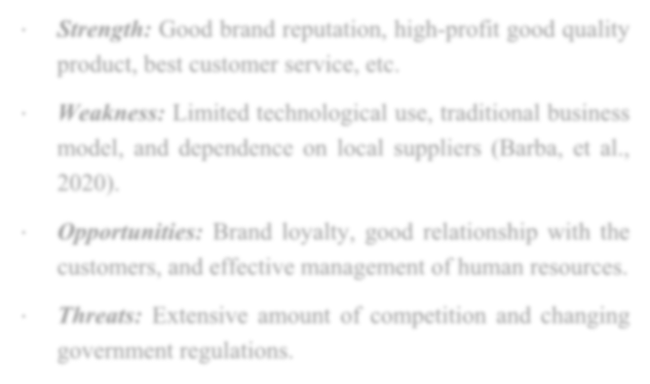
Figure 2
- Strength: Good brand reputation, high-profit good quality product, best customer service, etc.
- Weakness: Limited technological use, traditional business model, and dependence on local suppliers (Barba, et al., 2020).
- Opportunities: Brand loyalty, good relationship with the
customers, and effective management of human resources.
- Threats: Extensive amount of competition and changing government regulations.
Source:(Snider, 2022)

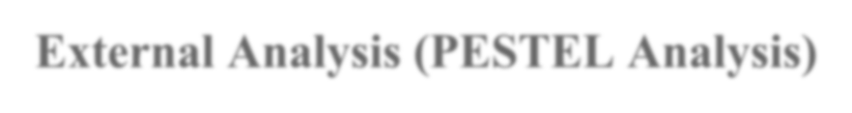
External Analysis (PESTEL Analysis)

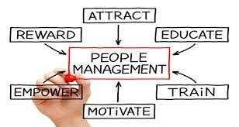

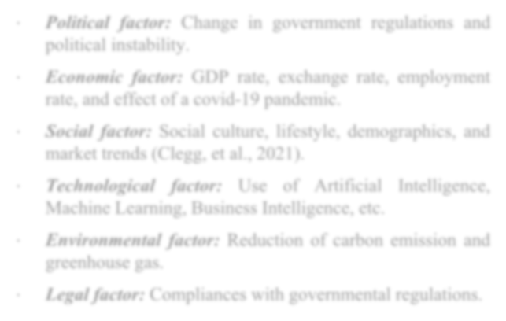
Figure 3
∙

∙

∙
Political factor: Change in government regulations and
political instability.
Economic factor: GDP rate, exchange rate, employment rate, and effect of a covid-19 pandemic.
Social factor: Social culture, lifestyle, demographics, and market trends (Clegg, et al., 2021).
∙
Technological factor: Use of Artificial Intelligence,
Machine Learning, Business Intelligence, etc.
- Environmental factor: Reduction of carbon emission and greenhouse gas.
- Legal factor: Compliances with governmental regulations.
Source:(Sheth, 2020)


Working personnel of Tesco Plc


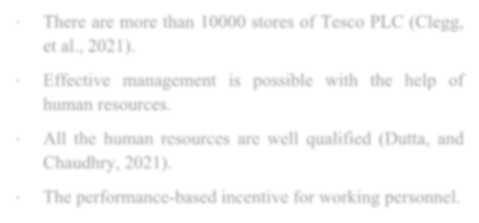
- There are more than 10000 stores of Tesco PLC (Clegg,
et al., 2021).
- Effective management is possible with the help of human resources.
- All the human resources are well qualified (Dutta, and
Chaudhry, 2021).
- The performance-based incentive for working personnel.

Figure 4 Source:(Milliken, and Bechky, 2020)

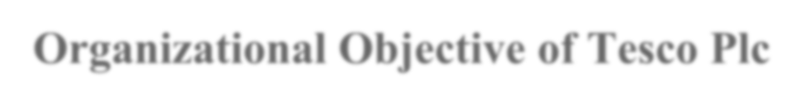
Organizational Objective of Tesco Plc

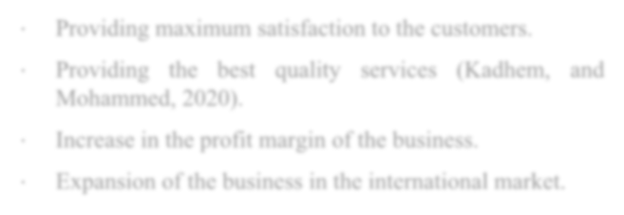

- Providing maximum satisfaction to the customers.
- Providing the best quality services (Kadhem, and Mohammed, 2020).
- Increase in the profit margin of the business.
- Expansion of the business in the international market.
Figure 5 Source:(McNulty, and Marcus, 2020)


HR Function of Tesco Plc


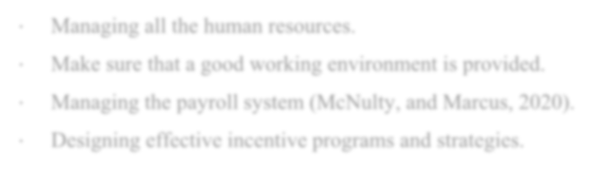
- Managing all the human resources.
- Make sure that a good working environment is provided.
- Managing the payroll system (McNulty, and Marcus, 2020).
- Designing effective incentive programs and strategies.

Figure 6 Source:(Kadhem, and Mohammed, 2020)


Planning function of Tesco Plc

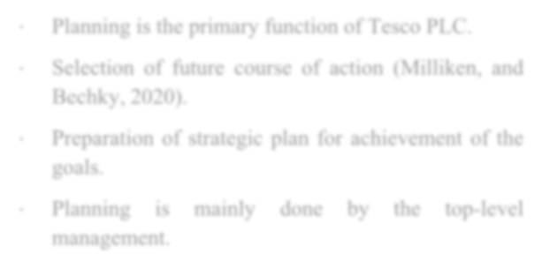
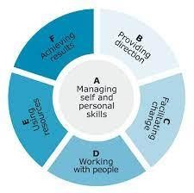
- Planning is the primary function of Tesco PLC.
- Selection of future course of action (Milliken, and Bechky, 2020).
- Preparation of strategic plan for achievement of the goals.
∙ Planning is mainly
done by
the top-level
management.

Figure 7 Source:(Dutta, and Chaudhry, 2021)

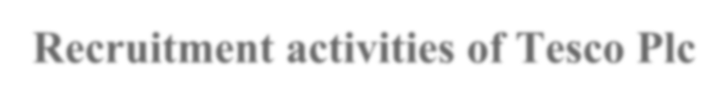
Recruitment activities of Tesco Plc

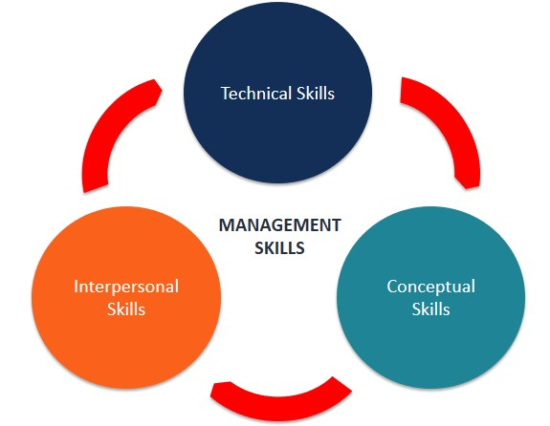
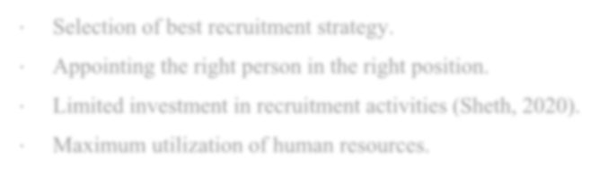
- Selection of best recruitment strategy.
- Appointing the right person in the right position.
- Limited investment in recruitment activities (Sheth, 2020).
- Maximum utilization of human resources.

Figure 8 Source:(Clegg, et al., 2021)


Selection activities of Tesco Plc

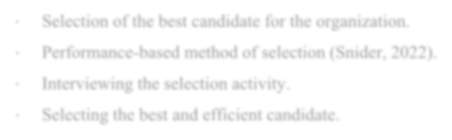

- Selection of the best candidate for the organization.
- Performance-based method of selection (Snider, 2022).
- Interviewing the selection activity.
- Selecting the best and efficient candidate.

Figure 9 Source:(Barba, et al., 2020)

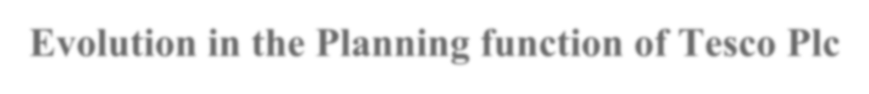
Evolution in the Planning function of Tesco Plc


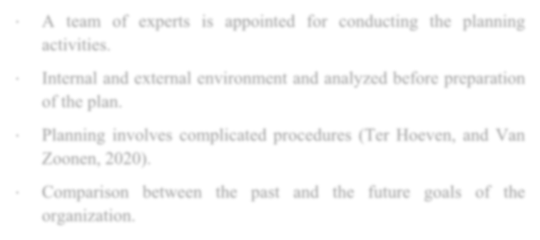
- A team of experts is appointed for conducting the planning
activities.
- Internal and external environment and analyzed before preparation of the plan.
- Planning involves complicated procedures (Ter Hoeven, and Van Zoonen, 2020).
∙ Comparison between
organization.
the
past and the future goals of the

Figure 10
Source:(Alcadipani, 2020)

Evaluation in the Recruitment activities of Tesco Plc

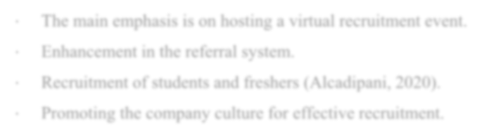
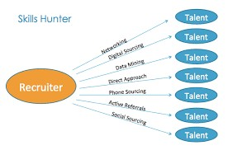
- The main emphasis is on hosting a virtual recruitment event.
- Enhancement in the referral system.
- Recruitment of students and freshers (Alcadipani, 2020).
- Promoting the company culture for effective recruitment.

Figure 11
Source:(Ter Hoeven, and Van Zoonen, 2020)

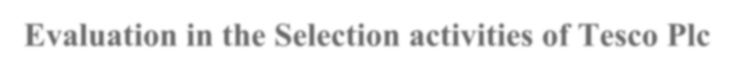
Evaluation in the Selection activities of Tesco Plc

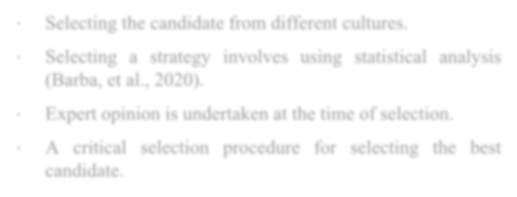

- Selecting the candidate from different cultures.
- Selecting a strategy involves using statistical analysis (Barba, et al., 2020).
- Expert opinion is undertaken at the time of selection.
- A critical selection procedure for selecting the best
candidate.

Figure 12
Source:(Snider, 2022)

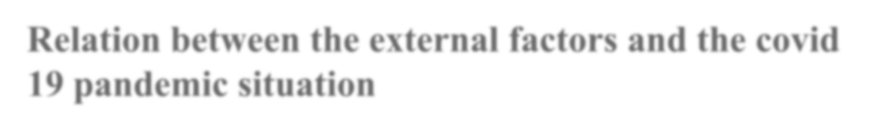
Relation between the external factors and the covid 19 pandemic situation

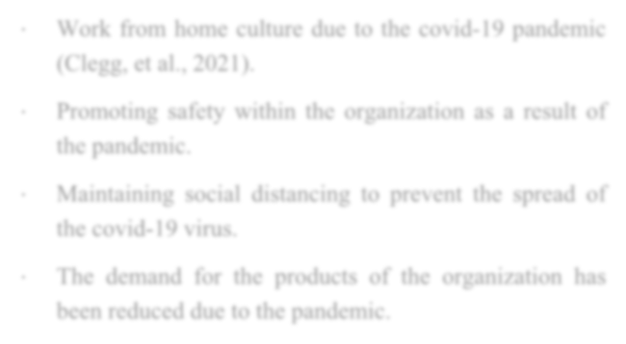

- Work from home culture due to the covid-19 pandemic (Clegg, et al., 2021).
- Promoting safety within the organization as a result of the pandemic.
- Maintaining social distancing to prevent the spread of
the covid-19 virus.
- The demand for the products of the organization has been reduced due to the pandemic.

Figure 13
Source:(Sheth, 2020)

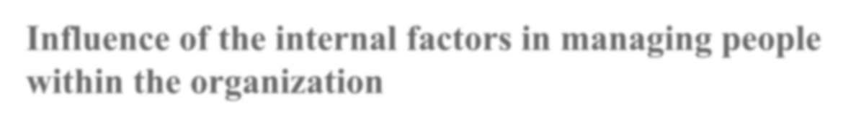
Influence of the internal factors in managing people within the organization


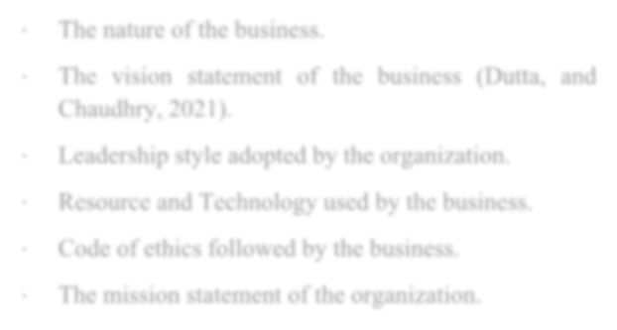
- The nature of the business.
- The vision statement of the business (Dutta, and Chaudhry, 2021).
- Leadership style adopted by the organization.
- Resource and Technology used by the business.
- Code of ethics followed by the business.
- The mission statement of the organization.

Figure 14 Source:(Milliken, and Bechky, 2020)

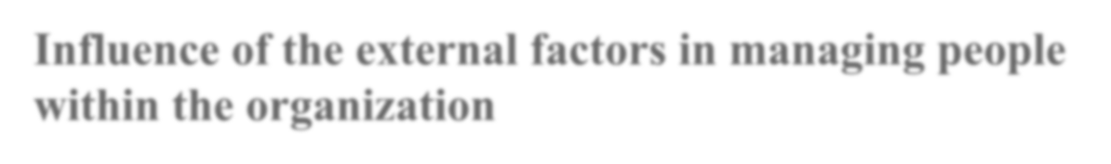
Influence of the external factors in managing people within the organization

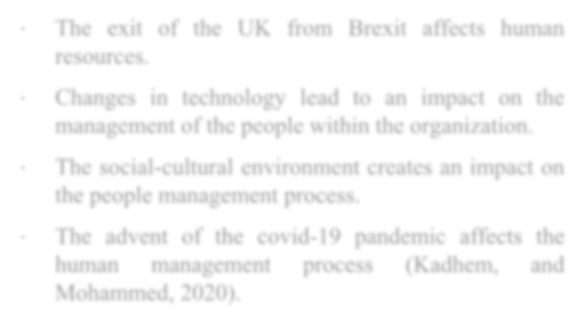

∙ The exit of the
resources.
UK
from Brexit affects human
- Changes in technology lead to an impact on the
management of the people within the organization.
- The social-cultural environment creates an impact on
the people management process.
- The advent of the covid-19 pandemic affects the human management process (Kadhem, and Mohammed, 2020).
Figure 15
Source:(McNulty, and Marcus, 2020)

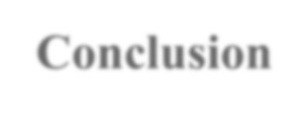
Conclusion

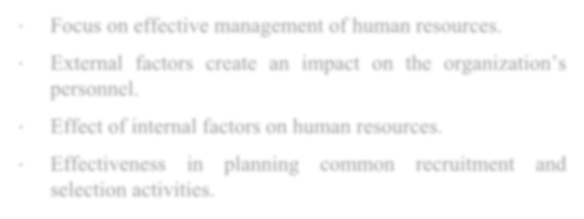
- Focus on effective management of human resources.
- External factors create an impact on the organization’s personnel.
- Effect of internal factors on human resources.
- Effectiveness in planning common recruitment and selection activities.

Figure 16 Source:(Kadhem, and Mohammed, 2020)

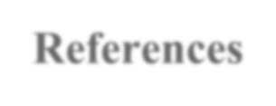
References

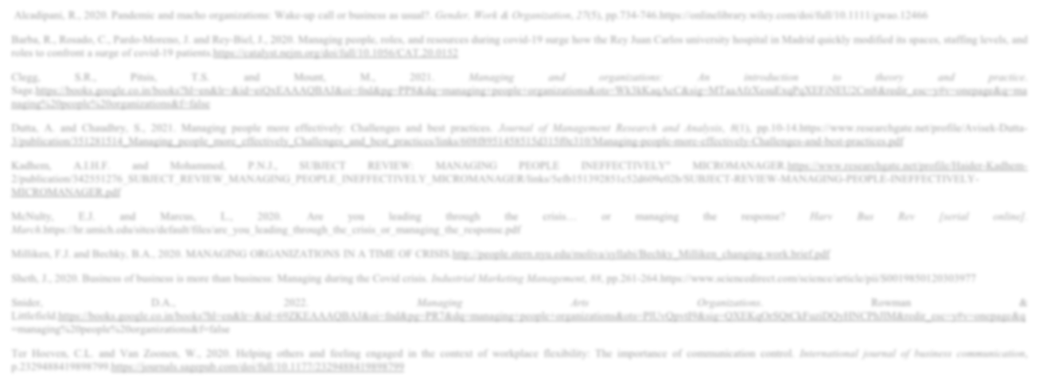
Alcadipani, R., 2020. Pandemic and macho organizations: Wake‐up call or business as usual?. Gender, Work & Organization, 27(5), pp.734-746.https://onlinelibrary.wiley.com/doi/full/10.1111/gwao.12466

Barba, R., Rosado, C., Pardo-Moreno, J. and Rey-Biel, J., 2020. Managing people, roles, and resources during covid-19 surge how the Rey Juan Carlos university hospital in Madrid quickly modified its spaces, staffing levels, and roles to confront a surge of covid-19 patients.https://catalyst.nejm.org/doi/full/10.1056/CAT.20.0152

Clegg, S.R., Pitsis, T.S. and Mount, M., 2021. Managing and organizations: An introduction to theory and practice. Sage.https://books.google.co.in/books?hl=en&lr=&id=eiQxEAAAQBAJ&oi=fnd&pg=PP8&dq=managing+people+organizations&ots=Wk3kKaqAcC&sig=MTaaAfzXesuExqPqXEFiNEU2Cm8&redir_esc=y#v=onepage&q=ma naging%20people%20organizations&f=false

Dutta, A. and Chaudhry, S., 2021. Managing people more effectively: Challenges and best practices. Journal of Management Research and Analysis, 8(1), pp.10-14.https://www.researchgate.net/profile/Avisek-Dutta- 3/publication/351281514_Managing_people_more_effectively_Challenges_and_best_practices/links/608f8951458515d315f0e310/Managing-people-more-effectively-Challenges-and-best-practices.pdf

Kadhem, A.I.H.F. and Mohammed, P.N.J., SUBJECT REVIEW: MANAGING PEOPLE INEFFECTIVELY" MICROMANAGER.https://www.researchgate.net/profile/Haider-Kadhem- 2/publication/342551276_SUBJECT_REVIEW_MANAGING_PEOPLE_INEFFECTIVELY_MICROMANAGER/links/5efb151392851c52d609e02b/SUBJECT-REVIEW-MANAGING-PEOPLE-INEFFECTIVELY- MICROMANAGER.pdf

McNulty, E.J. and Marcus, L., 2020. Are you leading through the crisis… or managing the response? Harv Bus Rev [serial online]. March.https://hr.umich.edu/sites/default/files/are_you_leading_through_the_crisis_or_managing_the_response.pdf

Milliken, F.J. and Bechky, B.A., 2020. MANAGING ORGANIZATIONS IN A TIME OF CRISIS.http://people.stern.nyu.edu/moliva/syllabi/Bechky_Milliken_changing.work.brief.pdf

Sheth, J., 2020. Business of business is more than business: Managing during the Covid crisis. Industrial Marketing Management, 88, pp.261-264.https://www.sciencedirect.com/science/article/pii/S0019850120303977

Snider, D.A., 2022. Managing Arts Organizations. Rowman & Littlefield.https://books.google.co.in/books?hl=en&lr=&id=69ZKEAAAQBAJ&oi=fnd&pg=PR7&dq=managing+people+organizations&ots=PlUvQpvtI9&sig=QXEKqOrSQtCkFuziDQyHNCPhJlM&redir_esc=y#v=onepage&q
=managing%20people%20organizations&f=false

Ter Hoeven, C.L. and Van Zoonen, W., 2020. Helping others and feeling engaged in the context of workplace flexibility: The importance of communication control. International journal of business communication, p.2329488419898799.https://journals.sagepub.com/doi/full/10.1177/2329488419898799


THANK YOU !!!!!

