Kilvey Hill Ecosystem Services

Introduction

Site Description

Kilvey Hill is a hill in the St. Thomas area of Swansea. It is 193 metres high and is 3km² (Swansea Council, 2021). It is classified as a Sub Marilyn Hill (Wikipedia, 2023). It is one of Swansea’s largest woodlands and is a community woodland managed by Kilvey Community Woodland Volunteers.

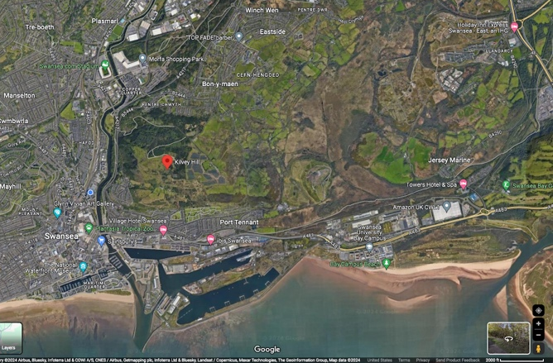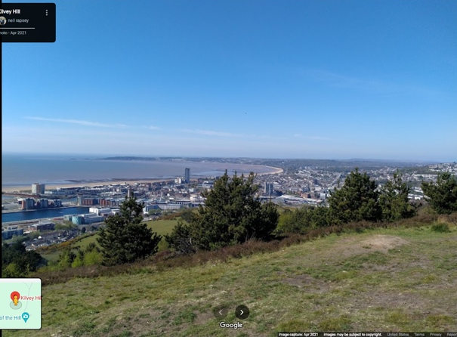

Study Aim

The aim of this study is to assess the health of Kilvey Hill using different sampling methods. This is important as it helps gain a better understanding of the health of the site, which aids in making a more informed decision regarding future site management.

Ecosystem Services

Kilvey Hill provides many ecosystem services to the local community and wildlife. An example of an ecosystem service is access to green spaces for local residents. Yes, Swansea is a coastal city, which is one form of accessible nature, however there aren’t many green spaces. The only one of note is Singleton Park, which is outside the city centre. Green spaces are such a valuable ecosystem service as it has been proved in studies that nature helps human obtain better mental health (Marcia P. Jimenez, 2021).

Methodology

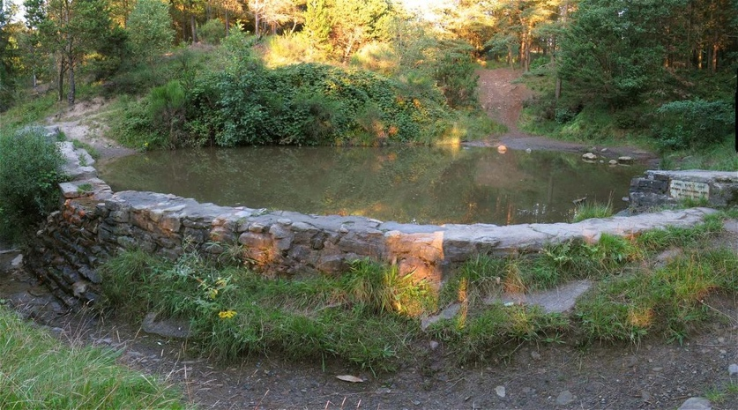

The methods used for testing the health of the site were a Nitrate, Ph, Chlorine, Phosphate, Sulphate, Ammonia, Copper and Iron test on a pond around halfway up Kilvey. The reason these tests were performed on the pond is because it has been reported that it has resisted expected biodiversity development. We wanted to test that finding. Each test was repeated 3 times to rule out anomalies and were performed at different points in the pond. Samples for Nitrate, Iron, Sulphate, Chlorine, Phosphate and Ammonia were taken at the pond and then analysed at the lab at the IQ Building of UWTSD. The reason these methods were appropriate is because they relate to the history of Kilvey Hill being dumped with copper slag, during the industrial revolution. Before it was reclaimed as a community woodland in the 1960s. I expect there to be fairly high copper and iron levels due to the hill being dumped with copper slag previously.

Equipment

- For the copper test, a photo spectrometer was used. A spectrometer is a scientific tool which can analyse proteins or in this case concentrations of chemicals dissolved in water (Spectrecology, 2021). This device was used as it is widely regarded as one of the powerful analysis tools in the life sciences.
- For the rest of the tests a palintest was used. A palintest is a cost effective and simple field testing kit which makes it valuable as there’s a low barrier to entry for its use.
- For measuring the Ph of the water a dipstick was used. A dipstick is a thin, plastic stick with strips of chemicals on it, which is normally used to test the acidity of urine (Mayo Clinic, 2023). It can also be used to measure acidity of water. How it works is that the chemical strips change colour if certain substances are present or if their levels are above typical levels.

Results
Key

Ppm - Parts per million

Mg/l - Milligrams per litre

- Copper = 0.49 mg/l
- Water Ph = 6.2

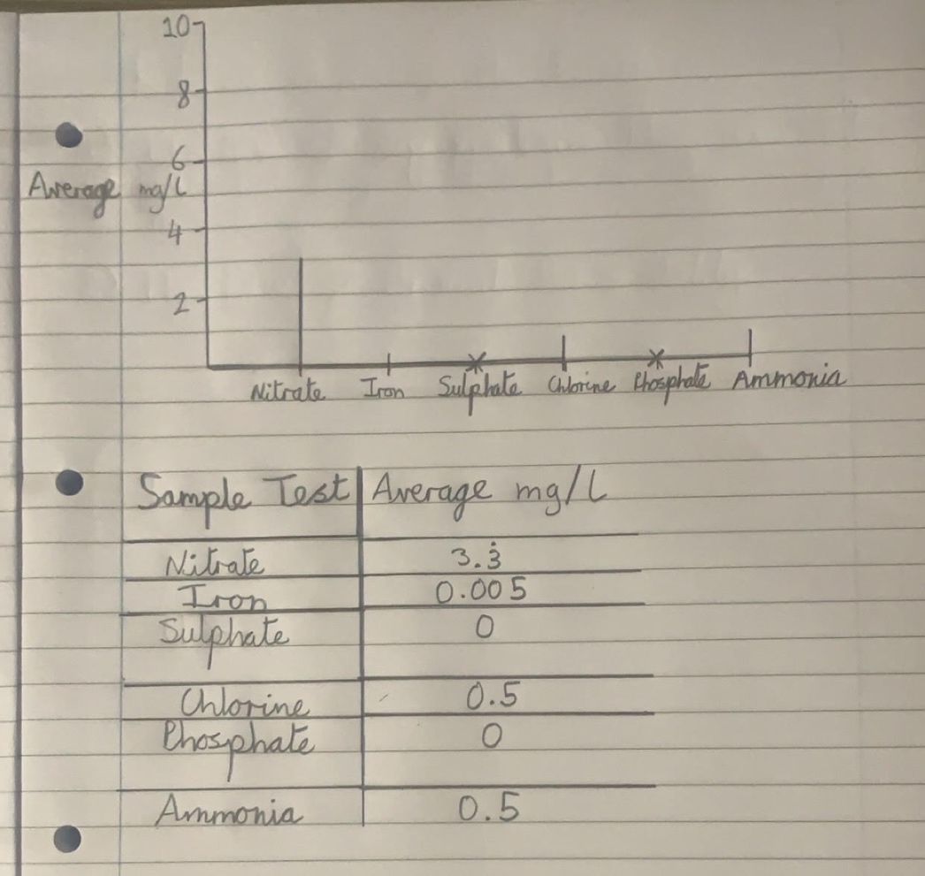

Discussion

Results Analysis

Water Ph

The pond water is slightly acidic, as natural water typically has a Ph of 7 (Cirino, 2019). The Ph of the water was measured to be 6.2, which is not too acidic, yet still somewhat of a concern. This is probably due to Kilvey Hill’s industrial heritage as acidic water is often caused by industrial pollution (Kelli McGrane, 2020). A side effect of acidic water is heavy metal contamination as well.

Chemical Compounds

Ammonia is a naturally occurring organic compound formed mainly from nitrogen-containing compounds (Oregon Department of Human Services, 2000). At levels below 1 mg/l, it is toxic to some aquatic organisms, including fish. From the sample, ammonia levels in the pond were measured to be 0.5 mg/l. Proof that the ammonia is toxic to fish is that almost no fish were spotted in the pond. The only fish that were spotted were a few very small fish towards the end of the testing. This indicates poor health of the ecosystem, as fish play a valuable role in an ecosystem. They eat insects, preventing them from overpopulating, and are also prey for birds. On the other hand, it’s a good sign that no trace of sulphate was found. Sulphate can occur naturally, but typically it’s a contaminant that comes from industrial discharge (Envirotech, 2019). So considering Kilvey Hill’s industrial past, it is very surprising that no sulphate was detected in the survey. This could be interpreted as an indication that not as much industrial pollution has seeped into the site as hypothesised. To the contrary however, it is a poor sign of ecosystem health that no phosphate was found. Phosphate contains phosphorus, which is vital for the growth and development of plants and animals (Stones, 2017). This could potentially be why only a small number of fish were spotted and there wasn’t much sign of other aquatic life in the pond. Nitrate is a compound which can be found in water sources due to runoff from agricultural fields, as it’s found in manure and fertiliser (Commission, N/A). Just like phosphorus, nitrate helps algae growth, with algae being a food source for fish. However, excess nitrate will cause excessive algae growth, which leads to oxygen depletion in water. This process is called eutrophication and has negative effects for biodiversity. The good news is that nitrate levels between 0 - 40 ppm are generally safe for fish (Lenntech, N/A), and the nitrate level measured in the pond was 3.3 mg/l, which converts to 3.3 ppm (ITS Europe, N/A). This means we can rule out nitrate as being a factor in the lack of biodiversity in the pond. Chlorine is generally considered a toxin when present in water. This is because it reacts rapidly creating organochlorine compounds, some of which are harmful to water biota (Australian Government, N/A). The levels measured in the pond were 0.5 mg/l, which is a very high amount considering 0.1 mg/l is the maximum level adult fish can tolerate (Bartel, 2020). 0.3 mg/l is the level in which larvae and dragonflies are killed. Dragonflies eat insects, which keeps their numbers down and in balance, preventing them from overpopulating (Williams, 2018). Iron is an important mineral in aquatic environments around the globe as it’s responsible for certain biotic processes (K. Heikkinen, 2022). However, it is also a pollutant at high enough levels and is common near coal mines. The US Environmental Protection Agency says levels of iron at 0.499 mg/l are considered toxic based on single species toxicity tests (Pete Cadmus, 2018). The iron levels in the pond were 0.005 mg/l, which is considerably lower than toxic levels. Potentially, the iron levels in the pond are too low, as iron is important to aquatic biota. Unfortunately there isn’t enough research online to propose this theory. Finally, to conclude, due to the past dumped copper slag, high levels of copper were found in the pond. Toxic copper levels for aquatic organisms starts at 0.2 mg/l, and double the amount was observed in the pond, measured at 0.49 mg/l (Australian Government, 2000).

Future Site Management

Based on the study findings, many things could be implemented to rectify the site and maintain its ecosystem services. To focus on the pond that was surveyed, certain techniques can be used to rid the harmful chemicals from it, or at least reduce them. One of these techniques is a reverse osmosis system. This system is regularly used at water treatment plants, which makes it a verifiably accurate method (Centers for Disease Control and Prevention, N/A). It works by water passing from a more concentrated solution to a more dilute one through a semi-permeable membrane. Pre and post filters are also used in conjunction with the membrane. This system removes common chemical contaminants, the ones being relevant to the management of the site being copper and chloride. Once that is completed, the opposite procedure should be done, which is introducing certain compounds to boost site health. The compound in question is phosphorous, because as mentioned earlier, it aids in plant growth. This compound can be introduced slowly into the pond and other water sources on the hill, to gradually stimulate biodiversity development. Done gradually in order not to inadvertently cause eutrophication. The next step would be to perform studies on safe/optimal iron levels in freshwater, optimal for maximum biodiversity. Due to there being limited evidence on safe iron levels in freshwater, it’s very difficult to decide whether more iron should be introduced in the pond or not. This is an important piece of information to know as iron has been shown to have a part to play in biological processes.

Study Shortcomings

There were a few shortcomings/limitations in this study. Firstly, the pond which was surveyed was approximately 20 metres squared. This is not a very big sample size, considering the surface area of the entire hill is a great deal bigger. Much more data is needed before management prescriptions and statements on the health of the entire site can be made. Secondly, soil samples should have been done to test the hypothesis that copper slag and other mining wastes are still close to the surface under the thin soil profile. This would add more data to the survey which would allow for a more accurate picture of the health of the site.

Conclusion

To conclude, more data is needed to assess accurately the health of the site. From the data gathered, the site has clear degradation. However, with appropriate management actions, this site could return to the health that was present pre the copper mine in the industrial era.

Bibliography
Australian Government, 2000. Copper in freshwater and marine water. [Online]
Available at: www.waterquality.gov.au/anz-guidelines/guideline-values/default/water-quality-toxicants/toxicants/copper-2000#:~:
[Accessed 22 March 2024].
Australian Government, N/A. Chlorine and compounds. [Online]
Available at: www.dcceew.gov.au/environment/protection/npi/substances/fact-sheets/chlorine-and-compounds
[Accessed 22 March 2024].
Bartel, R., 2020. Dangers of Chlorine. [Online]
Available at: www.pondplace.com/resources/blog/dangers-of-chlorine_ae15.html
[Accessed 22 March 2024].
Centers for Disease Control and Prevention, 2023. A Guide to Drinking Water Treatment Technologies for Household Use. [Online]
Available at: www.cdc.gov/healthywater/drinking/home-water-treatment/household_water_treatment.html#:~:
[Accessed 22 March 2024].
Centers for Disease Control and Prevention, N/A. A Guide to Drinking Water Treatment Technologies for Household Use. [Online]
Available at: www.cdc.gov/healthywater/drinking/home-water-treatment/household_water_treatment.html#:~:
[Accessed 22 March 2024].
Cirino, E., 2019. What pH Should My Drinking Water Be?. [Online]
Available at: www.healthline.com/health/ph-of-drinking-water
[Accessed 22 March 2024].
Commission, E., N/A. Nitrates. [Online]
Available at: https://environment.ec.europa.eu/topics/water/nitrates_en
[Accessed 22 March 2024].
Envirotech, 2019. How Do Sulphates Get into Water?. [Online]
Available at: www.envirotech-online.com/news/water-wastewater/9/breaking-news/how-do-sulphates-get-into-water/48645
[Accessed 22 March 2-24].
ITS Europe, N/A. Conversion Formulas. [Online]
Available at: www.itseurope.co.uk/pages/conversion-formulas
[Accessed 22 March 2024].
K. Heikkinen, M. S. ,. J. H. A.-K. R. P. K. ,. S. J. A. V. S.-M. K. S. H. M. V. H. M., 2022. Iron in boreal river catchments: Biogeochemical, ecological and management implications, N/A: Science of The Total Environment.
Kelli McGrane, M. R., 2020. Acidic Water: Risks, Benefits, and More. [Online]
Available at: www.healthline.com/nutrition/acidic-water#_noHeaderPrefixedContent
[Accessed 22 March 2024].
Lenntech, N/A. Nitrate and nitrite. [Online]
Available at: www.lenntech.com/hazardous-substances/nitrate-and-nitrite.htm
[Accessed 22 March 2024].
Marcia P. Jimenez, N. V. D. E. G. E. J. E. S. G. E. W. J. E. H. a. P. J., 2021. Associations between Nature Exposure and Health: A Review of the Evidence. [Online]
Available at: https://www.ncbi.nlm.nih.gov/pmc/articles/PMC8125471/
[Accessed 22 March 2024].
Mayo Clinic, 2023. Urinalysis. [Online]
Available at: www.mayoclinic.org/tests-procedures/urinalysis/about/pac-20384907
[Accessed 22 March 2024].
Oregon Department of Human Services, 2000. Ammonia. [Online]
Available at: www.oregon.gov/oha/PH/HEALTHYENVIRONMENTS/DRINKINGWATER/MONITORING/Documents/health/ammonia.pdf
[Accessed 22 March 2024].
Pete Cadmus, c. a. S. F. B. a. M. K. M., 2018. Chronic Toxicity of Ferric Iron for North American Aquatic Organisms: Derivation of a Chronic Water Quality Criterion Using Single Species and Mesocosm Data. [Online]
Available at: https://www.ncbi.nlm.nih.gov/pmc/articles/PMC5893738/
[Accessed 22 March 2024].
Spectrecology, 2021. What is a Spectrometer?. [Online]
Available at: https://spectrecology.com/blog/what-is-a-spectrometer/
[Accessed 22 March 2024].
Stones, B., 2017. Why monitor phosphate levels in water?. [Online]
Available at: www.em-solutions.co.uk/insights/why-monitor-phosphate-levels-in-water/
[Accessed 22 March 2024].
Swansea Council, 2021. Kilvey Hill. [Online]
Available at: https://www.swansea.gov.uk/article/6855/Kilvey-Hill
[Accessed 22 March 2024].
Wikipedia, 2023. Kilvey Hill. [Online]
Available at: https://en.wikipedia.org/wiki/Kilvey_Hill
[Accessed 22 March 2024].
Williams, R., 2018. Why Are Dragonflies Important?. [Online]
Available at: https://sciencing.com/dragonflies-important-10068965.html
[Accessed 22 March 2024].

