Harvey Langston (1901416)

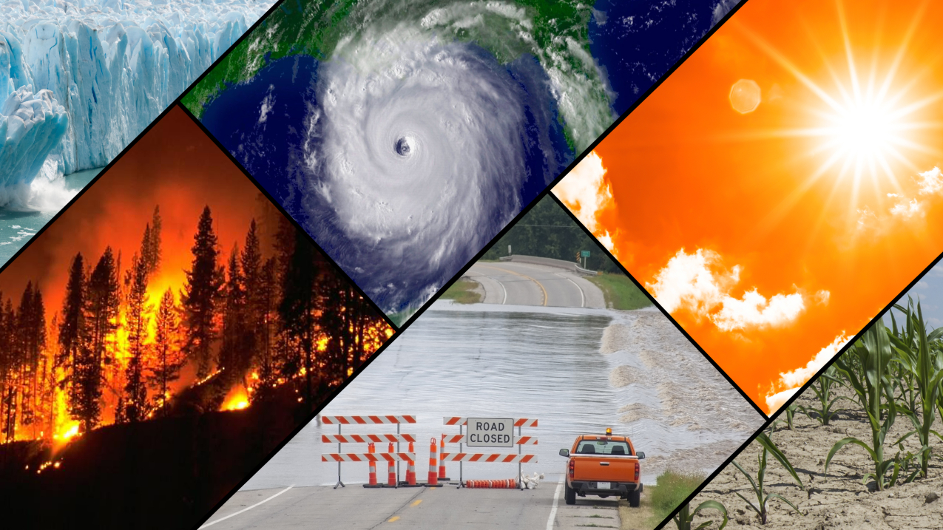
What is Climate Change?
The Past, present and future trends of climate change on businesses.

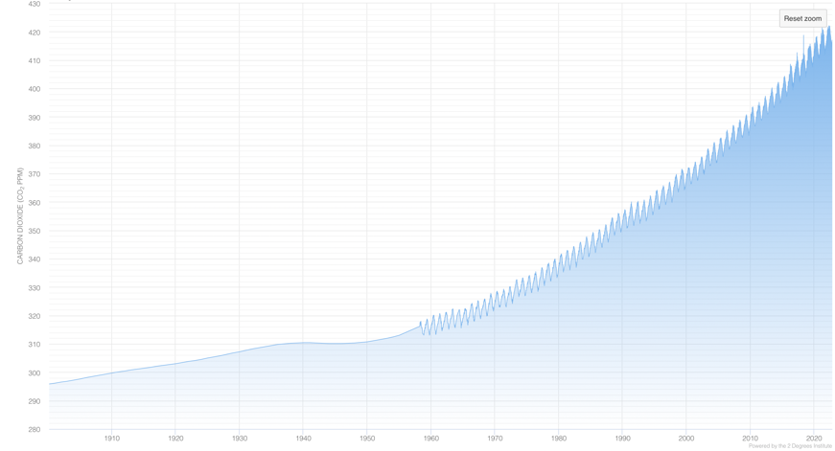
Climate change can be defined by the changes in our environment that can be considered both natural and man-made. Man-made impact has been the drastic driver of climate change since the industrial revolution due to the burning of fossil fuels.

According to research compiled by Temperature Record (Current & Historical Global Temperature Graph. (n.d.), the CO2 emissions produced have drastically increased since the 1900’s due to human activity. Because of the industrial revolution more fossil fuels are burned each day to accommodate for the demand of the consumer. As a rising global population increases further the consumer demands for more, henceforth, the further increase in CO2 production as each year passes with no sign of it decreasing. Due to human activity affecting the environment greatly, it has a knock-on effect on natural aspects of climate change. Rising temperatures due to our actions cause more change to the eco-system than previously occurred. Events such as droughts, rising sea levels, melting glaciers become a lot more frequent than what may have been pre-industrial revolution.

Sustainable Development

In a broad-spectrum sustainability means the growth of a current generation that neither hinders nor disadvantages future generations for their own personal value as stated by the United Nations (1987). The way in which human related activity effect climate change since the industrial revolution contradicts sustainable development. Since the 1900’s our economic gain has been our fuel to continue progressing. However, sustainable growth and development does not rely entirely on the economy. Yes, the economy plays a pivotal role in sustainable growth, however, is not the only factor.
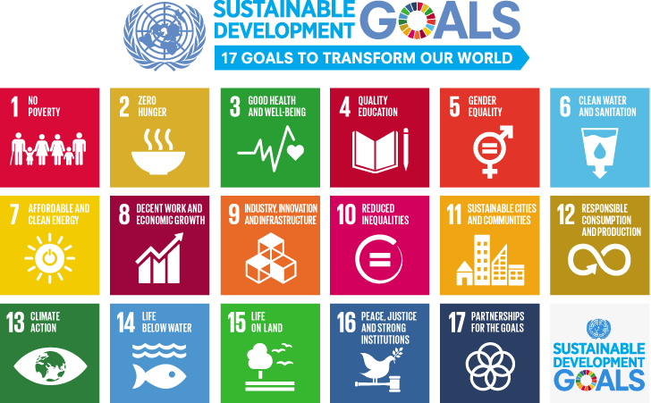
As shown by the UN Sustainable Development Goals, there are 17 factors that need to be progress in conjunction to each other. These may be development goals for the globe to reach, however, they are goals that businesses can incorporate too. Each factor links and each factor are affected one way or another by another factor.

How has it affected Business?

Businesses are suffering the impact of past actions more than ever before, forcing change and adaptability on a large scale. As stated by the IPCC (2013) the effects of climate change increase the chances of natural events such as droughts and irregular rainfall. This drastically affects the agricultural industry primarily as it becomes more difficult to function as a business. Businesses are affected economically and socially. Everyone’s knowledge and understanding of climate change has been heightened in the last decade drawing more attention to those business that lack care in their ways but also bring attention to those that do. This opens opportunity for all businesses both positive and negative opportunity, dependently only on how they assess the situation and deal with it.

What can Businesses do?

The consensus around making a difference to climate change is the damage is already done, however, this is far from the truth. Businesses alone can make a major difference for their own benefit and for the benefit of the consumer. Businesses, like the individual can assess their own carbon footprint and contribution to climate change to alleviate the problems that are most effected. Businesses act like influencers within society, the bigger the business the larger the influence it has. There are many ways each individual business can do to make change towards sustainability and reduce the effects of climate change for future generations whilst still reaping the benefits of today. The biggest contributor towards climate change would be C02 emissions and business can and have already began reducing their contribution to this factor. As technology advances, buying everyday goods became easier online, henceforth, leading to the rise of Amazon. Amazon has one of the largest delivery fleets in the world, therefore contribute a great deal of CO2 emissions into the atmosphere. Subsequently, according to CNBC news (2021), Amazon increased its carbon emissions by 19% in 2020. Due to this fact, Amazon has pledge to be net-zero by 2040. One way they wish to achieve this is by piling over one billion dollars into electric vehicle fleet to massively reduce their own carbon footprint. As a consequence of this smaller delivery business will follow suit by increasing their electrical vehicle fleet too. Nevertheless, radical changes at such short notice comes with a price which may delay smaller businesses achieving this whereas Amazon has the funds to do so at a quicker rate. Contrastingly, as significant as the cost may be, the greater effects are more valuable. The longer-term cost of electric vehicles will be considerably less whilst preventing the further increase of CO2 emissions. Contrastingly, the use of electric cars doesn’t come with its implications. Our current advances on electric car manufacturing aren’t the ideal place for it to be totally beneficial. To date, the largest range for an electric car is the Mercedes EQS with a range of 485 miles. For a delivery vehicle, some of which do a considerable amount of travel, that range simply isn’t great enough. Charging points are becoming more frequent but they still are currently not frequent enough, and the time to charge these vehicles consequently are not efficient enough.
As presented by University of Colorado (2021) methane produced from landfill is 84% greater at absorbing heat than CO2 hence the absolute necessity to convert to recyclable material. McDonalds are on the forefront in terms of using recyclable material when it comes to their packaging moving towards paper bags, cups and straws. By doing simple things like using recyclable materials for packaging which reduces the need to extract raw materials thus preventing their carbon footprint but also reducing the waste produced from the business. Due to these actions, McDonalds has gained the reputation of being ‘greener’ which opens to a wider consumer base. The title of being green in the 21st century provides much more meaning as the consumer will support business with that credibility as a result of more substantial education towards climate change.
As many businesses are becoming more educated on climate change and its affects, the majority are making changes. The most notable change seen is the use of renewable energy techniques. This can include wind, solar or tidal. The reason this change can be seen so often in businesses is because it benefits the business as much as it benefits the future of climate change. Not only can it be a way to become less dependent on fossil fuels and thus reduce their personal impact on climate change, but from a business standpoint, it’ll reduce the impact on the economic side, which many businesses thrive to improve. Contrastingly, the initial set up may seem costly, but in the long run being able to increase your usage of renewable energy will reward you a considerable amount in the future. However, as already shown in China, as stated by Carbon Brief (2020), the demand for solar panels has led to a more competitive marketplace and has driven the prices down globally. Therefore, that initial set up cost that many fear is only reducing the more we implement the change. According to IRENA (2021), the amount of renewable energy used in Europe between January 2022 and May 2022 solely from wind and solar applications generation the equivalent of USD 50 billion in fossil fuel importation. This staggering amount is just from 5 months of renewable energy. A prime example of this in show is Sky who in every set of offices they occupy run entirely off 100% renewable energy, gaining the title of being carbon Neutral since 2006. The affect this has on businesses is staggering, as they are carbon neutral paired with the demographic society of young adults that are more well informed about the effects of climate change. This only enhances their consumerism. Yes, the initial set up would have cost them, but the benefits they receive now can be considered unparallel. The investment into non-renewable energy sources is no longer needed hence allowing that investment to be turned into profit. The question that gets asked is “What happens to the oil production”. And the simple answer is that oil companies have already begun making the switch to renewable energy production. Oil rigs are turning from huge producers and outlets for fossil fuels to huge producers and outlets for renewable energy. However, there are downsides to this. It isn’t quite as simple as popping a wind turbine on your land. It requires the right permissions from governing bodies, which can complicate proceedings. Time and resources are of the essence and implicating such change requires both, some of which, primarily smaller businesses won’t and even can’t be patient for. Whereas the likes of Amazon can afford the changes without making too significant of a damage to their financial status, smaller local businesses may not have this choice. This could lead to businesses not taking the actions in the first place.
COVID-19, on face value had very little impact on climate change, however, it again opened opportunities for businesses to evolve, to be efficient and as a result become more profitable. COVID-19 gave businesses no choice but to be put on hold, however, it allowed those to work from home, it allowed advancements in technology it allowed businesses to evolve into more sustainable businesses. Working from home allowed people to not have the need to travel into work therefore not running their cars as often. As shown by Kareinen E, Uusitalo V, Kuokkanen A, Levanen J and Linnanen L (2022), the use of transportation globally has reduced 50% due to COVID-19’s impact on people being able to work from home. This has only continued post-COVID-19 as more and more people are finding other means of transportation such a cycling and walking. Businesses saved huge amounts on not paying from peoples travel into work and continue to do so now. As the middle class began working from home, and their travel costs reduced, they had more expendable money, which was piled back into other businesses. Amazon is a business that thrived off this, as people were at home, and people could buy from home with the extra money that was saved due to travel.
However, due to COVID-19 people became more aware and more conscious about their own health, more specifically not catching the virus. This in turn led to decrease in car shares and public transport use thus contradicting the event of people working from home. As more drove independently, more individual emissions rose.
Furthermore, import and export has become more difficult in recent decades a result of climate change. Waterways transport for importing and exporting goods equivalate to 80% of global trade OECD (2019) and this is only becoming more difficult to occur due to our changing environment. As sea levels rise, using waterways become more difficult with more extreme conditions and more likely for ports to be closed. This on face value seems like a problem. However, again it opens opportunities for businesses to sources goods from more local sources. There are many benefits to being able to source more locally. One being it reduces the carbon emissions created by your business. The less the transport time, the less fossil fuels you’re using to receive your goods. Using local sources will also help boost your local economy and even help drive competition from sellers. Again, this solution doesn’t come without its problems. Local sourcing limits the buyer to potentially lower quality products, short supply and no control over pricing with the lack on competition. When sourcing a product, looking for the highest quality is optimal, however, doing it locally is not always possible. If sourced locally, and with very little competition it can drive prices up of the product you intend on purchasing, both from the business and the consumer. This could altercate the circular economy.
The circular economy is imperative to climate change, Ellen Macarthur Foundation (2021). The circular economy can relate to every change that has been mentioned. The reduction of fossil fuel usage means that less raw materials are being extracted. With higher quality and more recyclable materials being used reduces this need for raw material, and a product which previously had a one-time use and one time revenue, now has multiple uses and multiple chances to make profit. This, for a business, makes perfect sense. Reusing the materials which not only reduces their own carbon footprint but also created opportunity to increased revenue from a single product multiple time.

All the changes mentioned are driving us into the future. Governmental awareness of the impacts has created a harsher environment for a business to adhere to, but it is necessary. As discussed to a large extent, there are many ways a business can implement change to combat their effects on climate change. There are many solutions, of all different scales. However, the main culprit for its ‘ineffectiveness’ is money. Money is the biggest driver for any business, whether that’s spending or investing and investing in some of the changes mentioned, can help businesses to face the current challenges and challenges that they could be faced with in the future. Change does not come without cost and since the alertness towards climate change has heightened in recent years so has the cost to make change. However, these changes do make a difference and will make a difference for the future. This is being sustainable. Sustainably growing a better future for us and the next. The need for change is imminent as the challenges will only become harder. Businesses have the influential presence to make change, and this could be the difference. If businesses can change, it impacts a larger group of society. That business will affect smaller businesses, the consumer and the environment.

References:
Current & Historical Global Temperature Graph. (n.d.). Retrieved from: https://www.temperaturerecord.org

United Nations (1987). Our Common Future. Retrieved From: https://sustainabledevelopment.un.org/content/documents/5987our-common-future.pdf

IPCC (2013). Climate Change 2013: The Physical Science Basis.
Cambridge University Press.

Palmer, A. (2021, July 1). CNBC. Amazon’s Carbon Emissions. Retrieved from:
https://www.cnbc.com/2021/06/30/amazon-says-carbon-emissions-rose-19percent-in-2020.html

Vasarhelyi, K. (2021, April 16). The Hidden Damage of Landfills. Retrieved from: https://www.colorado.edu/ecenter/2021/04/15/hidden-damage-landfills

Irena (2021). Renewable Power Generations: Costs in 2021. Retrieved from: /-/media/Files/IRENA/Agency/Publication/2022/Jul/IRENA_Power_Generation_Costs_2021.pdf?rev=34c22a4b244d434da0accde7de7c73d8

Carbon Brief (2020). Going carbon neutral by 2060 will make China richer. Retrieved from: https://www.carbonbrief.org/analysis-going-carbon-neutral-by-2060-will-make-china-richer/

Kareinen E, Uusitalo V, Kuokkanen A, Levanen J and Linnanen L (2022). Effects of COVID-19 on mobility GHG emissions. Lappeenranta-Lahti University of Technology LUT, Mukkulankatu.

OECD (2019). Trade policy brief. Retrieved from: https://www.oecd.org/trade/topics/trade-and-the-environment/

Ellen Macarthur Foundation (2019). Fixing the economy to fix climate change. Retrieved from: https://ellenmacarthurfoundation.org/topics/climate/overview

