Leadership Innovation and Product Development

Assignment 1:
Innovative Approaches

MSc Engineering Project Management

Name:
Stephen Thomas

Student Number:
P150906

Student Email: SThomas.150906@student.uwtsd.ac.uk

Contents

Introduction 2
Analysis of Valero Innovation Sources 3
Valero Innovation Types 3
Incremental Innovation 4
Benefits 4
Limitations 5
Disruptive Innovation 5
Benefits 6
Limitations 6
Radical Innovation 6
Benefits 7
Limitations 7
Valero Innovative Organisational Impact 8
Market Position 8
Incremental Innovative Impact 9
Disruptive Innovation Impact 10
Radical Innovation Impact 11
Failure in Initiatives 12
Failure Case Studies 12
Change Management Models and Competitive Strategies 13
➢ McKinsey 7S Model 13
➢ ADKAR Model 14
➢ Kotter’s Eight Steps 14
Referencing 16
Bibliography 21

Introduction
Different types of innovation will be researched, identifying the benefits and limitations associated with these novelties. The organisational impact on a company’s market position and competitive advantage subject to various types of innovation will be identified, by using Valero Energy as a focus for these innovative types. Research will then be carried out to identify why 70% of all initiatives fail and through this research identify change of management models and competitive strategies.

Analysis of Valero Innovation Sources
Innovation is defined by many as an act of creating an idea implemented in any setting to improve the associated organisation. By developing new and/or better solutions to customer problems, innovation can extend existing market or open new ones (Brem, Tidd AND Daim, 2019). Innovation is not just inventions, it can be the creation of a new application. Innovation is finding an improved or new solution to the market needs, that generates a long-term value (Kerzner, 2019).
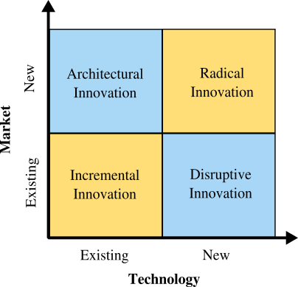
Figure 1: Innovation Types (Lopez, 2019)

Valero Innovation Types
Valero Energy is an international marketer and manufacturer of fuels and petrochemical products. Valero operates 15 petroleum refineries with a capacity of 3.1 million barrels per day and 14 ethanol plants with a throughput capacity of 1.73 billion gallons per year (Valero.com, 2019). Due to the vast complexity of Valero, the company is subject to Incremental, Disruptive and Radical innovation which affects the company’s performance and market position.

Incremental Innovation
Incremental innovation is the implementation of very small improvements or upgrades that an organisation makes to its products or services. The company makes small enhancements at regular intervals. This can potentially apply to methods, processes or services (Market Business News, 2019). Valero is subject to incremental innovation as it is consistently looking for ways to make small upgrades to their systems. An example of this is the recent upgrade of SCADA systems from TDC to Delta V. Delta V is a more up to date version that has a better response time and improved analytical analysis (Emerson.com, 2019). Valero is also using incremental innovation to improve safety systems, these systems consist of, Valero Protection Programme, Work Safe Home Safe, Loss Prevention Self-Assessment, and Loss Prevention Observations all of which are having massive benefits in terms of safety and process performance. Up until recently, Valero had gone 452 days without a recordable injury due to these systems being implemented and continuously improved.

Benefits
- Competitiveness – Due to technological change, products such as SCADA systems need to evolve to stay competitive in the market and this change can have huge benefits both financially and on process performance (Design Council, 2019). The implementation of incremental innovation helps companies remain competitive while having the ability to profit from a product that is developing onto the next generation (Swann, 2019).
- Affordability –Incremental production process permits for affordable progress. Products can be made better without being subject to huge financial implications (Design Council, 2019). This is subject to the organisation having all the infrastructure and capital needed to keep innovating on the same kind of services and products (Swann, 2019).
- Incremental innovation reduces the risks compared to the implementation of radical innovation (Swann, 2019).
- Ideas become easier to sell because customers are used to a type of service or product, they find it easier to understand and buy new improvements (Swann, 2019).

Limitations
A study conducted by (Kaderja, 2018) on the ‘Risks of Incremental, Differential, Radical, and Breakthrough Innovation Projects’ has recognised based, on statistics how incremental innovations tend to fail due to limitations. These limitations are as follows:
- In mature markets that are subject to many competitors, it is much harder to get noticed as a product is developed in stages.
- Incremental innovation, unlike radical takes time to implement and this will result in a longer process before the outcome can be analysed and criticised.
- The lack of coordination can result in poor system performance.
- Not enough planning and measurement during the project phase tend to occur through incremental innovation.
- Lack of knowledge can result in poor performance, for example the new Delta V SCADA system is unpopular by many control operators at Valero because it is slower, harder to use and very time consuming when making moves on the process unit. This system was put in place without any input from the control operators who use this system on a daily basis, for that reason Delta V has not been constructed correctly to meet the needs of the operators and therefore is jeopardising process performance and safety.

Disruptive Innovation
Disruptive innovation is defined as a process which a service or product takes root initially in simplistic form at the bottom of the market, and then moves up the market in a relentless manner and eventually displaces established competitors. (Strydom AND Buckley, 2019). Valero is currently constructing a 49.9MW cogeneration unit to provide their own electricity to the site process units due to the recent power failures. This example of disruptive innovation will initially be used for site purposes. However, when excess power is produced it will be sent to the national grid for profit. Valero being in the oil and gas industry will be subject to disruptive innovation as new products are developed on the market that produce little to no greenhouse gases. As new products develop such as electric powered cars the need for hydrocarbons such as diesel and petrol will diminish, thus affecting the market position of Valero and its competitors.

Benefits
- Disruptive innovation can deliver growth opportunities to organisations that take a share of the market (Livingston, 2019).
- It can benefit both consumers and competition by providing cheaper, better products overtime (Livingston, 2019).
- Smaller companies can compete with corporate enterprises by establishing and growing new market sections (Livingston, 2019).
- Companies that use modern technology can keep costs low so they can establish the prices much lower than competitive companies thus, generating a competitive advantage (Suandi Hamid AND Hasura Maulana, 2017).

Limitations
- Conflict from competitive companies can occur. Companies that have been growing consistently in the market, would become irritated by the new market entrants that come with new technology that can replace existing technology which would then generate further costs (Suandi Hamid AND Hasura Maulana, 2017).
- The financial implications associated with the state to create regulations for the new disruptive innovation (Suandi Hamid AND Hasura Maulana, 2017).
- Disruptive innovation could change into dispute. Innovation cannot be left alone or rejected because it will damage the market structure. Disruptive innovation is unregulated however, it is a useful technology that must be taken advantage of and regulated. The transition period is a risky period of negative effects (Suandi Hamid AND Hasura Maulana, 2017).

Radical Innovation
Radical innovation is an invention that displaces or destroys an existing business model. Unlike incremental or architectural innovation, radical innovation shocks the existing process or system and replaces it with something new entirely (SearchCIO, 2019). Valero is subject to radical innovation in terms of new environment friendly fuels that could potentially be developed in the future. This is due to the new environmental emissions standards set by the UK that places obligations on companies to produce greenhouse friendly fuels. Example of this is again electric power and more economical hydrocarbon fuels such as biodiesel.

Benefits
- With the innovator as an innovator in the field with no competitors, the company will gain a significant advantage (O'Sullivan AND Dooley, 2016).
- Radical innovation gives the opportunity to own a new market during the first stages, setting up the rules for own profit (O'Sullivan AND Dooley, 2016).
- New markets are subject to further innovation and expansion. Once a new market has been created, the options for future innovations are very high. This enables the organisation to capture the value much easier (O'Sullivan AND Dooley, 2016).

Limitations
A study conducted by (Keizer AND Halman, 2016) on ‘Diagnosing Risk in Radical Innovation Projects’ identified two types of risk associated with the implementation of radical innovation, unambiguous and ambiguous. Risk can be defined as a three-dimensional concept, involving level of control, outcome doubt and professed impact on the desired project performance. The following limitations have acknowledged through the study:
- Radial innovation life cycles are more random, longer, have more stops and starts, are more context dependent in that strategic considerations can accelerate, or terminate progress and more often include cross functional or cross unit teamwork (Keizer AND Halman, 2016).
- The probability of a satisfying solution for the newfound innovation is low (Keizer AND Halman, 2016).
- The controllability is low, which effects the ability of the innovation team to inspire the course of action.
- Relative position is high, not accomplishing a satisfactory solution for the innovation issue may endanger the desired project performance (Keizer AND Halman, 2016).

Valero Innovative Organisational Impact

Market Position
Valero Energy business is refining and marketing, the organisation offers many high-quality fuel products to its customers and opportunities for suppliers and business partners. Valero aims to drive for development by producing cleaner burner gasoline, diesel, ethanol blended fuels and many more hydrocarbons (Valero.com, 2019).
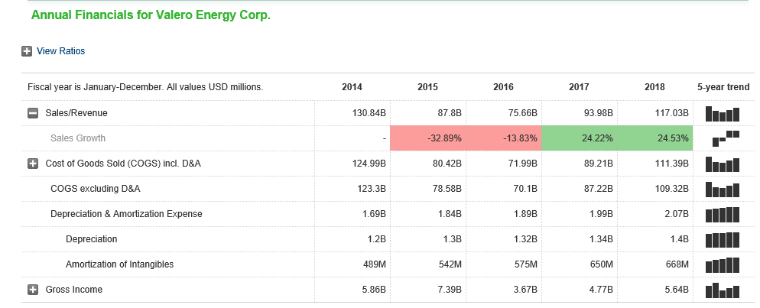
Figure 2: Annual Finance Report (Marketwatch.com, 2019).
Figures 2 and 3 identify the annual finance report and clearly recognises the sales growth through the years, all of which are impacted by the different types of innovation. Change in innovation strategy will inevitably alter the organisational performance.
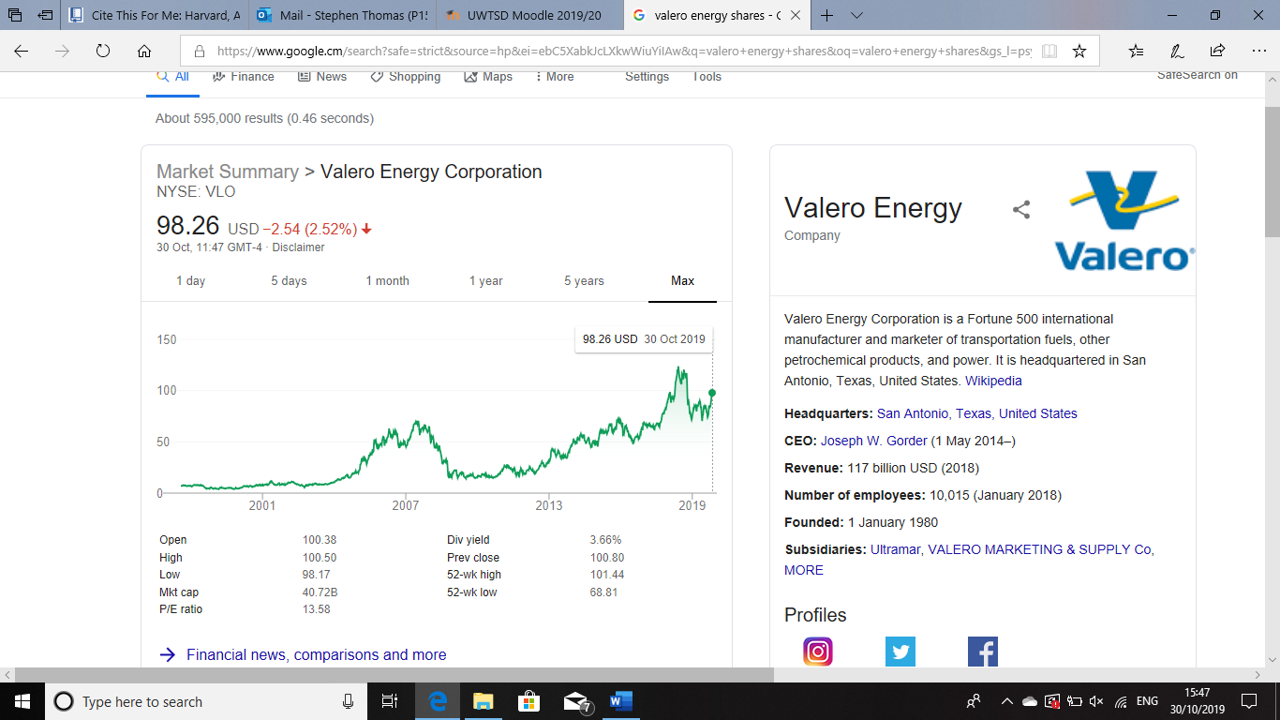
Figure 3: Valero Energy Shares. (Valero, 2019)

Incremental Innovative Impact
Studies conducted by (Staniškis AND Katiliūtė, 2019), (Ghosh, Kato AND Morita, 2017), (Geiger AND Finch, 2016) and (Perrons, 2014) have all acknowledged how adopting incremental innovation strategy can impact the company’s market position, competitive advantage and its leanness/agility. In particular, (Ghosh, Kato AND Morita, 2017) study on, ‘Incremental innovation and competitive pressure in the presence of discrete innovation’ has identified that incremental innovation made upon the current process or product, is often of restricted significance to the new product or process created upon successful radical innovation. The study goes on to address the impact on market competition by creating a model that shows how competition can reduce companies’ inducements to invest in incremental innovation in the presence of radical innovation. Enhanced competition, which manifest as improved product substitutability, results in an increase in the comparative importance of cost as a factor of market share.
(Perrons, 2014) study on, ‘How innovation and R&D happen in the upstream oil & gas industry: Insights from a global survey’ suggests that the oil and gas industry has a reputation for being slow to implement and develop innovations. Also, the high cost of failure and extreme risks associated with being a first user of new technologies are present which impacts the industries innovation, which consequently takes an average of 16 years to progress from the perception phase to widespread commercial acceptance. Incremental deviations that exceed 90% of all the distribution for innovation may be pointing to a problem, predominantly if it is happening consistently (Innovation-management, 2019). Small and regular changes over time will add up to significant changes, and signify continuous learning by managers, researchers, developers, customers and suppliers. A key foundation for low risk growth is incremental changes and successful innovation management must establish the equilibrium between evolutionary and revolutionary initiatives that will withstand and grow the business for the short and long term (Innovation-management, 2019).

Disruptive Innovation Impact
(Radnejad AND Vredenburg, 2019), (Kramer, 2018) and (Dedehayir, Nokelainen AND Mäkinen, 2014) studies have identified how disruptive innovation can effect a company such as Valero in terms of competitive advantage, agility and market position. (Radnejad AND Vredenburg, 2019) study on ‘Disruptive technological process innovation in a process-oriented industry’ goes on to suggests that to avoid failure in the process of commercialising and evolving a disruptive innovation, new entrants in a process oriented industry need to acquire experiences and capabilities which have been expressed in three proposals.
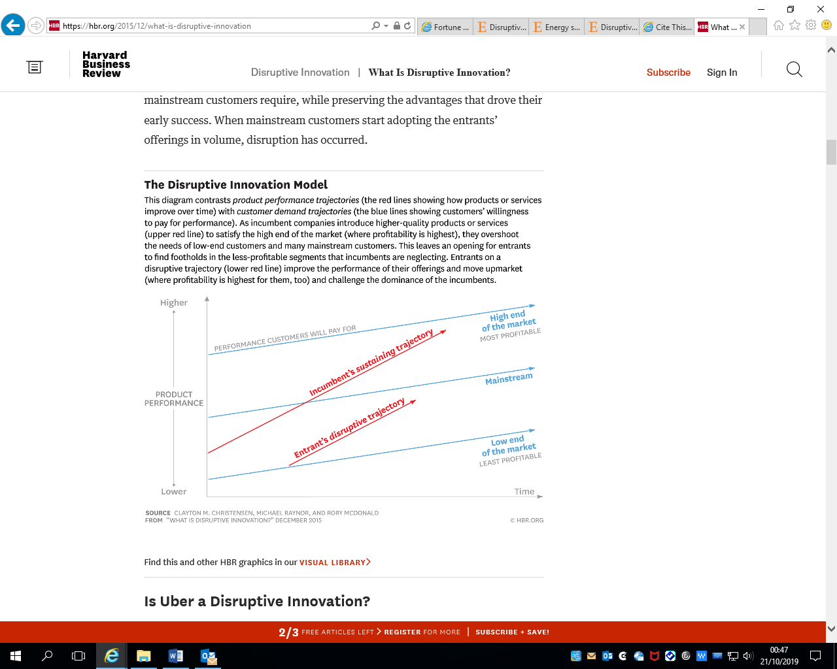
Figure 4: Disruptive Innovation Model (Harvard Business Review, 2019).
Disruptive technologies offer other benefits such as, they are more appropriate, simpler and less costly products that appeal to the less challenging or new customers. The improvement cycle begins when the disruptive product gains a position in low end or new markets. Also, because the pace of technical progress surpasses the customers’ ability to use it, the previous technology ultimately improves enough to intersect with the needs of more demanding customers (Christensen, 2019).When this occurs, the disruptors are on a course that will eventually extinguish the incumbents. Innovators seeking to produce new-growth businesses must remember the importance of this distinction. Whereas, the current leaders of the industry almost always achieve sustaining innovation, the odds at disruptive innovation heavily favor new entrant organisations (Christensen, 2019).
A company’s ability to adapt to this innovation is subject to strategy changes. These changes set out objectives for the company to perform. Such as, the definition of business in terms of the tasks its target customers want to get done with its offering, not its products, services or delivery (Wood, 2016). Companies must understand the distributor’s advantages over your own by knowing how to discern when, where, why and how the distributor serves customers better, versus their own offerings (Wood, 2016). Continually scan the environment for emerging technologies. For many organisations, the danger is not that disruptive innovation technologies will make offerings obsolete. Rather, the threat is that they will have a sever restriction in their ability to adapt to participate in the disruptive economy, because the companies will not understand the distributors advantage versus their own (Wood, 2016).

Radical Innovation Impact
(Lennerts, Schulze AND Tomczak, 2019), (Johansson, Raddats AND Witell, 2019), (Sainio, Ritala AND Hurmelinna-Laukkanen, 2012) and (Ringberg, Reihlen AND Rydén, 2019) studies have identified how radical innovation can effect a company such as Valero in terms of competitive advantage, agility and market position. (Johansson, Raddats AND Witell, 2019) study on ‘The role of customer knowledge development for incremental and radical service innovation in servitized manufacturers’ identified that a focus on radical innovation service drives manufacturers such as Valero to better performance, while a focus on incremental innovation defends the present market position. The study goes on to suggest that manufacturers undertaking incremental innovation as appose to radical have the most to gain when involving customers in new service development.
(Ringberg, Reihlen AND Rydén, 2019) study on ‘the technology-mindset interactions: Leading to incremental, radical or revolutionary innovations’ goes on to address the need for companies to change their managerial mind set in order to adapt to radical innovation as seen in figure 5.
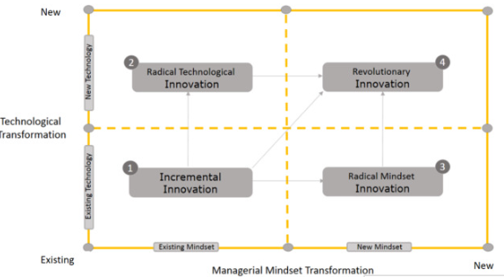
Figure 5: Managerial Mindset Transformation (Ringberg, Reihlen AND Rydén, 2019)
In radical technological innovation camp disruptive innovations happen based on technological breakthrough that are discontinuous and radical in nature. Valero subject to radical innovation would inevitably adapt in order to stay competitive and this adaption can occur through the mind set of managerial personnel through the company and then look into different modes of analysis such as porters five forces, FMEA for continuous improvement and then SWOT analysis to identify the opportunities and threats that radical innovation brings to the market.

Failure in Initiatives
According to (Innovation-management.org, 2019), business leaders often declaring high overall innovation failure rates, fluctuating anywhere between 70 to 98% will result in 70% of change initiatives failing. This level of failure makes incremental changes look attractive when considering the risk related with innovation investments. (Forbes.com, 2019), goes on to suggest 70% of all innovation fail due to lack of participation, a weak culture that isn’t aligned with the mission, under communicating a powerful vision, over communicating a poor vision, enough training or resources and resistance by the work force.

Failure Case Studies
(Kamoto, 2017), (Raven AND Walrave, 2018), (de Jong, Gillert AND Stock, 2018) and (Jenson et al., 2016) studies have all discussed why failures in initiatives are present. The studies clearly identify resistance as a major factor that contributes towards failures. Innovation is expensive in terms of time, energy and currency. Companies may fall behind innovation if the organisations does not have adequate money to fund the program of innovation or does not currently employ the kind of workers required to be innovative. With unlimited resources of money time, and technical and material expertise, companies can enter the market earlier, thus reducing the risk of failure (Samson, Donnet AND Daft, 2016). The ability to distinguish opportunities can also impact failure rates. Organisations cannot pursue all innovation, they need to develop competences that carefully evaluate innovations and to select the ones that hold the greatest potential. An organisations must make investments decision before the innovation process reaches the established stage to achieve a competitive advantage. Greater risk will be inevitable with earlier investment (Samson, Donnet AND Daft, 2016). The majority of organisations incline to resist change. Innovation means giving up old habits and products in favor new products. These changes can be personally difficult for managers and associates of an organisations. Thus, the innovation process can slow with resistance to change. Lack of inspired individuals or are committed to too many other creative activities, fail to identify opportunities, or resist the change that innovation requires causes organisations to fail to innovate despite the importance of innovation (Samson, Donnet AND Daft, 2016).

Change Management Models and Competitive Strategies
(Cleverism, 2017) refers to Change management term that is used to refer to transitioning companies, project, groups and people form one state to another. The application of pre-planned framework and structured methods to steer business from its current state to a desired state is involved with change management. The primary advantage or benefit of change management is that it increases the chances of a business staying on budget (Cleverism, 2017). As identified in previous studies, the organisation as a whole must be willing to change or these management models and competitive strategies will inevitably fail. Some examples of these models and strategies are as follows:

McKinsey 7S Model
The McKinsey 7S framework, is an organisational diagnosis tool, schematically in the form of an atom that was created by consultancy firm McKinsey (Samygin-Cherkaoui, Cadiat AND Probert, 2016). The objective of this method is to show how 7 elements of a company (Structure, Strategy, Skills, Staff, Style, Systems, and Shared values) can be aligned together to achieve effectiveness in an organisation. All seven areas are interconnected and a change in one area impacts the rest of the company for it to function effectively (Jurevicius, 2018).
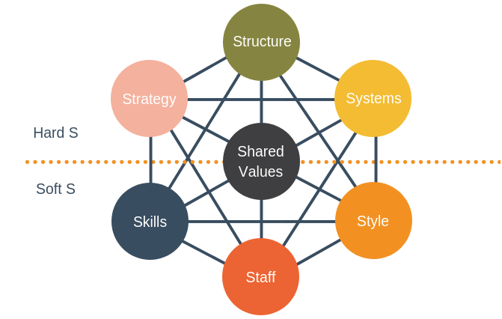
Figure 6: McKinsey 7S Framework (Samygin-Cherkaoui, Cadiat AND Probert, 2016).

ADKAR Model
The ADKAR change management model is constructed with research on best human resource management practises. ADKAR focuses on a set of process and tools to achieve a desired performance by concentrating on the people side of change. Change management process is supported in the three phase of planning, implementing and evaluating the team learning process (Mense AND Crain-Dorough, 2017). The ADKAR model framework can be seen in figure 7.
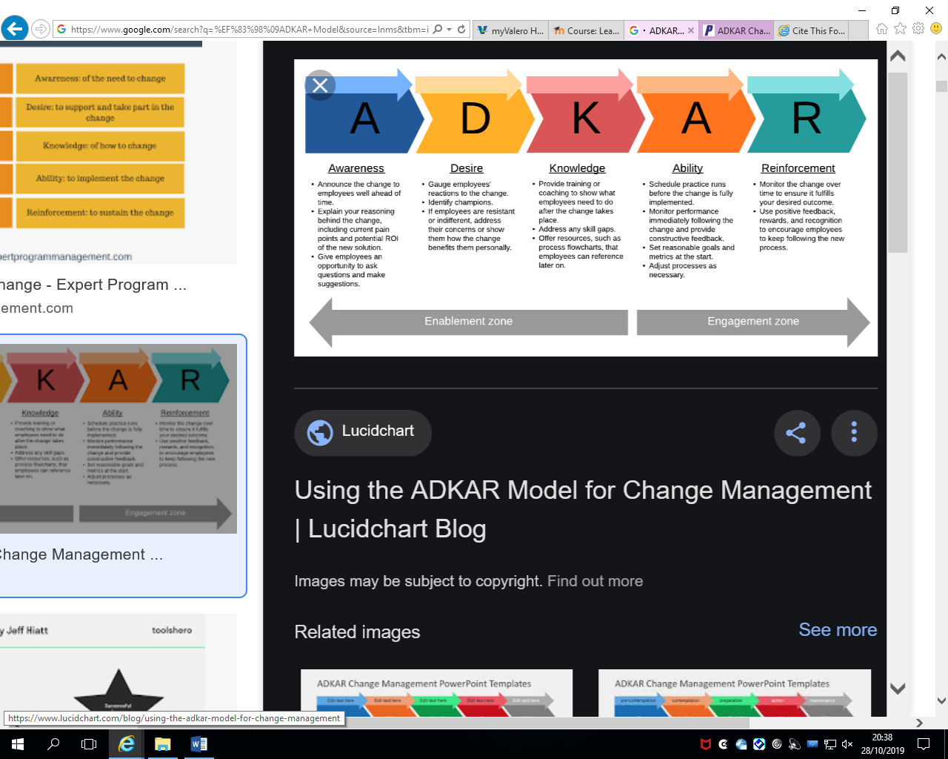
Figure 7: ADKAR Model (Mense AND Crain-Dorough, 2017).

Kotter’s Eight Steps
John Kotter’s 8-step change model consist of eight overlapping steps which consist of the first three about creating a climate for change. The next on engaging and enabling the organisation. And the last, implementing and sustaining change (Eds, 2016).
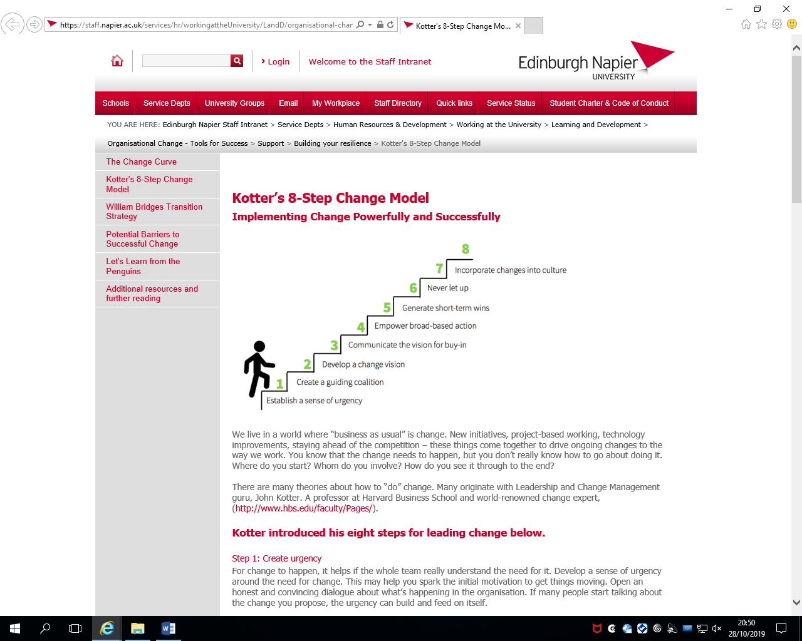
Figure 8: Kotter’s Eight Steps Framework.

These models and strategies will only work if the company and personnel are willing to change. From studies conducted by (Kamoto, 2017), (Raven AND Walrave, 2018), (de Jong, Gillert AND Stock, 2018) and (Jenson et al., 2016) it is clear that unless the organisation and its personnel are willing to change, these models will indeed likely to fail.
Conclusion
The type’s innovation subject to organisational impact on Valero has been researched and critically examined by identifying different types of innovation, organisation impact of innovation and innovative failures. Studies conducted by (Kaderja, 2018), (Keizer AND Halman, 2016) and (Swann, 2019) acknowledge the benefits and limitations associated with different types on innovation. Studies conducted by (Staniškis AND Katiliūtė, 2019), (Ghosh, Kato AND Morita, 2017), (Geiger AND Finch, 2016), (Perrons, 2014) (Radnejad AND Vredenburg, 2019), (Kramer, 2018) and (Dedehayir, Nokelainen AND Mäkinen, 2014) have all identified how an organisation such as Valero will be effected by the different types of innovation, in particular discussing the effects on market position and competitive advantage. (Kamoto, 2017), (Raven AND Walrave, 2018), (de Jong, Gillert AND Stock, 2018) and (Jenson et al., 2016) studies have all discussed why 70 % of failures in innovations are present and have gone on to discuss the change in management models and competitive strategies such as, McKinsey 7S model, ADKAR model and Kotter’s eight steps.

Referencing
- Aarikka-Stenroos, L. AND Lehtimäki, T. (2014). Commercializing a radical innovation: Probing the way to the market. Industrial Marketing Management, [online] 43(8), pp.1372-1384. Available at: https://www-sciencedirect-com.ezproxy.uwtsd.ac.uk/science/article/pii/S0019850114001412.
- Brem, A., Tidd, J. AND Daim, T. (2019). Managing innovation. 1st ed. London: World Scientific Publishing Europe LTD, pp.3-10.
- Christensen, C. (2019). Disruptive Innovation. [online] The Interaction Design Foundation. Available at: https://www.interaction-design.org/literature/book/the-encyclopedia-of-human-computer-interaction-2nd-ed/disruptive-innovation [Accessed 20 Oct. 2019].
- Cleverism. (2017). Major Approaches & Models of Change Management. [online] Available at: https://www.cleverism.com/major-approaches-models-of-change-management/ [Accessed 28 Oct. 2019].
- Dedehayir, O., Nokelainen, T. AND Mäkinen, S. (2014). Disruptive innovations in complex product systems industries: A case study. Journal of Engineering and Technology Management, [online] 33, pp.174-192. Available at: https://www-sciencedirect-com.ezproxy.uwtsd.ac.uk/science/article/pii/S0923474814000381 .
- De Jong, J., Gillert, N. AND Stock, R. (2018). First adoption of consumer innovations: Exploring market failure and alleviating factors. Research Policy, [online] 47(2), pp.487-497. Available at: https://www-sciencedirect-com.ezproxy.uwtsd.ac.uk/science/article/pii/S0048733318300040.
- Design Council. (2019). Incremental vs. radical: What’s the future of product innovation? [online] Available at: https://www.designcouncil.org.uk/news-opinion/incremental-vs-radical-what-s-future-product-innovation [Accessed 13 Oct. 2019].
- Emerson.com. (2019). DeltaV | Emerson GB. [online] Available at: https://www.emerson.com/en-gb/automation/deltaV [Accessed 13 Oct. 2019].
- (Eds.), V. (2016). Successful Change Management — Kotter’s 8-Step Change Model. [online] Leadership Thoughts. Available at: https://www.leadershipthoughts.com/kotters-8-step-change-model/ [Accessed 28 Oct. 2019].
- Forbes.com. (2019). 1 Reason Why Most Change Management Efforts Fail. [online] Available at: https://www.forbes.com/sites/brentgleeson/2017/07/25/1-reason-why-most-change-management-efforts-fail/#5aa787ab546b [Accessed 23 Oct. 2019].
- Geiger, S. AND Finch, J. (2016). Making incremental innovation tradable in industrial service settings. Journal of Business Research, [online] 69(7), pp.2463-2470. Available at: https://www-sciencedirect-com.ezproxy.uwtsd.ac.uk/science/article/pii/S0148296316000862
- Ghosh, A., Kato, T. AND Morita, H. (2017). Incremental innovation and competitive pressure in the presence of discrete innovation. Journal of Economic Behavior & Organization, [online] 135, pp.1-14. Available at: https://www-sciencedirect-com.ezproxy.uwtsd.ac.uk/science/article/pii/S0167268116303213 .
- Innovation-management.org. (2019). Incremental Innovation. [online] Available at: https://innovation-management.org/incremental-innovation.html [Accessed 20 Oct. 2019
- Jenson, I., Leith, P., Doyle, R., West, J. AND Miles, M. (2016). Innovation system problems: Causal configurations of innovation failure. Journal of Business Research, [online] 69(11), pp.5408-5412. Available at: https://www-sciencedirect-com.ezproxy.uwtsd.ac.uk/science/article/pii/S0148296316303502.
- Johansson, A., Raddats, C. AND Witell, L. (2019). The role of customer knowledge development for incremental and radical service innovation in servitized manufacturers. Journal of Business Research, [online] 98, pp.328-338. Available at: https://www-sciencedirect-com.ezproxy.uwtsd.ac.uk/science/article/pii/S0148296319301080
- Jurevicius, O. (2018). Conquer the Challenge of Expansion with McKinsey 7s. [online] Strategic Management Insight. Available at: https://www.strategicmanagementinsight.com/tools/mckinsey-7s-model-framework.html [Accessed 28 Oct. 2019].
- Kaderja, A. (2018). Risks of Incremental, Differential, Radical, and Breakthrough Innovation Projects. [Online] 1, pp.1-20. Available at: https://innovationmanagement.se/2013/07/29/risks-of-incremental-differential-radical-and-breakthrough-innovation-projects/ [Accessed 16 Oct. 2019].
- Kamoto, S. (2017). Managerial innovation incentives, management buyouts, and shareholders' intolerance of failure. Journal of Corporate Finance, [online] 42, pp.55-74. Available at: https://www-sciencedirect-com.ezproxy.uwtsd.ac.uk/science/article/pii/S0929119916302528.
- Kerzner, H. (2019). Innovation Project Management: Methods, Case Studies, and Tools for managing innovation projects. 1st Ed. New Jersey: John Wilet & Sons, pp.1-30.
- Keizer, J. and Halman, J. (2016). DIAGNOSINGRISKINRADICAL INNOVATIONPROJECTS. [Online] 2(2), pp.1-6. Available at: https://www.researchgate.net/publication/232274080_Diagnosing_Risk_in_Radical_Innovation_Projects/link/09e41507fd9ac63aac000000/download [Accessed 17 Oct. 2019].
- Kramer, G. (2018). Energy scenarios—Exploring disruption and innovation. Energy Research & Social Science, [online] 37, pp.247-250. Available at: https://www-sciencedirect-com.ezproxy.uwtsd.ac.uk/science/article/pii/S221462961730378X
- Lennerts, S., Schulze, A. AND Tomczak, T. (2019). The asymmetric effects of exploitation and exploration on radical and incremental innovation performance: An uneven affair. European Management Journal, [online] 1(2), pp.1-20. Available at: https://www-sciencedirect-com.ezproxy.uwtsd.ac.uk/science/article/pii/S0263237319300726
- Livingston, J. (2019). How Disruptive Innovation Benefits The Marketplace. Innovation Enterprise, [online] 2(1), pp.1-15. Available at: https://channels.theinnovationenterprise.com/articles/how-disruptive-innovation-benefits-the-marketplace [Accessed 16 Oct. 2019]
- Lopez, J. (2019). Types of Innovation | Constant Contact Tech Blog. [online] Constant Contact Tech Blog. Available at: https://techblog.constantcontact.com/software-development/types-of-innovation [Accessed 16 Oct. 2019].
- Market Business News. (2019). Incremental innovation - definition and examples - Market Business News. [online] Available at: https://marketbusinessnews.com/financial-glossary/incremental-innovation [Accessed 12 Oct. 2019].
- Marketwatch.com. (2019). Valero Energy Corp... [online] Available at: https://www.marketwatch.com/investing/stock/vlo/financials [Accessed 19 Oct. 2019].
- Mense, E. and Crain-Dorough, M. (2017). Data leadership for K-12 schools in a time of accountability. 5th ed. Hershey, PA, USA: IGI Global, pp.60-70.
- Narayanan, V. AND O'Connor, G. (2016). Encyclopedia of technology and innovation management. 3rd ed. Chichester: Wiley, pp.94-100.
- O'Sullivan, D. AND Dooley, L. (2016). Applying innovation. 2nd ed. Los Angeles, Calif: Sage, pp.23-25.
- Perrons, R. (2014). How innovation and R&D happen in the upstream oil & gas industry: Insights from a global survey. Journal of Petroleum Science and Engineering, [online] 124, pp.301-312. Available at: https://www-sciencedirect-com.ezproxy.uwtsd.ac.uk/science/article/pii/S0920410514003155
- Raven, R. and Walrave, B. (2018). Overcoming transformational failures through policy mixes in the dynamics of technological innovation systems. Technological Forecasting and Social Change, [online] 4(11), p.119297. Available at: https://www-sciencedirect-com.ezproxy.uwtsd.ac.uk/science/article/pii/S0040162516308460.
- Ringberg, T., Reihlen, M. AND Rydén, P. (2019). The technology-mindset interactions: Leading to incremental, radical or revolutionary innovations. Industrial Marketing Management, [online] 79, pp.102-113. Available at: https://www.sciencedirect.com/science/article/pii/S0019850118304218 .
- Samson, D., Donnet, T. AND Daft, R. (2016). Fundamentals of management. 3rd ed. Texas, USA: Houghton Muffin Company, pp.207-208.
- Sainio, L., Ritala, P. AND Hurmelinna-Laukkanen, P. (2012). Constituents of radical innovation—exploring the role of strategic orientations and market uncertainty. Technovation, [online] 32(11), pp.591-599. Available at: https://www-sciencedirect-com.ezproxy.uwtsd.ac.uk/science/article/pii/S0166497212000764.
- Samygin-Cherkaoui, A., Cadiat, A. and Probert, C. (2016). McKinsey 7S framework. 4th ed. pp.1-20.
- SearchCIO. (2019). what is radical innovation? - Definition from WhatIs.com. [online] Available at: https://searchcio.techtarget.com/definition/radical-innovation [Accessed 13 Oct. 2019].
- Strydom, M. AND Buckley, S. (2019). AI and big data's potential for disruptive
Innovation. 1st ed. Hershey, PA, USA: IGI Global, pp.281-300.

- Staniškis, J. AND Katiliūtė, E. (2019). Unsustainability reduction in enterprises by incremental innovations implementation and management. Journal of Cleaner Production, [online] 236, p.117542. Available at: https://www-sciencedirect-com.ezproxy.uwtsd.ac.uk/science/article/pii/S095965261932356X .
- Suandi Hamid, E. AND Hasura Maulana, I. (2017). Advantages and disadvantages of disruptive innovation in the context of Indonesia economic development: need regulations? International Journal of Economics, Business and Management Research, [online] 1(1), pp.558-559. Available at: http://ijebmr.com/uploads/ART_01_84.pdf [Accessed 16 Oct. 2019].
- Swann, G. (2019). Economics as anatomy: Radical Innovation in Empirical Economics. 1st ed. Cheltenham, UK: Edward Elgar Publishing, pp.107-119.
- Valero.com. (2019). About Valero. [online] Available at: https://www.valero.com/en-us/AboutValero [Accessed 12 Oct. 2019].
- Valero.com. (2019). Products & Services. [online] Available at: https://www.valero.com/en-us/ProductsAndServices [Accessed 20 Oct. 2019].
- Wood, U. (2016). 3 ways to adapt to disruptive innovation in the economy. [Online] 2(1), pp.1-5. Available at: https://www.bizjournals.com/bizjournals/how-to/technology/2015/07/3-ways-to-adapt-to-disruptive-innovation.html [Accessed 23 Oct. 2019].

Bibliography
- Globerman, S. and Lybecker, K. (2014). The Benefits of Incremental Innovation. 1st ed. [ebook] pp.1-50. Available at: https://www.fraserinstitute.org/sites/default/files/benefits-of-incremental-innovation.pdf [Accessed 16 Oct. 2019].
- Two strategic approaches to innovation: incremental vs radical. (2017). [Blog] Available at: https://bmilab.com/blog/2017/8/3/two-strategic-approaches-to-innovation-incremental-vs-radical [Accessed 16 Oct. 2019].
- Harvard Business Review. (2019). What Is Disruptive Innovation?. [online] Available at: https://hbr.org/2015/12/what-is-disruptive-innovation [Accessed 20 Oct. 2019].
- Sen, T. and Ghandforoush, P. (2016). Radical and Incremental Innovation Preferences in Information Technology: An Empirical Study in an Emerging Economy. Journal of technology management & innovation, 6(4), pp.33-44.

