UNIVERSITY OF WALES
TRINITY SAINT DAVID
LCBB5004

Managing People

ASSESSMENT 1
GROUP 1 TERM 2

LECTURER: TANJA NATHAN STUDENT: 1913404
IOANA TRIFOI

AUGUST 2021

Table of Contents
Introduction 3
Task 1: 3
Briefing statement evaluating what it means to be an HR professional 3
Reference to the current CIPD professional map 3
Task 2: 5
The organizational objective of Magnum Photos 5
Explanation of the organizational objectives with resourcing activities of Magnum 5
Evolution of the organizational objectives and resourcing activities of Magnum 7
Conclusion 8
Reference list: 9

Introduction
People management professions deal with handling the workforce within a business organization and increase the potential performance of the workforce and the organization. This paper will aim towards shedding light on what it means to be an HR professional. It highlights the employability role of the HR professionals within the organization. Along with that, the paper also focuses on explaining the CIPD professional maps and their benefits in association with managing people. Furthermore, the business aims of Magnum Photos have been explained in this paper along with the evaluation of the resource management, recruitment, selection, and workforce planning activities of the organization.

Task 1:

Briefing statement evaluating what it means to be an HR professional
According to Hertati (2019), the HR professionals of a company are entrusted with the role of managing the liability and assets of the company. They have a major role in the acquiring extensive success of the company. Human resources can be rightly defined as the efficient practice of managing people in order to enhance their performance towards completing operational activities. As enlisted by Pandita and Ray (2018), employee engagement can be a suitable example of the employability role for human resource professionals. The professionals associated with the human resource contribute towards the development of the business of the organization by making up the rest of the company's workforce. On a contractual basis, employees are also selected and recruited by human resource professionals. As highlighted by Gikopoulos (2019), the HRM professionals are also entrusted with the responsibility of providing necessary training and skill development activities for the workforce and mitigate the mutual conflicts between them.
The professional map is helpful in terms of setting international benchmarks associated with professions associated with people. The human resource professionals use the professional map in terms of enabling better decision-making abilities within themselves and encourage the professionals associated with managing people to work with confidence (CIPD Profession Map, 2021). The effective evaluation of the professional map also helps the professional associated with the human resource to consistently deliver excellent performance in order to meet the organizational goals within the stipulated time. Furthermore, another benefit of using the professional map by the human resource professionals can be associated with enabling the confidence to drive change mechanisms within the organization and acquire extensive progress in the future career of an individual. The professional map is relevant for all the human resource professionals irrespective of the fact as to whether they are CIPD members or not.
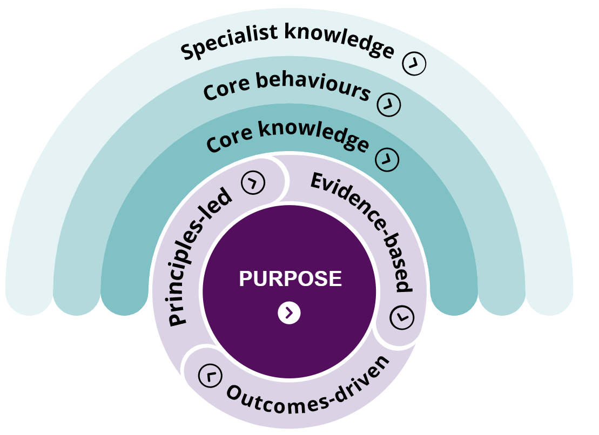
Figure 1: CIPD Professional Map
(Source: CIPD Profession Map, 2021)
At the centre of the map, the purpose is defined by the human resource professionals in association with developing the essential knowledge outcome (CIPD Profession Map, 2021). Evidence-based learning helps in supporting professional judgement by strong cases of previous justifications. The core knowledge areas that can be understood from the CIPD professional map can be enlisted as culture and behaviour, change management, people management, technological apprentice, and implementing evidence-based practice (CIPD Profession Map, 2021). The professional map must be adopted by human resource professionals by multinational companies in order to provide transparency and clarity about the skills, expertise, and knowledge that will be required in every employability role under the human resource department (CIPD Profession Map, 2021). This helps in aligning the teams with their specific areas of expertise in order to mitigate the issues in the operational activities and develop career enhancement communications within the professionals of people management departments. The effective usage of the professional map also helps in building professional credibility.

Task 2:

The organizational objective of Magnum Photos
Magnum Photos can be rightly defined as a business organization that can basically be viewed as a community of thoughts (Magnum Photos, 2021). The business objective of the company is associated with enhancing the shared human quality within the organization. The business objective of the company is also associated with increasing respect for what is going on around the world and transcribing it visually for the global audience (Magnum Photos, 2021). This legacy alliance was founded by four photographers after the second world war in order to combine an extraordinary range of photographic styles into a singular didactic collaboration. Magnum has been in operation for more than 70 years now and they have created high-quality content associated with photography for their clients across the globe (Magnum Photos, 2021). It is also the business objective of Magnum Photos to focus on the consistent development of a safe and robust working environment for everyone (Magnum Photos, 2021). They do so by remaining loyal to their ability to curate, originate photographic content and deliver uncompromising excellence and value to their clients.

Explanation of the organizational objectives with resourcing activities of Magnum
Planning: Magnum Photos have planned to implement their safeguarding and reporting policies for their educational programs in order to stay committed to the protection of the human rights of the workforce (Magnum Photos, 2020). The management of Magnum Photos takes special care while working with young adults and vulnerable adults. The entire workforce of the organization is administered to follow a code of conduct in order to enhance the significance of the workforce planning activities and repercussions of the business organization. The code of conduct of the company aims towards setting expectations associated with the behaviour of an individual as a part of the workforce in accordance with their personal and professional surroundings (Magnum Photos, 2020). The strategic planning of participation of the entire workforce in the education programs of the company not only enhances the skills and performance of the workforce but also enhances the value and brand image of the company (Magnum Photos, 2020). The management of Magnum Photos has also constructed plans towards providing a verbal briefing to the workforce and help them understand the policies of the company better. Magnum constantly focuses on implementing plans to increase workforce safety and wellbeing management (Magnum Photos, 2020). They strategically make plans to evaluate the hazards and risks before every event in order to take precautionary measures to mitigate the identified risks (Magnum Photos, 2020). They also make plans towards actively listening to the requirements of the workforce in order to implement the use of safety equipment along with providing relevant training for using them efficiently.
Recruitment and selection: Magnum Photos are run by the member photographers of the company. The agency can be considered self-selecting and grant membership to some of the finest accolades associated with the photographic career of an individual (Magnum, 2021). In order to become a full-time member of the photographic agency, an individual has to complete a term of four years of association with the company. The potential portfolios of the new members are scrutinized in order to conduct the selection of the liable permanent membership of the organization once every year (Magnum, 2021). This selection process usually takes place around the month of June during the Annual General Meeting of Magnum Photos. All the professional photographers interested to be a part of the organization from any global location can duly submit their portfolio consisting of their extensive work to the HRM of the company (Magnum, 2021). However, the existing member's discretion and support are highly important in order to make the most successful submission of the application. Therefore, it can be concluded that the recruitment and selection process of Magnum Photos is partially biased as the current members of the organization can help in the formulation of the submission of portfolios of the potential candidates. The management of the organization also provides a position for the nominee members of the organization (Magnum, 2021). This category of membership from the end of the company provides an opportunity for the workforce to get to know the new applicants within the nominee meets. This enables the formulation of comfortable communication and the building of trust and commitment between the existing members of the organization with the new nominees (Magnum, 2021). In order to become an associate member with the organization, the professional photographers have to be associated with the company as nominee members for a period of two years. After the completion of this period, the members are liable to submit a new portfolio to be considered for the position of associate membership (Magnum, 2021). Finally, after effective completion of two years of being associated with the company as an associate member, the individual can stand liable for applying to gather full membership of the company. The membership of the company adheres to the applicant for a lifetime once they become a full member of the organization (Magnum, 2021). There have been no instances within the company where a permanent member of Magnum Photos has been asked to leave by the HRM of the organization (Magnum, 2021).

Evolution of the organizational objectives and resourcing activities of Magnum
The human resource management of the company has recently developed the system of reporting to the Magnum Staff Manager or the HR Manager by means of report forms (Magnum Photos, 2020). The management has evolved the internal system of reporting by emails in order to report the grievances of the workforce and escalate the matter to the management as and how required. The HR management has enhanced the complaint management process in a way that the President of the company and the CEO of the company are also aware of the activities that are going on between the management and the workforce (Magnum Photos, 2020). The HRM of Magnum is committed to investigating all the complaints of the workforce in order to make the workforce feel included and taken care of. Currently, they have worked on developing their complaint handling procedure in order to follow the guidelines stratified by the Equality and Human Rights Commission (Magnum Photos, 2020). In order to enhance their female engagement and retention policies, the HRM of Magnum has also entrusted the responsibility of handling the complaint management procedure to a female-led team along with the leadership of the President and the CEO of the company. They have also planned recently towards developing the procedures for enhancing the confidentiality of the workforce (Magnum Photos, 2020). They have also aimed towards increasing their discrimination policies in the future. The management of the company will do so in the future by carefully and honestly investigating during the ongoing complaint management procedure. The discrimination policies of the company will further aim towards reducing the occurrence of harassment within the workforce of the organization (Magnum Photos, 2017).
The history of Magnum Photos represents the individual patronage of the founding members of the organization. Magnum is currently also focusing on enhancing its brand building activities in order to enhance the creative representation of its memberships (Magnum Photos, 2017). The implementation of the Turning Point program in 2020 has been helpful for them in conducting the selection of over 120 international artists and professional photographers (Magnum Photos, 2017). This has been essential in attracting personal archives in order to authenticate images that represent a change in the course of the history associated with humans and their development. They have acquired donations and funds of $500,000 and have invested in the development of training programs and attracting more professional photographers to join their organization (Magnum Photos, 2017).

Conclusion
After the effective completion of the paper, it can be concluded that the paper highlights the roles and responsibilities associated with managing people and becoming a successful professional photographer. It can also be concluded that the CIPD professional map has been evaluated in this paper along with understanding the benefits it provides to the people management professionals of multinational and popular companies. It can further conclude that this paper highlights the organizational visions and business objectives of Magnum Photos based in the UK market. Along with that, it can further be concluded that the paper also highlights the recruitment procedures and selection processes undertaken by the HRM of the company. Lastly, the evolution of the company in terms of resource activities has been enlisted in this research paper analysis.

Reference list:
CIPD Profession Map, 2021. Profession Map | CIPD Profession Map. [online] CIPD People Profession. Available at: <https://peopleprofession.cipd.org/profession-map#gref> [Accessed 21 July 2021].
Gikopoulos, J., 2019. Alongside, not against balancing man with machine in the HR function. Strategic HR Review.
Hertati, L., Zarkasyih, W., Suharman, H. and Umar, H., 2019. The effect of human resource ethics on financial reporting implications for good government governance (survey of related sub-units in state-owned enterprises in SUMSEL). International Journal of Economics and Financial Issues, 9(4), p.267.
Magnum Photos, 2017. Inside Magnum: Collecting Photography • Magnum Photos Magnum Photos. [online] Magnum Photos. Available at: <https://www.magnumphotos.com/theory-and-practice/inside-magnum-collecting-photography/> [Accessed 22 July 2021].
Magnum Photos, 2020. Safeguarding and Reporting Policy | Magnum Photos Magnum Photos. [online] Magnum Photos. Available at: <https://www.magnumphotos.com/safeguarding-reporting-policy/> [Accessed 20 July 2021].
Magnum Photos, 2021. Overview | Magnum Photos Magnum Photos. [online] Magnum Photos. Available at: <https://www.magnumphotos.com/about-magnum/overview/> [Accessed 22 July 2021].
Magnum, 2021. Submissions • Magnum Photos Magnum Photos. [online] Magnum Photos. Available at: <https://www.magnumphotos.com/about-magnum/submissions/> [Accessed 20 July 2021].
Pandita, D. and Ray, S., 2018. Talent management and employee engagement–a meta-analysis of their impact on talent retention. Industrial and Commercial Training.

