

Nike’s Marketing Strategies and Approach to Managing the Customer Journey
Module: Marketing Management – Assessment 1
Module code: LCMB7001
Lecturer: Tushara Balendran

Student Name: Lucien H K Yao
Student ID: 1916224
10th August 2023, London UWTSD
Word Count: 3600

Table of Contents
Introduction 3
Rationale and Overview of the Organization 3
Marketing Communication 4
Shannon-Weaver model 4
Integrated Marketing Communication 5
New Online and Offline Promotion Strategies for Nike 6
Online promotion strategies 6
Offline promotion strategies 8
Brand Resonance Analysis using Keller’s Model 9
Nike Customer Persona 12
Customer Touchpoints and Journey 13
Customer Touchpoints 13
Customer Journey 15
Conclusion and Recommendation 17
References 19

Introduction
Nike, a renowned global sportswear brand, operates in a dynamic and competitive marketplace that presents numerous challenges and opportunities. In today’s fast-paced business environment, multinational corporations such as Nike encounter a myriad of challenges, including the impact of globalisation, rapid digitalisation, the need for increased brand awareness, reputation management, and the continuously rising expectations of customers (Kyove et al., 2021). However, Nike has in the past shown the ability to navigate these challenges, mainly due to its effective and efficient marketing systems, as well as its differentiated value proposition, enabling the brand to achieve sustainable competitive advantage. This paper aims to critically appraise Nike’s innovative marketing strategies by focusing on the customer’s end-to-end journey. By delving into Nike’s marketing strategies and approach to managing the customer journey, this paper sheds light on the company’s resilience and success in the crowded marketplace.

Rationale and Overview of the Organization
Nike Inc. is a renowned American multinational corporation known for its involvement in the design, development, manufacturing, and global marketing and sales of athletic apparel, footwear, accessories, equipment, and services. Established on January 1964 by Bill Bowerman and Phil Knight under the name Blue Ribbon Sports, Chang (2014) notes that the company adopted the name Nike, Inc. on May 1971, inspired by the Greek goddess of victory, Nike (Νίκη). Since then, Nike has earned a reputation as a dominant player in the athletic apparel industry. With a workforce of over 44,000 employees worldwide, Mahdi et al. (2015) note that the company’s brand alone was valued at $19 billion in 2014, making it the most valuable brand among sports businesses.

Marketing Communication
In week 5 lecture, we learned that communication is the transmission of information from one person to another through verbal or non-verbal means, including speech and texts. By drawing from this definition, marketing communication can be broadly defined as the process of using different marketing tools and channels with the aim of delivering consistent and persuasive messages about a company’s products, services, brand messages to the targeted audience. As illustrated by Brunello (2013), the primary goals of marketing communication are to build and maintain strong relationships with customers, enhance brand awareness, drive sales, and influence consumer behaviour positively. As such, this process plays a crucial role in the overall marketing strategy, as it helps create a unified and impactful brand image by ensuring that all communication efforts align with the brand’s identity and positioning.

Shannon-Weaver model
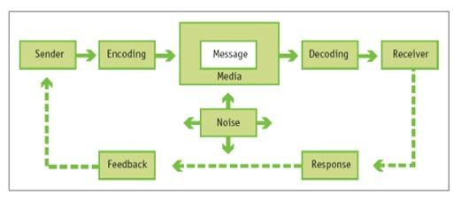
The Shannon-Weaver model is a commonly used structure to describe communication. It was developed in 1949 by Claude Shannon and Warren Weaver, and consists of five parts - information source, encoder, channel, decoder, and receiver. According to this model, communication begins with an information source, which could be someone, a group, or an organisation with something to communicate. Once the message is created, the information source encodes it into a transmittable format or signal. As Drew (2023) shows, this encoding process prepares the message for transmission through a chosen medium or channel, which may be a physical medium such as printed paper or a digital medium such as the internet or telecommunications networks. The channel facilitates the transfer of the message from the sender to the receiver. On the receiver’s end, the transmitted signal is received and interpreted by a decoder. The decoder converts the encoded signal back into a form that the receiver can understand, allowing them to extract meaning from the message. Lastly, the receiver is the intended destination of the message. They play a crucial role in the communication process by decoding the message and understanding its meaning. Based on these key elements used by the model to explain the process, one can note that the Shannon-Weaver model depicts communication as a linear flow of information from the sender to the receiver. Equally important, this model considers the important role played by feedback, which is an integral part of the process in real-world communications. The figure below summarises the Shannon-Weaver model of communication.
Figure 1: Shannon-Weaver model of communication.

Integrated Marketing Communication
According to Kliatchko (2005), Integrated Marketing Communication (IMC) is a strategic approach that involves coordinating and integrating various marketing communication tools and channels to deliver a consistent and unified brand message to target audiences. Its importance lies in reinforcing brand messages across multiple touchpoints, ensuring that customers receive a coherent and cohesive brand experience. This aligns with Kliatchko’s (2005) argument that IMC allows organisations to synergise their marketing efforts, consequently increasing brand awareness, enhancing brand image, and fostering brand loyalty among consumers.

New Online and Offline Promotion Strategies for Nike
Promotion is one of the essential elements of the marketing mix, along with product, price, and place (distribution). It refers to the communication activities undertaken by a company to inform, persuade, and influence its target audience about its products or services. In week five lecture we learned about the key components of promotion strategies, including advertising, personal selling, sales promotion, public relations, and digital marketing. These strategies can be broadly divided into online and offline promotion strategies.

Online promotion strategies
Applied in the case of Nike, one of the key online promotion strategies used by the company is digital marketing, which refers to advertising delivered through digital channels such as search engines, websites, social media, email, and mobile apps. Yang (2022) shows that Nike’s mobile phone promotion strategy is a significant aspect of its IMC approach. The brand develops functional mobile apps like Nike Training Club and Nike Running Club, which provide users with fitness content and personalised services. These apps not only enhance the customer experience but also foster brand loyalty by providing valuable tools for fitness enthusiasts. In addition to this, we propose the need for Nike to leverage its app and website data to provide personalised product recommendations based on Alex’s preferences, previous purchases, and fitness goals. By using artificial intelligence and machine learning algorithms, Nike can create a more personalised shopping experience, which, as shown by Lindecrantz et al. (2020), increases the likelihood of conversion and customer loyalty. This approach aligns with the Relationship Communication Model (RCM), where the focus is on building long-term relationships with customers through interactive and personalised communication.
Similarly, Nike’s official website serves as a comprehensive e-commerce platform where it can effectively promote its brand by creating awareness about their futures. In addition to this, we advocate for a partnership between the Nike brand and with popular online retailers like Amazon and major sportswear retailers to expand its distribution network and ensure its products are easily accessible to consumers worldwide. Partnering with well-established online retailers like Amazon can significantly expand Nike’s global reach. Amazon has a vast customer base across various regions, allowing Nike to reach new markets and consumers who might not have easy access to physical Nike stores.
Research conducted by Brandberg et al. (2020) has highlighted how Nike collaborates with established advertising companies such as Wieden+Kennedy to create emotionally-driven digital marketing campaigns. These advertisements are focused on messages that resonate with an individual’s ambitions, inspiring them to reach their goals and become the best they can be through sports and physical activity. Nike has a strong presence on various social media platforms, such as Twitter, Facebook, Instagram, and YouTube, where they regularly share content from athletes and sports stars that motivates their followers. For instance, their Instagram page is full of powerful images and videos of athletes in action, which are usually accompanied by motivational captions. The hashtag “#JustDoIt” is synonymous with the Nike brand, and is often used by consumers to generate content, thereby extending the brand’s reach.
This study also recommends the need for Nike to create interactive social media campaigns that encourage engagement and participation from its audience. For example, they could launch fitness challenges, where customers like Alex can share their workout videos or achievements using specific hashtags. This approach capitalises on the power of user-generated content and fosters a sense of community among Nike’s customers. Interactive campaigns align with the concept of classical conditioning, where positive emotions and attributes are associated with the Nike brand. According to Cherry (2023), classical conditioning is a psychological concept that involves connecting a stimulus to a response, leading to a learned behaviour. When it comes to marketing, this can mean tying positive emotions or attributes to a brand, thus impacting consumers’ perceptions and preferences. By consistently communicating these emotionally charged messages, Nike can condition customers to associate the company with striving to reach one’s highest goals.

Offline promotion strategies
When it comes to offline promotion strategies, one of the key strategies used by Nike is the engagement of celebrities. Ahmed et al. (2016) note that celebrity endorsements and sponsorships play a vital role in Nike’s IMC strategy. The company strategically partners with high-profile athletes like Michael Jordan and Cristiano Ronaldo, associating its products with successful and iconic sports figures. These endorsements boost brand credibility and appeal to consumers who look up to these athletes as role models. To further enhance the impact of this strategy, this study proposes the need for the company to organise frequent athletes’ and influencers’ meet and greets. Organising meet-and-greet events with Nike-sponsored athletes and influencers can create a sense of exclusivity and strengthen the emotional connection between consumers and the brand. Fans and customers can have the opportunity to meet their favourite athletes, receive autographs, and engage in conversations, fostering a sense of loyalty and admiration.
Nike is also well known for its sponsorship of major sports teams and events such as the English Premier League teams Liverpool and Chelsea, which reinforces the company’s connection to excellence in sports. The brand is also involved in sponsorships of global sporting competitions, marathons, and other events, allowing it to interact with athletes and sports fans. Additionally, Nike need to consider sponsoring events outside of sports that are in line with their values, such as music festivals, fitness expos, or cultural gatherings. These activations could potentially include product displays, interactive games, and brand ambassador appearances.
Furthermore, Nike prioritises providing a great in-store experience for its customers. Physical stores, according to Cicerchia (2021), are designed to provide immersive and interactive experiences in which customers can try out products, interact with brand ambassadors, and participate in various events, thereby building their emotional connection with the company. Pop-up stores and experiential marketing are ideal offline promotion strategies that the company should consider utilising. Nike can set up pop-up stores in high-traffic areas or at special events. These pop-up stores provide customers with one-of-a-kind and immersive brand experiences, allowing them to interact with products, participate in fitness challenges, and interact with brand ambassadors. Experiential marketing can leave a lasting impression on customers and build a buzz around a company.
Lastly, the company has been known to promote its products through launch events, which generally create excitement among customers and the media. For example, when releasing a new sneaker or clothing collection, Nike holds exclusive launch events attended by athletes, celebrities, and influencers. These events gain attention and receive media coverage, creating more interest and demand for the brand’s latest products. This study holds that Nike can build further excitement by releasing limited edition items or partnering with popular designers, artists, or brands. Limited edition releases create a sense of urgency and exclusivity, driving demand and encouraging customers to stay engaged with the brand.

Brand Resonance Analysis using Keller’s Model
Brand resonance refers to the level of emotional connection and loyalty that consumers have with a brand. It goes beyond simple brand awareness and recognition and represents a deep and meaningful relationship between the brand and its customers. As summarised by Chunling et al. (2008), Keller’s Brand Equity Model provides a comprehensive framework for assessing and understanding brand resonance. As shown by the figure below, which showcases Nike’s resonance using Keller’s model, at the top of the pyramid, Nike has achieved strong brand resonance through attachment and community engagement. As seen by its “Just Do It” tagline, which pushes consumers to chase their ambitions and push their limits, the company has successfully built an emotional connection with its customers. As indicated by Zhavoronkova (2021), Nike’s affiliation with top athletes generates a strong spiritual foundation for the company, making it aspirational and inspiring for consumers. Furthermore, with its NikePlus Membership program and personalised experiences through its app, Nike has developed a community of athletes and fitness lovers, fostering a sense of belonging and loyalty among its clients.
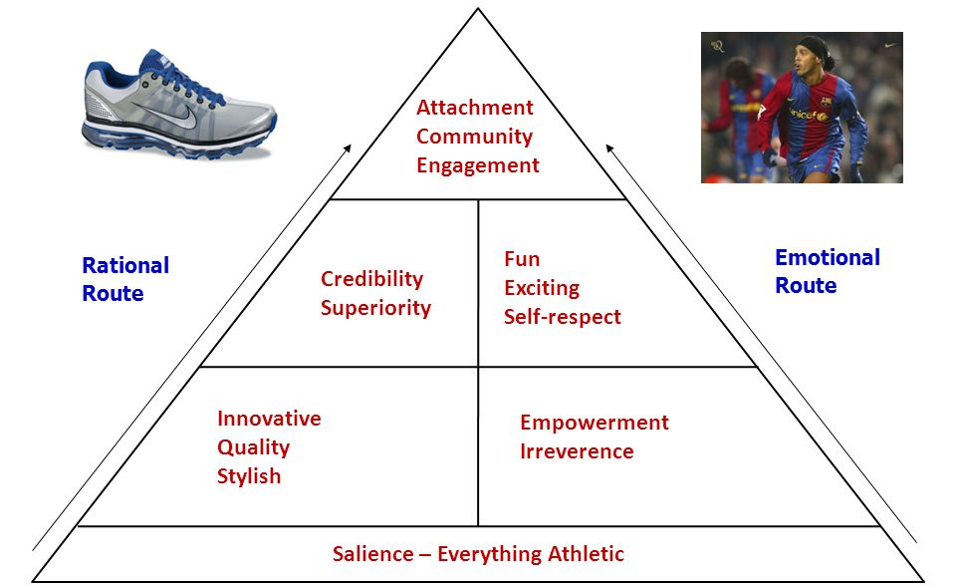
Figure 2: Nike Keller’s Brand Equity Model.
Nike’s brand equity is strengthened in the middle of the pyramid by credibility, superiority, enjoyment, excitement, and self-respect. Because of its long-standing market presence and relationship with elite athletes and sporting events, the brand is seen as credible and trustworthy. According to DeLong (2009), Nike’s drive for innovation has resulted in superior products that outperform competitors, strengthening the company’s brand image. The brand’s marketing efforts and partnerships, such as the renowned “Swoosh” emblem and collaborations with players such as Michael Jordan and Cristiano Ronaldo, add to the brand’s fun and excitement. Furthermore, Nike promotes a positive and inspiring brand identity for its clients through empowering athletes and fostering self-respect.
Nike’s brand equity is built at the bottom of the pyramid by traits such as being inventive, high-quality, stylish, empowering, and irreverent. Nike is well-known for its continual innovation in sportswear and footwear, providing cutting-edge technology and styles that appeal to both athletes and fitness aficionados. According to Wang (2017), the brand’s devotion to excellence guarantees that consumers trust and appreciate Nike items, resulting in high brand loyalty. Furthermore, Nike’s fashionable designs and fashion-forward approach distinguish it as a trendsetter in the athletic wear business. The company’s empowerment of athletes, as evidenced in its “Equality” campaign and emphasis on inclusivity, strengthens its brand resonance even more. Lastly, Nike’s irreverent and rebellious attitude, as showcased in some of its marketing campaigns, appeals to consumers looking for a brand that challenges conventions and stands out from the crowd.
The use of Keller’s Brand Equity model in the analysis of Nike’s brand resonance is characterised by both advantages and limitations. One of the advantages is that the model provides a comprehensive and structured framework to analyse brand resonance. As illustrated by Duman et al. (2018), the model includes multiple dimensions, such as brand salience, brand performance, brand imagery, brand judgments, and brand feelings, which collectively offer a holistic view of Nike’s brand equity. Besides, by embracing a consumer-centric approach, the model its very helpful in identifying the key drivers of brand resonance from the consumers’ perspective, enabling organisations like Nike to tailor their marketing strategies to meet customer expectations. However, although the model provides a structured framework for brand resonance analysis, it arguably tends to oversimplify some complex constructs related to brand resonance. Emotions and consumer behaviours are intricate and can be challenging to capture solely through such a simple model. Another important limitation is the fact that the model primarily focuses on internal aspects of brand resonance, such as brand associations and consumer perceptions but overlooks important external factors, such as industry dynamics, which can also influence brand resonance.

Nike Customer Persona
According to Trischler et al. (2018), a persona is a fictional representation of a specific target customer based on real data and insights. The persona provides a clear picture of the customer’s motivations, goals, behaviours, and pain points, allowing companies like Nike to create more personalised and relevant experiences for their target audience. The persona presented in the figure below depicts a typical consumer of Nike products named Alex, who is a fitness enthusiast with a busy lifestyle. His interest in staying active and participating in various sports activities closely aligns with Nike’s brand identity, which focuses on athleticism, performance and innovation. Alex’s passion for fitness and outdoor activities makes him loyal to Nike, and he seeks out their high-quality sportswear to enhance his performance for workouts and sports. His preference for comfort and style in his sportswear choices coincides with Nike’s focus on creating functional and fashionable athletic wear. With a Bachelor’s degree in Fashion Design, Alex has a good eye for quality and innovative designs, making him appreciate Nike’s cutting-edge products and technologies.
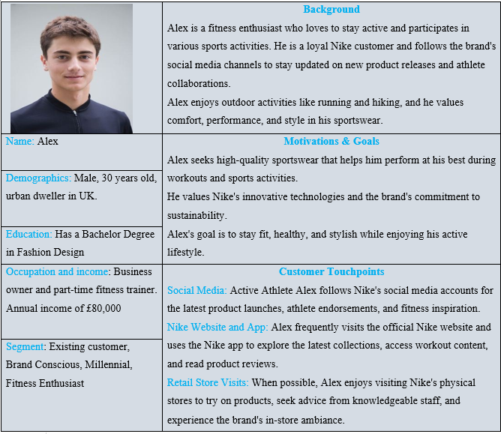
Figure 2: Nike Customer Persona

Customer Touchpoints and Journey

Customer Touchpoints
According to Roggeveen and Rosengren (2022), customer touchpoints refer to the various points of interaction between a customer and a brand throughout their journey with the company. The scholars argue that touchpoints occur at different stages of the customer lifecycle and can be both online and offline interactions. According to Duncan and Moriarty (2006), each touchpoint represents an opportunity for the brand to engage, communicate, and leave an impression on the customer. As such, the customer touchpoints present a crucial opportunity for Nike to engage with its target audience, building brand loyalty, and driving sales. Here are some of the key touchpoints that Nike utilises to engage with its customers.
- Before Purchase Touchpoints
  - Social Media Content: Nike maintains an active presence on social media platforms like Instagram, Facebook, and Twitter to engage with potential customers and showcase its products and brand values.
  - Website: Nike’s official website serves as a crucial touchpoint where customers can explore the product catalogue, read reviews, and learn more about the brand’s initiatives.
  - Nike App: The Nike app provides personalised content, product recommendations, and exclusive offers to enhance the pre-purchase experience for customers.
- During Purchase Touchpoints
  - Nike Store Experience: Customers visiting Nike’s physical stores receive in-person assistance, product demonstrations, and the chance to try on and purchase products.
  - Nike Online Store: The online shopping experience on Nike’s website or app allows customers to browse products, add items to their cart, and complete the purchase process seamlessly.
- After Purchase Touchpoints
  - Product Feedback Surveys: Nike may solicit feedback from customers to gather insights and improve its products and services.
  - NikePlus Membership: Members of NikePlus receive exclusive offers, early access to product launches, and personalised content, enhancing post-purchase engagement and loyalty.
  - Loyalty Programs: Nike’s loyalty programs, such as the NikePlus Membership, reward customers for repeat purchases and brand engagement.
- Post-Use Touchpoints
  - Product Care Information: Nike provides guidance on product care to help customers maintain and prolong the life of their purchases.
  - Customer Service: Post-use touchpoints include any interactions customers may have with Nike’s customer service team, such as returns or warranty inquiries.

Customer Journey
The customer journey has been broadly defined as a series of steps and experiences a customer goes through when interacting with a brand, from the initial awareness stage to becoming a loyal advocate. This is an important concept in marketing as it allows organisations to understand and map out the customer’s entire experience, enabling them to identify touchpoints where they can engage and influence customers positively. As shown by Ramadan and Kanso (2023), the customer journey is made up of different stages, including awareness, evaluation and consideration, decision, retention, and advocacy.
For Nike, the initial step of recognition awareness is the buyer’s initial introduction to the Nike brand and its items. Nike customers can become mindful of the company and its offerings through commercials, web-based media, verbal exchange, or visiting physical stores. After individuals are familiar with Nike and what it offers, they progress to the examination and thought stage. During this period, they deliberately contrast Nike’s items with those of other brands, analysing their elements, advantages, and worth. Customers may visit Nike’s website, read reviews, seek advice from friends and family, or explore the products in-store to make an informed decision. In the decision stage, customers make the final choice to purchase Nike’s products, and they proceed with the purchase either through the company’s e-commerce platform or its physical stores. After successfully acquiring a customer, Nike’s focus shifts to the retention phase, where it strives to build a lasting relationship with the customer by providing excellent post-purchase support and personalised experiences. The final stage of the customer journey is advocacy, where the customers become brand advocates after a positive experience with Nike’s products and services. They share their positive experiences with others, recommend the brand to friends and family, and promote it through social media. The table below summarises the customer journey map for Nike, illustrating key interaction points and customer experiences.
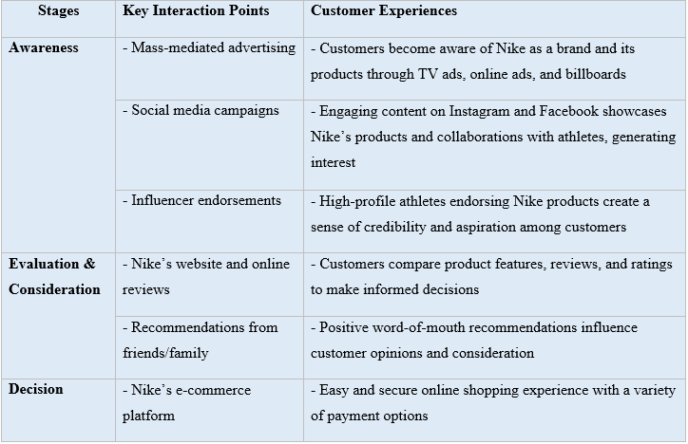
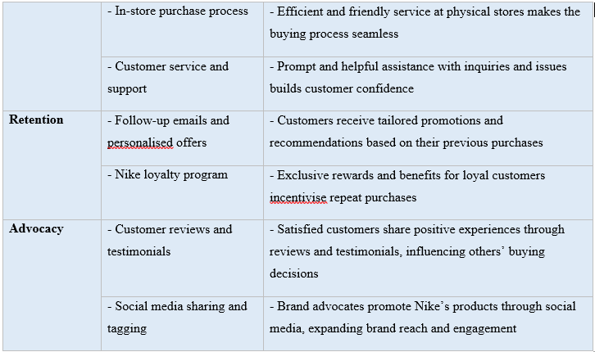
Table 1: A Summary of the customer journey map for Nike

Conclusion and Recommendation
It is evident that Nike’s success in the sportswear industry can be linked to its marketing tactics, brand placement, and customer-focused attitude. The company has created a strong value proposition through endorsements from well-known athletes and strategic co-branding. This has resulted in Nike being recognised as a source of inspiration and creativity. Through classical conditioning and endorsements from well-known people, Nike has been able to create positive emotions and aspirations in its customers, leading to strong loyalty to the brand.
In order to strengthen Nike’s customer journey and brand recognition, it is crucial to focus on optimising customer touchpoints. These touchpoints are essential for Nike to connect with their target audience and make an impact. This study suggests that Nike should use data and customer insights to personalise experiences at each touchpoint. For example, they can use the Nike app and website data to give product recommendations, deals, and content relevant to each customer’s likes and fitness objectives. It is also important for Nike to provide the same quality of experience across all channels, whether customers are interacting with Nike online or in physical stores. Technologies such as augmented reality (AR) and virtual reality (VR) can be utilised to engage customers and give them a unique brand experience. Integrating both online and offline touchpoints together will create a unified brand experience, resulting in increased loyalty and trust. Lastly, Nike should actively seek customer feedback through surveys and reviews and act on it to keep improving products, services, and the overall customer experience.

References
Ahmed, R.R., Brohi, H., Bhutto, A.H., Prithiani, J., Khubchandani, R., Kumar, S. and Abbas, Z., 2016. „Strategic Marketing Plan of Nike “. ResearchGate, Indus Institute of Higher Education.
Brandberg, O., Myrefelt Norlinger, M. and Ngo, K., 2020. Nike’s Dream Crazy campaign and how it influenced views and opinions towards the brand.
Brunello, A., 2013. The relationship between integrated marketing communication and brand equity. International Journal of Communication Research, 3(1), p.9.
Chang, C. Y. (2014). Visualising brand personality and personal branding: case analysis on Starbucks and Nike’s brand value co-creation on Instagram. The University of Iowa.
Cherry, K. 2023. What Is Classical Conditioning in Psychology? Verywell Mind. https://www.verywellmind.com/classical-conditioning-2794859
Chunling, Y.U., Ping, ZHAO and Haizhong, WANG, 2008. An empirical evaluation of a customer-based brand equity model and its managerial implications. Frontiers of Business Research in China, 2(4), pp.553-570.
Cicerchia, S., 2021. The digital transformation in the sneaker market: Nike’s in-store customer experience.
DeLong, M., 2009. Innovation and sustainability at Nike. Fashion Practice, 1(1), pp.109-113.
Drew, C. 2023. Shannon Weaver Model Of Communication – 7 Key Concepts. https://helpfulprofessor.com/shannon-weaver-model/
Duman, T., Ozbal, O. and Duerod, M., 2018. The role of affective factors on brand resonance: Measuring customer‐based brand equity for the Sarajevo brand. Journal of destination marketing & management, 8, pp.359-372.
Duncan, T. and Moriarty, S., 2006. How integrated marketing communication’s ‘touchpoints’ can operationalise the service-dominant logic. The service-dominant logic of marketing: Dialog, debate, and directions, 21(1), pp.236-249.
Kliatchko, J., 2005. Towards a new definition of integrated marketing communications (IMC). International Journal of Advertising, 24(1), pp.7-34.
Kotler, P., Armstrong, G., Harris, L.C. and Piercy, N., 2013. Principles of Marketing PDF eBook. Pearson Higher Ed.
Kyove, J., Streltsova, K., Odibo, U. and Cirella, G.T., 2021. Globalisation impact on multinational enterprises. World, 2(2), pp.216-230.
Lindecrantz, E., Gi, M.T.P. and Zerbi, S., 2020. Personalising the customer experience: Driving differentiation in retail. Retrieved January, 9, p.2022.
Locke, R.M., 2003. The promise and perils of globalisation: The case of Nike. Management: Inventing and delivering its future, 39, p.40.
Mahdi, H.A.A., Abbas, M., Mazar, T.I. and George, S., 2015. A Comparative Analysis of Strategies and Business Models of Nike, Inc. and Adidas Group with special reference to Competitive Advantage in the context of a Dynamic and Competitive Environment. International Journal of Business Management and Economic Research, 6(3), pp.167-177.
Ramadan, Z. and Kanso, J., 2023. Zomato: shaping the future of food. Emerald Emerging Markets Case Studies, 13(1), pp.1-16.
Roggeveen, A.L. and Rosengren, S., 2022. From customer experience to human experience: Uses of systematised and non-systematised knowledge. Journal of Retailing and Consumer Services, 67, p.102967.
Trischler, J., Zehrer, A. and Westman, J., 2018. A designerly way of analysing the customer experience. Journal of Services Marketing, 32(7), pp.805-819.
Wang, H.J., 2017. A brand-based perspective on differentiation of green brand positioning: A network analysis approach. Management Decision, 55(7), pp.1460-1475.
Yang, L., 2022. Digitisation: A New Opportunity for the Sustainable Development of China’s Sportswear Industry.
Zhavoronkova, A., 2021. Sport Marketing and Its Social Implications. Realise Nike Social Media Marketing Strategy Using In-Depth Analysis On Four Social Media Platforms.

