

Module name: Introduction to Health and Social Care
Module code: LCHS4003_LON

Student name: Maria Gabriela Ion
Student ID: 2509672

Lecturer’s name: Inye Abel-Tariah

Contents
1. Introduction 3
2. Importance of Effective Communication 3
3. Importance of Good Administrative Skills 5
4. Importance of Working Collaboratively 6
5. Conclusion 7
References 7

1. Introduction
This assignment focuses on the case of Mr Ahmed, a 68‑year‑old man who recently returned home following treatment for a stroke. He receives support from a domiciliary care agency three times a day for personal care, medication administration and meal preparation. Although he understands some English, his first language is Bengali, and he experiences difficulty with complex communication. This language barrier affects his ability to understand healthcare instructions and engage fully in his care. A recent missed home visit resulted in delayed medication, raising concerns about communication, record‑keeping and coordination within the multidisciplinary team. This report examines three essential areas of professional practice relevant to Mr Ahmed’s situation. First, it explores the importance of effective communication, supported by the Shannon and Weaver communication model and the Equality Act 2010. Second, it discusses the importance of good administrative skills, including accurate record‑keeping and compliance with the Data Protection Act 2018. Third, it examines the importance of collaborative working among professionals involved in Mr Ahmed’s care. Together, these areas demonstrate how safe, person‑centred and legally compliant care can be achieved.

2. Importance of Effective Communication
Effective communication is fundamental to ensuring that service users receive safe, high‑quality and person‑centred care (RCN, 2021; CQC, 2023). For individuals like Mr Ahmed, who face language barriers, communication must be adapted to meet their specific needs (NHS England, 2022). Because Bengali is his first language, he may struggle to understand complex English instructions, which increases the risk of misunderstanding and medication errors (Stroke Association, 2023). His wife often acts as a mediator, helping him communicate with professionals. While family involvement can support understanding, it should not replace the responsibility of health and social care staff to ensure that communication is accurate, accessible and appropriate (Equality Act 2010).
Professionals must consider cultural, cognitive and linguistic differences when communicating with service users. Using simple, jargon‑free language helps reduce confusion and ensures that information is understood (RCN, 2021). Avoiding complex medical terminology is particularly important, as this can create unnecessary barriers and reduce patient confidence (RCN, 2021). Visual aids, translated materials and professional interpreters can further support understanding, especially when discussing medication, therapy or safety instructions (NHS England, 2022). These adjustments are also required under the Equality Act 2010, which states that organisations must remove barriers and make reasonable adjustments to ensure equal access to services for individuals with protected characteristics, including race and disability.
The Shannon and Weaver (1949) communication model provides a useful framework for understanding how communication works in practice and how it can break down. In Mr Ahmed’s case, the model can be applied as follows:

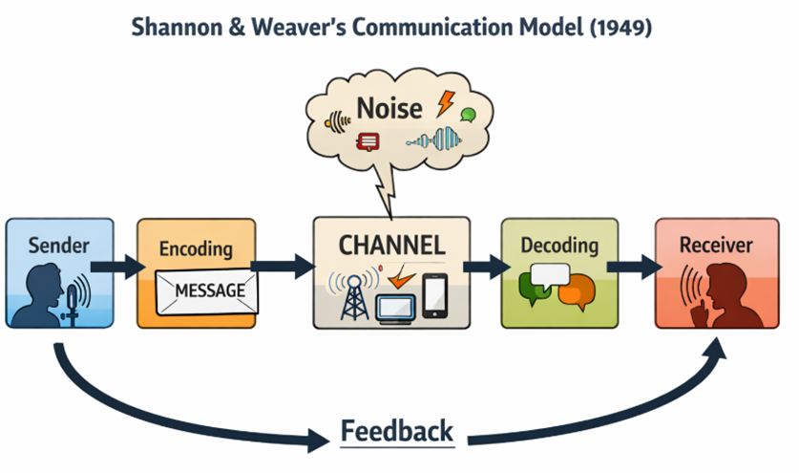
Sender: The professional providing information (e.g., domiciliary carer, GP).
Message: Instructions about medication, therapy or daily care routines.
Encoding: Using simple language, illustrations or translation into Bengali.
Channel: Face‑to‑face communication, written notes or digital messages.
Receiver: Mr Ahmed, who interprets the message based on his language ability and post‑stroke cognitive processing.
Noise: Barriers such as language difficulties, hearing problems or environmental distractions.
Feedback: Checking understanding through questions or demonstrations, such as asking Mr Ahmed to show how he will take his medication.
Reducing communication noise is essential for patient safety. Using bilingual staff, interpreters or translated care plans can significantly improve comprehension and reduce the risk of medication errors (NHS England, 2022). Active listening, checking understanding and allowing extra time for responses are particularly important for stroke survivors, who may experience speech or cognitive difficulties (Stroke Association, 2023). These strategies help ensure that Mr Ahmed remains involved in his care and can make informed decisions about his treatment.

Effective communication also promotes autonomy, dignity and person‑centred care (CQC, 2023). When Mr Ahmed understands his care plan, he is better able to participate in decision‑making and express his preferences. Clear communication also strengthens trust between professionals, service users and families, which is essential for building positive care relationships (RCN, 2021). Overall, effective communication enhances safety, compliance and engagement, ensuring that care is inclusive, ethical and legally compliant.

3. Importance of Good Administrative Skills
Good administrative skills are essential for ensuring accuracy, continuity and safety in health and social care practice. Record‑keeping is a core professional responsibility, as it provides
a clear and accurate account of the care delivered. In Mr Ahmed’s case, a missed home visit resulted in delayed medication, demonstrating how poor documentation or scheduling errors can directly impact patient well-being. Accurate records help prevent such incidents by ensuring that all staff are aware of planned visits, medication times and any changes in the care plan.
Health and social care workers must document all activities clearly and consistently. This includes recording medication administration, observations, therapy progress, communication with family members and any concerns that require escalation. Clear documentation supports effective communication within the multidisciplinary team, ensuring that all professionals have access to the same information. It also promotes accountability and transparency, as records provide evidence of the care delivered (CQC, 2023).
The Data Protection Act 2018 and UK GDPR set out strict requirements for handling personal and sensitive data. Professionals must ensure that records are accurate, up to date and stored securely. Only authorised staff should have access to personal information, and data should be shared only when necessary and with informed consent, unless safeguarding concerns apply. Key GDPR principles include lawfulness, fairness, transparency, accuracy, data minimisation and confidentiality. In practice, this means that Mr Ahmed’s medical history, communication needs and care notes must be handled with care and shared appropriately with his GP, district nurse and speech and language therapist (UK GDPR 2018).
The Caldicott Principles also guide information governance in health and social care. These principles emphasise the need to justify the purpose of data use, limit access to the minimum necessary and ensure that staff understand their responsibilities for confidentiality (Department of Health and Social Care, 2021). Applying these principles ensures that Mr Ahmed’s information is protected while still enabling effective communication within the multidisciplinary team.
Good administrative practice also supports risk management. Recording missed visits, incidents or changes in condition allows organisations to investigate issues and prevent future errors. Documentation also strengthens teamwork by ensuring that all professionals have access to consistent and accurate information. Whether using digital systems or paper records, entries must be legible, factual and completed promptly.
Professional standards reinforce the importance of record‑keeping. The Nursing and Midwifery Council (NMC, 2018) requires nurses to maintain clear, accurate and relevant records. Skills for Care (2020) also highlights that care workers must document care activities consistently to support accountability and communication. In Mr Ahmed’s case, strong administrative skills ensure that no visits are missed, medication is administered correctly, and all professionals have the information needed to deliver safe, coordinated care.

4. Importance of Working Collaboratively
Collaborative working ensures coordinated and holistic care delivery, particularly for individuals with complex needs such as Mr Ahmed. His multidisciplinary team includes a GP, district nurse, domiciliary carers and a speech and language therapist. Each professional contributes specialist knowledge, and effective collaboration ensures that care is consistent, safe and person‑centred.
Several approaches support collaborative working. Multidisciplinary team (MDT) meetings allow professionals to exchange information, review progress and plan interventions. Shared care plans ensure that all staff have access to accurate and up‑to‑date information about medication schedules, therapy goals and communication needs. Open communication channels between professionals and family members help maintain continuity while respecting Mr Ahmed’s autonomy.
Structured communication tools such as SBAR (Situation, Background, Assessment, Recommendation) support clear and concise information sharing, reducing misunderstandings and improving escalation processes (NHS Improvement, 2018). This is particularly important when reporting missed visits or medication errors.
However, collaborative working can face challenges such as role confusion, communication breakdowns and conflicting priorities. These issues can lead to delays or gaps in care. Addressing these challenges requires clear role definitions, shared goals, regular communication and training in cultural competence.
Effective teamwork enhances risk management and patient safety. Professionals can coordinate therapy sessions, monitor medication compliance and share observations to support early intervention. For Mr Ahmed, collaboration between the speech and language therapist and carers ensures consistent communication strategies, while coordination with the district nurse supports monitoring of his post‑stroke health needs.
Overall, collaborative working promotes integrated, person‑centred care and improves outcomes for individuals with complex needs.

5. Conclusion
In conclusion, the case of Mr Ahmed demonstrates the importance of effective communication, strong administrative skills and collaborative working in delivering safe and person‑centred care. Communication must be adapted to meet his language needs, supported by interpreters, visual aids and structured models such as Shannon and Weaver. Administrative competence ensures accurate record‑keeping, compliance with the Data Protection Act 2018 and effective information sharing across the multidisciplinary team. Collaborative working between the GP, district nurse, domiciliary carers and speech and language therapist ensures coordinated interventions and timely responses to risks. By integrating these practices, professionals can enhance safety, uphold legal and ethical standards and promote positive health outcomes. This approach ensures that care remains inclusive, culturally sensitive and responsive to Mr Ahmed’s individual needs.

References
Care Quality Commission (CQC) 2023, Fundamental Standards, CQC. Available at:https://www.cqc.org.uk/about-us/fundamental-standards. (Accessed: 6 April 2026).
Department of Health and Social Care 2021, The Caldicott Principles, UK Government. Available at: https://www.gov.uk/government/publications/the-caldicott-principles. (Accessed: 6 April 2026).
Equality Act 2010, legislation.gov.uk. Available at: https://www.legislation.gov.uk/ukpga/2010/15/contents. (Accessed: 6 April 2026).
NHS England 2022, Accessible Information Standard (AIS). Available at: https://www.england.nhs.uk/ourwork/accessibleinfo/. (Accessed: 6 April 2026).
NHS Improvement 2018, SBAR Communication Tool. Available at: https://www.england.nhs.uk/patient-safety/essential-safety/communication/sbar/. (Accessed: 6 April 2026).
NMC 2018, The Code: Professional Standards of Practice and Behaviour for Nurses, Midwives and Nursing Associates. Available at: https://www.nmc.org.uk/standards/code/. (Accessed: 6 April 2026).
RCN 2021, Principles of Effective Communication. Available at: https://www.rcn.org.uk/professional-development/publications/rcn-communication-guide-pub-009-366. (Accessed: 6 April 2026).
Skills for Care 2020, Record Keeping: Good Practice Guide. Available at: https://www.skillsforcare.org.uk/. (Accessed: 6 April 2026).
Stroke Association 2023, Communication Problems After Stroke. Available at: https://www.stroke.org.uk/stroke/effects/communication-problems. (Accessed: 6 April 2026).
UK GDPR 2018, Data Protection Act 2018. Available at: https://www.legislation.gov.uk/ukpga/2018/12/contents. (Accessed: 6 April 2026).

