Zakir Hussain -0251055

DVLA Coping with COVID-19
Table of Contents
INTRODUCTION 1
PROJECT MANAGEMENT 1
Project Initiation 2
Project Planning 4
Project Execution 6
Project Closure 7
DVLA COPING WITH COVID-19 8
CONCLUSION 10
REFERENCES 12

INTRODUCTION
Today the threat of COVID-19 has turned into pandemic affecting countries and its societies. It has hampered operations of businesses and functioning of various government organisations and institutions. One such organisation in the UK is the Driver and Vehicle Licensing Agency (DVLA). It is the body that issues licenses to drivers for driving different types of vehicles within the country. However, its operations also have been significantly affected due to the COVID-19 pandemic. In this report, the researcher discusses and sheds light on the ways in which this crisis has affected the DVLA and the steps taken by the DVLA to manage and counter this situation.

PROJECT MANAGEMENT
Project management is defined as the use of different tools and methods through which a project can be effectively managed so that its goals and targets can be fulfilled (Joslin & Müller, 2015). In the current context, managing COVID-19 has emerged as a major project management challenge, as the world neither foresaw such an event nor did it prepare for it. Due to this reason, different organisations and institutions are adopting different approaches to manage the situation and control it, as well as reduce its negative effects. It is imperative for the project managers that they pay attention to the tools and methods they use for managing the project (Todorović & Petrović, 2015). Any mistake can be very dangerous and could have lasting adverse effects of the project itself.
Several challenges and issues can be associated with the task and process of project management. One of them and the key challenge is to achieve all goals and targets of the project within the given constraints or limitations such as scope, time, quality, budget and many more (Hornstein, 2015). The project managers, thus, should perform a thorough assessment of the environment so that they can identify all the limiting factors. Based on such information, they can make effective plans, so that the project can be executed smoothly, and its objectives can be fulfilled (Badewi, 2016). Another major challenge in project management is regarding optimum allocation and utilisation of the resources and their application for meeting the pre-defined objectives.
There are four main stages in the process of project management – project initiation, project planning, project execution and project closure (de Carvalho & Patah, 2015). By following these stages, the project manager can control the flow of the project and its overall execution, thereby focusing on ensuring that it is able to achieve its goals and targets. It is extremely important for the project manager to ensure that these stages are carried out in a proper manner so that the project can fulfil its aims and targets (Svejvig & Andersen, 2015). However, it should be noted that every stage has its own tools and methods. Thus, it can be said that the project manager must be very knowledgeable about each of these stages, so as to ensure that project is properly executed.

Project Initiation
The initiation stage decides the nature and extent of the project. If this stage is not performed well, it is far-fetched that the undertaking will be fruitful in addressing the business needs (Ramazani & Jergeas, 2015). The key undertaking controls required here are comprehension of the business condition and ensuring that every single important control is consolidated into the task. Any insufficiencies ought to be accounted for, and a proposal ought to be made to fix them. The starting stage ought to incorporate an arrangement that includes the accompanying territories. These territories can be recorded in a progression of archives called Project Initiation reports. Task Initiation records are a progression of arranged archives used to make a request for the term of the venture (Radujković & Sjekavica, 2017).
Several types of tools and methods are available to help in the project initiation stage. Through such tools and techniques, the project manager can carry out the project effectively and ensure that it is properly carried out. One such very important aspect is determining the scope of the project (Eskerod & Huemann, 2015). This is an important aspect of any project. By properly determining project scope, the project manager can ensure that it is carried out smoothly right from the initiation to the closure stage without any delays or budgetary issues. Determining the project scope helps in determining and documenting a list of the project’s goals, tasks, deliverables, budgets, and deadlines (Kivilä & Martinsuo, 2017). Similarly, the aim and objectives of the project also an important part of this stage. Here the project manager and relevant authorities have to decide on the aim and objectives of the project. These act as a guiding mechanism for the project and therefore help in conducting the project as efficiently and effectively as possible. If the aim and objectives are not clear, then there are chances that the manager might not be able to control the project effectively, which then could have a significant negative impact on the way the overall project is carried out and its successful completion (Conforto & Amaral, 2016).
Apart from this, the project manager also needs to pay attention to determining the project deliverables. They can be defined as the end results that will be obtained once the project is completed in a pre-determined manner (Papke-Shields & Boyer-Wright, 2017). Here it can be said that project deliverables are the pre-determined targets that will be achieved once the project is completed; for the DVLA they are, to return its workforce to COVID 19 safe environment and to increase its services from essential only to essential and non-essential. Critical Success Factors (CSFs) are also an important aspect of the project initiation stage. These guide the project manager in determining and ensuring that the project is being carried out in a manner that results in the attainment of its aim and objectives (Klein & Biesenthal, 2015). Quad charts are also another key aspect of the project initiation stage. It provides a quick overview of the project that eventually leads to faster decision making. It segregates the key information into four quadrants so that the readers have consistent information to look at. By reading such charts, stakeholders and decision-makers can get a better and quick understanding of the project, thereby enabling them to make quick and relevant decisions (Serra & Kunc, 2015). Stakeholder analysis is also an important part of the overall project. Here the focus of the project manager is on identifying and understanding all stakeholders related to the project and how they are being influenced by the project, as well as the influence and power of these stakeholders on the progress of the project itself (Hu & Chan, 2015).
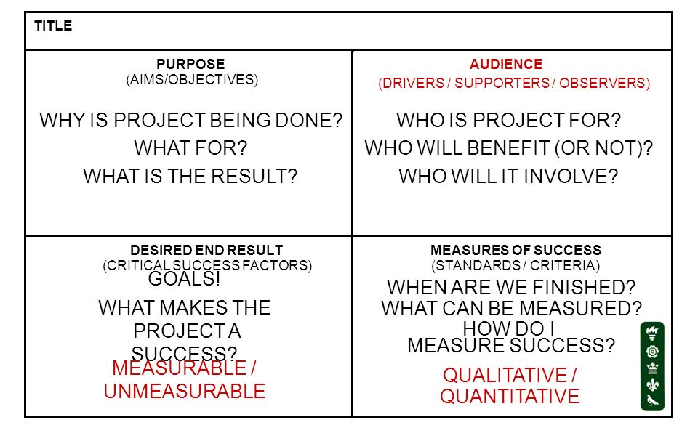
Figure 1: Quad Chart
Source: (Marcelino-Sádaba & González-Jaen, 2015)

Project Planning
After the initiation stage, the next task is, wanting a proper degree of detail. The primary intention is to design time, cost and assets enough to gauge the work required and to successfully oversee hazard during venture execution (Demirkesen & Ozorhon, 2017). Similarly, as with the Initiation procedure gathering, an inability to sufficiently design significantly decreases the task's odds of effectively achieving its objectives. The arranging stage dives into somewhat more detail. Administrators will think about what explicit advances and errands required for venture conveyance. Each progression and errand will have its own assessed expenses and course of events. In spite of the fact that these estimations do not should be altogether precise, it gives venture chiefs a general thought regarding the task's achievability and conveyance time (Andersen, 2016). This stage includes assembling an undertaking plan that affirms the course of events, recognises the assignments to be performed and achievements to be accomplished, and clarifies any expected requirements. Making work process records that envision the undertaking course of events and its achievements. Gantt graphs are a typical method for recognising the basic way of a task (Takey & de Carvalho, 2015). Making a money related arrangement to stay inside the assessed financial plan. A task director needs to decide what amount must be spent so as to understand the greatest quantifiable profit. Building the correct group and ensuring that all individuals have the assets they have to finish their undertakings (Martens & Carvalho, 2016).
When the group is collected, it is a smart thought to have a task kick-off gathering with the goal that everybody comprehends what should be practised and when. Distinguishing dangers or barricades that could obstruct the task and thinking of approaches to forestall or moderate them without bargaining the undertaking's quality or course of events (Ziek & Anderson, 2015). Extra procedures, for example, making arrangements for interchanges and for scope the executives, recognising jobs and duties, figuring out what to buy for the task and holding a commencement meeting are likewise commonly fitting. For new item improvement ventures, the calculated structure of the activity of the last item might be performed simultaneous with the task arranging exercises and may assist with educating the arranging group while distinguishing expectations and arranging exercises (Hornstein, 2015).
In this stage as well, the project manager has access to various tools and methods that can be helpful. One such tool is the SWOT analysis. It is an acronym for Strengths, Weaknesses, Opportunities and Threats analysis. By performing such an analysis, the project manager can identify the strengths of the project and determine ways through which they can be further strengthened (Ramazani & Jergeas, 2015). It also helps in identifying weak areas of the project, for which the project manager has to determine ways to overcome them. While identifying opportunities helps in exploring future options for the project and also to identify ways that can help in its effective management as well. Moreover, lastly, identifying the threats can hinder the progress of the project (Kivilä & Martinsuo, 2017).
Boston grid is also an effective tool through which the project planning stage can be effectively carried out. This grid enables the project manager to divide different aspects of the project into four – question marks, stars, cash cows and dogs (Conforto & Amaral, 2016). If an aspect of the project is in the cash cow grid, then it means it will bring money to the project, while in the star quadrant, then it would be a lot beneficial for the overall project itself. Nevertheless, if it is in the dog quadrant, then that aspect should be removed from the project, because it is consuming and wasting a lot of resources of the project (Todorović & Petrović, 2015). If in the question mark grid, then the project manager should pay significant attention to it so that it can be improved.
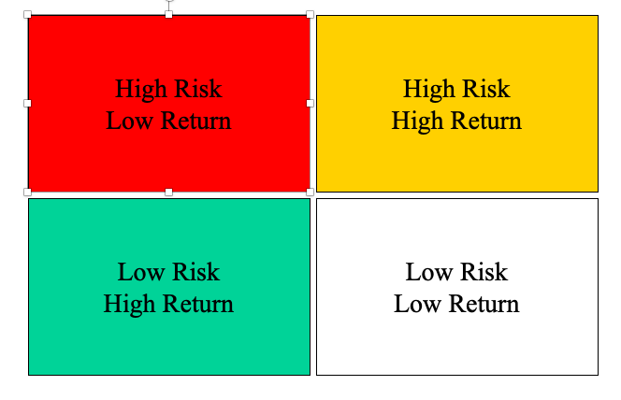
Figure 2: Boston Grid
Source: (Conforto & Amaral, 2016)

Iron triangle, also known as the project management triangle, is also a key aspect of the project management process. It is defined as a model of constraints or limiting factors while managing a project (Andersen, 2016). It states that the quality of the work is limited by budget, deadline and scope or features of the project. Further, the project manager can trade between the constraints, but the change in one of the constraints results in similar or equally proportionate changes in other constraints as well. If this does not happen, then the quality of the project will be hampered.
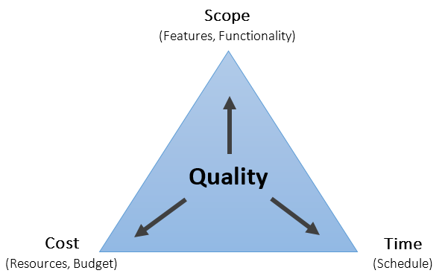
Figure 3: Iron Triangle
Source: (Joslin & Müller, 2015)

Project Execution
Various tools and methods can be used during the project execution stage. They are hard and soft evaluations. Hard evaluation entails determining whether or not profit has been made through the project (Ramazani & Jergeas, 2015). While the soft evaluation technique focuses on determining and understanding the effects of the project on different areas of the project such as society. It analyses reactions and experiences gained during the project; the learning and knowledge gained from it and how the results have changed the behaviour of the people associated with the project.
The execution stage is the genuine beginning of the venture's usage. Severe spending the board becomes possibly the most important factor here, as the venture has left the arranging stage and is presently going all out (Joslin & Müller, 2015). Managers will need to be reliably refreshed on the task's advancement as they should have full information on how the venture is falling off the ground. Consequently, venture administrators will continually speak with their workers, getting refreshes as well as issues that the task experiences. Undertaking administrators are additionally continually in contact with their customers at this stage, as during the execution stage, financial specialists are generally worried about the venture's turn of events (Martens & Carvalho, 2016). From the controlling point of view, the administration group must dissect the announcements and settle on any required choices. The key in this stage is for the group to know the measurements it ought to look at to guarantee that the venture is proceeding as arranged. For example, if a notice demonstrates that the task is delayed or is over the financial plan, the group will anticipate the undertaking chief and group to make or have taken restorative move (Takey & de Carvalho, 2015). On the off chance that the remedial activity is esteemed inadequate, the administration group must make a move themselves either through the undertaking administrator or straightforwardly.
In the event that announcements show that the venture is proceeding true to form, the administration group can stay in an observing job. In any case, when activities do not proceed true to form, the administration group must decide whether these tasks should proceed (Joslin & Müller, 2015). Task notices must give the data the administration group needs to evaluate the continuous wellbeing of the venture. A significant piece of this stage perceives when to drop a task that has gotten gravely crazy. This is a choice some administration groups may battle with because of enthusiastic connection to ventures. This might be because of the apparent value of the venture or the measure of cash previously put resources into the undertaking (Svejvig & Andersen, 2015). They may have spent a million dollars on a venture and need to prop it up despite the fact that it has little any desire for arriving at the ROI anticipated in the commencement stage.

Project Closure
In this stage, the task project manager starts shutting the undertaking once the last item is conveyed. In addition to other things, they wrap up the venture by conveying consummation to partners and discharging assets to different activities (Martens & Carvalho, 2016). As a piece of the end procedure, the undertaking supervisor should report the scope of measurements to the administration group. These measurements may incorporate articulations identifying with the accomplishment of setting up goals, a last correlation of expenses to unique gauges alongside any balanced evaluations, a refreshed timetable to survey whether the undertaking was finished on schedule, and the ROI figuring (Svejvig & Andersen, 2015). On the off chance that the association needs to consistently improve its venture, the executives rehearse, the administration group can audit interchanges from the task director to increase significant knowledge on two levels. On the execution level, they can decide if there are any procedure changes that ought to be made with respect to how undertakings are done. Maybe the anticipated ROI was not accomplished (de Carvalho & Patah, 2015). Data assembled during the end procedure may show that the explanation was that undertaking costs were not appropriately controlled, or the extent of the task extended without suitable extension the board and administration endorsements. At the administration level, the group can decide if they should make changes in how activities are directed and controlled. Maybe the venture was late or over spending plan. The purpose behind this could be that, restorative activities and vital endorsements were not noticeable to the administration group soon enough or with fitting recurrence (Klein & Biesenthal, 2015).

DVLA COPING WITH COVID-19
COVID-19 has become the worst pandemic the world has ever seen. It has affected world economies in a very bad manner. Several organisations and institutions are not able to operate due to the pandemic. DVLA, the licensing authority in the UK also has been affected by the crisis (Roy & Kumar, 2020). In this regard, the government, as well as the DVLA, has taken certain steps that aim at helping the situation and keep it in control so that the organisation can continue its operations and the people can be kept as safe as possible. The new introduction of a ‘floor monitor’, who give permission for movement to toilets and canteen at a safe flow of numbers of people walking around at any time. The following paragraphs provide a discussion on how the DVLA is managing and coping with the crisis situation.
Although the DVLA has taken several steps to manage and cope with the situation, one of the biggest steps taken by the organisation is to provide a vast majority of its functions online. The DVLA is now offering many of its services online (Duan & Zhu, 2020). In addition, the organisation is also encouraging the people to avail its online services even before calling the DVLA’s contact centre. These online services are enabling people to avoid going into public and open spaces (Burki, 2020). This way, they can avoid coming in contact with others and potentially an individual with COVID symptoms.
In order to cater to people who are looking to renew their photocard driving licenses, the DVLA has extended expiry of all the licenses that were expiring between 1st February 2020 and 31st August 2020 by further seven months from the date of expiry. This extension is automatic, and therefore the people do not have to do anything, as the validity of their licenses will be increased by seven months (Smith & Thomas, 2020). However, the DVLA has issued a statement stating this automatic renewal process is applicable only to the photocard. However, it is not applicable to the entitlement to drive. If the entitlement to drive is near its expiry, then the concerned person will have to apply for its renewal the normal way by applying to continue driving. Failure to do so will make the driving license invalid, which is illegal and an offence (Smereka & Szarpak, 2020).
In addition, the DVLA is also stating that if any person renewing their driving license with a medical condition that requires further examination or information, then there will be delays in their applications (Ramanathan & Antognini, 2020). This is because currently the NHS doctors and consultants are busy with the COVID patients and therefore are not readily available. However, if the concerned person has a valid driving license and has not been informed by their doctor or optician that they should not drive, then as well they will be able to drive while the DVLA will consider their case and application.
The government is making transitory arrangements for transport, and lorry drivers matured 45 and over to forego the requirement for a D4 clinical so as to re-establish their driving privilege. These progressions are impermanent and will just apply where the permit has not lapsed before 1 January 2020. The permit may be legitimate for one year rather than five years, and the driver should present a finished D4 when the permit is expected for reestablishment in a year (Duan & Zhu, 2020). Drivers with medical problems will at present need to proclaim these, and those with medical problems that keep them from driving securely will not have their permit recharged. All drivers must guarantee they are restoratively fit to drive. With NHS staff properly centred around the across the country reaction to Coronavirus, these transitory changes will help ensure basic flexibly chains and keep the nation moving at this crucial time (Ramanathan & Antognini, 2020).
In accordance with the administration's recommendation, DVLA has a set number of staff nearby who are just managing applications from the individuals who are legitimately engaged with the reaction to the COVID-19 pandemic (Smereka & Szarpak, 2020). Specifically, DVLA is organising applications identifying with professional drivers and key labourers to ensure they get any documentation they need as fast as could be expected under the circumstances. DVLA cannot manage some other paper applications until further notification. Both BERT (Bulk Electronic Relicensing Transaction) and POL (Post Office Licensing) plans to stay operational. Anyway, because of constrained quantities of staff, nearby DVLA suggests that entries are made in an opportune way to guarantee adequate time is given for handling. Exchange authorising applications are not being prepared at this current time (Smith & Thomas, 2020).
There are plans for vehicle testing to continue on a staged premise from 20 July. As testing will at the first resume in a constrained limit, the DVA will organise those classifications of vehicles which are at present not ready to benefit from a Temporary Exemption Certificate (TEC). The DVLA has issued a number to arrange for booking appointments. This number is solely for booking vehicle testing arrangements (Ramanathan & Antognini, 2020). Different inquiries should keep on being submitted utilising the contact subtleties. There will be a few changes to the procedure for taking a vehicle through the test, so as to agree to the direction on COVID-19 and refreshed wellbeing and security conventions. Subtleties on this will be given in the arrangement affirmation letter (Burki, 2020). Not all test communities will revive. Vehicle testing for every single other vehicle will stay suspended, and proprietors of these vehicles ought not to endeavour to book an arrangement.
For these vehicles, Temporary Exemption Certificates (TECs) will keep on being applied. There are plans to stretch out testing to different classes from August, including multi-year old vehicles and motorbikes and multi-year-old light merchandise vehicles. Moreover, the DVLA plans to recommence testing of substantial merchandise vehicles, trailers and transports simultaneously (Duan & Zhu, 2020). These clients will be sent update letters with subtleties of how to book a test. Further subtleties and dates will be distributed soon.

CONCLUSION
In this report, the researcher discusses and sheds light on the ways in which this crisis has affected the DVLA and the steps taken by the DVLA to manage and counter this situation. Project management is defined as the use of different tools and methods through which a project can be effectively managed so that its goals and targets can be fulfilled. In the current context, managing COVID-19 has emerged as a major project management challenge, as the world neither foresaw such an event nor did it prepare for it. There are four main stages in the process of project management – project initiation, project planning, project execution and project closure. By following these stages, the project manager can control the flow of the project and its overall execution, thereby focusing on ensuring that it is able to achieve its goals and targets. DVLA has taken certain steps that aim at helping the situation and keep it in control so that the organisation can continue its operations and the people can be kept as safe as possible. The DVLA have introduced floor monitors to give re-assurance to staff, there is guidance on when movement around the building is safer; which has seen from 3% to 10% of the workforce returning to the workplace; this trend must keep continuing for further increase in returning all services to the stakeholders. The DVLA is now offering many of its services online. In addition, the organisation is also encouraging the people to avail its online services even before calling the DVLA’s contact centre. The DVLA is also stating that if any person renewing their driving license with a medical condition that requires further examination or information, then there will be delays in their applications.

REFERENCES
Joslin, R., & Müller, R. (2015). Relationships between a project management methodology and project success in different project governance contexts. International journal of project management, 1377-1392.
Todorović, M., & Petrović, D. (2015). Project success analysis framework: A knowledge-based approach in project management. International journal of project management, 772-783.
Hornstein, H. (2015). The integration of project management and organisational change management is now a necessity. International Journal of Project Management , 291-298.
Badewi, A. (2016). The impact of project management (PM) and benefits management (BM) practices on project success: Towards developing a project benefits governance framework. International Journal of Project Management, 761-778.
de Carvalho, M. M., & Patah, A. L. (2015). Project management and its effects on project success: Cross-country and cross-industry comparisons. International Journal of Project Management, 1509-1522.
Svejvig, P., & Andersen, P. (2015). Rethinking project management: A structured literature review with a critical look at the brave new world. International Journal of Project Management, 278-290.
Ramazani, J., & Jergeas, G. (2015). Project managers and the journey from good to great: The benefits of investment in project management training and education. International Journal of Project Management , 41-52.
Radujković, M., & Sjekavica, M. (2017). Project management success factors. Procedia engineering, 607-615.
Eskerod, P., & Huemann, M. (2015). Project stakeholder management—Past and present. Project Management Journal, 6-14.
Kivilä, J., & Martinsuo, M. (2017). Sustainable project management through project control in infrastructure projects. International Journal of Project Management , 1167-1183.
Conforto, E. C., & Amaral, C. D. (2016). The agility construct on project management theory. International Journal of Project Management, 660-674.
Papke-Shields, K., & Boyer-Wright, K. (2017). Strategic planning characteristics applied to project management. International Journal of Project Management, 169-179.
Klein, L., & Biesenthal, C. (2015). Improvisation in project management: A praxeology. International journal of project management, 267-277.
Serra, C. E., & Kunc, M. (2015). Benefits realisation management and its influence on project success and on the execution of business strategies. International Journal of Project Management, 53-66.
Hu, Y., & Chan, A. (2015). From construction megaproject management to complex project management: Bibliographic analysis. Journal of management in engineering , 04014052.
Marcelino-Sádaba, S., & González-Jaen, L. F. (2015). Using project management as a way to sustainability. From a comprehensive review to a framework definition. Journal of cleaner production, 1-16.
Demirkesen, S., & Ozorhon, B. (2017). Impact of integration management on construction project management performance. International Journal of Project Management, 1639-1654.
Andersen, E. (2016). Do project managers have different perspectives on project management? International Journal of Project Management, 58-65.
Takey, S. M., & de Carvalho, M. M. (2015). Competency mapping in project management: An action research study in an engineering company. International Journal of Project Management, 784-796.
Martens, M. L., & Carvalho, M. (2016). The challenge of introducing sustainability into project management function: multiple-case studies. Journal of Cleaner Production , 29-40.
Ziek, P., & Anderson, D. (2015). Communication, dialogue and project management. International Journal of Managing Projects in Business.
Roy, D., & Kumar, S. (2020). Study of knowledge, attitude, anxiety & perceived mental healthcare need in Indian population during COVID-19 pandemic. Asian Journal of Psychiatry, 102083.
Duan, L., & Zhu, G. (2020). Psychological interventions for people affected by the COVID-19 epidemic. The Lancet Psychiatry, 300-302.
Burki, T. K. (2020). Cancer guidelines during the COVID-19 pandemic. The Lancet Oncology, 629-630.
Smith, A., & Thomas, E. (2020). Telehealth for global emergencies: Implications for coronavirus disease 2019 (COVID-19). Journal of telemedicine and telecare , 1357633X20916567.
Smereka, J., & Szarpak, L. (2020). Modern medicine in COVID-19 era. Disaster and Emergency Medicine Journal.
Ramanathan, K., & Antognini, D. (2020). Planning and provision of ECMO services for severe ARDS during the COVID-19 pandemic and other outbreaks of emerging infectious diseases. The Lancet Respiratory Medicine.

