

Programme: BSc (Hons) Health and Social Care
Module: Changemakers: Creativity and Value Creation
Module code: BMHP5014
Lecturer: G1: Dr Laila Surani G2: Caroline Salami (Module leader)
Student name: Tania Habib
Student ID number: 2336623
Submission Date: 02-12-2025

Confess: No use of AI in this report except Microsoft word for Spelling and Grammer check.

Table of Contents

Task 1- Defining Key Concepts in Practice 3
Task 2 - Mind Map 5
Task 3 - Self-Reflection of Group Activity 6
Task 4 - Case Study Analysis of a UK Innovation 7
Task 5 - Research Task 8
Task 6 - Exploring Digital Innovation in Health and Social Care 8
Task 7 - Understanding the NHS Leadership Framework 9
References 11
Figure – 1 15
Figure - 2 15
Figure - 3 16
Figure - 4 16
Figure - 5 17
Figure - 6 17

Task 1- Defining Key Concepts in Practice
Innovation
Definition: The procedure of innovation is introducing current concepts, process and technological advancements to upgrade services and results within organisations (Tidd, 2023).
Importance: In the healthcare sector, there is a significant issue with striking a balance between rising demand and subpar service. Improvement of innovation becomes even more important when the right balance is achieved (Flessa and Huebner, 2021). Affordable health care is the most important factor. Second, patients should feel safe using the service. Lastly, the service should be able to change with the needs and requirements of the customer. Patients require the service, and there can be no significant change in the demand for healthcare, so people's demands cannot disappear due to capacity limitations.
Examples: One example of these reduced costs and increased accessibility is the NHS's online forums. The service allows patients to receive medical care in the convenience of their own homes while also reducing waiting times.
Creativity
Definition: Developing fresh, practical ideas to solve problems or improve care delivery is the essence of creativity (Brewster et al. 2022).
Importance: Because health professionals frequently deal with a diverse range of individuals and complex care issues, creativity is also crucial (Tofani et al. 2021). Innovation promotes patient welfare and serves as the foundation for individualised care and compassionate treatment.
Examples: Creative techniques like music therapy and art projects can improve memory and lower anxiety in dementia patients, improving their life standard and facilitating communication (Emblad and Mukaetova-Ladinska, 2021).
Value Creation
Definition: Value, according to Sønderskov and Rønning (2021), is exceptional support that satisfies customers' demands while effectively using resources from a social and health standpoint.
Importance: It makes it feasible for medical personnel to give patients the finest care possible in a timely and long-lasting way (Pecoraro et al. 2023). It may also aid in patient satisfaction and system optimisation.
Examples: Personalised care planning, that lowers preventable hospital admissions by addressing patient issues early and increasing self-management, is an example of value creation.
Change
Definition: Change requires embracing new ideas, behaviours, or operational strategies in order to overcome challenges or achieve better outcomes (Hoffman et al. 2025). It is about improving and adapting so that individuals and organisations may continue to develop and adjust to new needs.
Importance: The industry as a whole is changing due to new regulations, technology, and patient expectations. Positive changes make led to current, safe, and equitable care (World Health Organization, 2021).
Examples: It involves the widespread use of electronic medical records in the healthcare industry, which has improved patient safety, accelerated information retrieval, and boosted data accuracy.

Task 2 - Mind Map
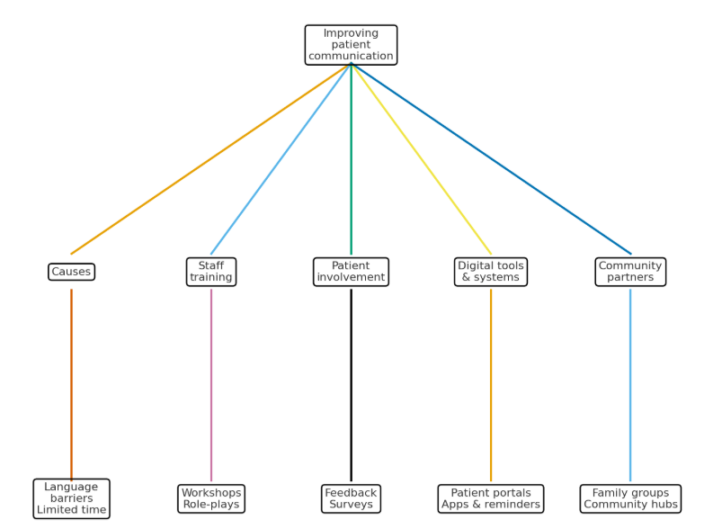
Figure 1: Mind Map
(Source: Self-Created)
The primary topics of this mind map are how problem-solving methods might improve the provision of medical and social services. Patient experience and care quality are two other topics on the mind map. Through individualised treatment, the approach ensures that the treatment is acceptable. By putting patients in charge of their care, they elevate it and encourage digital communication that gives patients clear information to cut down on miscommunications. By ensuring that experts learn from one another, they also promote collaboration. These methods provide a framework for communication. It facilitates information storage, telehealth, and technological judgement (Muthuvairavan, 2025). They therefore facilitate the planning and structuring of the workforce's advancement in providing high-quality care. Updated guidelines to support the development of support networks that meet the fundamental requirements of community and family involvement, effective safeguarding protocols, and evidence-based patient care. The methods are thorough and encourage effective methods and results.

Task 3 - Self-Reflection of Group Activity
This part is done with the help of Gibbs reflection model.
Description
Based on the group project to create tools for enhancing patient engagement, the in-class exercise has allowed us to practise both convergent and divergent thinking concepts as a group (Asiello and Winstead, 2025). We were able to develop a wide range of ideas through divergent thinking and refine them through convergent thinking. Our team was able to come up with concepts for digital storytelling, gamified health education, and an interactive feedback tool.
Feelings
I react and respond confidently to the phase of divergent because I had a solid understanding of the creative loop and the ideation process. I was a little anxious during the convergent phase, though, when we had to assess, contrast, and determine what should or shouldn't have been included. I was concerned that my concepts were not well-considered or practical.
Evaluation
Collaborating on the project was thrilling and fascinating. The conversation and the dispelling were enjoyable. My team worked as a cohesive unit and everyone contributed ideas. Divergent was energising, while convergent was difficult but required compromise and critical thinking (Javaid and Pandarakalam, 2021). I'm grateful that each team member respected the opinions of others.
Analysis
I learnt from this experience that both ways of thinking have value when it comes to solving problems. While convergent thinking ensures that an idea can actually work in the real world, divergent thinking fosters creativity (Rawlings et al. 2025). I've noticed that, in order to be more valuable to a team, I need to improve my critical thinking abilities as I tend to lean more towards creativity.
Conclusion
I learnt that teamwork requires criticism at times in addition to amazing ideas. I also discovered that in order to generate worthwhile ideas, criticism, active listening, and feedback are crucial.
Action Plan
The following time, we will work in a collaborative manner. I will focus on applying my imagination with some degree of revision. I'll hear other people's opinions and provide them with input on what needs to be addressed in order to make better decisions.

Task 4 - Case Study Analysis of a UK Innovation
The NHS Test Beds Programme, specifically the Diabetes Digital Coach, is an example of this innovative use of technology in conjunction with patient-centered care ( Goldthorpe et al. 2022). It supported Type 2 diabetes self-management through the use of wearable technology, a Smartphone app, and remote coaching. In order to guarantee the platform's usability and relevance to real-world, non-clinical needs, patients and clinicians collaborated on its design. The growing prevalence of diabetes and the need for scalable, individualised care between clinical visits served as the rationale. Poor glycaemia control and a higher need for hospitalisations were linked to the traditional delivery systems' low levels of engagement. By electing patients with increased levels of empowerment, better adherence to treatment plans, and less reliance on the primary care service capacity, value was created. The patients were given the option to track their blood sugar levels, receive real-time, personalised feedback on their food and other lifestyle choices, and access real-time educational resources. According to the data in the NHS England evaluation, the program had raised patient satisfaction levels, decreased HbA1c levels, and improved clinical outcomes (McManus et al. 2022). The program's beneficial effects on improved digital inclusion and behavioural changes were corroborated.

Task 5 - Research Task
One of the most important, if not the most important, problems facing the health and social care systems of today and tomorrow is the length of patient wait times. Limiri (2025), claims that inadequate funding for necessary services, a lack of resources, and a staffing shortage are the causes of lengthy wait times. Healthcare teams are unable to manage their workload and respond to patient needs because of these systemic pressures. As a result, patients' symptoms worsen and their chances of recovery decline as they must wait longer to begin therapy or be added to treatment lists. However, since patients frequently experience elevated levels of stress and anxiety while waiting for care, their mental health is just as much at risk as their physical health. Furthermore, Rastpour and McGregor (2022), raise comparable issues with mental health services, whose average capacity is three months. Numerous scheduled appointments, a high percentage of missed reservations, and priority systems are some of the reasons for the low capacity. All things examined, the two studies that are being provided emphasise the notion that patient waiting times, whether direct or clinical, are associated with workforce limitations, inefficient service models, and growing pressure on the health and social care systems. These wait durations therefore have a detrimental effect on patients' well-being, highlighting the need for quick service planning and provision augmentation in addition to wise personnel and investment.

Task 6 - Exploring Digital Innovation in Health and Social Care
Wearable Health Technologies benefits for chronic conditions management
In order to effectively treat chronic conditions like diabetes, hypertension, and heart disease, wearable health devices like fitness trackers and smartwatches are essential (Adepoju et al. 2025). They collect real-time indicators like heart rate, sleep patterns and the patient’s daily activity levels and connect to mobile applications or healthcare personnel. The parameters assist in recognizing deviations from the norm and assist in the preparation of a patient-specific plan. Smartwatches with ECG measurements, for example, are particularly helpful for patients with atrial fibrillation and help patients to anticipate emergency room visits. Furthermore, this technology fosters a patient-centric approach by making the patient responsible for his or her wellness through target-setting and secure reminders. According to Piwek et al. consumer wearables are a necessity for monitoring long-term health and behaviour alteration.
The way Electronic Health Records improves Communication and Collaboration
Electronic Health Records also offer numerous key contributions to health that can significantly change and help healthcare, notably real-time data entry and exchange (Adeniyi et al. 2024). In one place, patients’ medical histories, assessments, prescribed medications, and doctor appointments could all be accessible. Patients’ current or previous caregiver’s documentation makes it easier for more healthcare providers to treat the patient, reducing redundancy and transcription errors. For example, NHS spine enables patient information exchange between family doctors, hospital workers, and physicians. For example, family doctors make important, rapid medication decisions in times of crisis or when a patient transfers to one of our services. For instance, a research study by Greenhalgh et al. found that EHRs improve workflow, precision, and patient safety.
Digital Technology in Preventative Care and Health Promotion
Digital technology also plays a secret purpose in preventive care and health promotion by facilitating individualized interventions and identifying high-risk persons early. Mobile applications are used for the NHS Diabetes Prevention Program, which offers lifestyle coaching and tracking information on physical activity and educational materials to those at risk for developing type 2 diabetes (Hawkes et al. 2023). Several weeks before the symptoms appear, a person decides to embrace a healthier lifestyle. Furthermore, platforms that support this public message using customized messages and big data are regarded. Public Health England found that the approach decreased the likelihood of numerous critical health factors and boosted participation in at-risk populations. Individuals were empowered to make more educated and specific threats and to reduce the high degrees of public health. Implementing technology may attract more than 12 months.

Task 7 - Understanding the NHS Leadership Framework
Outline of the NHS Leadership Framework
The NHS Leadership Framework contribute a set of behaviours and values required at all levels among health and social care professionals to be effective leaders. It contains seven domains including Inspiring Shared Purpose, Leading with Care, Evaluating Information, Connecting Our Service, Sharing the Vision, Engaging the Team, and Holding to Account (England, 2025). These are not role specific but aimed to ensure coherence and compassion by having everyone in the practice in line with the same behaviours which include collaboration. The behaviours are fundamentally critical in health and social care since it ensures the provision is patient-centered, evidence-informed, and ethically grounded. It further enables professionals to navigate complexity, try out new ideas, and pursue high-quality care. By modelling the behaviour and making them part of my daily activities, the framework promotes behaviours related to distributed leadership, service express integration response to need framework.
Leadership Behaviour: Evaluating Information
A leader who behaves by evaluating information promotes creativity and care by encouraging evidence-based innovation (Okada, 2023). One example may include analysing the patient’s feedback and data from the clinical profile and coming up with innovations which are then developed in collaboration with the professional team and user. Staff members are forced to test and refine ideas in this way, which encourages reflective critical thinking and decision-making. Since successful leaders promote learning and inquiry, the initiative is backed by a well-founded need and measurable outcomes. For example, the results of the survey may reveal communication issues, leading to co-designed solutions like visual aids or multilingual apps. It improves patient engagement and trust in addition to the quality of care. As exemplified by the leaders, careful assessment encourages innovative thinking and collaborative patient-centered changes within the work teams.
Reflective Journal Entry
This module has significantly changed my viewpoint on innovation and creative value delivery in the health and social care sectors. Before the creativity mind map and interventions like the honest mind map, I thought it was a possibility. I now have a deeper understanding of creativity as an important consideration in clinical practice due to other activities like the case study analysis. I now know that empowerment, sustainable predictability, and empathic reasoning are the foundations of value addition. Through patient-determined evidence-based value additions, I will incorporate the new insights into my professional exercise.

References
Adeniyi, A.O., Arowoogun, J.O., Chidi, R., Okolo, C.A. and Babawarun, O., (2024). The impact of electronic health records on patient care and outcomes: A comprehensive review. World Journal of Advanced Research and Reviews, 21(2), pp.1446-1455. https://pdfs.semanticscholar.org/0756/c5c036d2c60de383189f7b3d5aab7098ac23.pdf

Adepoju, V.A., Jamil, S., Biswas, M.S. and Chowdhury, A.A., (2025). Wearable Technology in the Management of Chronic Diseases: A Growing Concern. Chronic Diseases and Translational Medicine, 11(02), pp.117-121. https://mednexus.org/doi/pdf/10.1002/cdt3.156?download=true

Asiello, J.D. and Winstead, S.R., (2025). Design Thinking as a Theoretical Framework to Spark Innovation in Post-Professional Occupational Therapy Doctoral Projects. Journal of Occupational Therapy Education, 9(1), p.11. https://encompass.eku.edu/cgi/viewcontent.cgi?article=2000&context=jote

Brewster, A.L., Lee, Y.S., Linnander, E.L. and Curry, L.A., (2022). Creativity in problem solving to improve complex health outcomes: insights from hospitals seeking to improve cardiovascular care. Learning Health Systems, 6(2), p.e10283. https://onlinelibrary.wiley.com/doi/pdf/10.1002/lrh2.10283

Emblad, S.Y. and Mukaetova-Ladinska, E.B., (2021). Creative art therapy as a non-pharmacological intervention for dementia: A systematic review. Journal of Alzheimer's disease reports, 5(1), pp.353-364. https://journals.sagepub.com/doi/pdf/10.3233/ADR-201002

England. (2025). Leadership-development.pdf. Available at: https://www.england.nhs.uk/wp-content/uploads/2018/03/leadership-development.pdf (Accessed 30th October 2025)
Flessa, S. and Huebner, C., (2021). Innovations in health care—a conceptual framework. International journal of environmental research and public health, 18(19), p.10026. https://www.mdpi.com/1660-4601/18/19/10026

Goldthorpe, J., Allen, T., Brooks, J., Kontopantelis, E., Holland, F., Moss, C., Wake, D.J., Brodie, D., Cunningham, S.G., Kanumilli, N. and Bishop, H., (2022). Digital interventions supporting self-care in people with type 2 diabetes across greater Manchester (Greater Manchester diabetes my way): protocol for a mixed methods evaluation. JMIR research protocols, 11(8), p.e26237. https://www.researchprotocols.org/2022/8/e26237/

Hawkes, R.E., Miles, L.M. and French, D.P., (2023). What behaviour change technique content is offered to service users of the nationally implemented English NHS Digital Diabetes Prevention Programme: Analysis of multiple sources of intervention content. Preventive Medicine Reports, 32, p.102112. https://www.sciencedirect.com/science/article/pii/S2211335523000037

Hoffman, J., Wenke, R., Angus, R.L., Shinners, L., Richards, B. and Hattingh, L., (2025). Overcoming barriers and enabling artificial intelligence adoption in allied health clinical practice: A qualitative study. Digital Health, 11, p.20552076241311144. https://journals.sagepub.com/doi/pdf/10.1177/20552076241311144

Javaid, S.F. and Pandarakalam, J.P., (2021). The association of creativity with divergent and convergent thinking.Psychiatriadanubina, 33(2), pp.133-139. https://hrcak.srce.hr/file/377408

Limiri, D.M., (2025). The Impact of Long Wait Times on Patient Health Outcomes: The Growing NHS Crisis. Premier Journal of Public Health. https://ir-library.ku.ac.ke/bitstreams/96ce6d78-7296-4db3-b1fd-b93329456192/download

McManus, E., Meacock, R., Parkinson, B. and Sutton, M., (2022). Population level impact of the NHS Diabetes Prevention Programme on incidence of type 2 diabetes in England: an observational study. The Lancet Regional Health–Europe, 19. https://www.thelancet.com/pdfs/journals/lanepe/PIIS2666-7762(22)00114-4.pdf

Muthuvairavan, N.M.P.P.N., (2025). An Architectural Framework for Telemedicine Systems: Components, Roles, and Implementation Challenges: Telehealth. Telehealth and Medicine Today, 10(3). https://telehealthandmedicinetoday.com/index.php/journal/article/download/596/1407
Okada, A., (2023). Inclusive Open Schooling with engaging and future-oriented science: Evidence-based Practices, Principle & Tools. https://oro.open.ac.uk/89951/1/CONNECT_EN.pdf

Pecoraro, V., Fasano, T., Aspromonte, N., Barocci, S., Bartolucci, D., Clerico, A., Gallucci, F., Gnerre, P., Sasso, B., Mariottini, A. and Medea, G., (2023). The role of laboratory medicine in a value-based healthcare system: the example of heart failure patient management in the Italian context. European Review for Medical & Pharmacological Sciences, 27(21). https://www.europeanreview.org/wp/wp-content/uploads/10763-10772.pdf

Rastpour, A. and McGregor, C., (2022). Predicting patient wait times by using highly deidentified data in mental health care: enhanced machine learning approach. JMIR Mental Health, 9(8), p.e38428. https://mental.jmir.org/2022/8/e38428/

Rawlings, B.S., Chetwynd-Talbot, D., Husband, E., Nuttall, A., Quinn, E., Taggart, R. and Roome, H.E., (2025). Divergent thinking is linked with convergent thinking; implications for models of creativity. Thinking & Reasoning, pp.1-23. https://www.tandfonline.com/doi/pdf/10.1080/13546783.2025.2485059

Sønderskov, M. and Rønning, R., (2021). Public service logic: An appropriate recipe for improving serviceness in the public sector?.Administrative Sciences, 11(3), p.64. https://www.mdpi.com/2076-3387/11/3/64

Tidd, J., (2023). Managing innovation. IEEE Technology and Engineering Management Society Body of Knowledge (TEMSBOK), pp.95-108. https://amberton.edu/wp-content/uploads/2024/01/MGT6705_E1_Spring2024.pdf

Tofani, L.F.N., Furtado, L.A.C., Guimarães, C.F., Feliciano, D.G.C.F., Silva, G.R.D., Bragagnolo, L.M., Andreazza, R. and Chioro, A., (2021). Chaos, organization and creativity: integrative review on Health Care Networks. Ciência&SaúdeColetiva, 26, pp.4769-4782. https://www.scielosp.org/pdf/csc/2021.v26n10/4769-4782/en

World Health Organization, (2021). Global patient safety action plan 2021-2030: towards eliminating avoidable harm in health care. World Health Organization. https://books.google.com/books?hl=en&lr=&id=csZqEAAAQBAJ&oi=fnd&pg=PR7&dq=changes+in+health+and+care+sector+Positive+changes+make+led+to+current,+safe,+and+equitable+care.&ots=xKWY60enzx&sig=NhHcAGbPoYuWPq1eQWFMuNp-wvY

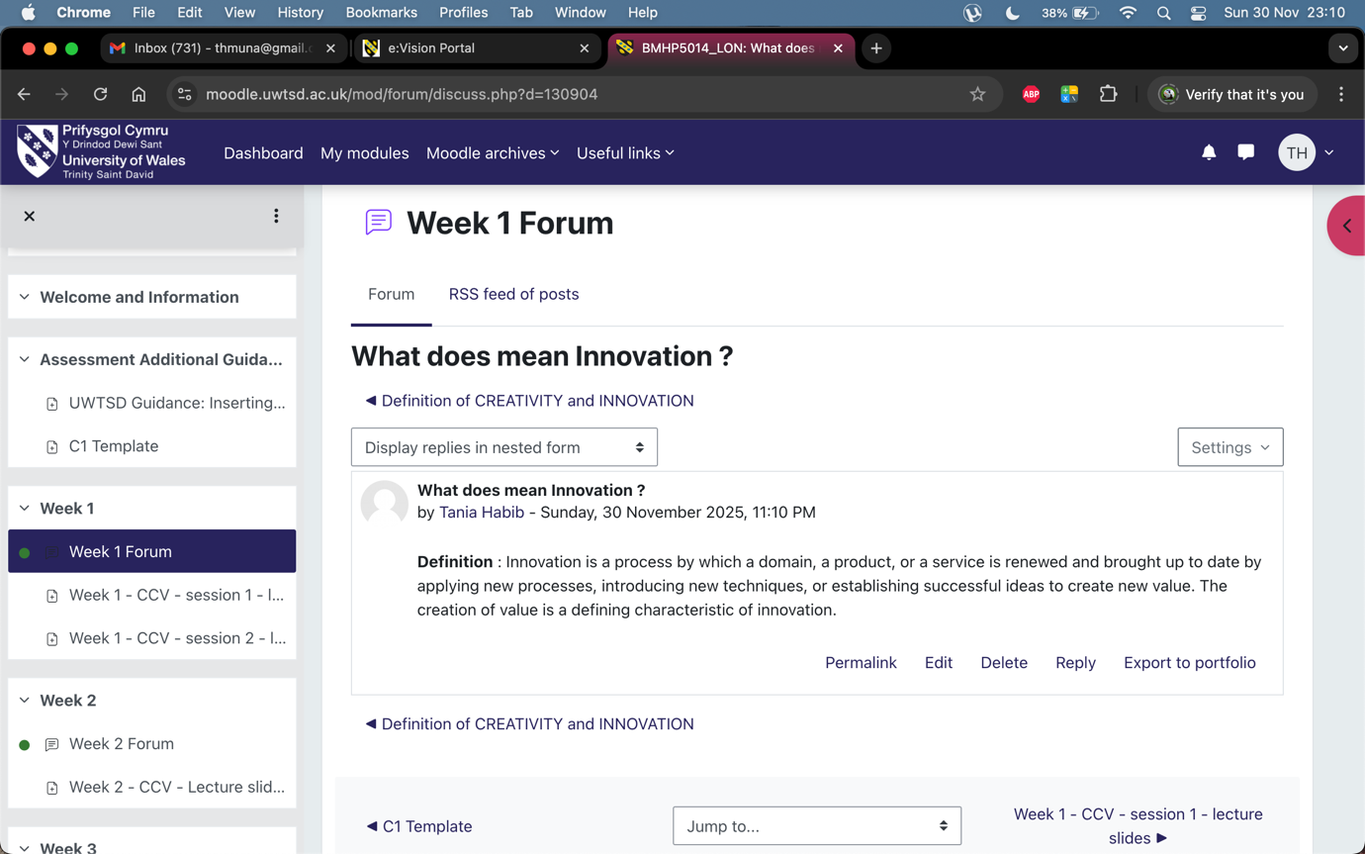

Figure – 1

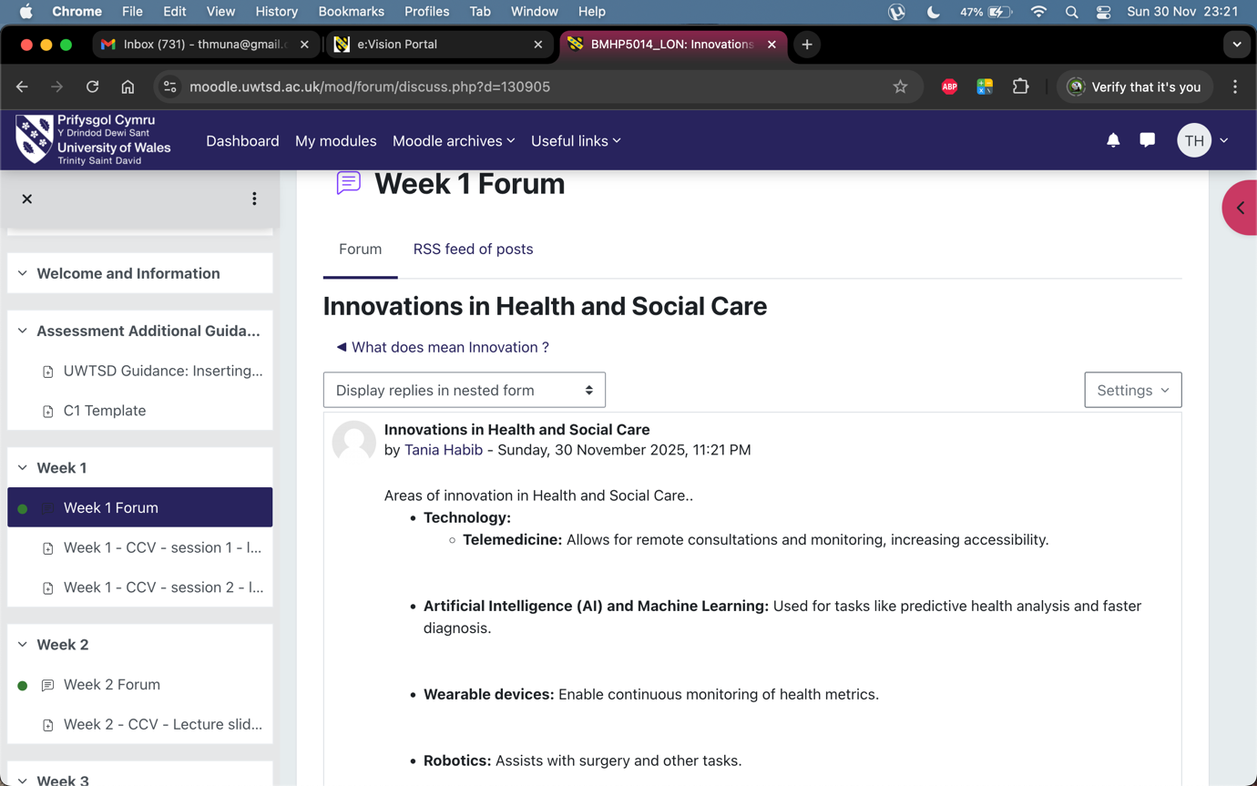

Figure - 2

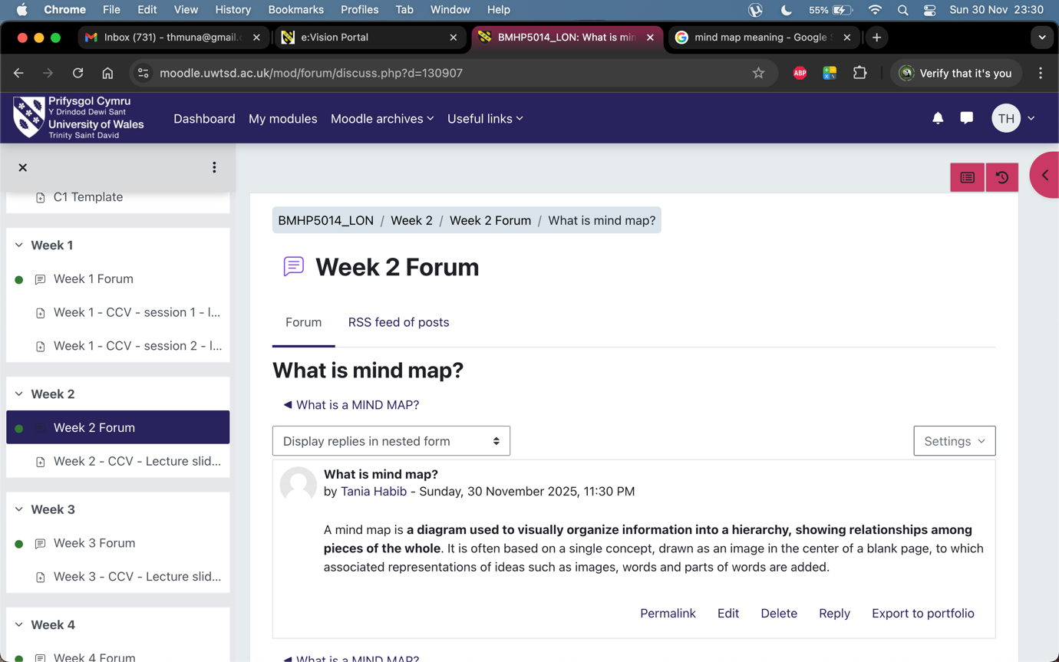

Figure - 3
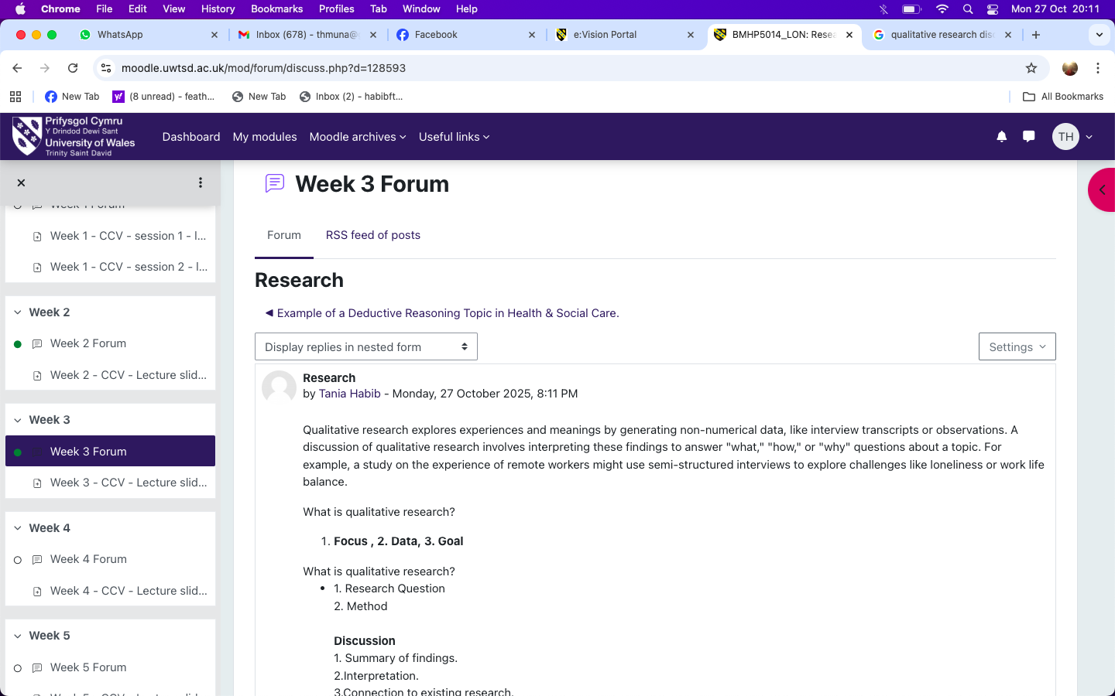

Figure - 4

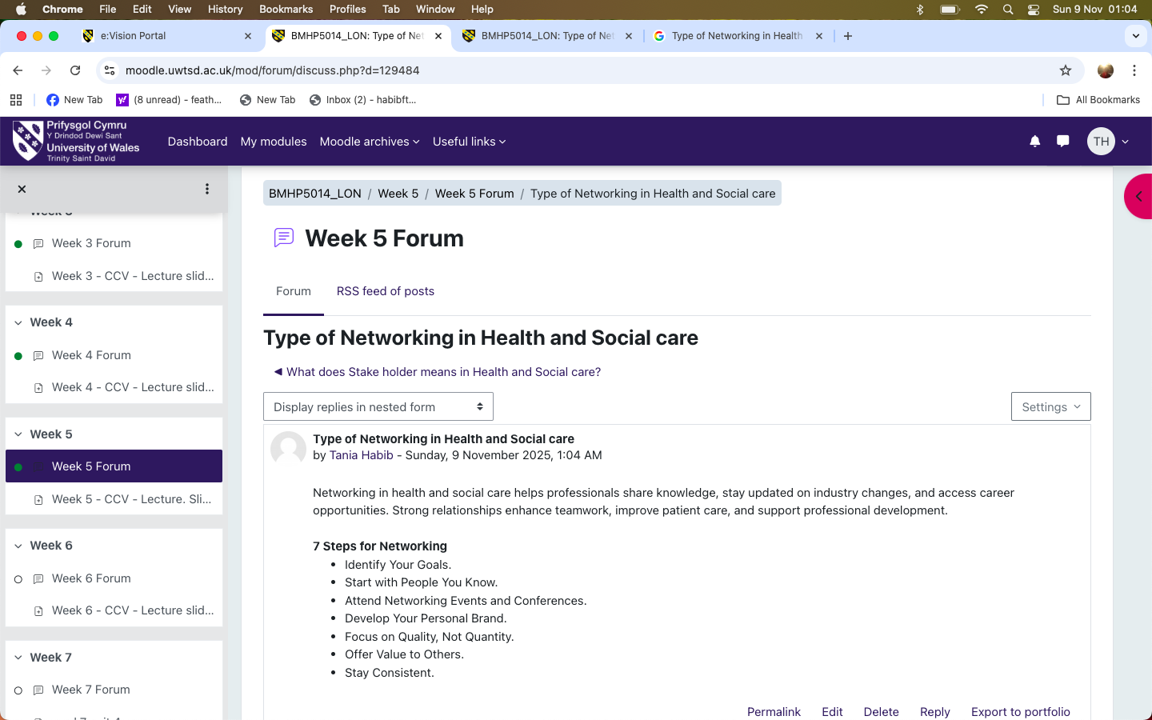

Figure - 5
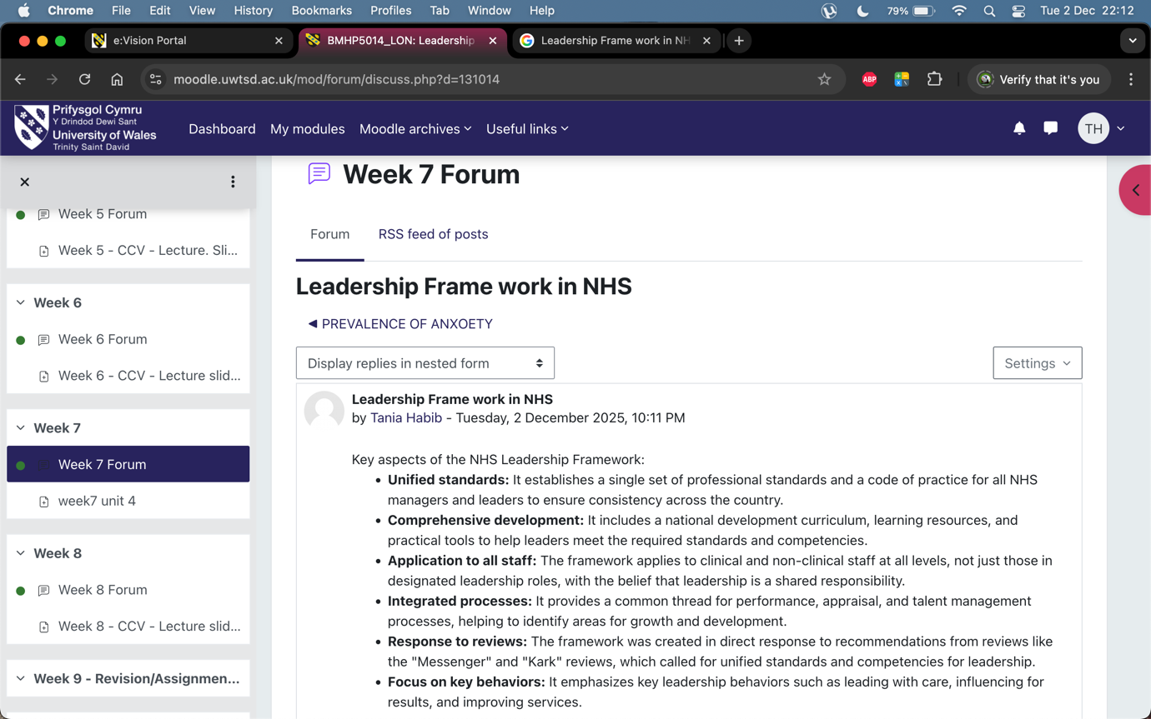

Figure - 6

