UNIVERSITY OF WALES TRINITY SAINT DAVID
LONDON CAMPUS
Assignment 1
Introduction to Web and Database Concepts
Module Name: Introduction to Web and Database Concepts
Module Code: ACCA4023

Student Name: Valerii Vdovin
Student ID:2510682
Group:4

Lecturer’s Name: Dr Suresh Shanmugasundaram

Table of Contents
Introduction 2
Main Body 2
Scenario Analysis 2
Identification of Entities, Attributes and Relationships 2
Entity Relationship Diagram (ERD) 4
Database Design in Microsoft Access 4
Normalisation to Third Normal Form 5
Sample Data Population 6
Queries 8
Purpose of each query 8
Forms and Reports 11
Validation and Testing 13
Testing methods & Results 13
Reflection 14
Conclusion 15
References 15

Introduction
In today’s world, the pharmaceutical sector faces an unprecedented need for reliable data processing methods. The development of personalised medicine and strict requirements for the recording of clinical prescriptions dictate the need for absolute accuracy in the storage of information about patients and medicines [1]. This project examines an automation scenario for ‘MediLink Pharmacy’ - a rapidly growing chain of community pharmacies. At present, the company relies on outdated manual and file-based accounting systems. Such an approach inevitably leads to fragmented information, duplication across different departments, and a high risk of critical errors when entering or updating records [2]. Manual inventory management, prescription tracking and sales history maintenance significantly slow down the pharmacy’s business processes and prevent management from obtaining analytical reports in a timely manner.
The main objective of this project is to design and develop a centralised relational database management system (DBMS) in the Microsoft Access environment, which will completely replace paper-based document flow. The database under development is intended to consolidate information on customers, suppliers, medicines and transactions within a single information space. The implementation of such a system will automate routine processes for dispensing goods, ensure strict control over stock levels, and provide managers with a convenient toolkit for generating financial and management reports.

Main Body

Scenario Analysis
System requirements analysis forms the foundation for the successful design of any database. At this stage, the pharmacy’s abstract business processes are translated into logical structures, enabling the company’s information needs to be precisely defined.

Identification of Entities, Attributes and Relationships
The subject area is based on entities (real-world objects) and their attributes (characteristics) [3]. An analysis of the ‘MediLink Pharmacy’ scenario identified the following key entities:
Customers: Stores basic information about customers and patients. Attributes: CustomerID (unique identifier), FirstName, LastName, Phone, Address.
Suppliers: Contains data on contractors supplying medicines. Attributes: SupplierID, SupplierName, ContactPhone, Email, Address.
Medicines: The main reference for the pharmacy’s product range. Attributes: MedicineID, MedName, Description, Price, StockQuantity and the foreign key SupplierID.
Prescriptions: Records the fact that a prescription has been issued to a customer. Attributes: PrescriptionID, CustomerID (reference to the patient), DoctorName, IssueDate (date of issue) and ValidUntil (expiry date).
PrescriptionItems (Prescription Items): Details the composition of the prescription. Attributes: PresItem (item identifier), PrescriptionID, MedicineID and Dosage (prescribed dosage).
Sales: Reflects general information about a cash register transaction. Attributes: SaleID, CustomerID and SaleDate.
SaleItems (Sales Items): Details the goods sold within a single receipt. Attributes: SaleItemID, SaleID, MedicineID, Quantity and SoldUnitPrice (price at the time of sale).
Relationships between entities in relational theory, entities interact with one another through logical relationships. The analysis identified the following cardinalities:
The relationship between Suppliers and Medicines (1:M, ‘supplies’): a single supplier provides a pharmacy with a variety of medicines.
The relationship between Customers and Sales (1:M, ‘places’): a customer may make multiple purchases.
The relationship between Customers and Prescriptions (1:M, ‘Holds’): multiple prescriptions may be issued in the name of a single patient. A conceptual issue is the relationship between prescriptions and medicines, as well as between sales and medicines (of the ‘many-to-many’ type). In accordance with relational database design principles, these have been decomposed using the associative entities PrescriptionItems (relationships ‘consist of’ and ‘Prescribed as’) and SaleItems (relationships ‘contains’ and ‘listed in’) [4]. An important feature of this scenario is that prescriptions and sales are logically separated at the schema level: this allows the pharmacy to freely sell over-the-counter medicines without having to link every sale to a medical document. As part of this course project, a relational database for the ‘MediLink Pharmacy’ chain was successfully designed, normalised and implemented. The transition from outdated manual spreadsheets to a fully-fledged DBMS has made it possible to completely eliminate data duplication, ensure the integrity of clinical and financial data through strict integrity constraints, and automate routine processes. The developed architecture, which is in third normal form, combined with a user-friendly interface and a powerful query engine, fully meets all the originally stated business requirements and has high potential for future scalability.

Entity Relationship Diagram (ERD)
Conceptual modelling using ER diagrams provides a graphical representation of how information entities interact within a system, abstracting away from the finer details of the physical implementation. The diagram serves as a universal means of communication between analysts and developers [5].
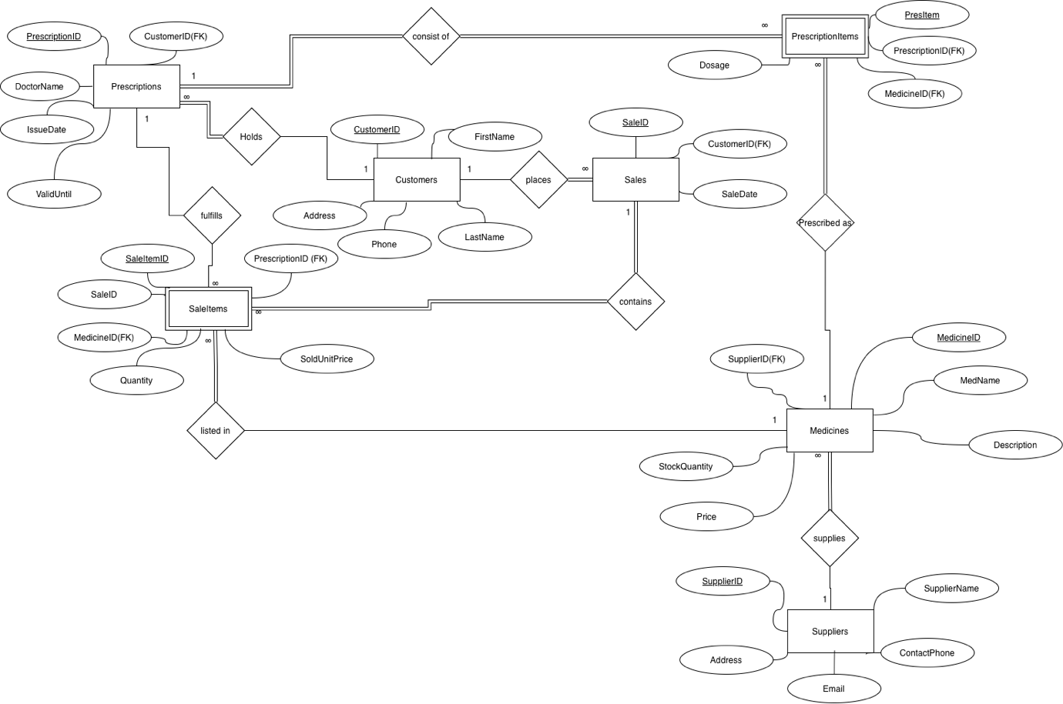
Figure 1: MediLink Pharmacy ERD (personal collection)
Primary keys, foreign keys, cardinality in the diagram shown, each rectangular area represents a separate entity. Primary keys (such as SaleID or PrescriptionID) serve to uniquely identify each record. Foreign keys act as a link, logically connecting child tables to parent tables, which forms the basis of relational algebra.
The lines in the diagram visualise the cardinality of the relationships, displaying the symbol ‘1’ on the parent table side and the infinity symbol ‘∞’ on the child table side. The diagram clearly illustrates the architectural solution: the Sales and Prescriptions entities exist in parallel, linked only through a common reference to the customer (CustomerID) and the product catalogue (Medicines), which ensures maximum flexibility of business processes.

Database Design in Microsoft Access
Once the conceptual schema has been approved, the process moves on to the physical design of the structure directly within Microsoft Access.
Tables created and Data types. Seven tables were created in the DBMS, exactly replicating the entities from the ER diagram. Each field was assigned the optimal data type. Primary keys are configured to use the AutoNumber type, which delegates responsibility for generating unique surrogate values to the DBMS, eliminating the human factor. For financial attributes, such as Price (in Medicines) and SoldUnitPrice (in SaleItems), the Currency data type was used, which is critical for avoiding rounding errors with floating-point numbers. The IssueDate, ValidUntil and SaleDate attributes are handled by the specialised Date/Time data type. The remaining descriptive fields have been assigned the Short Text type with reasonable length restrictions.
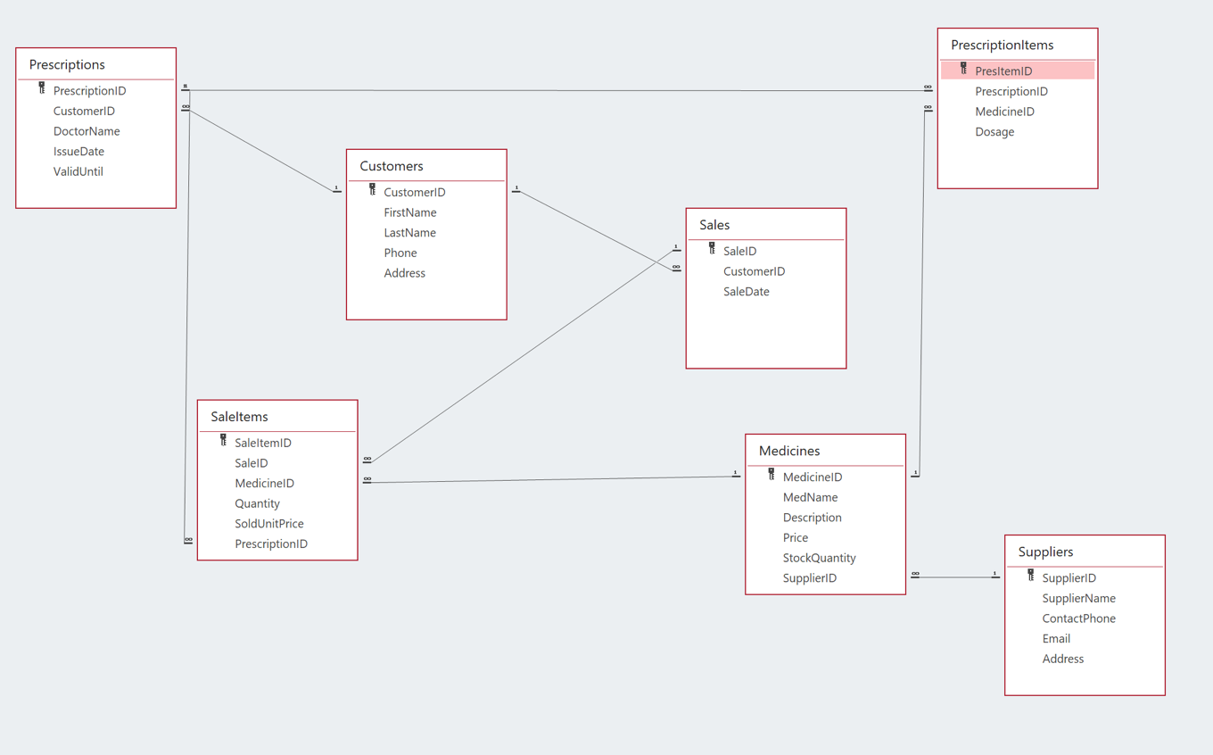
Figure 2: MediLink Pharmacy Relationships (Personal Collection)
Relationships and constraints. The primary mechanism for ensuring data integrity in the system is referential integrity [6]. In the Access settings, the ‘Enforce Referential Integrity’ function has been enabled for all relationships indicated on the ER diagram. This means that, at the physical level, the system will block any attempt to sell a medicine not registered in the Medicines table (via the MedicineID relationship) or to issue a prescription for a non-existent customer. Such structural constraints reliably protect the database from the occurrence of ‘orphan’ records.

Normalisation to Third Normal Form
Normalisation is a rigorous methodological process for reorganising the structure of tables, aimed at eliminating redundancy and protecting against anomalies when data is modified [7]. It has been proven that databases normalised to third normal form (3NF) provide the highest efficiency when processing complex queries in decision-making systems [8].
Steps of normalisation and design decisions
First Normal Form (1NF): A relation is in 1NF if it contains only atomic values and has no repeating groups. In our solution, instead of recording the list of sold medicines as continuous text in the Sales table, each item on the receipt was moved to a separate row in the SaleItems child table.
Second Normal Form (2NF): A table satisfies 2NF if it is in 1NF and all non-key attributes are fully dependent on the entire primary key. The creation of associative entities resolved the issue of partial dependency. For example, in SaleItems, the price of a specific medicine sold (SoldUnitPrice) depends on the composite concept of a specific transaction and a specific product (or on the unique key SaleItemID), whilst the overall sale date (SaleDate) is stored separately in Sales.
Third Normal Form (3NF): A relation is in 3NF if it contains no transitive dependencies. A striking example in our database is the handling of suppliers. If the supplier’s contact telephone number (ContactPhone) and address were stored directly in the Medicines table, this would lead to a massive duplication of information for each medicine from that distributor. Moving this data to a separate Suppliers table has eliminated the transitive dependency. Now, updating a supplier’s telephone number requires changing just one database cell, which prevents update anomalies.

Sample Data Population
To verify that the logic is working correctly, check the relationships and configure the analytical reports. Each database table has been populated with a representative set of test data.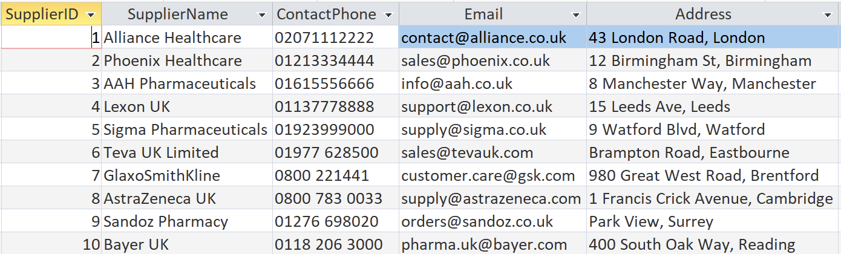
Figure 3: Suppliers Table (Personal collection)
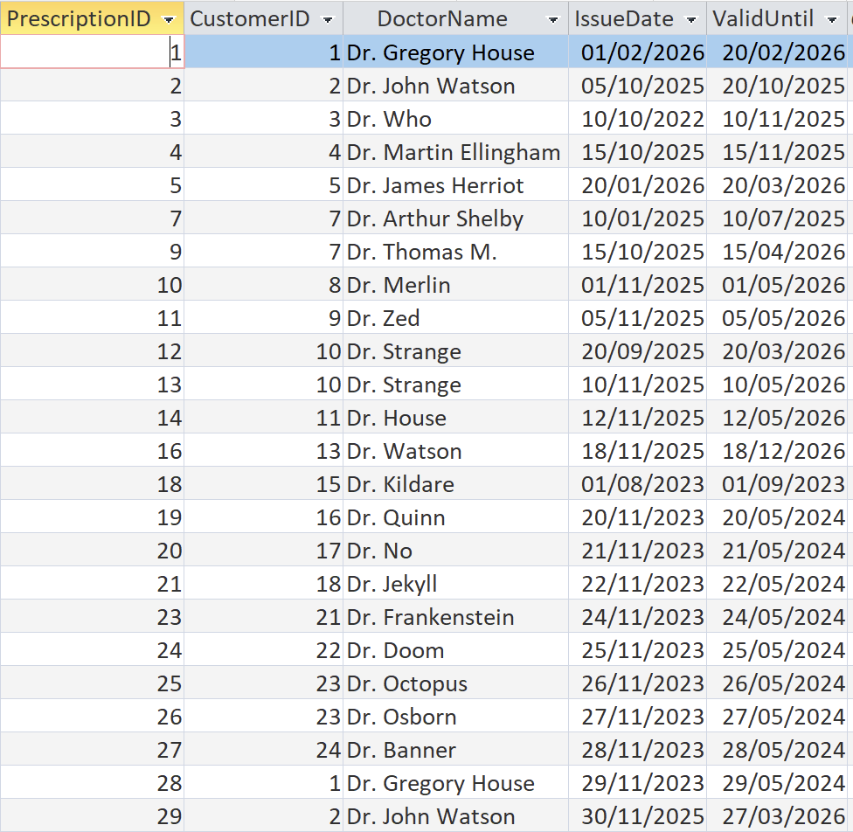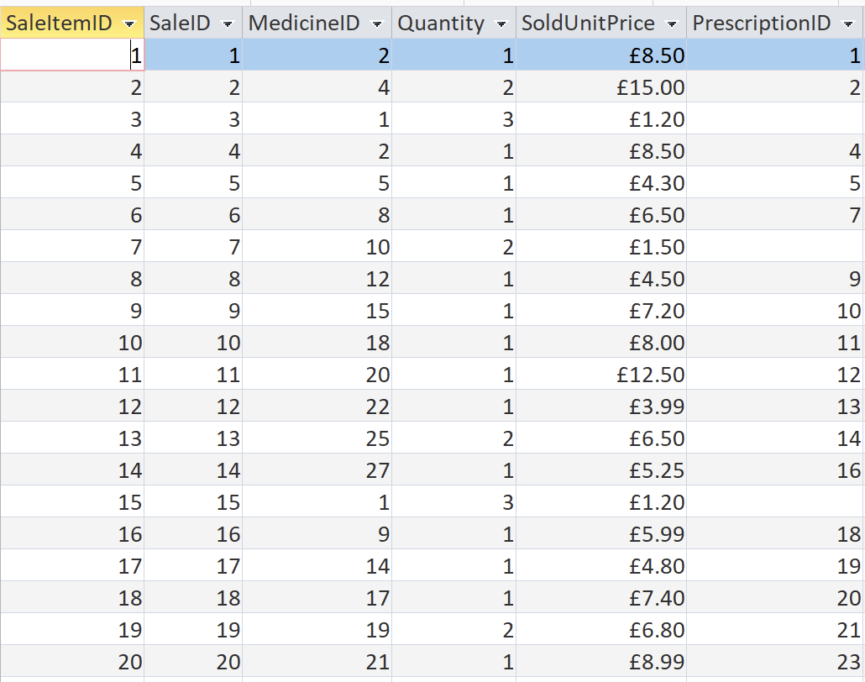
Figure 4: Prescriptions Table (Personal collection) Figure 5: SaleItem Table (Personal Collection)
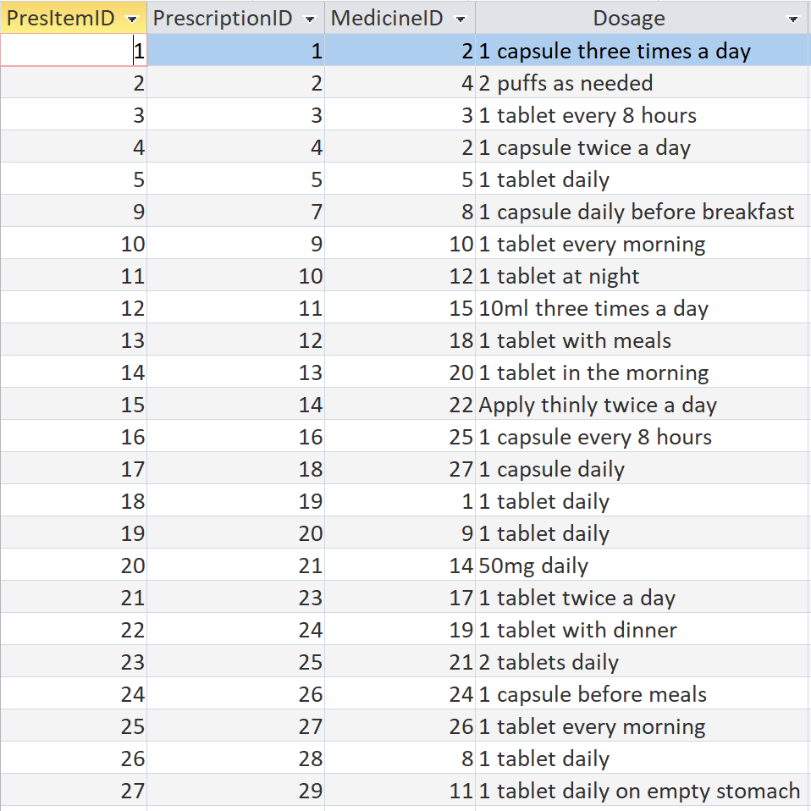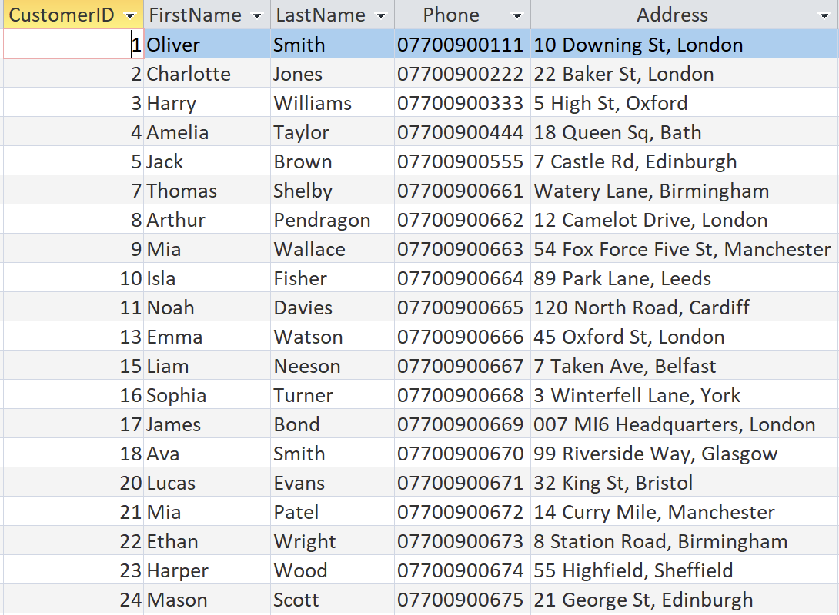
Figure 6: PrescriptionItems Table (Personal Collection) Figure 7: Customers Table (Personal Collection)
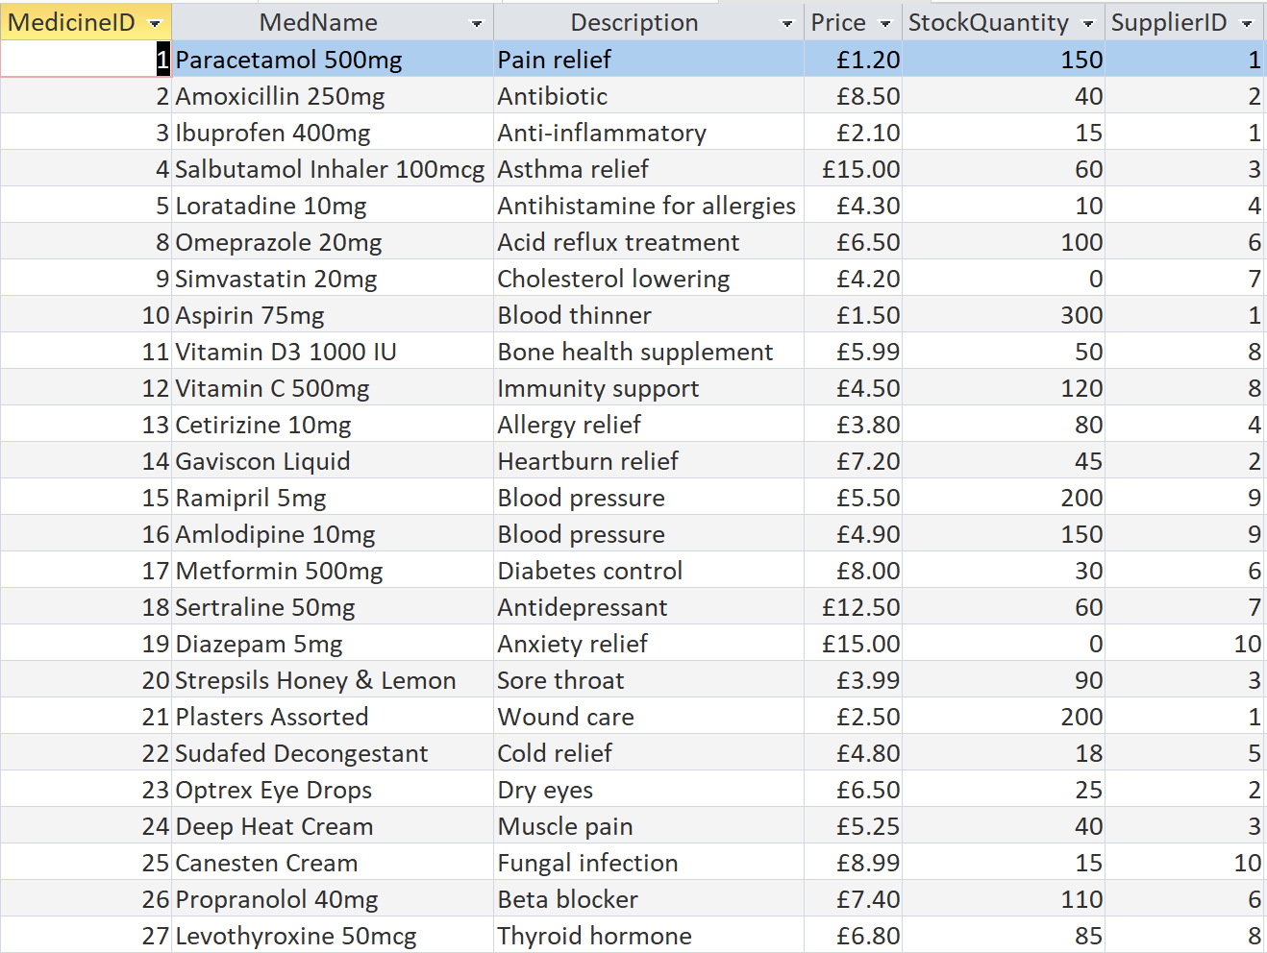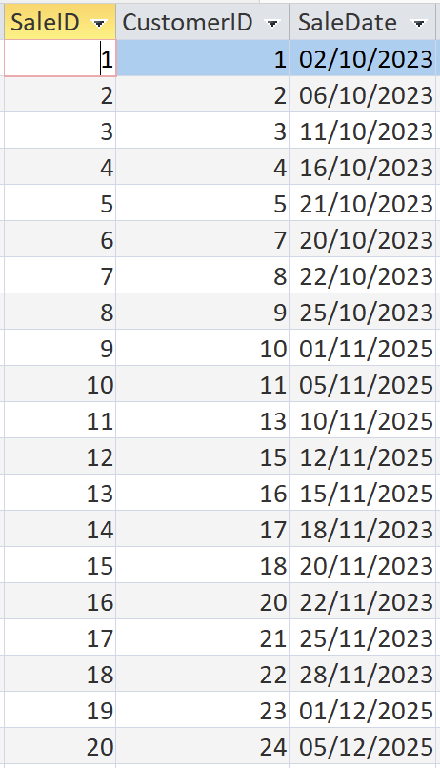
Figure 8: Medicines Table (Personal Collection) Figure 9: Sales Table (Personal Collection
Patient demographic data, supplier profiles, and a list of medicines with prices and stock levels (StockQuantity) were entered into the system, and real-world operations were simulated: issuing prescriptions with dosage (Dosage) and expiry date (ValidUntil), as well as recording sales. Filling in the transaction tables clearly demonstrates the ability of the designed architecture to correctly handle ‘one-to-many’ and ‘many-to-many’ relationships.

Queries
The use of structured queries (SQL) enables the conversion of raw data sets into valuable analytical and managerial information [9].

Purpose of each query
Low Stock Alert: This query filters the Medicines table using a condition (e.g., StockQuantity < 20). It is a vital operational tool for the procurement manager, enabling them to restock the range in good time.
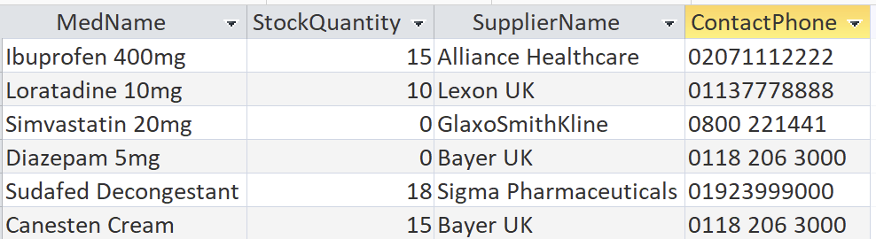
Figure 10: LowStockQuery Datasheet View (Personal Collection)
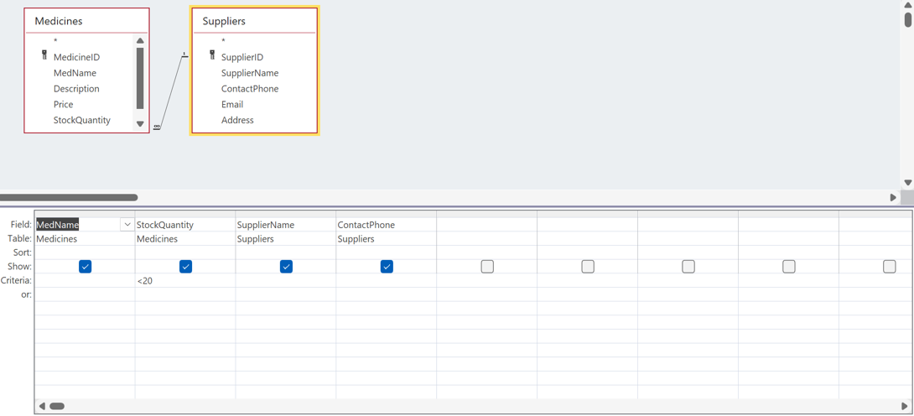
Figure 11LowStockQuery Design View (Personal collection)
Customer Prescription Details: A complex query that joins the Customers, Prescriptions, PrescriptionItems and Medicines tables. Its purpose is to allow a pharmacist to retrieve a patient’s full prescription history on request, including dosage (Dosage) and the names of the prescribing doctors (DoctorName).
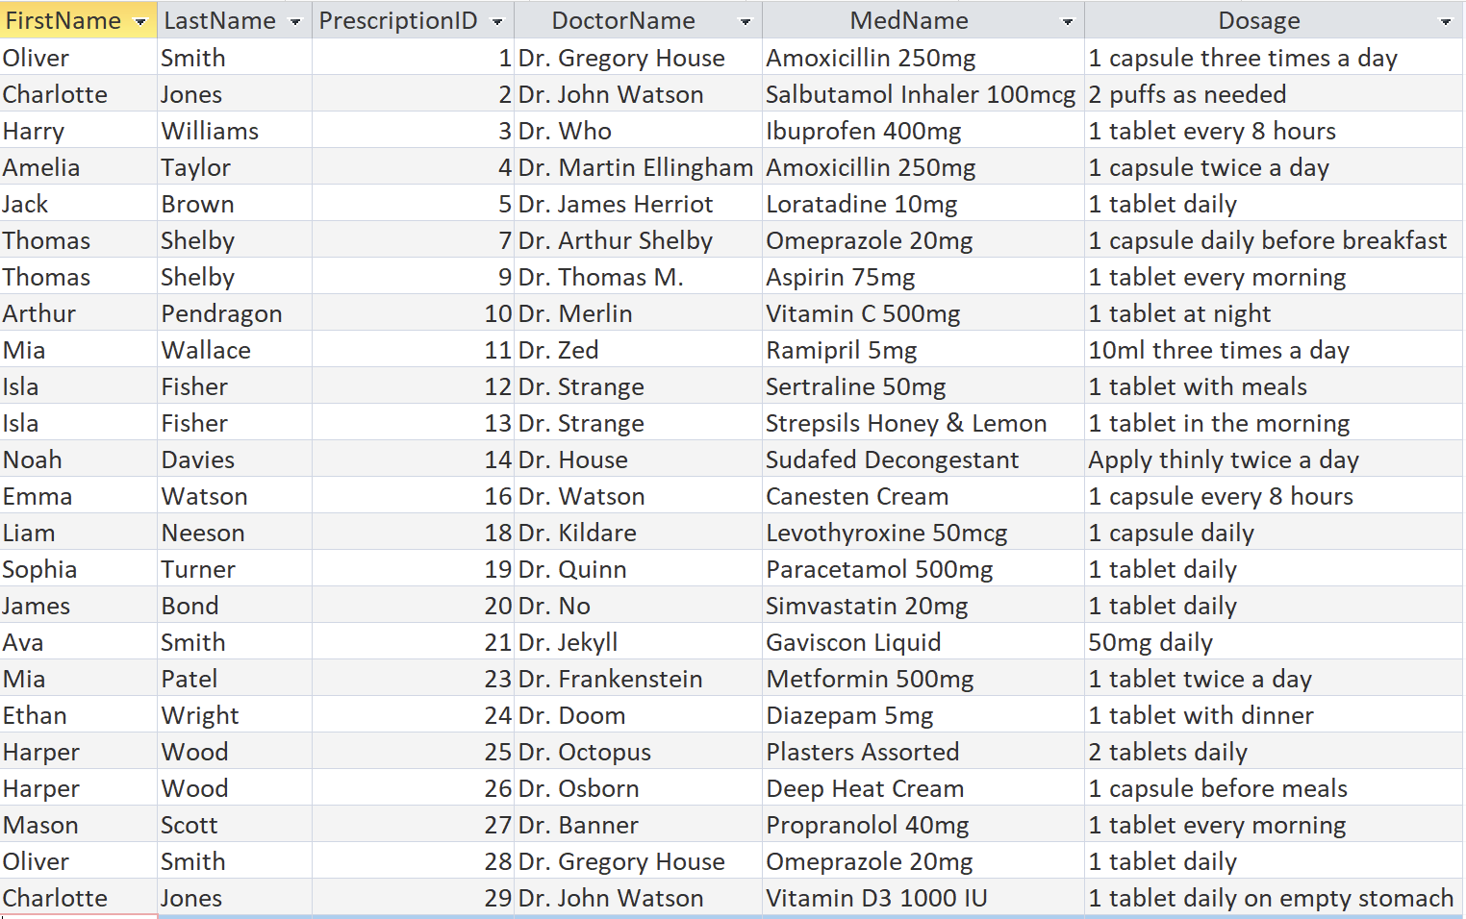
Figure 12: CustomerPrescriptionDetails Datasheet View (Personal collection)
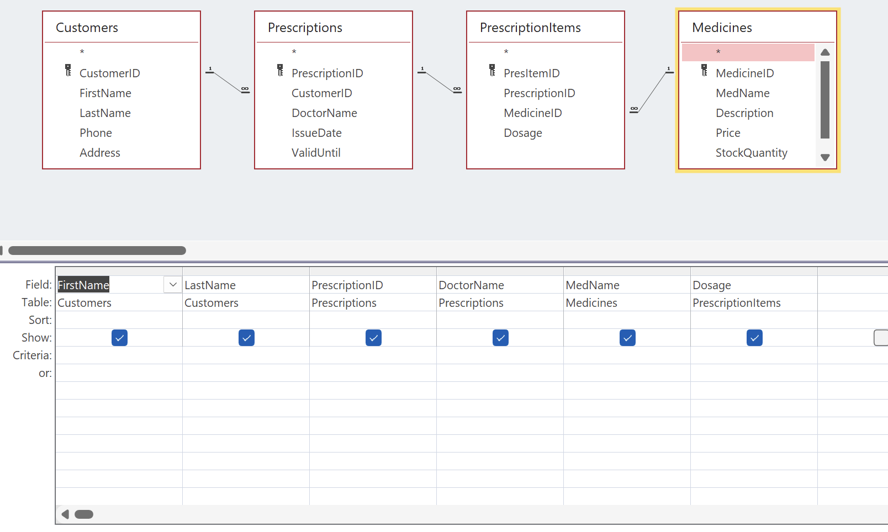
Figure 13: CustomerPrescriptionDetails Design View (Personal Collection)
Sales Revenue Analysis: A financial query that calculates the pharmacy’s revenue from sales receipts by multiplying the quantity of goods sold by their historical price (Quantity * SoldUnitPrice) in the SaleItems table, followed by grouping by date.
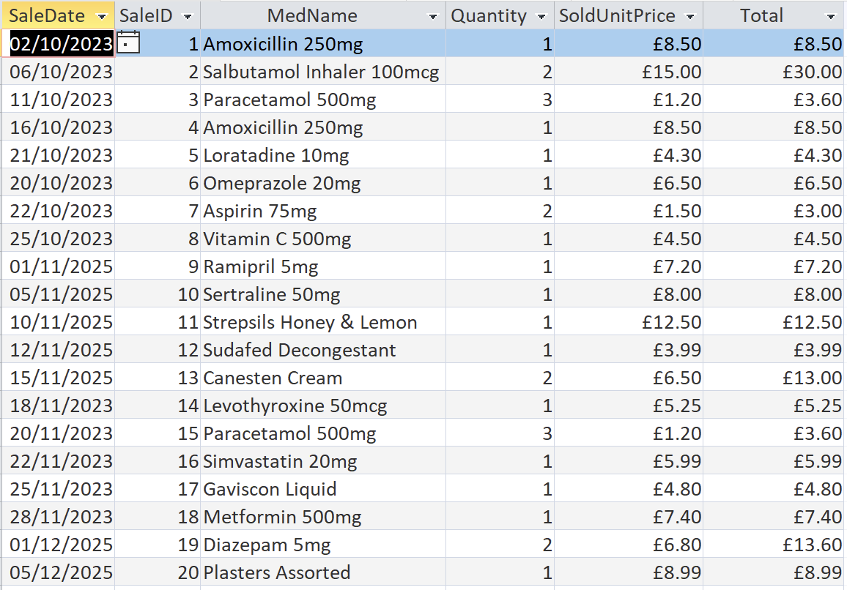
Figure 14: SalesRevenueAnalysis Datasheet View (Personal Collection)
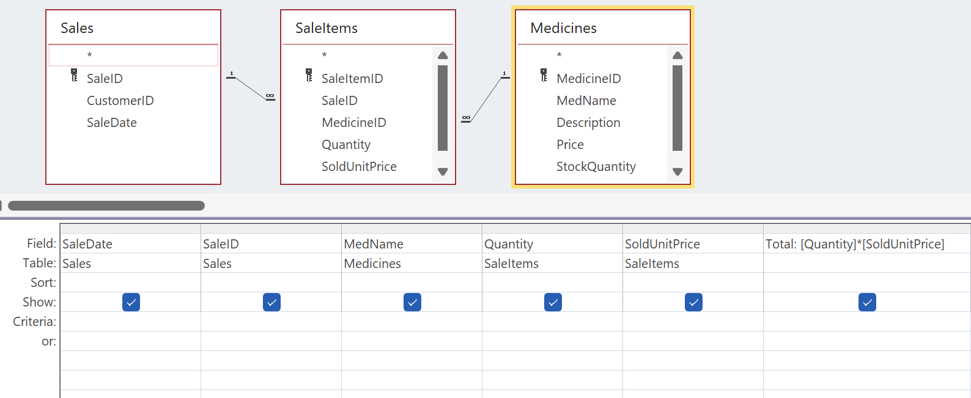
Figure 15: SalesRevenueAnalysis Design View (Personal Collection)
Expired Prescriptions Alert: A query that filters the Prescriptions table based on the condition ValidUntil < Date(). It helps identify expired prescriptions, which is critical for compliance with regulatory requirements for dispensing medicines.
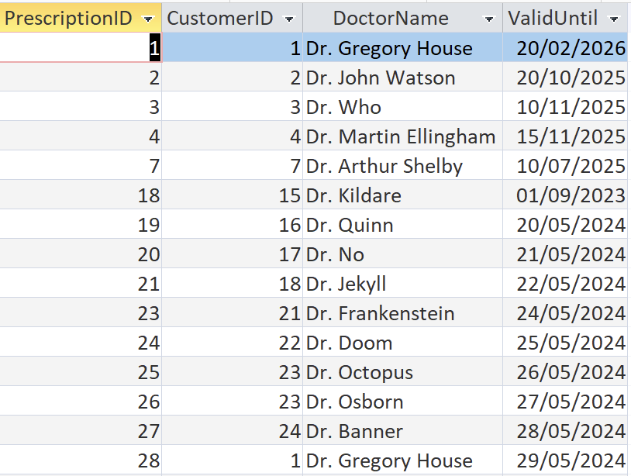
Figure 16: ExpiredPrescriptionsAlert Datasheet View (Personal Collection)
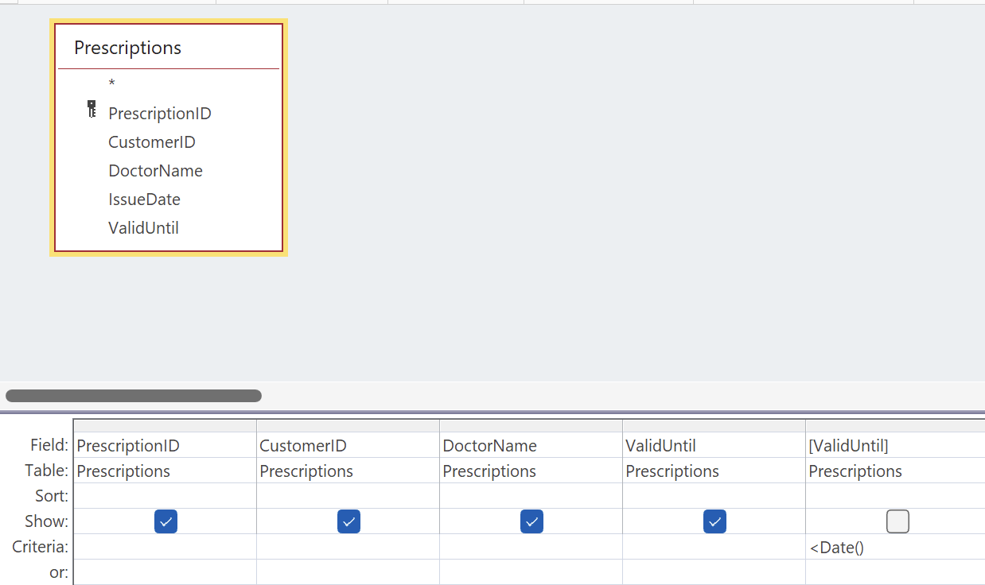
Figure 17: ExpiredPrescriptionsAlert Design View (Personal collection)

Forms and Reports
To ensure that staff without programming skills could use the system comfortably, an intuitive graphical user interface was developed using Access’s built-in features.
Explanation of functionality
Forms (Input forms): Screen forms were designed for data entry and editing. The most significant architectural decision was the use of the ‘Main Form / Subform’ structure for transactional processes [10]. When processing a sale, the main Sales form records the customer and date, whilst the embedded SaleItems subform allows medicines to be added to the receipt line by line, with Access automatically linking the records via the SaleID. A similar logic has been applied to Prescriptions and PrescriptionItems. Basic forms were also created for managing reference databases (Medicines, Customers) [11].
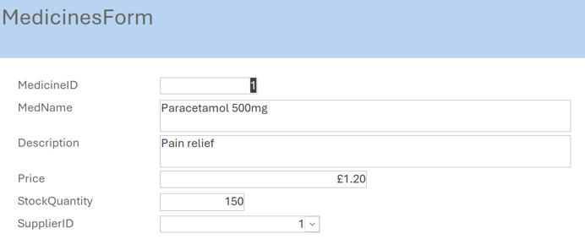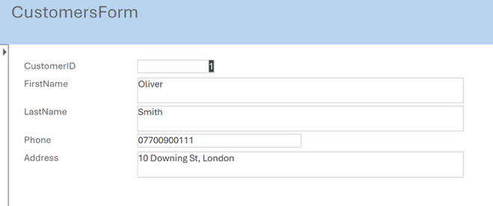
Figure 18: Medicines Form (Personal Collection) Figure 19: Customers Form (Personal Collection)
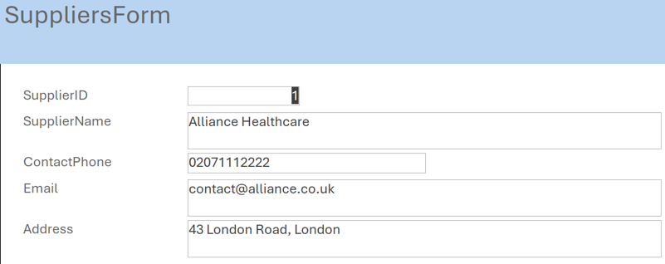
Figure 20: Suppliers Form (Personal Collection)
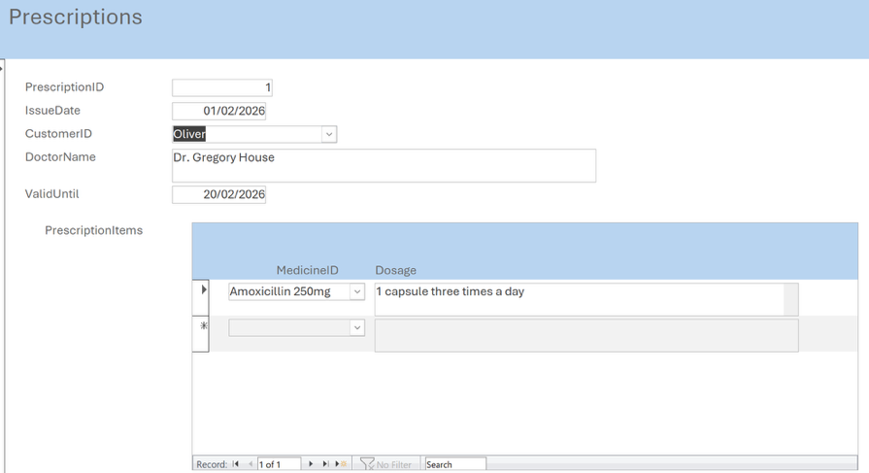
Figure 21: Prescription Form with PrescriptionItems subform (Personal Collection)
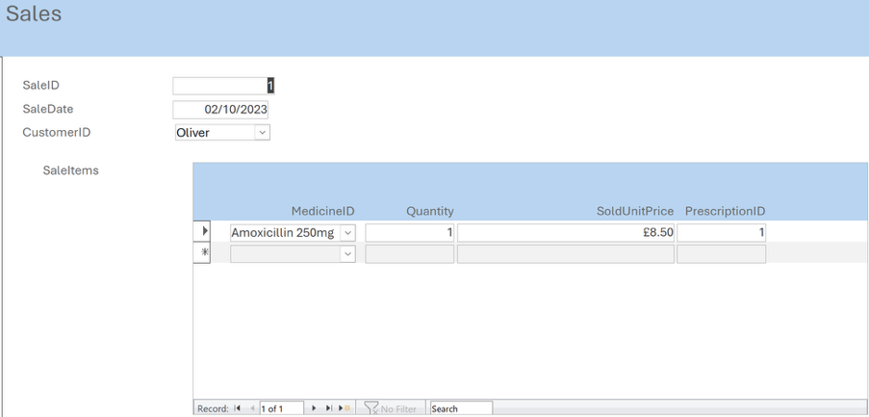
Figure 22: Sales Form with SaleItem subform (Personal collection)
Reports: Professional, print-ready reports have been configured for management purposes [12]. The following reports have been created: ‘Stock Shortage Report’ (based on the Low Stock Alert query) and ‘Sales Summary Report’. The reports utilise grouping and sorting functions to present aggregated data clearly.
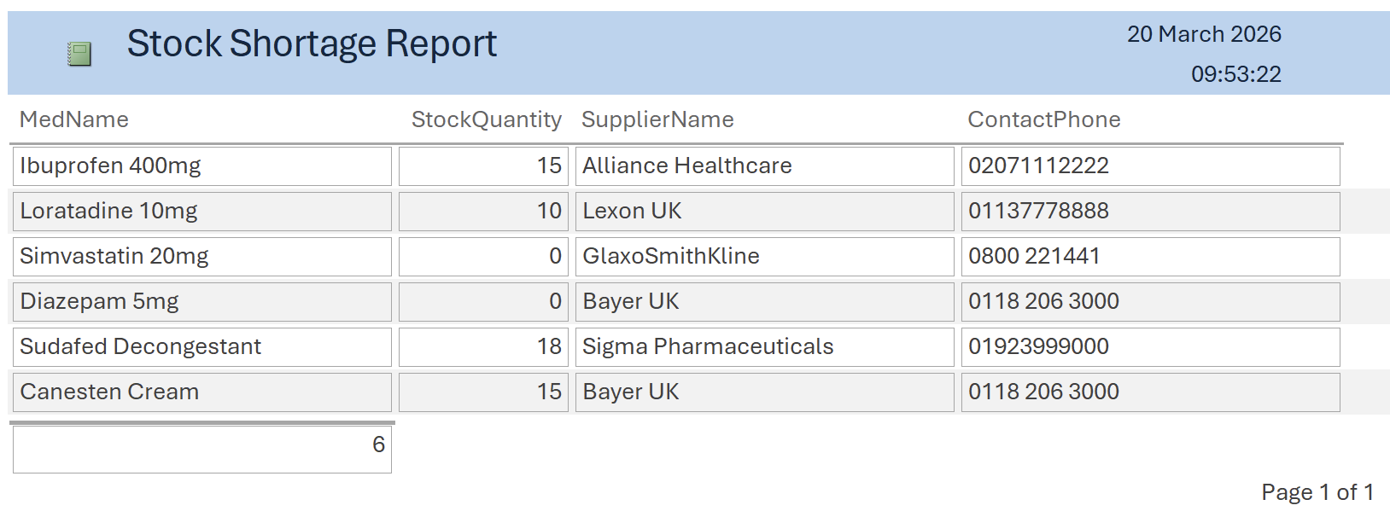
Figure 23: Stock Shortage Report (Personal Collection)
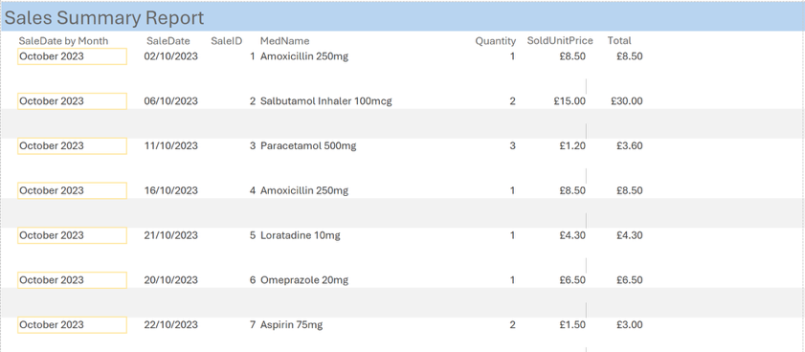
Figure 24: Sales Summary Report Top Page (Personal collection)
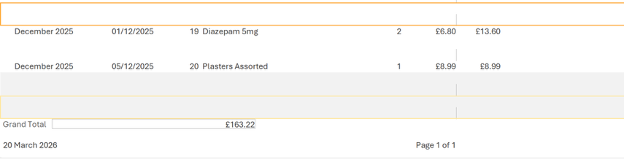
Figure 25: Sales Summary Report Bottom Page (Personal Collection)
In addition, a Dashboard form (Navigation Menu / Switchboard) has been implemented, serving as a single point of entry into the system and providing convenient navigation through the database sections.
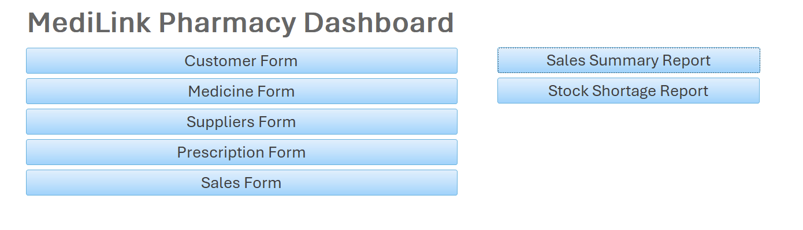
Figure 26: Dashboard form (Personal Collection)

Validation and Testing
The final stage before putting the database into operation is to test it for reliability, protection against input anomalies, and logical compliance with the specifications.

Testing methods & Results
Referential Integrity Testing: A deliberate attempt was made to insert a record into the SaleItems child table with a medicine identifier (MedicineID) that does not exist in the reference table. The system immediately blocked this operation, issuing a system error regarding a violation of referential integrity.
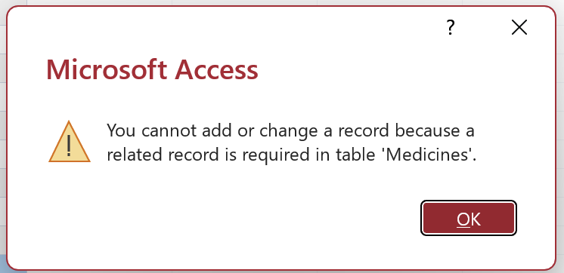
Figure 27: Referential Integrity Error (Personal Collection)
Subform binding check: When creating a new prescription via the composite Prescriptions form, the foreign key PrescriptionID was transparently and without error assigned to all child records in PrescriptionItems.
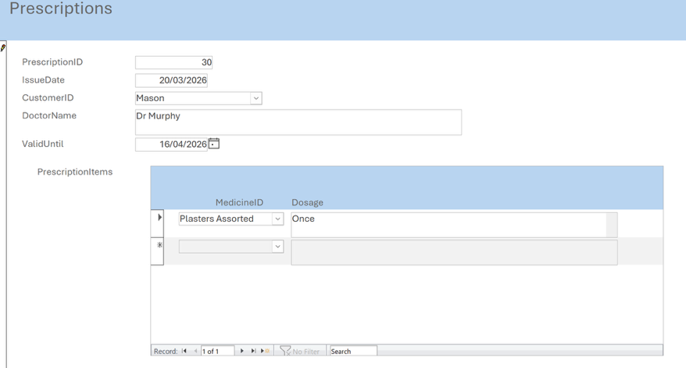
Figure 28: Creating new prescription via Form (Personal Collection)
Business logic validation in queries: The quantity of one of the medicines (StockQuantity) was artificially reduced to a critical value. When the ‘Low Stock Alert’ query was run, the medication immediately appeared in the results, confirming the correctness of the filtering algorithms.
Issues found and fixes. During the development of the sales report, an error was discovered in the calculation of the total receipt amount, as the total amount is not stored in the Sales table. The issue was promptly resolved by introducing a calculated field (Quantity * SoldUnitPrice) directly into the SQL query feeding the report, followed by the application of the SUM() aggregate function in the report headers.
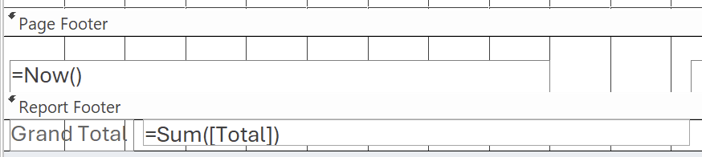
Figure 29: StockShortageReport Grand Total function (Personal Collection)

Reflection
Challenges faced: Database architecture design is a complex, iterative process. One of the main conceptual challenges was modelling the relationships between prescriptions and sales. Initially, there was a temptation to establish a hard join between the Sales table and the Prescriptions table. However, a thorough system analysis revealed that the pharmacy sells a wide range of over-the-counter medicines, and a hard join would have resulted in a huge number of empty (NULL) fields and structural anomalies. The final solution, reflected in the ER diagram—making these processes structurally independent and linking them only via the customer entity (CustomerID) and the product catalogue (Medicines)—proved to be the most elegant and correct from a normalisation perspective.
Improvements for the future. As a direction for the system’s future development, it would be advisable to consider the implementation of data macros to automatically deduct the quantity sold (Quantity from SaleItems) from stock levels (StockQuantity in Medicines) in real time. Furthermore, as the network expands, it will be necessary to integrate a role-based security model (Role-Based Access Control) to restrict the rights of ordinary pharmacists to delete historical financial transactions.
Conclusion
As part of this course project, a relational database for the ‘MediLink Pharmacy’ chain was successfully designed, normalised and implemented. The transition from outdated manual spreadsheets to a fully-fledged DBMS has made it possible to eliminate data duplication, ensure the integrity of clinical and financial data through strict integrity constraints, and automate routine processes. The developed architecture, which is in third normal form, combined with a user-friendly interface and a powerful query engine, fully meets all the originally stated business requirements and has high potential for future scalability.

References

[1] | J. C. Coons and P. E. Empey, “Towards consensus recommendations for pharmacogenetics testing,” American Journal of Health-System Pharmacy, vol. 81, no. 16, pp. 653-654, 2024.
[2] | M. Fotache, M.-I. Cluci, T. Taipalus and G. Talaba, “The effects of database normalization on decision support system performance,” Information Systems, vol. 136, p. 102636, 2026.
[3] | R. Elmasri and S. B. Navathe, Fundamentals of Database Systems, 7th, Ed., Boston: Pearson, 2016.
[4] | T. M. Connolly and C. E. Begg, Database Systems: A Practical Approach to Design, Implementation, and Management, 6th, Ed., Harlow, Essex: Pearson Education Limited, 2015.
[5] | S. Al-Fedaghi, “Conceptual Data Modeling: Entity-Relationship Models as Thinging Machines,” IJCSNS International Journal of Computer Science and Network Security, vol. 21, no. 9, pp. 147-160, 2021.
[6] | Microsoft, “Guide to table relationships,” [Online]. Available: https://support.microsoft.com/en-us/office/guide-to-table-relationships-30446197-4fbe-457b-b992-2f6fb812b58f . [Accessed 01 March 2026].
[7] | E. Eessaar, “The Database Normalization Theory and the Theory of Normalized Systems: Finding a Common Ground,” Baltic Journal of Modern Computing, vol. 4, no. 1, pp. 5-33, 2016.
[8] | A. Silberschatz, H. F. Korth and S. Sudarshan, Instructor’s Manual to Accompany Database System Concepts, 4th, Ed., Bell Laboratories, 2001.
[9] | Microsoft, “Create a simple select query,” [Online]. Available: https://support.microsoft.com/en-us/office/create-a-simple-select-query-de8b1c8d-14e9-4b25-8e22-70888d54de59. [Accessed 01 March 2026].
[10] | Microsoft, “Create a form that contains a subform (a one-to-many form),” [Online]. Available: https://support.microsoft.com/en-gb/office/create-a-form-that-contains-a-subform-a-one-to-many-form-ddf3822f-8aba-49cb-831a-1e74d6f5f06b. [Accessed 01 March 2026].
[11] | Microsoft, “Create a form in Access,” [Online]. Available: https://support.microsoft.com/en-us/office/create-a-form-in-access-5d550a3d-92e1-4f38-9772-7e7e21e80c6b. [Accessed 01 March 2026].
[12] | Microsoft, “Create a simple report,” [Online]. Available: https://support.microsoft.com/en-us/office/create-a-simple-report-408e92a8-11a4-418d-a378-7f1d99c25304. [Accessed 04 March 2026].

