Introduction
This assignment discusses the essential academic and employment skills needed for a career as a machine learning engineer.

Main body

Task1

Report on essential skills (a)

Whether it is to find evidence to support the students’ ideas or to question assumptions, critical thinking is the skill they need to apply those concepts. Dr Brian Wright and his colleagues argue that, by testing through experiments it strengthens and or develops critical thinking and analytical skills in machine learning (ML) [1].
Another useful skill for studying machine learning is mathematical reasoning because it helps with understanding calculations and interpreting results on a machine learning assignment [2]. To use an example, if a model makes 100 predictions and 90 out of a 100 of them are correct its accuracy on those is 90%. Students can then use this information to assess the accuracy of its predictions.

A machine learning engineer requires a set of strong foundations in mathematics, computer science and an expertise in python/ml engineering skills, data handling, communication skills and finally machine learning operations (MLOps) to release and maintain production ready models [3]. A study spanning from 2018 to 2023 in emerging professions like artificial intelligence (AI) and sustainability, shows that AI jobs became 21% more common in job adverts while simultaneously employers mentioned university qualifications 15% less often in AI job advertisements. [4]
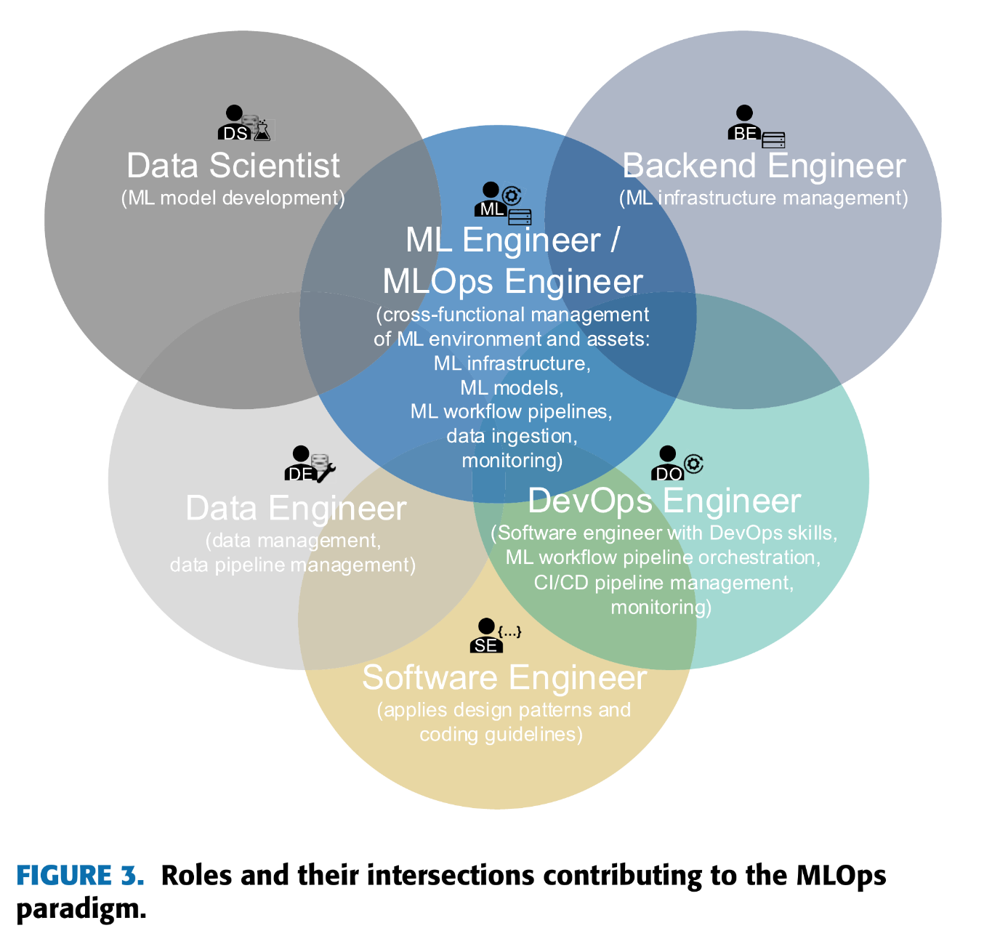
Figure 1. Roles contributing to MLOps. Reproduced unchanged from [3, Fig. 3, p. 31872], D. Kreuzberger, N. Kühl and S. Hirschl (2023), under CC BY-NC-ND 4.0.

Being a machine learning engineer offers varied career opportunities making the potential for growth significant, in turn leadership roles opportunities become realistically achievable. Some of the current positions available in the sector include :
- Senior Machine Learning Engineerrep
- AI Research Scientist
- Machine Learning Architect
- Head of AI/ML
- Chief Data Officer

Task 1 (b): AI Assistant Tools

Criteria | Chat gpt | Gemini | Cloude
Generating answers | Uses a more conversational model and generates human like answers. | Uses probability distribution on word-by-word text, answers can vary so in turn it can give different answers even if it receives 2 prompts that are exactly the same. [5]  -  Uses a multimodal transformer model | Uses a transformer based large language model.  Uses constitutional ai. [6]
Creative work, code/diagram generation | Can use blender, and image generation. can code with python for software like Godot intended for game development. | Can analyse a chart [7], visual layout and also diagrams natively | Less focused on multimodal creativity, but strong in text and contextual based diagrams
Data analysis | analyses files, answers questions about the data, and create tables or charts [8] | Gemini 1.0 Pro Vision extracted chart data, with errors requiring checks [7] | Claude 3 Haiku interpreted chart data, but its answers required checking [7]
Problem-solving | step-by-step it produces structured and analytical reasoning.  Does great in decomposition  and synthesis. | uses its high-speed multimodal inference, using text, images and code. | it clarifies questions and uses long-context reasoning, Good in architecture tasks.
ton
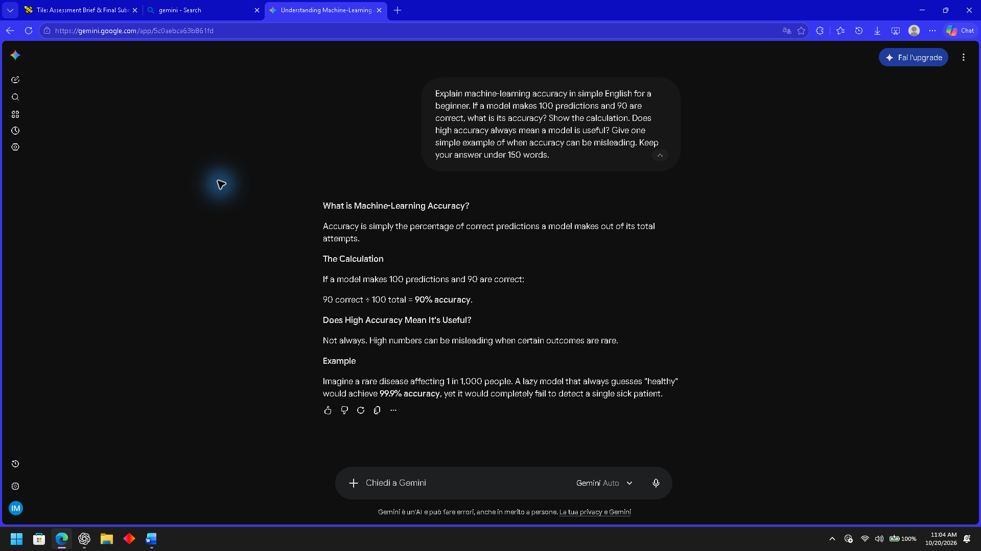
It helped me understand that even if the accuracy might seem high, it can still miss what you actually need it to find.
LinkedIn Learning: What Is Generative AI? — Pinar Seyhan Demirdag. Introduction watched: “Generative AI is a tool in service of humanity” (1 minute 6 seconds), 20 October 2026. Full course not completed.
https://www.linkedin.com/learning/what-is-generative-ai/generative-ai-is-a-tool-in-service-of-humanity
My reflection: for the time in our history humans are supervising while machines are generating, it will be a big shift in the future of jobs.
Bvc

Task 1 (c): Evaluation of Task 1 (a) based on Similarity report

Task2

Task3

Task4

Conclusion

Table of Contents
Introduction 1
Main body 1
Task1 1
Report on essential skills (a) 1
Task 1 (b): AI Assistant Tools 3
Task 1 (c): Evaluation of Task 1 (a) based on Similarity report 5
Task2 5
Task3 5
Task4 5
Conclusion 5
References 8

References

[1] | B. Wright et al., “The Importance of the Scientific Method in Machine Learning Education,” Harvard Data Science Review, vol. 8, no. 3, Jul. 2026, doi: 10.1162/99608f92.86d5f928.
[2] | O. Simeone, Machine Learning for Engineers: Principles and Algorithms Through Signal Processing and Information Theory, 1st ed. Cambridge, U.K.: Cambridge University Press, 2022.
[3] | D. Kreuzberger, N. Kühl, and S. Hirschl, “Machine Learning Operations (MLOps): Overview, Definition, and Architecture,” IEEE Access, vol. 11, pp. 31866–31879, 2023, doi: 10.1109/ACCESS.2023.3262138.
[4] | M. Bone, E. González Ehlinger and F. Stephany, “Skills or degree? The rise of skill-based hiring for AI and green jobs,” Technological Forecasting and Social Change, vol. 214, Art. no. 124042, May 2025, doi: 10.1016/j.techfore.2025.124042.
[5] | J. H. Lee and J. Shin, “How to Optimize Prompting for Large Language Models in Clinical Research,” Korean Journal of Radiology, vol. 25, no. 10, pp. 869–873, Oct. 2024, doi: 10.3348/kjr.2024.0695.  [6] S. Huang et al., “Collective Constitutional AI: Aligning a Language Model with Public Input,” in The 2024 ACM Conference on Fairness, Accountability, and Transparency (FAccT 24), Rio de Janeiro, Brazil, 2024, pp. 1395–1417, doi: 10.1145/3630106.3658979.  [7] M. S. Islam, R. Rahman, A. Masry, M. T. R. Laskar, M. T. Nayeem, and E. Hoque, “Are Large Vision Language Models up to the Challenge of Chart Comprehension and Reasoning?,” in Findings of the Association for Computational Linguistics: EMNLP 2024, Miami, FL, USA, Nov. 2024, pp. 3334–3368, doi: 10.18653/v1/2024.findings-emnlp.191.
 | [8] D. Koçak, “Examination of ChatGPT’s Performance as a Data Analysis Tool,” Educational and Psychological Measurement, vol. 85, no. 4, pp. 641–671, Aug. 2025, doi: 10.1177/00131644241302721.

