2019/20
Stella Mugabe
Leggett & Platt
1/1/2020
Leading and Managing Pojects


University of Wales St Davids
Leading And Managing Projects (MBA)
New Payroll Software for Leggett & Platt (Ammanford)

For Antje Cockrill

From Stella Mugabe

Contents

Project Description with Business Case 3
Environmental Analysis 6
Operational Requirements 7
Financial Projections 10
Recommendations & Findings 11
Appendices 12
References 14

Project Description with Business Case
The proposal is for a project to replace our legacy payroll system Timebags with a new cloud based, self-service system called BPT.
The full implementation from start to finish will take approximately 4 months. A Gantt chart has been attached in appendix 2 to show the projected time plan. Ideally the project should go live, after 2 clear parallel runs at the beginning of the next tax year.
Our current payroll system ‘Moneybags’ exists as a legacy software within the company. Specific issue relating to this software are that
- It has a high human resource demand to operate. At present we have a dedicated fulltime payroll employee for a company with 175 full time employees on its payroll. The systems require a minimum of 12 working days each month to manually calculate time & attendance hours for input into the system. Not only is this at a cost to the business, but a non-value adding activity.
- The system cannot be integrated with the HR, Time & Attendance and accounting software, meaning there is a lot of duplication in tasks. This in itself does not add any value to the company. Apart from it being an unnecessary cost to the company it also leaves the system prone to errors due to multiple entry of the same information in different systems.
- Moneybag is neither a good nor effective reporting tool. A significant additional amount of manipulation of data is required to make reports generated by the system meaningful or suitable for analysis. This manipulation often results in the final reports having errors due to incorrect formulas, miscopying etc.
- As the system is very old, the maintenance of it has also become rather expensive. With a very limited number of companies willing to offer systems support there is a very real danger and possibility that it could break down permanently.
- Moneybag does not have a self-service facility. The self-service facility allows employees to view and manage their payroll and HR information.

The benefits of the new payroll system are both financial and value adding.
- With the current payroll administrator set to retire in the next 5 months, there will be no need to replace this position. With the new system being integrated with the Time & Attendance software and HR, all information will automatically upload to the payroll system. The remaining function of running the payroll will now take approximately 2 days from start to finish, a function that can easily be absorbed by the finance team, giving them an opportunity of having payroll experience and added variety to their work. This alone will give a cost saving of £36,000.00 a year in salaries and fringes.
- BPT will be integrated with the HR, Accounts and Time & Attendance systems, no manual calculations and input of hours will be required into payroll. Rekeying of entries introduces costly errors to the system, that also take valuable time to correct.
- As the system can be customized in the report writing module, the reports generated will be timely, accurate and value adding to the business. The reports now generated can be structured to focus on the company’s key performance indicators such as absenteeism, lateness etc. allowing management to take early corrective action.
- BPT is used world wide which means there will be investments on updates, keeping the system relevant.
- There are then the many benefits of self- service;
Benefits of self service
- Printing and emailing payslips -Payroll administrators no longer need to manually print payslips for employees. Payslips are automatically available to employees through their self-service portal either on the on, before or after the payday as selected by the employer. This alone will save the company circa £14 thousand pounds a year.
- Responding to copy payslips requests – It is very time consuming and monotonous for payroll administrators to respond to employee requests for past and lost payslips. With the self-service portal, the employee can now access their information directly by logging onto their portal where they can view and download historic payslips. The employee can do this in the privacy of their own home.
- Responding to annual leave balance enquires – Similar to payslip requests, payroll administrators frequently get enquiries regarding an employee’s annual leave entitlement remaining. Again, the employee can login to their self-service portal to instantly view their leave balance along with leave entitlement for the year, allowing them to plan their holidays easily.
- Managing Annual Leave requests – managing annual leave could be considered a full-time job in itself with the amount of paperwork and administration required. An employee self service portal will enable employees to request annual leave electronically, with an automatic notification sent to the manager or supervisor to approve or decline the leave request instantly. Once approved, leave will be automatically added to the employee and employer calendars and will also synchronise back to the payroll software on the payroll administrator’s desktop, streamlining the entire annual leave process. No need for the Payroll administrator to maintain a spreadsheet with annual leave balances.
- Updating employee contact information – No longer does the HR personnel need to collect or change employee details. Instead the responsibility is fully with the employee to ensure that their personal details are updated and correct at all times. All amended information will automatically update payroll and Human resources files.

On the surface, an employee self service system seems designed to assist and to relieve some pressure on our HR department. But the benefits to the business go way beyond just the HR department. Employee self-service systems also been seen to have the following benefits for the business
- Reduce errors – Entry errors and other mistakes may be avoided by allowing employees to enter their own personal information. By eliminating the need for double entry and allowing employees to evaluate their own information, the chances of inaccurate information may be greatly decreased.
- Reduce of sick days – The Belgium site which implemented BPT last year has experienced a reduction in sick days since implementing self service systems. Its sick days are much more visible on screen to both employees and their managers, this likely acts as an incentive to keep sick days at a minimum.
- Cut costs – The administrative cost of processing annual leave or printing out payslips should not be under estimated, not to mention the financial costs in postage and the associated stationary.
- Reduce paper – The ability for employees to access payslips and other documents online is a time and money saver. By replacing paper documents, the company is also reducing our impact on the environment.
- Increased morale for payroll administrators – The ability for employees to access their own information and make changes were necessary means payroll administrators can actually work to a plan without the usual disturbances if employees requesting lost payslips or P60’s..
I have also explored the possibility of outsourcing our payroll function to a bureau, but have discounted this option for the reasons below
- This will only resolve the issue of the dated Timebags software system
- The time-consuming task of manually calculating the hours for input into payroll will still need to be undertaken
- The company will be handing over confidential and sensitive information to a third party
- The cost is more expensive overall
- There is a certain degree of risk if communication lapses.

Environmental Analysis
To ensure the success of the project it was important to have everyone who would be affected on board. To do this a Stake Holder analysis was carried out. A stakeholder analysis is the process of assessing a system and potential changes to it as they relate to relevant interested parties i.e. stakeholders (Wikipedia).
The stakeholders were identified from a brainstorming session. The identified stakeholders were then grouped by level of interest and level of influence they could have on the project as is shown in appendix 3 attached.
All stakeholders are important, but their levels of influence and interest determined the level of effort needed to keep them on side.
The trade union Leaders have great interest as they represent the workers body, but also exert great influence as they have the ability to convince the workforce to either work with us or make the job unnecessary difficult which could result in delays and increased costs to the project. For the project to be successful we need to work with them, taking their views on board and being flexible with our approach. We can keep them up to date on progress on the project by holding regular meetings. We need to engage with them from the onset.
The Finance director will be project sponsor, his reputation is at stake and we need his support, so we need to work very closely with him. The supervisors, HR manager, IT manager and Plant manager want to see this project succeed. Failure of the project could mean nonpayment of salaries, which will be disruptive for plant operations due to labour unrest. Will need to work with very closely.

For the rest of the employees whilst the project has a large impact on them, do not necessary carry a lot of influence, especially when looked at individually. The employees need to be kept updated from the very beginning of the project, explain to them the benefits of the new system and the cost savings to be achieved and how this would impact on the growth of the company. Allow them to ask questions and where possible give them an opportunity to test drive the test system.

Groups such as the HMRC and Pensions provider whilst they hold not much influence or are impacted would need to be kept on the radar. Making sure we are compliant with current Tax and Pension regulations.

The Executive management whilst the project has very little impact on them yield a significant amount of influence. They need to be kept satisfied by ensuring the project stays on track.

Operational Requirements

People
- Project Sponsor – According to the Project Management Body of Knowledge (PMBOK), the project sponsor is the is a person or group who provides resources and support for the project, program or portfolio for enabling success. The project sponsor will be responsible for many aspects of the project, from initiating and ensuring the success to approving and establishing parts of the project. According to the Project Management Institute (PMI), the project sponsor role can be broken into 3 parts; vision, governance and realization. In terms of Vision the project Sponsor will be responsible for a)making sure the business case is valid and in step with the business proposition, b)ensuring the project aligns with business strategy, goals and objectives, c)the project sponsor will stay informed of project events to keep project viable and d) will assist in defining the criteria for project success and how it fits with the overall business. On the issue of governance, the project Sponsor will a) ensure the project is properly launched and initiated, b)ensure organizational priorities are maintained throughout the project, c)offer support to the project manager for project organization, d)assist project manager in defining project roles and reporting structure, e)act as arbitrator on escalation points for issues when something is beyond the project managers control, f)assist in getting financial resources and g)will be the decision maker for progress and phases of the project. On the issue of value of benefits realisation, the project sponsor will a) make that any risks and changes are managed, b) oversee the delivery of the project, c) assist to ensure control and review processes, d) evaluate status and progress, e) approves deliverables, f) helps wit decision making, g) responsible for project quality throughout the project phases. As payroll fall under the Finance Directorate I propose the project Sponsor is the Director of Finance as he has a vested interest in the project’s success.
- Project Manager -The Project Manager will be the person responsible for delivering the project. The project Manager will achieve this by a) creating a clean and concise plan to both execute the project and monitor its progress b)organizing and motivating the project team, this will be especially important as most of the team members will still have an element of their day jobs and can experience periods of stress when expected to carry out both responsibilities, c)controlling time management. The success of this project will largely be judged on whether it has been delivered on time, making meeting deadlines non-negotiable. The project manager will need to define the activities to be undertaken, sequence the activities to avoid bottlenecks, accurately estimate the duration of activity and develop and maintain a working schedule, d) It will be the Project Managers responsibility to ensure the project stays on budget, the project manager will need to develop systems of control for this. Even if the project meets the organisations expectations and is delivered on time, it will still be a failure if it goes over budget, e)With any project Hiccups are inevitable, but it is the project managers responsibility to meticulously identify and evaluate potential risks before the project begins, e) To ensure the project stays on track, it is the Project Managers responsibility to monitor and analyse both expenditures and team performances and take corrective action as necessary, f)The senior management team will need to be kept informed on the projects progress and any critical issues, the responsibility to present comprehensive reports to senior management on a regular basis rests with the Project manager. This project is not big enough to warrant recruitment of a full-time person for the role. I propose the Financial controller takes over this position but is financially compensated for all overtime worked. I estimate the cost of that overtime to be £3,000.00.
- Payroll Administrators x2 – A temporary payroll administrator will need to be employed for a period of 4 months to make them 2. Our current payroll administrator will continue with business as usual, so the process is seamless for employees and will assist with reconciliations at the parallel run stage. The other payroll administrator will have the responsibility of populating the new system and assist with the parallel run. The cost of the additional payroll administrator will be £12,00.00 for the duration of the project.
- Availability of ITC staff – Having spoken with the ITC manager, 2 senior members if his team will be made available for the project. Their role will be to ensure the specification of the new system is compatible with existing systems, assisting with the data transfer from the legacy system to the new system, integrating and testing the systems ensuring they are accurately ‘talking to each other’. The ITC members will be available to the project throughout it’s duration at no additional cost to the project.
- The new software system – This will need to be purchased with all the necessary licensing arranged.
- Additional terminals – Terminals will need to be purchased with all the associated peripherals. These terminals are to be placed in the canteen to allow for use with members of staff who do not have an allocated desk top or laptop. This will mean no member of staff needs to use their personal computer equipment to be able to access the pay details.
- Additional and renovation work in canteen -This will be required to facilitate the additional terminals, slight renovations will need to undertaken in the canteen to accommodate the new terminals.
- Use of a control room- A meeting room will need to be booked in advance for all future meetings. In this room space is needed to keep information such as visual display of progress and workflow charts, which will help keep track of progress on the project.
- Time – A very important requirement from every member of the team. Most of the members will be required at times to manage to 2 jobs, the project and their day job. This will prove challenging at times, but it is important that managers appreciate that other tasks could be affected as people try to manage the 2 jobs.
For the project we will use the ‘waterfall’ also called the traditional project planning method. The fact that all the heavy analysis is undertaken at the very beginning of the planning phase makes it ideal. We need to understand exactly what our end product will be before work begins. As the system will need to integrate with other systems we will need to be very clear of the specifications from the very beginning ensuring compatibility. We will also need to be very clear on the deliverables from the very beginning, something that the waterfall method of project management will ensure. As the project is anticipated to only take 4 months, being absolutely sure of what our final product will be in paramount, there is no room for mistakes nor changes. The waterfall method of project management is also very easy to understand for all as it follows a natural projection.

Financial Projections
Below is a breakdown of forecast costs.
Project manager overtime costs £3,000.00
Temp payroll administrator £12,000.00
New Payroll system £15,000.00
Additional Terminals and Peripherals £6,000.00
Renovation to canteen £3,000.00
Contingency £1,000.00
Total One-off cost £40,000.00

Annual licensing fee £450.00

Saving to be made each year
Salary saved on reduced headcount £36,000.00
Annual support fees £450.00
Estimate of additional fees paid for support £2,500.00
Total Savings £38,950.00
This gives the project a payback period of just over 1 year and a Return on Invest of 96% in it’s second year and thereafter. The company currently has uses a weighted average cost of capital of 20% on evaluating all its capital projects.

Recommendations & Findings
I would strongly recommend that the company accepts this project proposal. The savings on the project pay for the initial costs within just over 1 one year. The return on the investment is more than 4 times the minimum expected on any investment.
There are also some benefits to which we cannot put s financial value to, these are things like target reporting that will help reduce absenteeism and assist in calculating critical issues like the number of parts produced per person per shift, which will in turn help us improve our productivity.
BPT has already been implemented by two companies in the group. The Belgium site has been using it for just 18 months and thy report that absenteeism has dropped by 15% since its implementation, productivity has increased by 7% due its measures implemented from its targeted reporting.

Appendix 1

Executive Summary

Pullmaflex a Division of Leggett and Platt manufactures seating components for the automotive industry.
The project proposal is for approval for funding to purchase and implement a new payroll system that allows for a self-service portal.
The current system, is a legacy system coupled with problems of not being able to integrate wit the Time & Attendance, HR and Accounting softwares, meaning multiple duplication of tasks.
The benefits of a self-service portal are immense, allowing staff to manage their own personal updates, manage annual leave and view payslips at any time.


Appendix 2

Appendix 3
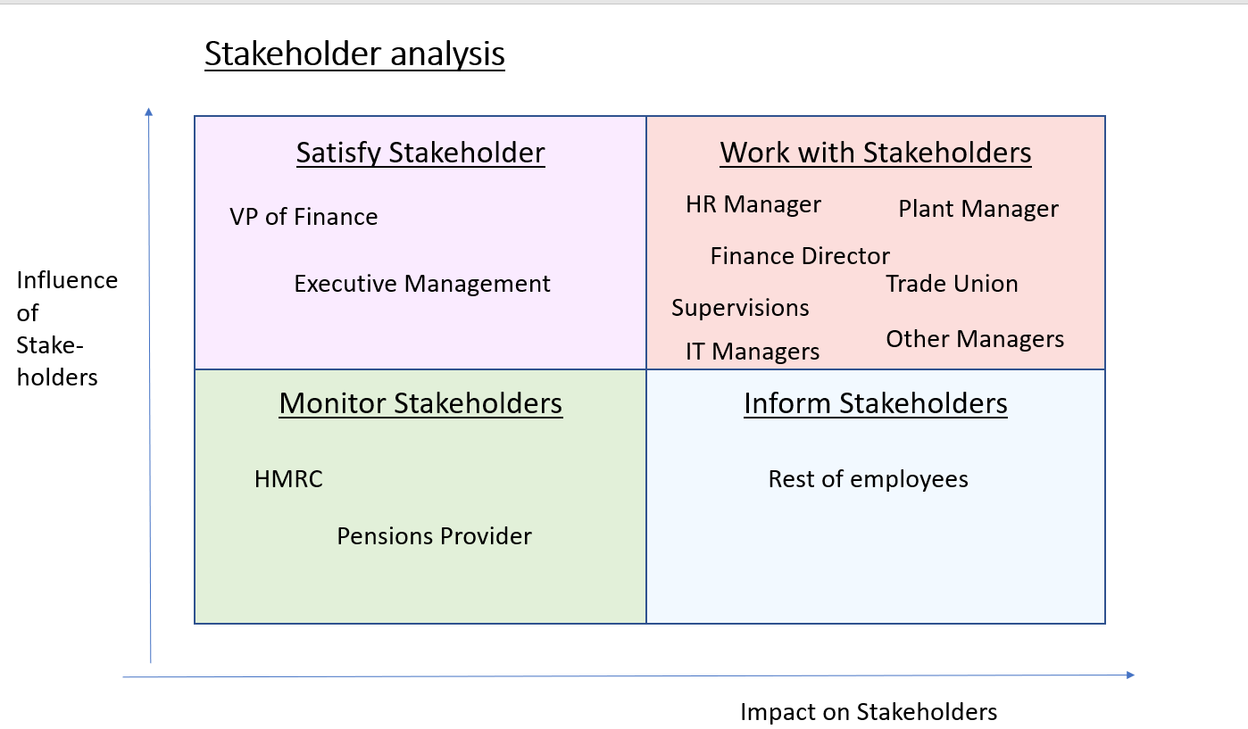

Environmental Analysis…Wikipedea
Project Sponsor……PMBOK
Waterfall project plan…..agile-scrum-masta training
Stakeholder analysis….mindtools.com
Gantt Chart……Copterra.com/project

