1a.

Test Case | Observed output | Error Type | Explanation
A | Error | Syntax | Incorrect casing on variable
B
C
D
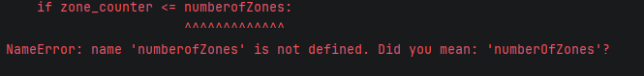
Error occurs in all cases
1b.
Test Case | Observed output | Error Type | Explanation
A | Error | Syntax | Underscores present where they shouldn't be
B
C
D

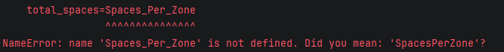
3a.
Test Case | Observed output | Error Type | Explanation
A | Error | Logic | free_spaces undefined
B
C
D

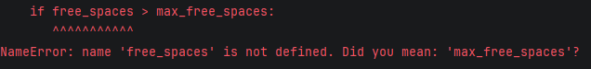
This error was corrected by defining the ‘free_spaces’ variable. The variable was defined as free_spaces=0.

Test Case | Observed output | Issue Resolved? | Explanation
A | Occupancy 4  100%  warning | yes | Algorithm reached end state, no errors.  All variables correctly defined.
B | Occupancy 3  100%  warning |  | Insufficient capacity
C | error | User is instructed to only use 1 or 0 | Cannot accept string (%)
D | Occupancy 3  100%  warning |  | Reached capacity
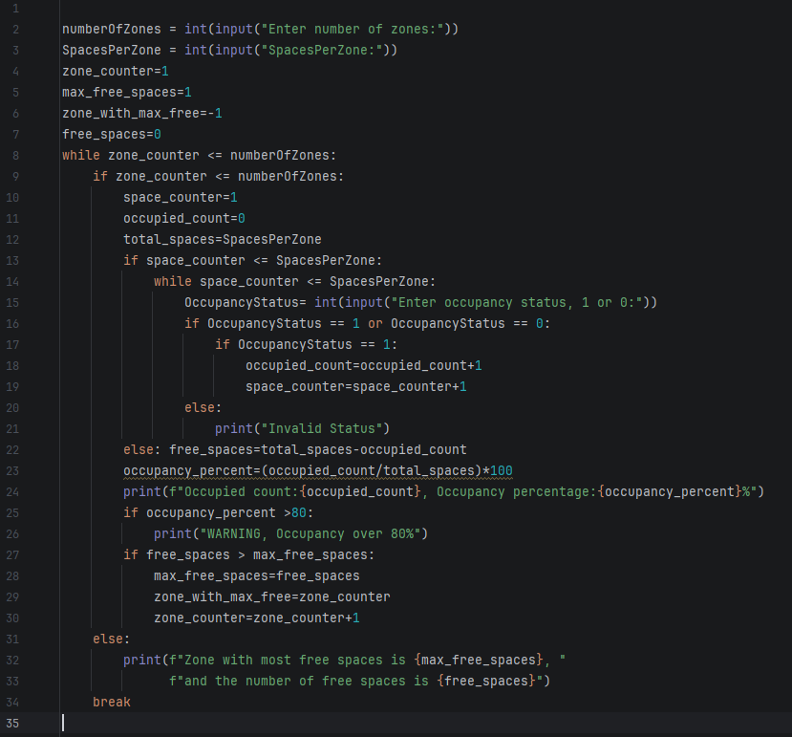
Script with all syntax, logic and spelling errors corrected.

Improving Logic
The example use of nested if statements makes the script unwieldy, and difficult to edit due to an obscure decision tree structure. Additionally, this example requires that its loop doesn't terminate, else it would stop the program prematurely.

Reflection
This script makes use of nested if and else statements, comparing multiple variables and indefinite loops, with the most challenging being the aligning of parent if statements with corresponding child statements.

The first test case in a table was always useful in identifying problems in the script, and was used to root out syntax and logic errors.

Running real test cases helped to confirm and identify suspected errors in the script, as multiple rounds of testing and correction were required to generate the desired output.

